ONLINE BOOK STORE
SOFTWARE ARCHITECTURE & DESIGN SPECIFICATION
Software Engineering Mini-Project
Document ID | OBS-ADS-001
Version | 1.0
Date | 29 September 2026
Project Type | Software Engineering Mini-Project
System | Online Book Store
Proposed Implementation | MERN-based web application
Name | Prabhu Hadagali
SRN | PES1UG24CS682

Version | Date | Author/Owner | Change Summary
1.0 | 29 September 2026 | Prabhu Hadagali  PES1UG24CS682 | Initial architecture and design specification for the Online Book Store.

Table of Contents
- 1. Introduction
- 1.1 Purpose
- 1.2 Scope
- 1.3 Definitions and Acronyms
- 2. Architecture Specification
- 2.1 Architecture Pattern
- 2.2 High-Level Architecture
- 2.3 Component Architecture
- 2.4 Component Descriptions
- 2.5 Data Architecture
- 2.6 Security Architecture
- 2.7 Architecture Traceability
- 3. Detailed Design
- 3.1 Design Principles
- 3.2 Sequence Diagram — Customer Order
- 3.3 Sequence Diagram — Administrator Inventory Update
- 3.4 API Design
- 3.5 Error Handling
- 3.6 Authentication and Authorization Design
- 3.7 Backup and Availability Design
- 4. Design Traceability Matrix
- 5. Assumptions and Open Points

1. Introduction

1.1 Purpose
This document defines the software architecture and detailed design of the Online Book Store (OBS) using the requirements established in the SRS and the testing expectations established in the Test Plan. It covers the architecture pattern, components, security architecture, data interactions, API design, UML sequence diagrams, error handling, and traceability.

1.2 Scope
The design covers customer functions including registration, login, browsing, searching, filtering, book details, cart management, ordering, payment, order viewing/cancellation and reviews. It also covers administrator functions including book management, inventory management, order-status updates, customer management and sales reporting.

1.3 Definitions and Acronyms
Term | Definition
SRS | Software Requirements Specification
OBS | Online Book Store
API | Application Programming Interface
UML | Unified Modeling Language
DB | Database
TLS | Transport Layer Security
RTM | Requirements Traceability Matrix

2. Architecture Specification

2.1 Architecture Pattern
The proposed implementation uses a layered three-tier architecture with an MVC-style separation of presentation, application/business logic and data access. The project Test Plan permits MERN or Django; for this design specification, MERN is used as the concrete reference implementation so that the components and APIs can be described consistently. If the team selects Django instead, the externally visible responsibilities and traceability remain applicable while the framework-specific implementation changes.
- Presentation layer: React-based customer and administrator web interface.
- Application layer: Node.js/Express REST API containing authentication, catalogue, cart, order, payment and administration services.
- Data layer: MongoDB for customer, book, inventory, order and related application data.
- External service boundary: supported payment mechanism accessed through HTTPS/TLS.

2.2 High-Level Architecture
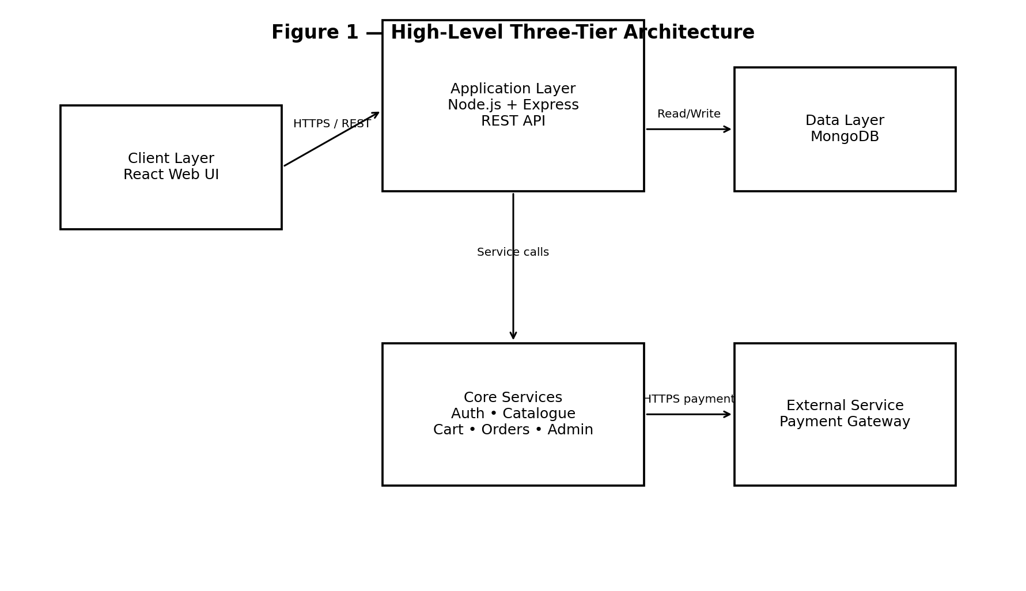
Figure 1 — High-Level Three-Tier Architecture

2.3 Component Architecture
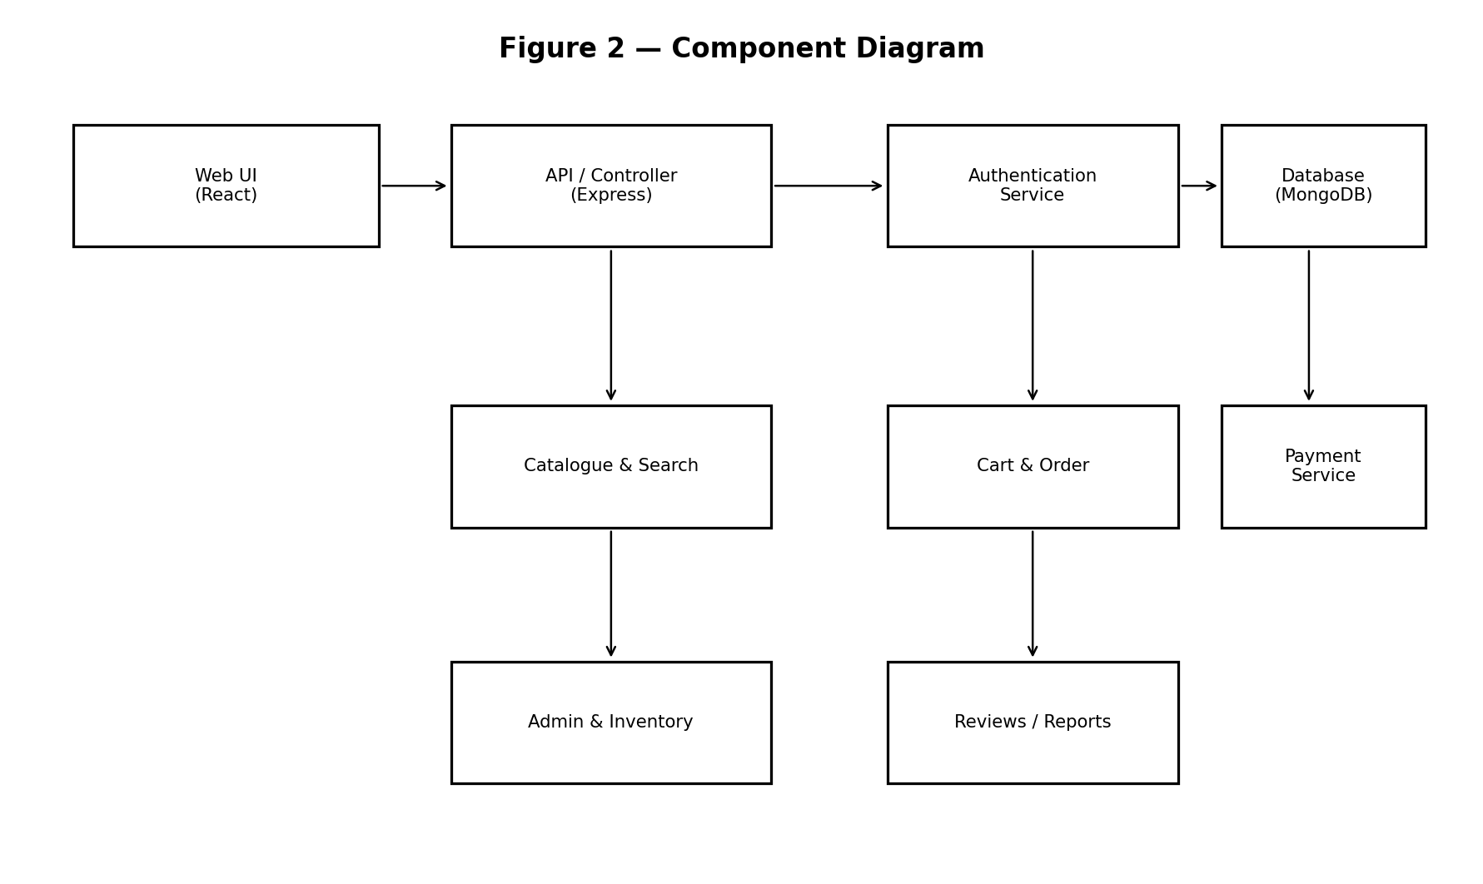
Figure 2 — Component Diagram

2.4 Component Descriptions
Component | Responsibility | Related SRS Requirements
Web UI | Customer and administrator screens for discovery, cart, checkout, orders, reviews and management. | OBS-F-001–F-018; OBS-NF-004
Authentication Service | Registration, login, session protection and role-based access. | OBS-F-001, F-002; OBS-SR-001, SR-002, SR-003, SR-006
Catalogue/Search Service | Book browsing, search, filtering and book details. | OBS-F-003–F-006
Cart Service | Add, modify, remove items and calculate totals. | OBS-F-007–F-009
Order Service | Order creation, availability checks, confirmation, viewing and eligible cancellation. | OBS-F-010, F-011, F-013–F-015
Payment Service | Communicates with supported payment mechanism for confirmed orders. | OBS-F-012
Admin/Inventory Service | Book CRUD, inventory and order-status management, customer management and reports. | OBS-F-017, F-018
Review Service | Ratings and reviews for eligible books. | OBS-F-016
MongoDB Data Layer | Persistent application data including catalogue, users, inventory and orders. | Supports functional and backup requirements

2.5 Data Architecture
The data layer is designed around the entities implied by the SRS: Customer, Administrator, Book, Inventory, Cart, Order, Payment, Review and Sales Report. Relationships and exact database schema fields are implementation details to be finalized with the selected build.
- Customer data supports registration, authentication, account access and order history.
- Book and Inventory data support browsing, search, filtering, availability checking and administrator updates.
- Cart and Order data support cart totals, order placement, confirmation, viewing and eligible cancellation.
- Payment records support the supported payment flow and confirmation.
- Review data supports ratings and reviews for eligible books.
- Order and inventory data are included in the automated backup requirement.

2.6 Security Architecture
Security architecture directly follows the SRS security objectives and requirements. The system separates customer and administrator roles and protects client-server communication with HTTPS/TLS.
Security Control | Design | Traceability
Authentication | Require authentication before protected account/order access. | OBS-SR-001
Authorization | Enforce role-based authorization; administrator functions are restricted to authorized administrators. | OBS-SR-002
Password Protection | Store passwords using a secure one-way hashing mechanism; never plaintext. | OBS-NF-003, OBS-SR-003
Transport Security | Use HTTPS/TLS between client and server. | OBS-SR-004
Integrity | Reject unauthorized inventory/order modifications. | OBS-SO-002, OBS-SR-005
Session Security | Terminate authenticated sessions after the configured inactivity period. | OBS-SR-006
Confidentiality | Prevent unauthorized access to customer, personal and order information. | OBS-SO-001

2.7 Architecture Traceability
The SRS RTM maps requirements to proposed modules and test cases. This design specification preserves those requirement IDs and refines the proposed modules into architecture components. The Test Plan retains the same requirement-to-test relationships.
Requirement Group | Architecture Component | Test Reference
OBS-F-001–F-002 | Authentication Service | TC-OBS-001, TC-OBS-002
OBS-F-003–F-006 | Catalogue/Search Service | TC-OBS-003–TC-OBS-006 in SRS RTM
OBS-F-007–F-009 | Shopping Cart Service | TC-OBS-007–TC-OBS-009
OBS-F-010–F-015 | Order Management / Inventory / Payment | TC-OBS-010–TC-OBS-015
OBS-F-016 | Review Service | TC-OBS-016
OBS-F-017–F-018 | Admin / Catalogue / Inventory | TC-OBS-017, TC-OBS-018
OBS-NF-001–NF-006 | Search, Infrastructure, Authentication, Cart UI, Backup | TC-OBS-019–TC-OBS-024
OBS-SO-001–SO-003 | Security Architecture | TC-OBS-025–TC-OBS-027
OBS-SR-001–SR-006 | Authentication, Security, Transport, Session | TC-OBS-028–TC-OBS-033

3. Detailed Design

3.1 Design Principles
- Separate presentation, application logic and persistence responsibilities.
- Expose application functionality through clear REST-style APIs.
- Keep customer and administrator authorization boundaries explicit.
- Validate book availability before confirming an order.
- Use secure transport and protected credential storage.
- Return controlled error responses rather than exposing internal implementation details.
- Keep architecture modules traceable to SRS requirements and Test Plan cases.

3.2 Sequence Diagram — Customer Order
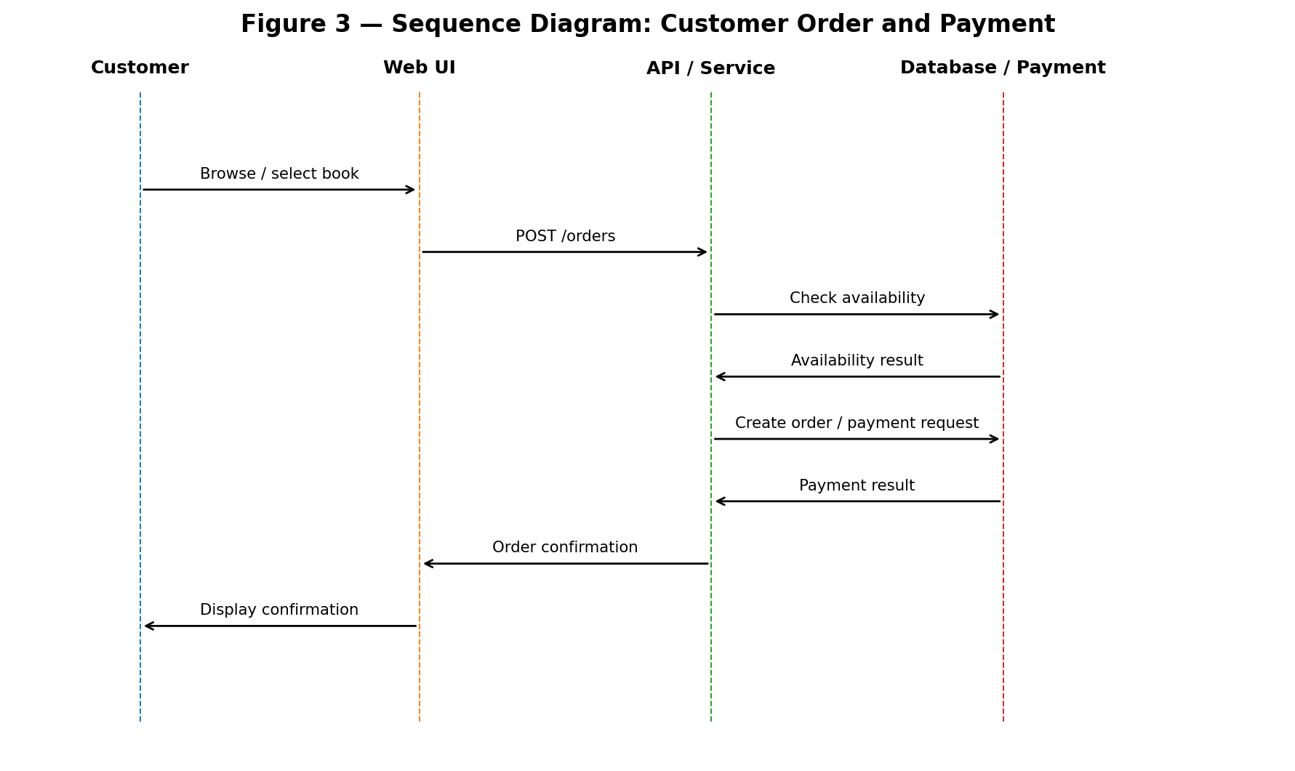
Figure 3 — Sequence Diagram: Customer Order and Payment
The sequence begins with book selection and continues through order creation, availability validation, payment and order confirmation. The flow reflects the SRS requirement that book availability is checked before order confirmation and that successful placement generates an order confirmation.

3.3 Sequence Diagram — Administrator Inventory Update
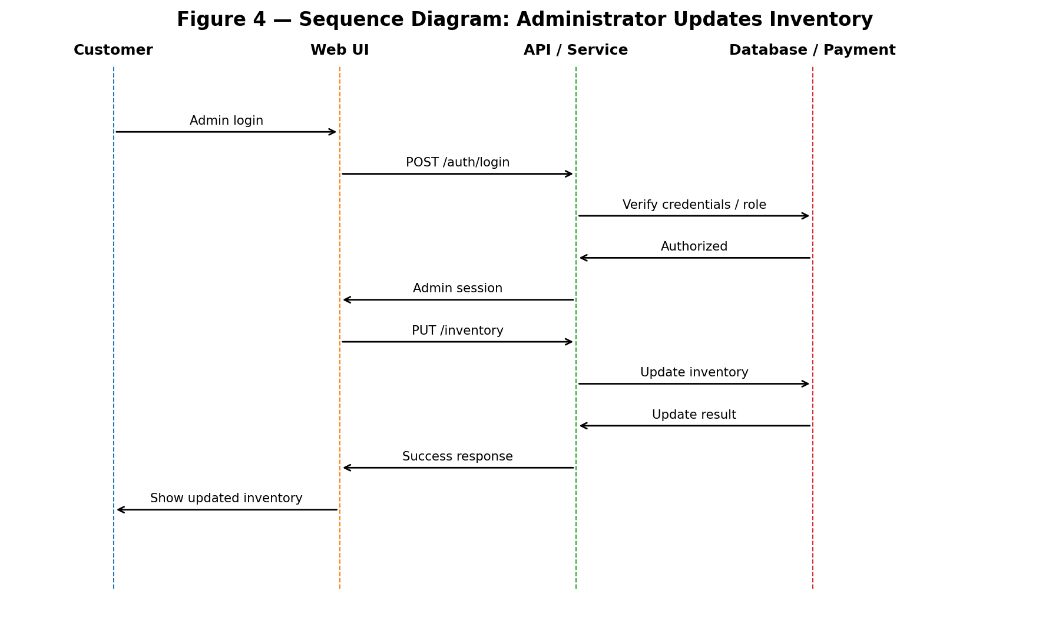
Figure 4 — Sequence Diagram: Administrator Inventory Update
The administrator authenticates first. The API verifies the role before allowing an inventory update. The application then updates the data store and returns the result to the administrator interface. This design supports role-based authorization and prevention of unauthorized inventory modification.

3.4 API Design
The following REST API table is a proposed interface design derived from the SRS functions. Exact request/response schemas can be finalized during implementation.
Method | Endpoint | Purpose | Role | Requirement
POST | /api/auth/register | Create customer account | Public | OBS-F-001
POST | /api/auth/login | Authenticate user | Public | OBS-F-002
GET | /api/books | Browse/search/filter books | Customer/Public | OBS-F-003–F-005
GET | /api/books/{id} | View book details | Customer/Public | OBS-F-006
POST | /api/cart/items | Add item to cart | Customer | OBS-F-007
PUT | /api/cart/items/{id} | Modify cart item | Customer | OBS-F-008
DELETE | /api/cart/items/{id} | Remove cart item | Customer | OBS-F-008
GET | /api/cart | View cart and total | Customer | OBS-F-009
POST | /api/orders | Place order after availability check | Customer | OBS-F-010, F-011
POST | /api/payments | Process supported payment | Customer | OBS-F-012
GET | /api/orders | View current/previous orders | Customer | OBS-F-014
DELETE | /api/orders/{id} | Cancel eligible order | Customer | OBS-F-015
POST | /api/books/{id}/reviews | Submit rating/review | Customer | OBS-F-016
POST | /api/admin/books | Add book | Administrator | OBS-F-017
PUT | /api/admin/books/{id} | Update book | Administrator | OBS-F-017
DELETE | /api/admin/books/{id} | Remove book | Administrator | OBS-F-017
PUT | /api/admin/inventory/{id} | Update inventory | Administrator | OBS-F-018
PUT | /api/admin/orders/{id}/status | Update order status | Administrator | OBS-F-018

3.5 Error Handling
Error Condition | HTTP Response | User-Facing Behaviour | Security Consideration
Invalid registration/login data | 400 | Display validation message and allow correction. | Do not expose internal details.
Authentication required | 401 | Ask user to log in. | Do not reveal protected data.
Insufficient role/permission | 403 | Show access denied. | Prevent customer access to admin functions.
Book/order not found | 404 | Show that the requested resource is unavailable. | Avoid leaking unrelated records.
Unavailable book during order | 409 | Prevent confirmation and inform customer. | Preserve inventory integrity.
Payment failure | 502/400 | Show payment failure and do not falsely confirm the order. | Do not expose provider secrets.
Unexpected server error | 500 | Show generic failure message and allow retry. | Log technical details server-side only.
Session timeout | 401 | Require re-authentication. | Protect protected functions after inactivity.

3.6 Authentication and Authorization Design
- Customer or administrator submits credentials through the login interface.
- Authentication service verifies the submitted credentials against the stored protected credential representation.
- On successful authentication, the system establishes an authenticated session/token according to the final implementation.
- Each protected API request is checked for authentication.
- Administrator endpoints additionally require the administrator role.
- After the configured inactivity period, the session is terminated and re-authentication is required.

3.7 Backup and Availability Design
The design includes automated backup of order and inventory data at least once every 24 hours, matching OBS-NF-006. Availability is measured against the SRS target of at least 99% monthly availability excluding scheduled maintenance. The final deployment mechanism and operational monitoring are implementation details to be finalized.
- Backup records should provide evidence for TC-OBS-024.
- Service availability records should provide evidence for TC-OBS-020.
- Load testing should support the 500-concurrent-user scalability requirement in OBS-NF-005.

4. Design Traceability Matrix
SRS Requirement | Design Element | Test Case | Coverage
OBS-F-001, F-002 | Authentication Service + Auth APIs | TC-OBS-001, 002 | Covered
OBS-F-003–F-006 | Catalogue/Search Service + Book APIs | TC-OBS-003–006 | Covered
OBS-F-007–F-009 | Cart Service + Cart APIs | TC-OBS-007–009 | Covered
OBS-F-010–F-015 | Order/Inventory/Payment Services + Order APIs | TC-OBS-010–015 | Covered
OBS-F-016 | Review Service + Review API | TC-OBS-016 | Covered
OBS-F-017, F-018 | Admin/Inventory Services + Admin APIs | TC-OBS-017, 018 | Covered
OBS-NF-001 | Search service design | TC-OBS-019 | Covered
OBS-NF-002 | Availability/operations design | TC-OBS-020 | Covered
OBS-NF-003 | Password protection design | TC-OBS-021 / 030 | Covered
OBS-NF-004 | Web UI/cart workflow | TC-OBS-022 | Covered
OBS-NF-005 | Infrastructure/load design | TC-OBS-023 | Covered
OBS-NF-006 | Backup design | TC-OBS-024 | Covered
OBS-SO-001–003 | Security architecture | TC-OBS-025–027 | Covered
OBS-SR-001–006 | Auth, authorization, hashing, TLS, integrity, session design | TC-OBS-028–033 | Covered

5. Assumptions and Open Points
- The SRS and Test Plan permit MERN or Django; this document uses MERN as the concrete reference architecture for design consistency. The final implementation choice should be confirmed by the team.
- The exact database schema, deployment configuration and payment-provider details are not defined in the supplied project material and remain to be finalized.
- The exact session inactivity duration is not given in the SRS; the final build should configure the value used by the corresponding test case.
- API request/response schemas are proposed design elements and should be finalized when implementation details are fixed.
- Test status remains 'Not Executed' until the actual system build is available and the planned tests are performed.
Prepared by: Prabhu Hadagali (PES1UG24CS682)
Project: Online Book Store — Software Engineering Mini-Project

