**Analysis**

With these results we can see clearly that the highest performing schools are Charter School type,

Having an average overall of 90.4% passing in comparation with the 53,7% in Districts Schools.

Where Charter Schools have about the same Budget per Students as the Districts Schools,

All of this taking in consideration that the infrastructure same as the quantity of Students in the District Schools are larger than Charter Schools.

Charter Schools are doing overall 90% passing against 54% from the District School

Which as a experience , and knowing that this data is not real, but close to reality:

In Schools where you have less Students its easier to focus and get better qualification, having a teachers less busy and students being taught with more customize classes, in the other side,

District School, the control from the teacher over a great quantity of students creates an area of work more conflicted at the time of reaching higher scores, same apply to Students.

Size Summary:

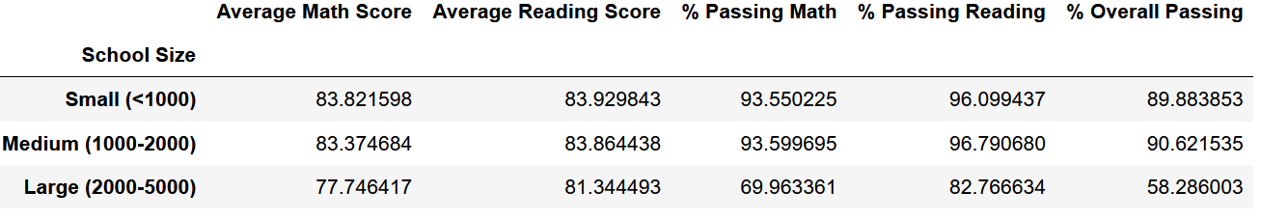

**District summary**



**School Summary**

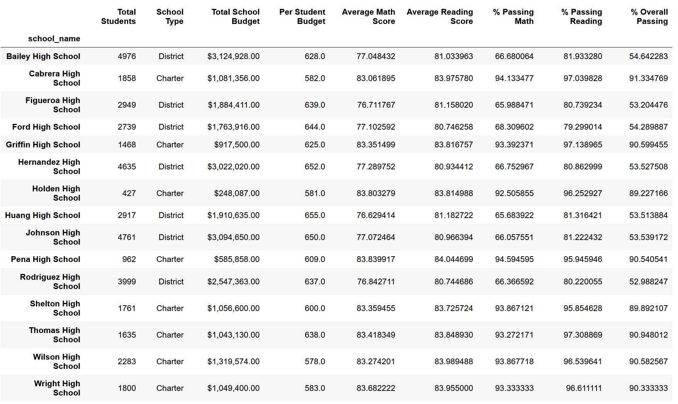

**Highest-Performing Schools (by % Overall Passing)**

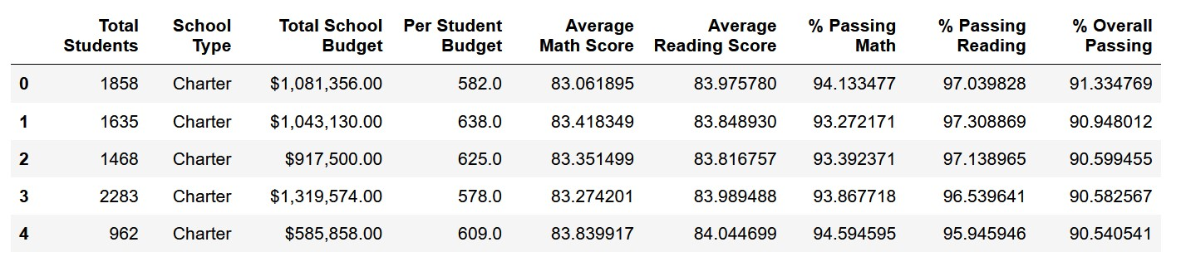 **Bottom Performing Schools (By % Overall Passing)**

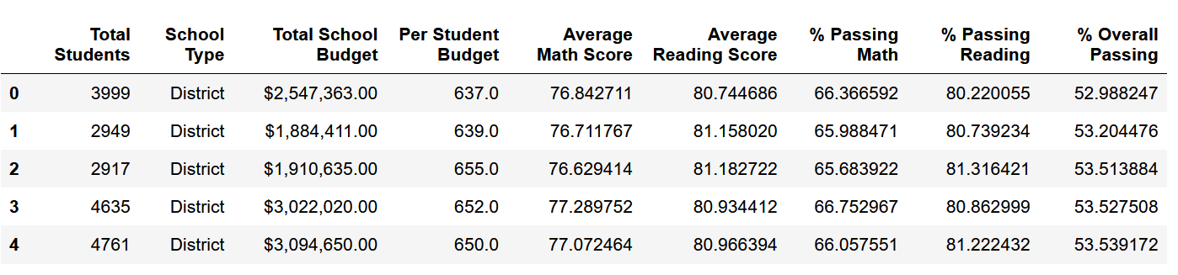

**Spending Summary by Scores**

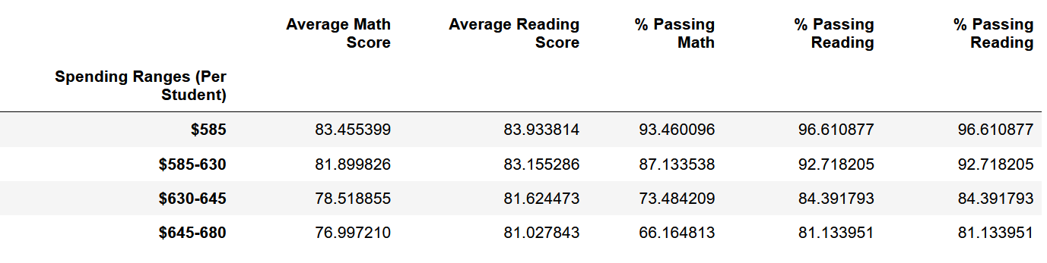

**Scores by School Type**

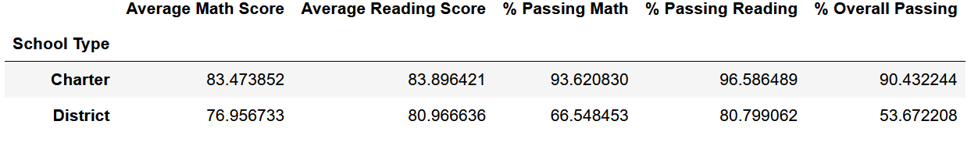

**Spending Summary**

