Software Requirements Specification (SRS)

Blood Bank & Donation Management System
Project: A System to Manage Blood Donation and Availability in Blood Banks
Version: 1.0
Authors: Bhooshan Deshpande(PES1UG24AM351),
Date: 05-09-2026
Status: Final Draft

Revision history
Version / Date / Author | Change summary / Approval
1.0 — 06-09-2025 — Team | Final SRS draft for mini-project

Approvals
Role | Name / Signature / Email / Date
Team Lead | Bhooshan – BD – bhooshan.u.deshpande@gmail.com - 04/09/2026

Table of Contents
1. Introduction
2. Overall description
3. External interface requirements
4. System features (detailed)
5. Non-functional requirements (detailed)
6. Quality attributes & Acceptance tests
7. System models and diagrams (UML Use-Case Diagrams)
8. Requirements Traceability Matrix (RTM)

1. Introduction

1.1 Purpose
This document is a Software Requirements Specification (SRS) for a Blood Bank & Donation Management System. It defines the functional and non-functional requirements, external interfaces, and verification criteria for a platform that manages blood donors, blood inventory, donation drives, and hospital requests. It is intended as the baseline reference for the team's GitHub organisation, Jira epics and mini-project design.

1.2 Scope
The system covers: donor registration and eligibility screening; blood unit collection, testing and inventory tracking with expiry management; donation drive/camp scheduling and slot booking; hospital blood request submission, cross-matching and dispatch; and role-based access for Donors, Hospital Representatives, Blood Bank Staff/Lab Technicians, and Administrators. It excludes the internal clinical/laboratory testing equipment logic beyond recording results, and excludes hospital-internal patient record systems beyond the request/dispatch interface.

1.3 Audience
Developers,Testers, Hospital IT Technicians, blood bank staff, hospital representatives and donors who represent the system's end users.

1.4 Definitions, Acronyms & Abbreviations
- FR / NFR — Functional Requirement / Non-Functional Requirement
- RBAC — Role-Based Access Control
- OTP — One-Time Password
- PRBC — Packed Red Blood Cells
- FFP — Fresh Frozen Plasma
- QR — Quick Response (code)
- RTM — Requirements Traceability Matrix
- TLS — Transport Layer Security
- WCAG — Web Content Accessibility Guidelines

2. Overall description

2.1 Product perspective
The Blood Bank & Donation Management System is a simple web application that connects donors, blood bank staff and hospitals. It replaces manual registers/spreadsheets used to track donor eligibility, stock and hospital requests.

2.2 Major product functions
- Donor registration, identity verification and eligibility screening
- Blood unit collection, barcode/QR tagging, component classification and expiry tracking
- Real-time inventory search and dashboard
- Hospital blood request submission, cross-matching, approval and dispatch
- Donation drive/camp scheduling and donor slot booking
- Automated SMS/email notifications and reminders
- Administrative reporting, audit logging and role management

2.3 User roles and characteristics
- Donor: general public; expects a simple mobile-friendly flow to register, check eligibility and book slots.
- Hospital Representative: needs fast, reliable emergency request submission with clear status tracking.
- Blood Bank Staff / Lab Technician: manages day-to-day inventory, testing results and dispatch; needs an efficient desktop dashboard.
- Drive Coordinator: NGO/blood-bank staff who schedule and manage donation camps.
- System Administrator: manages accounts, roles, and views audit/compliance reports.

2.4 Operating environment
Web application, usable on a normal browser (Chrome/Firefox/Edge) on desktop or mobile, with a database on the backend.

2.5 Constraints
- Donor/patient data should be handled carefully, not exposed publicly.
- Blood group compatibility must follow standard rules (e.g. O- is a universal donor).

3. External interface requirements

3.1 User interfaces
Simple web pages per role: Donor page (register, check eligibility, book slot, view history), Hospital page (submit/track request), Staff/Admin page (manage inventory, requests, drives).

3.2 Hardware interfaces
- None

3.3 Software interfaces
- A notification API/service (SMS or email) for OTPs and reminders.
- A database (e.g. MySQL/PostgreSQL/SQLite) for donor, inventory and request records.

3.4 Communications
- HTTPS between the front end and backend.
- Simple REST APIs (JSON) between front end, backend and the notification service.

4. System features (detailed)
Each requirement below includes acceptance criteria and a reference test case. IDs follow BBS-F-###. A total of 15 functional requirements are specified across five feature areas.

4.1 User Authentication & Role-Based Access Control
Description: Authenticate all users and restrict actions to those permitted for their role.
Req ID | Requirement (shall...) | Type | Priority | Source / Stakeholder | Acceptance criteria / Test case ref | Comments / Dependencies
BBS-F-001 | The system shall support login for four roles: Donor, Hospital Rep, Blood Bank Staff, and Admin. | Functional | High | All users | AC-001: Each role sees only its own dashboard. Test: TC-Auth-01 | Login credentials stored in database
BBS-F-002 | The system shall verify a new user's identity using an OTP sent to their phone/email during signup. | Functional | High | Security | AC-002: Signup completes only after correct OTP entry. Test: TC-Auth-02 | Notification API
BBS-F-003 | The system shall lock an account for 30 minutes after 5 wrong password attempts in a row. | Functional | Medium | Security | AC-003: 6th wrong attempt shows 'account locked' message. Test: TC-Auth-03 | Depends on login attempt counter

4.2 Donor Registration & Eligibility Screening
Description: Capture donor data, enforce medical eligibility rules, and maintain donation history.
Req ID | Requirement (shall...) | Type | Priority | Source / Stakeholder | Acceptance criteria / Test case ref | Comments / Dependencies
BBS-F-010 | The system shall let a donor create a profile with blood group, date of birth, weight and contact details. | Functional | High | Donor | AC-010: Profile save fails if a required field is empty. Test: TC-Donor-01 | Stored in database
BBS-F-011 | The system shall check donor eligibility using simple rules: weight >= 45 kg, age 18-65, and at least 56 days since the last donation. | Functional | High | Blood Bank Staff | AC-011: A donor who donated 30 days ago is shown as not yet eligible. Test: TC-Donor-02 | Depends on last donation date in DB
BBS-F-012 | The system shall save each completed donation to the donor's history (date, blood bank, quantity). | Functional | High | Lab Technician | AC-012: New donation appears in the donor's history list. Test: TC-Donor-03 | Stored in Database

4.3 Blood Inventory & Component Tracking
Description: Track every blood unit from collection through testing, storage, expiry and disposal.
Req ID | Requirement (shall...) | Type | Priority | Source / Stakeholder | Acceptance criteria / Test case ref | Comments / Dependencies
BBS-F-020 | The system shall assign a unique ID to every blood bag when it is collected. | Functional | High | Lab Technician | AC-020: Each bag ID is searchable and shows its details. Test: TC-Inv-01 | Auto-generated ID, stored in DB
BBS-F-021 | The system shall record the component type (Whole Blood, RBC, Platelets, Plasma) and set an expiry date for each unit based on that type. | Functional | High | Lab Technician | AC-021: Expiry date is auto-filled once component type is chosen. Test: TC-Inv-02 | Expiry rules hardcoded per component
BBS-F-022 | The system shall mark a unit as expired and remove it from available stock once its expiry date passes. | Functional | High | Blood Bank Staff | AC-022: An expired unit no longer shows up in the available-stock list. Test: TC-Inv-03 | Runs as a check on save/query, no scheduler needed

4.4 Hospital Requests & Blood Dispatch
Description: Allow hospitals to request blood and the system to match, approve and dispatch compatible units.
Req ID | Requirement (shall...) | Type | Priority | Source / Stakeholder | Acceptance criteria / Test case ref | Comments / Dependencies
BBS-F-030 | The system shall let a hospital rep submit a blood request with blood group, component and quantity needed. | Functional | High | Hospital Rep | AC-030: Submitted request appears in the staff queue. Test: TC-Hosp-01 | Stored in database
BBS-F-031 | The system shall check available stock for compatible blood groups and suggest matching units for a request. | Functional | High | Blood Bank Staff | AC-031: An A+ request never suggests a B- unit. Test: TC-Hosp-02 | Uses blood group compatibility table
BBS-F-032 | The system shall let staff approve a request and mark the matched unit as dispatched. | Functional | Medium | Blood Bank Staff | AC-032: Approved request status changes to 'Dispatched'. Test: TC-Hosp-03 | Updates request status in DB

4.5 Donation Camp & Drive Management
Description: Allow blood banks/NGOs to schedule drives and donors to discover and book slots.
Req ID | Requirement (shall...) | Type | Priority | Source / Stakeholder | Acceptance criteria / Test case ref | Comments / Dependencies
BBS-F-040 | The system shall let a coordinator create a donation drive with a location, date and number of slots. | Functional | Medium | Drive Coordinator | AC-040: A drive cannot be created without at least one slot. Test: TC-Drive-01 | Stored in database
BBS-F-041 | The system shall let a donor view upcoming drives and book an open slot. | Functional | Medium | Donor | AC-041: A full slot can no longer be booked. Test: TC-Drive-02 | Depends on drive/slot data
BBS-F-042 | The system shall send a reminder notification to a donor before their booked slot. | Functional | Low | Donor | AC-042: Reminder is sent before the slot time. Test: TC-Drive-03 | Depends on Notification API

5. Non-functional requirements (detailed)
NFRs below are measurable and tied to test plans. IDs follow BBS-NF-###.
Req ID | Requirement | Category | Priority | Acceptance criteria / Measurement
BBS-NF-001 | Inventory search results shall load in under 1-2 seconds under normal use. | Performance | High | Search returns results quickly in manual testing. Test: TC-Perf-01
BBS-NF-002 | The system should stay available during normal usage hours, with minimal downtime. | Availability | Medium | No unplanned downtime observed during demo/testing period.
BBS-NF-003 | Donor passwords and personal details shall be stored securely, not in plain text. | Security / Privacy | High | DB check confirms passwords are hashed. Test: TC-Sec-01
BBS-NF-004 | The UI shall be simple enough for a non-technical user (donor or hospital staff) to use without training. | Usability | Medium | A test user can complete registration/request without help. Test: TC-UX-01
BBS-NF-005 | The system shall prevent two staff members from allocating the same blood unit to two different requests at the same time. | Data Integrity | High | Only one of two simultaneous allocation attempts succeeds. Test: TC-Conc-01

5.1 Security

5.1.1 Security Objectives
- Protect donor personal and medical data from being accessed by unauthorized users.
- Make sure only the right role (Donor, Hospital Rep, Staff, Admin) can perform actions meant for that role.

5.1.2 Security Requirements
Req ID | Requirement (shall...) | Type | Priority | Acceptance criteria / Test case ref
BBS-SR-001 | All login traffic shall use HTTPS. | Security | High | Site is only reachable over HTTPS. Test: TC-Sec-01
BBS-SR-002 | Passwords shall be stored as hashed values, never in plain text. | Security | High | DB inspection shows hashed passwords. Test: TC-Sec-02
BBS-SR-003 | A Donor account shall not be able to access Staff/Admin-only pages or actions. | Security | High | Donor login blocked from staff pages. Test: TC-Sec-03
BBS-SR-004 | Key actions (approving a request, marking a unit expired) shall be logged with user and timestamp. | Security | Medium | Log entry created for each such action. Test: TC-Sec-04
BBS-SR-005 | A user session shall expire after a period of inactivity and require re-login. | Security | Medium | Session times out after inactivity. Test: TC-Sec-05

6. Quality attributes & Acceptance tests
Exit criteria for acceptance: all High-priority functional requirements implemented and verified, no critical NFR failures, and the RTM shows all associated test cases passed.
Acceptance test suites: Authentication & RBAC, Donor Eligibility, Inventory & Expiry, Hospital Request & Cross-Matching, Drive Scheduling, Performance, Security, and Accessibility.

7. System models and diagrams

7.1 UML Use-Case Diagram — Donor & Drive Management
Covers registration/login, eligibility screening, drive discovery/booking, donation history, drive scheduling and donor-screening result recording.
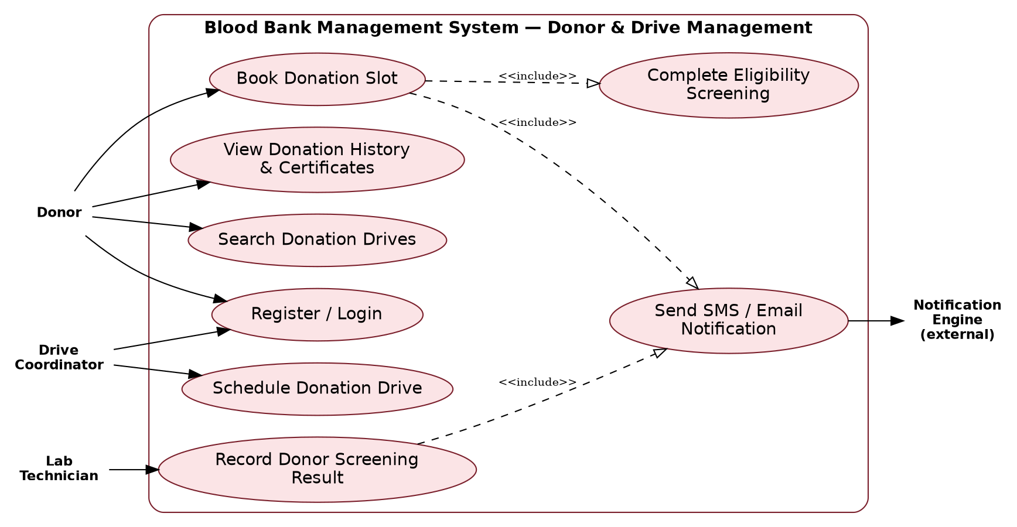

7.2 UML Use-Case Diagram — Inventory & Hospital Requests
Covers blood bag logging, test-result entry, expiry monitoring, hospital request submission, cross-matching/allocation, approval and dispatch.
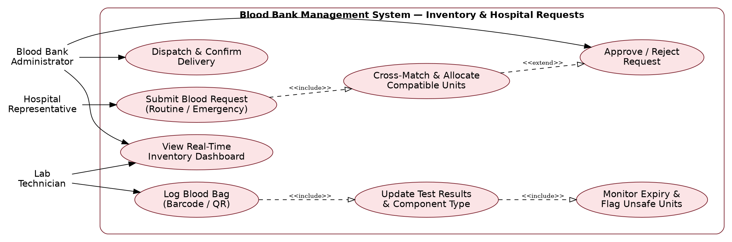

8. Requirements Traceability Matrix (RTM)
Representative sample; extend this matrix to cover every requirement ID once design specs and test cases are finalised.
Req ID | Requirement (short) | Section ref / Design Spec | Module | Test case(s) | Status (N/P/A) | Comments
BBS-F-001 | Role-based login | 4.1 / DS-Auth-01 | AuthModule | TC-Auth-01 | N
BBS-F-011 | Eligibility engine | 4.2 / DS-Donor-02 | DonorModule | TC-Donor-02 | N
BBS-F-020 | Barcode tracking | 4.3 / DS-Inv-01 | InventoryModule | TC-Inv-01 | N
BBS-F-023 | Auto-dispose expired units | 4.3 / DS-Inv-04 | InventoryModule | TC-Inv-04 | N
BBS-F-031 | Cross-match & allocate | 4.4 / DS-Hosp-02 | RequestModule | TC-Hosp-02 | N
BBS-F-041 | Donor slot booking | 4.5 / DS-Drive-02 | DriveModule | TC-Drive-02 | N
BBS-NF-001 | Search response time | 5 / DS-Perf-01 | InventoryModule / API | TC-Perf-01 | N
BBS-NF-006 | No double allocation | 5 / DS-Conc-01 | RequestModule | TC-Conc-01 | N
BBS-SR-003 | API-level RBAC | 5.1.2 / DS-Sec-03 | AuthModule / API Gateway | TC-Sec-03 | N

