// **Структуры.**

// Преобразование прямоугольных координат в полярные.

#include <iostream>

#include <math.h>

#include <iomanip>

using namespace std;

struct rect

{

double x;

double y;

};

struct polar

{

double v;

double angle;

};

int main()

{

const double d=180/3.1416;

cout<<" 1 rad = "<<d<<" degree "<<endl;

rect rpos={3,4};

polar ppos;

ppos.v=sqrt(pow(rpos.x,2)+pow(rpos.y,2));

ppos.angle=atan2(rpos.x,rpos.y);

cout<<" distance ="<<ppos.v<<setw(6)<<setprecision(3)<<" angle= "<<ppos.angle*d<<

" degrees"<<endl;

return 0;

}

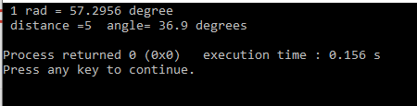

#include <iostream>

#include <math.h>

#include <iomanip>

using namespace std;

struct rect

{

double x;

double y;

};

struct polar

{

double v;

double angle;

};

int main()

{

const double d=180/3.1416;

cout<<" 1 rad = "<<d<<" degrees "<<endl;

rect rpos;

polar ppos;

cout << "Input x y :" << endl;

while(cin>>rpos.x>>rpos.y)

{

ppos.v=sqrt(pow(rpos.x,2)+pow(rpos.y,2));

ppos.angle=atan2(rpos.x,rpos.y);

cout<<" distance ="<<ppos.v<<setw(6)<<setprecision(3)<<"angle= " <<ppos.angle*d<<" degrees"<<endl;

cout<<" next two numbers ( input q for quit): ";

}

return 0;

}

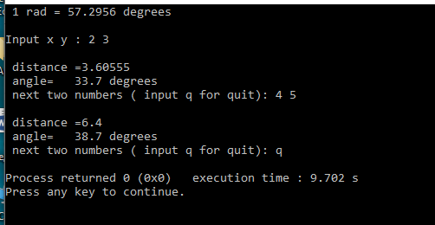

#include <iostream>

#include <math.h>

#include <iomanip>

using namespace std;

struct rect

{

double x;

double y;

};

struct polar

{

double v;

double angle;

};

polar rec_pol(rect rpos);

void shou_pol(polar ppos,const double d);

int main()

{

const double d=180/3.1416;

cout<<" 1 rad = "<<d<<" degrees "<<endl;

cout<<endl;

rect rpos;

polar ppos;

cout << "Input x y : ";

while(cin>>rpos.x>>rpos.y)

{

ppos=rec_pol(rpos);

shou_pol(ppos,d);

cout<<" next two numbers ( input q for quit): ";

}

return 0;

}

polar rec_pol(rect rpos)

{

polar ppos;

ppos.v=sqrt(pow(rpos.x,2)+pow(rpos.y,2));

ppos.angle=atan2(rpos.x,rpos.y);

return ppos;

}

void shou_pol(polar ppos,const double d)

{

cout << endl;

cout<<" distance ="<<ppos.v<<endl;

cout<<" angle= " <<setw(6)<<setprecision(3)<<ppos.angle*d<<" degrees"<<endl;

}

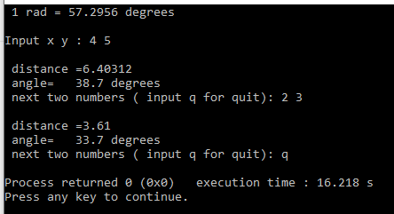

#include <iostream>

#include <math.h>

#include <iomanip>

using namespace std;

struct rect

{

double x;

double y;

};

struct polar

{

double v;

double angle;

};

**void rec_pol(const rect* rpos, polar* ppos);**

**void shou_pol(const polar* ppos,const double d);**

int main()

{

const double d=180/3.1416;

cout<<" 1 rad = "<<d<<" degrees "<<endl;

cout<<endl;

rect rpos;

polar ppos;

cout << "Input x y : ";

while(cin>>rpos.x>>rpos.y)

{

**rec_pol(&rpos, &ppos);**

**shou_pol(&ppos,d);**

cout<<" next two numbers ( input q for quit): ";

}

return 0;

}

**void rec_pol(const rect* rpos, polar* ppos)**

{

ppos->v=sqrt(pow(rpos->x,2)+pow(rpos->y,2));

ppos->angle=atan2(rpos->x,rpos->y);

}

**void shou_pol(const polar* ppos,const double d)**

{

cout << endl;

cout<<" distance ="<<ppos->v<<endl;

cout<<" angle= " <<setw(6)<<setprecision(3)<<ppos->angle*d<<" degrees"<<endl;

}

