Practical 2: Interfacing LED and push button switch to 8051

#### Electrical Switch

The switch is a basic input device, use to control the operation of any output device using the microcontroller or control unit. It basically breaks the electrical circuit and interrupts the flow of current.

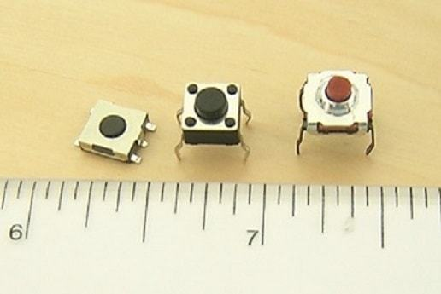

#### Connection of electrical Switch

In-circuit Pull-up and Pull-down resistor use to convert infinite or zero resistance into the digital signal, on the basis of pull-up and pull-down resistor, we can interface the switch in two-way, but most important point need to remember the value of pull-up and pull-down resistor depends on the microcontroller.

**Positive Logic:** In this connection, we use a pull-down resistor connected to ground. When we pressed the switch then logic asserts high and when we disconnect the switch logic assert low.

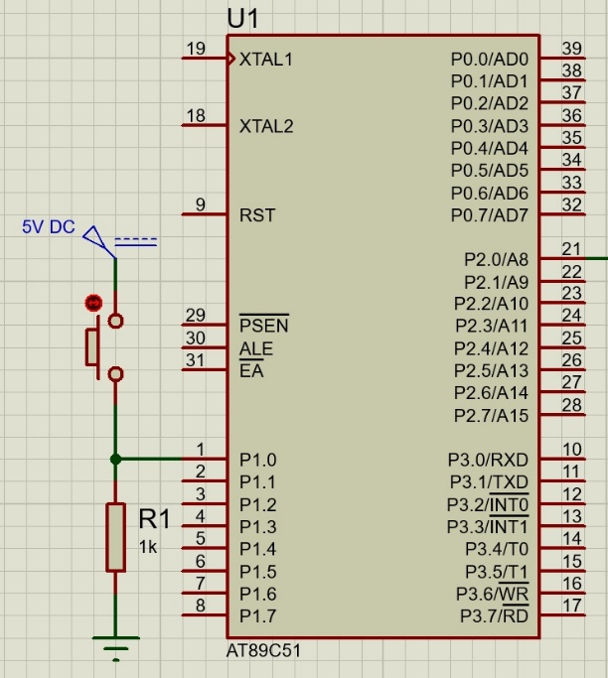

**Negative Logic:** In this connection, we use a pull-up resistor connected to Vcc. When we pressed the switch then logic asserts low and when we disconnect the switch logic assert high.

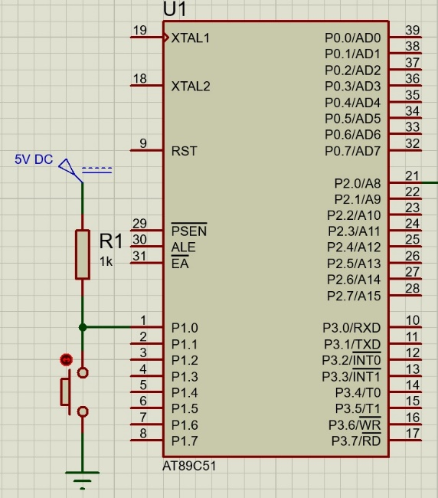

#### Algorithm to control the led using the switch (SPST)

* The microcontroller pin connected to the led makes the output.
* The microcontroller pin connected to the switch makes the input.
* Continuous monitor the status of the switch, if the switch is pressed then led pin status high either make it low.

#### Interfacing of led and switch with 8051 microcontrollers

In the below circuit, I have connected an SPST switch with P1.1 and a Led with P2.1. I am using the here negative logic circuit to connect the switch to the microcontroller.

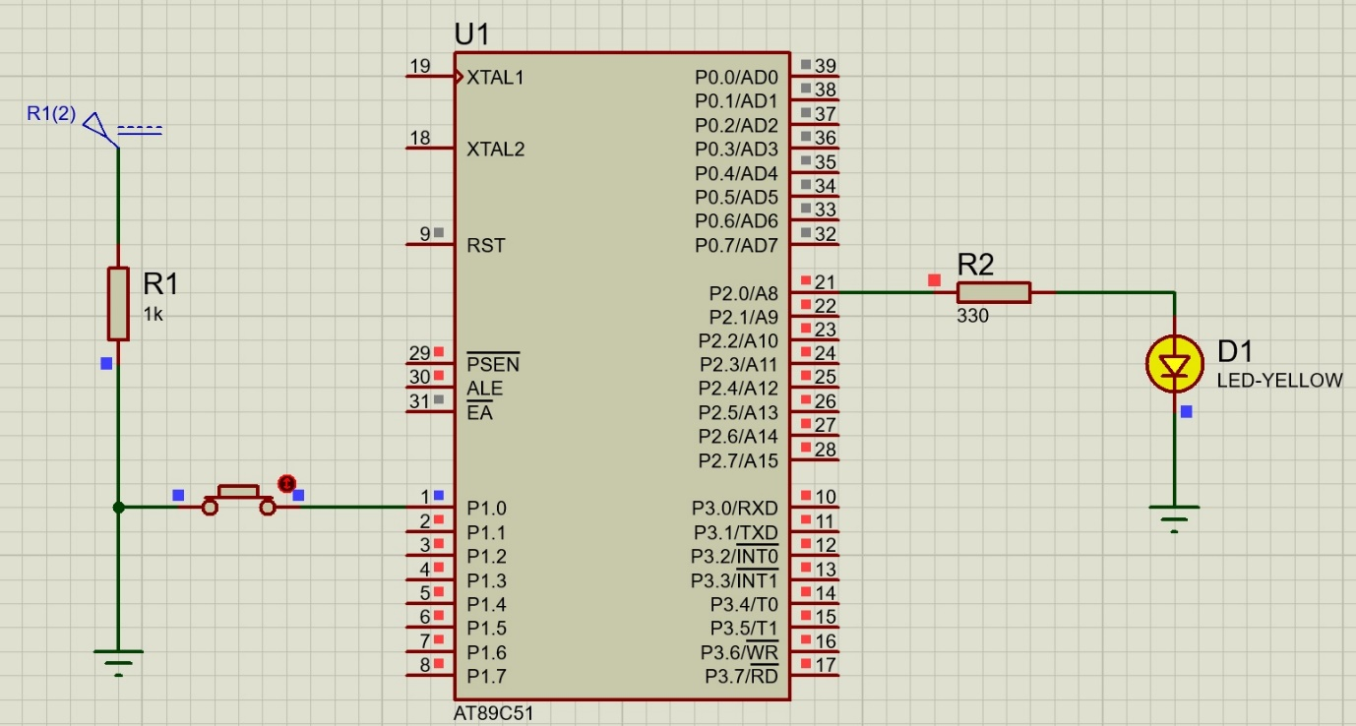  
  
  
Sample program to describe the interfacing of led and switch with 8051 microcontrollers

#include <REGX51.H>

sbit button = P1^0; // Assign Pin 1.0 connect to button

sbit led = P2^0; // Assign Pin 2.0 connect to led

void delay (unsigned int time) // Definition of Delay function is declared

{

unsigned int i,j;

for (i=0;i<time;i++)

{

for(j=0;j<1275;j++);

}

}

void main ()

{

int b=0;

button = 1;

led = 0;

while(1)

{

if (button==0)

{

delay(50);

led=1;

b++;

if (b==2)

{

led=0;

b=0;

}

}

}

}