DOCUMENTATION OF TURBINE

DARRIEUS TUBO DI FLUSSO SINGOLO

FUNCTION

Angelo Renzo Dasco – Marco Gugliucciello

Gennaio 2021

**Table of content**

**Theory** 3

**Input and Output** 4

**Algorithm description** 4

**Test Case** 6

**Bibliography** 8

# **Theory**

This function implements the single-streamtubes theory. The principal features of the vertical-axis turbine will be elicited by considering a two-dimensional rotor.

The determination of the induction factor *a* is connectedwith the assumed functional dependence of *a* with the azimuth angle $ϕ$. In this approach, *a* is assumed to be independent of $ϕ$.

From the momentum equation, the force in wind direction D can be derived as:

$$D=2Rρ2a(1-a)V^{2}$$

From the forces on the blade elements of a B-bladed rotor, averaged during one revolution, it follows that:

$$D= \frac{B}{2π}\int_{0}^{2π}{\frac{1}{2}ρ{V_{∞}}^{2}cC_{l} cos⁡(ϕ+ α)dϕ}$$

For a given geometry of the turbine and introducing the variable *y* with a given value, *a* can be calculated from the following equation:

$$\frac{1}{1-a}=1+ \frac{ Bc}{8R2π}\int_{0}^{2π}{\left\{{\left(y+\sin{ϕ}\right)}^{2}+ \cos^{2}ϕ\right\}} C_{l} cos\left\{ϕ+arc tg \left[\frac{\cos{ϕ}}{y+\sin{ϕ}}\right]\right\}dϕ$$

With $C_{l}$ is equal to:

$$C_{l}= C_{lα}arctan\frac{cosϕ}{y+sinϕ}$$

And the corresponding tip speed ratio can be calculated:

$$λ= y(1-a)$$

The generated power is calculated from the tangential force, in which the profile drag is included:

$$P=ΩR\frac{N}{2π}\int_{0}^{2π}{\frac{1}{2}ρV^{2}(C_{l} sinα-C_{d}cosα)} dϕ$$

The corresponding power coefficient:

$$C_{p}=\frac{Nc}{4πR}λ\int_{0}^{2π}{{\left(\frac{V}{V_{∞}}\right)}^{2}C_{l} sinα(1-\frac{C_{d}}{C_{l}}cotα)} dϕ$$

# **Input and Output**

Aerodynamic parameters:

* $C_{lα}$ = Cl curve slope
* Cd = Airfoil drag coefficient
* αmax = Stall angel

Geometrical parameters:

* N = Blades number
* C = Chord
* R = Radius

y

*α*

*a*

*Cq*

*Cp*

**Figure 1.** Flow chart of the function code.

# **Algorithm description**

The aim of the following paragraph is to describe the code in every details. First of all, the function receives in input the following parameters:

* Clα, that is the slope of the Cl-α curve of the profile.
* c, that is the chord of the profile.
* R, that is the radius of the rotor.
* N, that is number of blades.
* Cd, that is the drag coefficient.
* αmax, that is the angle of stall of the profile.

At the beginning of the function an azimuth angle domain and variable *y* domain are created. The *y* variable is used as proxy variable to evaluate the induction *a*.

function [cp2, lambda2] = Turbine_single_tube(Cla, c, R, N, cd,alphamax)

%Domain vector, initial values.

y1=linspace(0.0,20,100); %Introduction of the variable y

phiv = linspace(0,360,100); %Phi domain (deg)

phiv = deg2rad(phiv); %Phi domain (rad)

alphamax = deg2rad(alphamax);

Inside of the *for* cycle the variables *v/vinf*, α, *Cp* and *Cq*, considering that they change when φ changes, are evaluated starting from the dependence of the induction compared with the tip speed.

for i = 1:length(y1) % a, lambda, cp, cq computing

y=y1(i);

% Computing of the induction factor a

Y= ((y-sin(phiv)).^2+cos(phiv).^2).*Cla.*atan(cos(phiv)./(y+sin(phiv))).*...

cos(phiv+atan(cos(phiv)./(y+sin(phiv))));

A = trapz(phiv,Y);

x = 1 + (N.*c./(8.*R.*2.*pi)).*A;

a= 1-1/x;

% Determination of tip speed ratio

lambda = y.*(1-a);

% Determination of velocity ratio

v_vinf = sqrt((lambda + (1-a).*sin(phiv)).^2 +...

(1-a).^2 .*cos(phiv).^2);

if a < 0.5

% Determination of angle of attack

alpha = atan2(((1-a).*cos(phiv)),(lambda + (1-a).*sin(phiv)));

if alpha < alphamax

Lambda(i,1)=lambda;

% Computing Cp - numerical integration

cost_p = (N*c*lambda)./(4*pi*R); % Costant part

cpint =trapz(phiv,(v_vinf.^2.*Cla.*alpha.*sin(alpha).*...

(1-(cd./(Cla.*alpha)).*cot(alpha)))); % Integral

cp=cost_p.*cpint; % Cp value

cq = cp/lambda; % Cq value

%Cq and Cp vectors

Cp(i,1)=cp;

Cq(i,1)=cq;

end

end

end

The trapezoidal numerical integration is used to resolve the integrals. There is a control on the minimum tip speed because the alpha of the blade elements has always to be smaller than alpha max, otherwise the wing will not work properly and will not generate any power.

# **Test Case**

In order to validate the function, some test cases have been run. The obtained results have been compared with the values of De Vries. The table 1 shows the whole parameters taken into account to carry out validation procedure.

|  |  |  |  |  |  |  |  |
| --- | --- | --- | --- | --- | --- | --- | --- |
| Test | σ | αmax | c | R | Clα | N | Cd |
| 1 | 0.1 | 14 | 1 | 30 | 6.28 | 3 | 0.01 |
| 2 | 0.1 | 14 | 1 | 30 | 6.28 | 3 | 0 |
| 3 | 0.2 | 14 | 1 | 15 | 6.28 | 3 | 0.01 |
| 4 | 0.2 | 14 | 1 | 15 | 6.28 | 3 | 0 |

**Table 1.** Test case values

**Test 1**

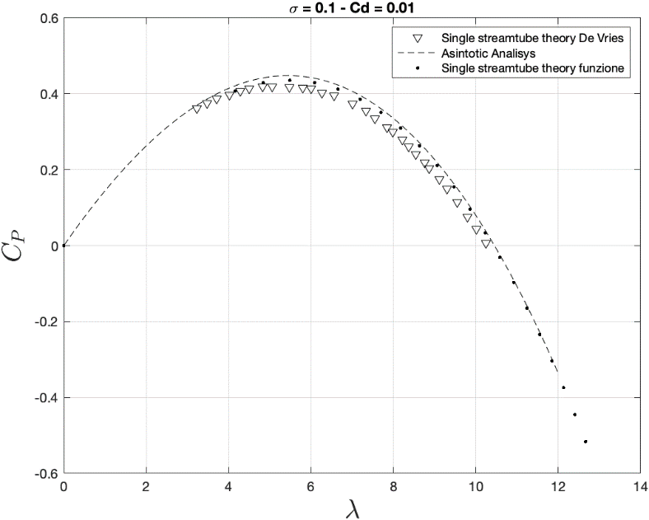

**Figure 2.** Values compared with single streamtube theory from De Vries and with Asintotic Analisys

**Test 2**

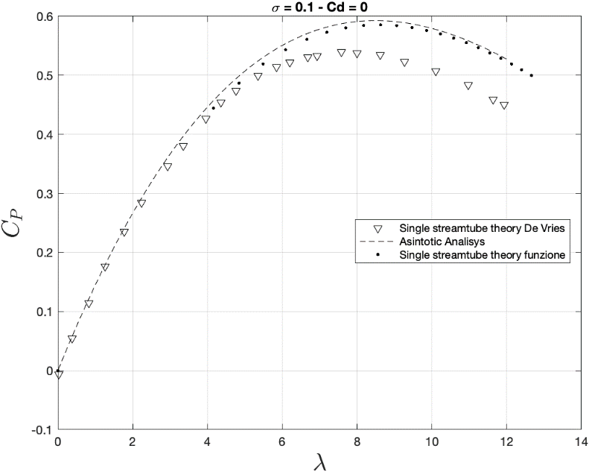

**Figure 3.** Values compared with single streamtube theory from De Vries and with Asintotic Analisys

**Test 3**

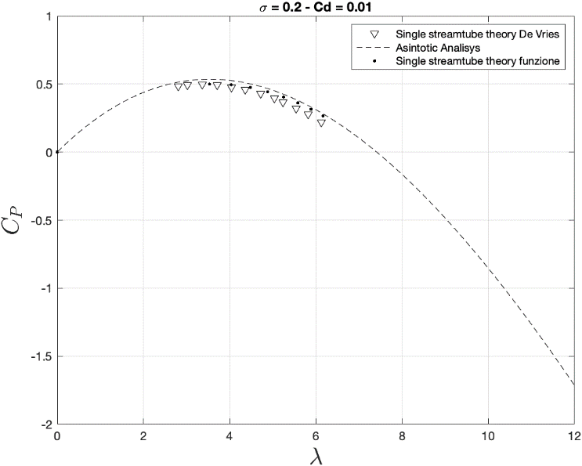

**Figure 4.** Values compared with single streamtube theory from De Vries and with Asintotic Analisys

**Test 4**

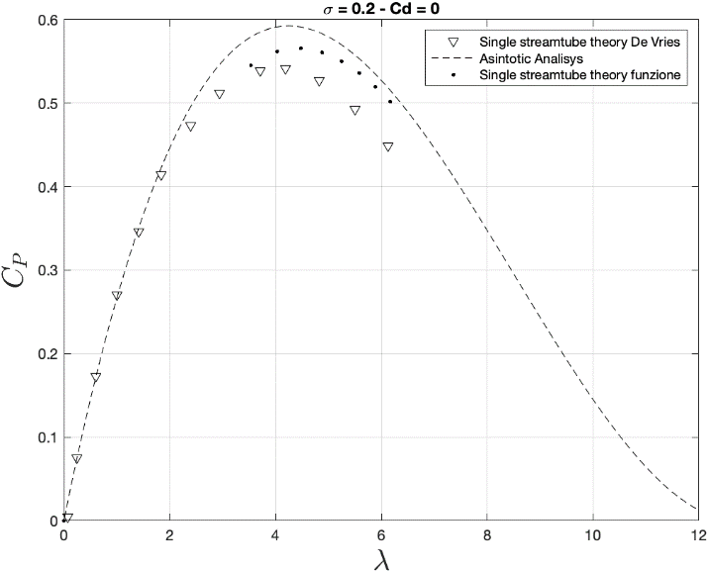

**Figure 5.** Values compared with single streamtube theory from De Vries and with Asintotic Analisys

# **Bibliography**

[1] Tognaccini R., (2019), “Lezioni di Aerodinamica dell’ala rotante”.

[2]. De Vrues O., (1979), “Fluid Dynamic Aspects of Wing Energy Conversion”,