A Real time research project report on
ROAD ACCIDENT ANALYSIS AND PATTERN IDENTIFICATION SYSTEM
submitted in partial fulfillment of the requirements for the award of degree of
BACHELOR OF TECHNOLOGY
in
COMPUTER SCIENCE & ENGINEERING
(AI&ML)

by

24WH1A6647 Ms. M PRANAVI
24WH1A6649 Ms. K REVATHI
24WH1A6650 Ms. TABASSUM BEGUM
24WH1A6651 Ms. A THANVI

under the esteemed guidance of
Ms. Spurthi Kalevar
Assistant Professor, CSE(AI&ML)



Department of Computer Science & Engineering
(Artificial Intelligence & Machine Learning)

BVRIT HYDERABAD COLLEGE OF ENGINEERING FOR WOMEN
(NAAC Accredited-A Grade | NBA Accredited B.Tech. (EEE, ECE, & CSE) (Approved by AICTE, New Delhi and Affiliated to JNTUH, Hyderabad) Bachupally, Hyderabad – 500090
2025 - 2026

i

BVRIT HYDERABAD COLLEGE OF ENGINEERING FOR WOMEN
(NAAC Accredited-A Grade | NBA Accredited B.Tech. (EEE, ECE, & CSE) (Approved by AICTE, New Delhi and Affiliated to JNTUH, Hyderabad) Bachupally, Hyderabad– 500090

Computer Science & Engineering (Artificial Intelligence & Machine Learning)



CERTIFICATE

This is to certify that the Real time research project entitled “ROAD ACCIDENT ANALYSIS AND PATTERN IDENTIFICATION SYSTEM” is a bonafide work carried out by Ms. M PRANAVI (24WH1A6647), Ms. K REVATHI (24WH1A6649), Ms. TABASSUM BEGUM (24WH1A6650), Ms. A THANVI (24WH1A6651), in partial fulfillment for the award of B.Tech degree in Computer Science & Engineering (AI&ML), BVRIT HYDERABAD College of Engineering for Women, Bachupally, Hyderabad, affiliated to Jawaharlal Nehru Technological University Hyderabad,Hyderabad under my guidance and supervision. The results embodied in the project work have not been submitted to any other.

Internal Guide Head of the Department
Ms. Spurthi Kalevar Dr. B. Lakshmi Praveena
Assistant Professor, Professor and HoD,
Department of CSE(AI&ML) Department of CSE(AI&ML)

ii

DECLARATION

We hereby declare that the work presented in this project entitled “Road accident analysis and pattern identification system” submitted towards completion of Real Time Research Project in II of B.Tech, II semester, CSE(AI&ML) at ‘BVRIT HYDERABAD College of Engineering for Women’, Hyderabad is an authentic record of our original work carried out under the guidance of Ms. Spurthi Kalevar, Assistant Professor, Department of CSE(AI&ML).

Ms. M Pranavi
(24wh1a6647)

Ms. K Revathi (24wh1a6649)
Ms. Tabassum Begum (24wh1a6650)
Ms. A Thanvi
(24wh1a6651)

iii

ACKNOWLEDGEMENT
We would like to express our sincere thanks to Dr. K. V. N. Sunitha, Principal, BVRIT HYDERABAD College of Engineering for Women, for her support by providing the working facilities in the college.
Our sincere thanks and gratitude to Dr. B. Lakshmi Praveena, Head of the Department, Department of CSE(AI&ML), BVRIT HYDERABAD College of Engineering for Women, for all timely support and valuable suggestions during the period of our project. We are extremely thankful to our Internal Guide, Ms. Spurthi Kalevar, Assistant Professor, CSE(AI&ML), BVRIT HYDERABAD College of Engineering for Women, for her constant guidance and encouragement throughout the project.
We would like to thank our Real Time Project Coordinators, Ms. A. Naga Kalyani and all the Staff of Department of CSE(AI&ML) department who helped us directly or indirectly throughout the project.

Finally, Last but not least, we wish to acknowledge our Parents and Friends for giving moral strength and constant encouragement.

iv

ABSTRACT

Road accidents remain a critical public safety concern, causing significant loss of life and injuries worldwide. This project presents a Road Accident Analysis and Pattern Identification System that leverages data analytics and visualization techniques to uncover meaningful patterns from real-world accident data sourced from Kaggle, containing attributes such as accident severity, weather conditions, road type, vehicle type, time of occurrence, and geographic location. The system follows a structured pipeline where raw data is collected, cleaned, and preprocessed using Python's Pandas and NumPy libraries to handle missing values and inconsistencies, followed by GroupBy-based analysis to identify accident trends across dimensions such as time of day, weather, road type, and location, with results visualized through bar charts, pie charts, and line graphs using Matplotlib and Seaborn via an interactive Accident Intelligence Dashboard. Findings reveal that rainy and stormy weather conditions contribute most to accident frequency, while state highways and village roads record the highest incident counts. Unlike prior approaches such as static government reports and basic Excel-based analysis, the proposed system delivers an automated, interactive, and interpretable analysis platform aimed at improving road safety awareness, with future scope for machine learning-based prediction, real-time GPS integration, and mobile alert systems.

v

LIST OF CONTENTS

S.NO | CONTENT | PAGE.NO
 | Introduction  Problem Statement  Objectives  Background | 1  1  2  3
 | Literature Survey | 4
 | System Requirements  Software Requirements  Hardware Requirements | 5-6  5  6
 | Proposed System Analysis  - Existing Systems  - Disadvantages  - Proposed System  - Advantages  - Proposed System Architecture | 7-8  7  7  7  7  8
 | Implementation  Sample code | 9-14
 | UML diagrams | 15-16
 | Result Analysis | 17-23
 | Conclusion | 23
 | Reference | 24

INTRODUCTION
Road accidents have become one of the most serious concerns in today's world, claiming thousands of lives every single day and leaving countless others with permanent disabilities and injuries. The problem is especially significant in a developing country like India, where rapid urbanization, increasing vehicle ownership, and expanding road networks have together contributed to a dramatic rise in road accident frequency and severity. Beyond the human cost, road accidents also carry a significant economic burden, affecting national productivity and development.
Despite the scale of this problem, the tools and methods currently used to analyze road accidents remain largely outdated and insufficient. Government accident reports are static and difficult to explore interactively, Excel-based analysis is time-consuming and less scalable, and basic visualization tools provide only visual output without generating meaningful insights. There is therefore a clear need for a system that can automatically process raw accident data, analyze it across multiple dimensions, and present findings in a simple, interactive, and meaningful way.
This project addresses these challenges by developing a Road Accident Analysis and Pattern Identification System using a real-world dataset sourced from Kaggle covering multiple Indian states. Using Python along with Pandas, NumPy, Matplotlib, and Seaborn, the system processes raw data through a structured pipeline involving data cleaning, GroupBy-based analysis, and graph-based visualization. The results are presented through an interactive Accident Intelligence Dashboard featuring bar charts, pie charts, and line graphs. By analyzing key factors such as time, weather, location, road type, and accident severity, the system transforms raw data into actionable insights with the ultimate goal of improving road safety awareness and reducing future accidents across India.

PROBLEM STATEMENT

Despite the increasing number of road accidents in India, existing methods of accident analysis such as government reports, Excel-based tools, and basic visualization systems are static, non-interactive, and fail to generate meaningful insights. There is no efficient system that can automatically analyze large-scale accident data across multiple factors such as time, weather, location, road type, and vehicle type to identify patterns and support road safety decisions. This project aims to address this gap by developing an automated Road Accident Analysis and Pattern Identification System that processes real-world accident data from Kaggle and delivers actionable insights through interactive visualizations to improve road safety awareness and help reduce future accidents.

OBJECTIVES

The primary objectives of this project are as follows:
- To collect real-world accident dataset from Kaggle containing key attributes such as accident severity, weather conditions, road type, vehicle type, time of occurrence, and geographic location across multiple Indian states.
- To clean and preprocess the dataset by handling missing values, removing duplicate records, eliminating unnecessary columns, and formatting the data to make it suitable for analysis using Python and Pandas.
- To analyze accident patterns based on multiple dimensions including:
  - Time — identifying the hours and periods of the day when accidents are most frequent.
  - Weather — examining how conditions such as rainy, foggy, hazy, stormy, and clear weather influence accident occurrence.
  - Location — determining which states and cities such as New Delhi record the highest number of accidents.
  - Road Type — analyzing accident frequency across state highways, national highways, village roads, and urban roads.
  - Accident Severity — studying the distribution of minor, serious, and fatal accidents across the dataset.
- To perform data analysis using GroupBy logic in Python to group and aggregate accident records across various categories and extract meaningful statistical patterns.
- To visualize the analyzed data using bar charts, pie charts, and line graphs with the help of Matplotlib and Seaborn libraries, making the patterns easy to understand and interpret.
- To develop an interactive Accident Intelligence Dashboard that displays key performance indicators such as total incidents, unsafe time, safe time, unsafe location, and safe location, allowing users to dynamically explore accident trends.
- To derive meaningful insights from the visualized data that can support road safety awareness initiatives, assist traffic authorities in decision making, and contribute toward reducing the number of future road accidents across India.

BACKGROUND

Road accident analysis has been an area of growing research interest over the past few decades, driven by the need to understand and mitigate the causes of traffic-related fatalities and injuries. Earlier studies and systems relied heavily on manual data collection and static statistical reporting methods, which were limited in their ability to provide dynamic and actionable insights. Government accident reports, though comprehensive, were largely presented as fixed documents with no scope for interactive exploration or pattern identification. With the emergence of data science and big data technologies, researchers began leveraging computational tools to analyze accident datasets more effectively. Platforms like Kaggle have made large-scale real-world accident datasets publicly available, enabling data analysts and developers to apply modern techniques such as exploratory data analysis, data visualization, and machine learning to extract meaningful patterns. In the Indian context, road accident analysis has gained particular importance given the country's rapidly growing vehicle population and the diverse range of contributing factors including varying weather conditions, road infrastructure quality, and regional traffic behaviors. Previous works in this domain have used tools such as Matplotlib and Seaborn for basic visualization and machine learning models for accident prediction, but these approaches were often too complex, lacked user-friendliness, or were limited to predefined graphs without flexibility. This project builds upon these existing efforts by developing a more accessible, automated, and interactive system that analyzes accident data across multiple dimensions including time, weather, location, road type, and vehicle type, specifically tailored to provide insights relevant to the Indian road network.

LITERATURE SURVEY

Road Traffic Accidents in India: Issues and Challenges
Sanjay Kumar Singh (2017), published in Transportation Research Procedia, Volume 25, analyzed road accidents in India at national, state, and metropolitan city level. The study examined how accident distribution varies according to age, gender, month, and time, and found that road accidents are relatively higher in extreme weather and during working hours. However, the study was limited to static statistical analysis with no interactive visualization or automated insight generation. This project builds upon such findings by providing an interactive dashboard that dynamically explores similar factors.
Road Accident Analysis and Prediction of Accident Severity Using Machine Learning
Md. Farhan Labib, Ahmed Sady Rifat, Md. Mosabbir Hossain, Amit Kumar Das, and Faria Nawrine (2019), published in IEEE 7th International Conference, analyzed traffic accidents using machine learning approaches including Decision Tree, K-Nearest Neighbors, Naïve Bayes, and AdaBoost to classify accident severity into fatal, grievous, simple injury, and motor collision categories. While the study achieved good predictive accuracy using AdaBoost, the models were complex and lacked a user-friendly interface for non-technical users. This project addresses this limitation by providing a simple and intuitive system that is accessible to a broader audience.
Road Accident Analysis: A Case Study of Patna City
Sanjay Kumar Singh and Ashish Misra, published in Urban Transport Journal, Volume 2(2), pages 60-75, conducted a detailed case study of road accidents in Patna City, examining location-based accident patterns and contributing factors at a city level. While the study provided valuable regional insights, it was limited to a single city and relied on manual analysis methods. This project improves upon this by covering multiple Indian states and automating the entire analysis pipeline using Python.
Government Accident Reports
Government agencies have long published periodic statistical reports summarizing accident counts and fatality rates at national and state levels. These reports, while comprehensive, are entirely static in nature and offer no interactivity, making it difficult for users to explore specific trends. This project addresses this by providing an interactive dashboard with dynamic graphs and multiple filters.

Kaggle Accident Analysis Projects
Several data analysis projects on Kaggle have attempted to visualize road accident datasets using Matplotlib and Seaborn. However, these projects are limited to predefined graph types with no flexibility for the user to customize the analysis. This project improves upon this by allowing users to choose their preferred graph type and category for a more flexible and personalized analysis experience.
Excel-Based Analysis
Excel has traditionally been widely used for accident data analysis through manual charts and reports. However, this approach is time-consuming, less scalable with large datasets, and heavily dependent on manual effort. This project replaces manual workflows with fully automated analysis using Python, significantly improving efficiency and scalability.
Basic Data Visualization Tools
Basic visualization tools have been used in several studies to present accident data visually. While effective at generating visual outputs, they are limited in their ability to derive meaningful insights from the data. This project goes beyond simple visual output by combining visualization with interpretation, providing users with meaningful insights and pattern identification alongside every graph generated.

SYSTEM REQUIREMENTS

Functional Requirements
- Data Collection: Load accident data (CSV) from Kaggle with attributes like time, weather, location, and severity.
- Data Preprocessing: Handle missing values, remove duplicates, drop unnecessary columns, and standardize data.
- Data Analysis: Perform GroupBy analysis to identify patterns based on time, weather, road type, location, and severity.
- Data Visualization: Generate bar, pie, and line charts; allow users to select graph type and category.
- Dashboard: Provide an interactive dashboard with KPIs (total incidents, safe/unsafe time & location), filters, and CSV upload option.
- Insight Generation: Identify accident-prone conditions and safest/unsafe times for travel.

Non-Functional Requirements
- Performance: Efficiently handle large datasets (~18,000+ records) with quick visualization.
- Usability: Simple, user-friendly interface with clear graphs and filters.
- Reliability: Accurate and consistent results with proper handling of missing data.
- Scalability: Supports larger datasets and future feature expansion.
- Maintainability: Modular code using standard Python libraries.
- Portability: Works on Windows/Ubuntu with Python 3.8+.
- Security: Uploaded data is used only for analysis; no sensitive data storage.

Software Requirements
- Operating System: Windows 10 / Ubuntu 20.04
- Programming Language: Python 3.8 or above
- Development Environment: Jupyter Notebook / Visual Studio Code
- Dataset Format: CSV (Comma Separated Values)
- Dataset Source: Kaggle
- Microsoft Excel 2016 or above for initial dataset viewing

Hardware Requirements
Minimum Requirements:
- Processor: Intel Core i3 or equivalent
- RAM: 4 GB
- Hard Disk Space: 10 GB free space
- Display: 1024 x 768 resolution
- Internet connection for dataset download and library installation
Python Libraries and Their Roles
- Pandas — For loading, cleaning, and preprocessing the accident dataset, handling missing values, duplicates, and data formatting
- NumPy — For numerical computations and efficient handling of large data arrays during analysis
- Matplotlib — For generating primary visualizations including bar charts, pie charts, and line graphs
- Seaborn — For advanced statistical visualizations providing deeper insights into accident data distributions and trends
Dataset Requirements
- Dataset Name: India Road Accident Dataset
- Source: Kaggle
- Format: CSV
- Coverage: Multiple Indian states
- Key Attributes:
  - Accident Severity (Minor, Serious, Fatal)
  - Weather Conditions (Rainy, Foggy, Hazy, Stormy, Clear)
  - Road Type (State Highway, National Highway, Village Road, Urban Road)
  - Vehicle Type
  - Time of Occurrence
  - Lighting Conditions
  - Geographic Location (City, State)

PROPOSED SYSTEM ANALYSIS

1. Existing System Analysis
The current approach to road accident analysis mainly relies on static reports, basic data visualization tools, or manual analysis using spreadsheets. These systems often provide limited insights and lack interactivity, making it difficult to explore accident patterns effectively. Most existing solutions focus only on predefined graphs and do not allow users to dynamically analyze different factors such as time, weather, and location.
Additionally, many systems require manual effort for data cleaning and analysis, which is time-consuming and prone to errors. The absence of an integrated system limits the ability to extract meaningful insights from large datasets. As a result, decision-making related to road safety becomes less efficient and less accurate.

Disadvantages of Existing Systems
- Limited Interactivity: Users cannot dynamically explore data or customize analysis.
- Time-Consuming: Manual data cleaning and analysis require significant effort.
- Limited Insights: Systems provide only basic visual outputs without deeper interpretation.
- Lack of Flexibility: Fixed graphs and limited filtering options restrict usability.
- Scalability Issues: Difficulty in handling large datasets efficiently.
- No Insight Generation: No automated identification of accident patterns or trends.

2. Proposed System
The proposed system introduces a Road Accident Analysis and Pattern Identification System that provides an interactive and efficient way to analyze accident data. The system uses real-world datasets from Kaggle and processes them using Python for accurate and meaningful analysis.
The system performs data preprocessing to handle missing values, remove duplicates, and standardize the dataset. It then applies GroupBy-based analysis to identify patterns based on time, weather conditions, road type, location, and accident severity.
An interactive dashboard is developed to display key insights such as total accidents, unsafe times, and accident-prone locations. Users can apply filters and select different graph types such as bar charts, pie charts, and line graphs for better understanding.
The system also generates meaningful insights, helping users identify high-risk conditions and safer travel times. This improves decision-making and contributes to road safety awareness.

Advantages of Proposed System
- Interactive Dashboard: Allows users to explore data with filters and dynamic graphs.
- Automated Analysis: Reduces manual effort through data preprocessing and analysis.
- Better Insights: Identifies accident patterns based on multiple factors.
- User-Friendly Interface: Easy to use even for non-technical users.
- Scalable: Can handle large datasets efficiently.
- Flexible Visualization: Supports multiple graph types and categories.

System Architecture:

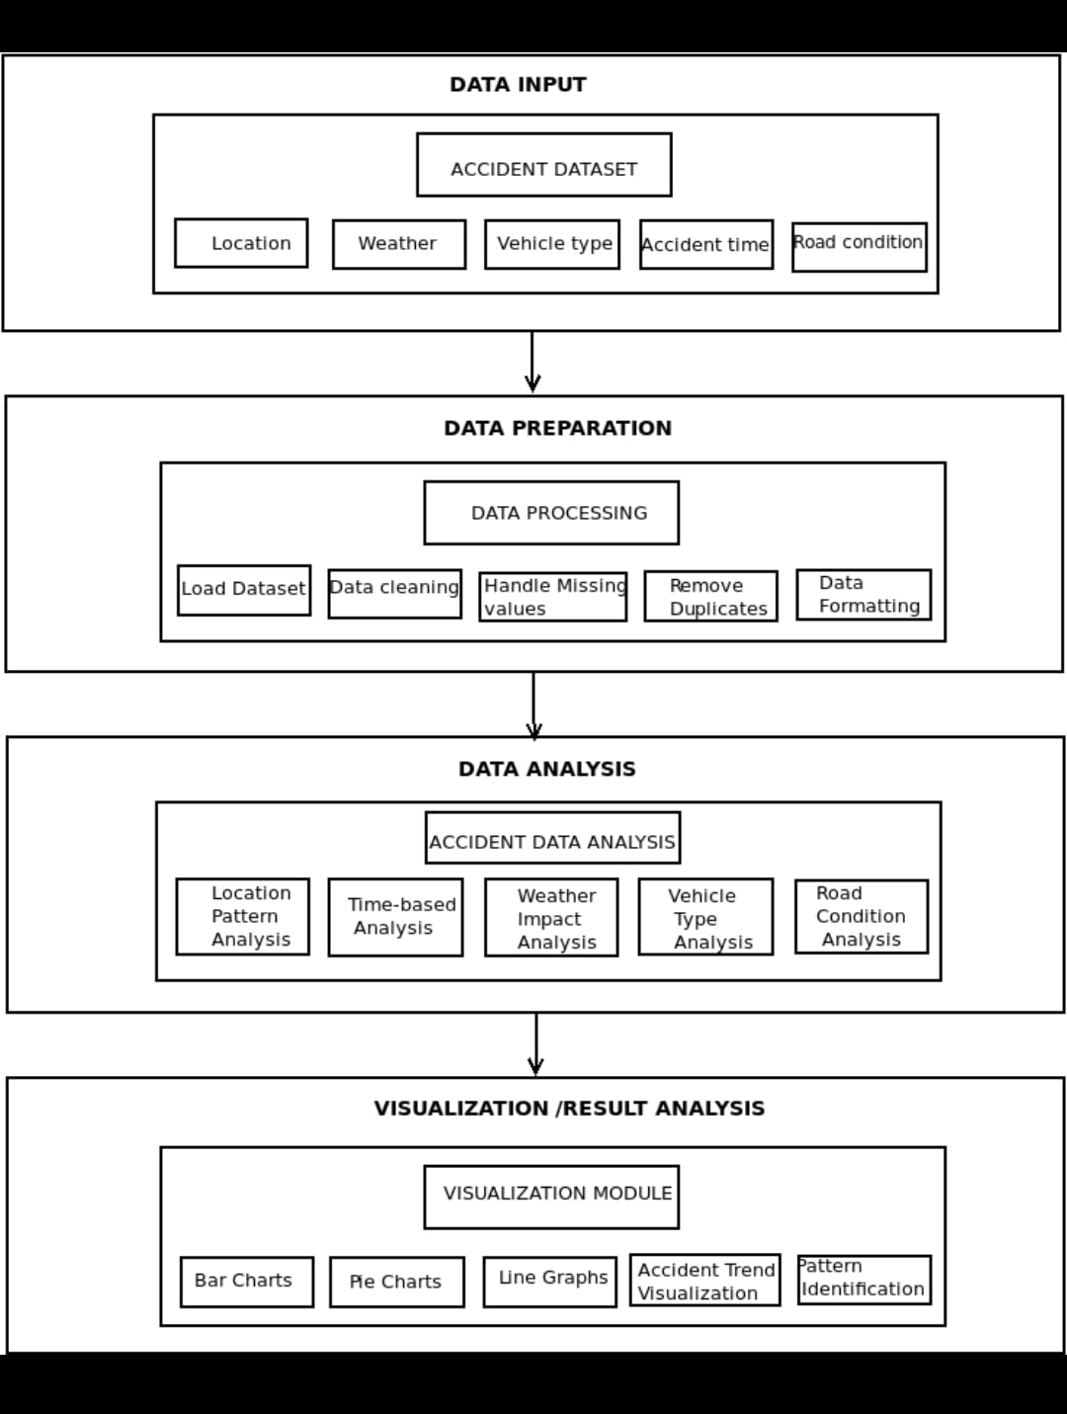

The proposed Road Accident Analysis and Pattern Identification System follows a structured and modular architecture. It consists of multiple stages including data collection, data preprocessing, data analysis, visualization, and insight generation.
The system begins by collecting real-world accident datasets from Kaggle in CSV format. The dataset is then passed to the preprocessing module, where data cleaning operations such as handling missing values, removing duplicates, and formatting are performed.
After preprocessing, the cleaned data is analyzed using GroupBy techniques to identify patterns based on various factors like time, weather conditions, road type, location, and accident severity. The analyzed results are then visualized using different graph types such as bar charts, pie charts, and line graphs.
Finally, the system generates meaningful insights from the visualizations, which are displayed on an interactive dashboard. Users can upload datasets, apply filters, and explore results dynamically.

1. Architecture Components
- Data Collection Module
Collects accident dataset from Kaggle in CSV format.
- Data Preprocessing Module
Cleans and prepares data by handling missing values, removing duplicates, and standardizing the dataset.
- Data Analysis Module
Performs GroupBy operations to identify accident patterns based on different parameters.
- Visualization Module
Generates graphs such as bar charts, pie charts, and line graphs for better understanding of data.
- Insight Generation Module
Interprets results and provides meaningful conclusions like accident-prone conditions and unsafe times.
- Dashboard Module
Displays results interactively with filters and allows users to upload datasets and choose visualization types.

2. Architecture Flow
- User uploads accident dataset (CSV file)
- System loads and preprocesses the data
- Cleaned data is analyzed using GroupBy logic
- Results are visualized using graphs
- Insights are generated from analyzed data
- Dashboard displays results with filtering options

3. Advantages of Architecture
- Modular and easy to maintain
- Efficient handling of large datasets
- Supports future enhancements
- Provides clear separation of functionalities
- Enables interactive and dynamic analysis

IMPLEMENTATION

Analysis code:

import pandas as pd
import matplotlib.pyplot as plt

# Load dataset
df = pd.read_csv("accident_prediction_india.csv")

# Clean column names
df.columns = df.columns.str.strip()

# Select required columns
df = df[['Accident Severity', 'Weather Conditions', 'Road Type',
'Lighting Conditions', 'Time of Day',
'City Name', 'State Name']]

# Clean text
df['State Name'] = df['State Name'].astype(str).str.strip()
df['City Name'] = df['City Name'].astype(str).str.strip()

# ---------------- TELANGANA DATA ----------------
df_telangana = df[df['State Name'].str.contains('Telangana', case=False, na=False)]

print("Telangana Data Shape:", df_telangana.shape)

# ---------------- WEATHER (TELANGANA) ----------------
weather_counts = df_telangana['Weather Conditions'].value_counts()

weather_counts.plot(kind='bar')

plt.title("Telangana Accidents by Weather Condition")
plt.xlabel("Weather")
plt.ylabel("Number of Accidents")
plt.xticks(rotation=45)
plt.tight_layout()
plt.show()

# ---------------- SEVERITY (TELANGANA) ----------------
severity_counts = df_telangana['Accident Severity'].value_counts()
print("Telangana Severity:\n", severity_counts)

severity_counts.plot(kind='bar')
plt.title("Telangana Accident Severity Distribution")
plt.xlabel("Severity")
plt.ylabel("Count")
plt.xticks(rotation=0)

plt.tight_layout()
plt.show()

# ---------------- CITY ANALYSIS (ALL INDIA) ----------------
df_clean_city = df[df['City Name'].str.lower() != 'unknown']

location_counts = df_clean_city['City Name'].value_counts().head(10)

location_counts.plot(kind='bar')

plt.title("Top Cities with Most Accidents (India)")
plt.xlabel("City")
plt.ylabel("Number of Accidents")
plt.xticks(rotation=45)
plt.tight_layout()
plt.show()

# Save cleaned dataset
df.to_csv("cleaned_accident_data.csv", index=False)

Loading dataset (analysis) code:

import pandas as pd
import matplotlib.pyplot as plt

# Load dataset
df = pd.read_csv("accident_prediction_india.csv")

# Clean column names
df.columns = df.columns.str.strip()

# Select required columns
df = df[['Accident Severity', 'Weather Conditions', 'Road Type',
'Lighting Conditions', 'Time of Day',
'City Name', 'State Name']]

# Clean text
df['State Name'] = df['State Name'].astype(str).str.strip()
df['City Name'] = df['City Name'].astype(str).str.strip()

# ---------------- TELANGANA DATA ----------------
df_telangana = df[df['State Name'].str.contains('Telangana', case=False, na=False)]

print("Telangana Data Shape:", df_telangana.shape)

# ---------------- WEATHER (TELANGANA) ----------------
weather_counts = df_telangana['Weather Conditions'].value_counts()

weather_counts.plot(kind='bar')

plt.title("Telangana Accidents by Weather Condition")
plt.xlabel("Weather")
plt.ylabel("Number of Accidents")
plt.xticks(rotation=45)
plt.tight_layout()
plt.show()

# ---------------- SEVERITY (TELANGANA) ----------------
severity_counts = df_telangana['Accident Severity'].value_counts()
print("Telangana Severity:\n", severity_counts)

severity_counts.plot(kind='bar')

plt.title("Telangana Accident Severity Distribution")
plt.xlabel("Severity")
plt.ylabel("Count")
plt.xticks(rotation=0)
plt.tight_layout()
plt.show()

# ---------------- CITY ANALYSIS (ALL INDIA) ----------------
df_clean_city = df[df['City Name'].str.lower() != 'unknown']

location_counts = df_clean_city['City Name'].value_counts().head(10)

location_counts.plot(kind='bar')

plt.title("Top Cities with Most Accidents (India)")
plt.xlabel("City")
plt.ylabel("Number of Accidents")
plt.xticks(rotation=45)
plt.tight_layout()
plt.show()

# Save cleaned dataset
df.to_csv("cleaned_accident_data.csv", index=False)

Frontend code:

import streamlit as st
import pandas as pd
import plotly.express as px

# 1. Dashboard Configuration - FORCING WIDE MODE
st.set_page_config(layout="wide", page_title="Ultimate Accident Analytics")

# Injecting Custom CSS for visibility and prevention of text clipping

st.markdown("""

<style>
.main .block-container {
padding-top: 1rem;
padding-bottom: 1rem;
max-width: 98%;
}
[data-testid="stMetricValue"] {
font-size: 38px !important; /* Balanced size to fit names like New Delhi */
font-weight: 700;
color: #1f77b4;
}
[data-testid="stMetricLabel"] {
font-size: 18px !important;
font-weight: 600;
}
</style>
""", unsafe_allow_html=True)

# 2. Sidebar - Data Management & Mapping
with st.sidebar:
st.header("📂 Data Management")
uploaded_file = st.file_uploader("Upload Accident CSV", type=["csv"])

if uploaded_file is not None:
df = pd.read_csv(uploaded_file)
st.success("Analysis Ready!")
else:
st.info("Please upload a CSV file to begin.")
st.stop()

st.divider()
st.header("🎯 KPI & Column Mapping")
all_cols = df.columns.tolist()

# Hybrid Auto-detection logic
auto_name = next((c for c in all_cols if "type" in c.lower()), all_cols[0])
auto_val = next((c for c in all_cols if "count" in c.lower()), all_cols[min(1, len(all_cols)-1)])
auto_group = next((c for c in all_cols if "category" in c.lower()), all_cols[min(2, len(all_cols)-1)])

name_col = st.selectbox("Label Column (Type)", all_cols, index=all_cols.index(auto_name))
val_col = st.selectbox("Value Column (Count)", all_cols, index=all_cols.index(auto_val))
group_col = st.selectbox("Grouping Column (Category)", all_cols, index=all_cols.index(auto_group))

st.divider()

st.header("Chart Settings")

target_cats = ["Weather", "Time", "Location", "Road", "Severity", "Light"]

available_options = [cat for cat in target_cats if cat in df[group_col].unique()]
if not available_options:
available_options = df[group_col].unique().tolist()

x_axis_filter = st.selectbox("Select Category Group", options=available_options)

selected_graph = st.selectbox("Choose Graph to Display",
["Bar Chart", "Line Chart", "Pie Chart", "Scatter Plot"])

# 3. KPI Header - Safe/Unsafe Logic (Excluding "Unknown")
st.title("🚗 Accident Intelligence Dashboard")
m1, m2, m3, m4, m5 = st.columns(5)

def get_filtered_kpi(data, category_keyword, find_max=True):
try:
# Exclude 'Unknown' and 'Other' to show meaningful locations/times
subset = data[(data[group_col].str.contains(category_keyword, case=False, na=False)) &
(~data[name_col].astype(str).str.lower().isin(["unknown", "other"]))]

if subset.empty: return "N/A"

idx = subset[val_col].idxmax() if find_max else subset[val_col].idxmin()
return subset.loc[idx][name_col]
except:
return "N/A"

with m1:
total_val = df[val_col].sum() if pd.api.types.is_numeric_dtype(df[val_col]) else len(df)
st.metric("Total Incidents", f"{total_val:,}")
with m2: st.metric("Unsafe Time", str(get_filtered_kpi(df, "Time", True)))
with m3: st.metric("Safe Time", str(get_filtered_kpi(df, "Time", False)))
with m4: st.metric("Unsafe Location", str(get_filtered_kpi(df, "Location", True)))
with m5: st.metric("Safe Location", str(get_filtered_kpi(df, "Location", False)))

st.divider()

# 4. Performance-Optimized Visualization Display
CHART_HEIGHT = 700
# Limit to top 15 results to prevent lag with large datasets like Locations
display_df = df[df[group_col] == x_axis_filter].sort_values(by=val_col,

ascending=False).head(15)

st.subheader(f"📊 {selected_graph}: {x_axis_filter} (Top Results)")

if selected_graph == "Bar Chart":
fig = px.bar(display_df, x=name_col, y=val_col, color=name_col, text=val_col, height=CHART_HEIGHT)
fig.update_traces(textposition='inside', textfont=dict(size=16))
elif selected_graph == "Line Chart":
fig = px.line(display_df, x=name_col, y=val_col, markers=True, text=val_col, height=CHART_HEIGHT)
fig.update_traces(textposition="top center")
elif selected_graph == "Pie Chart":
fig = px.pie(display_df, names=name_col, values=val_col, hole=0.4, height=CHART_HEIGHT)
fig.update_traces(textinfo='percent+label')
else:
fig = px.scatter(display_df, x=name_col, y=val_col, size=val_col, color=name_col, height=CHART_HEIGHT)

# Fixed layout property structure to avoid ValueErrors
fig.update_layout(
font=dict(size=15),
xaxis=dict(title=dict(font=dict(size=18)), tickfont=dict(size=14), tickangle=45),
yaxis=dict(title=dict(font=dict(size=18)), tickfont=dict(size=14)),
margin=dict(l=10, r=10, t=50, b=150)
)

st.plotly_chart(fig, use_container_width=True)

# 5. Data Explorer
with st.expander("🔍 View Raw Analysis Data"):
st.dataframe(df, use_container_width=True)

UML DIAGRAMS
USE CASE DIAGRAM:

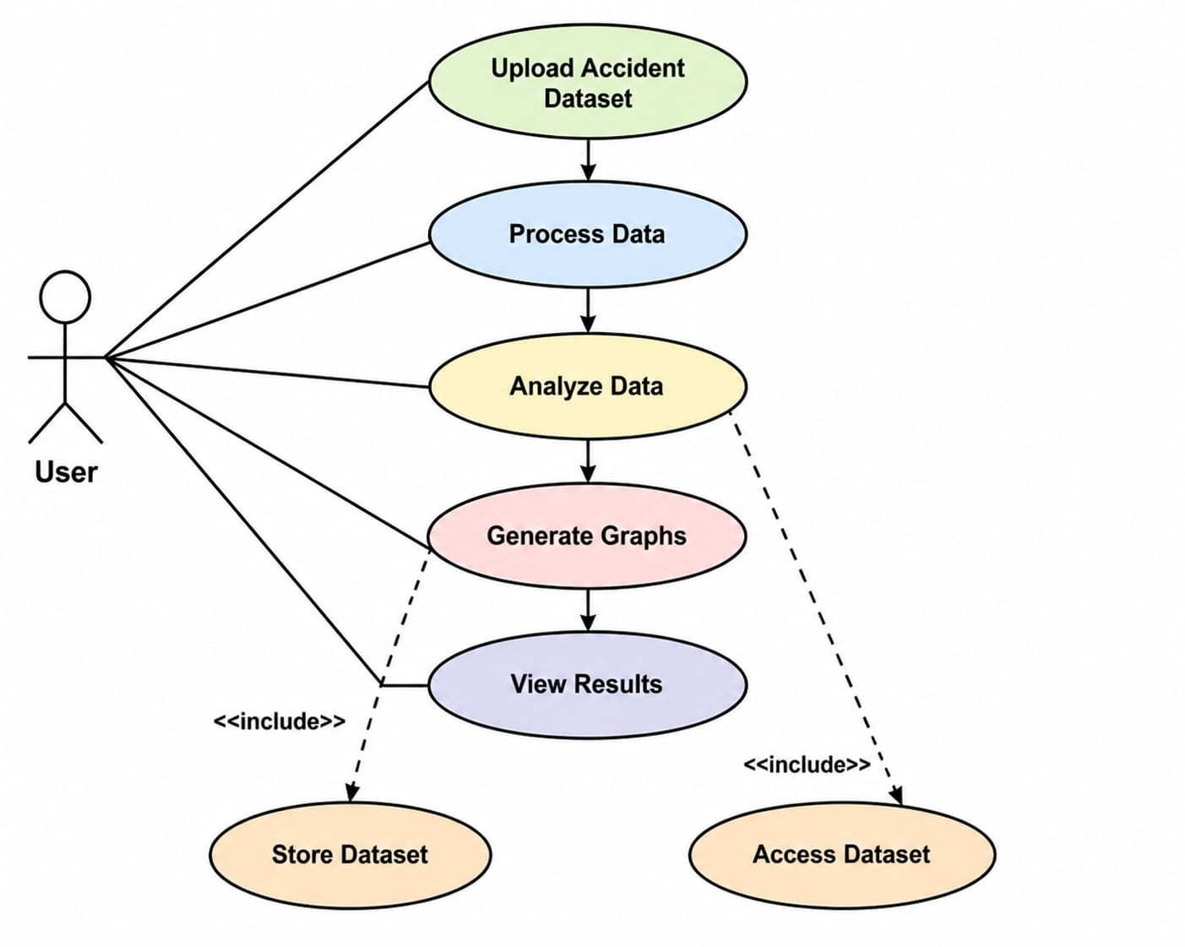

CLASS DIAGRAM:

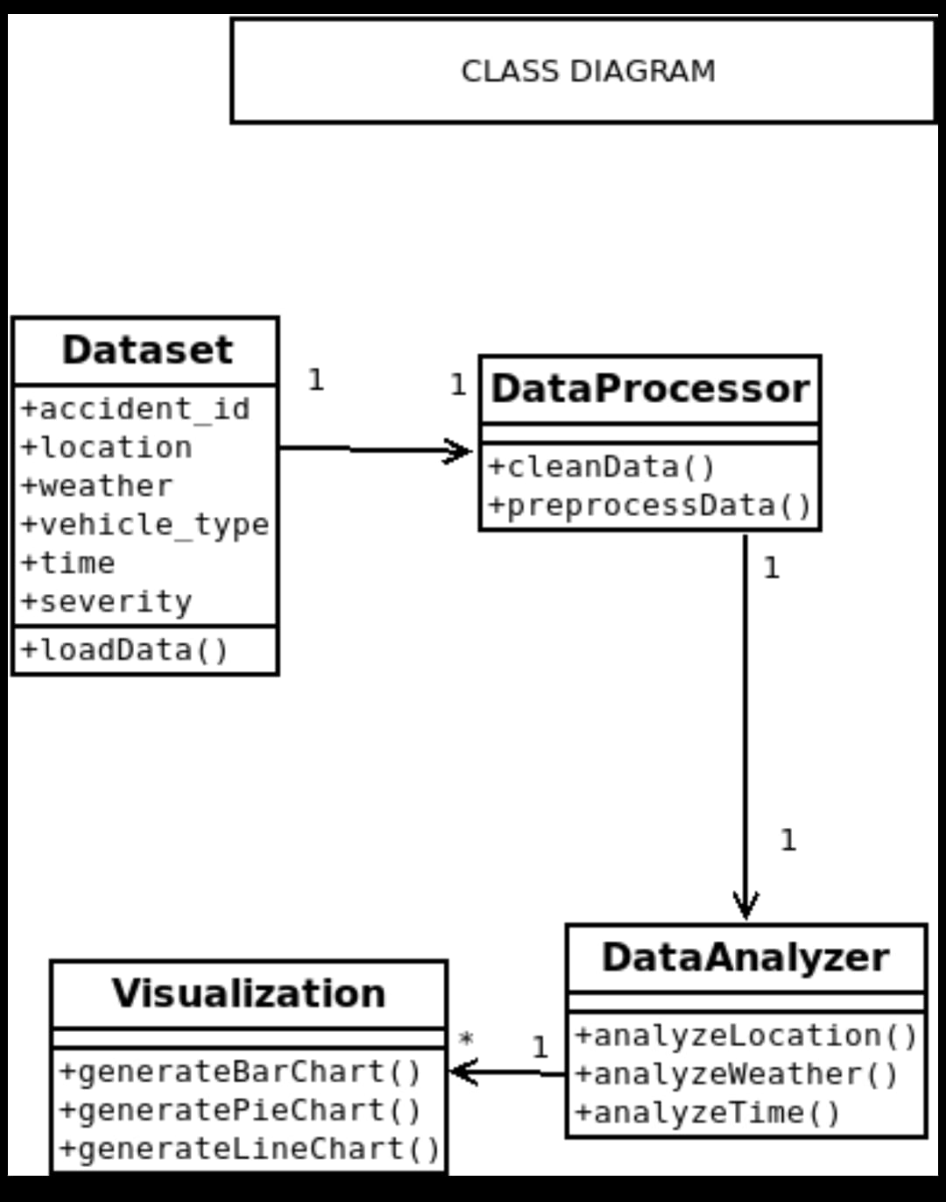

SEQUENCE DIAGRAM:

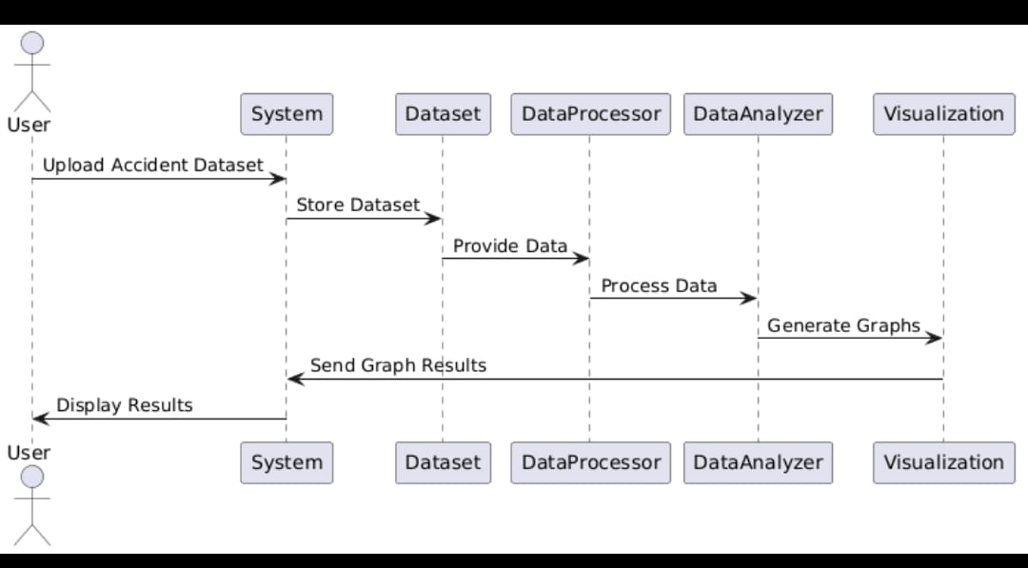

RESULT ANALYSIS

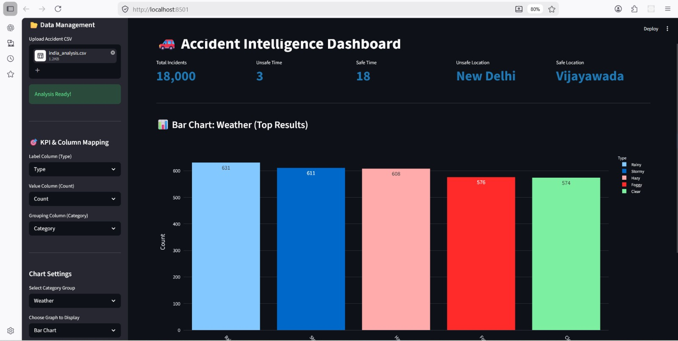

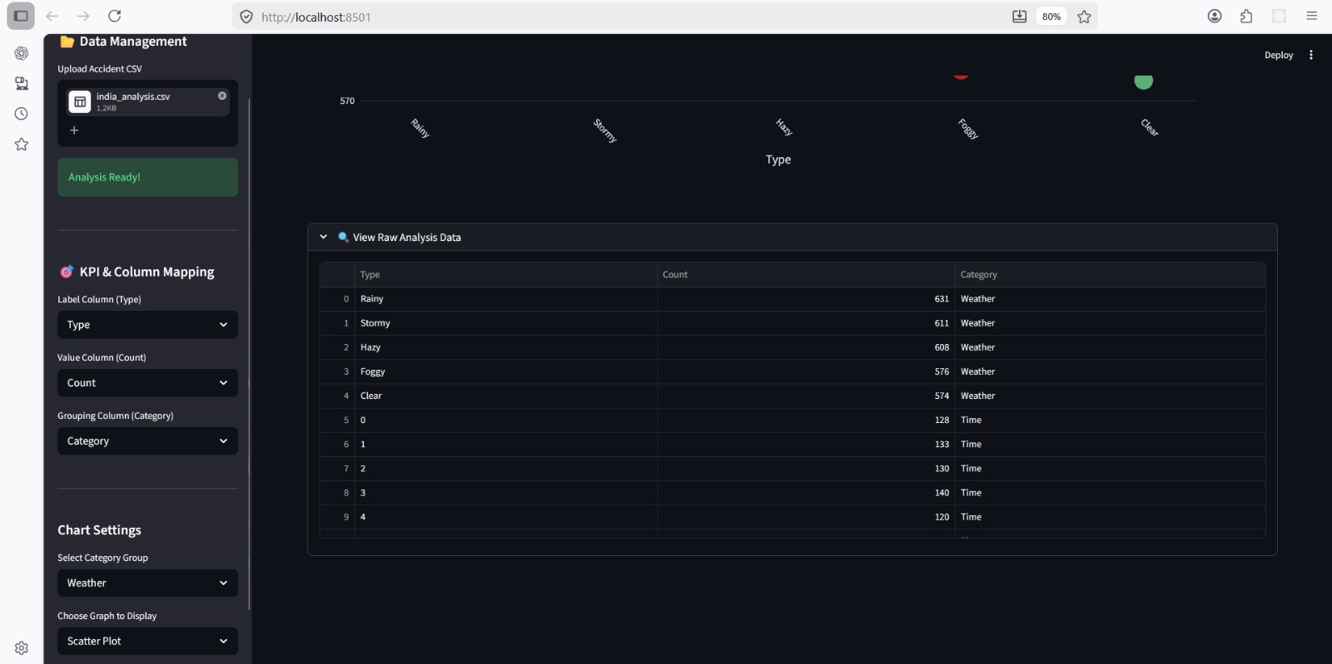

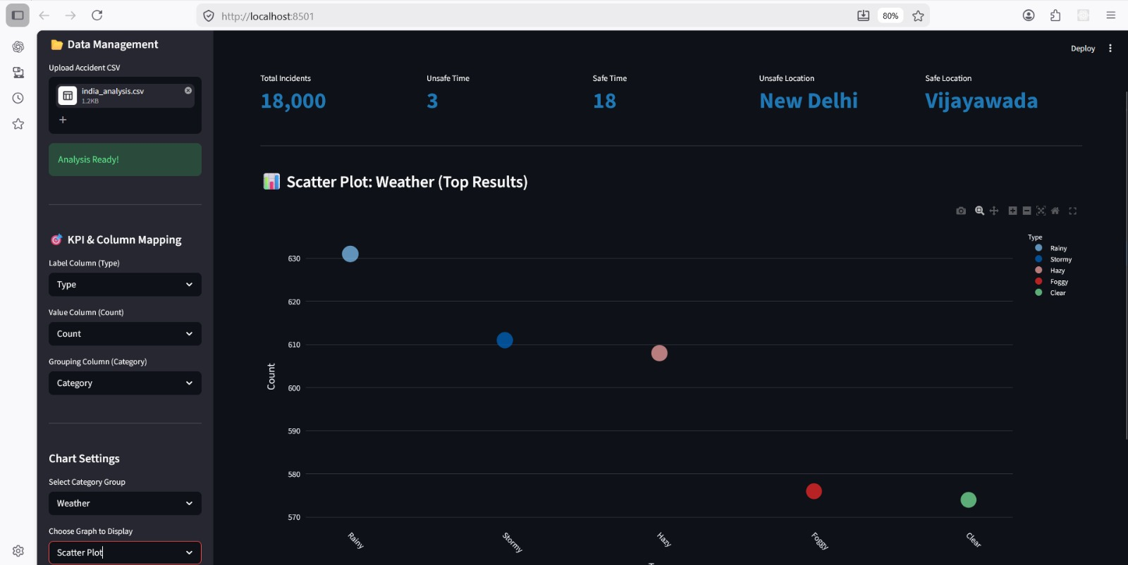

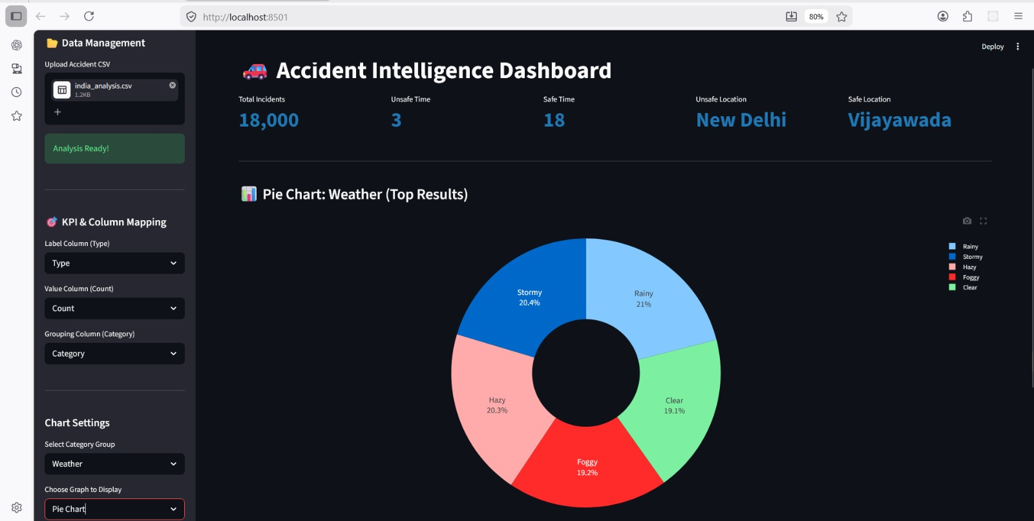

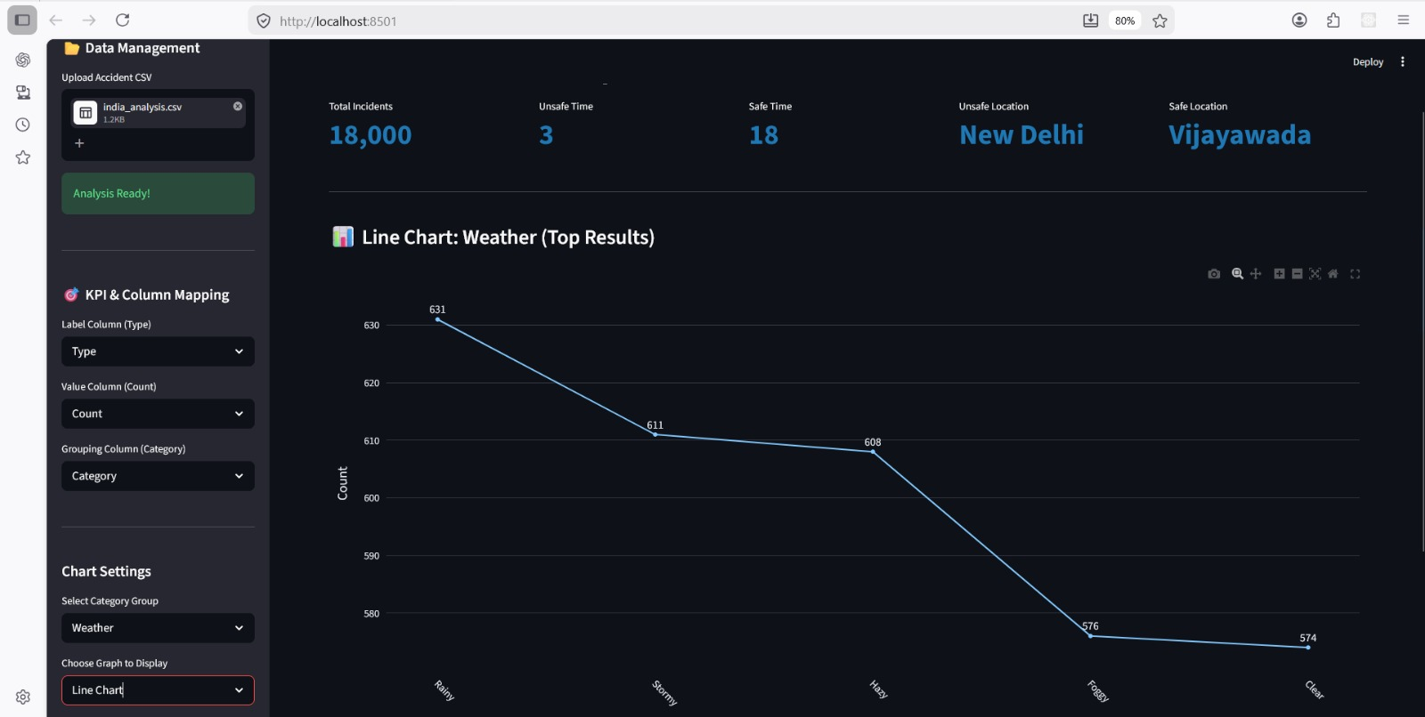

CONCLUSION

The Road Accident Analysis and Pattern Identification System demonstrates an effective approach to transforming raw accident data into meaningful and actionable insights using data analysis techniques. By collecting real-world datasets from Kaggle and performing essential preprocessing steps such as handling missing values, removing duplicates, and standardizing data, the system ensures high data quality and reliability for further analysis. Through the use of GroupBy-based analytical methods, the system successfully identifies patterns and trends in accidents based on important factors such as time of occurrence, weather conditions, road type, location, and accident severity. These patterns are visually represented using intuitive and easy-to-understand graphs including bar charts, pie charts, and line graphs, which enhance the interpretability of the results. Furthermore, the integration of an interactive dashboard allows users to upload datasets, apply filters, and explore different aspects of the data dynamically, making the system highly user-friendly and flexible even for non-technical users. The system also generates meaningful insights, such as identifying accident-prone conditions, high-risk locations, and unsafe time periods, which can significantly contribute to improving road safety awareness and supporting informed decision-making. Overall, this project highlights the importance of combining data preprocessing, analysis, and visualization in a structured manner to derive valuable knowledge from data, and it provides a scalable and efficient solution that can be further enhanced with advanced features such as machine learning-based prediction, real-time data integration, and intelligent traffic management systems.

REFERENCES
[1] S. K. Singh, "Road Traffic Accidents in India: Issues and Challenges," Transportation Research Procedia, vol. 25, pp. 4708–4719, 2017.
[2] Md. F. Labib, A. S. Rifat, Md. M. Hossain, A. K. Das, and F. Nawrine, "Road Accident Analysis and Prediction of Accident Severity by Using Machine Learning in Bangladesh," 2019 7th International Conference, IEEE, 2019.
[3] S. K. Singh and A. Misra, "Road Accident Analysis: A Case Study of Patna City," Urban Transport Journal, vol. 2, no. 2, pp. 60–75.

