BIT Project
Requirement Analysis
AI driven telematics online support

Contents
Project Title………………….........................................................
Project Team………………..........................................................
Stakeholder Analysis………………………………………………...
Requirements Analysis……………………………………………...
System Modelling…………………………………………………….
Project Management Tool Utilization………………………………

- Sushil Sapkota (Business Analyst): Requirements Analysis
- Tomas Aquino Heneine (Group Leader and Solution Architect): System Modelling
- Kushal Sharma (Project Strategist): Stakeholder Analysis
- Srijan Dangol (The Project Manager): Procject management Tool Utilization.
- Tshering Wangchuk (The Risk & Quality Assurance): Formatation.

1.Ethical, Security, and Stakeholder Requirements
Stakeholder Requirements Analysis
Following Project 1's initial identification of stakeholders, this section outlines the needs of each stakeholder group for an AI-driven telematics online support assistant. This is critical in ensuring the Proof of Concept (POC) meets the business needs.

- Ctrack Australia Pty Ltd (Client & Mentors):
Efficiency is the most important need for the business. The telematics support system must successfully intercept common telematics questions (e.g. "Why did my vehicle trigger a harsh braking alert?") and give correct answers without human intervention. The mentors want the POC to be developed using architecture that allows it to be scaled up and made ready for production.
- End-Users (Fleet Managers and Drivers):
End-user requirements is to revolve around usability and simplicity. The vehicle or system assistance should have the ability to accept natural language input in the form of speech or text, without burdening the user with command protocols or the use of specialized technical language. It should provide context-sensitive fast responses, directly address to fleet ownership questions such as vehicle or System health queries.
- Support Teams:
The AI assistant must act as a filter. The requirement is to be able to tackle Level 1 support issues only and takeover more complex or unresolved issues to the human support team. Which cut down their overall number of tickets coming in and prevent data fatigue.
Ethical Requirements and AI Governance:
AI solutions telematics systems create major ethical challenges for their implementation. As the system will be working with data about driver behaviour, vehicle GPS locations and system alerts. So, AI system needs strict rules for data processing to be carefully controlled.

- Transparency: Users need to informed that they are interacting with an AI assistant, not a human support agent. The procedure creates expectations which match the rules for responsible AI system operation.
- Minimizing AI Bias and Hallucinations: A strict requirement for the Large Language Model (LLM) must be constrained on the provided Ctrack knowledge base and Retrieval Aaugmented Generation (RAG) framework. The AI system needs to respond to users through fallback mechanisms which include the statement, (e.g., "I am unable to find that information, connecting you to a human agent") and should not create false information because it might cause unsafe decisions among fleet managers.
Security and Data Privacy Requirements
The Security of telematics data requires protection as it contains sensitive data. All information must be compliant with Ctrack's Global Data Protection Policy, among other things the Protection of Personal Information Act (POPIA) and the General Data Protection Regulation (GDPR).
Data Anonymization: The POC must only use synthetic or heavily anonymised data as its only acceptable data source. The AI model will not process any data points which can reveal the identity of specific drivers or client companies or their particular operational routes.
Access Control: The system must have role-based access control (RBAC). Only authorized persons (approached fleet managers or support personnel) can access the system and query their own fleet for insight.
Data Retention: The AI assistant must delete all user chat logs which contain sensitive information because POPIA and GDPR require organizations to limit their data retention period. The system will remove session data automatically after it has solved a query or reached its established session timeout period.
Agile Requirement Management (Scrum Framework)
To ensure these requirements are meet within the project schedule, the team will implement an Agile Scrum Framework. All functional and non-functional requirement will be translated to the User Stories.
In order to maintain and monitor the quality, every user story need to meet Definition of Done (DOD) before it is considered complete. For this POC, The DOD are as follows:
- The code maeets all requirements which the user story acceptance criteria establish.
- All AI responses has been tested with synthetic data.
- The features do not violate any established security, or data privacy constrains.
The output has been checked by the Risk and Quality Assurance Lead.

2.Requirement Analysis Overview
Requirement analysis is an essential part of the project that follows the initial proposal stage and seeks to analyze the requirements of the proposed AI-based telematics business intelligence (BI) system for Ctrack Australia Pty Ltd. This section will aim to clearly outline the requirements of the system, the demands of the stakeholders, and a logical reasoning on how the proposed solution will remedy the weaknesses of the current system.
The purpose of integrating AI technology into the telematics BI system is to move from the traditional mode of data presentation to instant data-driven decisions making.
2.2Key Stakeholders' Profile
It is necessary to recognize the needs of the significant individuals involved in the activities of fleet management and data analytics for the success of the proposed solution.
Profile of Key Stakeholders
. Drivers and Fleet Managers
. Data Analysts
. Corporate Clients (Ctrack Clients)
. Government Regulations
The stakeholders have varied interests in the AI-based BI platform.
2.3. Requirements of Stakeholders Essential to Address the Problem
The problems discussed in the above proposal (manual analysis, absence of insights for predicting, and absence of decision support) will influence the requirements of stakeholders identified below:
Managers of Fleets
. Efficiency demands real-time insights.
. Insights are needed to predict cost savings.
. Automated alerts are anticipated to guarantee safety.
Vehicle Drivers
. Please provide your driving remarks immediately.
. Safety alerts should be anticipated to minimize risks.
Data Analysts
. Data analysis must be automated.
. More advanced analytics are expected rather than simple dashboard visualization.
Commercial Clients
. Decision support must be enhanced.
. Performance reporting will be expected to improve.
Governments
. Compliance monitoring is anticipated.
. Accurate and truthful data reporting is anticipated.

2.4. High Level Requirements Analysis
Functional Requirements (Essential Characteristics of the System)
The following characteristics should be considered while developing a suggested system:
. Real-time telematics data collection from cars
. Anomalies' detection through artificial intelligence (for example, unusual driving behaviour)
. Prediction of maintenance and fuel consumption
. Smart visualization dashboards
. Automated system for monitoring performance and safety
. Possibility to formulate queries in natural language
The problems that can be seen within an existing BI system are instantly solved by these solutions.
2.5 Non-Functional Requirements
The following non-functional requirements should be met in order to achieve high system performance and effectiveness:
. Performance – capability to process data in real time
. Security – protection of sensitive driver and vehicle information
. Scalability – ability to process increasing amounts of data
. Usability – convenient and simple interface
2.6 Relation of the Issue with the Proposed Solution
Problems related to human analysis of data and static visualization in the current system lead to loss of information and delays. These issues are readily solved by the proposed AI BI system through:
. Using AI for automation of data analysis
. Providing suggestions and alerts in real time
. Making predictions based on the analyzed data
. Providing natural language interaction between humans and data
It ensures that organizations can achieve improved efficiency and safety of the fleet and decision making in general.
2.7. System Modelling (Overview Contribution)
Modelling of the system using techniques such as UML diagrams will be used in the latter parts of the study to facilitate system design. Such models will help in visualizing the system structure and its interactions.
For example:
. Use cases will visualize the interaction between stakeholders and the system.
. Sequence diagrams will help visualize the flow of data in the system.
. Activity diagrams will help visualize the data analysis decision flow.
Such models give stakeholders a proper understanding of how an AI BI system works.
2.8 Conclusion of Stakeholder Identification Contribution
The recognition of relevant stakeholders, their requirements and system requirements forms the basis for carrying out requirement analysis. The identified problems with the current system are found to be relevant for implementing an AI-based BI system.
The research ensures that the proposed system will be both viable and efficient in improving the telematics offerings of Ctrack.

3. System Modelling

This section presents the system modelling for the AI-driven telematics support assistant, designed to enhance how users interact with complex telematics data through natural language queries. The system is modelled using UML diagrams to represent both user interactions and internal system processes, including the integration of AI components such as Large Language Models (LLMs) and Retrieval-Augmented Generation (RAG).
Our system modelling approach aims to provide a structured representation of how the proposed solution operates across different levels, including user interaction, process flow, system communication, and data structure. By applying multiple UML techniques, the design captures both the functional behaviour of the system and the relationships between its core components.
Each model is developed to focus on a specific perspective of the system. The use case diagram defines the interactions between users and the system, the activity diagram illustrates the workflow of processing user queries, the sequence diagram represents the communication between system components, and the class diagram outlines the structure of the system and its data entities.
Together, these models ensure that the system design is coherent, well-structured, and aligned with the project requirements. They also support clearer communication within the development team and with stakeholders by providing a visual and logical representation of how the system is expected to function.

3.1 Use Case Diagram
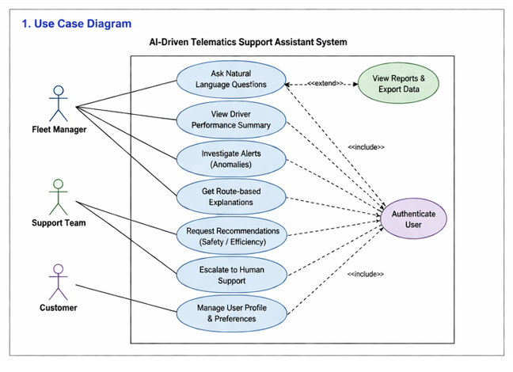
The use case diagram Illustrates the interactions between the main actors and the AI-driven telematics support assistant system. The primary actors include the fleet Manager, Support Team, and Customer each interacting with the system based on their roles and needs. Key functions include asking natural language questions, viewing driver performance summaries, investigating alerts or anomalies, and receiving recommendations based on telematics data.

The diagram also represents system-level processes such as authentication and integration with external telematics data sources. This model defines the system boundary and highlights how users engage with the system, ensuring that all core user requirements are clearly represented.

3.2 Activity Diagram
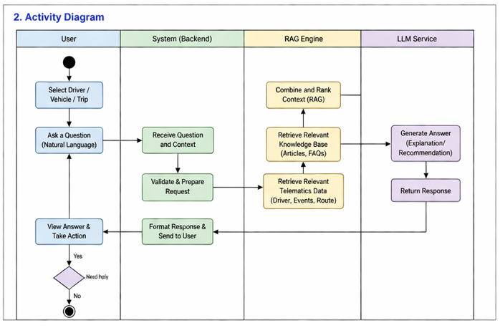
The activity diagram represents the workflow of how the system processes a user request from initiation to completion. The process begins with the user selecting a driver, vehicle, or trip and asking a question in natural language. The backend system receives the request, validates it, and prepares it for processing.
The system then retrieves relevant telematics data, such as driver behaviour and route information, along with knowledge base content including articles and FAQs. These inputs are combined and ranked by the RAG engine to create a contextual input for the LLM. The LLM generates an explanation or recommendation, which is returned to the backend and presented to the user.
The diagram also includes a decision point where the user can choose to take further action or request additional help, ensuring flexibility in user interaction. This model clearly demonstrates the end-to-end processing flow and highlights the integration of AI components within the system.

3.3 Sequence Diagram

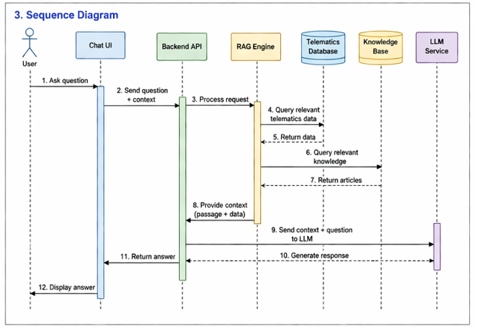
The sequence diagram illustrates the communication between system components over time when a user submits a query. The interaction begins with the user sending a question through the Chat UI, which forwards the request along with context to the Backend API. The backend processes the request and passes it to the RAG engine.
The RAG engine retrieves relevant telematics data from the telematics database and relevant articles from the knowledge base. Once the data is collected, it is combined into a structured context and returned to the backed. The backend then sends the context and user query to the LLM service.
The LLM generates a response based on the provided information and returns it to the backed, which then forwards the answer to the Chat UI for display. This diagram highlights the step-by-step communication flow between components and clearly demonstrates how data retrieval and AI processing are coordinated to generate responses.

3.4 Class Diagram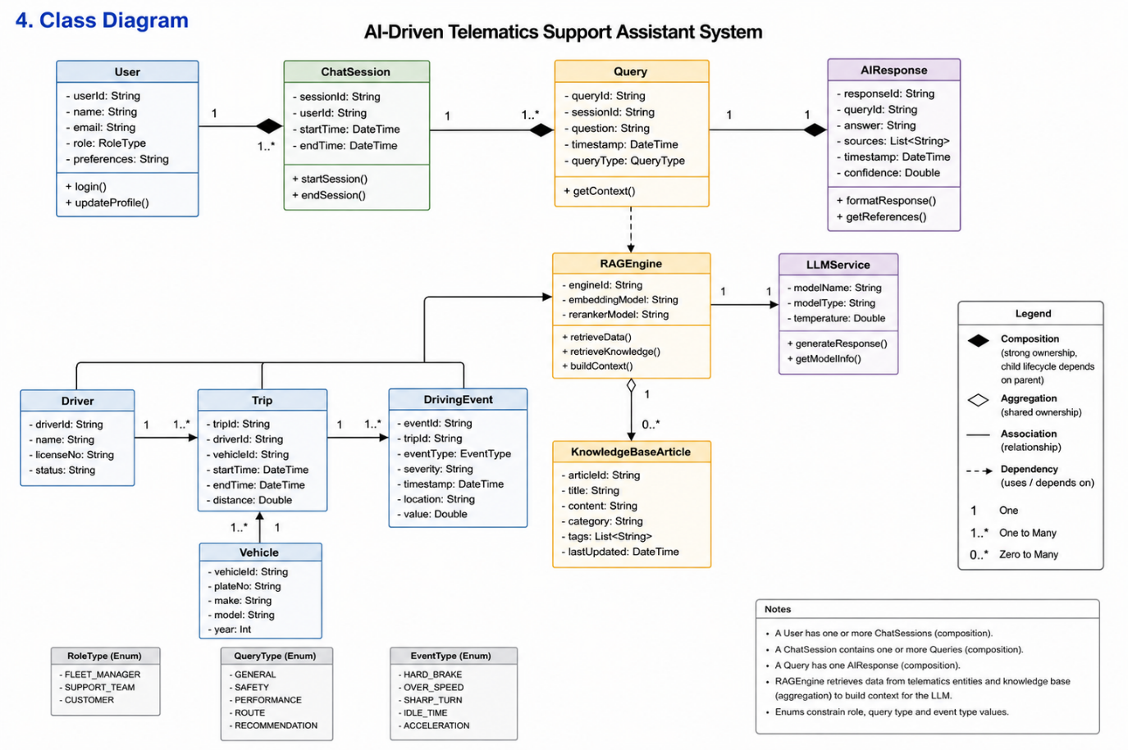
The class diagram represents the structural design of the AI-driven telematics support assistant system, showing the main entities, their attributes, and the relationships between them. The model is divided into three main areas: user interaction, telematics data, and AI processing components.
The user interaction layer includes the User, ChatSession, Query, and AIResponse classes. A user can have multiple ChatSession, and each session can contain multiple Queries. Each Query generates a single AIResponse, representing the system’s answer to a user request. These relationships are modelled using composition, indicating strong ownership and lifecycle dependency between these components.
The telematics data layer includes: Driver, Vehicle, Trip, and DrivingEvent classes. A Driver can be associated with multiple Trips, each Trip is linked to a Vehicle, and each Trip can contain multiple DrivingEvents such as breaking, speeding, or route deviations. These relationships ensure that real-world telematics data is accurately structured and can be analysed by the system.
The AI processing layer is represented by the RAGEngine and LLMService classes. The RAGEngine is responsible for retrieving relevant telematics data and knowledge base content, combining them into a contextual input. The LLMService then uses this context to generate a response. The KnowledgeBaseArticle class supports this process by providing structured reference content used during retrieval.
Overall, the relationships between these classes demonstrate how user queries are transformed into meaningful AI-generated responses by integrating structured telematics data with contextual knowledge. This diagram provides a clear view of the system’s internal architecture and supports a modular and scalabe design.

4. Project Management Tool Utilization

As Project Planner for this AI-Driven Telematics Online Support Assistant project, my job is to ensure everything is organized, t‌hat we are monitoring things pr​operly, and that the project finishes w‍hen it should. To help do that the team will use a project management tool, p⁠robably Jira, to help with planning tasks, to collaborate and communicate better, p​lus keep track of how things are p⁠rogressing during develo‎pment.

Jira lets the project team stick to an Agile workflow, where, the tasks get broken down which is into smaller activities and things are watched over time. It should make coordination better between everyone, and provide some transparency about the project as it moves forward.

The project management process focuses on:

* Task allocation
* Sprint planning
* Progress mon‍itoring
* Requirement tracking
* Risk identifi‍cation
* Te⁠am collabor​ation
* Milestone management

Using Jira means we can log all the project activities clearly and keep them lined up wi﻿th what the project trying to achieve.
20. 1 Project Setup in Jira

Right at the start of the project, what the team leader will do is set up a Jira project workspace, and the title for that will be:

“AI-Driven Telemat﻿ics Online Support Assis﻿tant”

Inside the Jira workspace we are going to have the fol⁠lowing listed below:

Pr‎oject backlog
Scrum/Kanban board
Task assignments
Sprint progress
Team collaboration records
Issue tracking
Priority management

All team mem͏bers can get to the project board, and the reason is to make sure everything is open and collaborative as the project moves forward.

21. 2 A‎gile Project Management Approach

We are going to be using an Ag‍ile method for the pro‍ject. Because the system needs to be develo﻿ped in stages that are tested and get feedback on as it go​es.

U‎sing Agile has a few good things going for it:

Quicker at finding problems
Ea͏sier for the team to work together
Can change t⁠hings easier if needed
Can see how far we have got all the time
Keeps making the system better bit by bit

The project gets broken down into sprints lasting a week, and tasks get done little by l⁠ittle in those sprints.

What you do in each sprint:

Sprint Planning
Task Assignment
Development Activities
Testing
Sprint Review
Progress Evaluation

This repeati‎ng process helps k‎eep the project structured and not too hard to handle.
20.2 Agile Project Management Approach.

The project will be performed according to the Agile approach as the system would need to be developed in iterations, be tested on a regular basis and have feedback regularly.

Agile approach has a number of benefits:

Faster issue identification
Improved team collaboration
Increased flexibility to changes.
Continuous progress tracking
Incremental system improvement

The project will be segmented into weekly sprints with completion of tasks being progressive.

Each sprint includes:

Sprint Planning
Task Assignment
Development Activities
Testing
Sprint Review
Progress Evaluation

This cyclic approach makes sure that the project is planned and handled in an organised manner.

20.3 Task Backlog Management

All the requirements of the project and development activities will be included in the Jira backlog. Priorities of tasks will be based on the importance and dependencies of projects.

All tasks will entail:

Task title
Description
Assigned team member
Priority level
Due date
Status
Linked requirement

Examples backlog tasks are:

Task ID Task description Assigned to Priority.
T1 Requirement Analysis Project Manager High.
T2 Stakeholder Analysis Project Manager High.
T3 Develop Telematics Dataset Data Specialist High.
T4 Create Backend APIs Backend Developer High.
T5 Integrate AI Model AI Engineer High
T6 Develop Chat Interface Frontend Developer Medium.
T7 Test AI Responses AI Engineer Medium
T8 UI Improvements Frontend Developer Low.
T9 Final Documentation Project Manager High.

The backlog enables the team to properly comprehend project priorities and progressions in project development.
Requirement and Progress Tracking.

Requirement traceability and progress monitoring will also be done with Jira. All the requirements will be attached to particular development activities so that all the project goals could be implemented in the proper way.

For example:

FR1: Natural language query processing.
FR2: System of alert explanation.
FR3: AI troubleshooting assistant.

The workflow will pass through the workflow phases including:

To Do
In Progress
Testing
Review
Completed

This graphic workflow enables the team to easily track the development progress and to determine delays or blockers.

Communication and Risk Management.

Communication is the key to successful implementation of the project. The team will use:

Microsoft Teams to meet and communicate.
Source code management with Github.
Task Tracking and Reporting Jira.

Meetings every week will be held to:

Review sprint progress
Discuss technical issues
Reallocate tasks if necessary
Monitor deadlines

The possible risks of the project are:

AI response inaccuracies
Integration challenges
Time management issues
Limited telematics datasets

Having a record of problems in Jira, the team can track and solve the problems effectively before they could impact the project deadlines.
Conclusion

As the Project Planner, it is important to install an organized project management plan to make sure that the successful implementation of the AI-Driven Telematics Online Support Assistant project is effective. Jira usage aids in managing tasks, tracking requirements, collaborating in a team, and planning a sprint across a development lifecycle.

Through the use of Agile methodologies, the effective allocation of responsibilities as well as the maintenance of continuous communication, the project team can enhance its productivity, minimize the risk of development, and ensure that all project deliverables will be implemented successfully. This project management method exhibits professional software development practices and gives a solid base towards the ultimate attainment of the project objectives in a professional manner.

