Assessment Cover Sheet

Unit Code and Title | ICT 307
Assessment Name and Number | ICT307_ASS3_AI-Driven_Telematics_Support_Assistant_report
Teaching Period / Year | 1st semester 2026
Lecturer / Unit Coordinator | Dr Javad Rezazadeh
Student Full Name | Tomas Aquino Heneine
Student ID | CIHE 241731
Submission Date | 24/05/2026
Submission Type | Group

Team Members (Complete ONLY for group assessments)
Student Name | Student ID | Contribution (%) | Responsibilities for the Assessment
Tomas Aquino Heneine | CIHE241731 | 25% | System Architecture(1), User interface design(2) sections, such as build own images and responsible for Figma.  Also Group leader and responsible for handle meetings, review and submit.
Sushil Sapkota | CIHE240586 | 20% | Ethical and Security Considerations(5)
Kushal Sharma | CIHE250106 | 20% | Usability testing and user feedback(4)
Srijan Dangol | CIHE24021 | 20% | Database Design(3)
Tshering Wangchuk |  | 15% | Format and Support.

Declaration
By submitting this assessment, I/we confirm that this work is my/our own and complies with the CIHE Academic Integrity Policy. Any use of AI or other tools has followed the assessment instructions and has been fully acknowledged in the AI/Tool Use Declaration Table below. I/we understand that inappropriate or unacknowledged use of AI, or submission of work that is not my/our own, may constitute academic misconduct. I/we also confirm that this assessment has not been previously submitted unless approved, and I/we consent to its use for standard academic integrity and quality assurance processes.

Student(s) Signature: 
Date: 24/05206
GenAI Tool | Description

Table Of Content
1.System Architecture 2
1.1 Overview of the System Architecture……………………………………. 2
1.2 System Component Interaction…………………………………………….. 2
1.3 API- Centred Architecture……………………………………………………… 2
1.4 Escalation Workflow……………………………………………………………… 2
2. User Interface (UI) Design 2
2.1 User Interface Overview…………………………………………………………2
2.2 UI/UX Design Decisions………………………………………………………… 2
2.3 Usability Considerations…………………………………………………………2

3. Database Design 2
3.1. Customer 2
3.2. Device 2
3.3. Chat Session 2
3.4. Support Ticket 2
3.5. Notification 2
3.6. Support Agent 2
4. Usability Testing and User Feedback 2
4.1. Usability Testing User Feedback 2
4.2. Scenario-Based User Testing 2
4.3. Continuous User Feedback Machanism: 2
4.4. Iterative Design Improvements 2
5. Ethical, Security, and Compliance Design 2
5.1. Ethical Issues 2
5.2. Security Measures 2

1. System Architecture
1.1 Overview of the System Architecture
The proposed AI-Driven Telematics Support Assistant uses a modular system architecture to support scalability, usability, and easier integration with the existing Ctrack platform. The system is designed to allow users to interact with telematics data using natural language instead of only using dashboards and reports.
The architecture is divided into different layers to separate responsibilities and improve maintainability. The system is also designed to support both reactive and proactive AI operations, allowing the platform to not only answer user questions but also generate automated operational reports and recommendations.
The first layer is the presentation layer, which includes the telematics dashboard, route visualisation, and the floating AI chatbot interface. This is the main part of the system where fleet managers and support teams interact with the platform. The interface is designed to improve usability and reduce the complexity of analysing telematics information manually.
The second layer is the backend application layer. This layer handles API communication, user authentications, session management, request validation, escalation workflows, and communication between the frontend and AI services. The backend layer is also responsible for coordinating proactive AI-generated reports and monitoring system activity.
The third layer is the AI processing layer. This includes the Retrieval-Augmented Generation (RAG) engine and the Large Language Model (LLM). The RAG engine retrieves relevant telematics data and knowledge base information before sending context to the AI model to generate more accurate responses. This layer is responsible for analysing telematics activity, generating contextual explanation, and providing operational recommendations.
The final layer is the data layer, which stores telematics records, driver information, route history, driving events and operational data collected from the telematics platform.
Security is integrated into the architecture from the beginning of the design process. The system uses role-based access control (RBAC), anonymised datasets, secure API communication, and session timeout policies to protect sensitive telematics data.
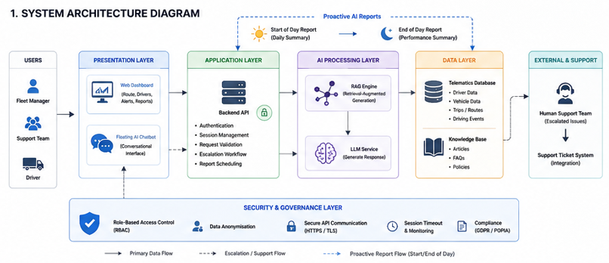
Figure 1: it shows the overall structure of the AI-Driven Telematics Support Assistant and how the main system components interact. Also shows how the proactive AI work.

1.2 System Component Interaction
The system interaction begins when a user asks a question through the chatbot interface. The frontend sends the request to the backend API together with the selected context, such as the driver, trip, or route.
The backend validates the request and forwards it to the RAG engine. The RAG engine retrieves relevant telematics information, including driving events, route data, and knowledge base articles related to the request.
After the context is prepared, the backed sends the information to the LLM service. The AI model then generates an explanation, recommendation, or troubleshooting response based on the provided context.
The generated response is returned through the backend API and displayed to the user in the chatbot interface.
In addition to responding to responding to user questions, the system also supports proactive AI-generated reporting. The backend system can automatically trigger operational reports at the beginning and end of the operational day.
At the start of the day, the AI assistant can generate a summary containing:
- Driver risk alerts,
- Vehicle health information,
- Unresolved incidents,
- Planned routes,
- And operational recommendations.
At the end of the day, the AI assistant can generate a performance report based on telematics activity collected throughout the day. This may include:
- Speeding incidents,
- Harsh braking events,
- Route deviations,
- Fuel efficiency observations,
- And driver performance summaries.
This proactive reporting approach reduces manual monitoring and helps fleet managers identify operational issues more efficiently.
If the AI assistant cannot confidently answer the request, the system activates the escalation workflow and forwards the issue to a human support team member.
This interaction process allows the system to combine AI automation with human support when necessary.
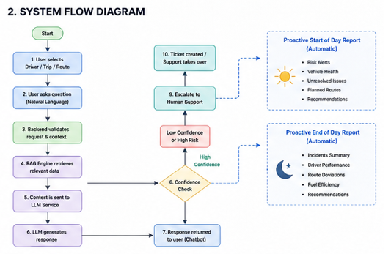
Figure 2: It illustrates how user requests move through the system, from the chatbot interface to the backend, RAG engine, AI model, and final response generation. Also shows how the proactive AI should delivery daily improvements.

1.3 API- Centred Architecture
The system follows an API-centred architecture because APIs are responsible for connecting all major components of the platform.
The APIs are responsible for managing:
- Frontend and backend communication,
- Telematics data retrieval,
- AI service interaction,
- Authentication,
- And support ticket integration.
This approach makes the system more flexible and scalable for future improvements such as mobile integration, external services, or additional AI features.
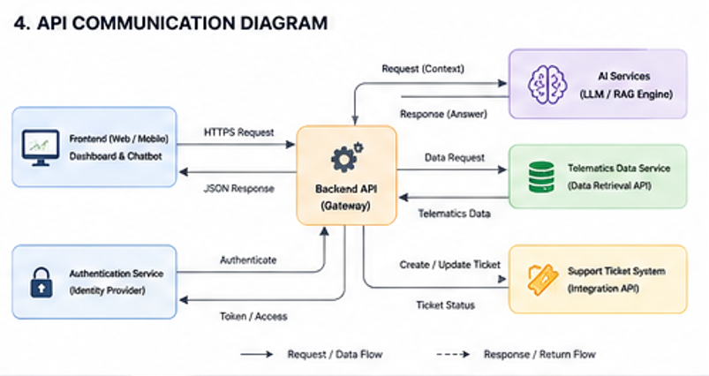
Figure 4:It shows how APIs connect the frontend, backend, AI services, telematics database, authentication system, and support ticket integration.

1.4 Escalation Workflow
The system includes an escalation workflow to reduce incorrect AI responses and improve reliability.
If the AI assistant cannot provide a confident answer, or if the issue is considered high risk, the request is escalated to a human support operator.
Examples of escalation scenarios include:
- unclear user requests,
- missing telematics data,
- safety-critical events,
- or unsupported technical issues.
This process improves trust in the system and reduces the risk of AI hallucinations. The escalation workflow also helps maintain system reliability and prevents users from relying on inaccurate AI-generated information during critical operational situations.
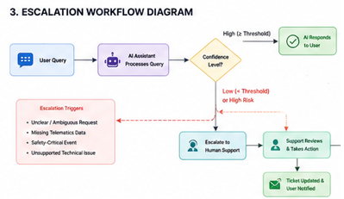
Figure 3: It shows how the system transfers unresolved or high-risk issues from the AI assistant to human support operators when the AI confidence level is low.

2. User Interface (UI) Design
2.1 User Interface Overview
The user interface was designed to improve usability and reduce the complexity of analysing telematics information. Instead of forcing users to manually interpret dashboards and reports, the system allows users to ask questions directly through a conversational AI assistant.
This interface combines traditional telematics monitoring features with an AI-powered conversational support experience.
The main interface components include:
- telematics dashboard, route visualisation,
- driver performance panels,
- alert notifications,
- and the floating AI chatbot.
The chatbot remains visible while users navigate through the platform, allowing continuous interaction without interrupting the workflow.
Figma link: https://www.figma.com/make/9R8EV76K7YYPTZUlzg3m32/Fleet-Management-Dashboard-Design?t=TyoEvnxr3eHFfNPG-1
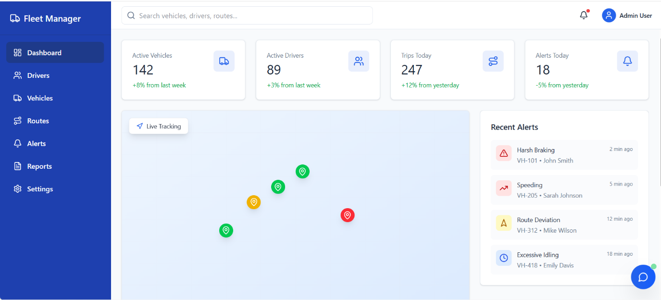
Figure 5: How looks like the system
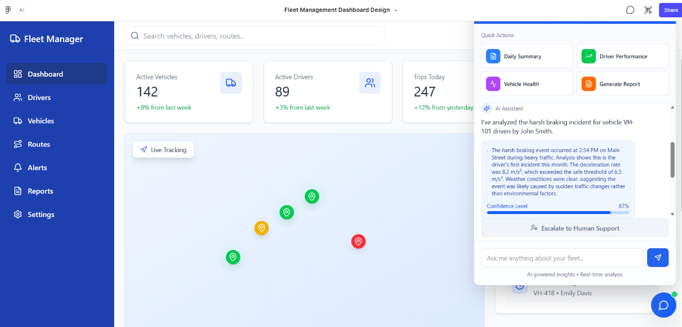
Figure 6: How suppose interaction works.

2.2 UI/UX Design Decisions
The UI/UX design focused on simplicity, accessibility, and workflow efficiency.
One important design decision was using a floating chatbot interface instead of creating a separate support page. This allows users to continue viewing telematics data while interacting with the AI assistant at the same time.
The interface also avoids displaying excessive technical information. AI responses are presented using short summaries and contextual explanations to reduce cognitive overload.
The design also focuses on keeping the workflow simple and reducing the number of steps required for users to access operational insights.
Visual indicators are used for important driving events such as:
- speeding,
- harsh braking,
- route deviations,
- and idling behaviour.
The system also supports error prevention by validating user input and suggesting corrections when queries are unclear.
Another important consideration was scalability. The modular UI design allows future integration of:
- voice interaction,
- mobile support,
- live notifications,
- and advanced analytics features.

2.3 Usability Considerations
The system was designed for users with different technical skill levels. Fleet managers and support teams may not have advanced technical knowledge, so the conversational interface helps simplify interaction with telematics data.
The chatbot reduces the time required to understand driver behaviour and operational issues. Instead of manually analysing multiple dashboards, users can ask direct questions and receive contextual explanations immediately.
The design also focuses on reducing support ticket volume by helping users solve common issues through AI assistance before escalating to human support.

3. Database Design
The database was normalized to achieve the following objectives:

Minimize redundancy of data
Increase consistency
Facilitate easy maintenance
Scale easily
Increase security and performance

Customers, devices, tickets, chatbot communications, and notifications have been separated into various entities to avoid redundancy and enable record management.
Main Entities
3.1. Customer
Stores customer account details.
Attributes
- CustomerID (PK)
- FullName
- Email
- PhoneNumber
- PreferredNotificationMethod
- PasswordHash
- CreatedDate
Purpose
A single customer can own multiple telematics devices and create multiple support tickets.
3.2. Device
Stores telematics device information.
Attributes
- DeviceID (PK)
- CustomerID (FK)
- SerialNumber
- DeviceType
- BatteryStatus
- SignalStrength
- LastSeen
- DeviceStatus
Relationship
- One customer → many devices
Purpose
Separating devices prevents duplication of customer information for every device.
3.3. ChatSession
Stores chatbot conversations.
Attributes
- ChatSessionID (PK)
- CustomerID (FK)
- DeviceID (FK)
- StartTime
- EndTime
- AIConfidenceScore
- SessionStatus
Purpose
Tracks AI conversations and troubleshooting history.
3.4. SupportTicket
Stores escalated support issues.
Attributes
- TicketID (PK)
- CustomerID (FK)
- DeviceID (FK)
- ChatSessionID (FK)
- TicketStatus
- Priority
- CreatedDate
- ClosedDate
- AssignedSupportAgent
Relationship
- One customer → many tickets
- One chat session → may create one ticket
Purpose
Keeps ticket management independent from chatbot conversations.
3.5. Notification
Stores customer notifications.
Attributes
- NotificationID (PK)
- TicketID (FK)
- CustomerID (FK)
- NotificationType
- SentDate
- DeliveryStatus
Purpose
Tracks email, SMS, or in-app notifications when tickets are updated or resolved.
3.6. SupportAgent
Stores support department staff details.
Attributes
- AgentID (PK)
- AgentName
- Email
- Role
- AccessLevel
Purpose
Supports role-based access control and accountability.
Entity | Relationship | Entity
Customer | 1 → Many | Device
Customer | 1 → Many | ChatSession
Customer | 1 → Many | SupportTicket
Device | 1 → Many | ChatSession
ChatSession | 1 → 0..1 | SupportTicket
SupportTicket | 1 → Many | Notification
SupportAgent | 1 → Many | SupportTicket
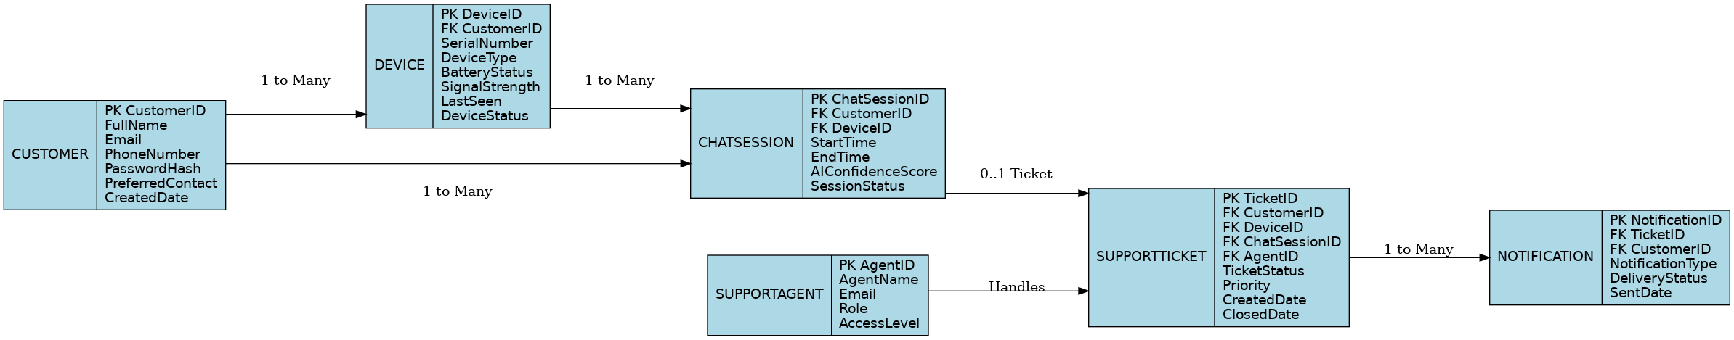
Reason Why the Database is User-Friendly

Ease of use is achieved through:

Grouping data into meaningful categories
Facilitating search for customer records easily
Making ticket management easier
Debugging becomes quicker
Report generation becomes easier
Makes upgrades simple in the future
Allows for secure access control
Security Aspects in the Database Design

Depending on your security needs:

The database also allows for:

Password encryption
Access based on roles
Audit trail
API security integration
Limit access to sensitive data

4. Usability Testing and User Feedback

4.1. Usability Testing Strategy
The main intention behind the AI driven telematics online support assistant is to close Level 1 support requests fast, like device pairing or those harsh braking alerts, in a smooth way. Since the end-users mostly fleet managers and drivers usually don’t have strong technical background, the system usability ends up being as important as the backend AI design itself. So, for the Proof of Concept, we made a usability testing plan that’s meant to cut down user effort and boost task success.
Our method is based on iterative testing during the design phase. Before we locked the user interface, we ran trial and error checks against common usability rules, and we made sure the chat experience stays in everyday conversational language instead of heavy telematics terms. The whole interface is meant to be easy to see and responsive too, giving quick visual feedback when the AI is “typing” or when it is pulling information from the Ctrack knowledge base.
4.2. Scenario-Based User Testing
To validate the design, we planned scenario-based testing with synthetic data, like mostly artificial but still realistic. The testers that represent our core user personas were given certain tasks to do on the POC. Slightly, the goal was to let them follow the same kind of journeys, and yes those scenarios parallel with the pain points we found during the requirements analysis, not just loosely.
- Scenario A (Driver): "Ask the AI why the tracking unit in Vehicle #42 isn’t reporting its location."
- Scenario B (Fleet Manager): "Query the system to explain a recent 'harsh braking' alert, and also ask for the recommended troubleshooting steps."
In the middle of these tests, we measure a few usability metrics, that we care about pretty directly:
- Time to Resolution: We check whether the chatbot resolves the setup or debugging query within our 2-minute target.
- Task Success Rate: We measure how often the user gets an accurate and genuinely helpful answer without having to escalate the issue.
- Error Rate: We track how frequently the AI misunderstands the user’s natural language input, and that basically tells us we need to refine our Retrieval-Augmented Generation (RAG) prompts.
4.3. Continuous User Feedback Machanism:
The usability quarries cannot be solved with a single test; it is monitored continuously after implementation. To guarantee that the AI assistant fulfills efficiently the needs of Ctrack everyday business needs, we have built users' feedback features into the system:
- In-Chat Micro-Feedback: Once the AI delivers a troubleshooting step or describes a telematics incidents in the conversation, you see this clean line with a straightforward "Thumbs Up / Thumbs Down" (for example, "Did this resolve your issue?").So much easier to give instant feedback without interrupting the user experience.
- Post-Interaction Surveys: if the conversation ends up solving the users request, a brief CES survey is launched to understand how easy it was for the users to get help.
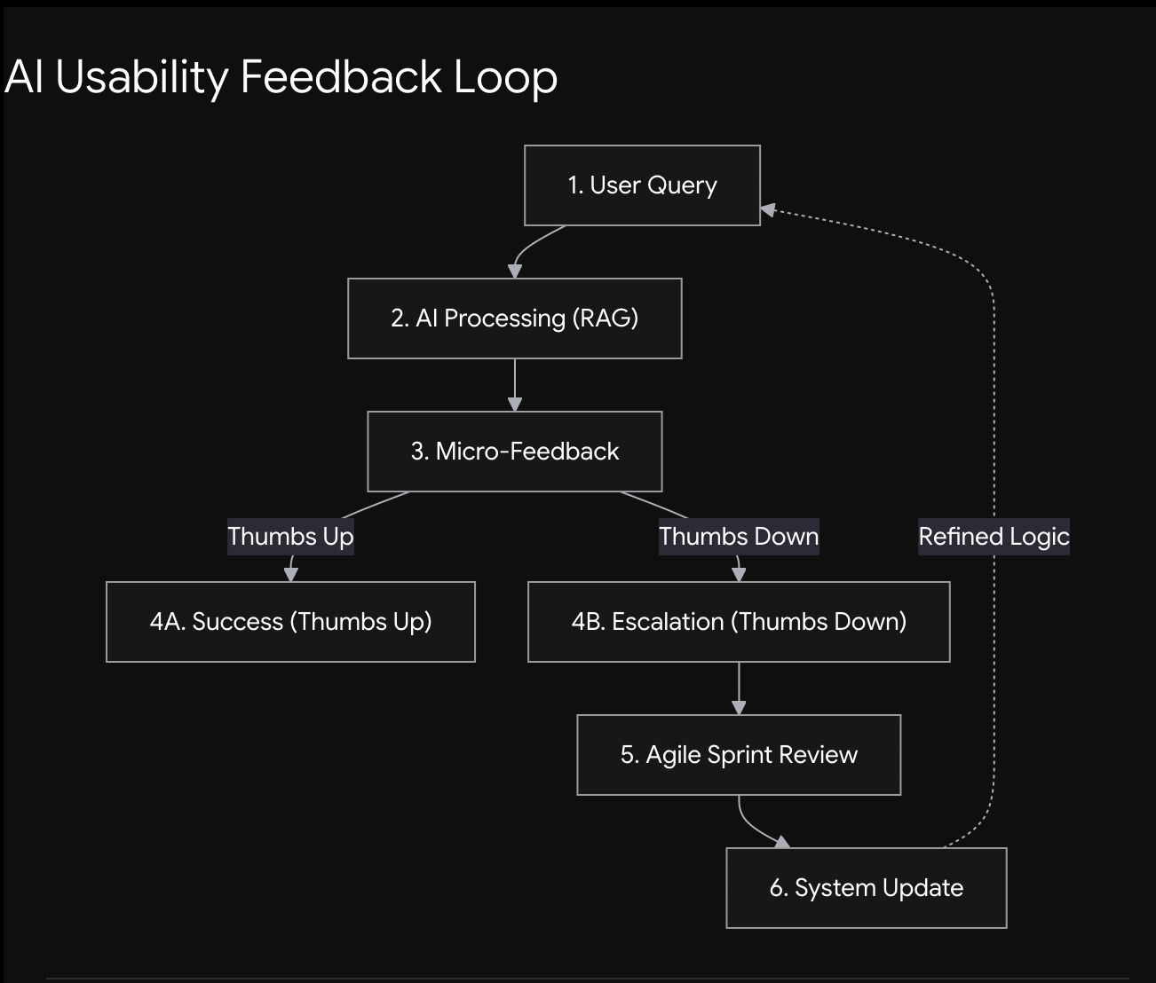
Figure 1: AI Usability Feedback Loop

The AI Usability Feedback Loop is designed to make the telematics AI assistant smarter, and more helpful, the more you use it. It kicks off the moment someone asks a question, and the AI replies, but also right away it asks for a quick “Thumbs Up” or “Thumbs Down” rating. When the user selects “Thumbs Down” ,the system kind of becomes a safety net by instantly moving the chat to an actual human support agent, so the issue is handled and the person doesn’t get stuck or annoyed. After that, the development team reviews the “Thumbs Down” entries, digging into the exact point where the AI didn’t land the answer. Then they update the knowledge base and its programming, so that when the same question shows up later, it can answer correctly, without the same stumble.
4.4. Iterative Design Improvements:
Any information obtained from both the scenario style testing and the in app continuous feedback will be pushed directly back into our Agile development loop. For instance, if a user point of contact feedback indicated that the explanation of an error code by the AI was too complex, the product and engineering teams could change the intent editor and knowledge base to create a plainer language version. By treating usability testing and user feedback as an endless feedback loop, we can iterate the AI assistant to be a helpful, user focused application, and not an obstacle to task flow.

5. Ethical, Security, and Compliance Design

Telematics Business Intelligence (BI) solution involving AI will process sensitive data like location of the vehicles, driver behavior, fuel usage, vehicle maintenance, and performance data in respect of Ctrack Australia. This is because artificial intelligence, surveillance in real time, and predictive analytics will be applied. As such, security, privacy, and ethical issues must be addressed.
5.1 Ethical Issues
Data Protection and Privacy
Ethically, there is the issue concerning the monitoring and collection of driving data. Vehicle location, speed, driving behaviors, and safety behaviors are some of the telematics data collected by the system. Even though data can improve management decisions, there could be ethical challenges associated with excessive surveillance of the drivers.
The following aspects will be taken into account when dealing with the problem:
. methods of minimizing data in a way that only relevant data will be collected.
. the consent of the user with complete transparency regarding the data collection process.
. privacy rules describing how the data is going to be used, stored and analyzed.
. Roles-based access control will be employed to ensure that only authorized users can access the data.
These steps help maintain ethical treatment of data that complies with Australian privacy laws.
Artificial Intelligence: A Moral Perspective
The proposed solution can have benefits in the areas of anomaly detection, decision support and predictive maintenance. On the other hand, a poorly designed algorithm might bring problems of bias, false predictions, and discrimination.
The following threats can occur as a result of this approach:
. incorrect prediction of the risk associated with the driver.
. bias in forecasts made by the algorithm.
. a great reliance on intuition.
To minimize these potential threats, the system needs to ensure the following:
. human involvement in the decision-making process.
. testing and validating the model created by AI.
. explaining the decision of Explainable AI.
. evaluating the reliability and impartiality of the model.
Ethics in Artificial Intelligence positively impacts decision-making accountability.
Accountability and Transparency
For those implementing this system there must be accountability on how the data is processed and automated suggestions made.
Hence the platform should provide the following:
. Process of transparent reporting.
. Audit trails for the systems' activity
. Notifications and loging of AI recommendations
. Establishment of accountbility measures for system administrators and management
These are good governance techniques of technology use.
5.2 Security Measures
Since the system will handle large quantities of telematic data and business inteligence, there must be good measures for cybersecurity.
Data Security and Encryption
This system holds valuable operational and driver data. Any leakage or interception can bring losses in terms of finance, security or damage in reputation.
Measures to be taken for protection are:
. End-to-end encryption for data transmission
. Encryption of data entries on the database.
. HTTPS / TLS (encrypted communication protocols)
. Good API Security
This greatly reduces risks of data theft and interception.
Authorisation and authentication
Amongst many other stakeholders include fleet managers, drivers, analysts, and corporate clients who require different levels of access to this system.
There is a need for:
. Implementation of two-factor authorisation.
. Strong passwords.
. Role Based Access Control (RBAC).
. Session Management and Auto-logout capabilities.
All the above methods will prevent access to an unauthorised system.
Cyber Threat Protection
Cloud-based BI systems are vulnerable to various cyber attacks such as viruses, ransomware, phishing attacks, insider threats and even unauthorized access to the system itself.
Risk mitigation strategies include:
. Utilization of firewalls and intrusion protection system
. Monitoring security and regularly carrying out security assessments
. Managing security patches
. Creating backup and disaster recovery plans.
. Carrying out cybersecurity training amongst employees
The above are some of the ways through which you can build up the resilience of the system.
Regulatory Compliance & Data Governance
This solution should be compliant with various data governance regulations in Australia.
Issues related to compliance include:
. Maintain confidentiality and integrity of our customers' data by storing data securely
. Implementing policies regarding data retention/destruction.
. Compliance with relevant privacy regulations and standards.
. Conducting audits and security assessments to ensure compliance.
Governance ensures that everything is carried out according to the law and the proper procedures.
Summary
In addition, the proposed AI-powered telematics BI solution is bound by issues of ethics and cyber security. With the implementation of measures that ensure privacy protection, responsible application of artificial intelligence, transparency, and robust cybersecurity, your solution will be made to remain ethical, secure, and compliant. It is possible for Ctrack Australia to apply these measures to ensure increased business intelligence.

