＜mainpage.jsp＞

header.jsp

Sign up

userid/email



login

password

▼comment

search

Sign in and

customize

KanDan!

Today’s Hot

Name 1 hours ago

Lorem ipsum dolor sit amet, consectetur adipiscing elit, sed do eiusmod tempor incididunt ut labore et dolore magna aliqua. Ut enim ad minim veniam, quis nostrud exercitation ullamco laboris nisi ut aliquip ex ea commodo consequat.

:

♡23　💬4

sidebar.jsp

＜userpage.jsp＞



💬 message(other)

👮 report(other)

⚠ ban(admin)

<hide>

logout

search

▼follow

Name

@userid

＜profile＞

132 Follower

128 Follow

:

Name ＜follow＞

@userid

＜profile＞

132 Follower

128 Follow

📒　profile

💬　message(0)

📣　topic

🔧　settings

self

reply

photo

favorite

Name 1 hours ago

Lorem ipsum dolor sit amet, consectetur adipiscing elit, sed do eiusmod tempor incididunt ut labore et dolore magna aliqua. Ut enim ad minim veniam, quis nostrud exercitation ullamco laboris nisi ut aliquip ex ea commodo consequat.

:

♡23　💬4

💬 show comment

👮 report

🚮 delete(self)

🚮 delete(admin)

<hide>

Name and 3 users likes your comment;

💻　inform(2)

＜mainpage.jsp＞



logout

search

▼follower

Name

@userid

132 Follower

128 Follow

📒　profile

💬　message(0)

📣　topic

🔧　settings

▼contribute 📷：

timeline

reply

photo

favorite

self

Name 1 hours ago

Lorem ipsum dolor sit amet, consectetur adipiscing elit, sed do eiusmod tempor incididunt ut labore et dolore magna aliqua. Ut enim ad minim veniam, quis nostrud exercitation ullamco laboris nisi ut aliquip ex ea commodo consequat.

:

♡23　💬4

💻　inform(2)

Name and 3 users likes your comment;

＜reply.jsp＞



logout

＜back

Name🔑

@userid

＜profile＞

132 Follower

128 Follow

Name 1 hours ago

Lorem ipsum dolor sit amet, consectetur adipiscing elit, sed do eiusmod tempor incididunt ut labore et dolore magna aliqua. Ut enim ad minim veniam, quis nostrud exercitation ullamco laboris nisi ut aliquip ex ea commodo consequat.

:

♡23　💬4

📒　profile

💬　message(0)

📣　topic

🔧　settings

＜Reply＞(4)

Name and 3 users likes your comment;

💻　inform(2)

＜settings.jsp＞



logout

Settings

Name(Required) :

Userid(Required) :

Profile :

Password(Required) :

phone :

email(Required) :

address :

private mode : ✅

allow message from unfamiliar user: □

Save

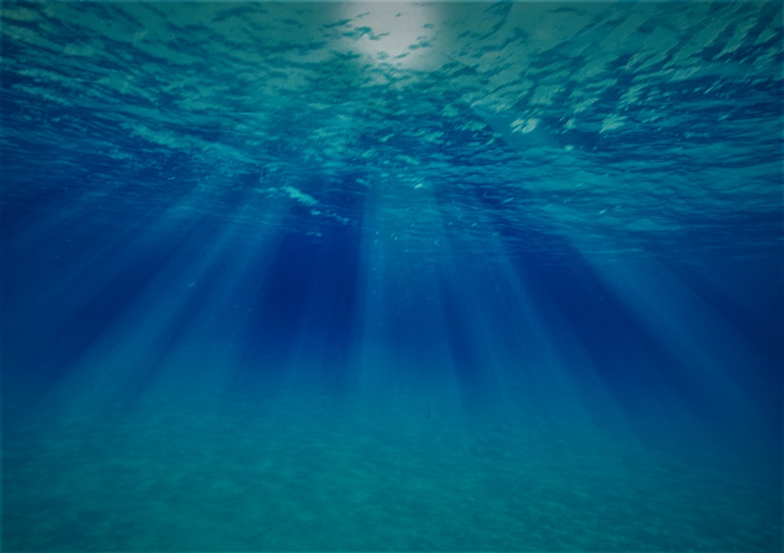

＜signup.jsp＞

private account : ✅

Register

＜back

**Name :**

**Userid :**

**Email :**

**Password :**

**Password(confirm) :**

Kan:Dan

Kan:Dan