Supplementary Material

Machine learning-guided optimization of atomic layer deposition process
Minjong Lee,¹ Doo San Kim,² Thi Thu Huong Chu,² Dushyant M. Narayan,²
Dan N. Le,² Soubhik De,² Soham Shirodkar,² Seungbin Lee,³ Sihoon Son,⁴
Ji Eun Kang,⁵ Hyunbin Choi,⁶ Sun Jae Jeong,⁷ Taesung Kim,^{4,6,8}
Geun Young Yeom,^{5,7} Si Joon Kim,^{3,*} and Jiyoung Kim^{1,2,*}

¹ Department of Electrical and Computer Engineering, The University of Texas at Dallas, Richardson, Texas 75080, USA
² Department of Materials Science and Engineering, The University of Texas at Dallas, Richardson, Texas 75080, USA
³ Department of Electrical and Electronics engineering, Kangwon National University, Chuncheon, Gangwon-Do 24341, Republic of Korea
⁴ SKKU Advanced Institute of Nano Technology (SAINT), Sungkyunkwan University, Suwon, Gyeonggi-do 16419, Republic of Korea
⁵ School of Advanced Materials Science and Engineering, Sungkyunkwan University, Suwon, Gyeonggi-do 16419, Republic of Korea
⁶ Department of Semiconductor Convergence Engineering, Sungkyunkwan University, Suwon, Gyeonggi-do 16419, Republic of Korea
⁷ Department of Display Engineering, Sungkyunkwan University, Suwon, Gyeonggi-do 16419, Republic of Korea
⁸ School of Mechanical Engineering, Sungkyunkwan University, Suwon, Gyeonggi-do 16419, Republic of Korea
* E-mail address: sijoon.kim@kangwon.ac.kr (S.K.), and jiyoung.kim@utdallas.edu (J.K.)

Supplementary Fig. 1
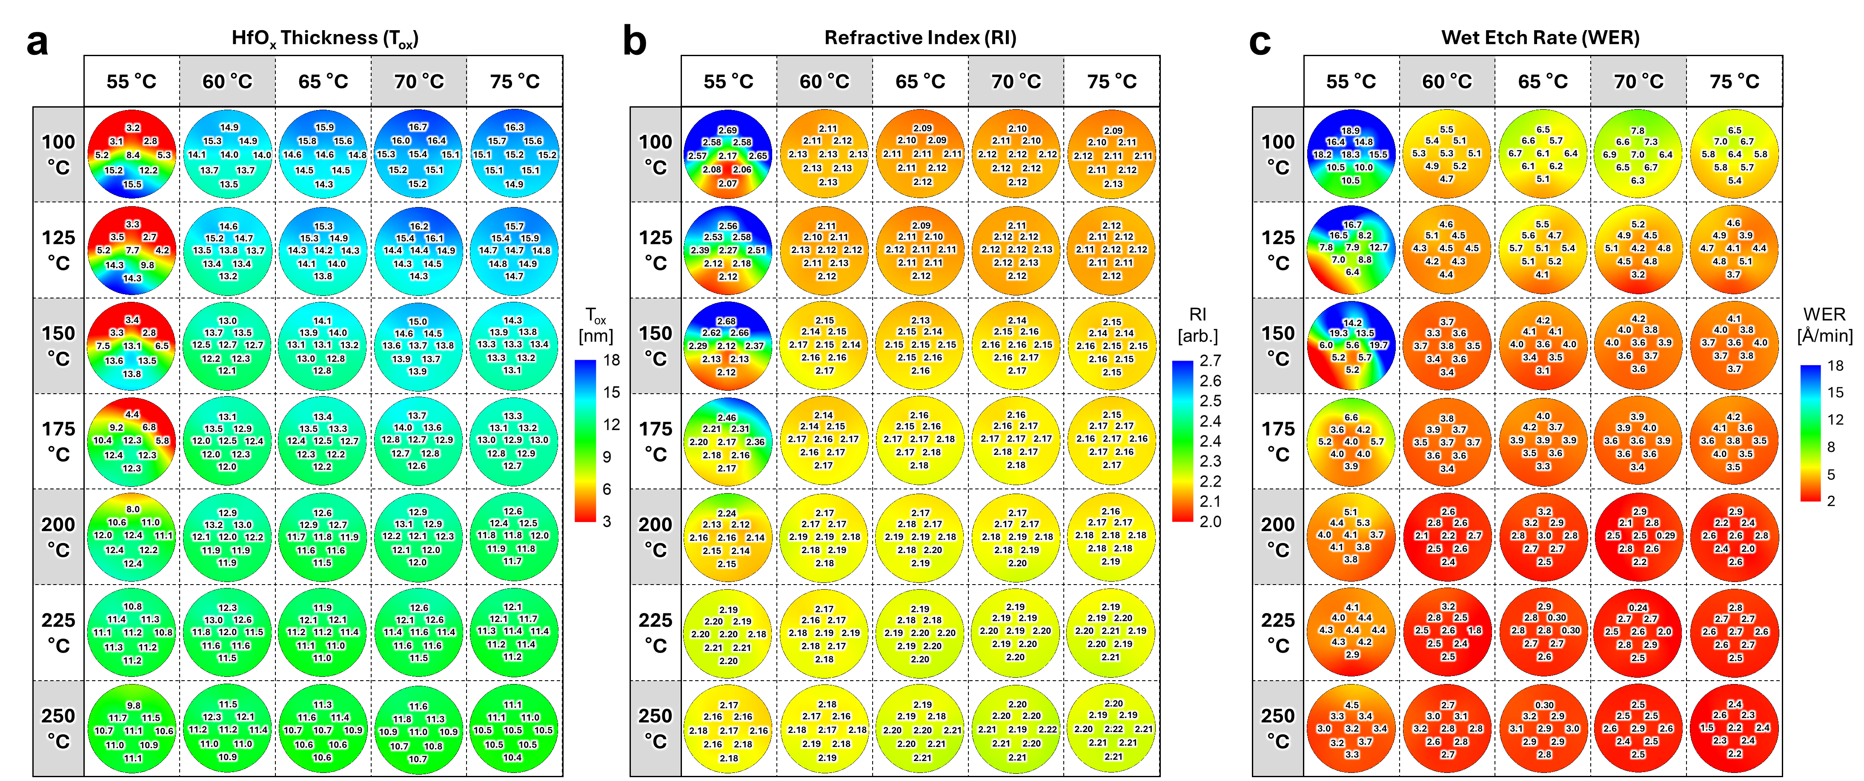
Supplementary Fig. 1 | Raw datasets from experimental data mining
(a) HfO_{x} thickness (T_{ox}), (b) refractive index (RI), and (c) wet etch rate (WER) datasets obtained under varying deposition temperatures, precursor temperatures, and sample locations during ALD processes. Each row in the plot corresponds to a specific deposition temperature, and each column corresponds to a precursor temperature. The intersection of each row and column represents the wafer map for the corresponding film properties.

Supplementary Fig. 2
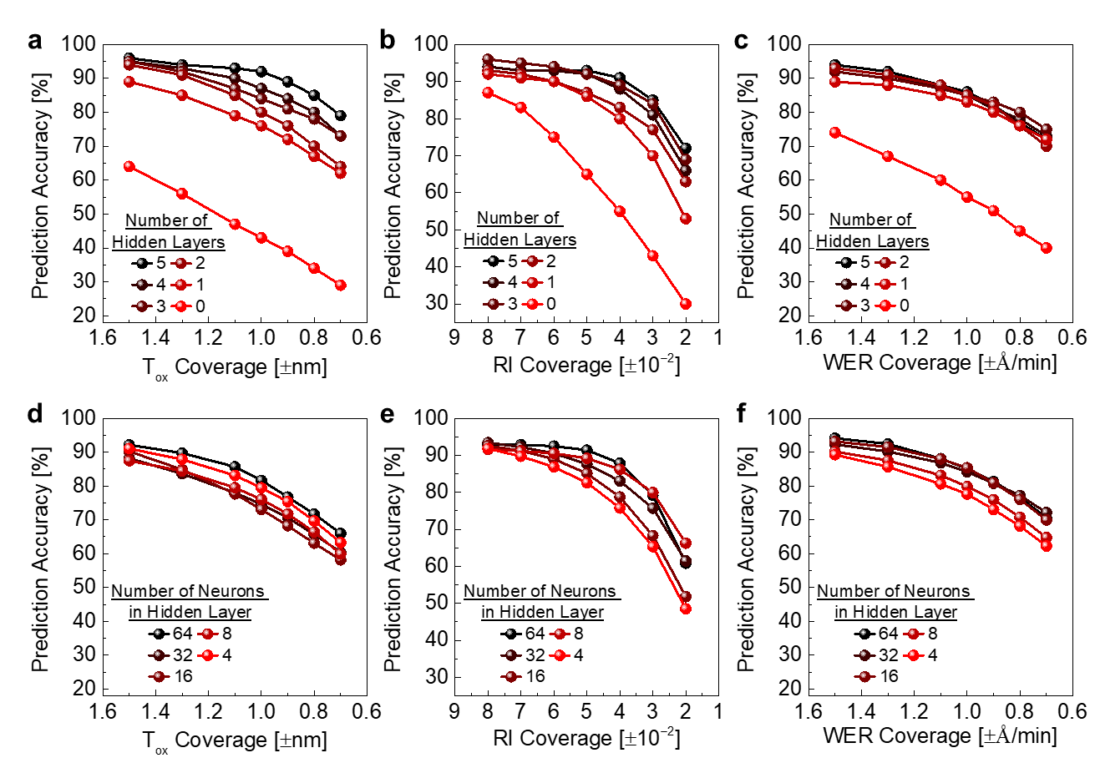
Supplementary Fig. 2 | Influence of hidden layers in DNN systems on ALD process prediction accuracy
The effect of the number of hidden layers on ALD process prediction accuracy for (a) T_{ox}, (b) RI, and (c) WER. Simulations were performed with 24 neurons in all hidden layers. A multi-layer perceptron model improved inference performance compared to a single-layer model, with higher accuracy observed as the number of hidden layers increased. The impact of neuron count in a single hidden layer is shown for (d) T_{ox}, (e) RI, and (f) WER predictions. These simulations used a single hidden layer with varying neuron counts, revealing no significant trend between neuron count and prediction accuracy.
Supplementary Fig. 3
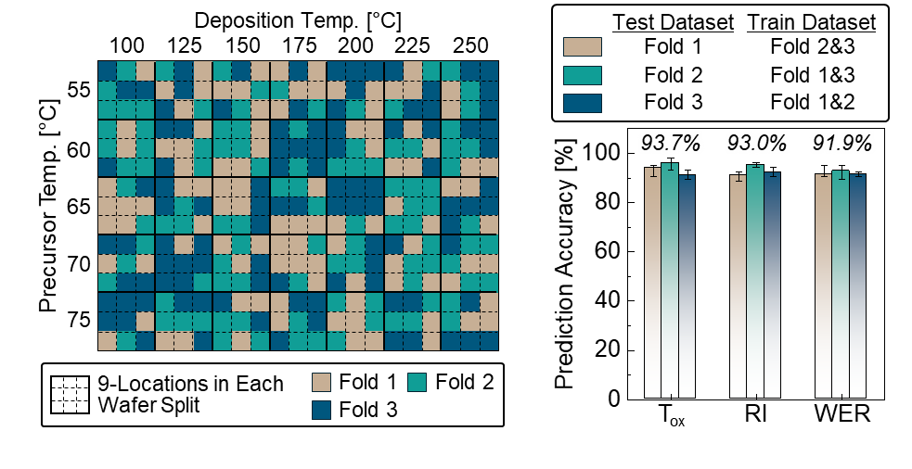
Supplementary Fig. 3 | Three-fold cross-validation of the DNN model.
The left panel shows the fold assignment across the ALD dataset, and the right panel summarizes the corresponding prediction accuracies for each train/test combination. The consistently high test accuracy across the three folds indicates stable model performance under different dataset partitions.

Supplementary Fig. 4
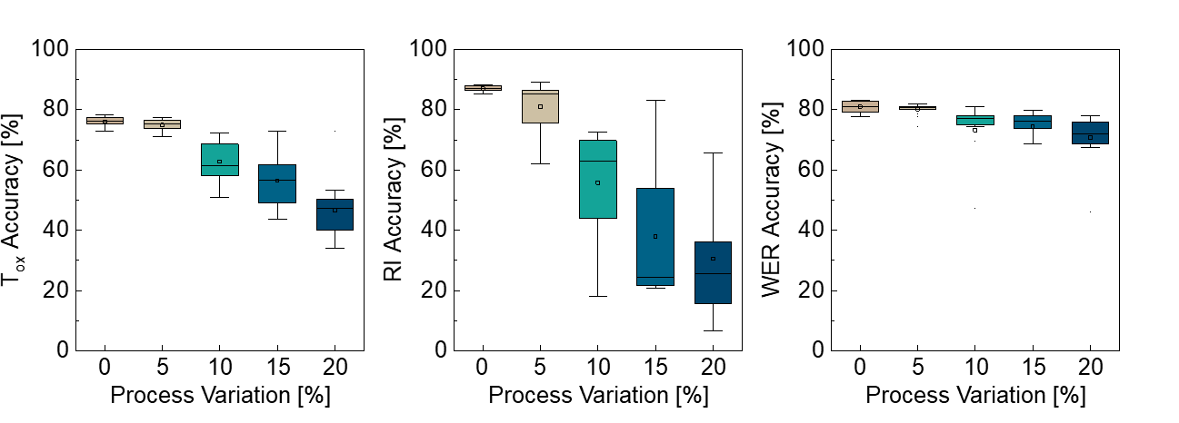
Supplementary Fig. 4 | Prediction accuracy under process variation.
Box plots of the predicted T_{ox}, RI, and WER under different levels of assumed relative Gaussian variation, based on 15 independent training runs. The variation was introduced as multiplicative zero-mean Gaussian noise to emulate practical process fluctuations in the film-property labels. As the level of process variation increases, the spread of the predicted film properties becomes larger, while the prediction accuracy decreases.

Supplementary Fig. 5
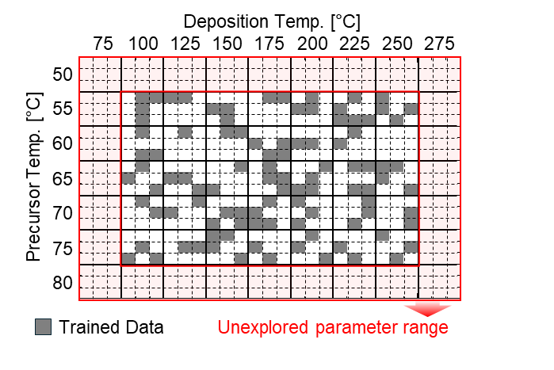
Supplementary Fig. 5 | Visualization of the extrapolation range used in this study.
The gray region indicates the experimentally sampled process window used for model training, while the red region denotes the extended parameter space used only for prediction outside the training domain.

Supplementary Fig. 6
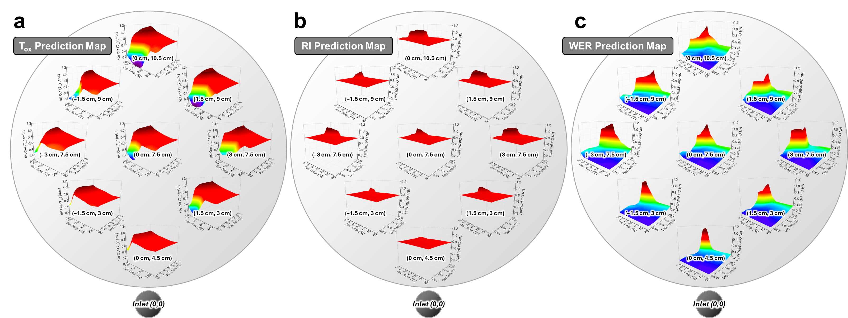
Supplementary Fig. 6 | Comprehensive 3D surface plots of prediction maps for film properties
3D surface plots illustrating prediction maps for (a) T_{ox}, (b) RI, and (c) WER, based on deposition temperature, precursor temperature, and sample location variations. The circled regions indicate analysis points corresponding to sample locations, while the x- and y-axes represent deposition and precursor temperatures, respectively.
Supplementary Fig. 7
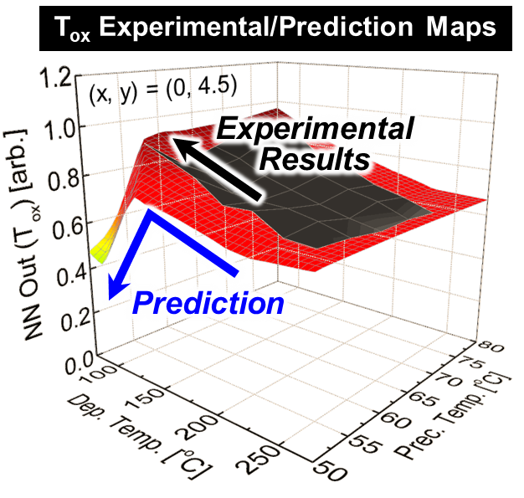
Supplementary Fig. 7 | Comparison between experimental and prediction maps of T_{ox}
Experimental and predicted maps of HfO_{x} T_{ox} for the case of (x, y) = (0, 4.5). Within the experimentally measured range, the data indicate an increasing T_{ox} trend as both deposition and precursor temperatures decrease. In contrast, the prediction map shows a downward trend when the parameters are extended beyond the measured window. This difference suggests that the DNN extrapolates based on global correlations learned from the full dataset, including other process conditions and sample locations, rather than simply extending the local measured trend.

Supplementary Fig. 8
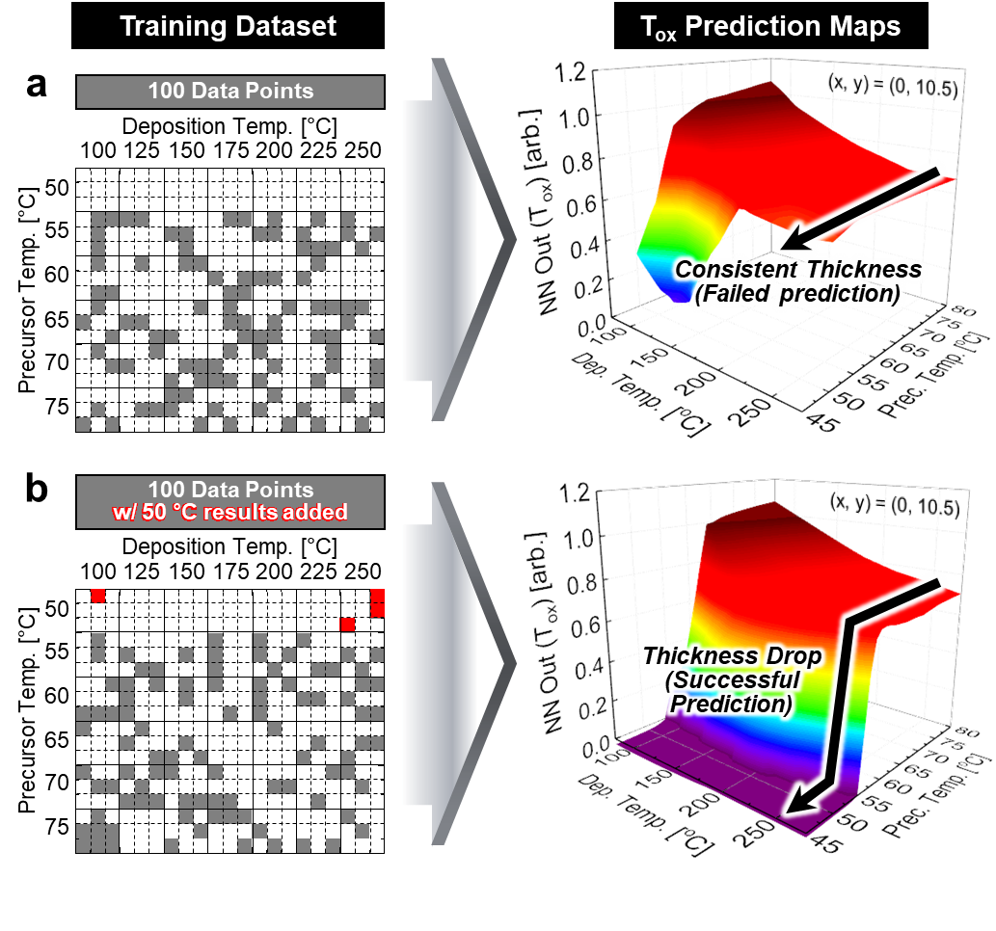
Supplementary Fig. 8 | Effect of including failure data (50 °C precursor temperature) on T_{ox} prediction maps.
(a) Without 50 °C precursor-temperature data in the training set, the model predicts nearly constant thickness in the extended low-temperature region, which does not reflect the physically expected no-growth behavior. (b) When 50 °C data are included in the training set, the prediction map captures a pronounced thickness drop in the same region, consistent with the insufficient vapor pressure of the precursor to sustain HfO_{x} growth. These results indicate that incorporating failure-region data helps the model better distinguish valid and invalid process windows and improves the physical plausibility of predictions near the boundary of the measured domain.

