Call For Mural Design

**LGBTQ+ Resource Center**

**Office of Multicultural Affairs  
  
Deadline:** Friday, January 14, 2022 – 5PM CST

**Project Budget:**The project budget is $2000 for materials. This project is funded by a Student Organization Grant for the Trans Advocacy Group. An award of an OMA Book Scholarship will be granted to the winning student.

**Project Details:**  
Louisiana Tech’s Trans Advocacy Group is seeking designs for a mural to be displayed in Louisiana Tech’s new LGBTQ+ Resource Center located in the Office of Multicultural Affairs in the upstairs TONK. Students of all majors are encouraged to apply, and the winning student will be offered an OMA Book Scholarship!

**Project Description:**  
The Trans Advocacy Group is looking for contestants to design and create a 12’ x 6’ mural, including an optional decorative border on a wall in the LGBTQ+ Resource Center. The contestant is not required to have mural experience or to paint the mural themselves. Should the contestant choose to paint the mural themselves, assistance will be offered.  
  
The mural will bring a welcoming feeling to the center by demonstrating equality, diversity, inclusivity, and most of all, the feeling of a safe space. A decorative frame is preferrable, but not required and must fit inside the 12’ x 6’ dimensions of the mural. If the mural depicts figures, it must be in an inclusive representation. Designs can include text, but the message of the mural should come through the imagery more than through words. The committee of jurors reserves the right to made recommendations and/or adjustments to the winning entry.

**Design Selection Process:**

* Contestant will submit design proposal and a description of the design through the Google Form by Friday, January 14, 2022.
* Your entry should include a finished design for the mural contest, digital or by hand, and a brief description of your design.
* The Contest Committee will select a contestant and announce the winning contestant on Friday, January 21, 2022
* Winning contestant receives an OMA Book Scholarship, learn more about it here: <https://tinyurl.com/OMAScholarship>

**Timeline:**  
Submission Deadline - Friday, January 14, 2022 @ 5PM CST  
Selected Design Announcement - Friday, January 21, 2022 @ 12PM CST

**How to Apply:**  
Create a google drive including your proposal and design and submit through the following Google Form. You will need to use your Tech email to submit: <https://tinyurl.com/LATechMuralForm>

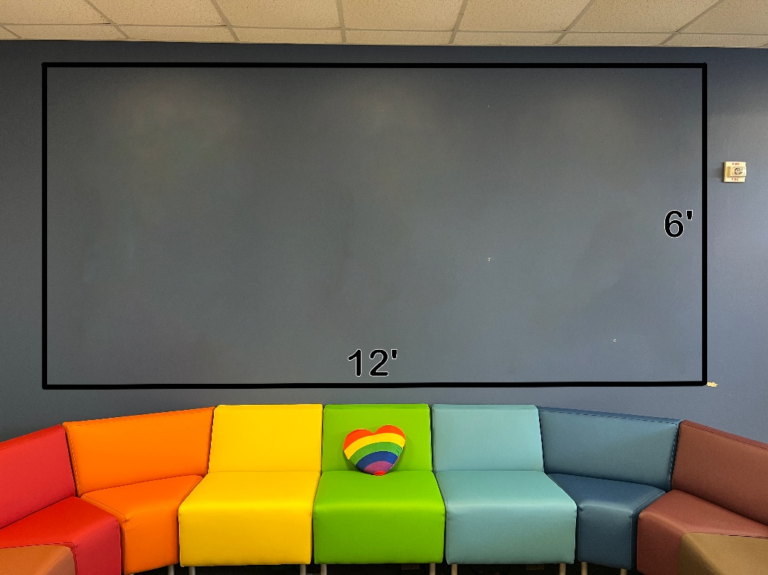**Canvas Pictures:**

**Front View**

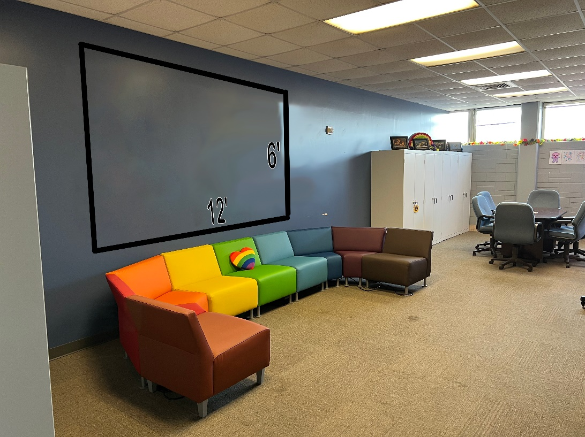

**Side View**