**JOBCONNECT**

USE CASE DOCUMENT

PRESENTED BY

MEMBER 1: NAILA HABIB(LEADER)

MEMBER 2: TAHA FAYYAZ

MEMBER 3: WAJEEHA KAMRAN

SUPERVISED BY

Dr. Onaiza Maqbool

Department of Computer Science

Quaid e Azam University, Islamabad

**USE CASE DOCUMENT APPROVEL SIGNATURES**

**PROJECT MANAGER**

Signature

Date

**WAJEEHA KAMRAN**

Student, QAU Islamabad

**MEMBER 1**

Signature

Date

**TAHA FAYYAZ**

Student, QAU Islamabad

**MEMBER 2**

Signature

Date

**NAILA HABIB**

Student, QAU Islamabad

**STAKEHOLDER**

Date

Signature

**DR. ONAIZA MAQBOOL**

Professor, QAU Islamabad

**Use Case Diagram:**

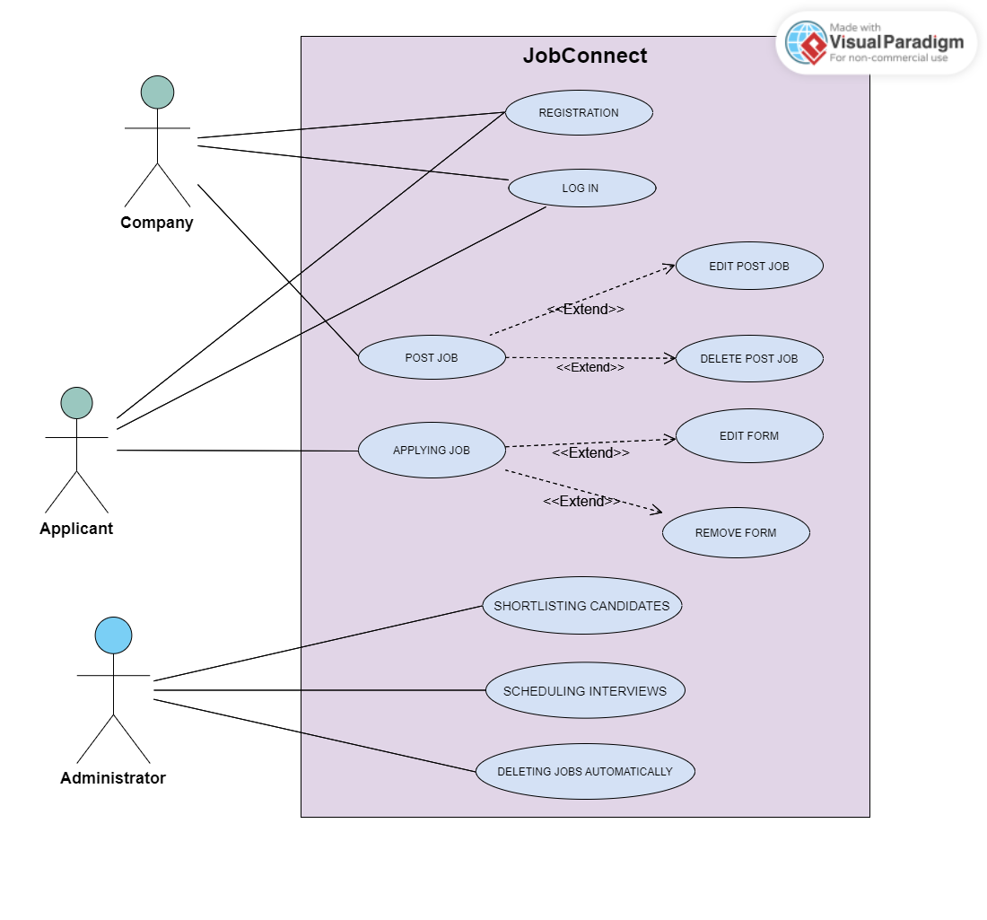

USE CASE BY NAILA HABIB

**UC 3: Shortlisting Candidates**

***Primary Actor:***

Company

***Stakeholders and Interests:***

- Company:

* Wants to easily get the list of the candidates shortlisted by the system according to the requirements provided by the company and proceed to the scheduling interview process .

- Applicant:

* Wants to be considered for the job position and to get timely feedback on the shortlisting process.

***Preconditions***:

* **Company** is registered and logged in.
* **Company** has already posted the job, and its deadline has already been reached and feedback is provided to it about this .

***Success Guarantee (postconditions)***:

* The System successfully shortlist the candidates and provides necessary feedback to both the company and the applicant .

***Main Success Scenario (or Basic Flow):***

1. Company clicks on the **shortlisting button**.
2. The System **retrieves all the applications** and cross match them with the requirements provided by the company.
3. The System shortlists the candidates **according to the criteria of shortlisting provided by the company** like skills , experience , education.
4. The System **navigates to the screen** containing the list of shortlisted candidates .
5. The Shortlisted and non-shortlisted candidates are **provided with feedback .**
6. The Company then presses the **schedule interview button**.

***Alternate Scenario (or Extensions):***

*a. At any time, **the Database fails**:

To ensure **recovery of the data**, the software saves the **existing data** of the company’s job applications in the form of backups on Microsoft azure .

1a. The System does **not open the screen** to shortlist the candidates:

1. The software displays a **message as feedback** that the screen

could not open at that time and asks the **company to try again**.

3a. No candidate matches the criteria provided by the company.

1. Feedback is provided to the company to wither change or reduce the criteria since no candidate matches their existing criteria .

4a . The screen does not show the list of shortlisted candidates.

1. The software displays a message as feedback that the screen

could not open at that time and asks the **company to try again**.

6a . The system does not navigate to new screen on pressing the schedule interview button.

1. The software displays a message as feedback that the screen

could not open at that time and asks the **company to try again**.

***Special Requirements***:

- The App should be developed in **Java**.

- **Feedback** section must be available for improving purpose.

- The **list of shortlisted candidates** should be easily visible to the users of the platform by using **font size** that is easily readable like **12 font size**.

***Frequency of Occurrence***:

It could be nearly continuous.

***Open Issues***:

Open for feedback to improve **use case text**.

------------------------------------------------------------------------------------------------------------------