**JOB CONNECT**

USE CASE DOCUMENT

PRESENTED BY

MEMBER 1: NAILA HABIB(LEADER)

MEMBER 2: TAHA FAYYAZ

MEMBER 3: WAJEEHA KAMRAN

SUPERVISED BY

Dr. Onaiza Maqbool

Department of Computer Science

Quaid e Azam University, Islamabad

**USE CASE DOCUMENT APPROVEL SIGNATURES**

**PROJECT MANAGER**

Signature

Date

**WAJEEHA KAMRAN**

Student, QAU Islamabad

**MEMBER 1**

Signature

Date

**TAHA FAYYAZ**

Student, QAU Islamabad

**MEMBER 2**

Signature

Date

**NAILA HABIB**

Student, QAU Islamabad

**STAKEHOLDER**

Date

Signature

**DR. ONAIZA MAQBOOL**

Professor, QAU Islamabad

**Use Case Diagram:**

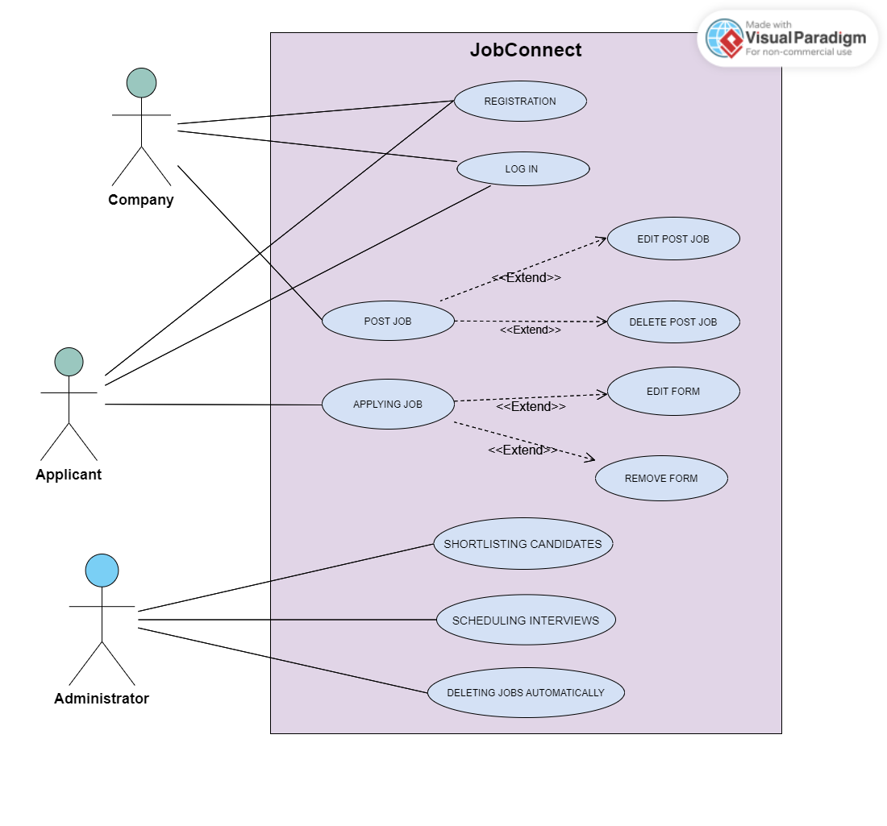

USE CASE BY: TAHA FAYYAZ

**UC 2: Applying Job**

***Primary Actor:***

Applicant.

***Stakeholders and Interests:***

- Company:

* Wants to easily check the records of the applicants those who have applied for their jobs.

- Applicant:

* Wants to have easy access to the jobs using key words or when their interests are mentioned, and applicants can easily apply for their relevant jobs.

***Preconditions***:

* Applicants are registered and logged in.

***Success Guarantee (postconditions)***:

* The Applicant applied successfully for the Job.
* The System provides the necessary feedback to the Applicant when the Applicant submits the form for applying for a job.

***Main Success Scenario (or Basic Flow):***

1. The Applicant sees the relevant **job poster on the post screen**.
2. The Applicant clicks on the link **Apply here** for applying for that job.
3. The System navigates on the google form screen for applying for a job.
4. The Applicant fills in the **required** **Personal Information like email, name, gender, contact number, country and city**.
5. The Applicant fills in the **required Academic Information like College Name, College Grade, Highest Academic Qualification, Grade of Highest Academic Qualification, Current Year of Course, Domain for Job Applying**.
6. The Applicants fills in the required **Documents in Pdf format like College Degree, University Degree, Certificates related to field of Interest, Experience Certificate** (if the Applicant has worked before).
7. The Applicant uploads the **CV in Pdf format**.
8. The Applicant clicks on the **Submit Button**.
9. The System provides **feedback** indicating that the **form for applying for a job** has been submitted successfully.

***Alternate Scenario (or Extensions):***

*a. At any time, **the System fails**:

To ensure the **recovery of the data of form for applying job**, the software saves the **existing data** of the Applicant’s form data and then when the Applicant reopens the form, app will resume its working where Applicant had left so that they can recover from any step.

1 a. The Post Screen does **not display Jobs to the Applicant** because of **lack of Internet or app is down**:

1. **Refresh the Screen by scrolling up**, that will trigger the spinner to refresh the screen and **allow the Applicant** to view the **posts again**.
2. a. The System does **not open the link** to apply for the job:
3. The software displays a **message as feedback** that the screen could not open at that time and ask the **Applicant to try again**.
4. a. The System does **not open the google form** to apply for the job:
5. The Software displays a **message as feedback** that the google form could not open at that time and ask the **Applicant to reopen the google form** to view the **form again**.

3 b. The **Image** file extension is other than **pdf, jpg, png**:

1. **Feedback** is provided specifying that this type of image contains the file extension that is not supported by the System and asks them to **resubmit the image file to the required extension of image, which is pdf, jpg, png**.

3 c. The Company **selects the deadline** for previous dates:

1. **Feedback** is provided specifying that the Company cannot select **past dates,** and Company must choose future dates.

4 a. **The link** for the form is **not opening**:

4 b. **The link** is opening but the form is **not opening**:

5. a. Company leaves any **text field empty** and presses the **post**

**button**:

1. **Feedback** is provided to the Company to not leave the fields

empty and fill out **all fields for successfully submitting the Post**.

***Special Requirements***:

- The website should be developed in Java .

- Feedback section must be available for improving purpose.

- The text of the job description should be easily visible to the users of the platform .

***Frequency of Occurrence***:

Could be nearly continuous.

***Open Issues***:

Open for feedback to improve use case texts.