**JOBCONNECT**

USE CASE DOCUMENT

PRESENTED BY

MEMBER 1: NAILA HABIB(LEADER)

MEMBER 2: TAHA FAYYAZ

MEMBER 3: WAJEEHA KAMRAN

SUPERVISED BY

Dr. Onaiza Maqbool

Department of Computer Science

Quaid e Azam University, Islamabad

**USE CASE DOCUMENT APPROVEL SIGNATURES**

**PROJECT MANAGER**

Signature

Date

**WAJEEHA KAMRAN**

Student, QAU Islamabad

**MEMBER 1**

Signature

Date

**TAHA FAYYAZ**

Student, QAU Islamabad

**MEMBER 2**

Signature

Date

**NAILA HABIB**

Student, QAU Islamabad

**STAKEHOLDER**

Date

Signature

**DR. ONAIZA MAQBOOL**

Professor, QAU Islamabad

**Use Case Diagram:**

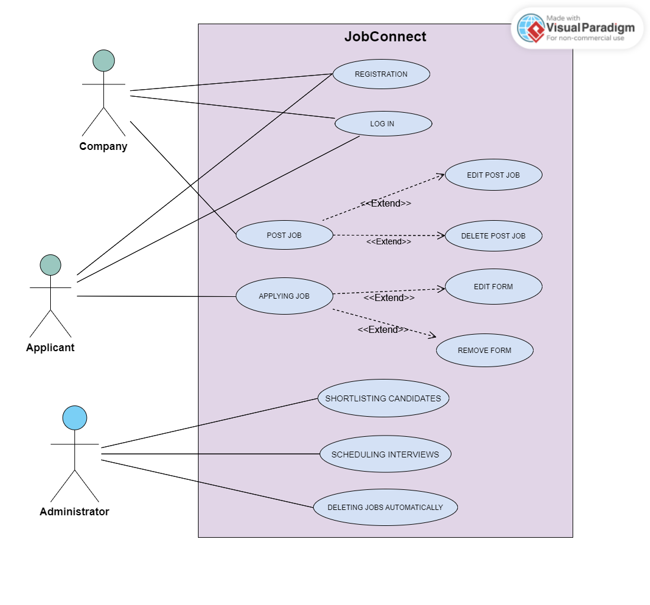

USE CASE BY WAJEEHA KAMRAN

**UC 1: Posting Job**

***Primary Actor:***

Company

***Stakeholders and Interests:***

- Company:

* Wants to easily upload the job post and it reaches the required audience like the Applicant who is applying for the related job.

- Applicant:

* Wants to have easy access to the jobs using key words or when their interests are mentioned on the related post jobs.

***Preconditions***:

* **Company** is registered and logged in.

***Success Guarantee (postconditions)***:

* The **Company** easily uploads the job posts.
* The System provides the necessary feedback to the company after post is uploaded.

***Main Success Scenario (or Basic Flow):***

1. Company clicks on the **post job button**.
2. The System opens the screen where the company must upload all the job description information.
3. The Company enters the required **job title, description, images, requirements and the deadline** for the job application.
4. The Company also adds the l**ink for the form** where the applicant must fill in his information to apply for the respective jobs.
5. The Company presses the **post button**.
6. The System provides **feedback** on the job being posted on the platform to the Company.

***Alternate Scenario (or Extensions):***

*a. At any time, **the System fails**:

To ensure **recovery of the Job Post data**, the software saves the **existing data** of the company’s post job and then when Company reopen the app, App will resume its working where Company had left so that they can recover from any step.

2 a. The System does **not open the screen** to upload the job:

1. The software displays a **message as feedback** that the screen could not open at that time and ask the **company to try again**.

3 a. The Company writes **long or short titles of Job Post**:

1. **Feedback** is provided specifying the length of a standard title, **for long title**, **length is 32 characters, for short title, length is 10 characters**.

3 b. The **Image** file extension is other than **pdf, jpg, png**:

1. **Feedback** is provided specifying that this type of image contains the file extension that is not supported by the System and asks them to **resubmit the image file to the required extension of image, which is pdf, jpg, png**.

3 c. The Company **selects the deadline** for previous dates:

1. **Feedback** is provided specifying that the Company cannot select **past dates,** and Company must choose future dates.

5. a. Company leaves any **text field empty** and presses the **post button**:

1. **Feedback** is provided to the Company to not leave the fields

empty and fill out **all fields for successfully submitting the Post**.

6.a. After Posting the job appropriate **feedback** is not provided:

***Special Requirements***:

- The App should be developed in **Java**.

- **Feedback** section must be available for improving purpose.

- The **job description** should be easily visible to the users of the platform by using **font size** that is easily readable like **12 font size**.

***Frequency of Occurrence***:

It could be nearly continuous.

***Open Issues***:

Open for feedback to improve **use case text**.

------------------------------------------------------------------------------------------------------------------