FitConnect Gym Management System
1. ACTORS 👥
🔹 Member (Adhérent)
- Registers in a gym branch.
- Holds a subscription.
- Performs gym sessions.
- Consults personal activity history.
🔹 Reception Employee
- Registers new members.
- Creates subscriptions.
- Records gym sessions.
- Updates member information.
🔹 Coach
- Consults members' activities.
- Tracks workout sessions.
- Monitors member participation.
🔹 Administrator
- Manages gym branches.
- Supervises system operations.
- Maintains database integrity.
- Controls access to the application.
2. BUSINESS RULES 📋
- Each member is identified by a unique ID.
- Each member belongs to one gym branch.
- A member can only have one active subscription at a time.
- Each subscription has a start date and an end date.
- A subscription type can be Monthly, Quarterly, or Annual.
- A session can only be recorded if the member's subscription is valid.
- Each session belongs to one member.
- Each session takes place in one gym branch.
- A session includes an activity type and duration.
- Equipment used during a session is optional.
- A member cannot be deleted if an active subscription exists.
- A member cannot be deleted if sessions are linked to the member.
- Referential integrity must always be respected.
3. USER STORIES 🧾
Member
- As a member, I want to have an active subscription so that I can access gym services.
- As a member, I want my sessions to be recorded so that my activities can be tracked.
Reception Employee
- As a reception employee, I want to register new members so that they can access gym services.
- As a reception employee, I want to create subscriptions so that members can use the gym.
- As a reception employee, I want to record workout sessions so that member activities are tracked.
Coach
- As a coach, I want to consult members' sessions so that I can monitor their progress.
- As a coach, I want to access activity history so that I can provide better coaching.
Administrator
- As an administrator, I want to manage gym branches so that the network remains organized.
- As an administrator, I want to maintain database information so that data remains consistent.
4. DATA DICTIONARY 📦
MEMBER
member_id, first_name, last_name, email, phone_number, registration_date, gym_id
SUBSCRIPTION
subscription_id, subscription_type, start_date, end_date, member_id
SESSION
session_id, session_date, activity_type, duration, equipment_used, member_id, gym_id
GYM
gym_id, gym_name, address, city
5. FUNCTIONAL DEPENDENCY GRAPH (GDF) 🔗
member_id → first_name, last_name, email, phone_number, registration_date, gym_id
subscription_id → subscription_type, start_date, end_date, member_id
session_id → session_date, activity_type, duration, equipment_used, member_id, gym_id
gym_id → gym_name, address, city
6. CONCEPTUAL DATA MODEL (MCD)
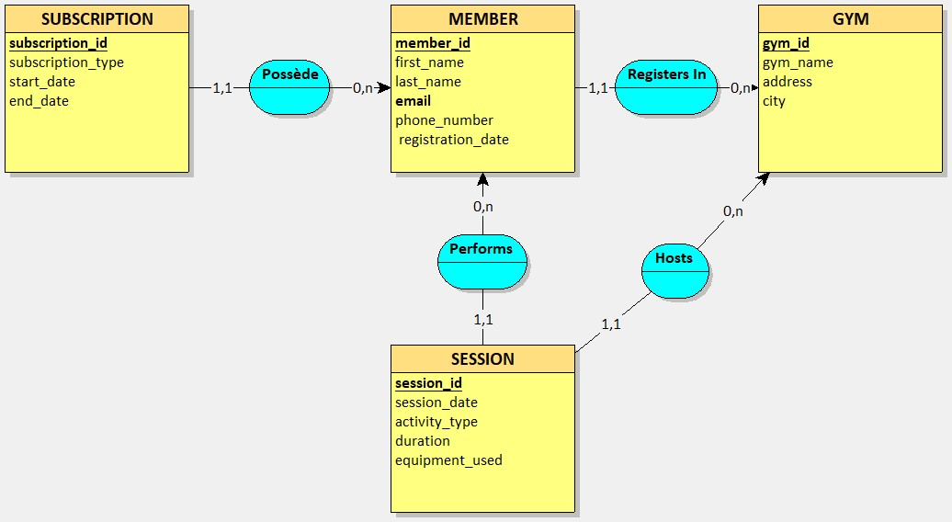
7. LOGICAL DATA MODEL (MLD)
