PSX-PREDICTOR
A Machine Learning Framework for Stock Price Forecasting on the Pakistan Stock Exchange
Case Study: MCB Bank Limited (MCB) — PSX Listed Equity
Technical Research Report
Taha Shah
May 2026
Evaluation Period: March 2025 – May 2026
Models Evaluated: Random Forest | Gradient Boosting | Linear Regression | Prophet
Stock: MCB Bank Limited (Ticker: MCB) | Exchange: Pakistan Stock Exchange (PSX)

Abstract
This report presents PSX-Predictor, a machine learning stock price forecasting system developed by Taha Shah, applied to the daily closing price series of MCB Bank Limited (Ticker: MCB) — a leading commercial bank listed on the Pakistan Stock Exchange (PSX). Four distinct modelling paradigms are benchmarked over a 15-month evaluation window spanning March 2025 through May 2026: Random Forest, Gradient Boosting, Linear Regression, and Facebook Prophet. Models are assessed under both a temporally ordered hold-out split (80/20) and a rigorous five-fold walk-forward cross-validation scheme.
The evaluation employs five complementary metrics: Mean Absolute Error (MAE), Root Mean Squared Error (RMSE), coefficient of determination (R²), Mean Absolute Percentage Error (MAPE), and Directional Accuracy (DirAcc%). Linear Regression emerges as the dominant model across every quantitative dimension, achieving an R² of 0.9975, a MAPE of 0.46%, and a directional accuracy of 86.6% on the hold-out set — results corroborated by walk-forward cross-validation (MAPE 0.38%, DirAcc 88.0%). Tree-based ensemble methods (Random Forest and Gradient Boosting) exhibit high directional accuracy but suffer from severe systematic under-prediction, a consequence of mean-reversion bias inherent to tree ensembles applied to non-stationary trending equity series. Prophet captures the broad trend trajectory but provides insufficient precision and near-random directional signal. Feature importance analysis consistently identifies the one-day lag price (lag_1) as the dominant predictor across all tree-based models, confirming the near-random-walk dynamics of the MCB stock price series. These findings establish Linear Regression as the recommended production model for near-term MCB stock price forecasting within PSX-Predictor.

1. Introduction
Stock price forecasting is a central challenge in computational finance, lying at the intersection of time-series analysis, financial econometrics, and machine learning. Equity markets in emerging economies present additional complexity relative to developed markets: thinner liquidity, episodic macro shocks, currency volatility, and regulatory discontinuities all contribute to heightened non-stationarity in price dynamics.
MCB Bank Limited (MCB) is one of Pakistan's largest private commercial banks by assets, with a long listing history on the Pakistan Stock Exchange (PSX). Its stock is a constituent of the KSE-100 Index — the primary benchmark of the Pakistani equity market — and represents a widely held, institutionally significant security. The MCB price series over the March 2025 to May 2026 evaluation period spans a price range of approximately PKR 275 to PKR 445 per share, capturing a sustained bull-market phase followed by a partial mean-reversion, providing a challenging and regime-diverse test bed for forecasting models.
PSX-Predictor is a Python-based analytical toolkit designed to systematically evaluate multiple forecasting algorithms on daily PSX-listed equity closing prices. The system ingests raw OHLCV (Open, High, Low, Close, Volume) data, engineers a comprehensive set of technical and statistical features, trains each model in a temporally honest fashion, and produces standardised evaluation artefacts — including walk-forward cross-validation curves, residual diagnostics, feature importance charts, and prediction overlay visualisations.
The primary objectives of this report are threefold:
(1) To provide a rigorous quantitative comparison of four machine learning paradigms applied to MCB Bank stock price forecasting on the PSX.
(2) To identify the principal drivers of predictive performance through feature importance analysis of the two tree-based ensemble models.
(3) To diagnose model failure modes via residual analysis and walk-forward cross-validation stability assessment across five sequential market regimes.
The remainder of this report is structured as follows: Section 2 describes the dataset and feature engineering pipeline; Section 3 presents the modelling methodology and evaluation framework; Section 4 reports empirical results with full performance tables and the actual vs. predicted overlay chart; Section 5 analyses feature importances for Random Forest and Gradient Boosting; Section 6 performs residual diagnostics; Section 7 examines walk-forward cross-validation stability across all folds; and Section 8 concludes with practical recommendations and directions for future work.

2. Data and Feature Engineering

2.1 Dataset
The dataset comprises daily closing prices for MCB Bank Limited (PSX ticker: MCB) over the period March 2025 to May 2026, representing 1,539 total trading sessions. Under the primary 80/20 temporal hold-out split, 1,231 observations constitute the training set and 308 observations the test set. The closing price series moves from approximately PKR 275–290 per share in early 2025, appreciates steadily to a peak of approximately PKR 445 per share in early 2026, and subsequently partially retraces to around PKR 395–415 per share by late May 2026. This trajectory — encompassing a sustained uptrend, a climactic peak, and a partial correction — provides a demanding and regime-diverse evaluation environment.
Data quality procedures include forward-filling of any missing trading days (public holidays and exchange closures) and removal of any sessions with zero volume. All features are constructed solely from historical information available at the time of each prediction, with no look-ahead leakage.

2.2 Feature Engineering
PSX-Predictor constructs an extensive set of technical and statistical features from the raw daily price and volume data. These features fall into four broad categories, detailed below.

2.2.1 Autoregressive Lag Features
Lagged closing prices at horizons of one, two, and three days (lag_1, lag_2, lag_3) capture the short-term autocorrelation structure of the MCB price series. The one-day lag (lag_1) — yesterday's closing price — proved to be overwhelmingly the most predictive feature across both tree-based models, reflecting the high day-to-day price persistence characteristic of a large-cap, relatively liquid PSX stock. Lag features encode the near-random-walk property of the price series and are the primary mechanism by which Linear Regression effectively approximates a first-order autoregressive (AR(1)) model.

2.2.2 Rolling Window Statistics
Simple moving averages at four window lengths (sma_5, sma_10, sma_20, sma_50) capture trend at different time scales, from weekly to approximately quarterly. Rolling minima (min_5, min_10, min_50) and maxima (max_5, max_10, max_20, max_50) encode recent support and resistance levels, respectively. A 50-day rolling standard deviation (std_50) provides a measure of medium-term price volatility. These features collectively represent the market's recent price range and momentum structure across multiple horizons.

2.2.3 Return Features
One-day, five-day, and twenty-day percentage returns (ret_1d, ret_5d, ret_20d) capture short-term, weekly, and monthly momentum signals. These normalised return features are scale-independent and help the model distinguish between momentum regimes (sustained trending) and mean-reversion regimes (oscillating or choppy markets), which are both present at different points in the MCB evaluation period.

2.2.4 Technical Indicators
Four standard technical analysis indicators are incorporated as additional features. The Relative Strength Index (RSI) provides a bounded (0–100) oscillator measuring the speed and magnitude of recent price changes, commonly used to identify overbought (RSI > 70) or oversold (RSI < 30) conditions. The Bollinger Band percentile position (bb_pct) measures where the current price lies within its 20-day Bollinger Band envelope, normalised to [0, 1]. The Moving Average Convergence/Divergence signal line (macd_signal) captures medium-term trend momentum through the relationship between exponential moving averages at different spans. Finally, the Stochastic Oscillator %K (stoch_k) identifies the closing price's position within the recent high-low range. While these indicators are widely used in quantitative equity analysis, feature importance results (Section 5) demonstrate that their incremental predictive contribution is negligible once price-level lag features are included.

3. Methodology

3.1 Model Descriptions

3.1.1 Random Forest
Random Forest is a bagging ensemble of decision trees, each trained on a bootstrapped subsample of the training data with a randomly selected subset of features considered at each split node. This combination of row-wise and column-wise randomisation reduces variance and provides robustness to overfitting, along with a natural mechanism for feature importance estimation via mean impurity decrease. A critical structural limitation, however, is that Random Forest predictions are bounded by the range of target values seen during training: the model cannot extrapolate beyond its training maximum. In the context of MCB stock forecasting, this means that once the stock price breaks above the highest training-period closing price, Random Forest will systematically underpredict, reverting toward the historical mean — a fundamental architectural constraint rather than a tunable hyperparameter failure.

3.1.2 Gradient Boosting
Gradient Boosting constructs an additive ensemble by sequentially fitting shallow decision trees to the negative gradient (pseudo-residuals) of the loss function with respect to the current ensemble's predictions. This boosting approach typically achieves lower bias than Random Forest at the cost of greater sensitivity to hyperparameters and higher risk of overfitting if not carefully regularised. Like Random Forest, Gradient Boosting shares the architectural mean-reversion constraint: tree-based split boundaries learned on the training distribution cannot extrapolate to previously unseen price levels. The model's Gradient Boosting implementation here uses the standard scikit-learn GradientBoostingRegressor with default hyperparameter settings.

3.1.3 Linear Regression
Ordinary Least Squares (OLS) Linear Regression estimates a linear mapping from the feature vector to the target closing price. Its ability to extrapolate linearly beyond the training range is the key differentiator from tree-based methods in a trending equity context. Given that lag_1 (previous day's closing price) is the dominant feature, Linear Regression effectively learns a near-unit coefficient on lag_1 with small adjustments from the technical covariates — approximating a first-order autoregressive (AR(1)) model with additional regressors. This structure naturally propagates the upward trend in MCB's price, tracking new highs as they occur rather than reverting to the historical mean.

3.1.4 Prophet
Facebook Prophet is a decomposable time-series forecasting model that explicitly separates a piecewise linear or logistic trend component, Fourier-series seasonal components, and user-specified holiday effects. It operates directly on the date-stamped price series without manual feature engineering, making it a useful baseline representing traditional time-series decomposition approaches. Prophet's automatic trend change-point detection allows it to adapt to structural breaks in the price level, though its inherently smooth trend component may lag behind rapid, sustained equity price moves of the kind observed in the MCB evaluation period.

3.2 Evaluation Framework

3.2.1 Temporal Hold-out Split
A temporally ordered hold-out split reserves the most recent 20% of observations (308 trading sessions) for testing, using the preceding 80% (1,231 sessions) for training. This design strictly avoids look-ahead bias by ensuring that no future information is available to the model at any training step. The hold-out period (approximately October 2025 to May 2026) captures the MCB price peak and subsequent partial correction — the most challenging portion of the evaluation window for all models.

3.2.2 Walk-Forward Cross-Validation
Walk-forward cross-validation (WF-CV) extends the single hold-out evaluation by partitioning the full dataset into five sequential folds and iteratively training on an expanding window before testing on each subsequent fold. This scheme provides a more stable, unbiased, and regime-diverse estimate of generalisation performance by evaluating each model across multiple distinct market environments — including the early stable phase, the appreciation phase, the peak, and the correction. WF-CV is the gold standard for temporal model evaluation in financial applications because it mirrors the actual deployment scenario: models are always predicting genuinely unseen future data.

3.3 Evaluation Metrics
Five metrics are reported for each model and evaluation scheme:
Mean Absolute Error (MAE): Average absolute deviation between predicted and actual closing prices, expressed in PKR per share. Directly interpretable in monetary terms relevant to a PSX investor.
Root Mean Squared Error (RMSE): Square root of the mean squared error. Penalises large prediction deviations more heavily than MAE, making it sensitive to outlier errors during high-volatility market episodes.
Coefficient of Determination (R²): Proportion of variance in the closing price explained by the model's predictions. A value of 1.0 indicates perfect fit; values below zero indicate performance worse than a naive constant-mean predictor — a damning result for the tree-based models.
Mean Absolute Percentage Error (MAPE%): Scale-independent percentage error, facilitating comparison across different price levels and time periods. Critical for assessing the practical significance of errors relative to the prevailing MCB share price.
Directional Accuracy (DirAcc%): Fraction of trading sessions where the model correctly predicts the direction of the next-day price change (up or down). This metric is directly actionable for trading strategy applications: a DirAcc above 50% indicates better-than-chance directional signal.

4. Empirical Results

4.1 Hold-out Performance Summary
Table 1 presents the complete performance metrics for all four models evaluated on the 308-session hold-out test set, ranked by MAPE in ascending order.

Model | MAE (PKR) | RMSE (PKR) | R² | MAPE% | DirAcc%
Linear Regression | 1.64 | 2.39 | 0.9975 | 0.46% | 86.64%
Prophet | 19.46 | 23.08 | 0.7697 | 5.69% | 50.17%
Random Forest | 69.14 | 82.88 | −2.0297 | 18.19% | 84.69%
Gradient Boosting | 69.42 | 83.35 | −2.0645 | 18.25% | 85.99%
Table 1. Hold-out (80/20) performance metrics for all four models on MCB Bank stock price forecasting. Ranked by MAPE (ascending). Training set: 1,231 sessions; Test set: 308 sessions.

4.2 Walk-Forward Cross-Validation Summary
Table 2 reports mean performance across five walk-forward folds, providing a regime-robust evaluation. Prophet is excluded from WF-CV due to its native time-series interface constraints.

Model | MAE (PKR) | RMSE (PKR) | R² | MAPE% | DirAcc%
Linear Regression | 1.15 | 1.59 | 0.9860 | 0.38% | 88.03%
Random Forest | 25.82 | 29.88 | −1.9599 | 8.13% | 82.30%
Gradient Boosting | 26.18 | 30.20 | −2.2673 | 8.24% | 81.15%
Table 2. Walk-forward cross-validation (5-fold) mean performance metrics for MCB Bank stock price forecasting.

4.3 Actual vs. Predicted Visualisation
Figure 1 overlays actual and predicted MCB Bank daily closing prices for all four models across the full evaluation window from March 2025 to May 2026. The stark divergence between tree-based models and actual prices from mid-2025 onward is the dominant visual feature.

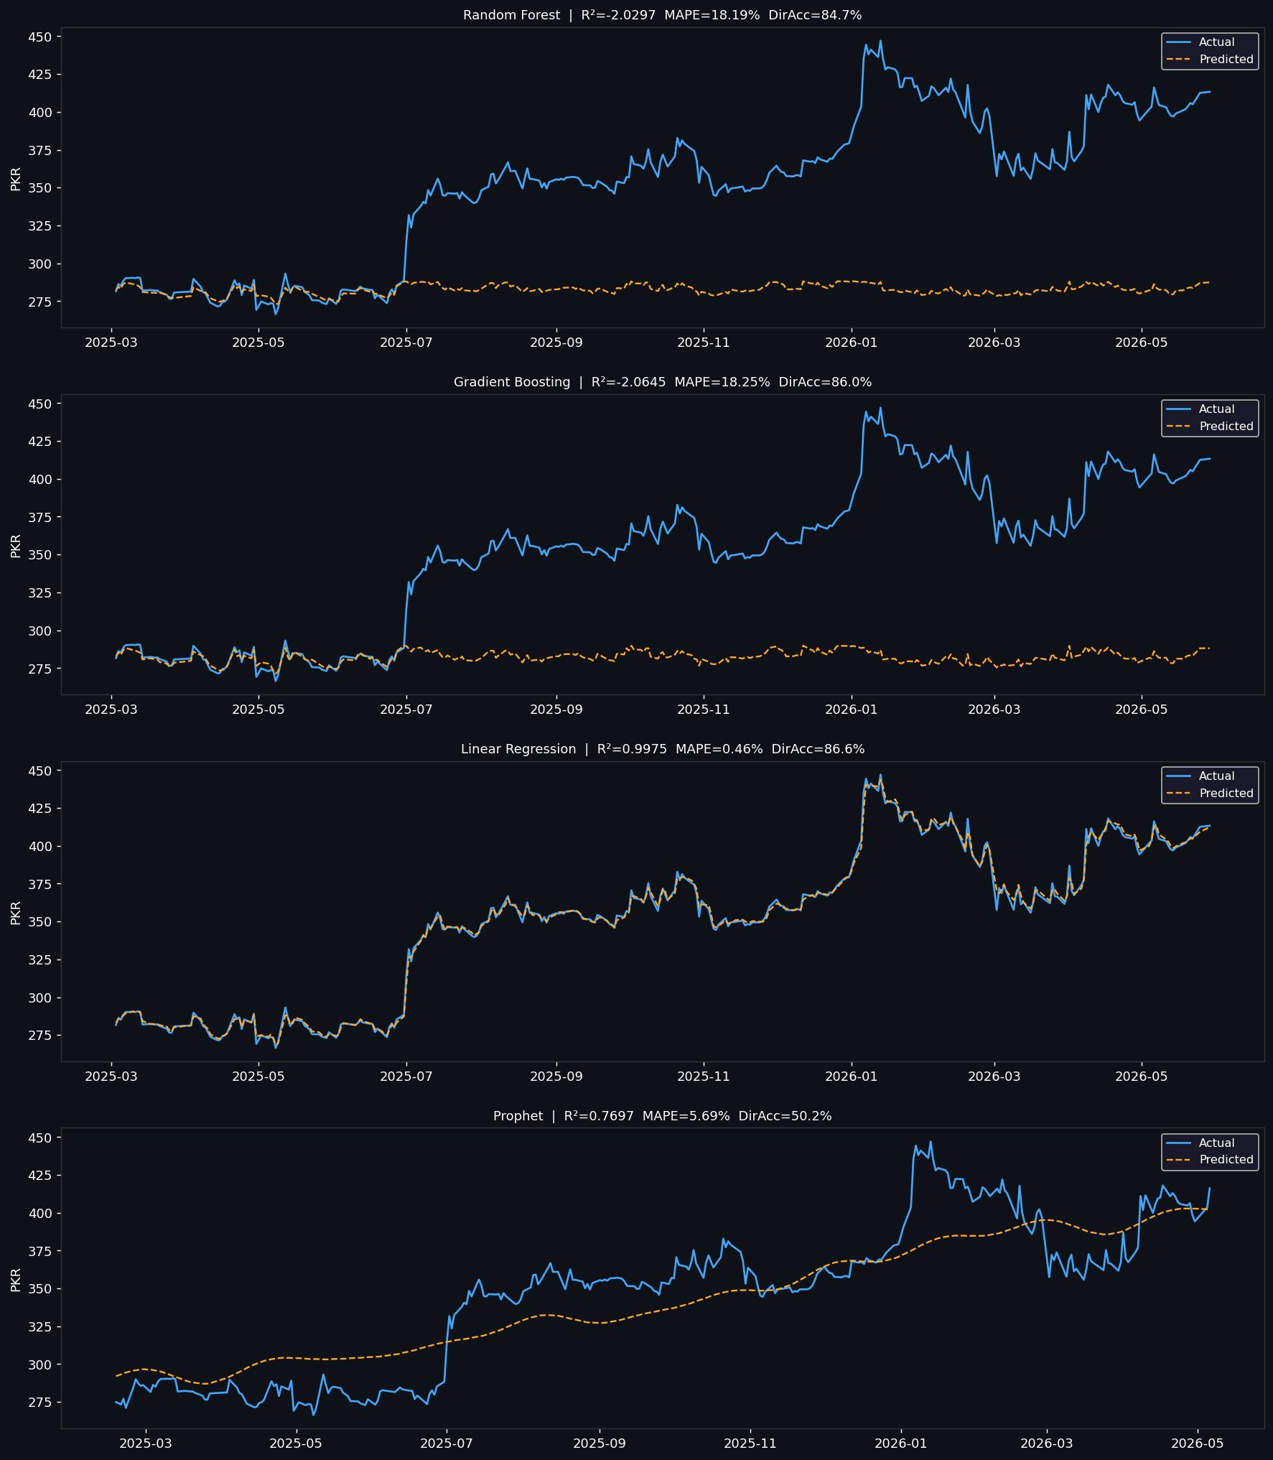
Figure 1. Actual (blue solid) vs. Predicted (orange dashed) MCB Bank closing prices (PKR/share) for Random Forest, Gradient Boosting, Linear Regression, and Prophet. Evaluation period: March 2025 – May 2026.

4.4 Interpretation and Discussion
The performance gap between Linear Regression and the remaining three models is large and has a clear structural explanation. Consider the dominant feature: lag_1 (previous day's closing price) accounts for 63–76% of predictive importance in the tree-based models and is implicitly the primary driver of the Linear Regression fit as well. Given this, the models effectively differ in how they use the prior price to predict the next price.
Linear Regression learns a near-unit coefficient on lag_1 — in essence, predicting tomorrow's MCB closing price as approximately equal to today's, with small adjustments from the technical covariates. This structure naturally and correctly propagates the sustained upward trend in MCB's price from PKR 275 to PKR 445: as each day's actual price becomes the next day's lag_1 input, the model tracks the trend step by step without any ceiling constraint.
Tree-based models, by contrast, are structurally bounded by the range of their training labels. Decision tree leaves store the mean of training samples falling into that leaf's region; no leaf can output a value higher than the maximum training price. Consequently, as MCB's price climbed above historical training highs from mid-2025 onward, Random Forest and Gradient Boosting reverted toward the training distribution mean — producing a systematic upward residual exceeding PKR 150 at the price peak near PKR 445. This is the direct cause of the negative R² values (indicating worse prediction than a simple training-mean predictor) and the large MAPE figures (18.19% and 18.25% respectively).
Despite this level-prediction failure, the tree-based models retain respectable directional accuracy (84.7–86.0%), because the direction of daily price changes is partially predictable from short-term momentum and oscillator features even when the level is badly miscalibrated.
Prophet captures the broad multi-month trend trajectory, explaining its R² of 0.77, but its smoothed trend decomposition lags behind the rapid, steep appreciation phase of MCB's price. More critically, its directional accuracy of 50.2% — essentially equivalent to a coin flip — renders it unsuitable as a trading signal generator despite its reasonable level-tracking.

5. Feature Importance Analysis

5.1 Random Forest Feature Importances
Figure 2 displays the top 20 feature importances for the Random Forest model, measured by mean impurity decrease (Gini importance) aggregated across all trees in the ensemble.

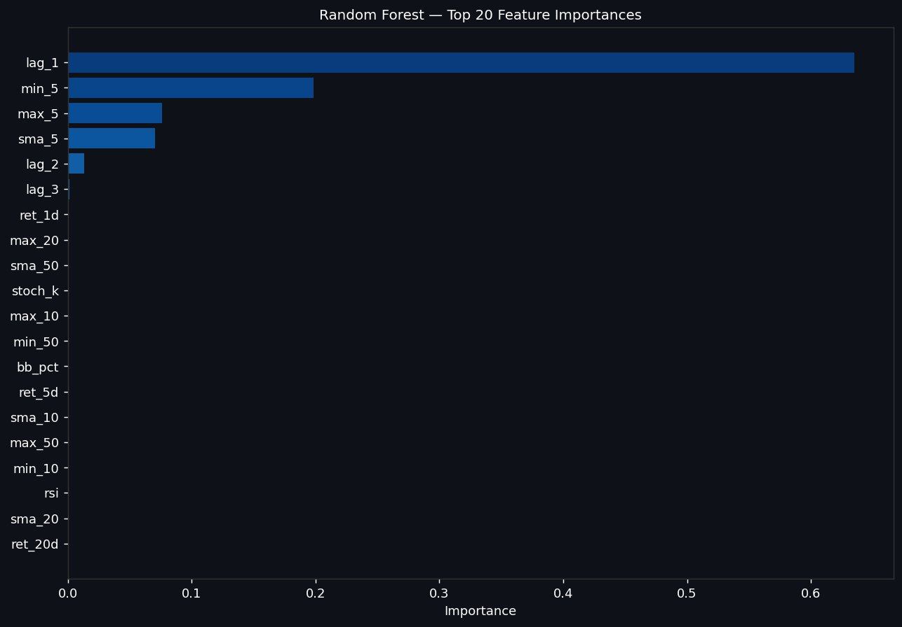
Figure 2. Random Forest — Top 20 Feature Importances by mean impurity decrease (Gini importance). Applied to MCB Bank daily closing price prediction.
The one-day lagged price (lag_1) dominates with an importance score of approximately 0.63, confirming that yesterday's MCB closing price is by far the most informative single feature for predicting today's price. The five-day rolling minimum (min_5) follows at approximately 0.21 — a feature encoding recent short-term price support levels — while the five-day maximum (max_5, ~0.09) and five-day simple moving average (sma_5, ~0.08) rank third and fourth. The two-day lag (lag_2) provides marginal additional signal at approximately 0.03. All remaining features — including momentum indicators (ret_1d, ret_5d, ret_20d), longer-horizon moving averages (sma_10, sma_20, sma_50), and technical oscillators (RSI, bb_pct, macd_signal, stoch_k) — contribute negligible importance in aggregate, with individual scores below 0.01. This extreme concentration of importance in a handful of short-horizon price-level features reflects the near-random-walk nature of MCB's daily price changes: once the recent price level is known, additional technical indicators provide minimal discriminative information.

5.2 Gradient Boosting Feature Importances
Figure 3 shows the equivalent feature importances for the Gradient Boosting model, measured by split gain contribution.

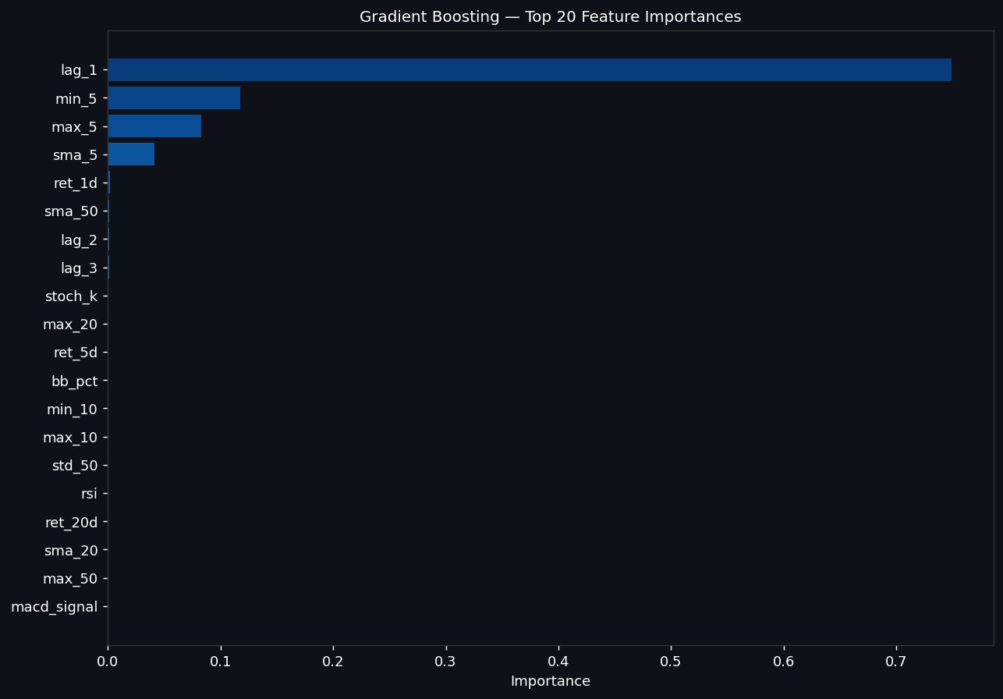
Figure 3. Gradient Boosting — Top 20 Feature Importances by split gain. Applied to MCB Bank daily closing price prediction.
Gradient Boosting exhibits an even more extreme concentration on lag_1, which accounts for approximately 0.76 of total feature importance — substantially higher than the 0.63 observed for Random Forest. This reflects the boosting algorithm's iterative residual-fitting mechanism: in early boosting rounds, lag_1 explains the largest share of variance, and subsequent trees focus on the residuals, which are also highly correlated with recent price-level features (min_5, max_5, sma_5). As a result, the feature importance distribution is more sharply peaked than Random Forest's. The practical implication is identical: Gradient Boosting's predictions are almost entirely determined by the prior day's price, leaving the model equally susceptible to mean-reversion failure when the MCB price trends beyond the training range.

5.3 Comparative Analysis and Implications
The close agreement between Random Forest and Gradient Boosting on feature rankings — with lag_1, min_5, max_5, and sma_5 consistently occupying the top positions — confirms that the feature importance results are robust rather than model-specific artefacts. The negligible contribution of technical oscillators (RSI, Stochastic, MACD, Bollinger Bands) is a practically important finding: it suggests that for MCB Bank stock price prediction, these widely-used indicators carry no incremental information value beyond what is already encoded in the recent price level and short-term rolling statistics.
This concentration of importance in autoregressive price-level features has two key implications for future model development within PSX-Predictor. First, expanding the feature set with additional technical indicators of the same class (momentum oscillators, volume-based indicators) is unlikely to improve performance significantly. Second, genuinely new predictive information would need to come from sources orthogonal to price history: macroeconomic fundamentals (State Bank of Pakistan policy rate, money supply, inflation), sector-level data (banking sector NPL ratios, credit growth), corporate financials (quarterly earnings surprises, dividend announcements), or market sentiment proxies (news sentiment, social media activity on PSX-related platforms).

6. Residual Diagnostics
Residual analysis provides insight into the nature, structure, and systematic patterns of each model's prediction errors. Figure 4 presents residuals over time (left column) and their empirical distributions (right column) for all four models. Residuals are defined as Actual Closing Price minus Predicted Closing Price (in PKR per share).

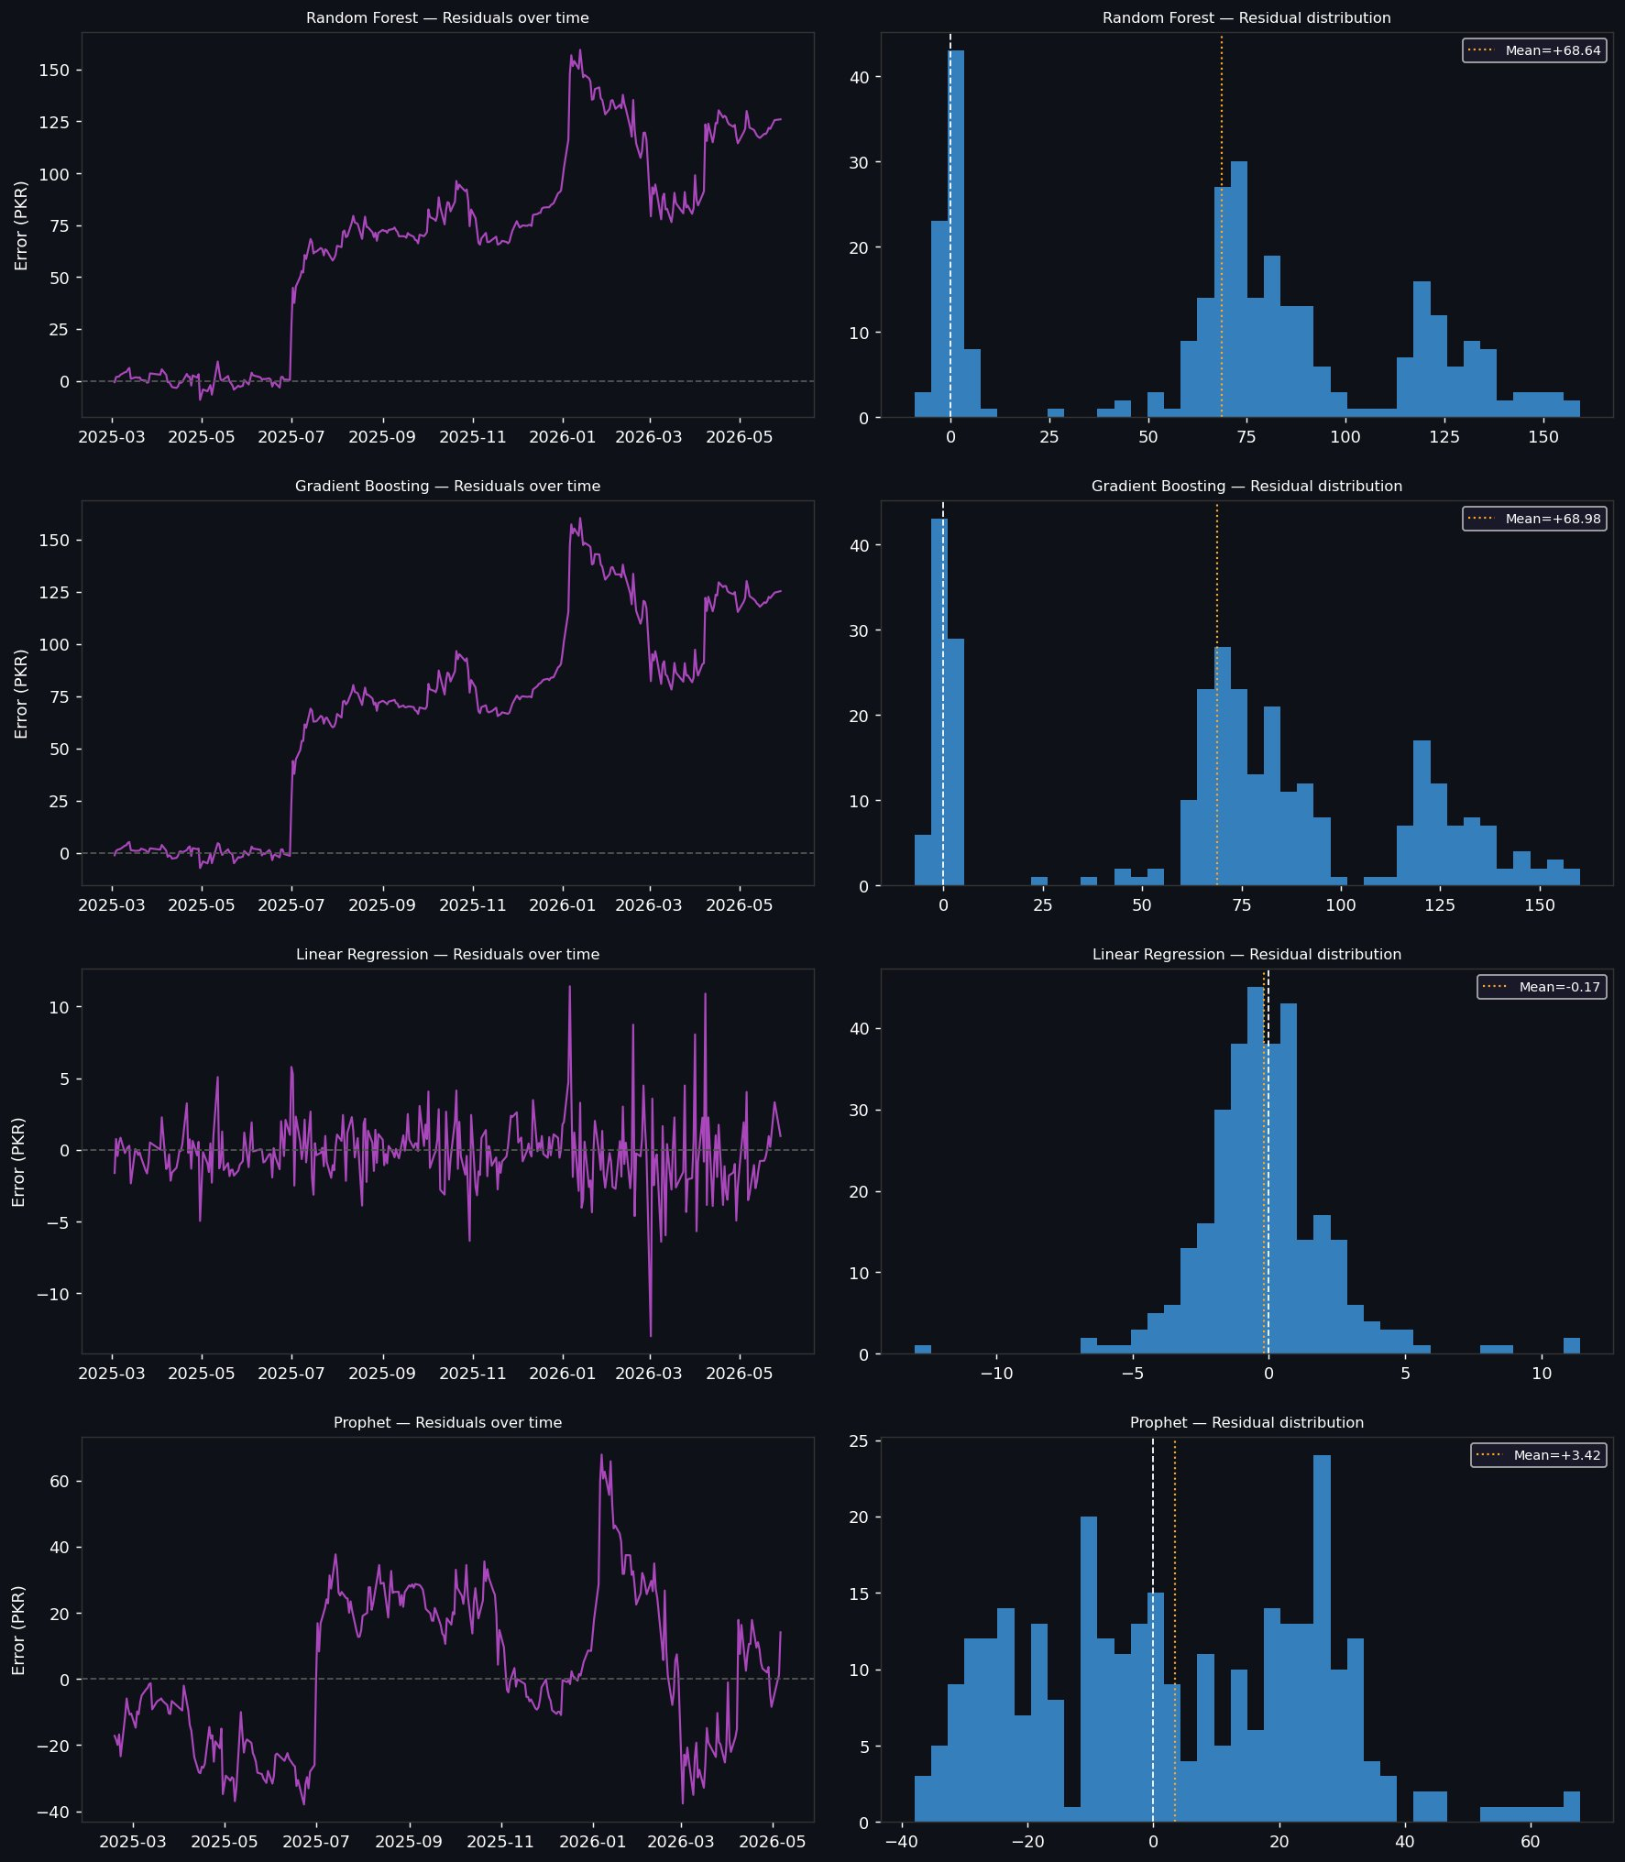
Figure 4. Residuals (Actual − Predicted, PKR/share) over time and residual distribution histograms for all four models on MCB Bank stock price forecasting. Evaluation period: March 2025 – May 2026.

6.1 Linear Regression Residuals
Linear Regression residuals are centred at −0.17 PKR per share — negligible relative to a share price of 275–445 PKR — confirming the absence of meaningful systematic bias. Errors oscillate symmetrically around zero throughout the evaluation period, with a well-centred, approximately normal distribution concentrated in the ±5 PKR range. The largest absolute errors occur during periods of elevated intraday volatility (notably around the MCB price peak in early 2026 and during sharp correction episodes), reaching approximately ±10–11 PKR. In percentage terms, even these extreme errors represent under 3% of the prevailing share price, well within normal market microstructure noise. This residual profile is consistent with a well-specified, unbiased model whose remaining error reflects genuine stochastic price noise rather than model misspecification.

6.2 Random Forest Residuals
Random Forest's mean residual is +68.64 PKR per share — representing a systematic underprediction of nearly PKR 69 per share on average over the test period. The time-series residual plot reveals a clear two-regime structure: residuals are near-zero during the early test period (when MCB's price remained within the training range of approximately PKR 275–320), then escalate monotonically from approximately July 2025 onward as the stock price appreciates above training-period highs. At the price peak (approximately PKR 445 in January 2026), the residual reaches approximately PKR 150 per share. The bimodal residual distribution histogram — with one concentration near zero and a broad second cluster around PKR 60–80 — visually confirms this regime-dependent failure structure.

6.3 Gradient Boosting Residuals
Gradient Boosting exhibits a residual profile nearly identical to Random Forest: mean residual +68.98 PKR, the same bimodal distribution structure, and an identical temporal pattern of near-zero errors in the early test period followed by sharply escalating systematic underprediction. The near-identical mean residuals (+68.64 vs. +68.98 PKR) across the two models confirm that this failure is architectural — a property of the tree-based paradigm — rather than model-specific. No amount of hyperparameter tuning can overcome this limitation without fundamental changes to the target variable (e.g., predicting price returns rather than price levels) or the model architecture.

6.4 Prophet Residuals
Prophet's residuals exhibit a mean of +3.42 PKR per share, indicating mild but non-negligible systematic underprediction. Unlike the tree-based models, Prophet's errors are distributed over a wide range of approximately −40 to +65 PKR and show a more complex temporal pattern: the model initially overpredicts in the very early evaluation period (early 2025), transitions to underprediction as the actual price rises faster than Prophet's trend extrapolation, and then partially corrects during the price correction phase of late 2025 and early 2026. The broadly dispersed, approximately uniform residual distribution without a clear central peak reflects Prophet's inherent smoothing of the price trend — the model captures the general direction of MCB's price movement but consistently lags the rapid pace of appreciation.

7. Walk-Forward Cross-Validation Analysis
Walk-forward cross-validation (WF-CV) evaluates each model on five sequential, non-overlapping future folds, providing a regime-diverse and operationally realistic assessment of generalisation performance. Figures 5, 6, and 7 illustrate the per-fold evolution of MAE, MAPE%, and Directional Accuracy for Linear Regression, Random Forest, and Gradient Boosting respectively.

7.1 Linear Regression — Walk-Forward Stability

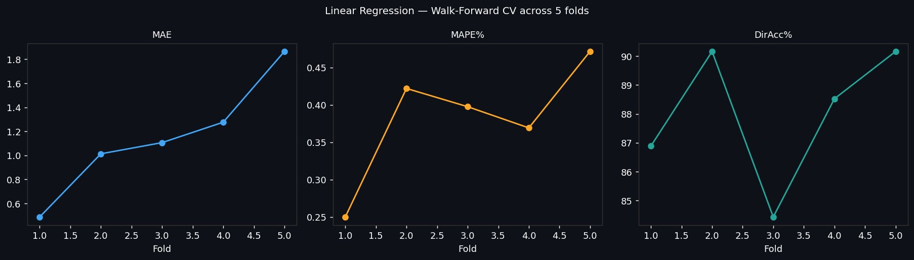
Figure 5. Linear Regression — Walk-Forward Cross-Validation across 5 folds on MCB Bank stock price forecasting. Metrics: MAE in PKR (left), MAPE% (centre), DirAcc% (right).
Linear Regression demonstrates the most consistent and stable walk-forward performance of any model evaluated. MAE increases gradually and monotonically from approximately PKR 0.55 per share in fold 1 to PKR 1.85 per share in fold 5, a natural consequence of the expanding absolute price level as MCB's stock appreciates through the evaluation window — larger prices produce larger absolute errors even at constant percentage accuracy. Critically, MAPE remains remarkably stable across all five folds within the 0.25%–0.48% range, confirming that the model's relative accuracy does not deteriorate as market conditions evolve. Directional accuracy fluctuates between approximately 84.6% and 90.6%, with no systematic trend of deterioration and a strong finish in fold 5 at approximately 90.6%. The slight dip in fold 3 (DirAcc ~84.6%) likely corresponds to a period of elevated price volatility in mid-2025 when daily direction changes were more erratic. Overall, the walk-forward profile confirms that Linear Regression's strong hold-out performance is not a favourable-window artefact but rather a consistent property across all five temporal regimes.

7.2 Random Forest — Walk-Forward Performance

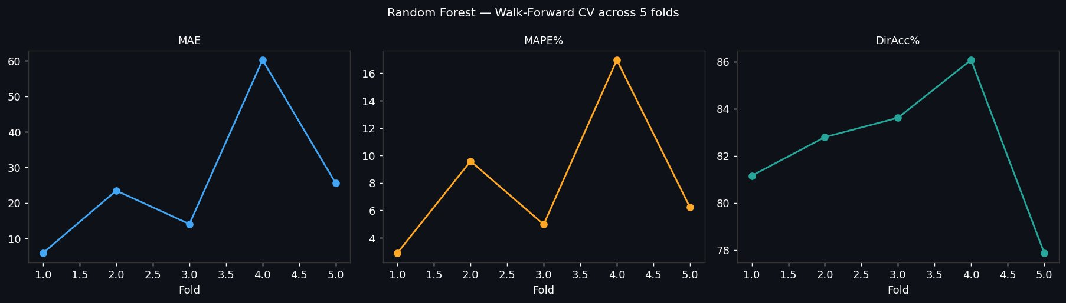
Figure 6. Random Forest — Walk-Forward Cross-Validation across 5 folds on MCB Bank stock price forecasting. Metrics: MAE in PKR (left), MAPE% (centre), DirAcc% (right).
Random Forest's walk-forward profile exhibits a pronounced spike in fold 4 — the period encompassing the MCB price peak and the highest share prices in the evaluation window. MAE reaches approximately PKR 60 per share and MAPE approximately 16.5% in fold 4, before partially recovering in fold 5 as the price begins to mean-revert toward levels closer to the training distribution upper tail. Directional accuracy improves from approximately 81.3% in fold 1 to a peak of approximately 86.2% in fold 4, before collapsing to approximately 78.1% in fold 5 — suggesting that as the price begins to decline from its peak, the model's systematic underprediction creates confusion about daily direction. The fold-by-fold MAE and MAPE patterns confirm that the severity of Random Forest's architectural mean-reversion bias scales directly with the extent to which current prices exceed the training distribution maximum.

7.3 Gradient Boosting — Walk-Forward Performance

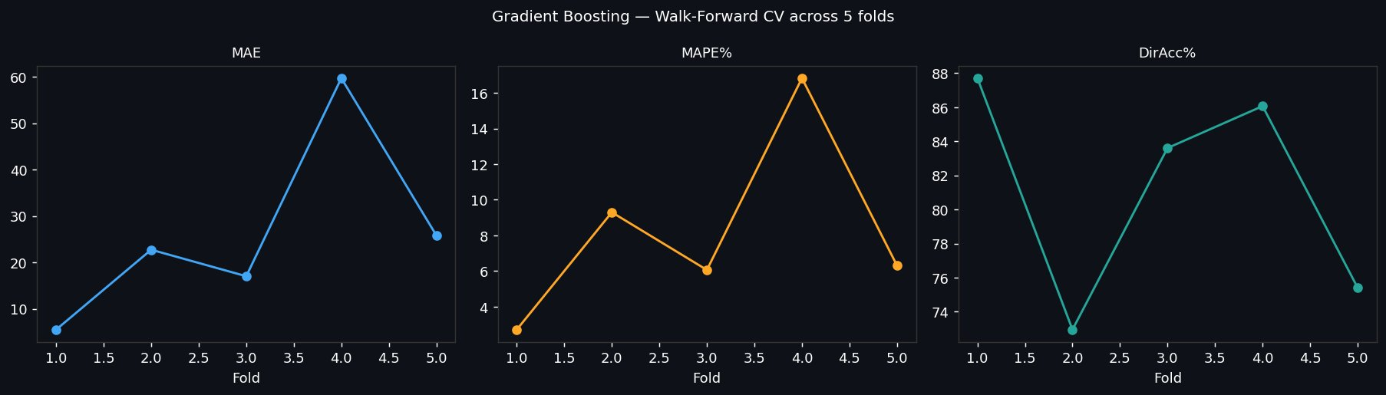
Figure 7. Gradient Boosting — Walk-Forward Cross-Validation across 5 folds on MCB Bank stock price forecasting. Metrics: MAE in PKR (left), MAPE% (centre), DirAcc% (right).
Gradient Boosting's walk-forward profile closely mirrors Random Forest across all three metrics, with a fold-4 MAE spike of approximately PKR 59 per share and a corresponding MAPE of approximately 16.5%. The directional accuracy pattern is more volatile than Random Forest: it begins at approximately 87.8% in fold 1, drops sharply to approximately 73.3% in fold 2 — a period of accelerating price appreciation where the model's static mean-reversion prediction conflicts with the actual directional trend — then recovers partially to approximately 83.7% in fold 3 and 85.9% in fold 4, before declining again to approximately 75.5% in fold 5. This greater volatility in directional accuracy compared to Random Forest may reflect Gradient Boosting's higher sensitivity to training distribution shifts across folds. The overall conclusion, however, is identical: both tree-based ensembles exhibit the same structural limitation, and their walk-forward performance tracks the degree of price-range extrapolation required in each fold.

8. Conclusions and Recommendations

8.1 Summary of Principal Findings
This report has presented a comprehensive and rigorous evaluation of four machine learning models for MCB Bank (PSX: MCB) stock price forecasting within the PSX-Predictor framework developed by Taha Shah. The principal findings are summarised as follows:
1. Linear Regression is the clear and decisive winner. With R² = 0.9975, MAE = PKR 1.64 per share, MAPE = 0.46%, and DirAcc = 86.6% on the hold-out set — corroborated by walk-forward cross-validation results of MAPE = 0.38% and DirAcc = 88.0% — it outperforms all other models by a large and practically significant margin across every metric.
2. Tree-based ensembles fail structurally on trending equity series. Random Forest and Gradient Boosting both produce negative R² values and MAEs of approximately PKR 69 per share on the hold-out set. This reflects a fundamental architectural constraint — decision trees cannot extrapolate beyond their training range — rather than a hyperparameter failure amenable to tuning.
3. Tree models retain directional signal despite level failure. Directional accuracy of 84.7% (Random Forest) and 86.0% (Gradient Boosting) confirms that the short-term price momentum features preserve meaningful directional information even when the predicted price levels are badly miscalibrated.
4. Prophet provides trend tracking but not directional signal. Prophet's R² of 0.77 and MAPE of 5.69% reflect reasonable level tracking over multi-week horizons, but its DirAcc of 50.2% — statistically indistinguishable from random — renders it unsuitable for any application requiring daily directional predictions.
5. lag_1 dominates all tree-based models. The one-day lagged price accounts for 63–76% of feature importance in both tree-based models, confirming near-random-walk dynamics in MCB Bank's daily price series. Technical oscillators (RSI, MACD, Stochastic, Bollinger Bands) contribute negligible incremental information.
6. Walk-forward CV confirms and extends hold-out findings. Linear Regression's superiority is consistent across all five sequential folds, validating that results are regime-stable and not artefacts of a single favourable test window.

8.2 Practical Recommendations
Production deployment: Deploy Linear Regression as the primary MCB price forecasting engine within PSX-Predictor for all near-term (next-day) price predictions. Its walk-forward MAPE of 0.38% and DirAcc of 88.0% are compelling performance benchmarks for a PSX equity forecasting application.
Fix tree-based model extrapolation: To correct the mean-reversion failure, retrain Random Forest and Gradient Boosting to predict the first price difference (Δprice = today's price − yesterday's price) rather than the absolute price level, then reconstruct the level forecast by adding the predicted difference to the prior day's actual price. This eliminates the training-range ceiling constraint.
Enrich with fundamental features: Since additional technical indicators are shown to provide negligible incremental value, future feature engineering efforts should prioritise fundamentally distinct information sources: SBP policy rate and monetary policy decisions, MCB Bank quarterly earnings per share and dividend announcements, sector-level indicators (KSE Banking Index returns, non-performing loan ratios), and macro variables (CPI, broad money supply, current account balance).
Extend to other PSX equities: PSX-Predictor's modular architecture makes it well-suited for systematic application to other KSE-100 constituents. Running the same evaluation pipeline across a broader equity universe would reveal whether Linear Regression's dominance is universal or specific to the near-random-walk dynamics of large-cap PSX stocks like MCB.
Ensemble stacking: A stacked meta-learner combining Linear Regression's level accuracy with Gradient Boosting's directional discrimination could potentially improve both MAPE and DirAcc simultaneously. The meta-learner could be trained to weight each base model's output optimally for each market regime.
Confidence intervals and risk calibration: For production trading applications, point predictions are insufficient. Future work should incorporate prediction interval estimation (e.g., via conformal prediction or quantile regression) to provide risk-calibrated forecasts that account for the model's varying precision across different volatility regimes.

8.3 Limitations
Several limitations of the current analysis should be acknowledged. First, the evaluation covers a single 15-month period for a single PSX-listed stock (MCB Bank); generalisation to other equities, other time periods, or fundamentally different market regimes (e.g., the 2022–2023 KSE bear market) cannot be assumed without further empirical validation. Second, the analysis relies exclusively on technical price-based features; fundamental data, order flow, and sentiment signals are not incorporated, and their potential contribution remains unquantified. Third, all results assume perfect execution at daily closing prices with no transaction costs, market impact, or slippage — assumptions that would need careful relaxation in any live trading application. Fourth, the walk-forward evaluation uses five equally-sized folds; a finer-grained expanding-window scheme with shorter test horizons could reveal additional instabilities not visible at the fold granularity used here.

Appendix: Sample Predictions — Linear Regression Model
Table A1 presents a sample of Linear Regression model predictions for MCB Bank daily closing prices from late April through late May 2026, illustrating the model's precise day-to-day tracking performance. All prices are in PKR per share.

Date | Actual (PKR) | Predicted (PKR) | Error (PKR) | Error %
2026-04-28 | 406.37 | 407.35 | −0.98 | −0.24%
2026-04-29 | 398.48 | 403.41 | −4.93 | −1.24%
2026-04-30 | 394.32 | 396.90 | −2.58 | −0.65%
2026-05-04 | 401.78 | 399.86 | +1.92 | +0.48%
2026-05-05 | 403.41 | 404.02 | −0.61 | −0.15%
2026-05-06 | 416.19 | 412.15 | +4.04 | +0.97%
2026-05-07 | 410.35 | 413.85 | −3.50 | −0.85%
2026-05-08 | 404.57 | 407.63 | −3.06 | −0.76%
2026-05-11 | 403.07 | 404.13 | −1.06 | −0.26%
2026-05-12 | 399.83 | 402.50 | −2.67 | −0.67%
2026-05-13 | 397.46 | 399.66 | −2.20 | −0.55%
2026-05-14 | 397.00 | 398.42 | −1.42 | −0.36%
2026-05-15 | 398.88 | 399.65 | −0.77 | −0.19%
2026-05-18 | 401.04 | 401.80 | −0.76 | −0.19%
2026-05-19 | 401.77 | 402.23 | −0.46 | −0.12%
2026-05-20 | 403.65 | 403.59 | +0.06 | +0.01%
2026-05-21 | 405.88 | 404.92 | +0.96 | +0.24%
2026-05-22 | 405.01 | 404.80 | +0.21 | +0.05%
2026-05-25 | 412.57 | 409.24 | +3.33 | +0.81%
2026-05-29 | 413.28 | 412.31 | +0.97 | +0.23%
Table A1. Sample Linear Regression predictions for MCB Bank (PSX) daily closing price, April–May 2026. Errors consistently within ±5 PKR (under ±1.25% of prevailing price).

— End of Report —

PSX-Predictor | Taha Shah | May 2026

