ROVER LAB — DOSSIER (TRAPPIST-1 e mission)
This file is CONFIDENTIAL. Students never see it.

# Planet
Name: TRAPPIST-1 e
Planet type: Temperate rocky planet, one of seven worlds orbiting an ultracool red dwarf
Surface temperature: ≈–24 °C equilibrium estimate (range reported –48 to –23 °C depending on assumed albedo). Tidally locked.
Surface pressure: Not directly measured; no atmosphere confirmed. 2025 JWST observations were inconclusive.
Gravity: ≈0.82 g
Atmosphere: Not confirmed. Data are consistent with either a bare rock or a thin nitrogen-dominated atmosphere (hypothesis, not measurement).

# Mission Briefing
TRAPPIST-1 e is a rocky, Earth-sized planet in the habitable zone of an ultracool red dwarf star, tidally locked so that one face permanently points toward its sun. The rover 'Terra-e' has landed near the twilight terminator, the only region with a stable, moderate climate between the scorched dayside and the frozen nightside. Orbital spectrometry has flagged several distinct rock and mineral formations within driving range. Given that TRAPPIST-1 planets are unusually dense for their size — hinting at large iron cores — mission control wants to know whether one of these formations holds a genuinely iron-rich brine that could be processed into iron oxide for the station's radiation shielding.

# Rover
Starting energy: 100
Site visit cost: 10
Experiment cost: 15

# Overview Image
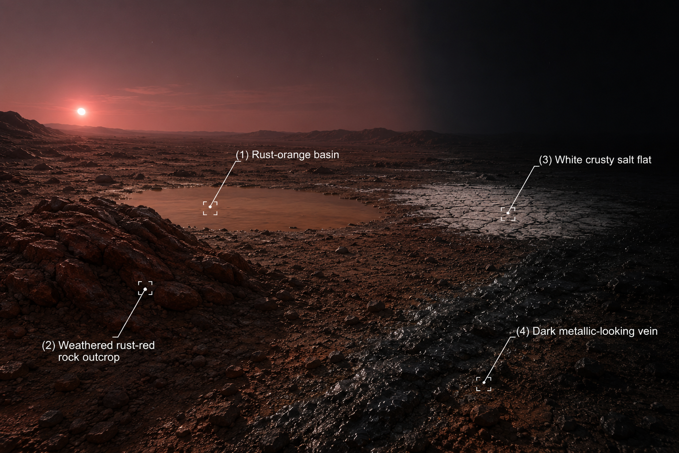

# Site: Rust-orange basin near the terminator
Description: A shallow, dry basin streaked with rust-orange mineral crusts, ringed by darker rock at the edge of the permanent twilight zone.
Identity: Iron(III) chloride solution (real sample) — medium-high concentration. THE ONLY IRON-BEARING SITE. REAL SAMPLE GROUP.
## Known Properties
Colour: Amber-orange
Odour: Faint, sharp
Solubility: Fully miscible with water
## Experiment Results
Measure pH: Strongly acidic, pH around 1.4–1.7
Measure density: 1.25 g/mL, denser than water
Test electrical conductivity: High
Add a magnet: No attraction
Add potassium thiocyanate solution: Turns deep blood-red almost immediately
Add sodium hydroxide solution: Forms a substantial reddish-brown gelatinous precipitate
Heat a small sample gently: Darkens slightly

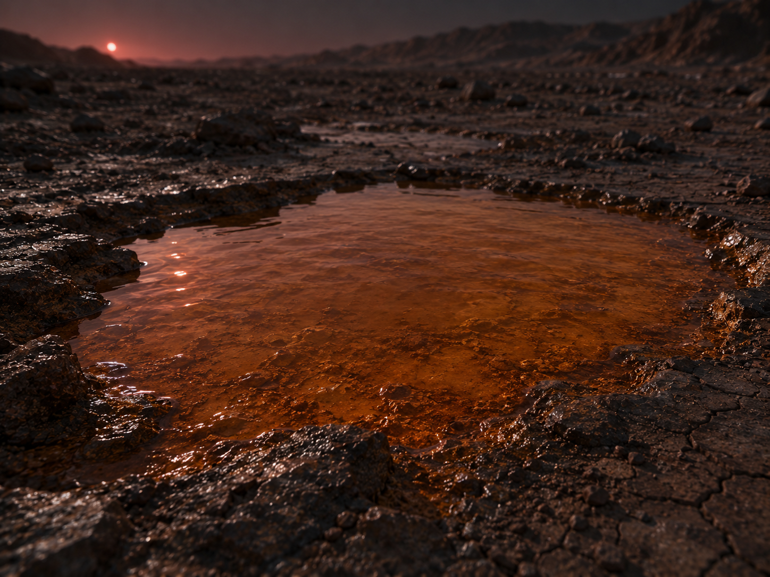
# Site: Weathered rust-red rock outcrop
Description: A weathered, rust-red rock formation jutting from the regolith a short distance from the basin, with a faint metallic sheen in places and darker red-brown bands.
Identity: Copper(I) oxide mineral (cuprite) — reddish colour resembles iron oxide but contains no iron; its high density is a giveaway if compared carefully. RED HERRING (no iron).
## Known Properties
Colour: Deep brick-red, faint metallic sheen in patches
Magnetism: None
Solubility: Insoluble
## Experiment Results
Measure pH: Close to neutral, pH around 6.9 (crushed sample in water)
Measure density: 6.0 g/cm3 — notably dense for a rock sample
Test electrical conductivity: Very low (crushed sample in water)
Add a magnet: No attraction
Add potassium thiocyanate solution: No colour change
Add sodium hydroxide solution: No precipitate forms
Heat a small sample gently: No visible change

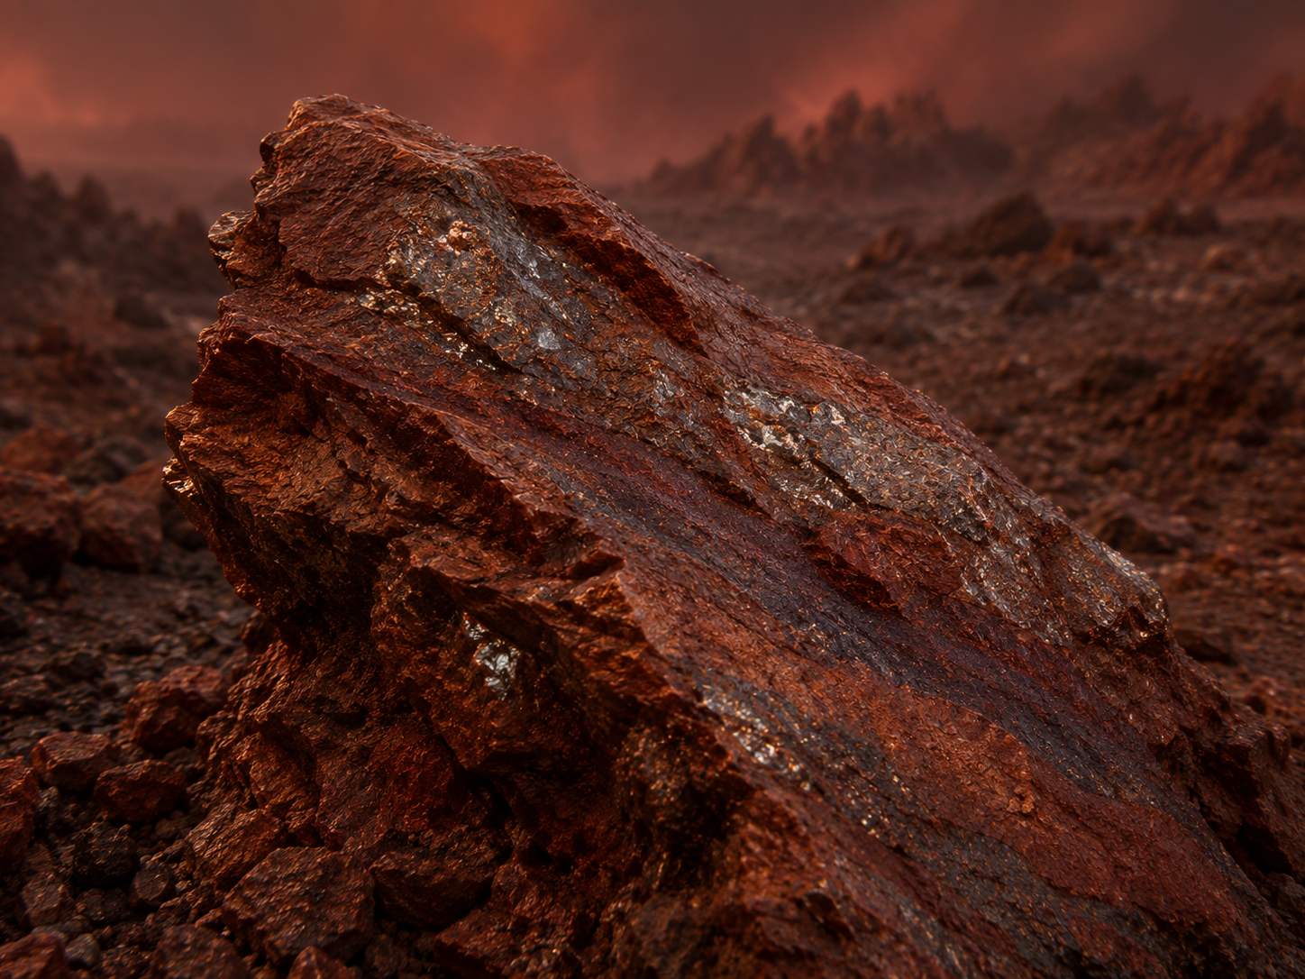
# Site: White crusty salt flat
Description: A flat expanse of pale, cracked crust near the basin that crunches faintly under the rover's wheels.
Identity: Sodium chloride evaporite deposit — no iron content.
## Known Properties
Colour: White to pale grey
Solubility: Fully soluble in water
## Experiment Results
Measure pH: Neutral, pH 7
Measure density: 1.02 g/mL once dissolved at saturation
Test electrical conductivity: High
Add a magnet: No attraction
Add potassium thiocyanate solution: No colour change
Add sodium hydroxide solution: No precipitate forms
Heat a small sample gently: No visible change; the crystals don't melt or scorch at this gentle heat

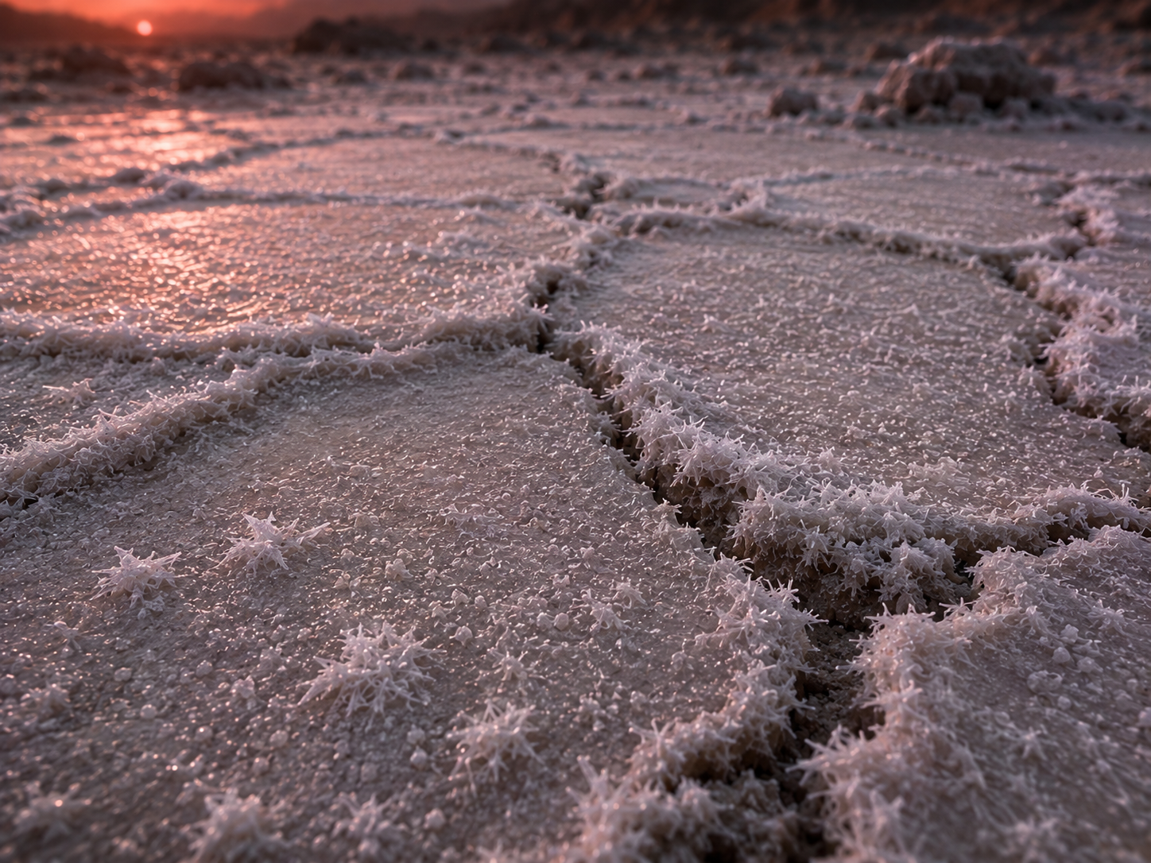
# Site: Dark metallic-looking vein
Description: A dark, almost black mineral vein embedded in the surrounding rock, with a faint metallic sheen.
Identity: Nickel-rich sulfide mineral — magnetic (nickel is ferromagnetic too) but contains no iron; deliberately designed so 'magnetic' does not mean 'iron' here, since the true sample is a non-magnetic solution.
## Known Properties
Colour: Dark grey to black, metallic lustre
Magnetism: Moderately attracted to a magnet
Solubility: Insoluble in water
## Experiment Results
Measure pH: Neutral, pH around 7 (crushed sample in water)
Measure density: 5.4 g/cm3 — dense, but the sample does not dissolve
Test electrical conductivity: Very low (crushed sample in water)
Add a magnet: Noticeably attracted, though less strongly than a pure iron ore would be
Add potassium thiocyanate solution: No colour change
Add sodium hydroxide solution: No precipitate forms
Heat a small sample gently: No visible change

# Experiments
Measure pH
Measure density
Test electrical conductivity
Add a magnet
Add potassium thiocyanate solution
Add sodium hydroxide solution
Heat a small sample gently
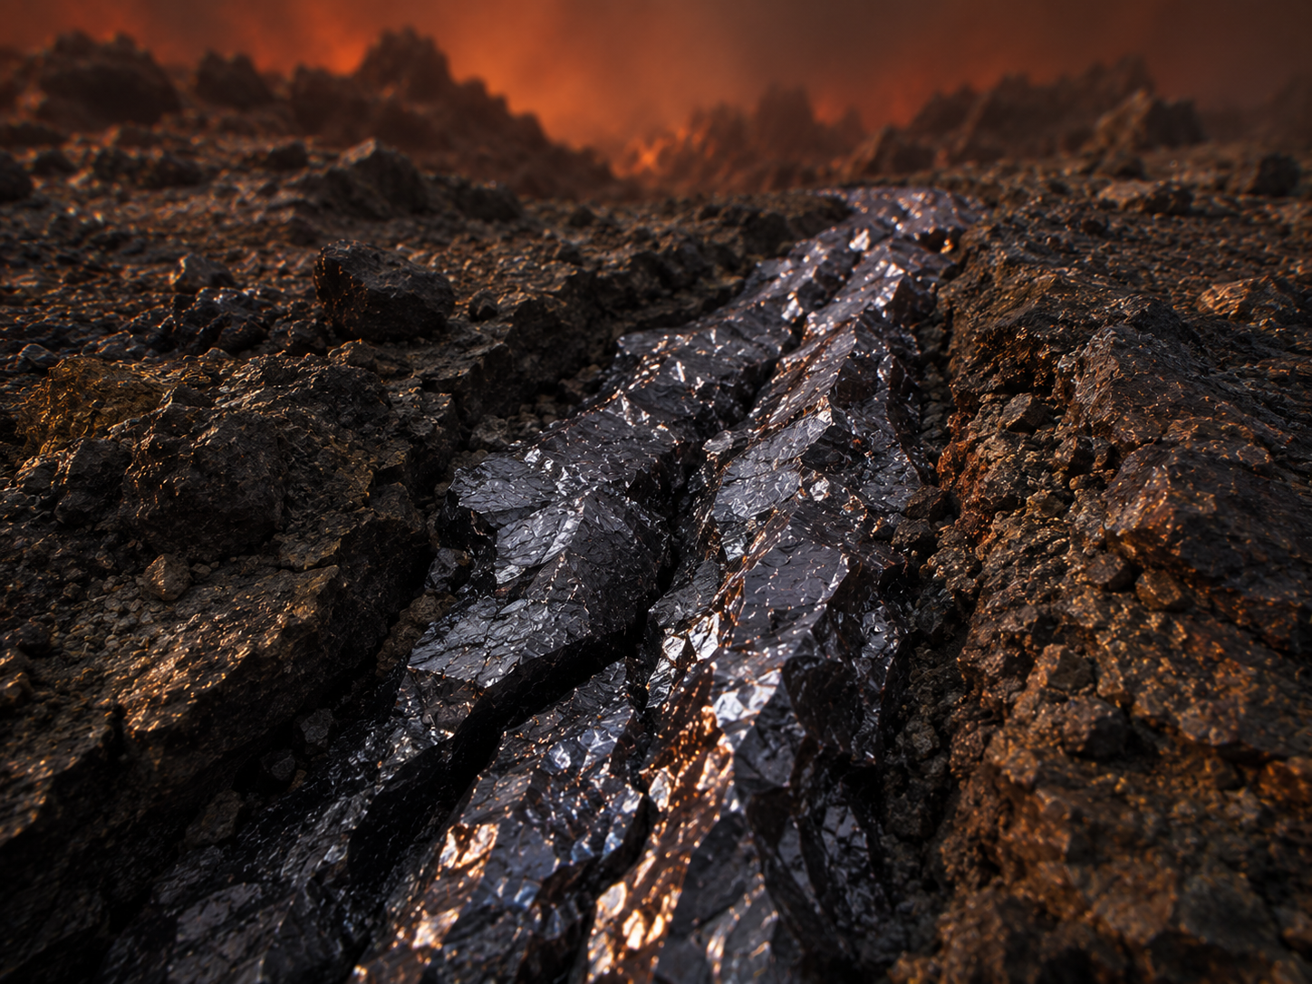
# AI Behaviour
Reveal remaining candidates after narrowing: Yes
Difficulty: Standard (15-16 years old)

# Teacher Notes
REAL SAMPLE GROUP — assign real FeCl3, medium-high concentration (suggested ≈0.4 M). TRAPPIST-1e is temperate (cooler/less evaporative than 55 Cancri e), so it's positioned as the second-most-concentrated of the five real groups.
This dossier reuses the same four-site pattern as the worked example bundled with the app (Dossier_RoverExoplanet_1.docx / Vestara-3): one genuine iron(III) chloride site (the basin), a colour red herring (cuprite, non-magnetic), a neutral salt decoy (NaCl), and a magnetic-but-iron-free decoy (nickel sulfide) — TRAPPIST-1e's temperate, rocky conditions are close enough to that example's setting to carry the same chemistry directly.
Real-science notes: TRAPPIST-1e is a genuine rocky exoplanet, ~40.7 light-years away, discovered in 2017 (Spitzer + TRAPPIST telescope, Gillon et al.), orbiting an M8 ultracool dwarf star every 6.1 days. Agol et al. (2021) found that TRAPPIST-1 planets as a group are unusually dense for their size, consistent with unusually large iron cores — TRAPPIST-1e itself is actually one of the least dense (most Earth-like) planets in the system, close to Earth's own bulk density (~4.9 g/cm3 vs Earth's 5.51 g/cm3). No atmosphere or surface chemistry has actually been detected on TRAPPIST-1e — 2025 JWST data were inconclusive. TRAPPIST-1 is a genuinely active flaring star, which matters for the biology lesson (see below): frequent stellar flares bathe the whole system in periodic bursts of UV/X-ray radiation.
Sources: Agol et al. 2021 and Gillon et al. 2017 (see en.wikipedia.org/wiki/TRAPPIST-1e for citations); NASA Exoplanet Archive (exoplanetarchive.ipac.caltech.edu/overview/TRAPPIST-1).
Cross-subject link: Biology selective pressure for this planet — intense stellar flares and radiation from an active red dwarf star. Pairs naturally with TRAPPIST-1 g (same system, cooler orbit) for a cross-group comparison at the final conference.

