ROVER LAB — DOSSIER (K2-18 b mission)
This file is CONFIDENTIAL. Students never see it.

# Planet
Name: K2-18 b
Planet type: Sub-Neptune ‘Hycean’ candidate — thick hydrogen atmosphere over a possible global ocean
Surface temperature: ≈–8 °C equilibrium estimate (no defined solid surface)
Surface pressure: No solid surface; pressure increases with depth through the atmosphere/ocean layer.
Gravity: ≈1.27 g
Atmosphere: Methane confirmed by JWST (2023). A disputed, unconfirmed hint of dimethyl sulfide (DMS) has been reported and is NOT accepted as a biosignature by the wider scientific community.

# Mission Briefing
K2-18 b is a candidate 'Hycean' world: a deep global ocean, possibly hundreds of kilometres deep, sealed beneath a thick hydrogen-rich atmosphere. A submersible probe, 'Abyss-1', has descended through the haze and sampled several distinct depths and features, hoping to find dissolved iron minerals seeping from a rocky core far below. There is no dry ground anywhere here — every 'site' is a different depth or feature within the ocean/atmosphere column, reached by descending or surfacing the probe, never by driving.

# Rover
Starting energy: 100
Site visit cost: 10
Experiment cost: 15

# Overview Image
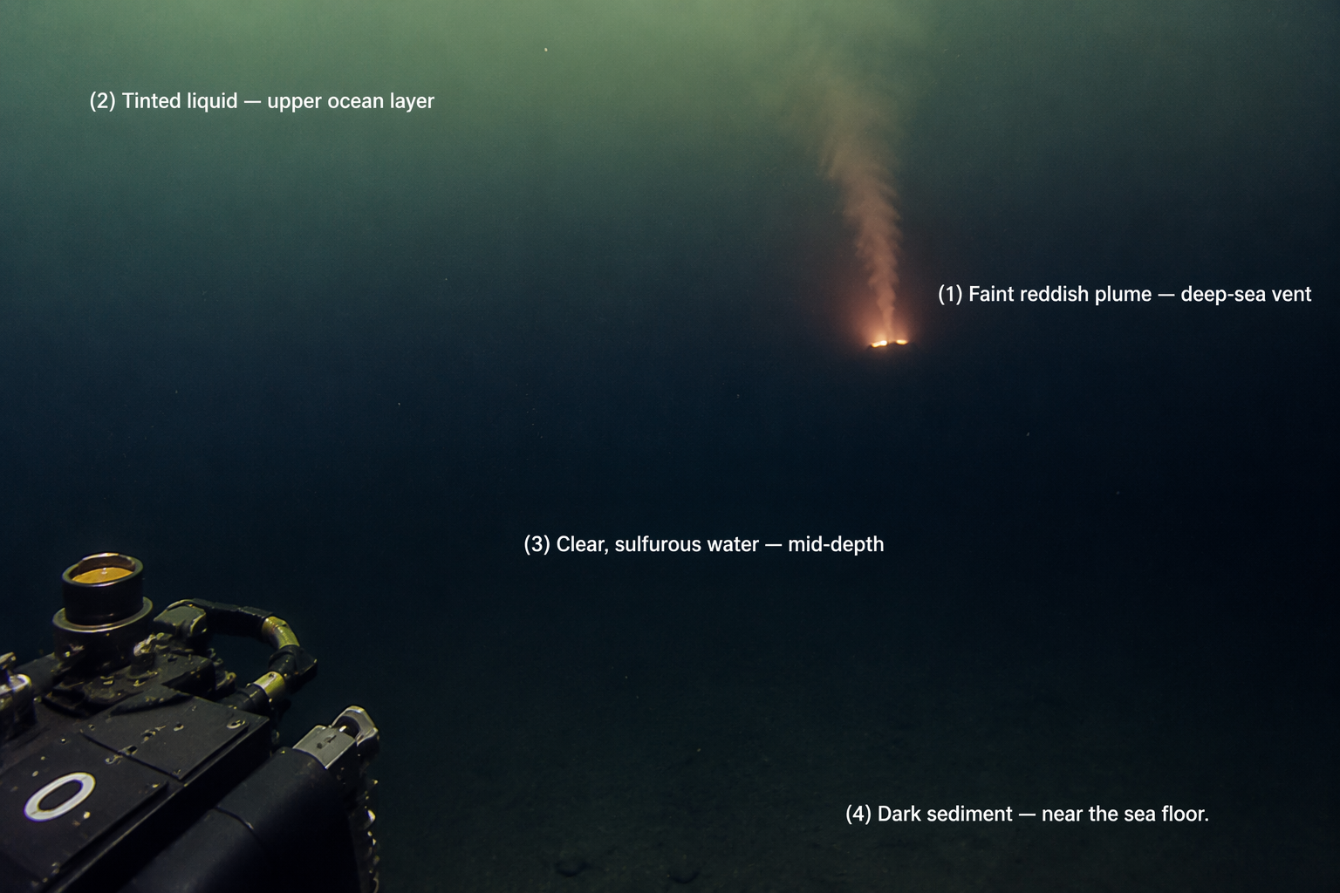

# Site: Faint reddish plume near a suspected deep-sea vent
Description: A warm, faintly reddish plume rising from a suspected hydrothermal vent far below, detected by the probe's heat sensors.
Identity: NOT genuine iron(III) chloride, despite matching every rover-test signature below. Earth's real hydrothermal vents commonly discharge iron-rich fluids from the mantle, so a rover field-test reading of 'iron' here is entirely plausible and is exactly what the onboard test kit reports — but this is the planet's deliberate TWIST: students should select this site as their best candidate based on the rover evidence, and the sample physically assigned to this group for the real wet lab (a food-colourant solution engineered to reproduce this same misleadingly iron-like field-test profile) will reveal, once tested rigorously in the real lab, that it is NOT genuine iron oxide/iron(III) chloride. THE ONLY SITE THE ROVER'S TESTS INDICATE AS IRON — keep Known Properties/Experiment Results exactly as written below; they are what makes the rover convincingly (and deliberately) wrong.
## Known Properties
Colour: Pale reddish-orange
Odour: Faint, sharp
Solubility: Fully miscible with water
## Experiment Results
Measure pH: Strongly acidic, pH around 1.5–2
Measure density: 1.3 g/mL
Test electrical conductivity: Very high
Add a magnet: No attraction
Add potassium thiocyanate solution: Turns deep blood-red almost immediately
Add sodium hydroxide solution: Forms an abundant reddish-brown gelatinous precipitate
Heat a small sample gently: Darkens slightly; the sample is already warm from the vent
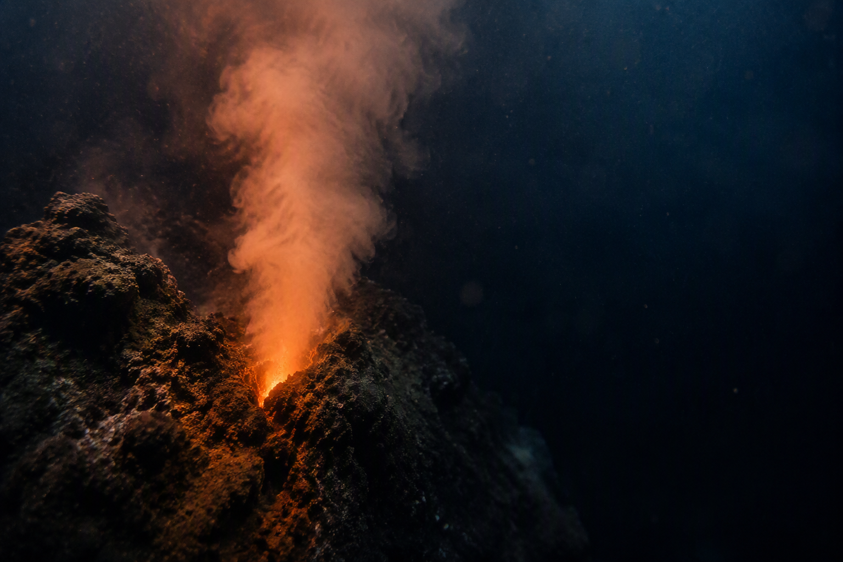

# Site: Tinted liquid from the upper ocean layer
Description: A sample of pale amber-tinted liquid drawn from just beneath the cloud deck, in permanent twilight far below the visible cloud tops.
Identity: Dissolved organic/sulfur-bearing compounds — possibly related to this planet's real, still-disputed dimethyl sulfide (DMS) signal. No iron content.
## Known Properties
Colour: Pale amber
Odour: Faint, slightly sulfurous
Solubility: Fully miscible with water
## Experiment Results
Measure pH: Close to neutral, pH around 7
Measure density: 1.0 g/mL
Test electrical conductivity: Low
Add a magnet: No attraction
Add potassium thiocyanate solution: No colour change
Add sodium hydroxide solution: No precipitate forms
Heat a small sample gently: No visible change
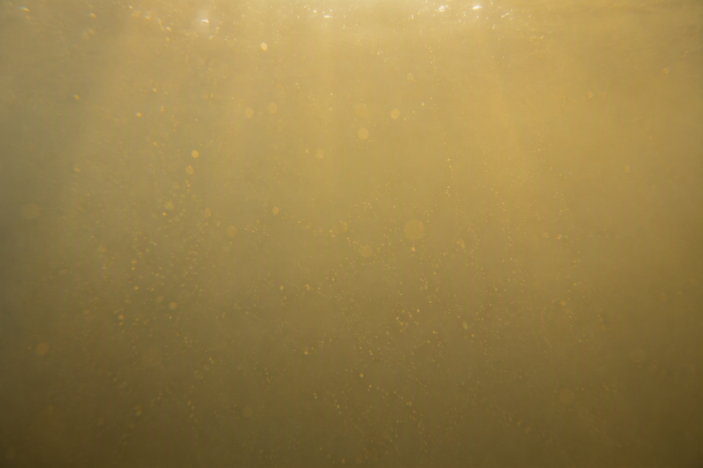

# Site: Clear, faintly sulfurous water from a mid-depth layer
Description: A clear sample from an intermediate depth, carrying a faint sulfurous smell from dissolved volcanic gases.
Identity: Dissolved volcanic gases in plain water (no iron content).
## Known Properties
Colour: Colourless to very pale
Odour: Faint sulfurous smell
Solubility: Fully miscible with water
## Experiment Results
Measure pH: Mildly acidic, pH around 5.5–6
Measure density: 1.0 g/mL
Test electrical conductivity: Low to moderate
Add a magnet: No attraction
Add potassium thiocyanate solution: No colour change
Add sodium hydroxide solution: No precipitate forms; a faint smell is released
Heat a small sample gently: Releases a faint sulfurous smell


# Site: Dark, fine sediment suspended near the sea floor
Description: A cloud of fine, dark mineral sediment stirred up by the probe while investigating the deep sea floor.
Identity: Nickel-rich sulfide sediment — magnetic, but contains no iron. RED HERRING.
## Known Properties
Colour: Dark grey to black
Magnetism: The suspended solids are noticeably attracted to a magnet
Solubility: Mostly insoluble; settles out over time
## Experiment Results
Measure pH: Neutral, pH around 7
Measure density: 1.15 g/mL, with suspended solids
Test electrical conductivity: Low
Add a magnet: Noticeably attracted
Add potassium thiocyanate solution: No colour change
Add sodium hydroxide solution: No obvious change beyond the existing solids
Heat a small sample gently: No visible change


# Experiments
Measure pH
Measure density
Test electrical conductivity
Add a magnet
Add potassium thiocyanate solution
Add sodium hydroxide solution
Heat a small sample gently

# AI Behaviour
Reveal remaining candidates after narrowing: Yes
Difficulty: Standard (15-16 years old)

# Teacher Notes
DECOY GROUP — students should pick site 1 (the vent plume) after running the rover's tests, since every reading it gives is deliberately consistent with iron(III) chloride, and Earth's real hydrothermal vents genuinely do discharge iron-rich fluid, so the field-test result is entirely plausible. The sample physically assigned to this group for the real wet lab IS site 1's sample — a food-colourant solution engineered to reproduce a misleadingly iron-like field-test profile — and it should fail under rigorous real-lab analysis (negligible or no genuine iron oxide recovered), which is the intended twist: a first rover-based guess is not the same as confirmed lab evidence. Site 2 (the tinted upper-ocean liquid) is now just an ordinary, honestly non-iron decoy (tied to this planet's real, disputed DMS story), unrelated to the twist.
K2-18b is real and famous for a genuinely disputed claim (dimethyl sulfide, a proposed biosignature) — which is why site 2's identity leans on that same real controversy rather than a generic decoy. Site 3 (mid-depth sulfurous water) is a simple neutral decoy; site 4 (deep sediment) is the magnetic red herring — real magnetism, no iron, and not itself the site that fools the rover. Use the final conference to connect this directly to how real scientists must independently verify extraordinary claims before accepting them (see DMS controversy below) — the twist here is a hands-on echo of that same lesson.
Real-science notes: K2-18b is a genuine sub-Neptune, ~124 light-years away, orbiting the red dwarf K2-18 every 32.9 days, discovered in 2015. JWST (2023, Madhusudhan et al.) robustly detected methane in its atmosphere — a real, solid measurement. A 2023 hint and 2025 follow-up claim of dimethyl sulfide (DMS), proposed as a possible biosignature, has been strongly disputed: multiple independent reanalyses in 2025 found the statistical evidence insufficient, and DMS can also form without life. Its low density (2.67 g/cm3, about half Earth's) means it is NOT a rocky terrestrial planet — the 'Hycean ocean world' picture is one leading hypothesis, but an ordinary gas-rich mini-Neptune with no ocean at all is an equally consistent alternative model. Teach this planet as a case study in scientific caution: methane = solid finding; DMS-as-life-signal = not yet accepted.
Sources: Madhusudhan et al. 2023 (science.org/content/article/alien-planet-s-atmosphere-bears-chemical-hints-life-astronomers-claim); 2025 reanalysis, A&A (aanda.org/articles/aa/full_html/2025/08/aa55580-25/aa55580-25.html).
Cross-subject link: Biology selective pressure for this planet — no sunlight reaches the deep ocean floor beneath a thick hydrogen atmosphere; organisms would need an energy source other than photosynthesis (chemosynthesis, as in Earth's deep-sea hydrothermal vent life).

