ROVER LAB — DOSSIER (TOI-700 d mission)
This file is CONFIDENTIAL. Students never see it.

# Planet
Name: TOI-700 d
Planet type: Earth-sized rocky planet in the habitable zone of a red dwarf
Surface temperature: ≈–4 °C equilibrium estimate; likely tidally locked
Surface pressure: Not measured; no atmosphere detected with current telescopes
Gravity: ≈1.2–1.7 g (the planet's mass is not yet precisely settled — present as an estimate)
Atmosphere: Unknown/undetected. Published climate scenarios are theoretical models, not measurements.

# Mission Briefing
TOI-700 d is an Earth-sized rocky world orbiting safely within the habitable zone of a small, quiet red dwarf. Likely tidally locked, it may have a permanent dayside and nightside separated by a band of eternal twilight. The rover 'Meridian-1' has been sent to this twilight band, where several reddish, iron-stained formations have been identified, their colouring reminiscent of the hematite-rich terrain found by rovers exploring ancient dried lakebeds on Mars. Orbital spectrometry suggests one of them holds a chloride brine rich enough in dissolved iron to be worth processing into iron oxide for the station's shielding — but only ground samples can confirm which.

# Rover
Starting energy: 100
Site visit cost: 10
Experiment cost: 15

# Overview Image
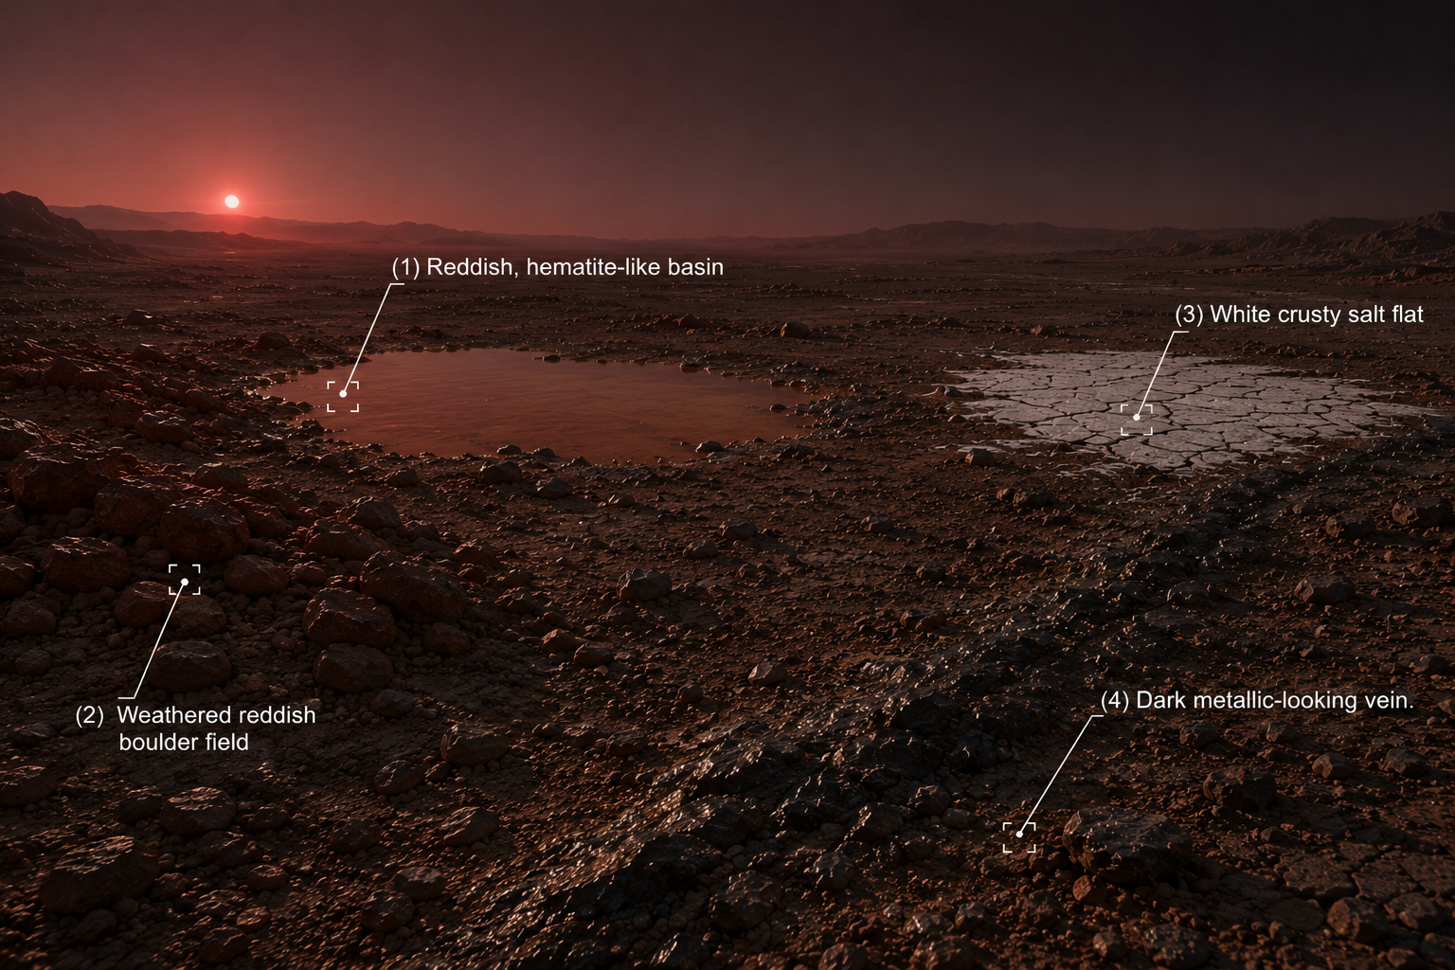

# Site: Reddish, hematite-like basin in the twilight band
Description: A shallow basin with a distinctive rusty-red crust, cut by cracked, sun-baked mineral ridges.
Identity: Iron(III) chloride solution (real sample) — medium concentration. THE ONLY IRON-BEARING SITE. REAL SAMPLE GROUP.
## Known Properties
Colour: Amber-orange, moderate intensity
Odour: Faint, sharp
Solubility: Fully miscible with water
## Experiment Results
Measure pH: Acidic, pH around 1.8–2.1
Measure density: 1.15 g/mL
Test electrical conductivity: Moderately high
Add a magnet: No attraction
Add potassium thiocyanate solution: Turns deep blood-red almost immediately
Add sodium hydroxide solution: Forms a moderate reddish-brown gelatinous precipitate
Heat a small sample gently: Slight darkening
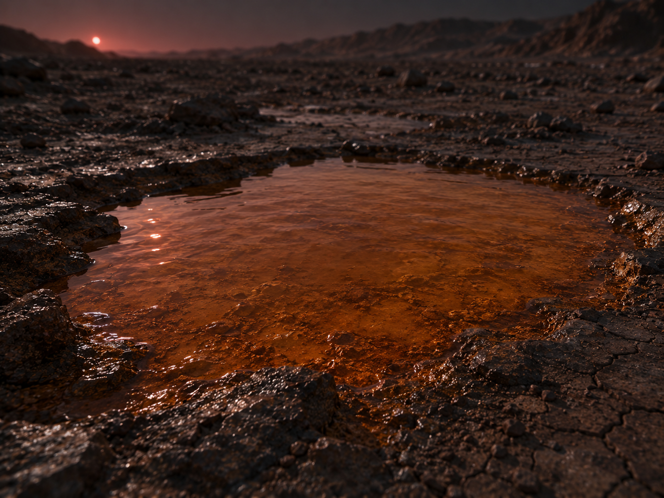

# Site: Weathered reddish boulder field
Description: A field of rounded, rust-coloured boulders scattered across the basin's edge, superficially resembling the famous iron-oxide 'blueberries' found on Mars.
Identity: Copper(I) oxide mineral (cuprite) — resembles a Mars-style hematite deposit by colour, but contains no iron. RED HERRING (no iron).
## Known Properties
Colour: Deep brick-red, faint metallic sheen in patches
Magnetism: None
Solubility: Insoluble
## Experiment Results
Measure pH: Close to neutral, pH around 6.9 (crushed sample in water)
Measure density: 6.0 g/cm3 — notably dense for a rock sample
Test electrical conductivity: Very low (crushed sample in water)
Add a magnet: No attraction
Add potassium thiocyanate solution: No colour change
Add sodium hydroxide solution: No precipitate forms
Heat a small sample gently: No visible change

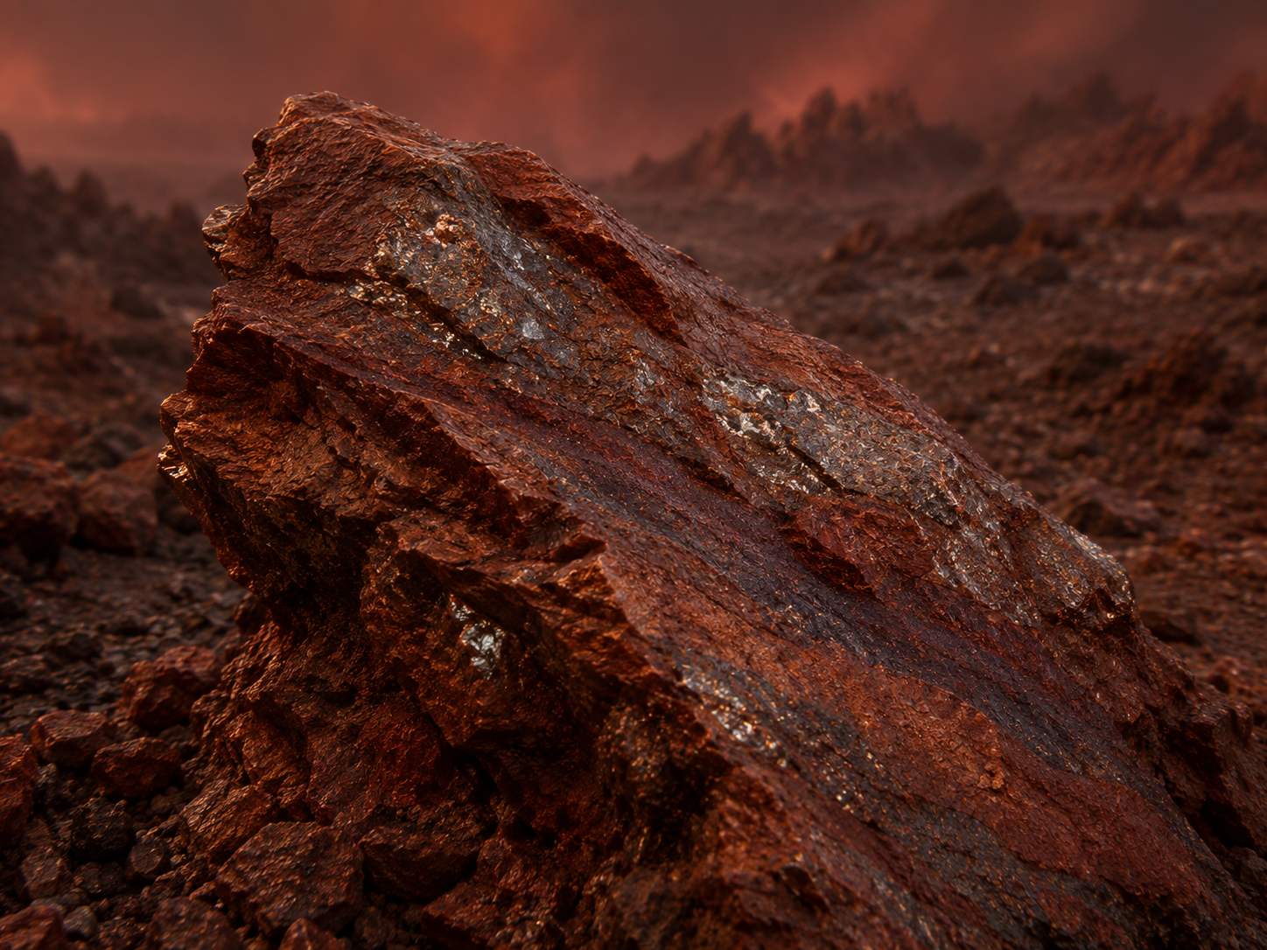
# Site: White crusty salt flat
Description: A flat expanse of pale, cracked crust nearby that crunches faintly under the rover's wheels.
Identity: Sodium chloride evaporite deposit — no iron content.
## Known Properties
Colour: White to pale grey
Solubility: Fully soluble in water
## Experiment Results
Measure pH: Neutral, pH 7
Measure density: 1.02 g/mL once dissolved at saturation
Test electrical conductivity: High
Add a magnet: No attraction
Add potassium thiocyanate solution: No colour change
Add sodium hydroxide solution: No precipitate forms
Heat a small sample gently: No visible change; the crystals don't melt or scorch at this gentle heat

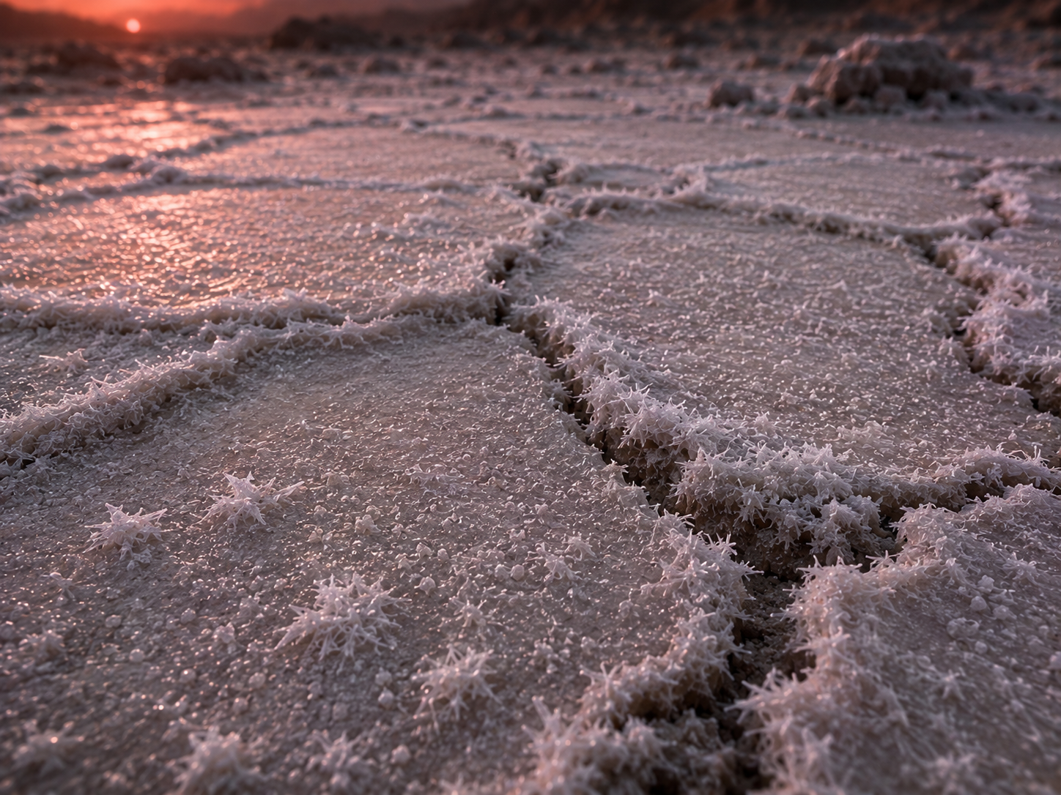
# Site: Dark metallic-looking vein
Description: A dark, almost black mineral vein embedded in the rock at the basin's rim, with a faint metallic sheen.
Identity: Nickel-rich sulfide mineral — magnetic (nickel is ferromagnetic too) but contains no iron; the trap is that magnetism alone does not mean iron here, since the true sample is a non-magnetic solution.
## Known Properties
Colour: Dark grey to black, metallic lustre
Magnetism: Moderately attracted to a magnet
Solubility: Insoluble in water
## Experiment Results
Measure pH: Neutral, pH around 7 (crushed sample in water)
Measure density: 5.4 g/cm3 — dense, but the sample does not dissolve
Test electrical conductivity: Very low (crushed sample in water)
Add a magnet: Noticeably attracted, though less strongly than a pure iron ore would be
Add potassium thiocyanate solution: No colour change
Add sodium hydroxide solution: No precipitate forms
Heat a small sample gently: No visible change

# Experiments
Measure pH
Measure density
Test electrical conductivity
Add a magnet
Add potassium thiocyanate solution
Add sodium hydroxide solution
Heat a small sample gently
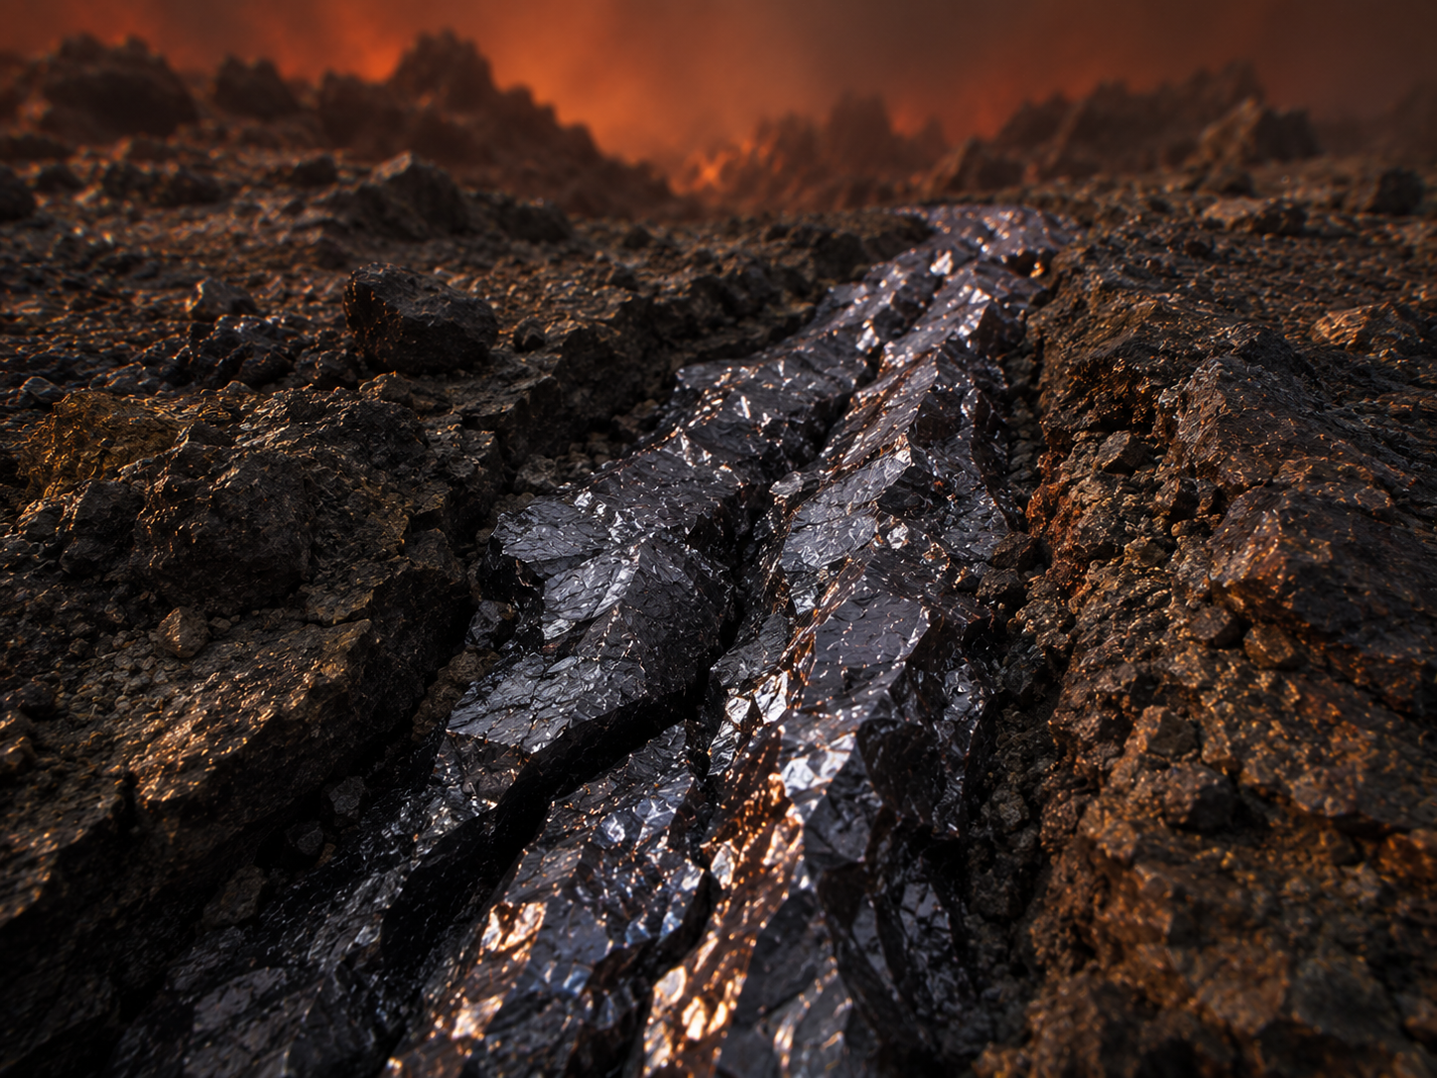
# AI Behaviour
Reveal remaining candidates after narrowing: Yes
Difficulty: Standard (15-16 years old)

# Teacher Notes
REAL SAMPLE GROUP — assign real FeCl3, medium concentration (suggested ≈0.2 M). The 'hematite-like basin' framing deliberately echoes a real Mars connection: NASA's Opportunity rover found iron-oxide-rich 'blueberries' (hematite spherules) in ancient, evaporated lake sediments at Meridian Planum — a genuine real-world precedent worth telling students directly. The red herring site (the boulder field) deliberately leans into this same Mars comparison, since it LOOKS like the famous hematite blueberries but is not iron at all — a good trap for students who pattern-match on the Mars story alone.
The white salt flat is a simple neutral decoy; the dark vein is the magnetic red herring (nickel, no iron) — the same pattern used across the other dossiers.
Real-science notes: TOI-700 d is a genuine, well-established Earth-sized habitable-zone planet, ~101 light-years away, discovered by TESS in 2020 (the first Earth-sized habitable-zone planet TESS found), orbiting its red dwarf star every 37.4 days. Its mass is still not precisely settled: an early statistical estimate gave ~1.7–1.9 Earth masses, while a newer (2024–25, still preliminary) radial-velocity measurement suggests ~2.4 Earth masses — a good example to show students that even 'known' exoplanet properties keep being refined by better data. No atmosphere has been detected; all climate/'twilight band' scenarios in the literature (e.g. Gilbert et al. 2020) are computer models of hypothetical atmospheres, not observations — make this distinction clear if students research this planet for the conference.
Sources: NASA (svs.gsfc.nasa.gov/13496); Gilbert et al. 2020 (arxiv.org/pdf/2001.00955).
Cross-subject link: Biology selective pressure for this planet — possible tidal locking means a permanent dayside and nightside with extreme temperature contrast across the twilight boundary.

