ROVER LAB — DOSSIER (55 Cancri e mission)
This file is CONFIDENTIAL. Students never see it.

# Planet
Name: 55 Cancri e (‘Janssen’)
Planet type: Ultra-hot rocky super-Earth with a permanent global lava ocean
Surface temperature: ≈1700–2400 °C on the permanently lit dayside (JWST-measured; varies between observations, possibly due to volcanic outgassing or clouds). Tidally locked.
Surface pressure: Not directly measured. A real, volatile-rich secondary atmosphere (CO/CO2-dominated) was confirmed by JWST in 2024.
Gravity: ≈2.3 g
Atmosphere: CO- and CO2-dominated, likely sustained by outgassing from the molten surface (JWST, Hu et al. 2024)

# Mission Briefing
55 Cancri e — nicknamed ‘Janssen’ — is a scorched rocky world orbiting so close to its Sun-like star that its dayside is a permanent ocean of molten rock. The rover ‘Solidus-1’ has been lowered onto a rare patch of solidified crust near the retreating edge of a lava flow, at the boundary between day and night — the only place on the whole planet solid enough, and cool enough, for a rover to operate at all. Several distinct mineral formations have been identified within reach along this narrow terminator strip. Orbital spectrometry suggests one of them is a chloride evaporite crust unusually concentrated in dissolved iron — exactly the kind of sample needed to produce iron oxide for radiation-shielding plates on the crew module still in orbit. Guide the rover to sample each formation before its brief window on the terminator closes.

# Rover
Starting energy: 100
Site visit cost: 10
Experiment cost: 15

# Overview Image
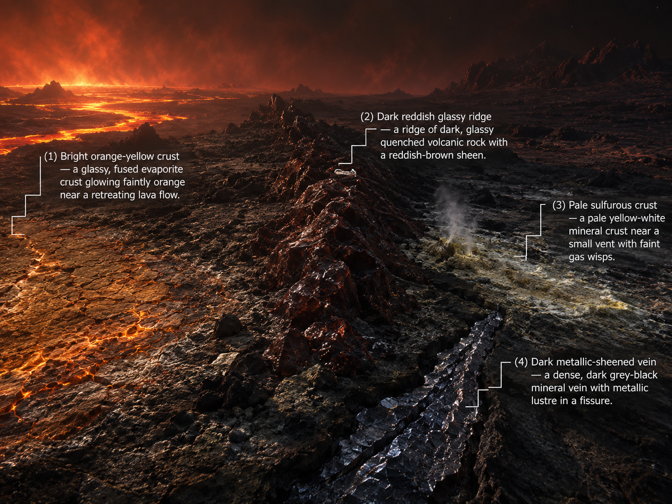

# Site: Bright orange-yellow crust at the day-night terminator
Description: A crust of fused, glassy salts rimming a cooling lava flow, glowing faintly orange in the dim terminator light.
Identity: Concentrated iron(III) chloride solution (real sample) — extreme dayside evaporation concentrates dissolved salts to unusually high levels. THE ONLY IRON-BEARING SITE. REAL SAMPLE GROUP.
## Known Properties
Colour: Deep orange-amber, darker than typical evaporite crusts
Odour: Faint, sharp
Solubility: Fully miscible with water
## Experiment Results
Measure pH: Strongly acidic, pH around 1.0–1.3
Measure density: Notably dense, around 1.4 g/mL
Test electrical conductivity: Very high
Add a magnet: No attraction
Add potassium thiocyanate solution: Turns deep blood-red almost immediately
Add sodium hydroxide solution: Forms an abundant reddish-brown gelatinous precipitate
Heat a small sample gently: Darkens slightly; no boiling yet
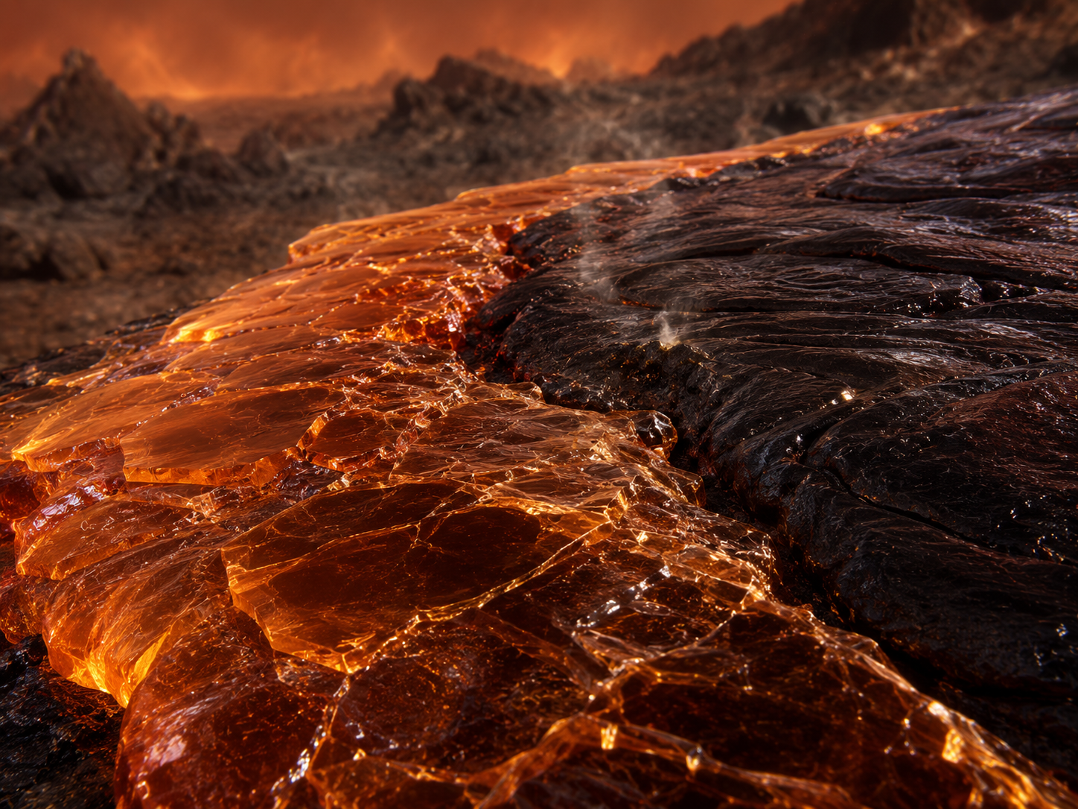

# Site: Dark reddish glassy ridge
Description: A ridge of dark, glassy rock a short distance along the terminator, quenched almost instantly when a lava flow met the cold nightside air, with a reddish-brown sheen.
Identity: Copper(I)-oxide-bearing volcanic glass — reddish colour resembles an iron-rich deposit, but contains no iron. RED HERRING (no iron).
## Known Properties
Colour: Reddish-brown with a glassy lustre
Magnetism: None
Solubility: Insoluble (crushed sample tested in water)
## Experiment Results
Measure pH: Close to neutral, pH around 6.8 (crushed sample in water)
Measure density: Notably dense for a rock sample, around 5.8 g/cm3
Test electrical conductivity: Very low (crushed sample in water)
Add a magnet: No attraction
Add potassium thiocyanate solution: No colour change
Add sodium hydroxide solution: No precipitate forms
Heat a small sample gently: No visible change
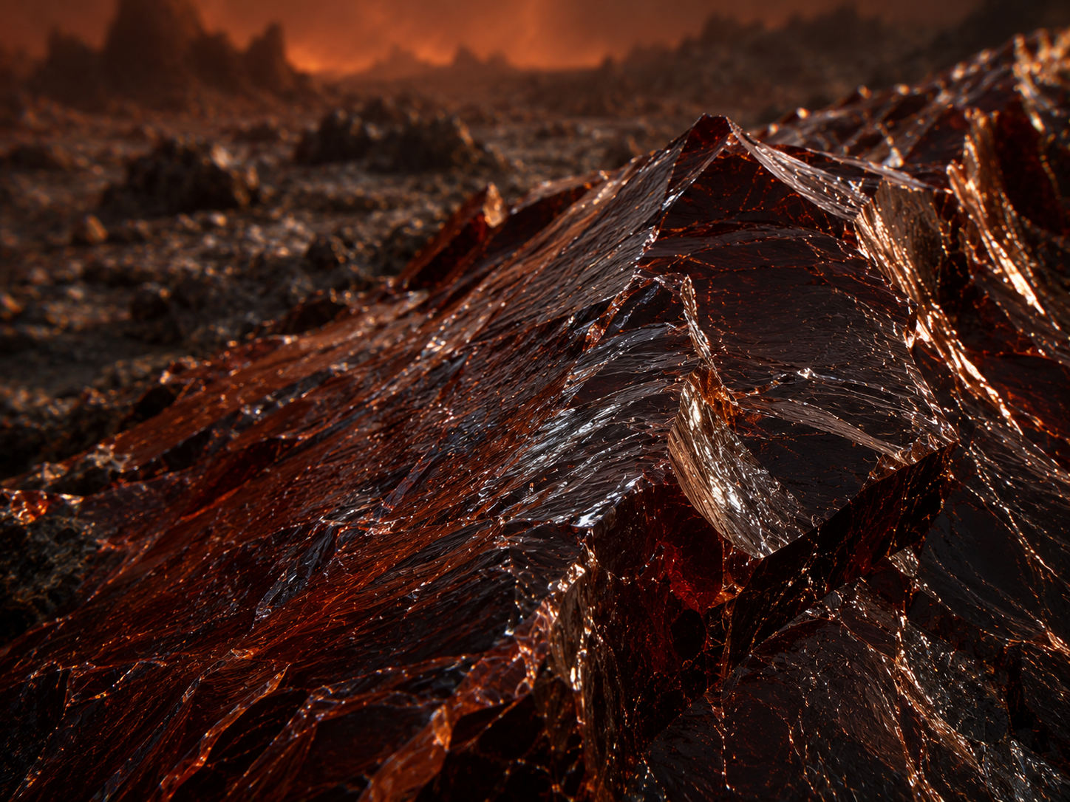

# Site: Pale sulfurous crust near a vent
Description: A pale, crusty flat downwind of a small volcanic vent, coated in fine mineral deposits left by escaping gases.
Identity: A sulfate salt crust (no iron content) formed from volcanic sulfur dioxide reacting with surface minerals.
## Known Properties
Colour: Pale yellow-white
Odour: Faint sulfurous smell
Solubility: Partially soluble
## Experiment Results
Measure pH: Mildly acidic, pH around 4.5
Measure density: 1.1 g/mL once dissolved
Test electrical conductivity: Moderate
Add a magnet: No attraction
Add potassium thiocyanate solution: No colour change
Add sodium hydroxide solution: No precipitate forms, only slight cloudiness
Heat a small sample gently: Releases a faint sulfurous smell
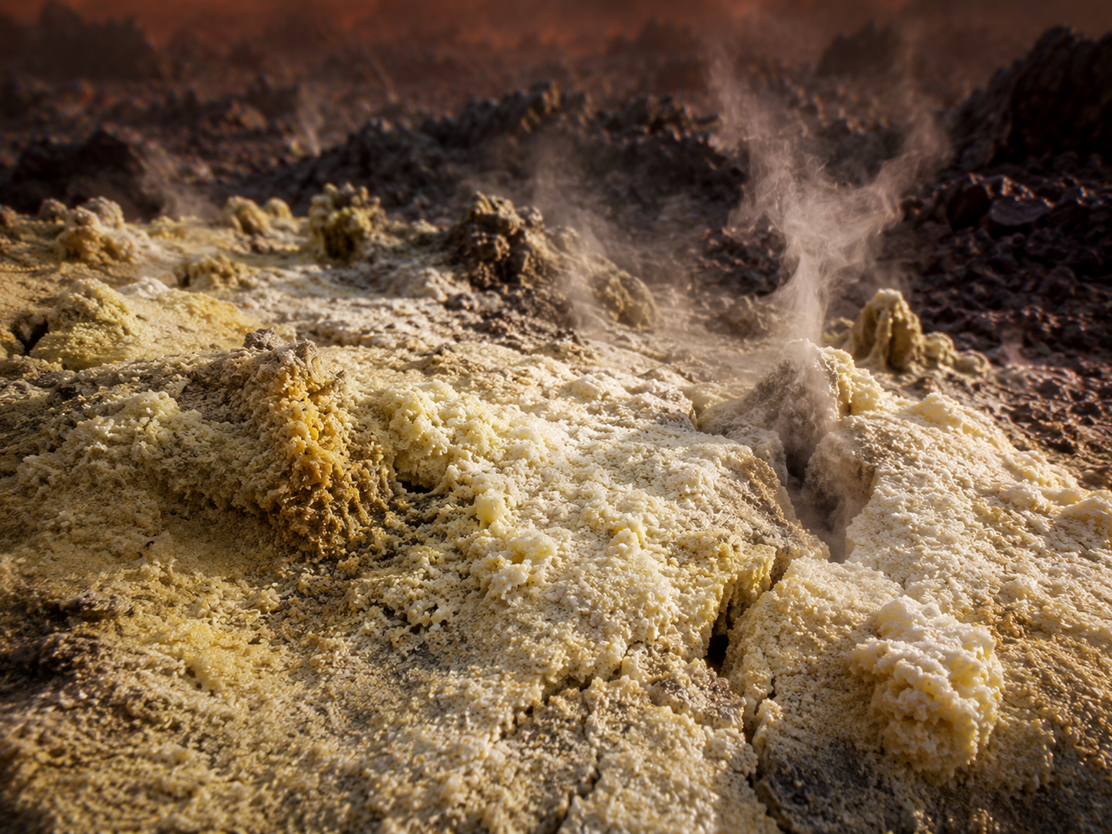

# Site: Dark metallic-sheened vein
Description: A dense, dark grey mineral vein exposed by a fresh fissure along the terminator, with a visible metallic lustre.
Identity: Nickel-rich sulfide mineral — magnetic (nickel is ferromagnetic too) but contains no iron; the trap is that magnetism alone does not mean iron here, since the true sample is a non-magnetic solution.
## Known Properties
Colour: Dark grey to black, metallic lustre
Magnetism: Moderately attracted to a magnet
Solubility: Insoluble
## Experiment Results
Measure pH: Neutral, pH around 7 (crushed sample in water)
Measure density: Dense, around 5.3 g/cm3 — does not dissolve
Test electrical conductivity: Very low (crushed sample in water)
Add a magnet: Noticeably attracted
Add potassium thiocyanate solution: No colour change
Add sodium hydroxide solution: No precipitate forms
Heat a small sample gently: No visible change

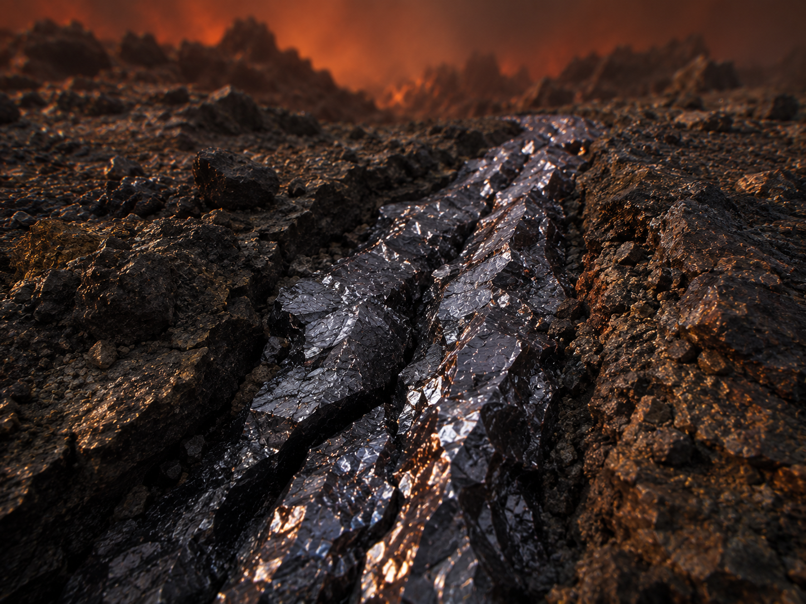
# Experiments
Measure pH
Measure density
Test electrical conductivity
Add a magnet
Add potassium thiocyanate solution
Add sodium hydroxide solution
Heat a small sample gently
# AI Behaviour
Reveal remaining candidates after narrowing: Yes
Difficulty: Standard (15-16 years old)

# Teacher Notes
REAL SAMPLE GROUP — assign an actual iron(III) chloride solution, concentrated (suggested ≈0.8 M FeCl3, adjust to your available stock). This is the most concentrated of the five real groups: 55 Cancri e is the hottest and most volcanically active planet in the set, so framing the deposit as heavily evaporated (hence concentrated) is the pedagogical link to real evaporite geology (comparable to how Earth's hottest, driest basins — e.g. the Dead Sea, Death Valley — produce the most concentrated salt deposits). In the real lab, this group should obtain the largest mass of iron oxide/hydroxide precipitate of the five real groups — the intended 'best source' result for the final conference ranking.
Of the four candidate sites, only the terminator crust (site 1) truly contains iron. The dark glassy ridge (site 2) is the red herring — resembles an iron deposit by colour but is copper-oxide based and gives no thiocyanate reaction. The sulfurous crust (site 3) is a simple neutral-ish decoy. The metallic-sheened vein (site 4) is genuinely magnetic (nickel) but iron-free — the sharpest trap, since the real sample is a non-magnetic solution. Guide students to run the potassium thiocyanate test at all four sites before concluding — it is the only test that isolates site 1 unambiguously.
Real-science notes (for you, not necessarily for students in this form): 55 Cancri e is a genuine, well-studied hot rocky exoplanet, ~41 light-years away, orbiting the Sun-like star 55 Cancri A in 17.7 hours. JWST (Hu et al. 2024, Nature) found real evidence of a volatile-rich secondary atmosphere (not vaporised rock), most likely CO/CO2 from magma outgassing — an actual 2024 measurement, not speculation. Reported dayside temperatures vary substantially between observations (~1700–2400 °C), itself a real and interesting finding (possibly patchy cloud cover or volcanic activity) — a good discussion point on measurement uncertainty in real science. There is no reported detection of chlorine, iron, or any 'evaporite basin' on 55 Cancri e — the deposit and rover mission are an invented framing built on real planetary conditions (extreme heat, volcanism, a genuine confirmed atmosphere), not an actual finding.
Sources: Hu et al. 2024, Nature (nature.com/articles/s41586-024-07432-x); NASA Exoplanet Catalog (science.nasa.gov/exoplanet-catalog/55-cancri-e).
Cross-subject link: Biology selective pressure for this planet — extreme heat and volcanic toxicity on a world with a permanent lava ocean.

