ROVER LAB — DOSSIER (WASP-76 b mission)
This file is CONFIDENTIAL. Students never see it.

# Planet
Name: WASP-76 b
Planet type: Ultra-hot, inflated gas giant (‘hot Jupiter’) — no solid surface
Surface temperature: Dayside ≈2400–2500 °C (measured); nightside ≈1500 °C (measured). Tidally locked.
Surface pressure: No solid surface — pressure increases with depth in the atmosphere; a 1 bar reference level is used by convention only.
Gravity: ≈0.7 g (surprisingly low for its mass — the planet is so puffed up by stellar heating that its radius is huge)
Atmosphere: Hydrogen/helium dominated, with confirmed atomic iron, titanium oxide, sodium, magnesium, calcium and manganese vapour detected (ESPRESSO, 2020–2022)

# Mission Briefing
WASP-76 b is a gas giant so close to its star that its dayside atmosphere reaches temperatures hot enough to vaporise iron. Astronomers have confirmed real iron vapour streaming from the scorching dayside toward the cooler nightside on winds of nearly 18,000 km/h — a phenomenon popularly described as 'iron rain'. There is no solid ground anywhere on this planet, so mission control has deployed an atmospheric probe, 'Skyhook-1', to skim several different cloud layers and collect whatever liquid or condensed droplets it can find at each, hoping to recover a sample rich enough in iron to be useful for radiation shielding back at the station. Every 'site' here is a different altitude and cloud band, not a place on the ground — the probe never touches down.

# Rover
Starting energy: 100
Site visit cost: 10
Experiment cost: 15

# Overview Image
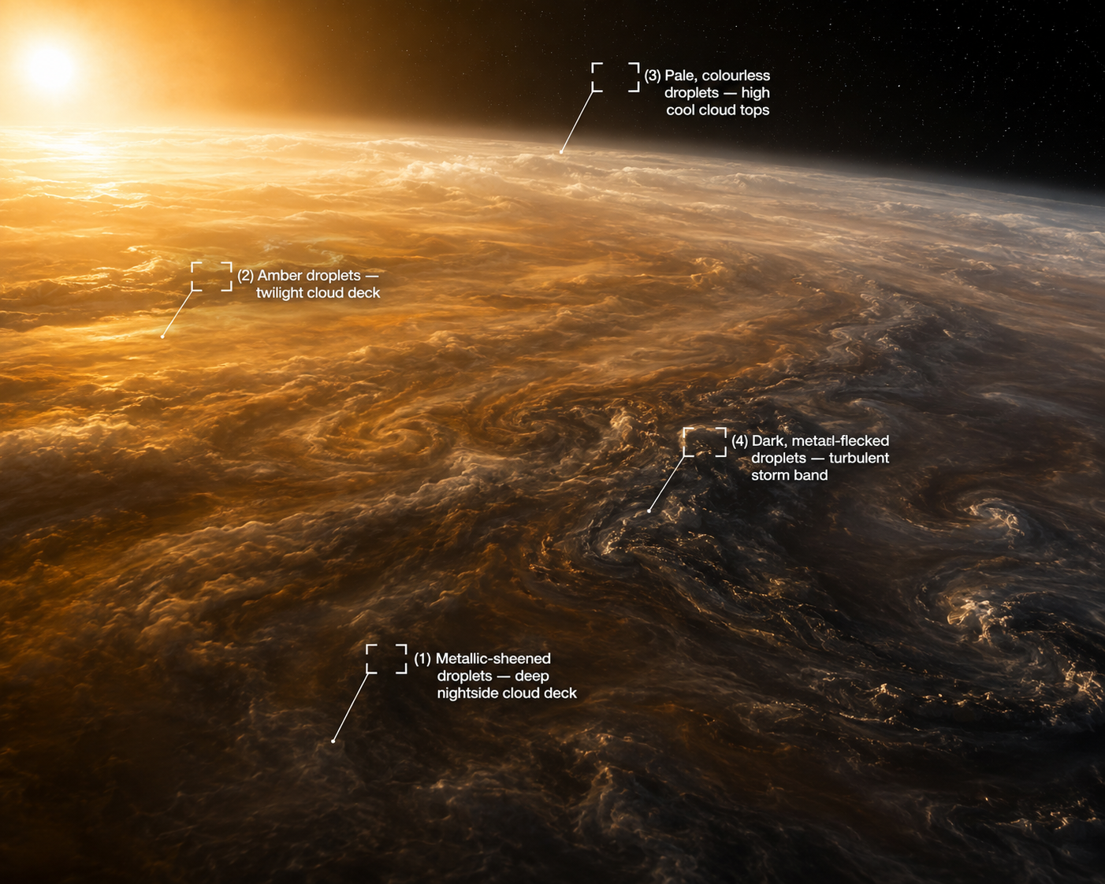

# Site: Metallic-sheened droplets from the deep nightside cloud deck
Description: A sample condensed from deep within the nightside clouds, where atmospheric models suggest metal vapours carried from the dayside cool and condense out.
Identity: NOT genuine iron(III) chloride, despite matching every rover-test signature below. Real atomic iron genuinely has been detected streaming through this planet's atmosphere, so a rover field-test reading of 'iron' here is entirely plausible and is exactly what the onboard test kit reports — but this is the planet's deliberate TWIST: students should select this site as their best candidate based on the rover evidence, and the sample physically assigned to this group for the real wet lab (a food-colourant solution engineered to reproduce this same misleadingly iron-like field-test profile) will reveal, once tested rigorously in the real lab, that it is NOT genuine iron oxide/iron(III) chloride. THE ONLY SITE THE ROVER'S TESTS INDICATE AS IRON — keep Known Properties/Experiment Results exactly as written below; they are what makes the rover convincingly (and deliberately) wrong.
## Known Properties
Colour: Dark amber, almost black, with a faint metallic sheen
Odour: Faint, sharp
Solubility: Fully miscible with water once collected
## Experiment Results
Measure pH: Strongly acidic, pH around 1.2–1.5
Measure density: Notably dense, around 1.4 g/mL
Test electrical conductivity: Very high
Add a magnet: No attraction
Add potassium thiocyanate solution: Turns deep blood-red almost immediately
Add sodium hydroxide solution: Forms an abundant reddish-brown gelatinous precipitate
Heat a small sample gently: Darkens slightly
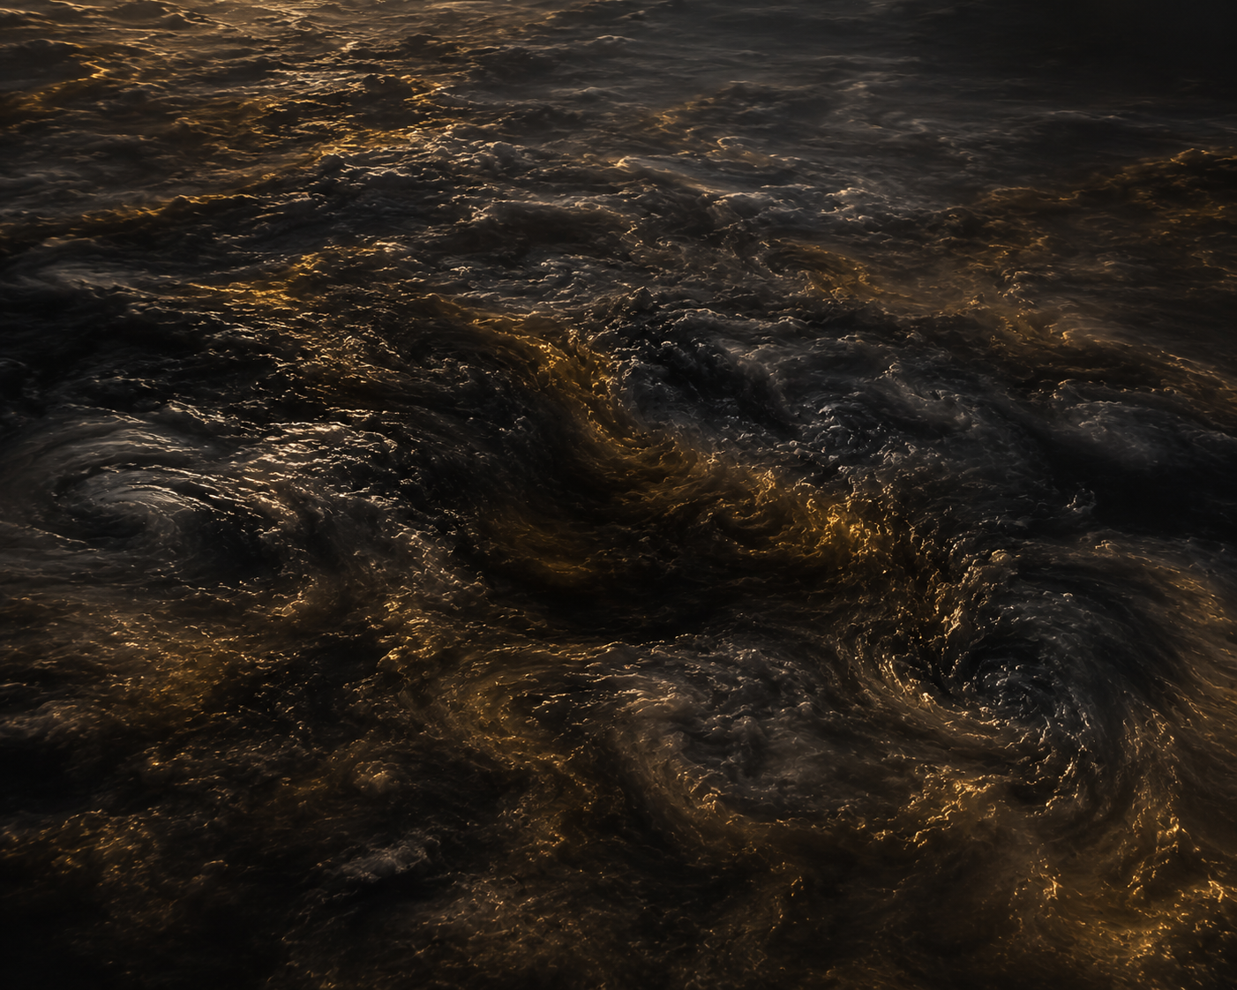

# Site: Amber droplets collected at the twilight cloud deck
Description: A sample of condensed liquid skimmed from swirling, glowing clouds at the boundary between the scorching dayside and the darker nightside.
Identity: Sodium-rich atmospheric condensate — a real class of alkali-metal vapour genuinely detected in this planet's atmosphere (ESPRESSO), but containing no iron at all. No iron content.
## Known Properties
Colour: Amber-orange, similar in hue to a concentrated salt solution
Odour: None
Solubility: Fully miscible with water
## Experiment Results
Measure pH: Close to neutral, pH around 6.5–7
Measure density: About the same as water, 1.0 g/mL
Test electrical conductivity: Moderate to high (a dissolved ionic salt)
Add a magnet: No attraction
Add potassium thiocyanate solution: No colour change
Add sodium hydroxide solution: No precipitate forms; the colour only fades slightly
Heat a small sample gently: No visible change


# Site: Pale, colourless droplets from the high, cool cloud tops
Description: A sample from far higher in the atmosphere than the others, well above the scorching depths, where simple volatile compounds are expected to condense.
Identity: A simple volatile-salt condensate (no iron) — the kind of chemistry commonly modelled in hydrogen-rich giant-planet atmospheres.
## Known Properties
Colour: Colourless to pale white
Odour: Faint, sharp/pungent
Solubility: Fully miscible with water
## Experiment Results
Measure pH: Mildly basic, pH around 8
Measure density: Close to water, 1.0 g/mL
Test electrical conductivity: Moderate
Add a magnet: No attraction
Add potassium thiocyanate solution: No colour change
Add sodium hydroxide solution: No precipitate forms; releases a faint pungent smell
Heat a small sample gently: Gives off a faint pungent odour, no residue

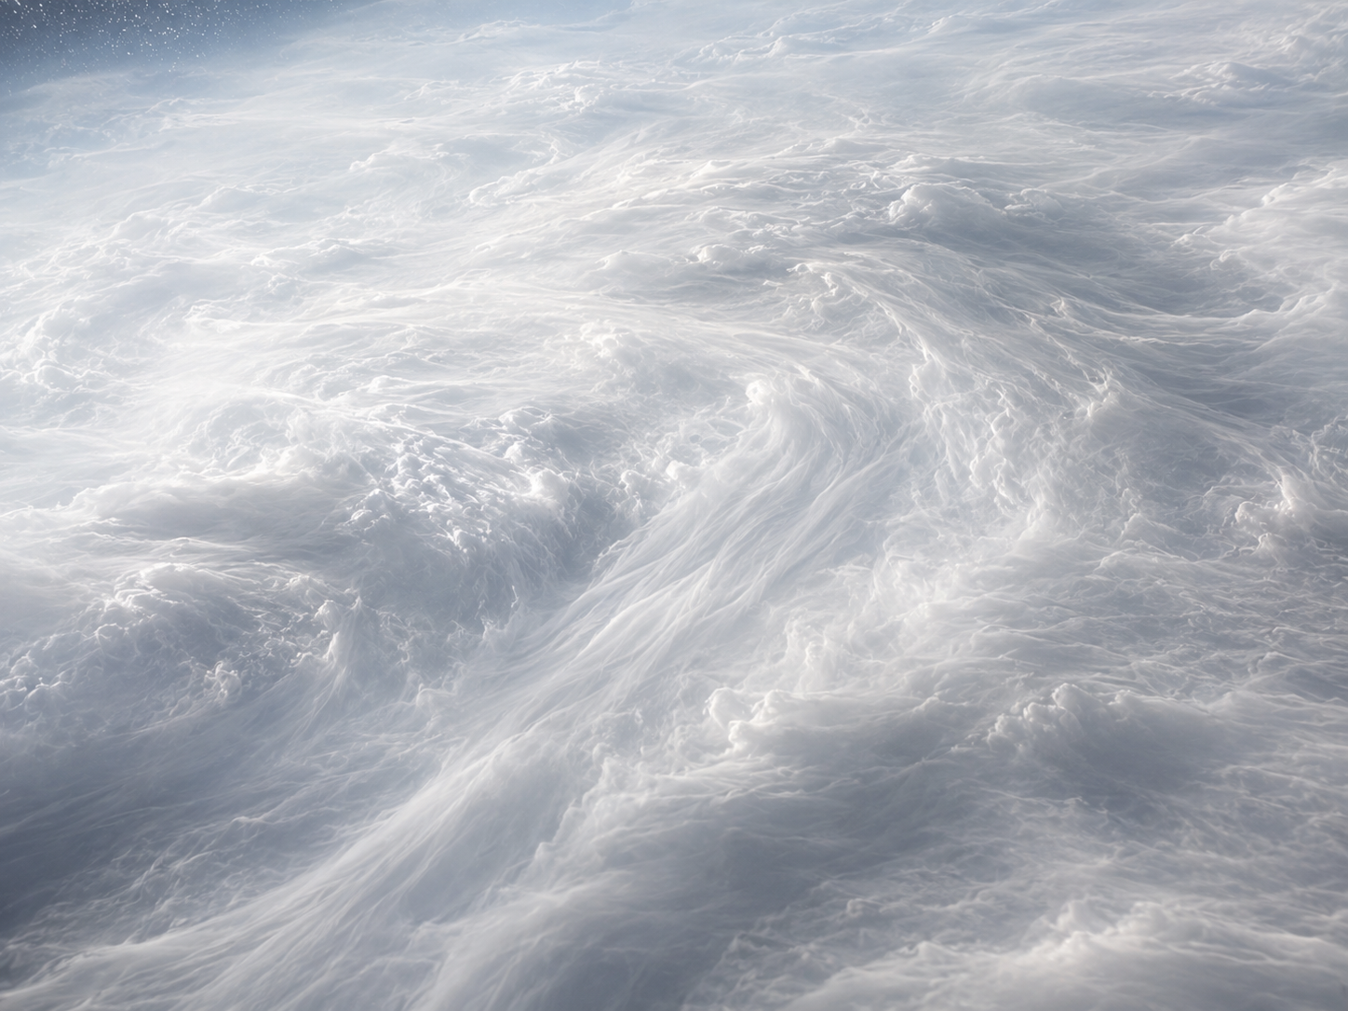
# Site: Dark, metal-flecked droplets from a turbulent storm band
Description: A turbulent sample carrying visible glinting flecks, drawn from a violent updraft thought to entrain material from deeper, hotter layers.
Identity: Suspended nickel-bearing particulates (no iron) — magnetic, but not the source of the real iron signal. RED HERRING.
## Known Properties
Colour: Dark grey with visible glinting flecks
Solubility: Partial — the liquid carries undissolved solid flecks
## Experiment Results
Measure pH: Close to neutral, pH around 7
Measure density: Moderately dense, around 1.2 g/mL, due to suspended particles
Test electrical conductivity: Low
Add a magnet: The suspended flecks are noticeably attracted to a magnet
Add potassium thiocyanate solution: No colour change
Add sodium hydroxide solution: No obvious precipitate beyond the existing suspended flecks
Heat a small sample gently: No visible change

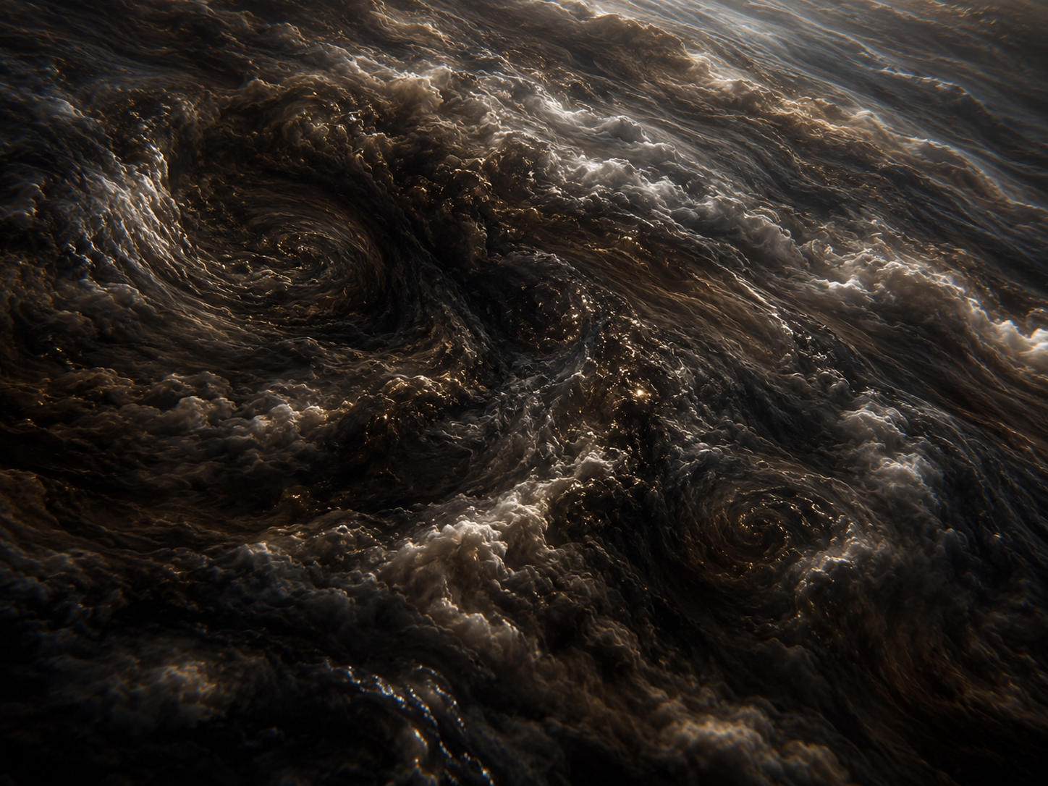
# Experiments
Measure pH
Measure density
Test electrical conductivity
Add a magnet
Add potassium thiocyanate solution
Add sodium hydroxide solution
Heat a small sample gently
# AI Behaviour
Reveal remaining candidates after narrowing: Yes
Difficulty: Standard (15-16 years old)

# Teacher Notes
DECOY GROUP — students should pick site 2 (the deep nightside condensate) after running the rover's tests, since every reading it gives is deliberately consistent with iron(III) chloride, and WASP-76b's 'iron rain' is a genuine, published finding so the field-test result is entirely plausible. The sample physically assigned to this group for the real wet lab IS site 2's sample — a food-colourant solution engineered to reproduce a misleadingly iron-like field-test profile — and it should fail under rigorous real-lab analysis (negligible or no genuine iron oxide recovered), which is the intended twist: a first rover-based guess is not the same as confirmed lab evidence. Site 1 (the twilight amber condensate) is now just an ordinary, honestly non-iron decoy (a real sodium condensate, unrelated to the twist) — students who test it should correctly rule it out from the rover stage alone.
Among the four sites, site 1 (twilight condensate) and site 3 (high cloud-top condensate) are simple neutral decoys, and site 4 (storm-band particulates) is the magnetic red herring — genuinely magnetic (nickel) but not the true iron signal, since site 2 (the one that fools the rover) is not itself magnetic. Use this in the final conference discussion: even a planet with dramatic, confirmed iron chemistry can be a poor (or literally impossible) source of a physical iron sample, since there is no solid surface anywhere to land a rover on and recover a real sample from.
Real-science notes: WASP-76 b is a genuine, well-studied ultra-hot Jupiter ~620–640 light-years away (distance estimates vary slightly by source), discovered in 2013 (SuperWASP), orbiting its star in just 1.8 days. Ehrenreich et al. 2020 (Nature, ESPRESSO spectrograph) detected real atomic iron absorption, strong on the dayside and weak/absent on the nightside — interpreted as iron vapour condensing on the night side. Important nuance for your own understanding: the popular 'iron rain' description is a simplification; follow-up work (Wardenier et al. 2021) shows a simple day-night temperature difference could reproduce the same signal without literal condensation/rain, and high-altitude mineral clouds may also be involved. The iron detection itself is solid; the 'rain' mechanism is genuinely still debated — a nice real example of how a popular-science headline can outrun the nuance of the actual paper.
Sources: Ehrenreich et al. 2020, Nature (nature.com/articles/s41586-020-2107-1); Wardenier et al. 2021, ApJ (iopscience.iop.org/article/10.3847/1538-4357/ac423f).
Cross-subject link: Biology selective pressure for this planet — (hypothetical) life adapted to floating in gas-giant clouds with ~900 °C day-night temperature swings and iron-vapour-laden winds — a thought experiment in the spirit of real 'aerial biosphere' hypotheses proposed for gas giants (Sagan & Salpeter 1976).

