ROVER LAB — DOSSIER (GJ 1214 b mission)
This file is CONFIDENTIAL. Students never see it.

# Planet
Name: GJ 1214 b
Planet type: Warm sub-Neptune (‘steam / haze world’) — no solid surface
Surface temperature: ≈280 °C dayside / ≈164 °C nightside (both JWST-measured)
Surface pressure: No solid surface; deep, high-pressure atmosphere
Gravity: ≈1.13 g
Atmosphere: Thick, high-altitude haze/clouds (measured, high Bond albedo ~0.51); likely a metal-rich, high-metallicity atmosphere with tentative (unconfirmed) hints of water vapour and CO2 beneath the haze

# Mission Briefing
GJ 1214 b is a warm, cloud-choked world where a thick haze hides the atmosphere's true composition from orbit — one of the most-studied 'mystery' planets of its kind. A probe, 'Haze-runner', has punched through the cloud deck at several altitudes, returning samples of tinted condensate from each layer. Given how metal-rich this atmosphere appears to be, mission control wonders whether one of these could be a concentrated iron-bearing brine, but the thick clouds have made it impossible to confirm anything remotely — every sample will have to speak for itself. There is no surface here at all: each 'site' is a different depth within the haze, never solid ground.

# Rover
Starting energy: 100
Site visit cost: 10
Experiment cost: 15

# Overview Image
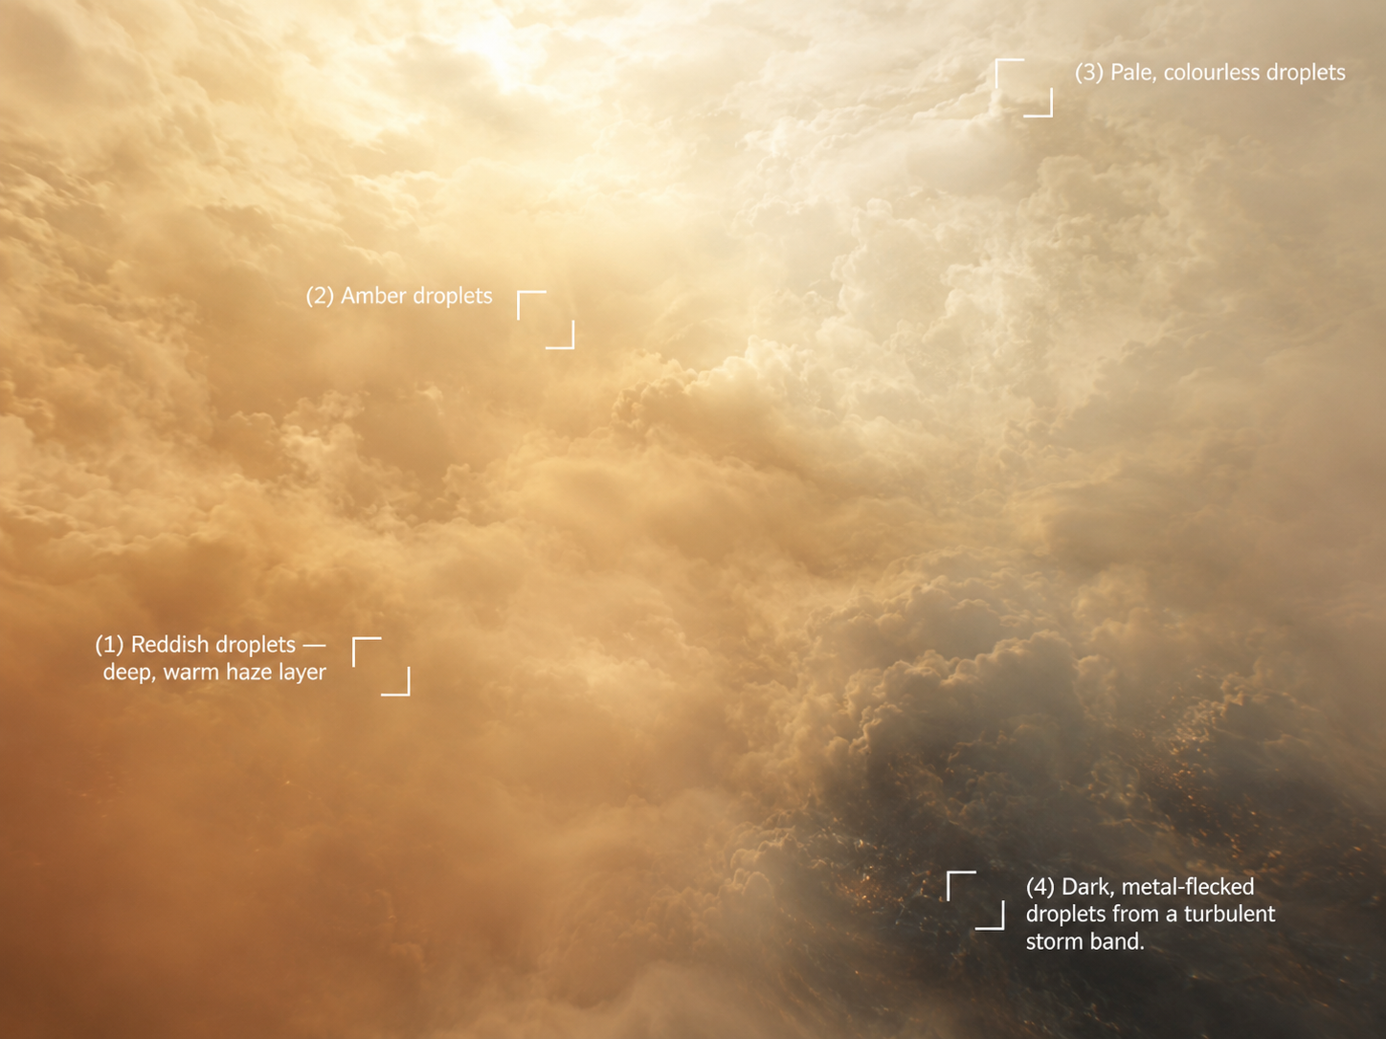

# Site: Reddish droplets from a deep, warm haze layer
Description: A sample from deep within the haze, considerably warmer than the layers above, where the atmosphere's real high metal content is expected to be most concentrated.
Identity: NOT genuine iron(III) chloride, despite matching every rover-test signature below. This planet's atmosphere is genuinely, measurably metal-rich, so a rover field-test reading of 'iron' here is entirely plausible and is exactly what the onboard test kit reports — but this is the planet's deliberate TWIST: students should select this site as their best candidate based on the rover evidence, and the sample physically assigned to this group for the real wet lab (a food-colourant solution engineered to reproduce this same misleadingly iron-like field-test profile) will reveal, once tested rigorously in the real lab, that it is NOT genuine iron oxide/iron(III) chloride. THE ONLY SITE THE ROVER'S TESTS INDICATE AS IRON — keep Known Properties/Experiment Results exactly as written below; they are what makes the rover convincingly (and deliberately) wrong.
## Known Properties
Colour: Deep orange-red
Odour: Faint, sharp
Solubility: Fully miscible with water
## Experiment Results
Measure pH: Strongly acidic, pH around 1.3–1.6
Measure density: 1.35 g/mL
Test electrical conductivity: Very high
Add a magnet: No attraction
Add potassium thiocyanate solution: Turns deep blood-red almost immediately
Add sodium hydroxide solution: Forms an abundant reddish-brown gelatinous precipitate
Heat a small sample gently: Darkens further; the sample is already warm from its depth


# Site: Amber droplets from deep within the haze layer
Description: A vial of orange, slightly cloudy liquid collected from deep inside the planet's dense, swirling haze layer.
Identity: A sulfur-bearing photochemical haze condensate — a real class of aerosol proposed for hot, high-metallicity sub-Neptune atmospheres like this one. No iron content.
## Known Properties
Colour: Orange, slightly turbid
Odour: None
Solubility: Fully miscible with water
## Experiment Results
Measure pH: Close to neutral, pH around 6.5–7
Measure density: About 1.0 g/mL
Test electrical conductivity: Low
Add a magnet: No attraction
Add potassium thiocyanate solution: No colour change
Add sodium hydroxide solution: No precipitate forms
Heat a small sample gently: No visible change


# Site: Pale, colourless droplets from the high reflective cloud deck
Description: A sample from the bright, reflective upper cloud deck responsible for this planet's unusually high measured albedo.
Identity: A simple high-altitude condensate (no iron content), consistent with the reflective haze particles measured from orbit.
## Known Properties
Colour: Milky white to pale
Odour: None
Solubility: Fully miscible, forms a slightly cloudy solution
## Experiment Results
Measure pH: Close to neutral, pH around 6.5–7
Measure density: About 1.0 g/mL
Test electrical conductivity: Low
Add a magnet: No attraction
Add potassium thiocyanate solution: No colour change
Add sodium hydroxide solution: No precipitate forms; the cloudiness clears slightly
Heat a small sample gently: No visible change

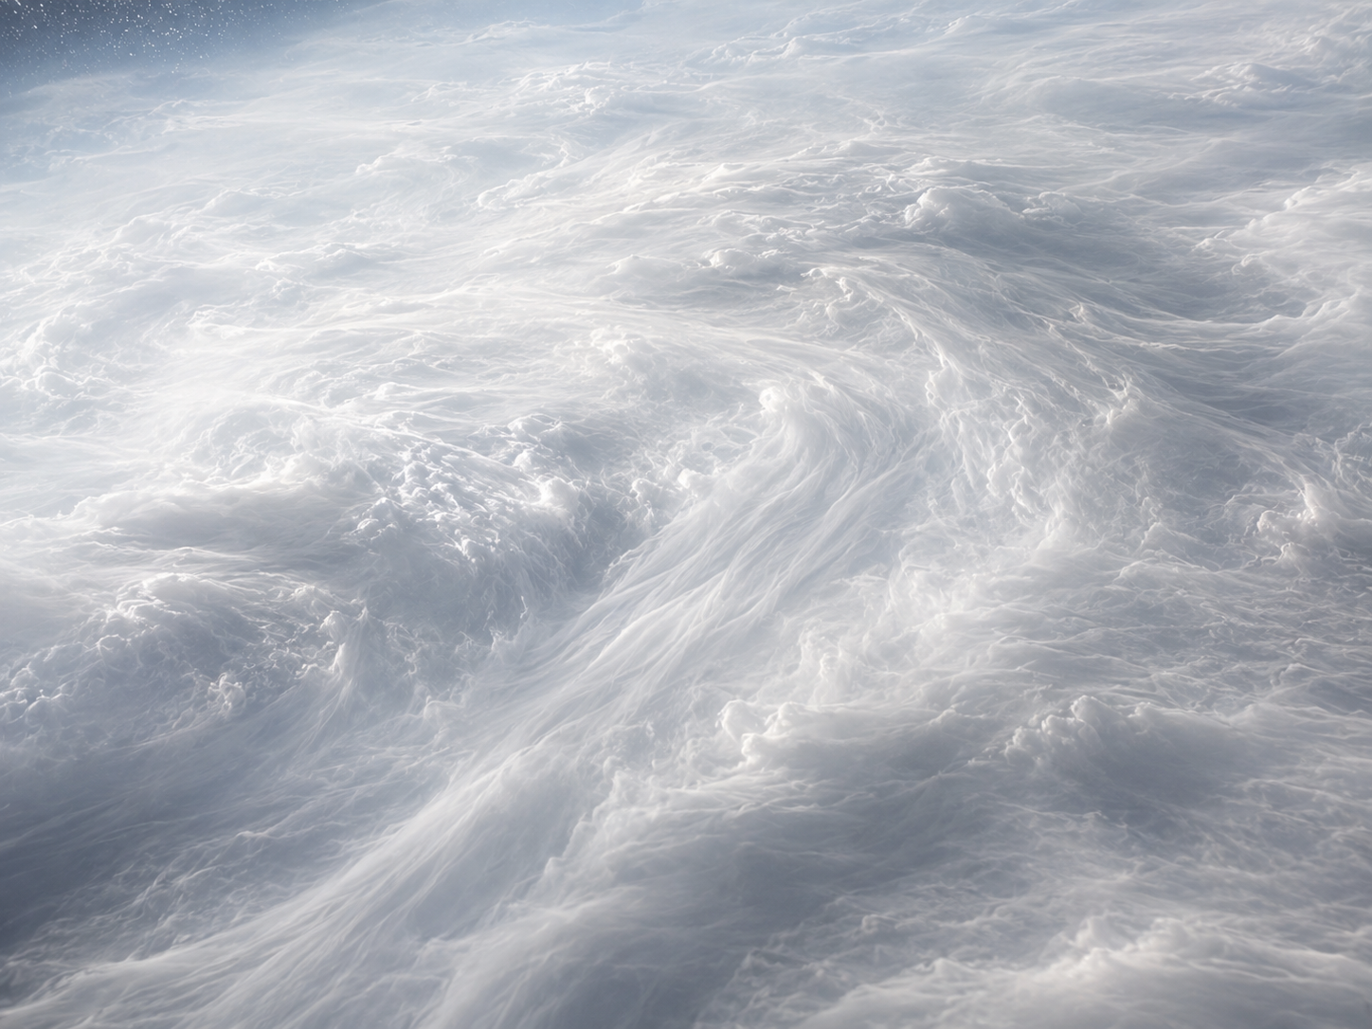
# Site: Dark metal-flecked droplets from a turbulent storm band
Description: A turbulent sample carrying visible dark speckles, drawn from a deep, violent layer known to entrain solid particulates.
Identity: Suspended nickel-bearing particulates (no iron) — magnetic, but not the source of the real iron signal. RED HERRING.
## Known Properties
Colour: Grey with dark speckles
Solubility: Partial — the particulates do not fully dissolve
## Experiment Results
Measure pH: Neutral, pH around 7
Measure density: 1.1 g/mL
Test electrical conductivity: Low
Add a magnet: Noticeably attracted
Add potassium thiocyanate solution: No colour change
Add sodium hydroxide solution: No obvious precipitate
Heat a small sample gently: No visible change

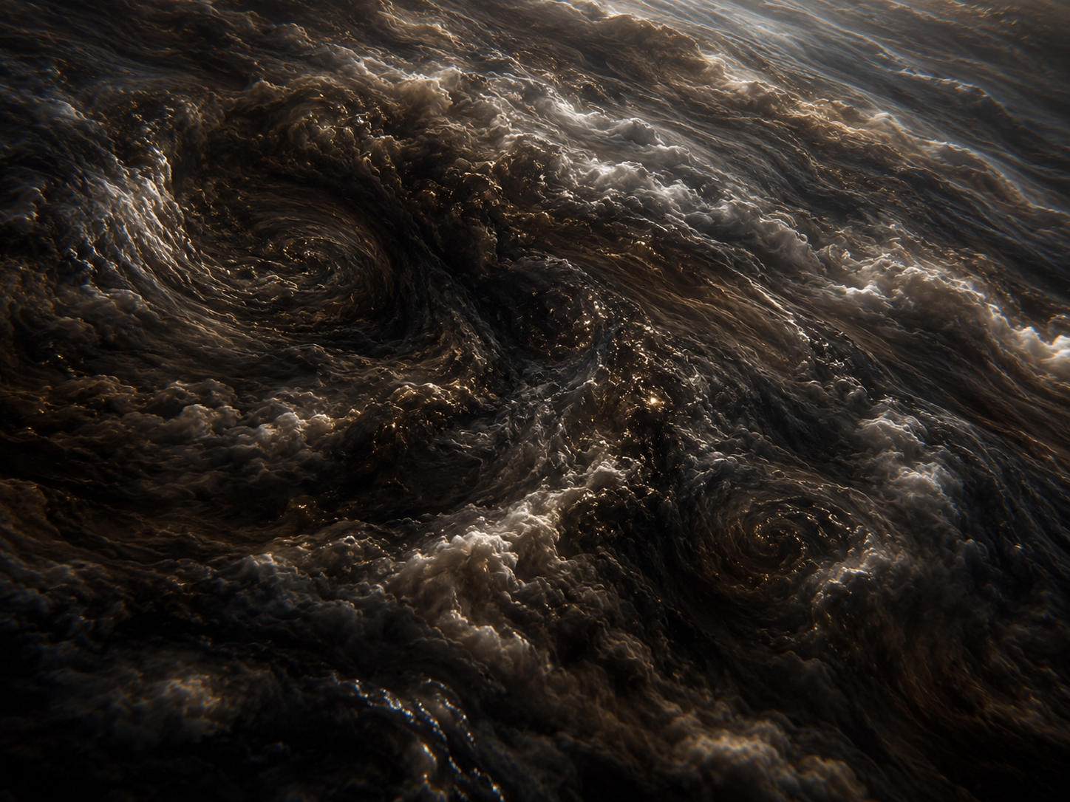
# Experiments
Measure pH
Measure density
Test electrical conductivity
Add a magnet
Add potassium thiocyanate solution
Add sodium hydroxide solution
Heat a small sample gently
# AI Behaviour
Reveal remaining candidates after narrowing: Yes
Difficulty: Standard (15-16 years old)

# Teacher Notes
DECOY GROUP — students should pick site 1 (the deep warm haze layer) after running the rover's tests, since every reading it gives is deliberately consistent with iron(III) chloride, and this planet's genuinely metal-rich, hazy atmosphere makes that reading entirely plausible. The sample physically assigned to this group for the real wet lab IS site 1's sample — a food-colourant solution engineered to reproduce a misleadingly iron-like field-test profile — and it should fail under rigorous real-lab analysis (negligible or no genuine iron oxide recovered), which is the intended twist: the planet's real atmospheric chemistry below the haze is still an open scientific question, and a first rover-based guess is not the same as confirmed lab evidence. Site 2 (the orange haze condensate) is now just an ordinary, honestly non-iron decoy, unrelated to the twist.
Site 3 (high reflective cloud deck) is a simple neutral decoy tied to this planet's real measured high albedo; site 4 (deep turbulent layer) is the magnetic red herring (nickel, no iron) and not itself the site that fools the rover.
Real-science notes: GJ 1214b is a genuine, much-studied sub-Neptune, ~48 light-years away, discovered in 2009, orbiting its red dwarf star in just 1.58 days. Pre-JWST spectra were famously flat/featureless, which was itself informative (ruled out a clear, low-metallicity H/He atmosphere). JWST (Kempton et al. 2023, Nature) directly measured a high Bond albedo (~0.51) and large day-night temperature swing, both real measurements pointing to reflective high-altitude clouds/haze and a high-metallicity atmosphere. Later JWST work (2024–2025) found tentative (not confirmed) hints of water vapour and CO2 beneath the haze. Whether the planet has a genuine deep water ocean or is closer to a metal-rich 'super-Venus' with no ocean at all is still actively debated — present as an open question if students research it.
Sources: Kempton et al. 2023, Nature (nature.com/articles/s41586-023-05951-7); follow-up 2025 (iopscience.iop.org/article/10.3847/2041-8213/ada02c).
Cross-subject link: Biology selective pressure for this planet — crushing atmospheric pressure and a permanent haze that blocks almost all sunlight from reaching lower layers.

