ROVER LAB — DOSSIER (LHS 1140 b mission)
This file is CONFIDENTIAL. Students never see it.

# Planet
Name: LHS 1140 b
Planet type: Dense, water-rich rocky super-Earth
Surface temperature: ≈–40 °C equilibrium estimate (range –45 to –38 °C)
Surface pressure: Not directly measured; JWST data hint at (not yet confirmed) a thin nitrogen- or CO2-dominated atmosphere
Gravity: ≈1.9 g
Atmosphere: A hydrogen-rich atmosphere has been firmly ruled out (JWST, >10σ); tentative, unconfirmed evidence points toward a thin N2- or CO2-dominated atmosphere

# Mission Briefing
LHS 1140 b is a dense, cold rocky super-Earth thought to hold a substantial fraction of water ice and rock, orbiting a quiet, calm red dwarf. The rover 'Frostline-1' has landed near a shallow, frozen basin at the planet's mild sub-stellar region, where several distinct frost-rimmed mineral formations have been detected. Orbital data suggest one of them could be an ancient brine, slowly concentrated over eons as the surface froze and thawed at the edges of a retreating ocean. Mission control hopes it contains enough dissolved iron to be worth mining for the base's radiation shielding.

# Rover
Starting energy: 100
Site visit cost: 10
Experiment cost: 15

# Overview Image
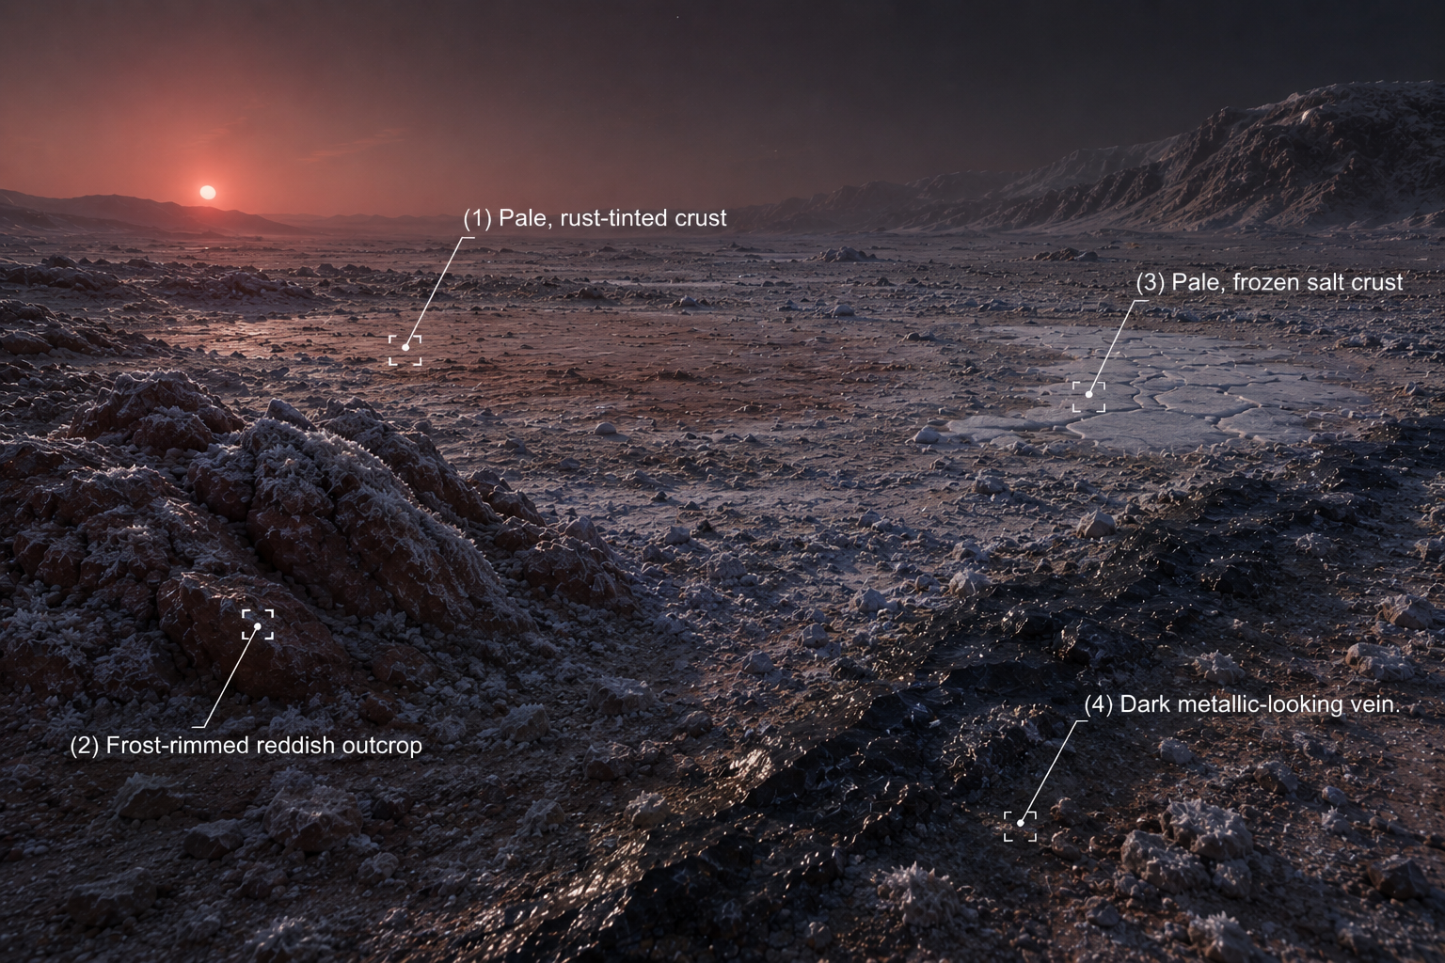

# Site: Pale, rust-tinted crust at the basin's edge
Description: A thin, frost-rimmed crust with a faint rusty tint, cracking underfoot at the edge of a shallow frozen basin.
Identity: Iron(III) chloride solution (real sample) — medium-low concentration. THE ONLY IRON-BEARING SITE. REAL SAMPLE GROUP.
## Known Properties
Colour: Pale yellow-orange, lighter than more concentrated samples
Odour: Very faint
Solubility: Fully miscible with water
## Experiment Results
Measure pH: Mildly acidic, pH around 2.3–2.6
Measure density: 1.06 g/mL
Test electrical conductivity: Moderate
Add a magnet: No attraction
Add potassium thiocyanate solution: Turns red, though less intensely than a more concentrated sample
Add sodium hydroxide solution: Forms a light reddish-brown precipitate
Heat a small sample gently: No strong visible change
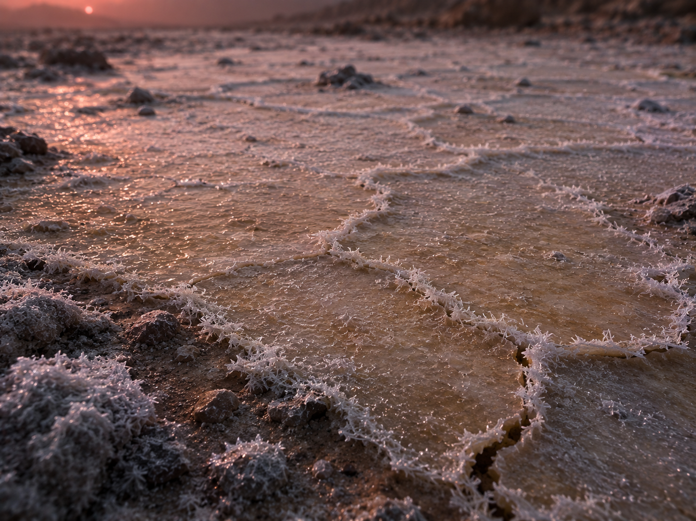

# Site: Frost-rimmed reddish outcrop
Description: A weathered, rust-red rock formation a short distance from the basin, dusted with frost and showing a faint metallic sheen in places.
Identity: Copper(I) oxide mineral (cuprite) — reddish colour resembles iron oxide but contains no iron. RED HERRING (no iron).
## Known Properties
Colour: Deep brick-red, faint metallic sheen in patches
Magnetism: None
Solubility: Insoluble
## Experiment Results
Measure pH: Close to neutral, pH around 6.9 (crushed sample in water)
Measure density: 6.0 g/cm3 — notably dense for a rock sample
Test electrical conductivity: Very low (crushed sample in water)
Add a magnet: No attraction
Add potassium thiocyanate solution: No colour change
Add sodium hydroxide solution: No precipitate forms
Heat a small sample gently: No visible change
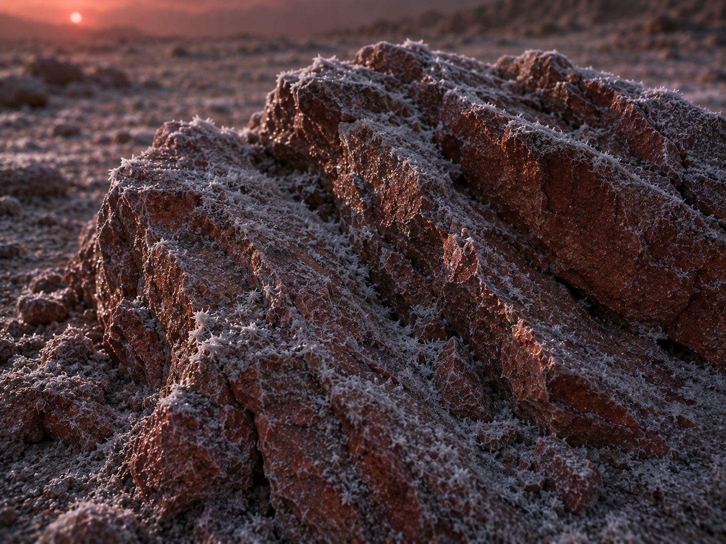

# Site: Pale, frozen salt crust
Description: A flat expanse of pale, frost-crusted salt nearby that crunches faintly under the rover's wheels.
Identity: Sodium chloride evaporite deposit, preserved by the cold — no iron content.
## Known Properties
Colour: White to pale grey
Solubility: Fully soluble in water
## Experiment Results
Measure pH: Neutral, pH 7
Measure density: 1.02 g/mL once dissolved at saturation
Test electrical conductivity: High
Add a magnet: No attraction
Add potassium thiocyanate solution: No colour change
Add sodium hydroxide solution: No precipitate forms
Heat a small sample gently: No visible change; the crystals don't melt or scorch at this gentle heat
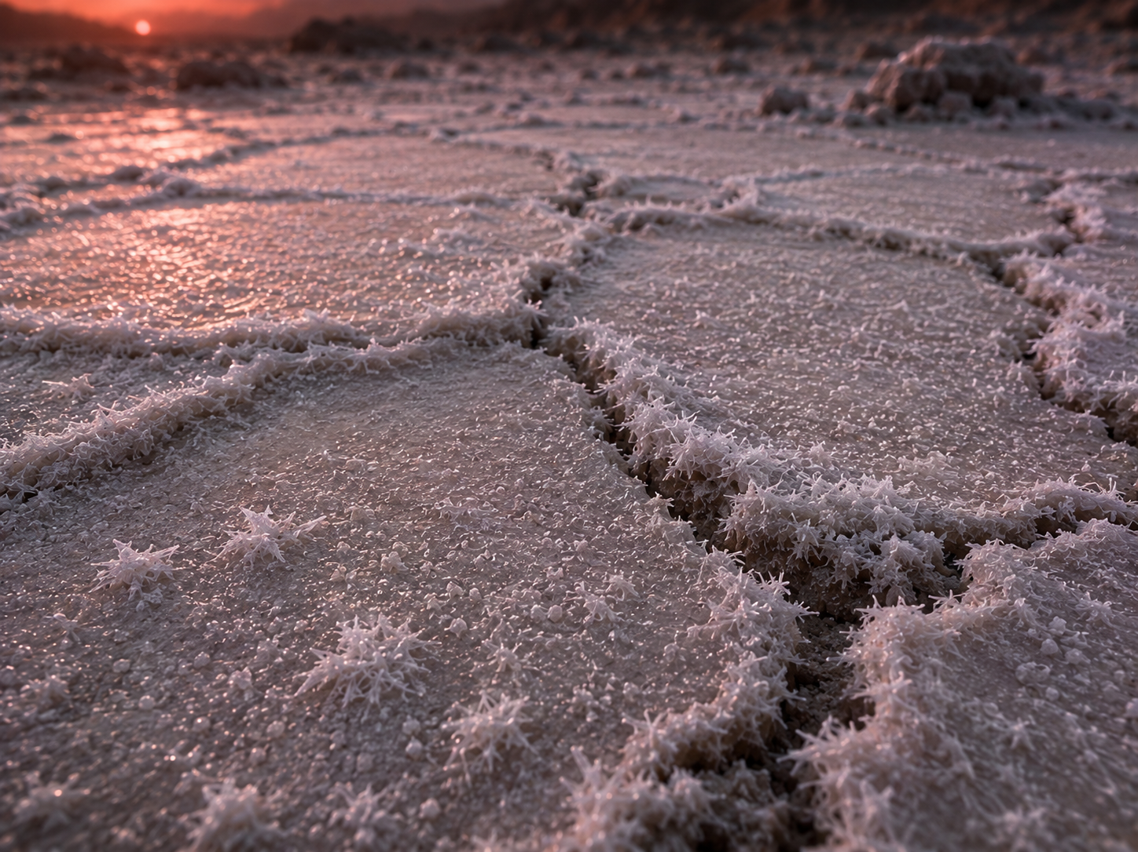

# Site: Dark metallic-looking vein
Description: A dark, almost black mineral vein exposed by a frost-cracked fissure near the basin, with a faint metallic sheen.
Identity: Nickel-rich sulfide mineral — magnetic (nickel is ferromagnetic too) but contains no iron; the trap is that magnetism alone does not mean iron here, since the true sample is a non-magnetic solution.
## Known Properties
Colour: Dark grey to black, metallic lustre
Magnetism: Moderately attracted to a magnet
Solubility: Insoluble in water
## Experiment Results
Measure pH: Neutral, pH around 7 (crushed sample in water)
Measure density: 5.4 g/cm3 — dense, but the sample does not dissolve
Test electrical conductivity: Very low (crushed sample in water)
Add a magnet: Noticeably attracted, though less strongly than a pure iron ore would be
Add potassium thiocyanate solution: No colour change
Add sodium hydroxide solution: No precipitate forms
Heat a small sample gently: No visible change

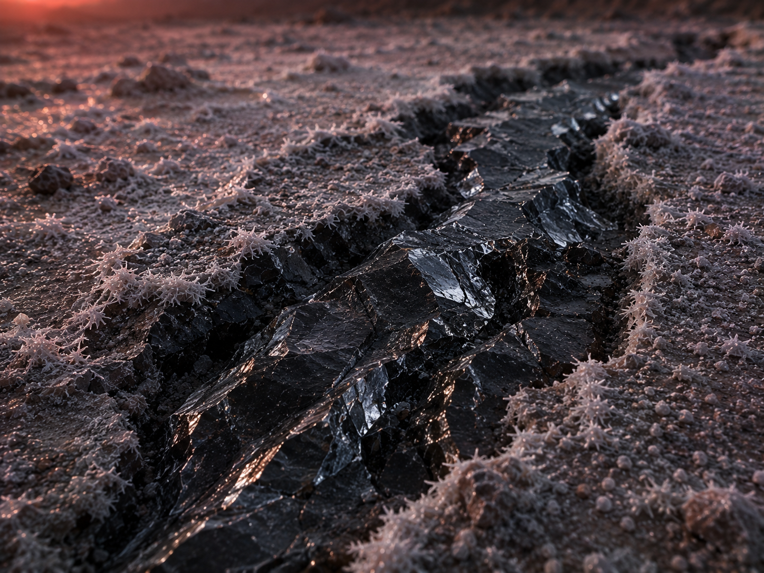
# Experiments
Measure pH
Measure density
Test electrical conductivity
Add a magnet
Add potassium thiocyanate solution
Add sodium hydroxide solution
Heat a small sample gently
# AI Behaviour
Reveal remaining candidates after narrowing: Yes
Difficulty: Standard (15-16 years old)

# Teacher Notes
REAL SAMPLE GROUP — assign real FeCl3, medium-low concentration (suggested ≈0.1 M). LHS 1140b is cold and likely water/ice-rich, so it's framed as more dilute than the hotter, drier planets, continuing the evaporation-concentration logic used across the other real groups.
The frost-rimmed outcrop is the colour red herring (cuprite, non-magnetic); the frozen salt crust is a neutral decoy; the dark vein is the magnetic red herring (nickel, no iron) — the same pattern used across the other dossiers, adapted to a frost/frozen-basin setting.
Real-science notes: LHS 1140b is a genuine, actively studied rocky exoplanet, ~48.8 light-years away, discovered in 2017 (MEarth Project), orbiting its red dwarf every 24.7 days. It is widely considered one of the single best real targets for eventually detecting a genuine rocky-exoplanet atmosphere, precisely because its high gravity and low stellar irradiation make atmospheric loss less likely than for most other candidates. Its measured density (recomputed in 2024, Cadieux et al.) is too high for a gas-rich mini-Neptune and instead points to a rocky planet with a substantial water-rich layer (roughly 9–19% water by mass) — a genuine 'water world' candidate. JWST has firmly ruled out a hydrogen-rich atmosphere and found tentative (unconfirmed) hints consistent with a thin nitrogen- or CO2-dominated atmosphere — the lead author has said more telescope time is needed to confirm this. No iron or chloride detection of any kind exists for this planet; as with the others, the mission/deposit is an invented framing.
Sources: Cadieux et al. 2024, ApJL (iopscience.iop.org/article/10.3847/2041-8213/ad5204); arXiv (arxiv.org/pdf/2406.15136).
Cross-subject link: Biology selective pressure for this planet — very dim red-dwarf starlight combined with unusually high surface gravity (~1.9 g).

