ROVER LAB — DOSSIER (TRAPPIST-1 g mission)
This file is CONFIDENTIAL. Students never see it.

# Planet
Name: TRAPPIST-1 g
Planet type: Cold rocky planet at the outer edge of the TRAPPIST-1 habitable zone
Surface temperature: ≈–76 °C equilibrium estimate. Tidally locked.
Surface pressure: Not measured; no atmosphere detected
Gravity: ≈1.04 g (essentially Earth-like)
Atmosphere: Unconfirmed. Theoretical models suggest either a global ice-covered ocean or a thick primordial steam atmosphere, but neither has been observed.

# Mission Briefing
TRAPPIST-1 g is the coldest of the temperate worlds in the TRAPPIST-1 system, likely locked in a permanent deep freeze except for a narrow band near its sunward face. The rover 'Terra-g' — a sister unit to the one exploring TRAPPIST-1 e closer to the star — has reached a pale, ice-crusted flat near the terminator, where several distinct frozen and mineral formations have been identified within its reach. Given how little evaporation happens on such a cold world, mission control expects any dissolved salts here to be far more dilute than on TRAPPIST-1 e, but even a weak signal of iron would be worth confirming for a future outpost.

# Rover
Starting energy: 100
Site visit cost: 10
Experiment cost: 15

# Overview Image
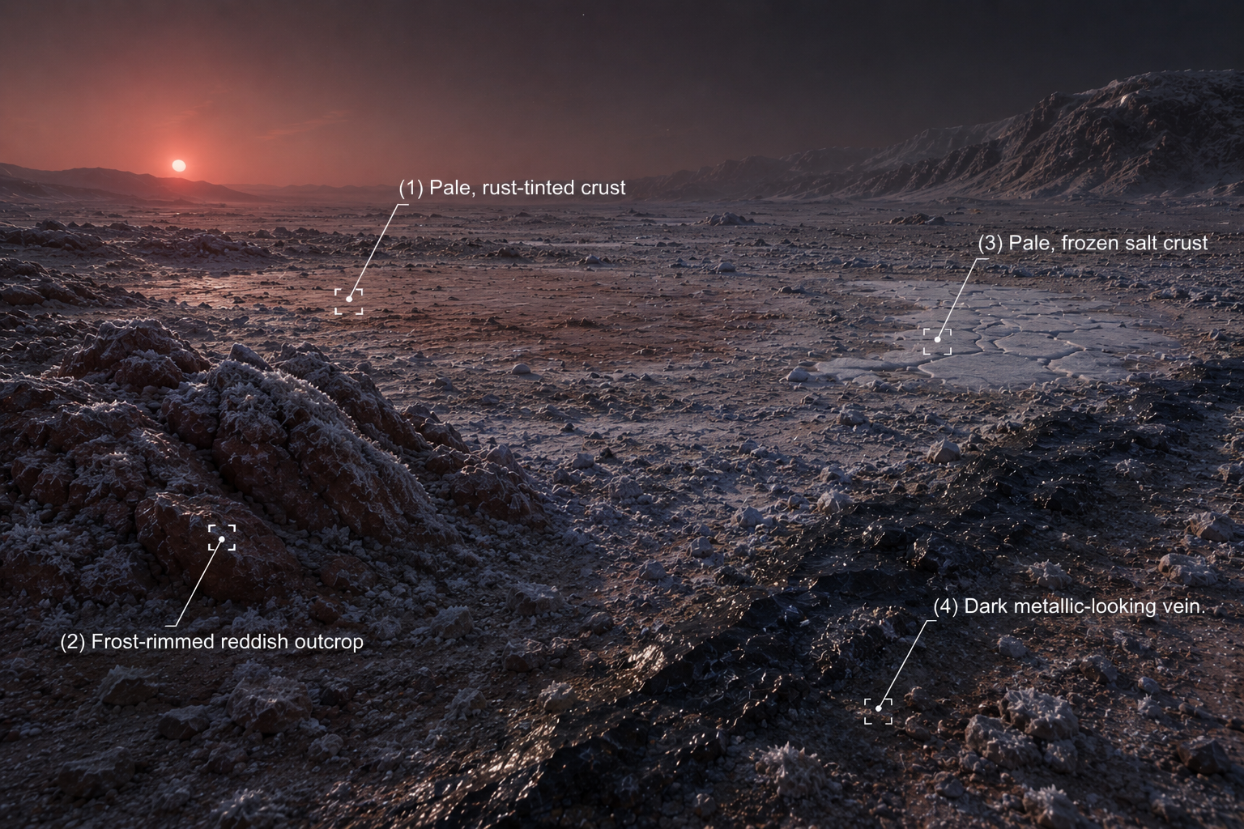

# Site: Pale, rust-tinted crust at the basin's edge
Description: A pale, frost-covered flat cut by thin cracks where a faintly tinted slush seeps to the surface.
Identity: Iron(III) chloride solution (real sample) — the most dilute of the five real groups. THE ONLY IRON-BEARING SITE. REAL SAMPLE GROUP.
## Known Properties
Colour: Very pale yellow
Odour: None detectable
Solubility: Fully miscible with water
## Experiment Results
Measure pH: Weakly acidic, pH around 3.0–3.3
Measure density: 1.02 g/mL, only slightly denser than water
Test electrical conductivity: Low to moderate
Add a magnet: No attraction
Add potassium thiocyanate solution: Turns a pale pink-red
Add sodium hydroxide solution: Forms a faint, fine reddish-brown precipitate
Heat a small sample gently: No visible change

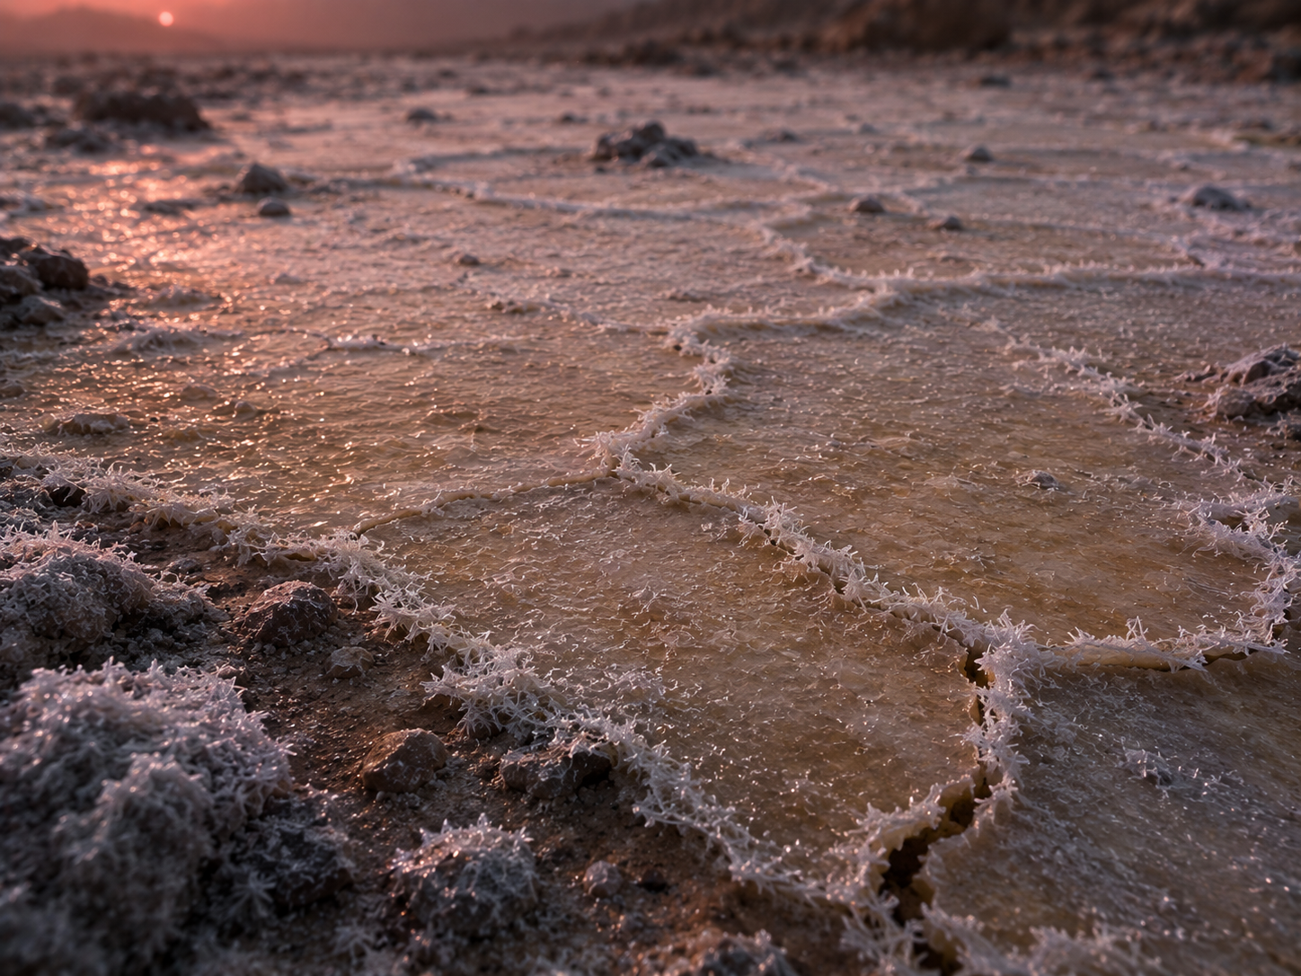
# Site: Frost-dusted reddish outcrop
Description: A weathered, rust-red rock formation a short distance from the ice flat, dusted with fine frost.
Identity: Copper(I) oxide mineral (cuprite) — reddish colour resembles iron oxide but contains no iron. RED HERRING (no iron).
## Known Properties
Colour: Deep brick-red, faint metallic sheen in patches
Magnetism: None
Solubility: Insoluble
## Experiment Results
Measure pH: Close to neutral, pH around 6.9 (crushed sample in water)
Measure density: 6.0 g/cm3 — notably dense for a rock sample
Test electrical conductivity: Very low (crushed sample in water)
Add a magnet: No attraction
Add potassium thiocyanate solution: No colour change
Add sodium hydroxide solution: No precipitate forms
Heat a small sample gently: No visible change
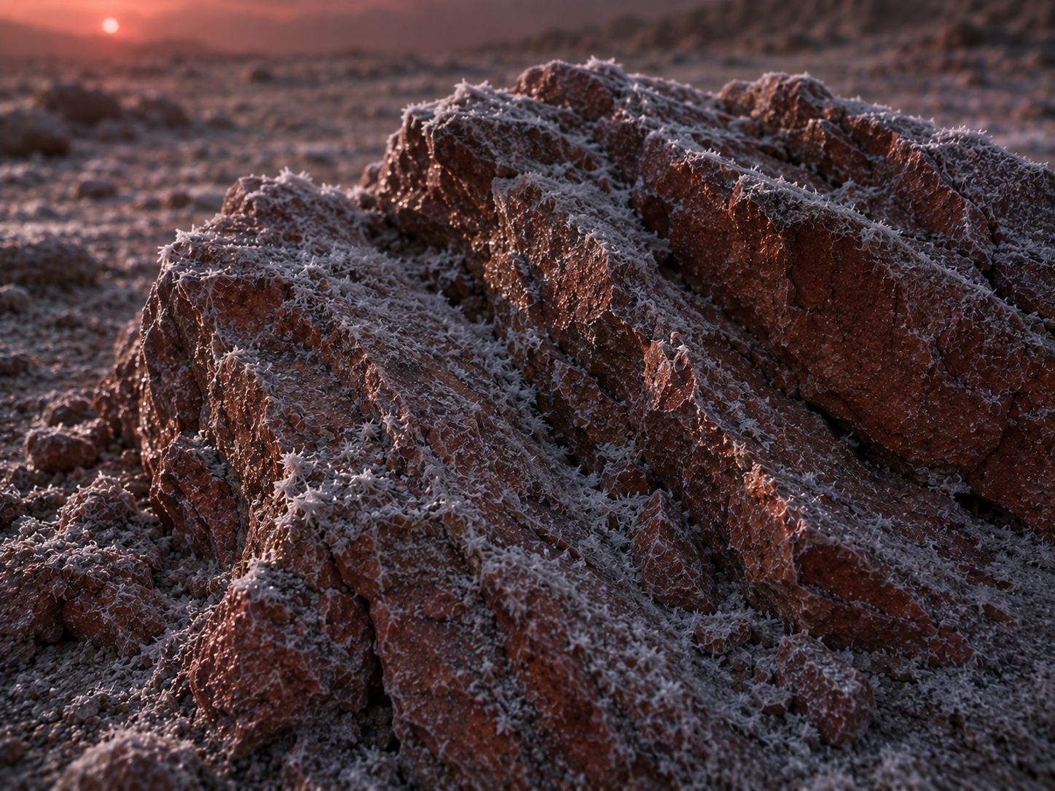

# Site: Pale, frozen salt crust
Description: A flat expanse of pale, ice-rimmed crust nearby that crunches faintly under the rover's wheels.
Identity: Sodium chloride evaporite deposit, preserved by the extreme cold — no iron content.
## Known Properties
Colour: White to pale grey
Solubility: Fully soluble in water
## Experiment Results
Measure pH: Neutral, pH 7
Measure density: 1.02 g/mL once dissolved at saturation
Test electrical conductivity: High
Add a magnet: No attraction
Add potassium thiocyanate solution: No colour change
Add sodium hydroxide solution: No precipitate forms
Heat a small sample gently: No visible change; the crystals don't melt or scorch at this gentle heat
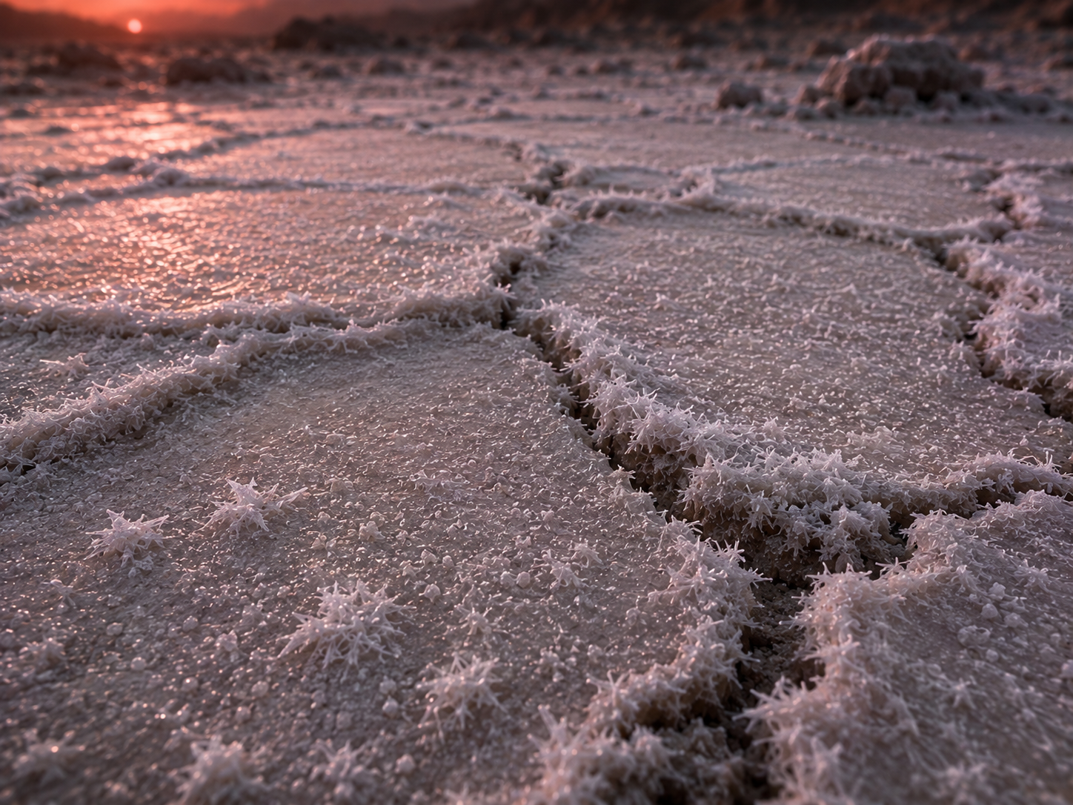

# Site: Dark metallic-looking vein
Description: A dark, almost black mineral vein exposed by a fracture in the ice near the flat, with a faint metallic sheen.
Identity: Nickel-rich sulfide mineral — magnetic (nickel is ferromagnetic too) but contains no iron; the trap is that magnetism alone does not mean iron here, since the true sample is a non-magnetic solution.
## Known Properties
Colour: Dark grey to black, metallic lustre
Magnetism: Moderately attracted to a magnet
Solubility: Insoluble in water
## Experiment Results
Measure pH: Neutral, pH around 7 (crushed sample in water)
Measure density: 5.4 g/cm3 — dense, but the sample does not dissolve
Test electrical conductivity: Very low (crushed sample in water)
Add a magnet: Noticeably attracted, though less strongly than a pure iron ore would be
Add potassium thiocyanate solution: No colour change
Add sodium hydroxide solution: No precipitate forms
Heat a small sample gently: No visible change

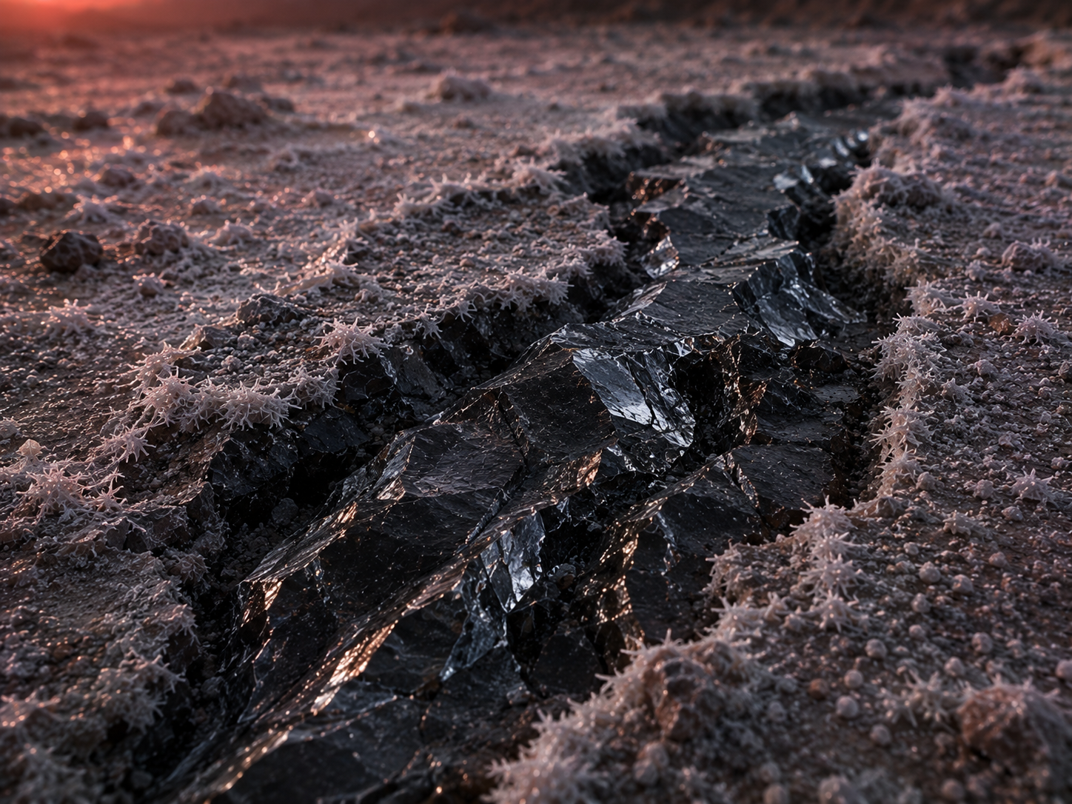
# Experiments
Measure pH
Measure density
Test electrical conductivity
Add a magnet
Add potassium thiocyanate solution
Add sodium hydroxide solution
Heat a small sample gently
# AI Behaviour
Reveal remaining candidates after narrowing: Yes
Difficulty: Standard (15-16 years old)

# Teacher Notes
REAL SAMPLE GROUP — assign real FeCl3, the most dilute of the five (suggested ≈0.05 M). TRAPPIST-1g pairs directly with TRAPPIST-1e (same star system, different orbital distance) — a nice opportunity for those two groups to compare notes at the final conference: same star, same likely iron-rich core hypothesis, but very different surface conditions and (by design) very different brine concentrations and iron oxide yields.
The frost-dusted outcrop is the colour red herring (cuprite, non-magnetic); the frozen salt crust is a neutral decoy; the dark vein is the magnetic red herring (nickel, no iron) — the same pattern used across the other dossiers.
Real-science notes: TRAPPIST-1g is a genuine rocky exoplanet in the same system as TRAPPIST-1e, discovered in the same 2017 study (Spitzer + TRAPPIST telescope), orbiting every 12.35 days at ~40.7 light-years from Earth. Its density (5.04 g/cm3) is close to Earth's, consistent with (like the rest of the system) an unusually large iron core for its size (Agol et al. 2021). It sits at the outer/cooler edge of the optimistic habitable zone. No atmosphere has been detected; published 'global ocean' or 'steam atmosphere' scenarios for this planet are theoretical models only, not observations.
Sources: Agol et al. 2021 (see en.wikipedia.org/wiki/TRAPPIST-1g for citations); NASA Exoplanet Archive (exoplanetarchive.ipac.caltech.edu/overview/TRAPPIST-1).
Cross-subject link: Biology selective pressure for this planet — permanent extreme cold, possibly beneath a global layer of ice.

