Decoding a Century of Wheat Breeding using Integrative Genomics and GWAS Analysis
Daniela Carvajal, Elise Ansell, Lubna Al Amri, Takahiro Kato

INTRODUCTION
Wheat (Triticum aestivum L.) is one of the world's most important staple crops, providing a vital source of dietary protein and calories (Shewry & Hey, 2015). Global food security is threatened by a growing population and limited resources, requiring innovative agricultural solutions to accelerate crop improvement and feed the future (Palayullaparambil et al., 2023).Food security remains a major priority in East Africa, especially in Ethiopia and Kenya, which account for 88.9% of the region’s wheat production. Over the past century, wheat production has grown significantly, making both countries leading producers (Andualem et al., 2025; Araus et al., 2022). However, productivity is constrained by abiotic stresses such as periodic heat and drought, and biotic factors, including diseases such as rusts, smuts, and Fusarium blight. These challenges pose a significant threat to regional food security (Sharma et al., 2019).
Plant breeding offers a way to overcome these challenges by modifying crop genetics to improve desirable traits. However, traditional breeding methods based on phenotypic selection are often slow and less effective because environmental factors can mask a crop's true genetic potential. Relying on phenotypic traits alone can also narrow the gene pool, hindering future development (Palayullaparambil et al., 2023; Sharma et al., 2019). Modern genomic tools enable whole-genome analysis and improve understanding of genetic variation underlying phenotypic changes. These approaches support crop improvement by providing the precision needed to identify valuable quantitative trait loci (QTL) and target specific genomic regions under selection (Palayullaparambil et al., 2023).
The complexity of wheat's hexaploid genome (~17 Gb), which originated from two successive hybridisation events involving three diploid progenitor species (Marcussen et al., 2014), has made genetic analysis difficult. However, genome wide association studies (GWAS) now offer a way forward. GWAS can dissect complex trait architecture at high resolution by exploiting historical recombination accumulated over many breeding cycles (Rafalski, 2010; Sukumaran et al., 2014). Unlike traditional biparental mapping, GWAS uses natural variation across diverse germplasm, enabling higher mapping resolution and evaluation of multiple alleles at once. Modern platforms such as genotyping by sequencing (GBS) generate thousands of SNP markers suitable for studies of population structure, characterization of genetic resources, breeding, and mapping of traits in a wide range of species (Elshire et al., 2011).
Within this genomic context, the Green Revolution of the 1960s to 1970s transformed global wheat production through semi dwarf varieties. These varieties carry reduced height (Rht) genes that shift resources from stems to grain, improving harvest index and reducing lodging (Hedden, 2003). The Rht-B1b and Rht-D1b genes remain common in modern cultivars worldwide. While semi dwarf varieties reached East Africa in the 1980s, the long-term phenotypic trajectory of regional cultivars, including shifts in plant height and grain weight, requires systematic characterisation. Yield improvement involves more than just plant height; factors such as grain weight, size, and phenological traits, such as days to heading and maturity, determine local adaptation (Gegas et al., 2012). Understanding how breeders balance these traits is essential, as selecting for one can inadvertently change others through pleiotropy or genetic linkage.
Intensive breeding may come at a cost. Studies in Europe and Asia show genetic diversity declining as programs focus on elite material, raising concerns about resilience to new stresses (Haudry et al., 2007; Van De Wouw et al., 2010). But diversity trends differ by region, and African wheat has received less attention. It remains to be determined whether historical phenotypic shifts reflect changes in allele frequencies at specific loci, and whether selection has reduced genetic diversity. This project addresses these questions by combining phenotypic data from multi location field trials with GBS genotyping from 185 East African wheat varieties spanning 1920 to 2020.
The project has two aims: first, to identify genomic loci controlling key agronomic traits through GWAS; second, to characterise phenotypic changes over a century of breeding. The objectives are to: (1) derive genotype-adjusted trait estimates from multi-location trials, (2) evaluate trait correlations, breeding trade-offs, and temporal trends, (3) assess population structure of East African wheat germplasm using discriminant analysis, (4) perform genome-wide association studies to map loci associated with agronomic and grain quality traits, and (5) annotate candidate genes at significant loci. These findings will inform marker-assisted selection for locally adapted varieties and clarify which genomic regions have driven breeding progress in East African wheat.

METHODS

Data Overview
There were 185 wheat varieties trialled, and each replicated three times with genotype and phenotype data collected for all varieties. The wheat was grown in four sites across East Africa: Debra Ziet, Kulumsa, and Bekoji in Ethiopia, and Njoro in Kenya. Collections took place in off-season (January-April) and main season (August-November). To minimise localised environmental effects the wheat was grown in a 13 x 45 grid plot with randomised variety placement.
The phenotypic traits consisted of two categories of traits: agronomic traits measured directly in the field and grain size traits measured after harvest. The agronomic traits were days to heading (DTH), days to maturity (DTM), plant height (PHT), spikelet number (SPNO), and spikelet length (SPL). The grain size traits were thousand kernel weight (TKW), thousand grain weight (TGW) and seed area (mm²), width (mm) and length (mm). Metadata included the year of the trial, site, plot, column, row, replicate, and genotype.
The genotype data consisted of 30,083 single-nucleotide polymorphisms (SNPs) recorded across 185 wheat varieties, with genetic information represented as genotype dosage coding, where 0 indicates homozygous reference, 1 indicates heterozygous, and 2 indicates homozygous alternate. Metadata included SNP chromosome and position.

Analysis of Phenotype Data
The preprocessing of the phenotype trait data was conducted in R, using two raw datasets: a grain trait dataset containing morphological measurements and a dataset containing agronomic traits. The data was pre-processed, removing empty and duplicated columns, before a consistent formatting check, and finally merged based on their common column to form a combined dataset.
Then the mean of the three replicates was calculated for each trait, to reduce within-site variation and replicate error. Then Linear mixed-effects models, which were fitted for each of the 14 agronomical and seed traits using the lmer function to estimate genotype performance whilst accounting for variation between sites. The model equation was:
Trait=Genotype + (1∣Site)
Genotype was the fixed effect, to measure performance of the wheat varieties, and the sites were the random effects, environmental factors. QQ plots were then used to confirm that the residuals were approximately normally distributed for each trait. Further data visualisation was conducted to assess the performance and similarity of traits over the duration of the study.

Analysis of Genotype Data
GBS data was used for this analysis providing genome-wide SNP coverage across the 185 wheat varieties. The genotype dataset was imported into a genlight object using dartR (Au, 2022), and then monomorphic loci were removed; call rate was filtered to retain SNPs with ≥ 70% non-missing data, and filtered loci by minor allele frequency (MAF), removing those with < 0.1. Then, the mean reproducibility was calculated to measure the proportion of technical replicates that are called consistently, and the SNP data were merged with our metadata based on taxa.
Before the GWAS was conducted, six different imputation methods were assessed for accuracy against a subset of known data. These methods were Random Forest, Hardy Weinburg, K Nearest Neighbours, Mode and from DartR, and MissForest was calculated using a custom script. Due to having the highest accuracy for imputation, K-Nearest Neighbours was used (Figure 1).
Figure 1. Comparison of six different imputation methods: K Nearest Neighbour (Neighbour), MissForest, Mode, Frequency, Hardy Weinberg (HW) and Random Forest (Random), based on accuracy calculated from a subset of known genotype calls.

To assess population stratification, a Discriminant Analysis of Principal Components (DAPC) was performed using adegenet 2.0.0 (Jombart & Collins, 2015). The resulting cluster assignments were used to account for genetic structure in the association models. GWAS was conducted using two different packages: GAPIT (Zhiwu Zhang Laboratory, 2014) and GWASPoly (GWASpoly Version 2, n.d.; Rosyara et al., 2016). For GAPIT, several GWAS models including BLINK and FarmCPU examined with and without population membership included as a covariate (Zhiwu Zhang Laboratory, 2014). Significant SNPs were then compared across these methods to identify robust associations.
Phenotypic validation of candidate SNPs was conducted using one-way ANOVA and Tukey’s HSD to compare allelic groups (reference, heterozygous, and alternative) on each trait, with statistical significance shown by letter groupings at p < 0.05.

Single Nucleotide Polymorphism Annotation
SNPs consistently present across the three GWAS methods were annotated using Ensembl Plants. SNPs were mapped to the T. aestivum reference genome IWGSC, and a genomic window of 100kb upstream and downstream of each variant was implemented to identify candidate genes. The SNPs that had no candidate genes had their orthologs reviewed in related species.
RESULTS AND DISCUSSION
This section presents the phenotypic and genotypic analyses of the 14 phenotypic trait data and the 30,000 SNP trait association data. Results are presented starting with the analysis of relationships between phenotypic traits, then temporal trends, and then progresses to the DAPC, GWAS, and SNP candidate analysis and annotation.
A phenotype correlation matrix was conducted to examine the relationships among the 14 phenotypic traits (Figure 2). The resulting correlogram identified two primary clusters of intercorrelated traits. First, grain dimension and weight parameters, including TKW, TGW, Area, Width, and Length, exhibited positive correlations with one another. These yield-related components appear to be developmentally linked. In contrast, phenological and structural traits (PHT, DTH, DTM) formed a distinct cluster characterised by robust positive internal associations.
Considering that wheat has undergone breeding improvement, the clear negative correlation between two clusters may reflect favorable combination of traits during modern breeding.

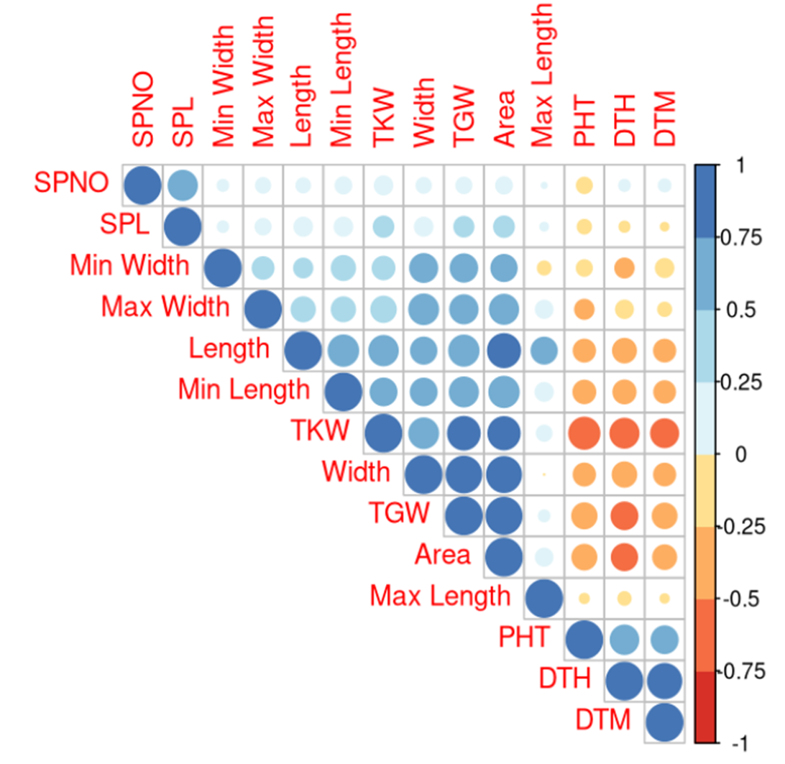
Figure 2. Phenotype correlation matrix between 14 traits. The relationship between various grain and plant development traits. Positive correlations are in blue, negative in red. The diagonal represents self-correlation. Strong positive inter-correlations exist within a block of size and weight traits (Width, Length, TKW, TGW, Area), and a separate block of duration/height traits (PHT, DTH, DTM). Cross-block correlations show a distinct negative trend, while SPNO and SPL show minimal association with other traits.
To evaluate phenotypic relationships in wheat breeding across multiple locations in Kenya and Ethiopia, 14 traits across the 100 years of release were analysed (Figure 3), indicating trends towards reduced plant height, earlier heading and maturity and increased grain weight. Grain-related traits, including TKW, TGW, and grain area, increased over time, whereas PHT, DTH, and DTM declined. These temporal patterns align with the observed correlations (Figure 2).
In particular, the decline in PHT is consistent with the introduction of semi-dwarf wheat after the Green Revolution. The decline in PHT is consistent with the role of semi-dwarf wheat in improving yield stability through reduced lodging risk and improved harvest index (Hedden, 2003)
Likewise, the decreases in DTH and DTM may reflect adaptation to semi-arid environments, where earlier heading and maturity can function as drought escape under rainfed conditions (Bapela et al., 2022). Therefore, the reductions in DTH and DTM may reflect adaptive selection under East African growing conditions rather than only a shorter growth period.

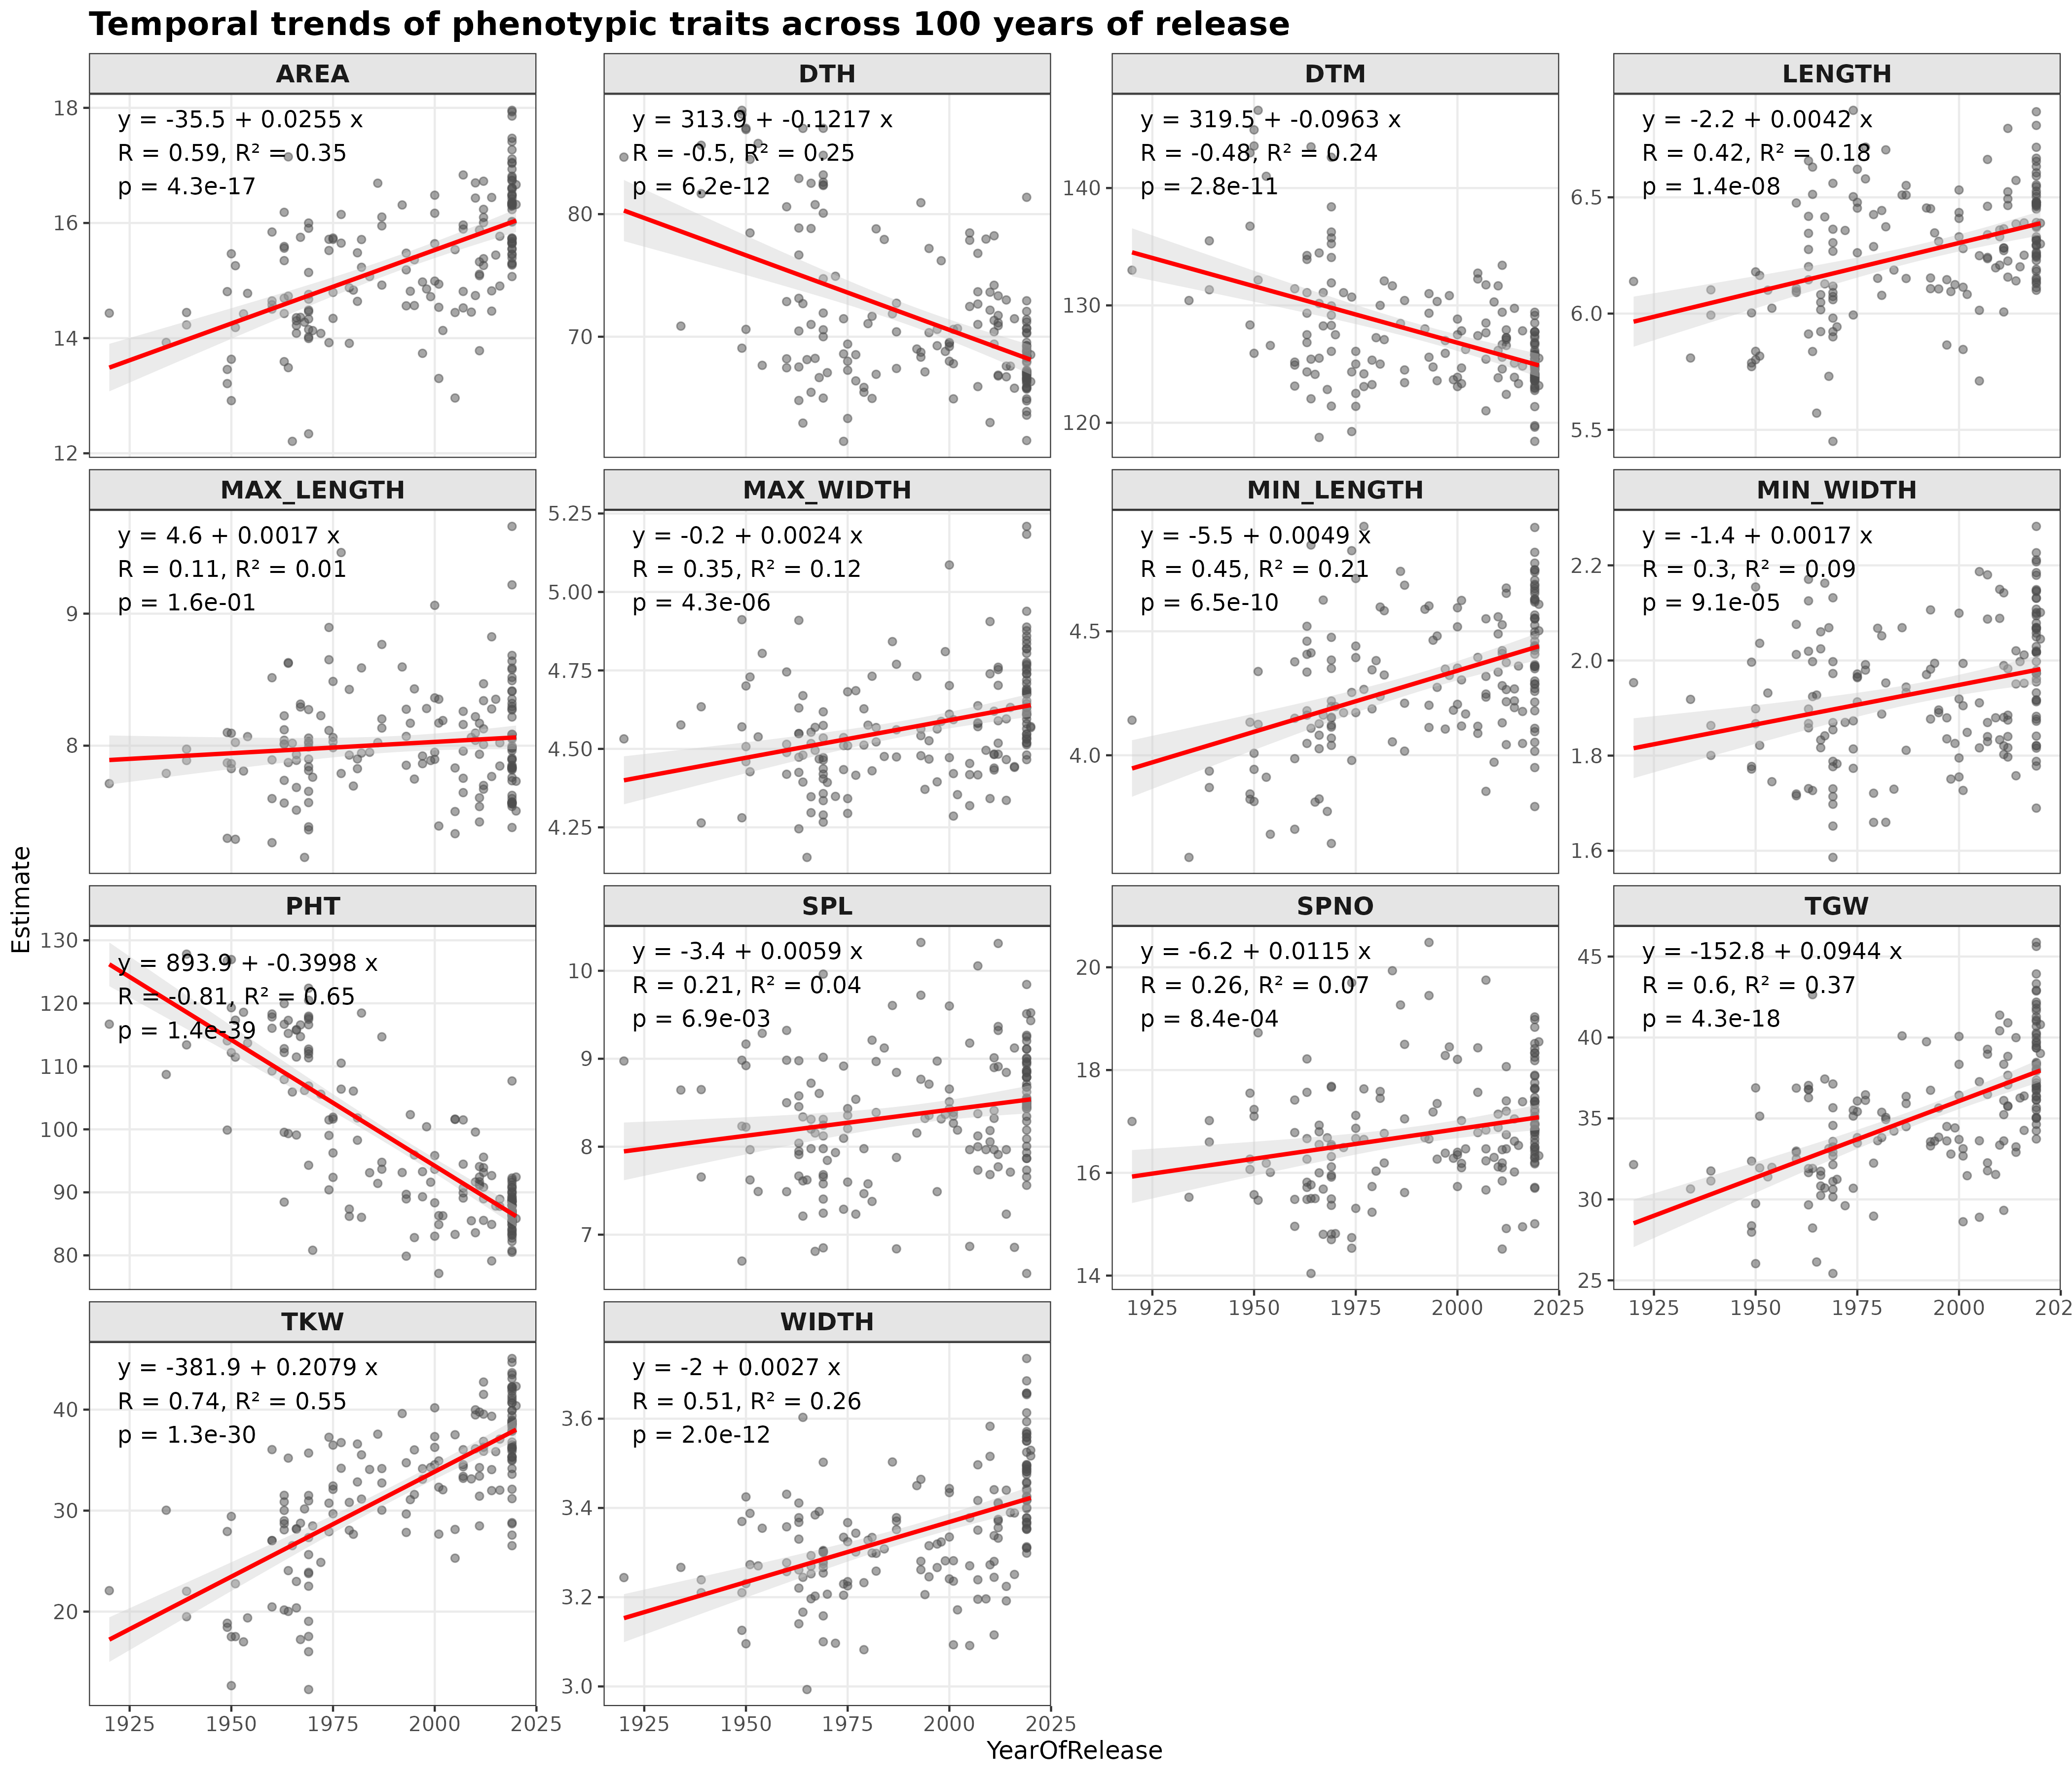Figure 3. Temporal trends of phenotypic traits across 100 years of release. Each panel represents a specific trait, with the x-axis showing the Year of Release and the y-axis showing the estimated values. Individual data points are shown as light pink circles. A linear regression line (black line) is fitted to the data to show the overall trend over time, with the 95% confidence interval.

The DAPC analysis revealed four distinct clusters along the first two discriminant axis, which indicates strong genetic differentiation between groups (Figure 4A). This also suggests there is significantly high genomic diversity amongst T. aestivum, like Zewdu & Yimam, (2024), who found significant phenotypic variation in wheat. Most clusters appear in both countries; however, varied abundances indicate distinct country-specific selection pressures (Figure 4B).

A B
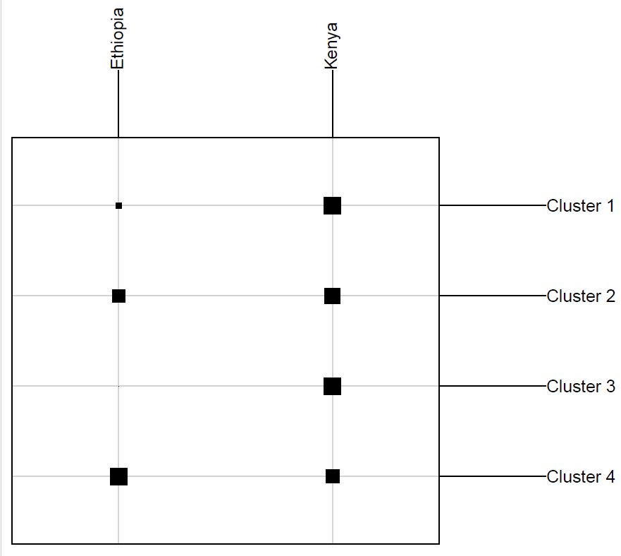
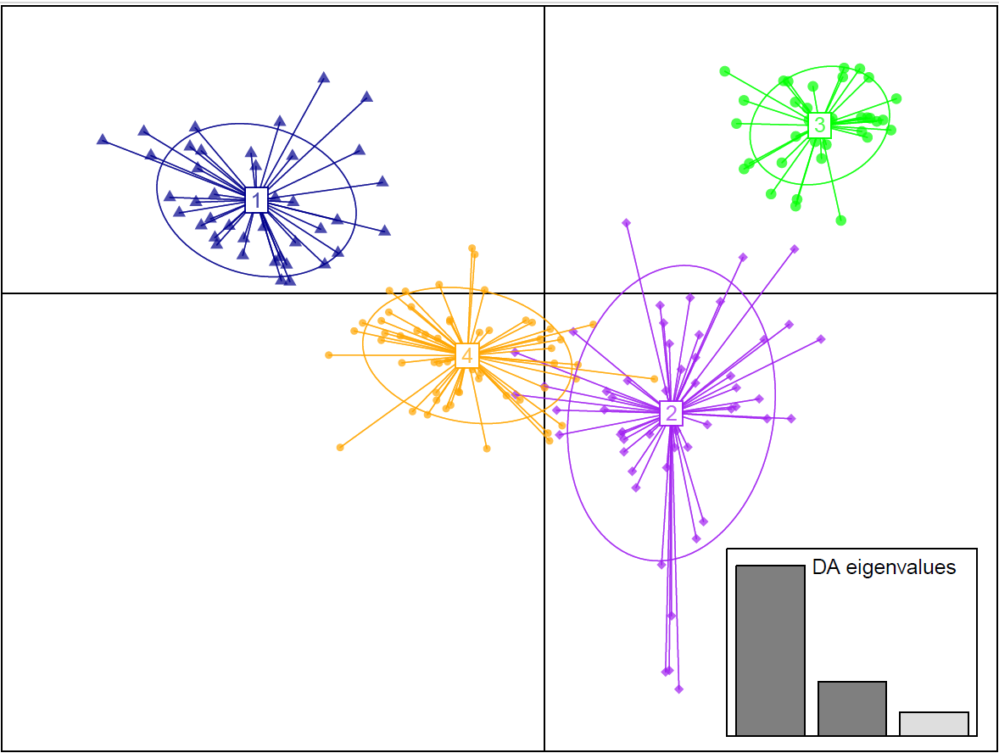
Figure 4. Population Structure and Geographic Distribution. (A) DAPC scatter plot. The wheat population is divided into four genetic clusters based on the first two discriminant axes. Points represent individual genotypes, with colours and ellipses defining cluster membership and group centroids. The inset bar plot indicates the eigenvalues for the discriminant functions. (B) Geographic assignment. Distribution of the four genetic clusters across Ethiopia and Kenya. The square size represents the frequency of individuals per cluster.

Of the 14 traits, PHT, DTH and DTM showed the most significant associations, as these traits consistently showed significant SNPs across-locus models (FarmCPU and BLINK). These robust associations, independent of population origin, are shown in the Figure 5.

Farm-CPU Based GWAS results for DTH, DTM, and PHT in East African Wheat
Blink-Based GWAS results for DTH, DTM, and PHT in East African Wheat
Figure 5. Manhattan plots showing genome-wide association results for DTH, DTM and PHT using (A-C) FarmCPU and (D-F) BLINK models. The dashed line represents the Bonferroni correction threshold (-log10(p) > 5.3). Green points indicate SNPs exceeding the threshold. Chromosomes are coloured by sub-genome: red = A, grey = B, orange = D.

Table 1. SNPs identified as significant in both FarmCPU and BLINK models for days to heading (DTH), days to maturity (DTM), and plant height (PHT). Chromosomes are named according to the hexaploid wheat genome (A, B and D sub-genomes). p-values shown as -log10(p). Bonferroni correction threshold: -log10(p) > 5.3. MAF = minor allele frequency.
SNP | Chr | Pos | MAF | Trait | FarmCPU-log10(p) | BLINK-log10(p)
1057749 | 1B | 685117897 | 0.31351351 | DTH | 12 | 10.91
1244465 | 2B | 94925484 | 0.11891892 | DTH | 6.67 | 6.3
992116 | 2B | 216469247 | 0.17567568 | DTH | 7.41 | 5.94
984177 | 6A | 38379225 | 0.1972973 | DTH | 9.24 | 7.93
1140879 | 6D | 22769897 | 0.1 | DTM | 8.93 | 8.54
1107370 | 7A | 712831281 | 0.38108108 | PHT | 8.5 | 10.75

Two significant SNPs on chromosome 2B were identified for DTH (Figure 6, Table 1). SNP 1244465 showed a pronounced effect, with the AA genotype delaying heading by approximately 15 days relative to TT. SNP 992116 also conferred delayed flowering in TT genotypes. Separated by over 120 Mb, these represent independent regulatory regions on chromosome 2B, reflecting the polygenic control of flowering time in wheat (Benaouda et al., 2022). A further association was detected on chromosome 1B (Figure 6A), where the GG genotype delayed heading. Functional annotation identified cysteine proteinase genes (Table 2), enzymes that regulate developmental transitions in plants (Liu et al., 2018).

Figure 6. Phenotypic distribution of chromosome 2B of DTH is shown for different genotypes of (A) SNP 1244465 (located at 94.9 Mb) and (B) SNP 992116 (located at 216.5 Mb). Each panel displays a combination of boxplots and violin plots, representing the median, interquartile range (IQR), and the density distribution of the data, respectively. Individual data points are overlaid as open circles.
The strongest association for DTH was on chromosome 6A (SNP 984177, Figure 7B), where the GG genotype delayed flowering substantially (> 80 days) compared to the AA genotype (< 70 days). This locus also showed a strong additive effect on DTM (Figure 8A), with the GG to AA transition significantly reduced maturity time (Tukey's HSD, p < 0.05). In Figure 7B and 8A, chromosome 6A shows significant peaks for both DTH and DTM across both models, confirming pleiotropic control of developmental timing.
A B
Figure 7. Phenotypic distribution of Days to Heading (DTH) based on the genotype, located on Chromosomes (A) 1B and (B) 6A. A significant association was observed in chromosome 6A between the SNP and flowering time. Individuals homozygous for the reference allele (GG) exhibited the latest flowering phenotypes, whereas those with the alternative allele (AA) flowered significantly earlier.
Functional annotation identified a proximal gene on chromosome 6A, TraesCS6A02G070500 (Table 2), which encodes glutamate-tRNA ligase (GluRS). This enzyme plays a role in chlorophyll biosynthesis via the tetrapyrrole pathway (Oborník & Green, 2005). Yue et al., (2024) reported in T. aestivum that GluRS expression is highly sensitive to environmental stress. Salinity-induced downregulation of this gene reduces chlorophyll biosynthesis and slows plant growth. While some maturity-associated hotspots, such as the region containing the ethylene receptor gene TRITD6Av1G220960 in T. turgidum, are located more distally (601.5–615.3 Mbp) (Mulugeta et al., 2023), this signal at 38.3 Mbp highlights the high genomic activity of the 6A short arm. The statistical support of this locus is further reinforced by the rapid linkage disequilibrium (LD) decay in the A sub-genome (~5.5 Mb), which allows for higher mapping resolution than in other sub-genomes (Ebrahimi et al., 2025; Gebreyohannes et al., 2025). Such loci are essential for environmental stability and are frequently detected under drought and heat stress conditions Because this region is linked to both DTH and DTM, GluRS may play a role in regulating development. Differences in GluRS genes seem to affect chlorophyll metabolism, which helps plants move more efficiently between growth stages.
In contrast, SNP 1140879 (6D) (Figure 8B) reached genome-wide significance but showed no genotypic differences in post-hoc analysis (p = 0.31, Figure 9B). The low minor allele frequency (MAF = 0.10) and small sample size (n = 10) reduced statistical power at this locus relative to 6A (MAF = 0.197). This also reflects limited D sub-genome diversity, where only 13.6% of markers reside due to the historical polyploid bottleneck (Vishwakarma et al., 2024; Wang et al., 2024). Although GWAS power was lower at this locus, both regions are important for breeding high-yield and resilient wheat varieties suited to East Africa's environment.

A B
Figure 8. Comparative impact of (A) SNP 984177 (6A) and (B) SNP 1140879 (6D) on Days to Maturity (DTM). SNP 984177 on chromosome 6A shows a highly significant association with maturity time, where different letters (a, b, c) indicate statistically significant differences between all genotypes (Tukey’s HSD, p < 0.05). SNP 1140879 on chromosome 6D exhibits no significant effect on DTM, with all genotypes sharing the same statistical group (a).
A QTL for PHT was identified on chromosome 7A (Figure 9), represented by SNP 1107370. Individuals with the alternate homozygous genotype (TT), were ~22cm taller than those with the reference genotype (CC), indicating this locus is a major contributor to plant height determination.
Zanke et al., (2014) researched the genetic architecture of plant height in 358 wheat varieties and found that Gibberellin acid (GA) related genes, such as DELLA genes and ent-kaurenoic acid oxidase (KAO), were orthologous to the wheat chromosome 7A and played a significant role in determining plant height. KAO is a key enzyme in the GA biosynthesis pathway, and mutations in this enzyme can lead to a dwarf phenotype in crops. DELLA proteins act as growth suppressors, regulating plant growth via transcription factors, and cause semi-dwarf phenotypes when not degraded (Sokolowska et al., 2026). This indicates there is still a solid association between chromosome 7A and plant height. This is further reinforced by our annotated candidate genes (Table 2), where IAA amino acid hydrolases were found on Chromosome 7A, which regulate auxin homeostasis by releasing active auxin from amino acid bound conjugates, and have been linked to increased plant height and also grain weight (Fu et al., 2019).
Figure 9. Phenotypic distribution of Plant Height (PHT) for the reference (CC) and alternative (TT) genotypes of SNP 1107370 on Chromosome 7A (712.8 Mb). Boxplots and violin plots show a highly significant association, different letters (a, b) above the boxes indicate statistically significant differences by Tukey’s HSD test (p < 0.05). The alternative allele (T) is linked to a substantial increase in plant height, with the median shifting from approximately 90 cm (CC) to 112 cm (TT).

Table 2. Annotated candidate genes from 4 significant SNPs. The genomic window extends 100kb upstream and downstream of the SNP position and SNP proximal genes represent those found within that window. Candidate Genes were identified through SNPs directly and orthologs in Arabidopsis thaliana, where there was no known functional annotation in T. aestivum.
Chromosome | SNP Position (bp) | Genomic Window (SNP Position ± 100kb) | Candidate Gene Identification Method | Candidate Genes
1B | 685117897 | 685017897 - 685217897 | Ortholog-based candidate gene | Gene: AT1G29080  Putative Function: Papain family cysteine protease  Species: Arabidopsis thaliana  Gene: AT1G29090  Putative Function: Cysteine proteinases superfamily protein  Species: Arabidopsis thaliana
2B | 94925484 | 94825484 - 95025484 | SNP-proximal gene | Gene: TraesCS2B02G126500  Putative Function: Wheat Ribosomal Protein L19  Species: Triticum aestivum
6A | 38379225 | 38279225 - 38479225 | SNP-proximal gene | Gene: TraesCS6A02G070500  Putative Function: Glutamate-tRNA ligase, chloroplast/mitochondrial  Species: Triticum aestivum
7A | 628984333 | 628884333 - 629084333 | SNP-proximal gene | Gene: TraesCS7A02G435700  Putative Function: IAA- amino acid hydrolases  Species: Triticum aestivum

Beyond these individual loci, Figure 7B and 8A reveal broader patterns in the genetic architecture of wheat traits by identifying significant loci across the hexaploidy genome for DTH, DTM, and PHT. No genome-wide signals were detected for grain weight traits despite strong phenotype trends (Figure 3) and correlations (Figure 2), indicating many small-effect loci control these traits. In contrast, major peaks for developmental traits suggest control by fewer, larger-effect loci suitable for marker-assisted selection.

CONCLUSION
Overall, the results show a strong genetic and phenotypic pattern underlying adaptation in East African wheat. Breeding practices select for earlier maturity, reduced plant height, and increased grain size. GWAS identified robust loci for DTH, DTM, and PHT. A shared signal on chromosome 6A indicates a common genetic basis for flowering and maturity. Candidate genes, including GluRS, provide a plausible link between metabolic processes and developmental timing, identifying key targets for future breeding efforts.

REFERENCES
Andualem, H. M., Gebbisa, M. B., & Bacsi, Z. (2025). Wheat Production Across East Africa: Trend, Instability, and Decomposition Analysis Using Time Series Approach. Journal of Sustainable Agriculture and Environment, 4(2), e70073. https://doi.org/10.1002/SAE2.70073;JOURNAL:JOURNAL:2767035X;PAGE:STRING:ARTICLE/CHAPTER
Araus, J. L., Kefauver, S. C., Vergara-Díaz, O., Gracia-Romero, A., Rezzouk, F. Z., Segarra, J., Buchaillot, M. L., Chang-Espino, M., Vatter, T., Sanchez-Bragado, R., Fernandez-Gallego, J. A., Serret, M. D., & Bort, J. (2022). Crop phenotyping in a context of global change: What to measure and how to do it. Journal of Integrative Plant Biology, 64(2), 592–618. https://doi.org/10.1111/JIPB.13191;WGROUP:STRING:PUBLICATION
Bapela, T., Shimelis, H., Tsilo, T. J., & Mathew, I. (2022). Genetic Improvement of Wheat for Drought Tolerance: Progress, Challenges and Opportunities. In Plants (Vol. 11, Number 10). MDPI. https://doi.org/10.3390/plants11101331
Bazhenov, M.S., Bespalova, L.A., Kocheshkova, A.A., Chernook, A.G., Puzyrnaya, O.Y., Agaeva, E.V., Nikitina, E.A., Igonin, V.N., Bazhenova, S.S., Vertikova, E.A., Kharchenko, P.N., Karlov, G.I. and Divashuk, M.G. (2022). The Association of Grain Yield and Agronomical Traits with Genes of Plant Height, Photoperiod Sensitivity and Plastid Glutamine Synthetase in Winter Bread Wheat (Triticum aestivum L.) Collection. International Journal of Molecular Sciences, [online] 23(19), p.11402. doi:10.3390/ijms231911402.
Benaouda, S., Dadshani, S., Koua, P., Léon, J., & Ballvora, A. (2022). Identification of QTLs for wheat heading time across multiple-environments. Theoretical and Applied Genetics 2022 135:8, 135(8), 2833–2848. https://doi.org/10.1007/S00122-022-04152-6
Ebrahimi, P., Karami, E., Etminan, A., Talebi, R., & Mohammadi, R. (2025). Genetic Diversity and Genome-Wide Association Study for Some Agronomic Traits in Durum Wheat (Triticum turgidum L.) Using Whole-Genome DArTseq Markers. Plant Molecular Biology Reporter 2025 43:3, 43(3), 1479–1495. https://doi.org/10.1007/S11105-025-01559-5
Elshire, R. J., Glaubitz, J. C., Sun, Q., Poland, J. A., Kawamoto, K., Buckler, E. S., & Mitchell, S. E. (2011). A Robust, Simple Genotyping-by-Sequencing (GBS) Approach for High Diversity Species. PLOS ONE, 6(5), e19379. https://doi.org/10.1371/JOURNAL.PONE.0019379
Fu, X., Shi, Z., Jiang, Y., Jiang, L., Qi, M., Xu, T., & Li, T. (2019). A family of auxin conjugate hydrolases from Solanum lycopersicum and analysis of their roles in flower pedicel abscission. BMC Plant Biology, 19. https://doi.org/10.1186/s12870-019-1840-9
Gebreyohannes, A., Shimelis, H., Gimode, D. M., Grandham, P., Valluri, V. K., Nida, H., Moenga, S. M., Ojiewo, C. O., Kilian, B., & Odeny, D. A. (2025). Genetic structure of Ethiopian finger millet landraces and genome-wide association mapping for agronomic and nutritional traits. Theoretical and Applied Genetics 2025 138:6, 138(6), 111-. https://doi.org/10.1007/S00122-025-04892-1
Gegas, V. C., Nazari, A., Griffiths, S., Simmonds, J., Fish, L., Orford, S., Sayers, L., Doonan, J. H., & Snape, J. W. (2012). A Genetic Framework for Grain Size and Shape Variation in Wheat. The Plant Cell, 22(4), 1046–1056. https://doi.org/10.1105/TPC.110.074153
Haudry, A., Cenci, A., Ravel, C., Bataillon, T., Brunel, D., Poncet, C., Hochu, I., Poirier, S., Santoni, S., Glémin, S., & David, J. (2007). Grinding up Wheat: A Massive Loss of Nucleotide Diversity Since Domestication. Molecular Biology and Evolution, 24(7), 1506–1517. https://doi.org/10.1093/MOLBEV/MSM077
Hedden, P. (2003). The genes of the Green Revolution. Trends in Genetics, 19(1), 5–9. https://doi.org/10.1016/S0168-9525(02)00009-4
Liu, H., Hu, M., Wang, Q., Cheng, L., & Zhang, Z. (2018). Role of papain-like cysteine proteases in plant development. Frontiers in Plant Science, 871, 417367. https://doi.org/10.3389/FPLS.2018.01717/TEXT
Marcussen, T., Sandve, S. R., Heier, L., Spannagl, M., Pfeifer, M., Jakobsen, K. S., Wulff, B., Steuernagel, B., Mayer, K. F. X., Olsen, O. A., Rogers, J., Doležel, J., Pozniak, C., Eversole, K., Feuillet, C., Gill, B., Friebe, B., Lukaszewski, A. J., Sourdille, P., … Praud, S. (2014). Ancient hybridizations among the ancestral genomes of bread wheat. Science, 345(6194). https://doi.org/10.1126/SCIENCE.1250092;ISSUE:ISSUE:DOI
Mulugeta, B., Tesfaye, K., Ortiz, R., Johansson, E., Hailesilassie, T., Hammenhag, C., Hailu, F., & Geleta, M. (2023). Marker-trait association analyses revealed major novel QTLs for grain yield and related traits in durum wheat. Frontiers in Plant Science, 13, 1009244. https://doi.org/10.3389/FPLS.2022.1009244/FULL
Oborník, M., & Green, B. R. (2005). Mosaic Origin of the Heme Biosynthesis Pathway in Photosynthetic Eukaryotes. Molecular Biology and Evolution, 22(12), 2343–2353. https://doi.org/10.1093/MOLBEV/MSI230
Palayullaparambil, T., Krishna, A., Veeramuthu, D., Maharajan, T., & Soosaimanickam, M. (2023). The Era of Plant Breeding: Conventional Breeding to Genomics-assisted Breeding for Crop Improvement. Current Genomics, 24(1), 24. https://doi.org/10.2174/1389202924666230517115912
Rafalski, J. A. (2010). Association genetics in crop improvement. Current Opinion in Plant Biology, 13(2), 174–180. https://doi.org/10.1016/J.PBI.2009.12.004
Sharma, D., Pandey, G. C., Mamrutha, H. M., Singh, R., Singh, N. K., Singh, G. P., Rane, J., & Tiwari, R. (2019). Genotype–phenotype relationships for high-temperature tolerance: an integrated method for minimizing phenotyping constraints in wheat. Crop Science, 59(5), 1973–1982. https://doi.org/10.2135/CROPSCI2019.01.0055
Shewry, P. R., & Hey, S. J. (2015). The contribution of wheat to human diet and health. Food and Energy Security, 4(3), 178–202. https://doi.org/10.1002/FES3.64;JOURNAL:JOURNAL:20483694;WGROUP:STRING:PUBLICATION
Sokolowska, P., Jöst, M., Buss, W., Ford, B., Chandler, P. M., Spielmeyer, W., Phillips, A. L., Huttly, A. K., Tarkowská, D., Alarcón-Reverte, R., Clark, S. J., Pearce, S., Hedden, P., & Thomas, S. G. (2026). INDETERMINATE DOMAIN-DELLA protein interactions orchestrate gibberellin-mediated cell elongation in wheat and barley. Proceedings of the National Academy of Sciences of the United States of America, 123. https://doi.org/10.1073/pnas.2528934123
Sukumaran, S., Dreisigacker, S., Lopes, M., Chavez, P., & Reynolds, M. P. (2014). Genome-wide association study for grain yield and related traits in an elite spring wheat population grown in temperate irrigated environments. Theoretical and Applied Genetics 2014 128:2, 128(2), 353–363. https://doi.org/10.1007/S00122-014-2435-3
Van De Wouw, M., Kik, C., Van Hintum, T., Van Treuren, R., & Visser, B. (2010). Genetic erosion in crops: concept, research results and challenges. Plant Genetic Resources, 8(1), 1–15. https://doi.org/10.1017/S1479262109990062
Vishwakarma, M. K., Bhati, P. K., Kumar, U., Singh, R. P., Kumar, S., Govindan, V., Mavi, G. S., Thiyagarajan, K., Dhar, N., & Joshi, A. K. (2024). Genetic dissection of value-added quality traits and agronomic parameters through genome-wide association mapping in bread wheat (T. aestivum L.). Frontiers in Plant Science, 15, 1419227. https://doi.org/10.3389/FPLS.2024.1419227/FULL
Wang, Z., Wang, W., He, Y., Xie, X., Yang, Z., Zhang, X., Niu, J., Peng, H., Yao, Y., Xie, C., Xin, M., Hu, Z., Sun, Q., Ni, Z., & Guo, W. (2024). On the evolution and genetic diversity of the bread wheat D genome. Molecular Plant, 17(11), 1672–1686. https://doi.org/10.1016/J.MOLP.2024.09.007
Yue, Z., Liu, Y., Zheng, L., Zhang, Q., Wang, Y., Hao, Y., Zhang, M., Chen, Y., Wang, Z., He, L., & Ma, K. (2024). Integrated transcriptomics, metabolomics and physiological analyses reveal differential response mechanisms of wheat to cadmium and/or salinity stress. Frontiers in Plant Science, 15, 1378226. https://doi.org/10.3389/FPLS.2024.1378226/TEXT
Zhang, M., Song, M., Cheng, F., Han, X., Cheng, C., Yu, X., Chen, J. and Lou, Q. (2024). The mutation of ent-kaurenoic acid oxidase, a key enzyme involved in gibberellin biosynthesis, confers a dwarf phenotype to cucumber. Theoretical and Applied Genetics, [online] 138(1). doi:10.1007/s00122-024-04785-9.
Zanke, C.D., Ling, J., Plieske, J., Kollers, S., Ebmeyer, E., Korzun, V., Argillier, O., Stiewe, G., Hinze, M., Neumann, K., Ganal, M.W. and Röder, M.S. (2014). Whole Genome Association Mapping of Plant Height in Winter Wheat (Triticum aestivum L.). PLoS ONE, [online] 9(11), p.e113287. doi:10.1371/journal.pone.0113287.
Zewdu, D., & Yimam, K. (2024). Evaluation of bread wheat (Triticum aestivum L.) genotypes for yellow and stem rust adult plant resistance and disease impact on grain yield. 40(02). https://doi.org/10.35248/0970-1907.24.40.974-979

REFLECTION
In semester 1 we all collaborated on the phenotypic preprocessing, LMMs and Data Visualisation including heatmaps and a temporal correlation analysis using shared scripts. In semester 2, after collaborative genotype preprocessing of the SNP data, Elise worked on comparative imputation accuracy analysis and data visualisation; Lubna and Daniella ran the DAPC, GAPIT analysis and data visualisation; and Taka ran the GWASpoly.
The challenges we experienced included, during data preprocessing even the slightest difference in analytic approach led to completely different statistical outputs from each person. To address this issue, we shared our scripts within the group and repeatedly revised the workflow and details of cording to standardise every step across the group.
In Semester 2, we were allocated different tasks such as: imputation accuracy analysis, DAPC, GAPIT analysis, GWAS, GWASpoly. Due to complete separation of tasks understanding each other's results could at times be confusing, however, to further our understanding we uploaded outputs to shared folders so that the overall analysis pipeline could be understood more clearly. In addition, we used the online code sharing website ‘Notion’ to ensure our preprocessing steps were identical to create an identical cleaned dataset to be used in the individual downstream analysis that each group member conducted.
Throughout this time, we had frequent meeting, consistently set individual tasks for the following meeting and taking the minutes was conducted evenly between our group. We were also in regular contact with our supervisor and took feedback onboard to further our analysis and written report.

