HW1-16b add/sub
Structure
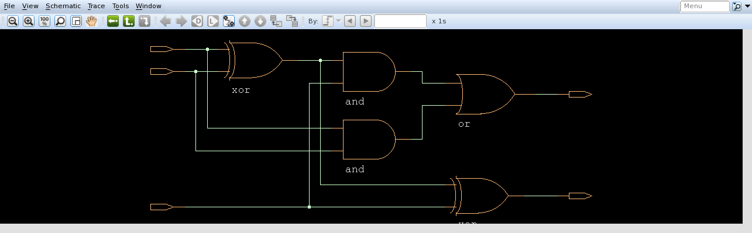
^ fulladder

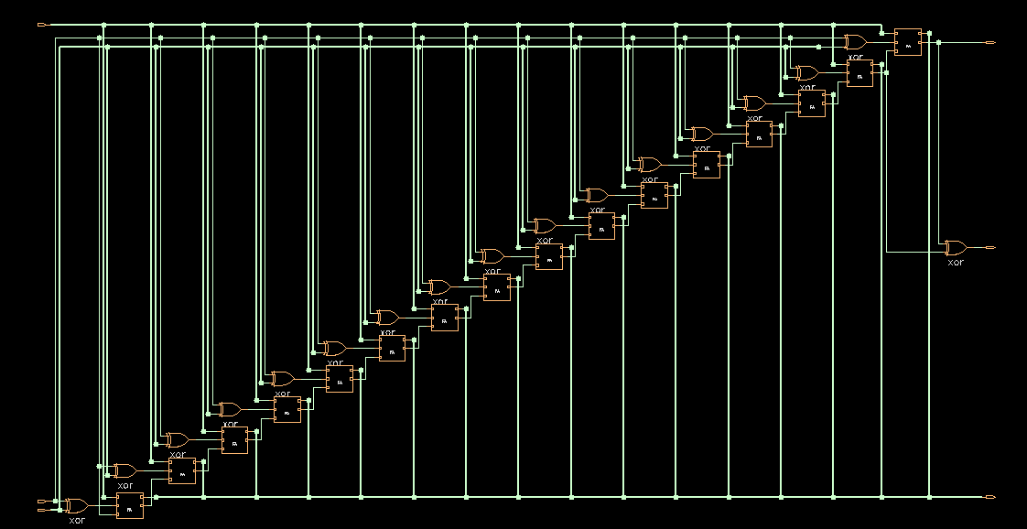
使用16個全加器組合，減法部分將B與control sinal XOR，來取得2補數。
Overflow將最後一個fall adder的Cout與Cin XOR來檢測。
Behavior
Use behavior description, just A+B. On overflow detection, I use the definition of overflow to catch it with some mux statement.
Basically, it should be able to pass provided testbench.

