**Seed 11111111**

**CHI SQUARED RESULTS**

11111111_lin_100_AVG

Power_divergenceResult(statistic=401.0000000000001, pvalue=0.9995864479155078)

Unique numbers generated: 100

The present of possible output covered is: 10.00%

11111111_lin_1000_AVG

Power_divergenceResult(statistic=2020.0280000000002, pvalue=2.7868686613654136e-181)

Unique numbers generated: 166

The present of possible output covered is: 16.60%

11111111_lin_10000_AVG

Power_divergenceResult(statistic=20182.243999999995, pvalue=0.0)

Unique numbers generated: 166

The present of possible output covered is: 16.60%

11111111_lin_10000000_AVG

Power_divergenceResult(statistic=20180722.891855992, pvalue=0.0)

Unique numbers generated: 166

The present of possible output covered is: 16.60%

11111111_lag_100_AVG

Power_divergenceResult(statistic=1022.2400000000002, pvalue=4.1920672301092137e-38)

Unique numbers generated: 47

The present of possible output covered is: 4.70%

11111111_lag_1000_AVG

Power_divergenceResult(statistic=2022.0320000000002, pvalue=1.3093061860941217e-181)

Unique numbers generated: 248

The present of possible output covered is: 24.80%

11111111_lag_10000_AVG

Power_divergenceResult(statistic=15328.555999999997, pvalue=0.0)

Unique numbers generated: 306

The present of possible output covered is: 30.60%

11111111_lag_10000000_AVG

Power_divergenceResult(statistic=15330740.345170397, pvalue=0.0)

Unique numbers generated: 306

The present of possible output covered is: 30.60%

11111111_mdl_100_AVG

Power_divergenceResult(statistic=531.26, pvalue=0.16117912042518853)

Unique numbers generated: 88

The present of possible output covered is: 8.80%

11111111_mdl_1000_AVG

Power_divergenceResult(statistic=35722.29799999998, pvalue=0.0)

Unique numbers generated: 296

The present of possible output covered is: 29.60%

11111111_mdl_10000_AVG

Power_divergenceResult(statistic=1129489.3297999997, pvalue=0.0)

Unique numbers generated: 296

The present of possible output covered is: 29.60%

11111111_mdl_10000000_AVG

Power_divergenceResult(statistic=1242384271.7203298, pvalue=0.0)

Unique numbers generated: 296

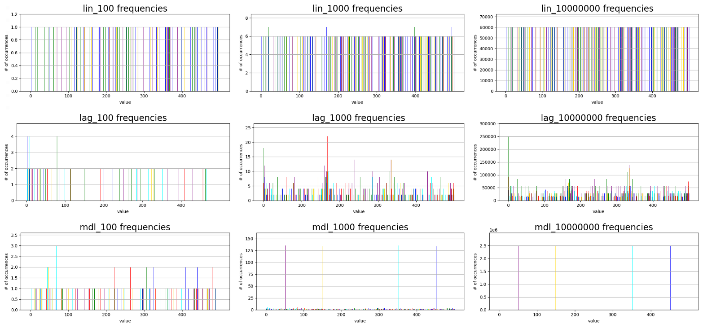The present of possible output covered is: 29.60%

**Seed 26857536**

**CHI SQUARED RESULTS**

26857536_lin_100_AVG

Power_divergenceResult(statistic=401.0000000000001, pvalue=0.9995864479155078)

Unique numbers generated: 100

The present of possible output covered is: 10.00%

26857536_lin_1000_AVG

Power_divergenceResult(statistic=2020.0280000000002, pvalue=2.7868686613654136e-181)

Unique numbers generated: 166

The present of possible output covered is: 16.60%

26857536_lin_10000_AVG

Power_divergenceResult(statistic=20182.243999999995, pvalue=0.0)

Unique numbers generated: 166

The present of possible output covered is: 16.60%

26857536_lin_10000000_AVG

Power_divergenceResult(statistic=20180722.891855996, pvalue=0.0)

Unique numbers generated: 166

The present of possible output covered is: 16.60%

26857536_lag_100_AVG

Power_divergenceResult(statistic=511.22000000000014, pvalue=0.3544876882706061)

Unique numbers generated: 90

The present of possible output covered is: 9.00%

26857536_lag_1000_AVG

Power_divergenceResult(statistic=951.8960000000002, pvalue=1.654460730406258e-30)

Unique numbers generated: 361

The present of possible output covered is: 36.10%

26857536_lag_10000_AVG

Power_divergenceResult(statistic=7308.347599999999, pvalue=0.0)

Unique numbers generated: 417

The present of possible output covered is: 41.70%

26857536_lag_10000000_AVG

Power_divergenceResult(statistic=7259172.503715199, pvalue=0.0)

Unique numbers generated: 417

The present of possible output covered is: 41.70%

26857536_mdl_100_AVG

Power_divergenceResult(statistic=461.1200000000001, pvalue=0.892820238844797)

Unique numbers generated: 94

The present of possible output covered is: 9.40%

26857536_mdl_1000_AVG

Power_divergenceResult(statistic=3918.8180000000007, pvalue=0.0)

Unique numbers generated: 118

The present of possible output covered is: 11.80%

26857536_mdl_10000_AVG

Power_divergenceResult(statistic=40253.005399999995, pvalue=0.0)

Unique numbers generated: 118

The present of possible output covered is: 11.80%

26857536_mdl_10000000_AVG

Power_divergenceResult(statistic=40373338.895117, pvalue=0.0)

Unique numbers generated: 118

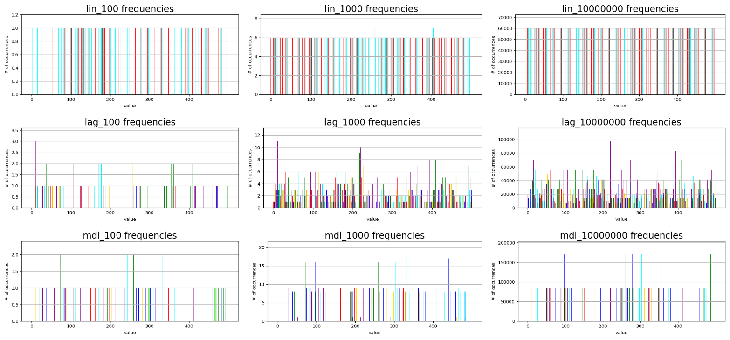The present of possible output covered is: 11.80%

**Seed 39991234**

**CHI SQUARED RESULTS**

39991234_lin_100_AVG

Power_divergenceResult(statistic=401.0000000000001, pvalue=0.9995864479155078)

Unique numbers generated: 100

The present of possible output covered is: 10.00%

39991234_lin_1000_AVG

Power_divergenceResult(statistic=2020.0280000000002, pvalue=2.7868686613654136e-181)

Unique numbers generated: 166

The present of possible output covered is: 16.60%

39991234_lin_10000_AVG

Power_divergenceResult(statistic=20182.244, pvalue=0.0)

Unique numbers generated: 166

The present of possible output covered is: 16.60%

39991234_lin_10000000_AVG

Power_divergenceResult(statistic=20180722.891855992, pvalue=0.0)

Unique numbers generated: 166

The present of possible output covered is: 16.60%

39991234_lag_100_AVG

Power_divergenceResult(statistic=481.15999999999997, pvalue=0.7198089652081128)

Unique numbers generated: 92

The present of possible output covered is: 9.20%

39991234_lag_1000_AVG

Power_divergenceResult(statistic=855.7040000000002, pvalue=4.3873910237885105e-21)

Unique numbers generated: 375

The present of possible output covered is: 37.50%

39991234_lag_10000_AVG

Power_divergenceResult(statistic=5816.8706, pvalue=0.0)

Unique numbers generated: 423

The present of possible output covered is: 42.30%

39991234_lag_10000000_AVG

Power_divergenceResult(statistic=5775095.363594599, pvalue=0.0)

Unique numbers generated: 423

The present of possible output covered is: 42.30%

39991234_mdl_100_AVG

Power_divergenceResult(statistic=521.2400000000001, pvalue=0.24717827881653207)

Unique numbers generated: 89

The present of possible output covered is: 8.90%

39991234_mdl_1000_AVG

Power_divergenceResult(statistic=995.9840000000002, pvalue=3.3179389396056563e-35)

Unique numbers generated: 330

The present of possible output covered is: 33.00%

39991234_mdl_10000_AVG

Power_divergenceResult(statistic=11166.348199999997, pvalue=0.0)

Unique numbers generated: 330

The present of possible output covered is: 33.00%

39991234_mdl_10000000_AVG

Power_divergenceResult(statistic=11359497.701947998, pvalue=0.0)

Unique numbers generated: 330

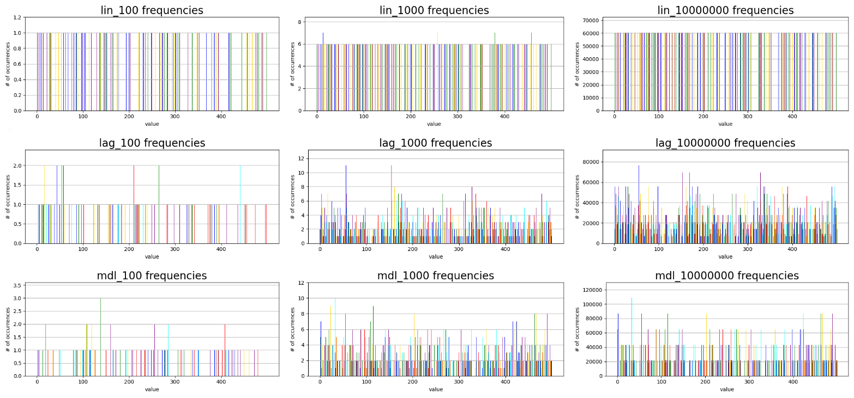The present of possible output covered is: 33.00%

**Seed 57224956**

**CHI SQUARED RESULTS**

57224956_lin_100_AVG

Power_divergenceResult(statistic=401.0000000000001, pvalue=0.9995864479155078)

Unique numbers generated: 100

The present of possible output covered is: 10.00%

57224956_lin_1000_AVG

Power_divergenceResult(statistic=2020.0280000000002, pvalue=2.7868686613654136e-181)

Unique numbers generated: 166

The present of possible output covered is: 16.60%

57224956_lin_10000_AVG

Power_divergenceResult(statistic=20182.243999999995, pvalue=0.0)

Unique numbers generated: 166

The present of possible output covered is: 16.60%

57224956_lin_10000000_AVG

Power_divergenceResult(statistic=20180722.891855992, pvalue=0.0)

Unique numbers generated: 166

The present of possible output covered is: 16.60%

57224956_lag_100_AVG

Power_divergenceResult(statistic=501.2, pvalue=0.4764773752653592)

Unique numbers generated: 90

The present of possible output covered is: 9.00%

57224956_lag_1000_AVG

Power_divergenceResult(statistic=1110.2120000000002, pvalue=2.6052551135478434e-48)

Unique numbers generated: 344

The present of possible output covered is: 34.40%

57224956_lag_10000_AVG

Power_divergenceResult(statistic=7962.052399999999, pvalue=0.0)

Unique numbers generated: 393

The present of possible output covered is: 39.30%

57224956_lag_10000000_AVG

Power_divergenceResult(statistic=7948191.456145399, pvalue=0.0)

Unique numbers generated: 393

The present of possible output covered is: 39.30%

57224956_mdl_100_AVG

Power_divergenceResult(statistic=481.15999999999997, pvalue=0.7198089652081128)

Unique numbers generated: 92

The present of possible output covered is: 9.20%

57224956_mdl_1000_AVG

Power_divergenceResult(statistic=51440.67200000001, pvalue=0.0)

Unique numbers generated: 369

The present of possible output covered is: 36.90%

57224956_mdl_10000_AVG

Power_divergenceResult(statistic=4342821.8671999965, pvalue=0.0)

Unique numbers generated: 369

The present of possible output covered is: 36.90%

57224956_mdl_10000000_AVG

Power_divergenceResult(statistic=4999319665.179867, pvalue=0.0)

Unique numbers generated: 369

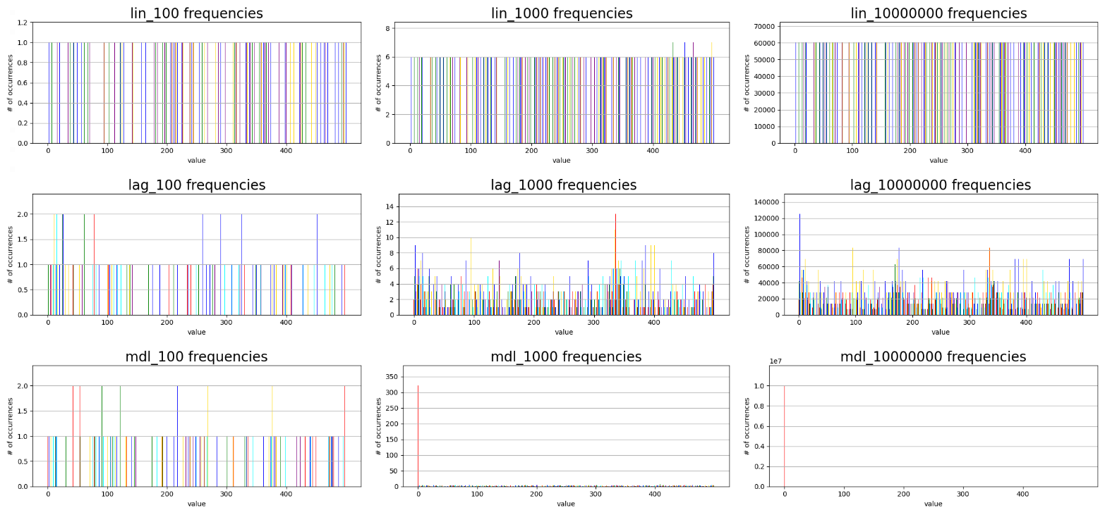The present of possible output covered is: 36.90%

linear congruential (lin) – Best used when only a few unique numbers are needed, fastest run time of all tested algorithms.

lagged Fibonacci (lag) – Best used when large quantities of random numbers are needed generated, runs faster than middle square method of generating pseudo random numbers.

Middle-square method (mdl) – Can be used to generate medium amounts of random numbers. However, this method is prone to entropy and even on good seeds produces a smaller range of numbers compared to the lagged Fibonacci method. No real advantages when compared to linear congruential and lagged Fibonacci generators.