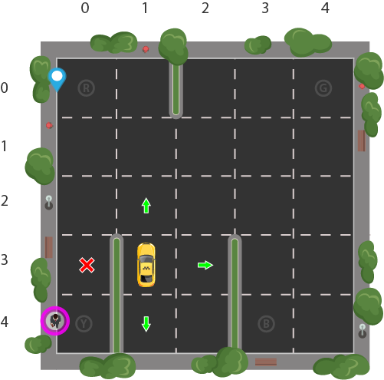
Reinforcement learning: 21/10/17

https://www.learndatasci.com/tutorials/reinforcement-q-learning-scratch-python-openai-gym/

Let's design a simulation of a self-driving cab. The major goal is to demonstrate, in a simplified environment, how you can use RL techniques to develop an efficient and safe approach for tackling this problem.
The Smartcab's job is to pick up the passenger at one location and drop them off in another. Here are a few things that we'd love our Smartcab to take care of:
Object functions ?
- Drop off the passenger to the right location.
- Save passenger's time by taking minimum time possible to drop off
- Take care of passenger's safety and traffic rules
There are different aspects that need to be considered here while modeling an RL solution to this problem: rewards, states, and actions.

1. Rewards
Since the agent (the imaginary driver) is reward-motivated and is going to learn how to control the cab by trial experiences in the environment, we need to decide the rewards and/or penalties and their magnitude accordingly. Here a few points to consider:
- The agent should receive a high positive reward for a successful dropoff because this behavior is highly desired

- The agent should be penalized if it tries to drop off a passenger in wrong locations

- The agent should get a slight negative reward for not making it to the destination after every time-step. "Slight" negative because we would prefer our agent to reach late instead of making wrong moves trying to reach to the destination as fast as possibl

2. State Space
In Reinforcement Learning, the agent encounters a state, and then takes action according to the state it's in.
The State Space is the set of all possible situations our taxi could inhabit. The state should contain useful information the agent needs to make the right action.
Let's say we have a training area for our Smartcab where we are teaching it to transport people in a parking lot to four different locations (R, G, Y, B):
Let's assume Smartcab is the only vehicle in this parking lot. We can break up the parking lot into a 5x5 grid, which gives us 25 possible taxi locations. These 25 locations are one part of our state space. Notice the current location state of our taxi is coordinate (3, 1).

You'll also notice there are four (4) locations that we can pick up and drop off a passenger: R, G, Y, B or [(0,0), (0,4), (4,0), (4,3)] in (row, col) coordinates. Our illustrated passenger is in location Y and they wish to go to location R.

When we also account for one (1) additional passenger state of being inside the taxi, we can take all combinations of passenger locations and destination locations to come to a total number of states for our taxi environment; there's four (4) destinations and five (4 + 1) passenger locations.

Recap:
Finally there are 25 possible locations for the taxi current location, there are 5 possible seats inside the car (yes, it is a self driving...no driver :)), and there are 4 possible locations for the passenger to be in. In total, the state space dimension is: 25x5x4=500.

3. Action Space
The agent encounters one of the 500 states and it takes an action. The action in our case can be to move in a direction or decide to pickup/dropoff a passenger.
In other words, we have six possible actions:
- south
- north
- east
- west
- pickup
- dropoff

The optimal action for each state is the action that has the highest cumulative long-term reward.

Reinforcement Learning will learn a mapping of states to the optimal action to perform in that state by exploration, i.e. the agent explores the environment and takes actions based off rewards defined in the environment.

The optimal action for each state is the action that has the highest cumulative long-term reward.
===============================================================
IN FACT THE TUTORIAL WAS TAKEN FROM THE NET AND THE TAXI2 VERSION

I AM NOW WORKING ON THE TAXI3 version I picked on the github repo. SO it is better explained as follows:

Description:
There are four designated locations in the grid world indicated by R(ed), G(reen), Y(ellow), and B(lue).
When the episode starts, the taxi starts off at a random square and the passenger is at a random location.
The taxi drives to the passenger's location, picks up the passenger, drives to the passenger's destination (another one of the four specified locations), and then drops off the passenger. Once the passenger is dropped-off, the episode ends.

Observations: (explained by me as well)

There are 500 discrete states since there are 25 taxi positions, 5 possible locations of the passenger (including the case when the passenger is in the taxi), and 4 destination locations.
Note that there are 400 states that can actually be reached during an episode. The missing states correspond to situations in which the passenger is at the same location as their destination, as this typically signals the end of an episode. (The 100 unreachable states come from: there are 4 possible destinations, if they are equal to the passenger pickup location, then there are 4 possible situations (pickup 0= destination 0, 1=1, 2=2 and 3=3). No matter the taxi location, which has 25 possible values, these 4 cases where the passenger pickup place and destination are the same still holds. Therefore, there are 25*4=100 cases where the state is not reachables, meaning that the episodes does not start since the objective is already achieved.

Four additional states can be observed right after a successful episodes, when both the passenger and the taxi are at the destination.
This gives a total of 404 reachable discrete states.

Passenger locations:
- 0: R(ed)
- 1: G(reen)
- 2: Y(ellow)
- 3: B(lue)
- 4: in taxi

Destinations:
- 0: R(ed)
- 1: G(reen)
- 2: Y(ellow)
- 3: B(lue)

Actions:
There are 6 discrete deterministic actions:
- 0: move south
- 1: move north
- 2: move east
- 3: move west
- 4: pickup passenger
- 5: drop off passenger

Rewards:
There is a default per-step reward of -1,
except for delivering the passenger, which is +20,
or executing "pickup" and "drop-off" actions illegally, which is -10.

Rendering:
- blue: passenger
- magenta: destination
- yellow: empty taxi
- green: full taxi
- other letters (R, G, Y and B): locations for passengers and destinations

state space is represented by:
(taxi_row, taxi_col, passenger_location, destination)
"""

