ENGINEERING CONFIGURATION GUIDE

PCB Motor Control Teaching Platform
  - Hall-based rotor-angle sensing, MP6550 phase drive, Arduino UNO R4 Minima and 2.5 V motor supply
Motor geometry: 6 PCB coils / 8 alternating rotor poles
Pitch diameter: Dpitch = 35.0 mm (radius 17.5 mm)
Magnets: 10 mm diameter × 1 mm thick, axially magnetized
Controller: Arduino UNO R4 Minima
Recommended status: Baseline configuration; validate field and waveform on the assembled motor

Recommended baseline Use three DRV5055A3 analog Hall sensors on a clean 3.3 V rail shared with Arduino AREF; use AR_EXTERNAL at 14-bit resolution. Drive the three isolated coil pairs with three MP6550 H-bridges from a TPS62A01-generated 2.5 V motor rail. Fit 27 kΩ at each MP6550 ISET pin.

1. Design basis and assumptions
Parameter | Design value
Stator | 6 evenly spaced PCB coils; 60° mechanical pitch
Rotor | 8 alternating N/S magnets; 4 pole pairs; 45° magnet pitch
Magnet geometry | 10 mm diameter × 1 mm thick
Magnet-to-Hall spacing | 4–5 mm from magnet face to active Hall die
Coil-pair resistance | 17.84 Ω for each driven pair
Motor supply | 2.5 V regulated from a 5 V source
Available source | 5 V at up to 0.75 A
Drive assumption | Three coil pairs are electrically isolated; one MP6550 per pair
Topology check: If the windings share a star point or are delta-connected, do not connect three full H-bridges as independent phase drivers. Re-evaluate the power stage as a conventional three-half-bridge inverter.

2. Mechanical placement of coils, magnets and Hall sensors
Mount all Hall sensing elements on the 17.5 mm pitch radius. The preferred fixed stator positions are 30°, 150° and 270° mechanical, placing each sensor between adjacent coil centers and keeping the three sensors 120° apart.
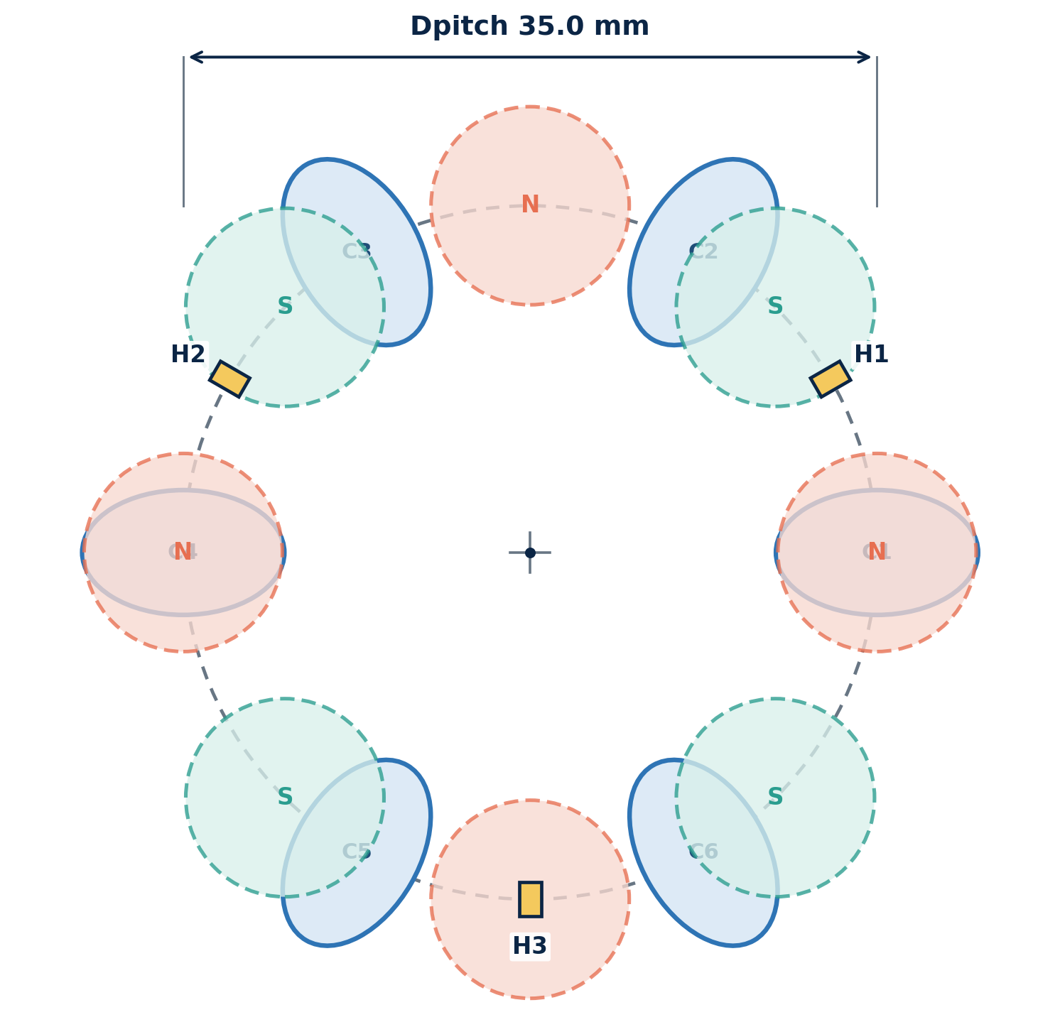
Figure 1. Top-view placement on the Ø35.0 mm pitch circle. Magnet positions are one instantaneous rotor orientation; Hall and coil positions are fixed to the stator.
Sensor | Mechanical angle | X from center | Y from center | Location
H1 | 30° | +15.16 mm | +8.75 mm | Between coils C1 and C2
H2 | 150° | −15.16 mm | +8.75 mm | Between coils C3 and C4
H3 | 270° | 0.00 mm | −17.50 mm | Between coils C5 and C6
Coordinate convention: +X is right and +Y is upward in Figure 1; angles increase counter-clockwise. Equivalent global rotation of all three Hall positions is acceptable if the 120° spacing and coil-gap placement are retained.

3. Hall sensor implementation
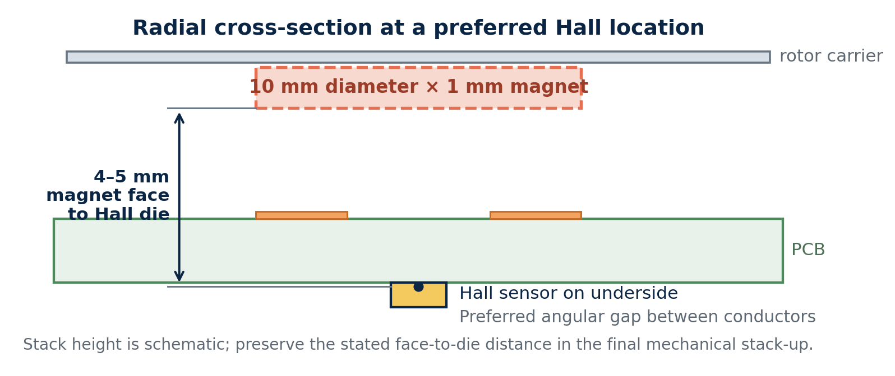
Figure 2. Preferred cross-section. The Hall package is on the PCB underside and angularly centered between coil conductors to reduce direct sensing of stator-coil field.

3.1 Recommended device
Item | Recommendation | Reason
Hall sensor | 3 × TI DRV5055A3, SOT-23 | Bipolar analog response with a safe range for the estimated rotor field
Supply | Clean 3.3 V | Directly compatible with the preferred external ADC reference
Sensitivity at 3.3 V | Approximately 15 mV/mT | Expected useful signal without likely saturation
Linear range at 3.3 V | At least approximately ±88 mT | Covers the initial 36–60 mT idealized field estimate
Local bypass | 100 nF at each sensor | Reduces supply-coupled PWM noise
Optional input filter | Footprint for 100 Ω + 4.7 nF | Provides light EMI filtering without excessive angle-loop phase lag

3.2 Sensitivity population options
Measured peak field at Hall die | Populate | Comment
Below approximately 35 mT | DRV5055A2 | Higher sensitivity; verify that neither polarity clips
Approximately 30–75 mT | DRV5055A3 | Recommended starting option
Above approximately 75 mT | DRV5055A4 | Lower sensitivity and wider field range
Important magnetic-error source A Hall sensor beneath an energized PCB coil measures rotor field plus coil field. Preserve the pitch radius but place the Hall die in a conductor-free angular gap. Calibrate Hall offset and gain with the assembled mechanics, and sample at a repeatable PWM phase.

3.3 Angle interpretation
With four pole pairs, electrical angle is four times mechanical angle. Three calibrated Hall waveforms can be converted to an electrical angle using a Clarke transformation followed by atan2(). Because the eight-pole pattern repeats four times per revolution, the resulting mechanical angle is known only modulo 90°. This is sufficient for commutation; unique 0–360° shaft position requires an index feature or a separate central angle sensor.

4. Arduino UNO R4 analog configuration
ADC reference setting Use the same clean 3.3 V rail for the three DRV5055 sensors and the UNO R4 AREF pin. This creates a ratiometric Hall measurement and uses more ADC range than the default 5 V reference.
void setup()
{
analogReference(AR_EXTERNAL);
analogReadResolution(14);
}
Do not use the internal 2.5 V reference with a 3.3 V-powered bipolar Hall sensor: its output is centered near 1.65 V and can rise above 2.5 V, causing clipping. The default 5 V reference is safe but uses only about two-thirds of the ADC span and does not provide supply-ratio cancellation.
- Power the Hall sensors from a clean 3.3 V rail, not from the 2.5 V switching motor rail.
- Connect all Hall grounds to the analog ground region; keep bridge-current returns out of this path.
- Sample Hall channels at a consistent point in the PWM cycle and apply calibrated offset/gain correction before angle calculation.

5. MP6550 phase-driver configuration
Setting | Recommended value | Engineering note
Number of drivers | 3 × MP6550 | One full H-bridge for each isolated coil pair
VIN | 2.5 V motor rail | Within the MP6550 operating range
ISET resistor | 27 kΩ, 1% | Sets approximately 2.7 V/A current-sense gain
Typical current limit | Approximately 185 mA | VISEN reaches approximately 0.5 V
Estimated tolerance band | Approximately 168–205 mA | Includes MP6550 sense and trip tolerances
nSLEEP_LDO | Logic low | Disable the internal 3.3 V LDO at 2.5 V VIN
nSLEEP_HB | MCU controlled | Provides a hardware-safe bridge disable
Local bypass | 100 nF + 4.7–10 µF | Place directly at every driver VIN/GND pair
Calculated maximum static current per coil pair: I ≈ 2.5 V / (17.84 Ω + 0.24 Ω) ≈ 0.138 A.
Expected current-sense voltage: VISEN ≈ 0.138 A × 2.7 V/A ≈ 0.373 V.
At a 3.3 V, 14-bit ADC reference, 0.373 V is approximately 1,850 ideal ADC counts. An amplifier is optional; for better oscilloscope visibility and ADC span utilization, reserve a footprint for a rail-to-rail amplifier of approximately 6× gain.
Current-sense limitation MP6550 VISEN is available when a low-side MOSFET conducts and is not a continuous signed phase-current output. Synchronize ADC sampling to known bridge states. Keep direct capacitive loading on VISEN at or below the datasheet limit of 500 pF; isolate larger filter capacitors with a resistor or buffer.

6. Recommended 5 V to 2.5 V converter
Converter choice Use TI TPS62A01PDDCR, a 1 A synchronous buck converter in SOT-23-6. It provides comfortable current margin and accepts the available 5 V input directly.
Reference / function | Suggested component or value | Notes
Buck regulator | TPS62A01PDDCR | 1 A; 2.5–5.5 V input; adjustable output
R1: VOUT to FB | 316 kΩ, 1% | Upper feedback resistor
R2: FB to GND | 100 kΩ, 1% | Lower feedback resistor; do not exceed 100 kΩ
Nominal output | 2.496 V | 0.6 × (1 + 316/100)
L1 | 1 µH, Isat ≥ 2 A | Example: Murata DFE252012F-1R0M
CIN | 4.7 µF, 10 V, X7R | Place directly at VIN/GND
COUT | 22 µF, 10 V, X7R | Allow for DC-bias capacitance loss
Motor-bus bulk | 220–470 µF | Place near the three H-bridges
PG pull-up | Optional, to 3.3 V | Use for startup interlock or diagnostics

6.1 Power budget
Operating condition | 2.5 V rail current | Approx. 5 V source current at 90% efficiency
One coil pair continuously energized | 0.138 A | 0.077 A
Two coil pairs continuously energized | 0.276 A | 0.153 A
All three coil pairs continuously energized | 0.414 A | 0.230 A
Converter rating | 1.0 A maximum | Adequate margin for this winding resistance
The 5 V, 0.75 A source is adequate for the calculated motor load and typically leaves about 0.52 A for the Arduino and auxiliary circuits in the all-three-phases static case. Confirm the total measured 5 V current with the final peripherals connected.
Regeneration caution A conventional buck converter does not normally sink regenerated current. Use the MP6550 slow-decay/brake behavior deliberately, provide motor-bus bulk capacitance, and monitor the 2.5 V rail during rapid deceleration or commanded reversal.

7. Wiring and PCB-layout priorities
- Create a compact 2.5 V power loop: converter output capacitor → MP6550 VIN → bridge ground → output capacitor.
- Use a star or split-return strategy so bridge currents do not flow through Hall/ADC ground traces.
- Route the three Hall outputs away from MP6550 OUT1/OUT2 nodes, PWM lines, the buck SW node and the inductor.
- Place 100 nF at each Hall sensor and 100 nF plus 4.7–10 µF at each MP6550.
- Place test points on H1/H2/H3, all three VISEN signals, AREF, 3.3 V, 2.5 V and every phase output.
- Provide a hardware pull-down that keeps every nSLEEP_HB low until firmware, AREF and PWM timers are initialized.

8. Commissioning procedure
- Power the board with all MP6550 H-bridges disabled. Verify 3.3 V Hall/AREF and 2.50 V motor rails before connecting the rotor assembly.
- Rotate the rotor slowly by hand with coil current disabled. Record each Hall waveform, minimum, maximum, offset and phase order.
- Confirm that no Hall output approaches the 0.2 V or 3.1 V linear-output boundaries. Substitute A2 or A4 sensitivity if needed.
- Calibrate per-channel offset and gain, then calculate electrical angle from the normalized three-channel set.
- Energize one coil pair at low PWM duty. Measure current independently and compare it with VISEN-derived current.
- Verify the nSLEEP_HB shutdown path and confirm that a reset or disconnected Arduino leaves all bridges disabled.
- Run open-loop commutation at low duty, verify direction and Hall phase order, and only then enable Hall-based commutation.
- Test rapid stop and reversal while monitoring the 2.5 V bus for regeneration-induced rise.

9. Design limitations to teach explicitly
- The three Hall sensors produce electrical angle; with four pole pairs they do not identify the absolute 90° mechanical sector.
- Coil-generated magnetic field and PWM switching can distort the measured rotor field.
- MP6550 current sensing is bridge-state-dependent and unsigned; it is less convenient than shunt-based bidirectional phase-current measurement for full FOC.
- The illustrated coil footprints are schematic because the PCB-coil inner/outer dimensions and copper geometry were not supplied.
- The initial magnetic-field estimate assumes NdFeB magnets approximately in the N35–N52 range; final sensor grade must be selected from measured assembled data.

10. Primary technical references
- Texas Instruments, DRV5055 ratiometric linear Hall-effect sensor datasheet
- Monolithic Power Systems, MP6550 H-bridge motor-driver datasheet
- Arduino, UNO R4 Minima schematic
- ArduinoCore-renesas analog reference implementation
- Renesas, RA4M1 group datasheet
- Texas Instruments, TPS62A01 synchronous buck-converter datasheet

