NanoBalancer
Two-wheeled self-balancing robot — mechanical design, mass properties, dynamic model, control design and simulation
TALs Education · Project documentation · November 2026
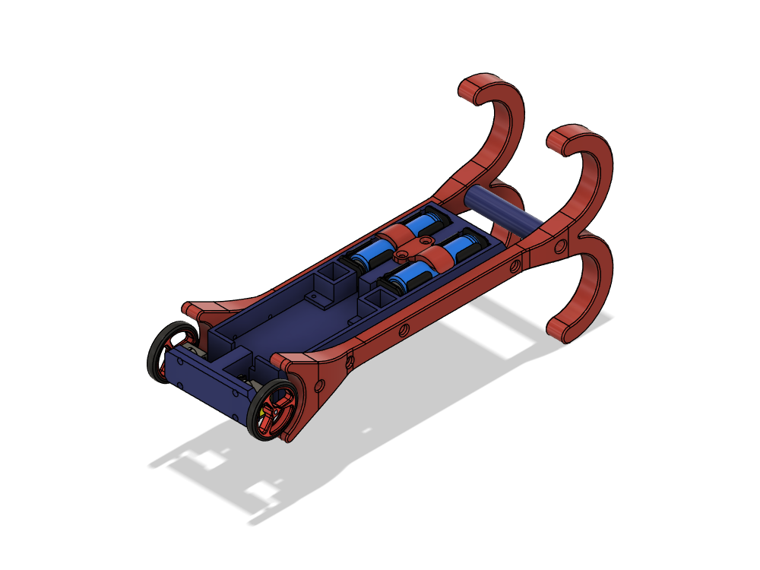
Figure 1. NanoBalancer V02 in Fusion 360 (PETG body in blue, Bambu TPU-for-AMS bumpers and battery clip in red, 2× 18650 cells, Pololu 30:1 gearmotors with 40 mm wheels).

Contents
1. Overview
2. Hardware and bill of materials
3. Mechanical design and mass properties
4. Actuation: gearmotor, driver and encoder
5. Governing equations
6. Control design
7. Implemented simulations
8. Project files and how to run
9. Assumptions and open items

1. Overview
NanoBalancer is a compact two-wheeled inverted-pendulum robot built for teaching control. A tall printed body carries two 18650 cells and an Arduino Nano Motor Carrier with an Arduino Nano ESP32. Two Pololu micro metal gearmotors with magnetic encoders drive 40 mm wheels. Two large TPU side bumpers with hooks protect the robot and let it hang from a beam.
This document collects the design data, the theoretical parameters, the governing equations, and the simulations built so far:
- Mass and inertia from the Fusion 360 model, with print masses verified in Bambu Studio at 35% infill.
- Motor and driver limits from the datasheets (Pololu #3049, Arduino ABX00041).
- Nonlinear and linearised wheeled-inverted-pendulum models, and an LQR controller at the 100 Hz BNO055 rate.
- MATLAB and Simulink simulations: a delay study with a predictor, Simscape gearmotors validated against the datasheet, and quadrature encoders with a Kalman observer.
Table 1. Headline numbers.
Key result | Value
Total mass (sliced print masses) | 426.3 g
Body CoM height above wheel axle | 135.3 mm (body) / 133.3 mm (whole robot)
CoM fore/aft offset from axle (CoM_TrayOffset = 8 mm) | ≈ 0.00 mm (vertical over the axle)
Body pitch inertia about axle / about CoM | 107,315 / 30,459 g·cm²
Max torque per motor (0.5 A driver limit) | 0.244 kg·cm (24.0 mN·m), 63% of stall
Open-loop unstable pole (with back-EMF) | 9.47 rad/s (fall time constant 106 ms)
LQR gains @ 100 Hz [θ, θ̇, x, ẋ] | [−107.8, −11.0, −25.9, −30.6] V/(rad, rad/s, m, m/s)
Largest recoverable initial tilt (nonlinear, limits) | ≈ 29–30°

2. Hardware and bill of materials
The bill of materials follows NanoBalancer BOM V02. The parts that matter for the dynamics are below. Fasteners and wiring are included in the mass budget.
Table 2. Main components.
Item | Part | Qty | Role / notes
Controller | Arduino Nano ESP32 | 1 | Runs the 100 Hz control loop (Simulink code generation)
Motor driver / IMU | Arduino Nano Motor Carrier ABX00041 | 1 | 4× MP6522, 12 V boosted output, 500 mA per driver, BNO055 9-axis IMU, 1S charger
Gearmotors | Pololu #3049, 30:1 Micro Metal HPCB 12 V, ext. shaft | 2 | 29.86:1, 1100 rpm and 0.39 kg·cm @ 12 V
Encoders | Pololu magnetic encoder kit (POL-4761) | 1 pair | 12 CPR on the motor shaft → 358.3 counts per wheel revolution
Brackets | Pololu extended micro motor bracket (POL-1089) | 1 pair
Wheels | Pololu 40 × 7 mm (POL-1453) | 1 pair | r = 20 mm
Battery | LG HE4 18650, 2500 mAh | 2 (model) | 1S2P (carrier accepts 1S only); BOM lists 1
Battery holders | 1×18650 holder | 2
Printed body | MainBody + Hanging Beam, Bambu PETG HF | 1+1 | 35% grid infill
Printed bumpers / clip | Bum1, Bum2, BatteryClips, Bambu TPU for AMS | 2+1 | 35% grid infill
Fasteners | M3×6 (4), M3×10 + nut (8), M4×20 (2) |  | Carrier mounting, bumpers, clip, beam

3. Mechanical design and mass properties

3.1 Geometry and coordinate system
The Fusion 360 model is NanoBalancer_V01 in TALs-Education / NanoBalancer. The world X axis is the wheel axle (y = 0, z = 0), Y points up along the body, and Z is the fore/aft (pitch) direction. The two bumpers extend in ±Z and end in hooks. The Hanging Beam joins them, and the separate Hanger is not part of the robot.
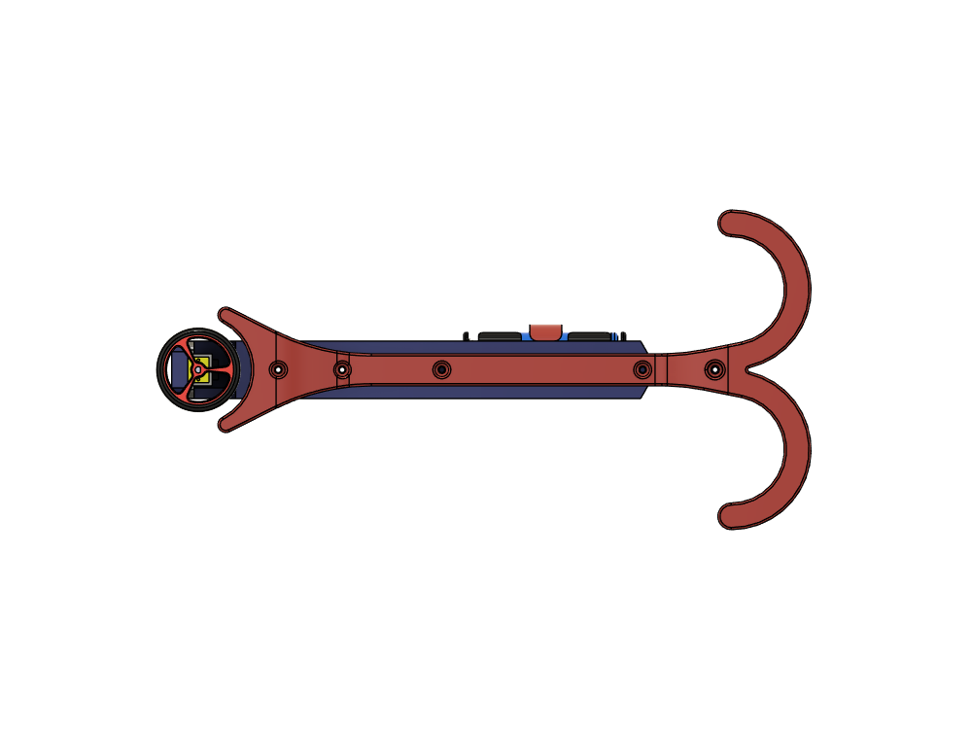
Figure 2. Side view (looking along the axle): wheel at the bottom, battery pack in the middle, hooks at the top.
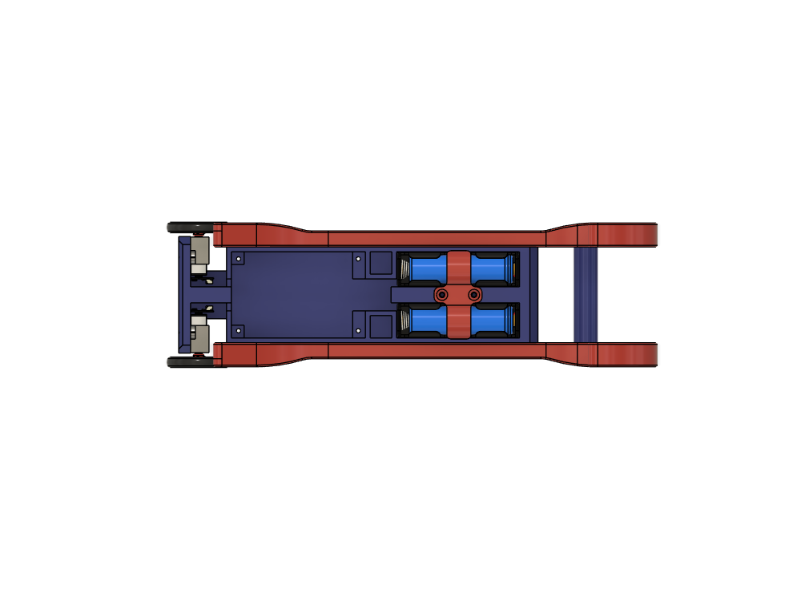
Figure 3. View onto the electronics side: carrier tray with its four M3 bosses (45 × 75 mm pattern), the two 18650 holders with the TPU clip, and the hanging beam.

3.2 Printed parts (Bambu Studio, 35% infill)
Every printed part was exported as STL and sliced with the Bambu Studio 2.05 command line. Settings: Bambu Lab H2C, 0.4 mm nozzle, 0.20 mm Standard, 35% grid infill, 2 walls, 5 top / 3 bottom layers, no brim or supports. Fusion 360 uses the sliced masses through per-body effective-density materials. The first estimate (0.85 mm solid shell plus 35% core) was within 1–5% of the sliced values.
Table 3. Printed parts: estimated and sliced masses.
Part | Material | Estimate [g] | Sliced [g] | Print time
MainBody | Bambu PETG HF (1.28 g/cm³) | 97.06 | 95.90 | 2 h 28 min
Hanging Beam | Bambu PETG HF | 7.14 | 7.33 | 17 min
Bumper 1 | Bambu TPU for AMS (1.26 g/cm³) | 58.48 | 56.68 | 1 h 41 min
Bumper 2 | Bambu TPU for AMS | 58.48 | 56.68 | 1 h 41 min
BatteryClips | Bambu TPU for AMS | 3.08 | 2.92 | 9 min
Total |  | 224.2 | 219.5 | ≈ 6 h 16 min

3.3 Mass budget and centre of mass
Bought parts use their datasheet masses. Parts that aren't modelled are point masses in the MassModel components: motors, fasteners and wiring. The Nano Motor Carrier and Nano ESP32 are rough solid bodies (PCB, components block, headers, Nano), 42 g in total, sitting on the tray bosses.
Table 4. Mass budget by group.
Group | Mass [g] | Share
Printed parts | 219.5 | 51.5%
Batteries + holders (2 × 18650) | 108.0 | 25.3%
Electronics (carrier + Nano ESP32) | 42.0 | 9.9%
Drive (motors, wheels, brackets, encoders) | 28.0 | 6.6%
Fasteners | 18.8 | 4.4%
Wiring (XT30, encoder cables) | 10.0 | 2.3%
Total | 426.3 | 100%

The tray-floor depth is set by the user parameter CoM_TrayOffset (formerly CoM_TrayOffset; Extrude32, side 2), while Extrude33 holds the back panel at 2.5 mm. It moves the electronics and battery pack fore/aft relative to the axle, 1 mm per mm of CoM_TrayOffset. It was solved so the CoM sits vertically over the axle, then rounded up to 8 mm to leave margin for unmodelled wiring:
Table 5. Effect of CoM_TrayOffset on the centre of mass.
CoM_TrayOffset | Model state | CoM height above axle | CoM offset from axle (Z)
1.5 mm | initial | 132.98 mm | 2.83 mm
2.5 mm | point-mass electronics | 133.03 mm | 2.38 mm
7.99 mm | solved, TPU clips | 133.54 mm | 0.0014 mm
8.0 mm | saved, sliced masses | 133.28 mm | −0.004 mm

A note on bumper weight: the two TPU bumpers make up 27% of the total mass and sit high (centroid y = 178 mm), so they are the main reason the CoM is high. A high CoM slows the fall dynamics, which suits a teaching platform, but it also raises the torque needed to recover a given tilt.

3.4 Moments of inertia
Fusion 360 gives the inertia tensor about the world origin, which lies on the axle, at very high accuracy. Splitting off the wheels gives the body properties used in the dynamic model:
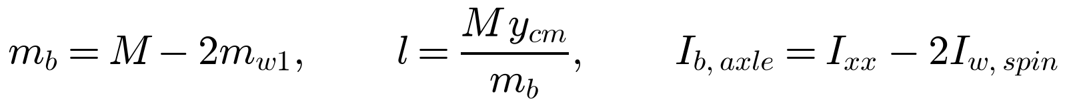 | (1)

(2)

Table 6. Mass and inertia parameters (CoM_TrayOffset = 8 mm).
Symbol | Parameter | Value | Source
M | Total mass | 426.4 g | Fusion
m_b | Body mass (all but wheels) | 420.0 g | Fusion
m_w | Both wheels | 6.40 g | Pololu (3.2 g each)
l | Body CoM height above axle | 135.3 mm | Fusion
I_b,axle | Body pitch inertia about axle | 107,315 g·cm² | Fusion
I_b | Body pitch inertia about own CoM | 30,459 g·cm² | parallel axis
I_w | Wheel-side inertia (2 wheels + reflected rotors) | 69.8 g·cm² | 16.3 wheels + 53.5 rotors (assumed J)
I_yaw | Yaw inertia (vertical axis) | 3,833 g·cm² | Fusion
r | Wheel radius | 20.0 mm | Pololu 40 mm wheel
d | Wheel track (centre to centre) | 84.3 mm | Fusion
y_IMU | BNO055 height above axle (approx.) | ≈ 62.5 mm | carrier centre

4. Actuation: gearmotor, driver and encoder

4.1 Gearmotor (Pololu #3049) and the linear motor model
A linear DC-motor model is fitted to the Pololu datasheet values at 12 V, referred to the gearbox output:
(3)

Table 7. Gearmotor parameters.
Parameter | Datasheet | Derived (output shaft) | Derived (motor shaft)
Gear ratio N | 29.86 : 1 | — | —
No-load speed / current @12 V | 1100 rpm / 0.08 A | ω_nl = 115.2 rad/s | 3439 rad/s
Stall torque / current @12 V | 0.39 kg·cm / 0.75 A | T_stall = 38.2 mN·m | —
Resistance R | — | 16.0 Ω | 16.0 Ω
Torque constant K_t | — | 0.0571 N·m/A | —
Back-EMF constant K_e | — | 0.0931 V·s/rad | 0.00312 V·s/rad
Gearbox efficiency η | — | 61% | —
Rotor inertia J_rotor | not published | — | 0.03 g·cm² (assumed)

4.2 Driver limits (Arduino Nano Motor Carrier ABX00041)
According to the ABX00041 datasheet, the carrier boosts a 1S Li-ion cell (max 4 V input) to a 12 V motor supply. Each MP6522 driver channel is limited to 500 mA. That's below the 750 mA stall current, so the driver, not the motor, sets the torque available at low speed:
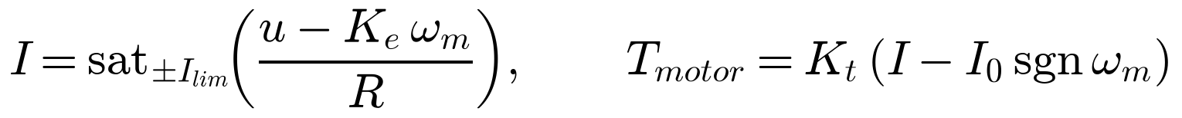 | (4)

Table 8. Actuation limits with the Nano Motor Carrier.
Quantity | Value
Max torque per motor at 0.5 A | 24.0 mN·m = 0.244 kg·cm (63% of stall)
Max total torque τ_max (both motors) | 48.0 mN·m
Full torque available up to | 0.86 m/s (410 rpm); top no-load speed 2.30 m/s
Max traction force | 2.40 N
Peak battery current (both motors at limit, 85% boost) | 4.12 A (2.06 A per cell)
Pack energy / estimated runtime | 18.0 Wh / ≈ 5.9 h (assumed 2.6 W average)

4.3 Encoder
The magnetic encoder gives 3 pulses per channel per motor revolution. With ×4 quadrature decoding that's 12 counts per motor revolution, or 12 × 29.86 = 358.3 counts per wheel revolution. One count is 1.0° of wheel angle, or 0.35 mm of travel. At the 100 Hz loop rate, a single count per sample corresponds to 35 mm/s, so speeds calculated from count differences are coarse (see Section 7.4).

5. Governing equations

5.1 Nonlinear wheeled inverted pendulum (planar)
The model has two degrees of freedom: θ is the body tilt from vertical (positive forward) and φ is the absolute wheel rotation, with wheel travel x = rφ. The motors apply a total torque τ between body and wheels, and F is an external horizontal force at the body CoM (the bump). Lagrange's equations give:
(5)

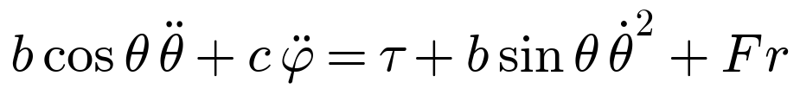 | (6)

(7)

The motor relative speed (gearbox output relative to the body/stator) is ω_m = φ̇ − θ̇. The torque comes from the current-limited motor model of Eq. (4), summed over both motors. The encoder measures the relative angle ψ = φ − θ.

5.2 Linearised model and open-loop behaviour
(8)

(9)

Torque authority and the steady lean that full torque can hold while accelerating (small angle):
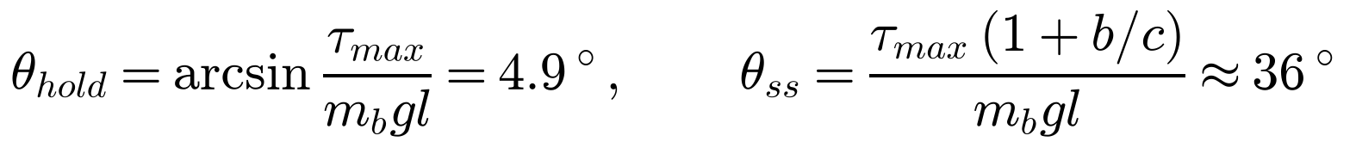 | (10)

5.3 State-space model with voltage input
The state is x = [θ, θ̇, x, ẋ]ᵀ and the input u is the voltage applied to both motors. The motor torque, with back-EMF damping, is:
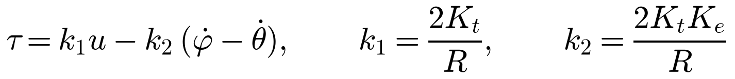 | (11)

Substituting into Eq. (8) gives A and B below. The model is discretised with a zero-order hold at T_s = 10 ms (A_d, B_d).
Table 9. Continuous state matrices, with B₂ = −(c+b)/D and B₄ = r(a+b)/D. Numerical values are in the workbook's State Space sheet.
 | θ | θ̇ | x | ẋ | B (u in V)
θ̇ eq. | 0 | 1 | 0 | 0 | 0
θ̈ eq. | c·m_b·g·l/D | B₂·k₂ | 0 | −B₂·k₂/r | B₂·k₁
ẋ eq. | 0 | 0 | 0 | 1 | 0
ẍ eq. | −r·b·m_b·g·l/D | B₄·k₂ | 0 | −B₄·k₂/r | B₄·k₁

The open-loop poles are {0, 9.47, −20.64, −3.08} rad/s: one unstable pendulum pole, one integrating wheel position, and two stable modes.

6. Control design

6.1 Discrete LQR at 100 Hz
The BNO055 fusion output is limited to 100 Hz, so the controller runs at T_s = 10 ms. The weights follow Bryson's rule (1/max²): θ 2°, θ̇ 30°/s, x 0.10 m, ẋ 0.30 m/s, u 6 V. The discrete Riccati equation is solved iteratively (no toolboxes needed):
(12)

That's 1.88 V per degree of tilt and 0.19 V per deg/s. The closed-loop poles (continuous equivalent) are −165, −14.6 and −1.33 ± 1.06j rad/s.

6.2 Sensor delay and the model predictor
The BNO055 sample adds latency. A linear stability check with the measurement delayed by d samples shows the loop stays stable at d = 0 or 1 (spectral radius 0.987) but goes unstable at d ≥ 2 (20 ms). A model predictor brings the stale measurement forward to the present:
(13)

6.3 Gearmotor friction feed-forward
The predictor alone produced a standing tilt offset of about 0.4° per prediction step. The cause was no-load friction in the gearmotor, which the linear model doesn't include. Adding a friction feed-forward term, and feeding only the linear part of u back to the predictor, removes the bias:
(14)

6.4 State observer with encoders (steady-state Kalman filter)
The encoder measures the wheel relative to the body, so wheel travel is reconstructed as below, from the count N_c:
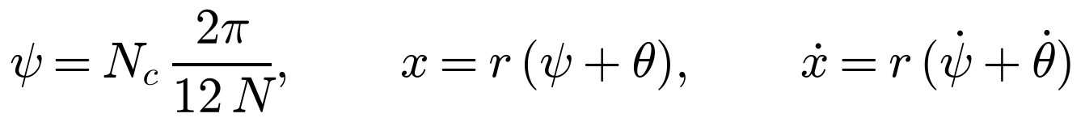 | (15)

Taking ẋ from count differences proved unstable (Section 7.4). The final design is a steady-state Kalman observer. It uses the measurements y = [θ, θ̇, x_enc] (BNO055 angle and gyro, encoder position), predicts with the model and the applied voltage, and corrects every sample:
(16)

The gain L comes from the discrete Riccati equation with process noise of 20 rad/s² (tilt) and 2 m/s² (wheel), and measurement noise of 0.2°, 1°/s and 0.1 mm (the encoder quantisation, 0.35 mm/√12).

7. Implemented simulations

7.1 Parameter workbook and MATLAB LQR script
NanoBalancer_Stabilization_Parameters.xlsx holds all the inputs (blue cells) and derives the inertia, motor, dynamics and state-space values with live formulas (267 formulas). matlab/NanoBalancer_LQR.m reads the workbook, builds the model, designs the discrete LQR, runs a nonlinear simulation with the 12 V and 0.5 A limits, sweeps the largest recoverable tilt, and exports lqr_gains.h and NanoBalancer_params.mat.
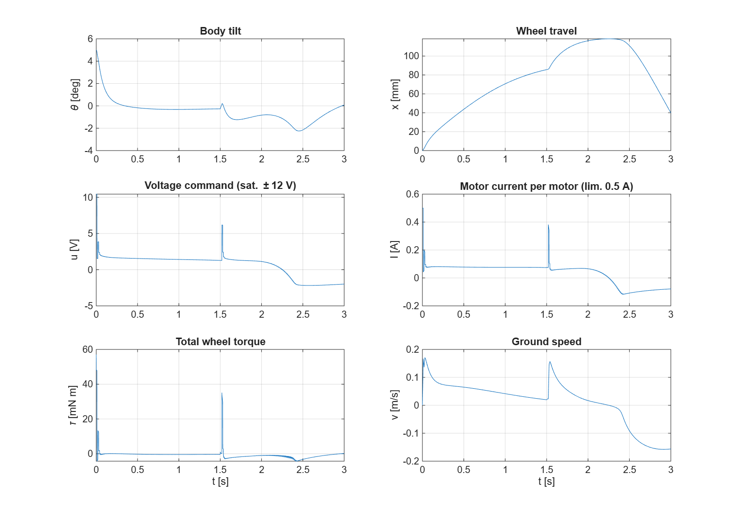
Figure 4. MATLAB nonlinear simulation: recovery from a 5° initial tilt and a 0.03 N·s push at t = 1.5 s (100 Hz LQR, one-sample delay with predictor).
Table 10. Recoverable tilt from the MATLAB nonlinear simulation, which is limited by torque and speed, not by the sample rate.
Setting (100 Hz) | Largest recoverable initial tilt
Ideal sensor | 30.1°
1-sample BNO055 delay | 30.2°
1-sample delay + predictor | 29.5°
2-sample delay + predictor | 28.3°

7.2 Simulink stabiliser with sensor-mode switch (NanoBalancer_Stabilizer.slx)
The plant is a nonlinear MATLAB Function block covering Eqs. (5)–(7), the current-limited motor model and friction. The plant is sampled by a 100 Hz zero-order hold. The controller is built from plain Simulink blocks (code-generation ready). A Multiport Switch driven by SensorMode selects the state estimate:
- 1 — ideal sensor
- 2 — one-sample delay, no predictor
- 3 — one-sample delay + predictor
- 4 — two-sample delay + predictor
The estimate then goes through the −K gain, friction feed-forward is added, and the result is limited to ±12 V. The test input is a 0.05 N·s horizontal bump at the body CoM (2.5 N for 20 ms at t = 1 s).
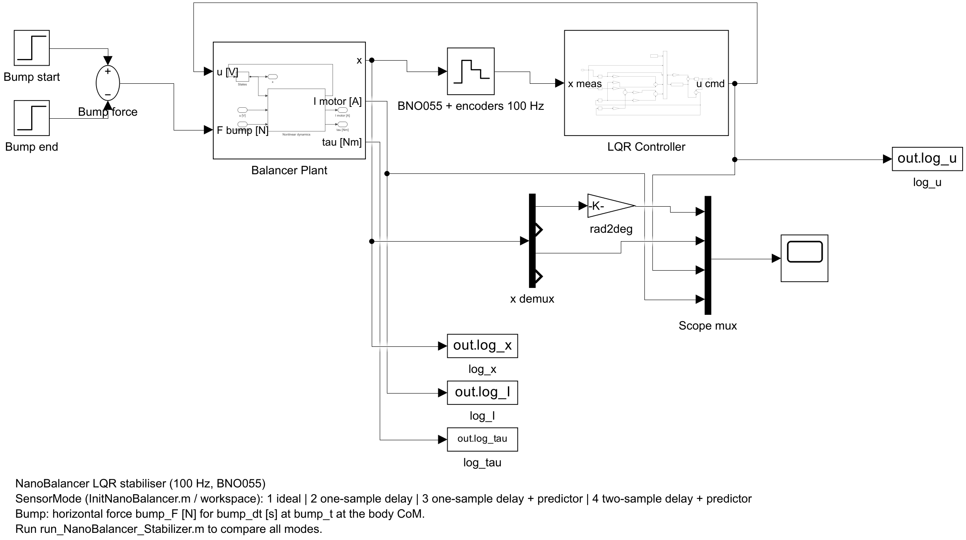
Figure 5. Top level of NanoBalancer_Stabilizer.slx.
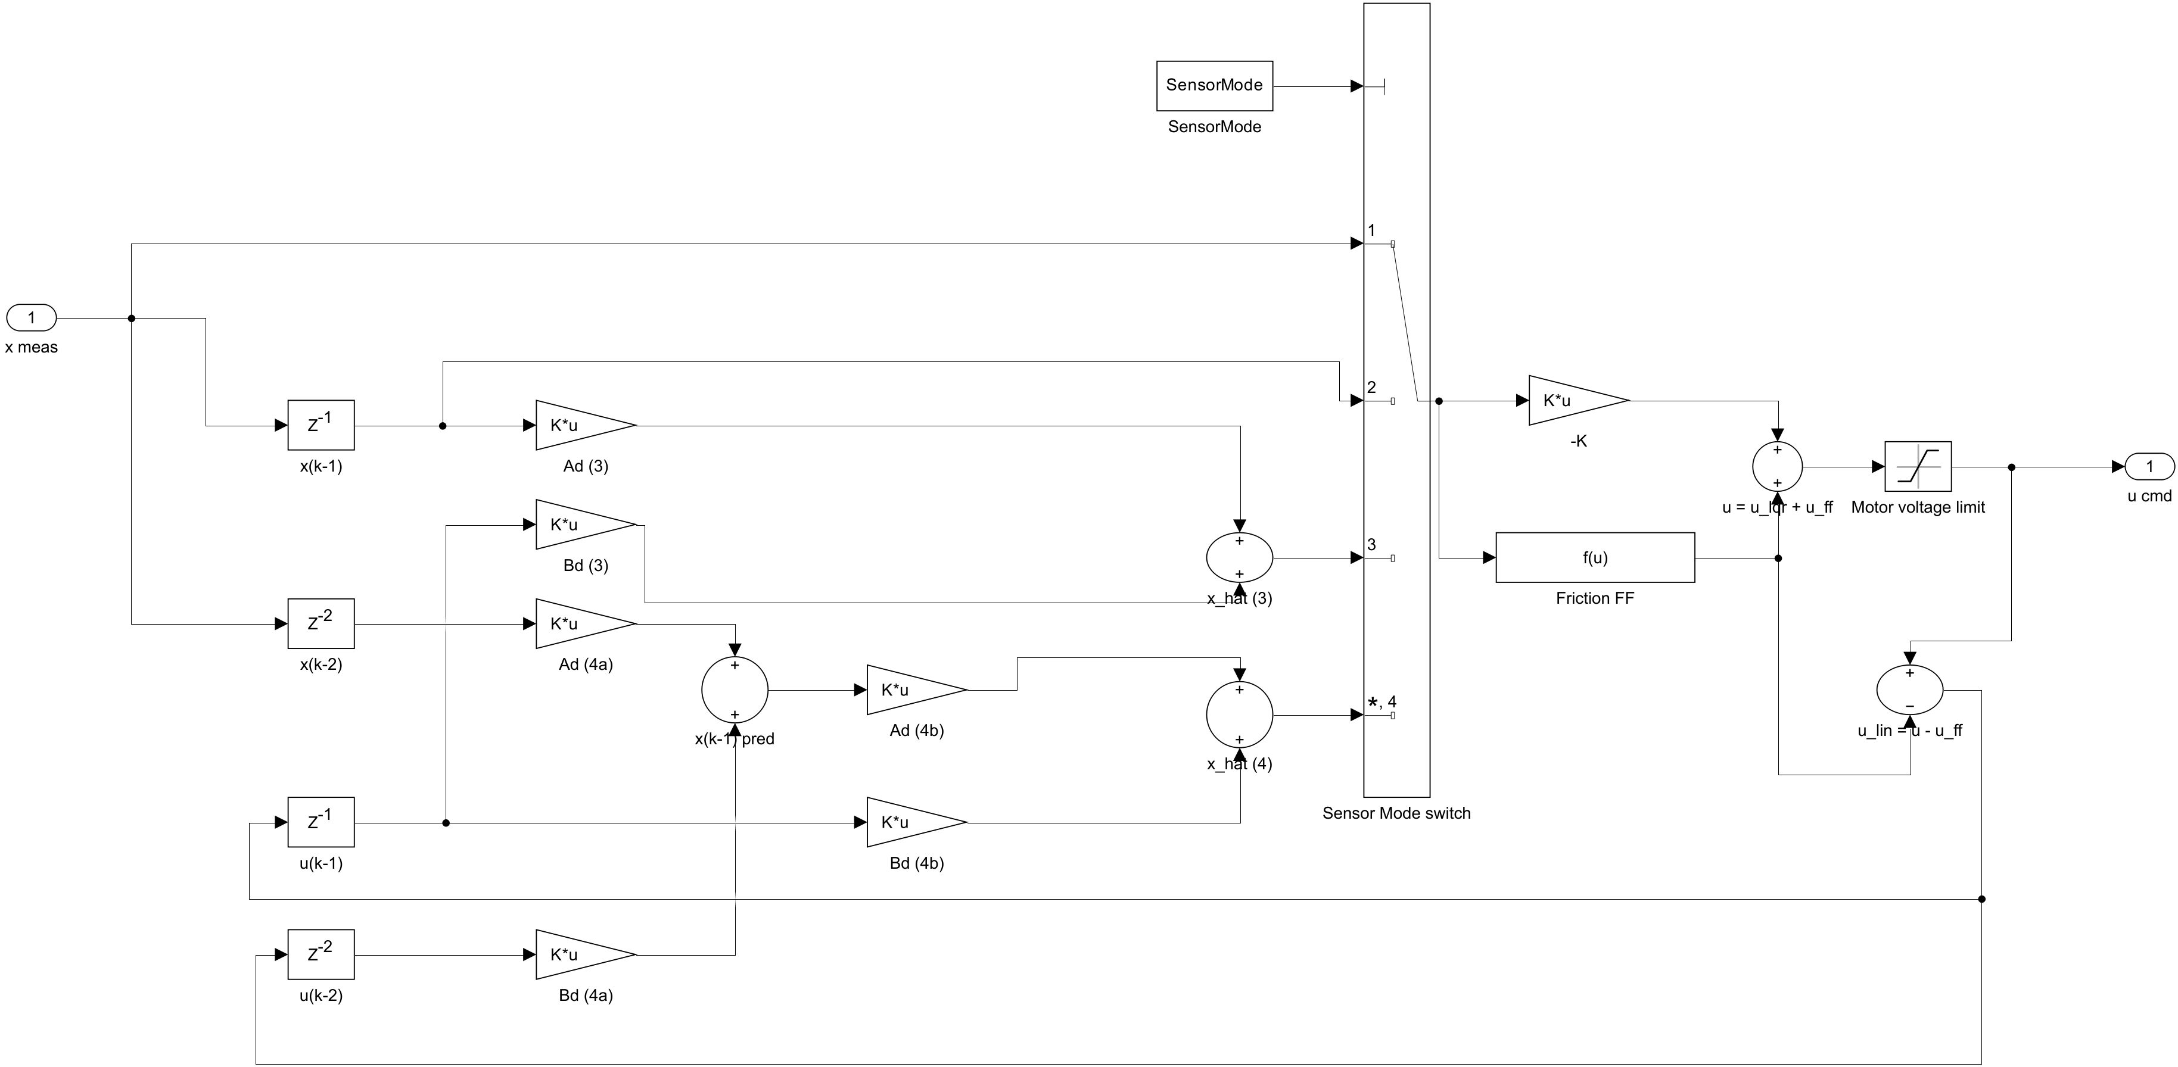
Figure 6. LQR controller subsystem: delay branches, predictors, Sensor Mode switch, −K, friction feed-forward and voltage limit.
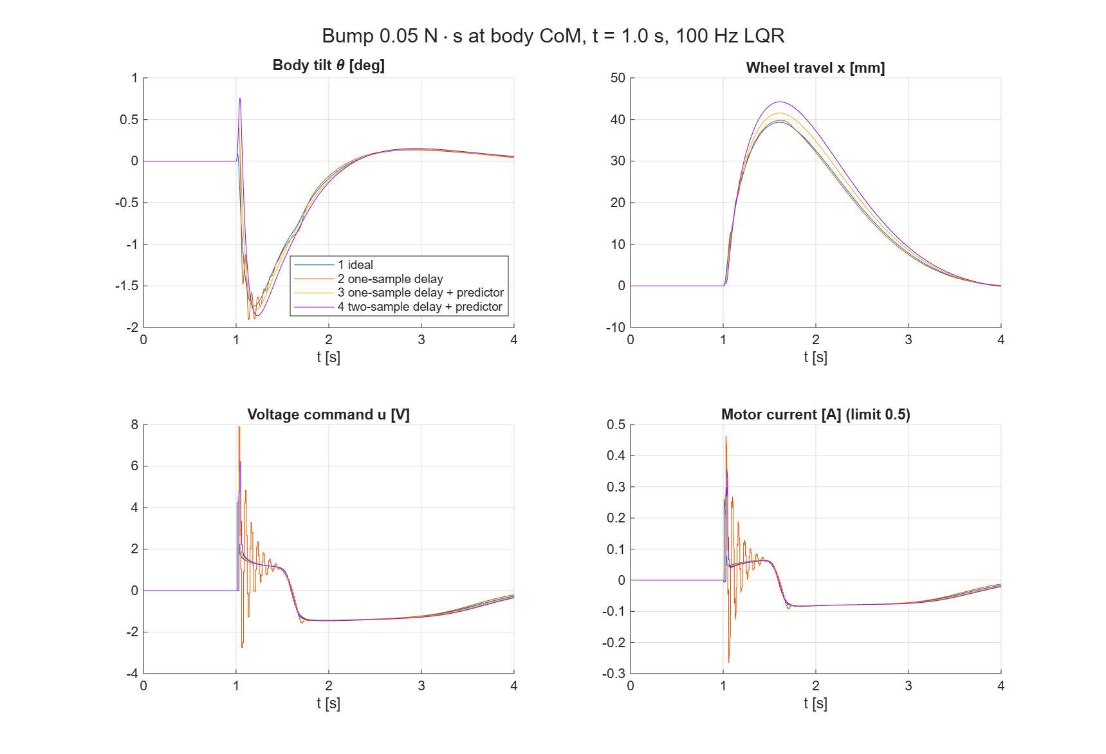
Figure 7. Bump response for the four sensor modes (friction feed-forward on).
Table 11. Simulink stabiliser bump results.
SensorMode | Peak tilt | Peak |u| | Largest bump recovered
1 ideal | 1.74° | 4.3 V | 0.76 N·s
2 one-sample delay | 1.91° | 7.9 V (rings) | 0.70 N·s
3 one-sample delay + predictor | 1.79° | 5.7 V | 0.69 N·s
4 two-sample delay + predictor | 1.86° | 6.2 V | 0.63 N·s

7.3 Simscape gearmotor and validation (NanoBalancer_MotorTest.slx)
The gearmotor subsystem follows the ZumoPi models. The MP6522 driver is averaged, with the 0.5 A current regulation implemented as a voltage clamp around the back-EMF. It feeds a Simscape DC Motor (circuit parameters at the motor shaft, Coulomb friction set for the 0.08 A no-load current), then a Simple Gear 29.86:1 with η = 0.61, then an interface to the body dynamics (velocity source plus torque sensor). The incremental shaft encoder (3 PPR) sits on the motor shaft and feeds an event-driven ×4 quadrature decoder.
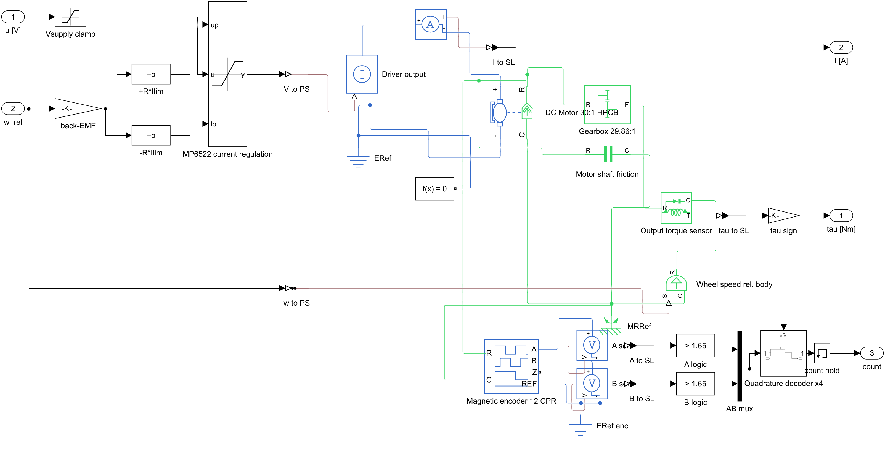
Figure 8. Gearmotor subsystem: MP6522 current regulation, Simscape DC motor, gearbox, friction, encoder and quadrature decoder.
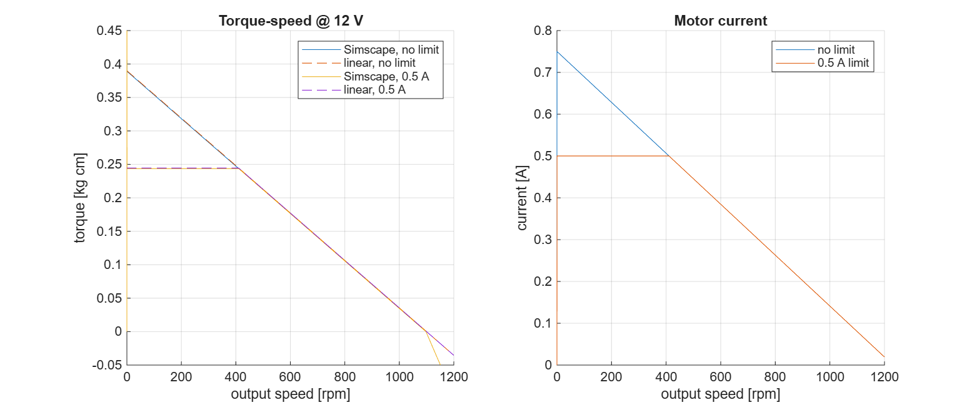
Figure 9. Torque–speed and current at 12 V: Simscape model (solid) against the linear model (dashed), with and without the 0.5 A limit.
Table 12. Gearmotor model validation.
Check | Simscape model | Datasheet / expected
Stall torque / current | 0.386 kg·cm / 0.744 A | 0.39 kg·cm / 0.75 A
No-load speed / current | 1098 rpm / 0.081 A | 1100 rpm / 0.08 A
Stall torque with 0.5 A limit | 0.244 kg·cm | 0.244 kg·cm
Encoder count over the sweep | 9263 | 9267 (−0.04%)

7.4 Balancer with encoders and Kalman observer (NanoBalancer_Encoder.slx)
Two gearmotor subsystems (left and right) drive the body-only dynamics. The Sensors 100 Hz block samples the BNO055 states and the encoder counts, builds the measured state, and offers an EncoderMode switch:
- 1 — true wheel state
- 2 — count-difference speed (optional low-pass)
- 3 — Kalman observer
The controller is the validated stabiliser controller.
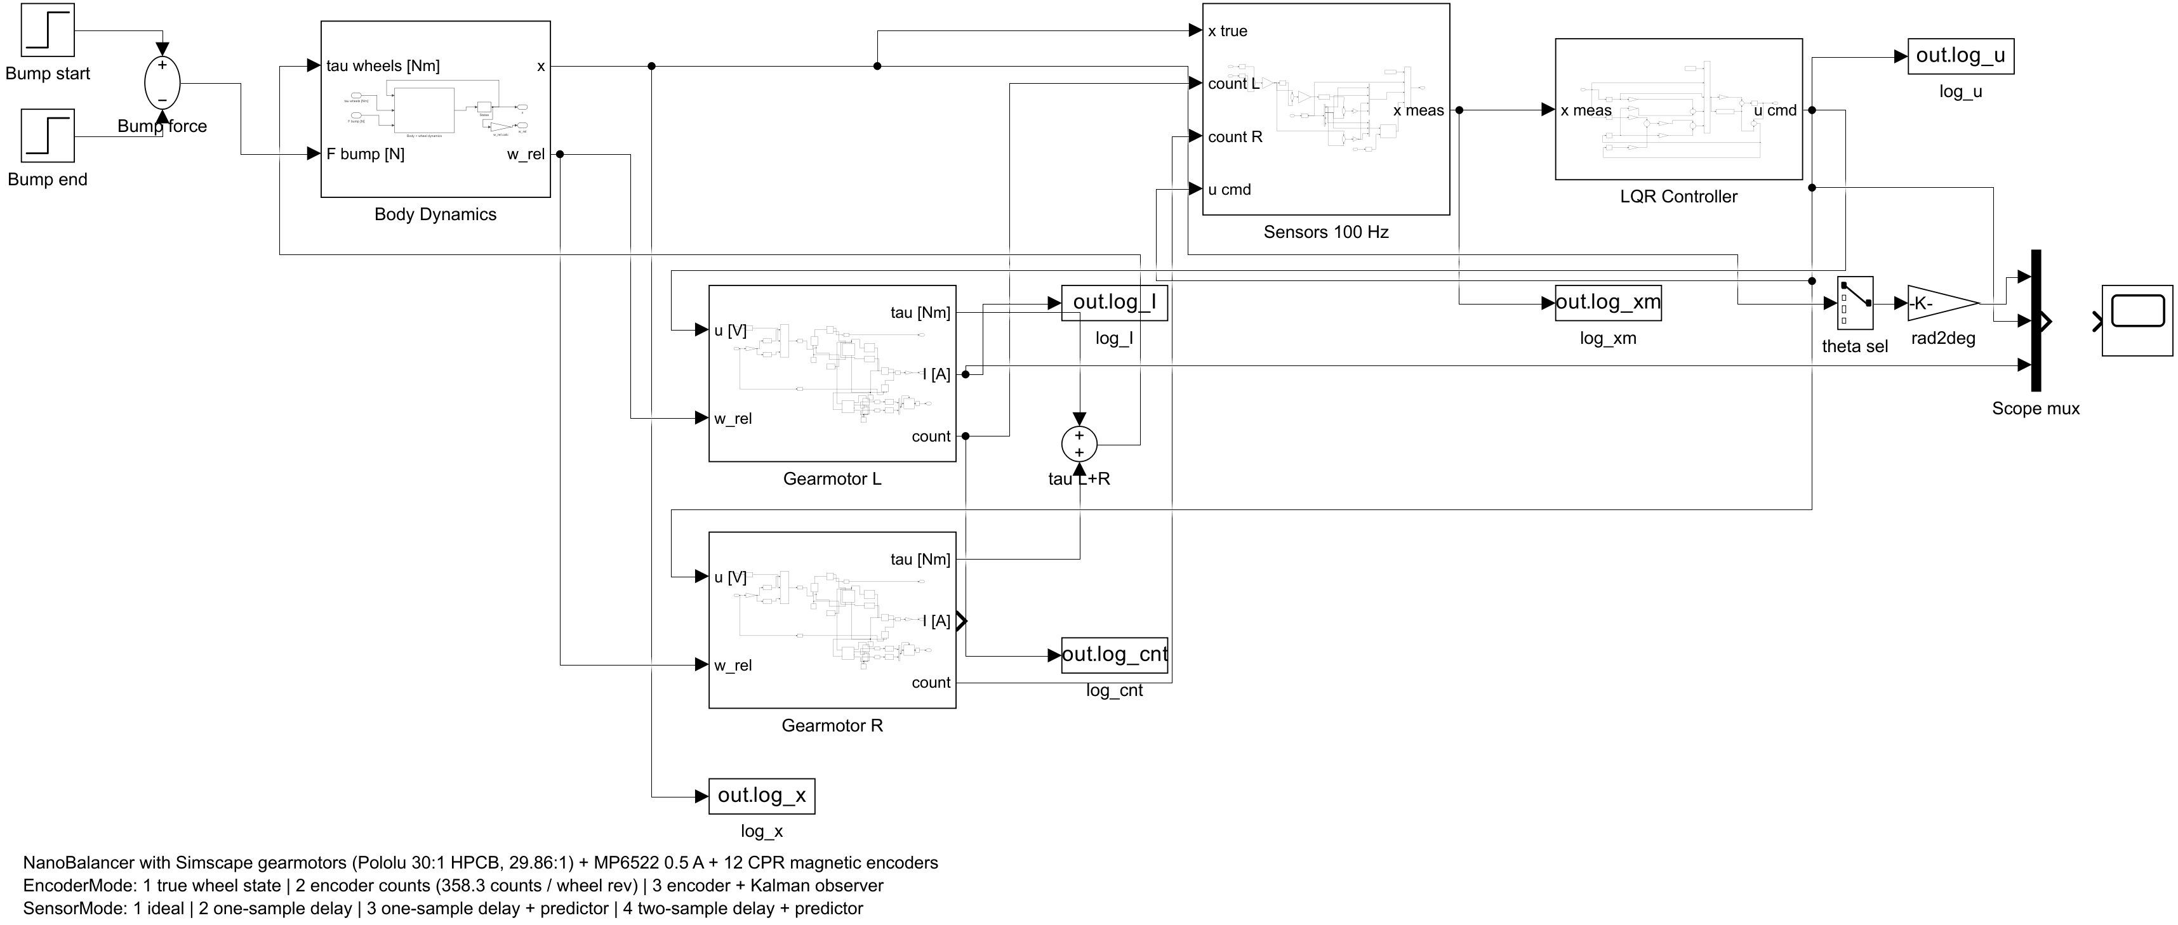
Figure 10. Top level of NanoBalancer_Encoder.slx.
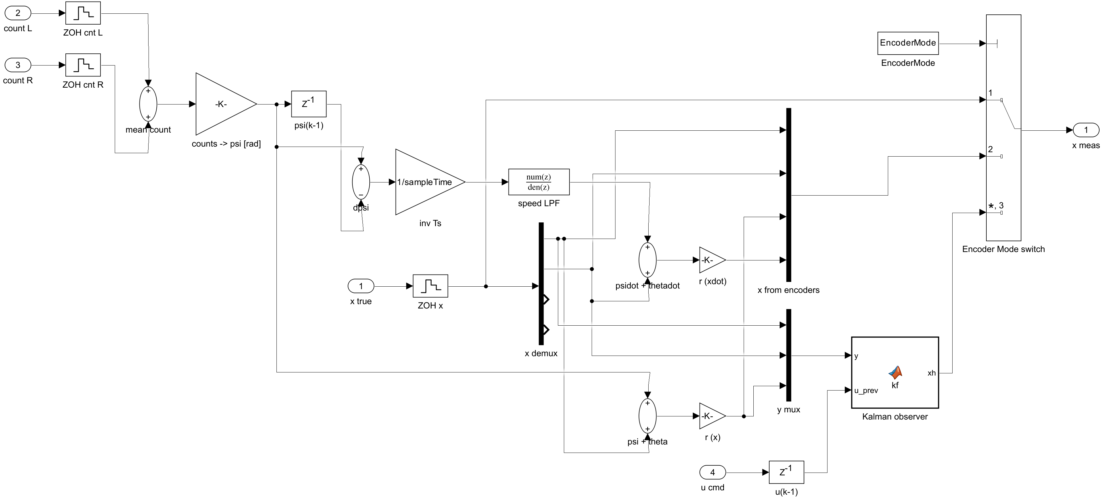
Figure 11. Sensors 100 Hz subsystem: encoder count processing and the Kalman observer.
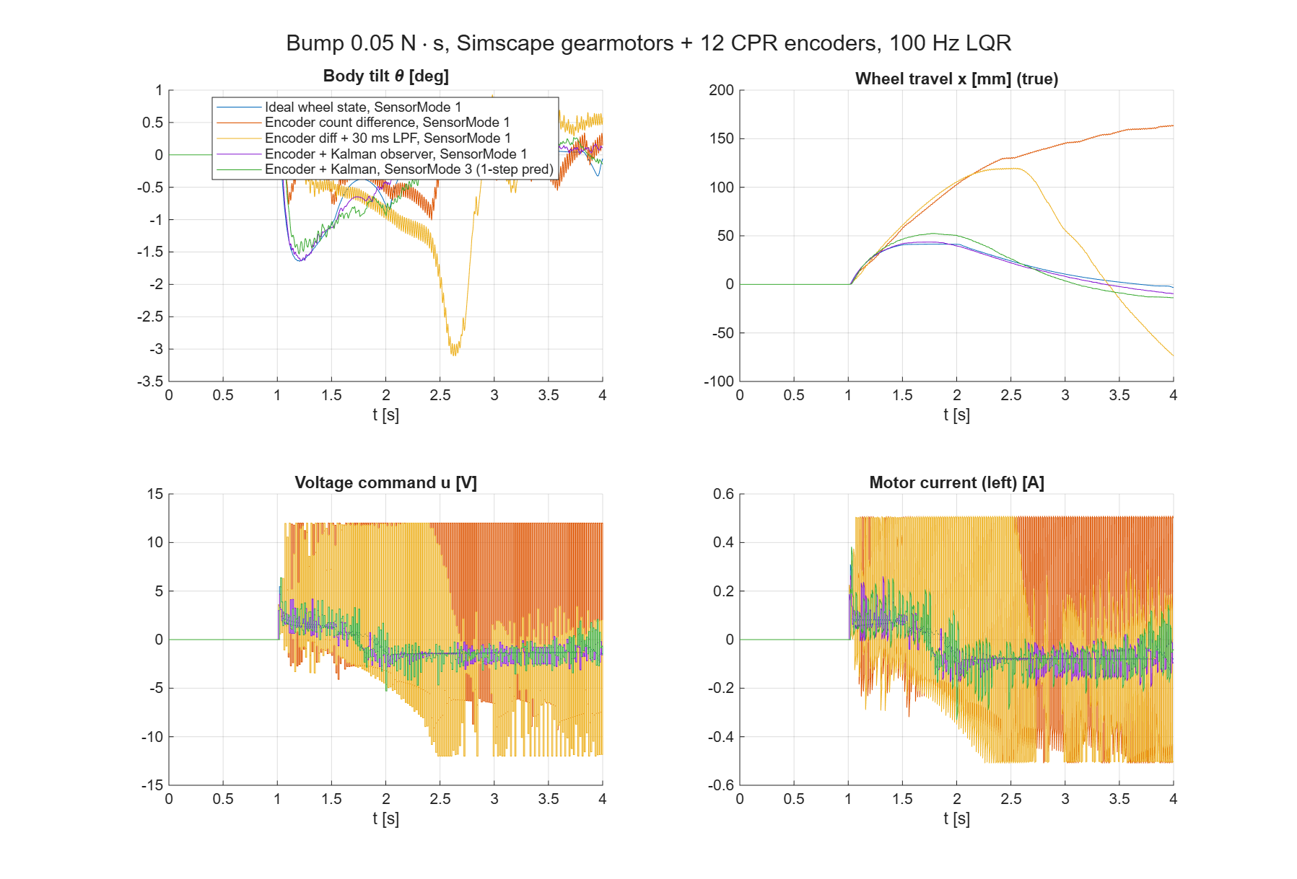
Figure 12. Bump response with Simscape gearmotors and 12 CPR encoders.
Table 13. Encoder model results.
Configuration | Peak tilt | Peak travel | Peak u | Steady u rms
Ideal wheel state | 1.64° | 41 mm | 5.4 V | 1.35 V
Encoder count difference | — | 162 mm | 12 V (sat.) | 9.9 V (limit cycle)
Count difference + 30 ms low-pass | 3.10° | 120 mm | 12 V (sat.) | 7.4 V
Encoder + Kalman observer | 1.64° | 44 mm | 4.7 V | 1.6 V
Encoder + Kalman, SensorMode 3 | 1.53° | 53 mm | 6.4 V | 1.8 V

Why count differences fail: the decoded counts track the true wheel angle within 1–2 counts, so the decoding is correct. But a speed calculated from the count difference over the last 10 ms is about half a sample late. The LQR's fast wheel mode (−165 rad/s) then limit-cycles at the Nyquist frequency (50 Hz), with the true wheel speed alternating between about 212 and −5 mm/s and the drivers saturating. A low-pass filter only adds lag. The Kalman observer estimates speed from the model and uses the encoder only as a position measurement, which restores near-ideal behaviour.
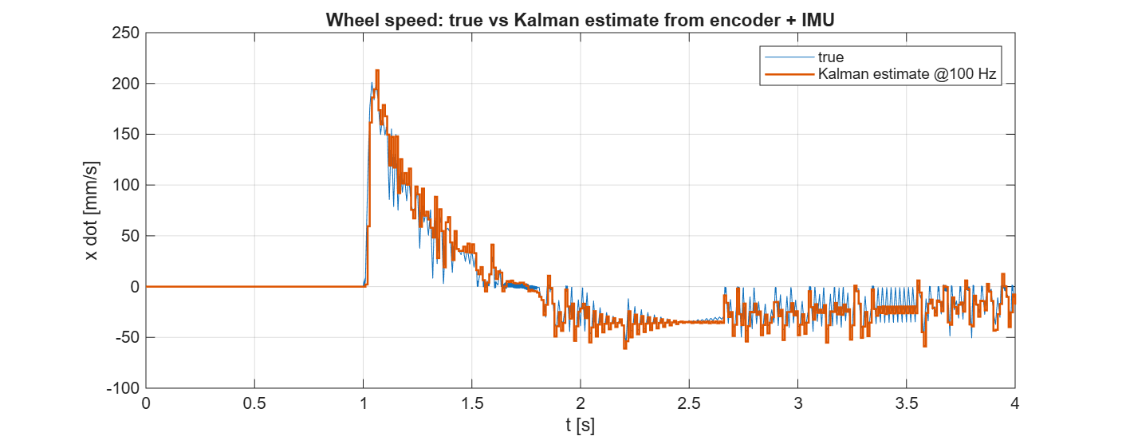
Figure 13. Wheel speed: true value against the Kalman estimate from encoder and IMU at 100 Hz.

8. Project files and how to run
Table 14. Project files.
File | Purpose
NanoBalancer BOM - NanoBalancer BOM V02.pdf | Bill of materials
3dModel/*.stl | Printed parts (PETG body/beam, TPU bumpers/clips, Hanger)
3dModel/sliced/*.3mf | Bambu Studio sliced projects (H2C, 35% infill)
3dModel/mass_budget.csv | Mass budget with positions
NanoBalancer_Stabilization_Parameters.xlsx | Parameter workbook (inputs and live formulas)
matlab/NanoBalancer_LQR.m | Model, LQR design, nonlinear simulation, gain export
matlab/delay_margin.m | Linear stability against BNO055 delay
matlab/lqr_gains.h, NanoBalancer_params.mat | Exported gains and model (struct NB)
matlab/Simulink/NanoBalancer/InitNanoBalancer.m | Init script (PreLoad/Init): NB, GM motor params, observer gain, modes
…/NanoBalancer_Stabilizer.slx + build_/run_ scripts | Stabiliser with SensorMode switch and bump
…/NanoBalancer_MotorTest.slx + build_/run_ scripts | Simscape gearmotor validation
…/NanoBalancer_Encoder.slx + build_/run_ scripts | Balancer with Simscape motors, encoders and Kalman observer
…/nb_add_gearmotor.m | Builds the gearmotor + MP6522 + encoder subsystem
…/check_predictor.m | Predictor and friction feed-forward check

Typical workflow in MATLAB R2024a:
cd matlab; NanoBalancer_LQR % design, simulate, export NB + gains
cd Simulink/NanoBalancer
run_NanoBalancer_Stabilizer % 4 sensor modes, bump + max bump
run_NanoBalancer_MotorTest % gearmotor vs datasheet
SensorMode = 1; EncoderMode = 3; % choose settings, then
run_NanoBalancer_Encoder % Simscape motors + encoders

Every model can be regenerated from its build_*.m script. The modes are workspace variables read by InitNanoBalancer.m: SensorMode (1–4), EncoderMode (1–3), FrictionComp (0/1), enc_tau, theta0_deg, bump_F, bump_t and bump_dt.

9. Assumptions and open items
- The motor rotor inertia (0.03 g·cm²), armature inductance (0.3 mH), boost efficiency (85%) and average power draw are estimates. A spin-down test and current measurements would confirm them.
- The no-load current I₀ = 0.08 A is a datasheet typical (±50%). The friction feed-forward depends on it, so measure it on the actual motors.
- The BNO055 noise and latency values in the observer are assumptions. The fusion filter's own dynamics are not modelled.
- The model has two 18650 cells in parallel; the BOM lists one. With one cell the total is 373.5 g and the CoM shifts by 2.3 mm sideways.
- The bought battery holders overlap the tray floor by 1 mm in CAD. This was already present and should be checked.
- The model is planar: both motors get the same command. Yaw dynamics, a turn command, and odometry/path control (x, y, heading from the two encoders, as in the ZumoPi models) are the next step.
- The Fusion renders in this document were captured before the final CoM_TrayOffset = 8 mm / BatteryClips update; the mass properties are from the final model.
Sources: Pololu #3049 specifications (pololu.com/product/3049/specs); Arduino ABX00041 datasheet (MP6522 ×4, 12 V, 500 mA); MPS MP6522 product page; Bambu TPU for AMS technical data sheet (1.26 g/cm³); Bambu Studio 2.05 slicing; Fusion 360 physical properties.

