David Instruments

Home Products About Contact

0

Your Music Journey **Starts Here**

Discover premium musical instruments from the world's finest brands. Professional quality, unbeatable prices, and expert support.

Shop Now Learn More

Free Shipping

Free shipping on orders over ₹500

Quality Guarantee

30-day money-back guarantee

Expert Support

24/7 customer support from music experts

Featured Instruments

Handpicked by our music experts for exceptional quality and value

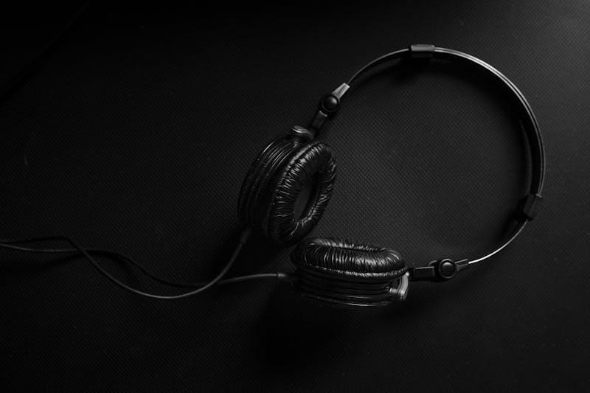

Featured

Yamaha

### Yamaha YAS-62 Alto Saxophone

★★★★☆ 4.9 (76 reviews)

$2,899

View Details Add to Cart

View All Products

Stay in Tune

Get the latest news, deals, and music tips delivered to your inbox

Subscribe

Thank you for subscribing!

Our Instruments

All Categories Guitars Pianos Drums Wind Instruments Keyboards Sort by Name Price: Low to High Price: High to Low Rating

×

About David Music Instruments Shop

For over , David Music Instruments Shop has been the premier destination for musicians seeking high-quality instruments, expert advice, and exceptional service.

10,000+

Instruments Sold

5,000+

Happy Customers

25+

Years Experience

100%

Satisfaction Rate

Our Story

Founded in 1998 by professional musician David Johnson, HarmonyHub began as a small local music store with a simple mission: to provide musicians with access to the finest instruments and the knowledge to choose them wisely.

What started as a passion project has grown into one of the most trusted names in musical instruments. We've built our reputation on three core principles: quality, expertise, and genuine care for our customers' musical journeys.

Our Mission

To inspire and empower musicians by providing exceptional instruments, expert guidance, and unparalleled service that helps bring their musical visions to life.

Contact Us

We're here to help you find the perfect instrument

Phone Support

+91 877 800 8348

Mon-Fri 9AM-6PM EST

Email Support

davidmusic@gmail.com

Response within 24 hours

Visit Our Store

123 Music Street

Erode, TN

Mon-Sat 9:30 AM-8 PM

### Send us a Message

Select Subject Product Inquiry Order Status Return/Exchange Technical Support

Send Message

Thank you! We'll get back to you within 24 hours.

Shopping Cart

Checkout

Contact Information

Shipping Address

Payment Information

Complete Order

David Music Instruments Shop

Your trusted partner in music

Quick Links

* Home
* Products
* About
* Contact

Customer Service

* Shipping Info
* Returns
* FAQ
* Support

Contact Info

+91 877 800 8348

davidmusic@gmail.com

Erode, TN

© 2025 David Music Instruments Shop . All rights reserved.