Error: Reference source not found
-Flight Reservation System
Document ID: 0000.doc
Author(s): Tamilarasan M
Version: 0.1
Date: March 26,2024

1. Abstract …………………………………………………………………………………………………………..3
2. Objective and Scope 3
3. Project End Users 4
4. Features 5
4.1 Registration 5
4.2 Login ……………………………………………………………………………………………………………..…………………….5
4.3 Select Location and Date 5
4.4 View Flights 6
4.5 passenger information management 6
4.6 Book Flight 6
4.7 Payment and Receipt Generation 6
4.8 Logout ……………………………………………………………………………………………………….…………………………7
5. Functional and Non-Functional Requirements ……………………………………………….....….7
5.1 Functional Requirements …………………………………………………………………………….……………………..7
5.2 Non-Functional Requirements ……………………………………………………………………….………………....8
6. Lower-Level Design ………………………………………………………………………………………..…9
7. Higher Level Design ………………………………………………………………………………….……….9
8. Diagrams …………………………………………………………………………………………………….…..10
8.1 Use Case Diagram ………………………………………………………………………………………………………………10
8.2 Flow Chart …………………………………………………………………………………………………………………………..11
8.3 Sequence Diagram ……………………………………………………………………………………………………………..12
8.4 Class Diagram …………………………………………………………………………………………………………………….13
9. ER Diagram ………………………………………………………………………………………………………14
10. Test Cases ………………………………………………………………………………………………………15

Abstract
The flight reservation system is a user-friendly online platform that simplifies the process of booking flights. It allows users to register for an account easily, providing their necessary details such as name, email, and password. Once registered, users can log in securely to access the system's features. The system enables users to specify their desired travel locations and dates, presenting them with a list of available flights that match their criteria. Users can browse through the flight options, viewing details like departure and arrival times, airlines, and prices. When selecting a flight, users can enter passenger information accurately, ensuring a smooth booking process. The system integrates a secure payment gateway, allowing users to make payments for their bookings with confidence. Upon successful payment, the system generates a booking confirmation receipt containing essential details such as the booking reference number, flight information, passenger names, and total cost. Users can conveniently access and download their receipts for future reference. Finally, the system ensures user privacy and security by providing a logout option, allowing users to end their sessions securely. Overall, the flight reservation system offers a seamless and efficient way for users to book their flights hassle-free.

Objective and Scope
The objective of the flight reservation system project is to develop a user-friendly online platform that simplifies the process of booking flights for travelers. The system aims to provide a seamless and efficient experience for users, allowing them to register, search for flights, manage passenger information, make secure payments, and generate booking receipts. The scope of the project includes implementing essential features such as user registration, login, flight search, booking management, payment processing, and receipt generation. The system will cater to both domestic and international flight bookings, ensuring flexibility and convenience for a wide range of users.
The scope of the product includes the following basic features:
- User Registration: Users can create accounts by providing necessary details like name, email, and password.
- Login: Registered users can securely log in to their accounts to access the system's functionalities.
- Location and Date Selection: Users can specify their desired departure and destination locations, as well as the date of travel.
- View Flights: The system displays a list of available flights based on the user's selected criteria, showing details such as flight number, departure time, and airline.
- Passenger Information Management: Users can enter and manage passenger details for their bookings, including names, ages, and contact information.
- Flight Booking: Users can select specific flights from the available options and proceed with the booking process.
- Payment Processing: The system integrates a secure payment gateway to process payments for flight bookings.
- Receipt Generation: Upon successful payment, the system generates booking confirmation receipts containing essential details such as booking reference numbers, flight information, and total costs.
- Logout: Users can securely log out of their accounts to end their sessions and protect their privacy.

Project End Users
- The flight reservation system is designed to serve a diverse range of end users, including both individual travelers and travel agencies. Individual travelers, such as vacationers, business professionals, and visiting families, can utilize the system to conveniently book their flights for various purposes. They can register for accounts, search for flights based on their preferences, manage passenger details, make secure payments, and receive booking confirmation receipts. The system caters to the needs of travelers seeking flexibility, convenience, and reliability in their flight booking process
- Additionally, travel agencies can benefit from the flight reservation system by using it as a tool to assist their clients in booking flights efficiently. Travel agents can access the system on behalf of their clients, helping them find suitable flights, manage bookings, and handle payment transactions seamlessly. By leveraging the features of the flight reservation system, travel agencies can enhance their service offerings, streamline their operations, and provide added value to their clients. Overall, the project's end users encompass a broad spectrum of individual travelers and travel agencies seeking a user-friendly and efficient platform for flight reservations.

Features

Registration
In our flight reservation system, users must create an account to access the portal. When a new user visits our platform for the first time, they'll need to register by providing their name, email address, contact number, and password. This information allows us to create a unique account for them in our system. Once they've completed the registration process, they'll have their own personalized account, which they can use to log in and access the various features and services offered by our flight reservation system. Creating an account ensures that users can securely book flights, manage their bookings, and enjoy a seamless experience while using our platform.

Login
In our flight reservation system, existing users can easily access their accounts by logging in with their email ID and password. When a user visits our website, they simply need to input their registered email ID and password into the login form. If the credentials match those stored in our system, a message confirming successful login will be displayed, allowing the user to access the website and all its features. However, if the provided credentials are incorrect or do not match any existing accounts, a message indicating unsuccessful login will be displayed, prompting the user to re-enter their credentials or register for a new account if they haven't already done so. This login process ensures that users can securely access their accounts and make flight reservations with ease.

Select Location and Date
In our flight reservation system, users can easily select their desired location, date, and time of travel from the Selection tab on the portal. They simply input the location they wish to travel to, along with the date and time they plan to depart. Once the user has made their selections, our system processes this information and generates a list of available flights that match their criteria. This list includes details such as flight numbers, departure times, arrival times, airlines, and estimated prices. Users can then review these options and choose the flight that best suits their needs and preferences. This streamlined process ensures that users can efficiently find and select their preferred flights for booking.

View Flights
In our flight reservation system, users can easily explore available flights by navigating to the View Flights section. Here, they'll find comprehensive details about various flights, including their departure and arrival times, airlines, and estimated charges. This user-friendly interface allows customers to browse through a wide range of flight options conveniently, empowering them to make informed decisions based on their preferences and travel requirements. By providing all the necessary information upfront, we aim to enhance the user experience and simplify the flight booking process for our customers.

Book Flight
In our flight reservation system, once users have selected their desired flight, they proceed to the Book Flight section to finalize their booking. Here, they confirm their choice and initiate the booking process. After confirming the booking, users are seamlessly directed to the Passenger Information Management section. In this section, users input details such as passenger names, ages, and contact information, ensuring that all necessary information is captured accurately for the booking. This smooth transition from booking to passenger information management streamlines the user experience, allowing customers to efficiently complete the necessary steps for their flight reservations.

Passenger Information Management
In our flight reservation system, managing passenger information is a crucial aspect of the booking process. Once users have selected their desired flight, they're prompted to provide essential details about the passengers who will be traveling. This includes entering names, ages, and any other relevant information required for each passenger. Our system ensures that this information is securely stored and associated with the corresponding flight booking. By managing passenger information effectively, we ensure accuracy and compliance with airline regulations while providing a seamless booking experience for our customers.

Payment and Receipt Generation
In our flight reservation system, once users have completed their selection and booking process, they are directed to the payment page to facilitate their reservation. Here, users can conveniently make online payments using various secure payment methods. Upon successful completion of the payment process, a booking receipt is automatically generated and displayed to the user. This receipt contains all the relevant details of the booked flight, including the booking reference number, flight information, passenger details, and total cost. The generated receipt serves as confirmation of the successful booking and provides users with a record of their transaction for future reference. Our system aims to ensure a seamless and secure payment experience while providing users with clear and detailed booking receipts.

Logout
In our flight reservation system, both customers and administrators have the option to securely end their session by logging out from their accounts. Users can initiate the logout process by simply clicking on the "Logout" button or link provided within the user interface. Upon clicking logout, the system clears the user's session and effectively logs them out from their account. A confirmation message is then displayed to the user, confirming the successful logout. Depending on the system's design, the user may be redirected to the login page or the homepage of the flight reservation system. Once logged out, users will need to provide their credentials again to access their account in the future. This logout feature ensures the security and privacy of user accounts within our system.

Functional and Non-Functional Requirements

Functional Requirements
User Registration and Login: Users should be able to register for an account by providing their name, email, contact number, and password. Registered users should be able to log in securely using their email and password.

Flight Search and Selection: Users should be able to search for available flights based on criteria such as departure location, destination, date, and time. The system should display a list of available flights matching the user's search criteria. Users should be able to select a specific flight from the list for booking.

Booking Management: Users should be able to manage their bookings, including viewing, modifying, and canceling existing bookings.

Payment Processing: The system should integrate with a secure payment gateway to facilitate online payments for flight bookings. Users should be able to make payments using various payment methods, such as credit/debit cards, PayPal, etc.

Notification System: The system should notify users about important updates related to their bookings, such as payment confirmation, flight status changes, etc.

Admin Panel: Administrators should have access to an admin panel to manage flights, user accounts, bookings, and payments. Admin should be able to add, edit, or remove flights, update flight schedules, and view booking details. notifications.

Non-Functional Requirements
Usability: The system should have a user-friendly interface that is easy to navigate and understand. Response times for search queries, booking requests, and payment processing should be minimal to provide a seamless user experience.

Security: User authentication and session management should be implemented securely to prevent unauthorized access to user accounts. Payment transactions should be encrypted and comply with industry standards for secure online payments.

Reliability: The system should be reliable and available 24/7, with minimal downtime for maintenance or updates. Backup and recovery mechanisms should be in place to ensure data integrity and availability in case of system failures.

Performance: The system should be able to handle a large number of concurrent users without significant degradation in performance. Response times for search queries, booking requests, and payment processing should be optimized to minimize user wait times.

Scalability: The system should be scalable to accommodate future growth in user traffic and data volume. It should be able to handle an increasing number of users, flights, and bookings without compromising performance or reliability.

Lower-Level Design
In the lower-level design of our Flight Reservation System, we meticulously structure the system into three core layers to ensure seamless functionality and optimal performance. At the presentation layer, we focus on crafting intuitive user interfaces, whether through web pages or mobile app screens, employing technologies like HTML, CSS, and JavaScript to deliver a compelling user experience. The business logic layer serves as the backbone of our system, managing user requests, enforcing business rules, and orchestrating interactions between the user interface and data access layers. Here, we prioritize efficiency and accuracy, ensuring smooth execution of critical operations such as booking flights and processing payments. The data access layer acts as the bridge between the application and the underlying database, facilitating seamless storage and retrieval of vital information pertaining to flights, bookings, and user accounts. Leveraging robust databases such as MySQL or MongoDB, and integrating external services for functionalities like payment processing and real-time flight updates, we enhance the system's reliability and scalability. Through meticulous attention to technical details and adherence to industry standards and best practices, our Flight Reservation System emerges as a robust, maintainable, and high-performing solution, poised to meet the evolving needs of users and stakeholders in the aviation industry.

Higher-Level Design
Our flight reservation system operates seamlessly through a client-server model, offering users a convenient interface accessible via web browsers or mobile applications, leveraging the latest web technologies. On the server side, we adopt a microservices architecture, facilitating modularization and independent deployment of crucial functionalities such as user authentication, flight booking, payment processing, and notifications. This approach not only enhances flexibility but also ensures efficient resource utilization and maintenance. Communication between clients and servers is secured using HTTPS protocols, with RESTful APIs enabling smooth data exchange, promoting interoperability and extensibility. Embracing cloud-based infrastructure guarantees scalability and reliability, catering to fluctuating demand and minimizing downtime. Data integrity and availability are upheld through a distributed database system, offering resilience against failures and facilitating rapid access to critical information. Moreover, integration with external APIs enriches our system's capabilities, supporting seamless interactions with airline ticket booking systems and payment gateways. In essence, our design emphasizes modularity, scalability, and reliability, aligning with the evolving requirements of users in the airline industry while ensuring a seamless and secure flight booking experience.

Diagrams

Use Case Diagram

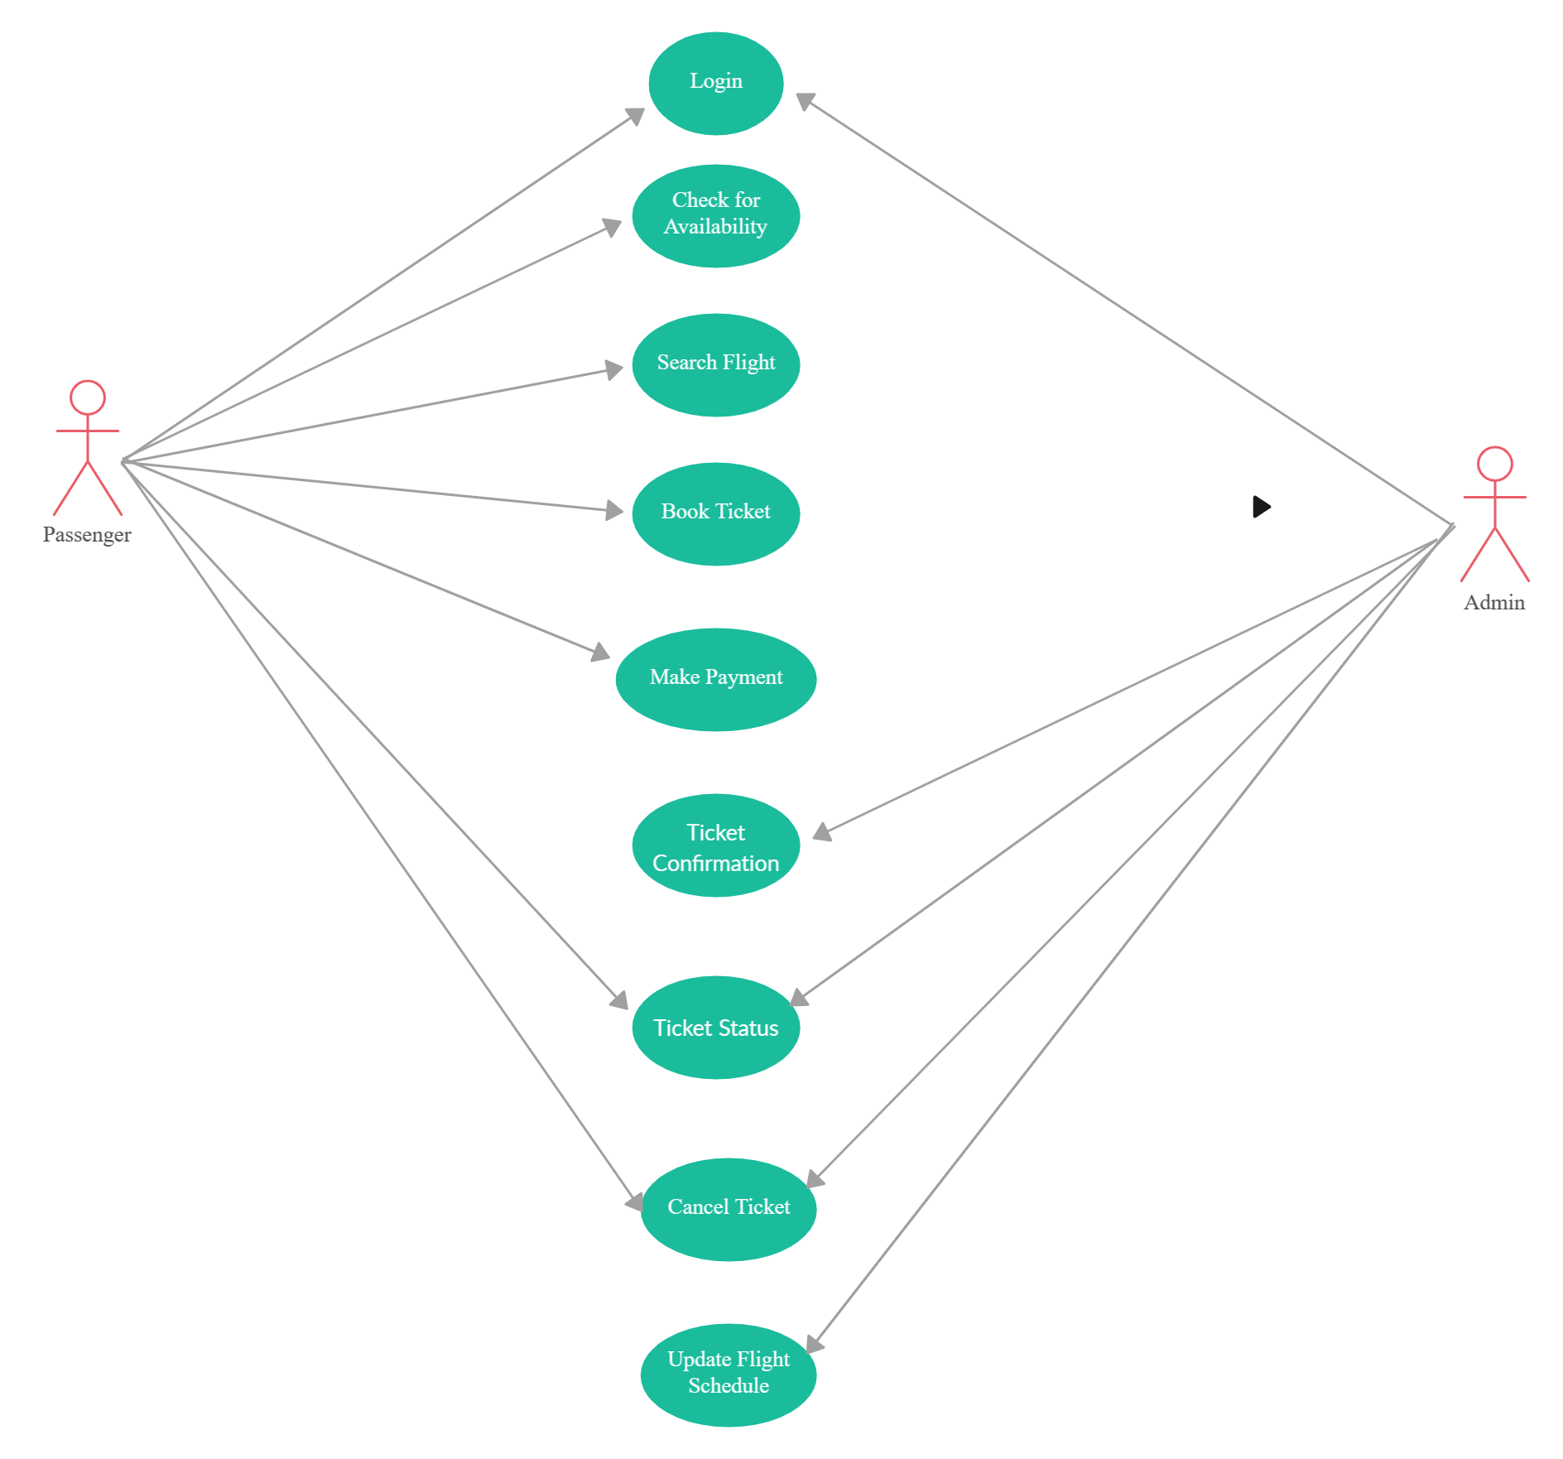

Flow Chart

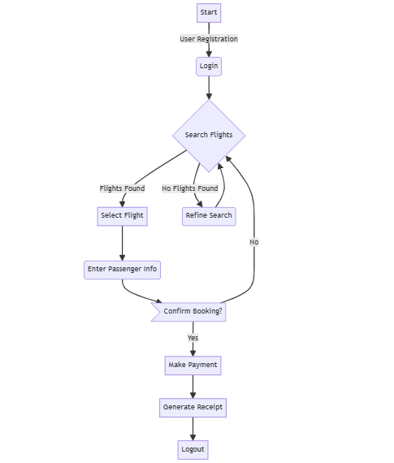

Sequence Diagram

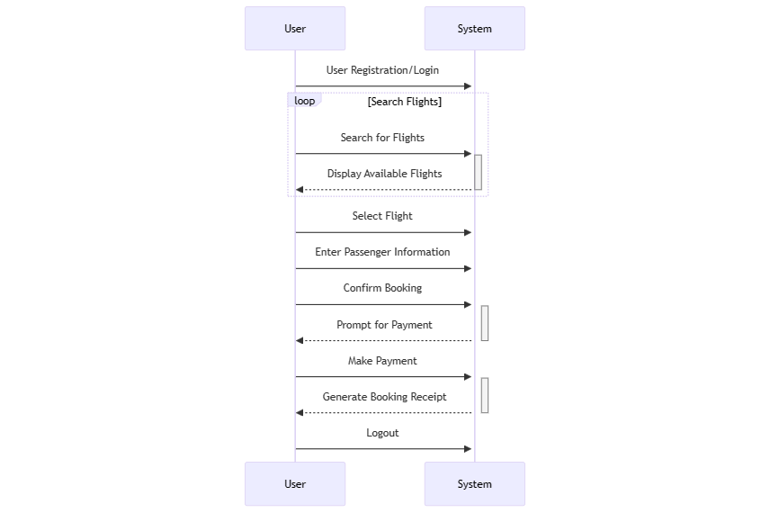

Class Diagram

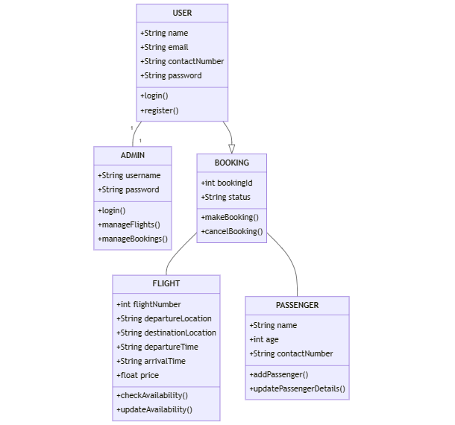

ER Diagram

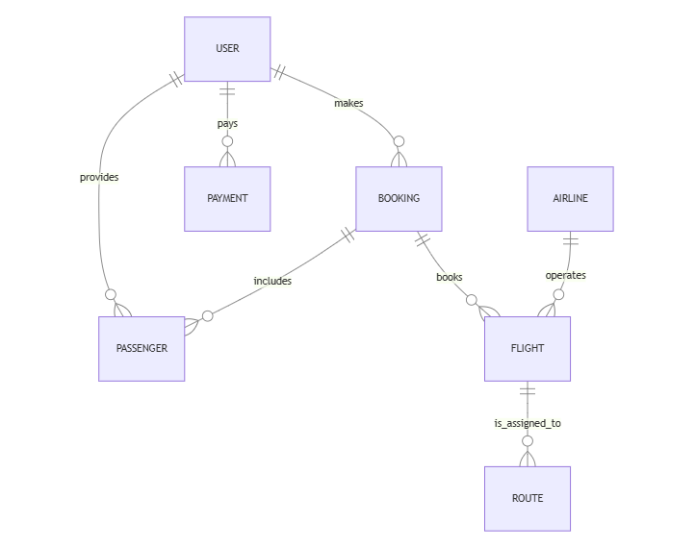

Test Cases
The Test Plan is derived from the Requirements, Functional Specifications and Detailed Design Specification.
Test Case | Test Purpose | Test Conditions | Expected Outcome | Actual Result
User Registration | To verify that users can successfully register for an account on the system. | User navigates to the registration page and fills in valid information. | User account is successfully created. | User registration is successful, and the confirmation email is received.
User Login | To ensure that registered users can log in to the system securely. | User enters valid credentials and clicks on the login button. | User is logged into the system. | User is logged in and redirected to the dashboard or home page.
Select Location and Date | To confirm that users can select their desired departure and destination locations along with the date of travel. | User selects departure and destination locations and specifies travel date. | System displays available flights for the selected criteria. | Selected locations and date are displayed, and available flights are filtered accordingly.
View Flights | To ensure that users can view available flights based on their search criteria. | User searches for flights based on selected criteria. | System displays flight information including airline, departure time, and price. | User sees a list of flights with relevant information (airline, departure time, price).
Passenger Information Management | To verify that users can input and manage passenger information for booking. | User enters valid passenger information for each traveler. | Passenger information is saved correctly. | User can successfully enter and manage passenger information for each traveler included in the booking.
Book Flight | To confirm that users can successfully book a flight after selecting a flight and entering passenger information. | User selects a flight and confirms booking. | System processes the booking and sends a confirmation email. | Booking is successfully processed, and a confirmation email is sent to the user.
Payment and Receipt Generation | To ensure that the payment process is secure and a receipt is generated after successful booking. | User completes the payment process. | System generates a receipt with booking details. | Payment is successfully processed, and a receipt with booking details is generated.
Logout | To verify that users can successfully log out of their accounts. | User clicks on the logout button. | User session is terminated, and user is redirected to the login page. | User is successfully logged out and redirected to the login page.

