cmd 1 :

ng new Demo --standalone=false

cd Demo

code .

ng serve

open the browser : localhost:4200

once after running , dont touch this cmd / dont kill

cmd :

inside the project

C:\Users\THANESH\OneDrive\Desktop\Trainig\Angular\Demo

cmd

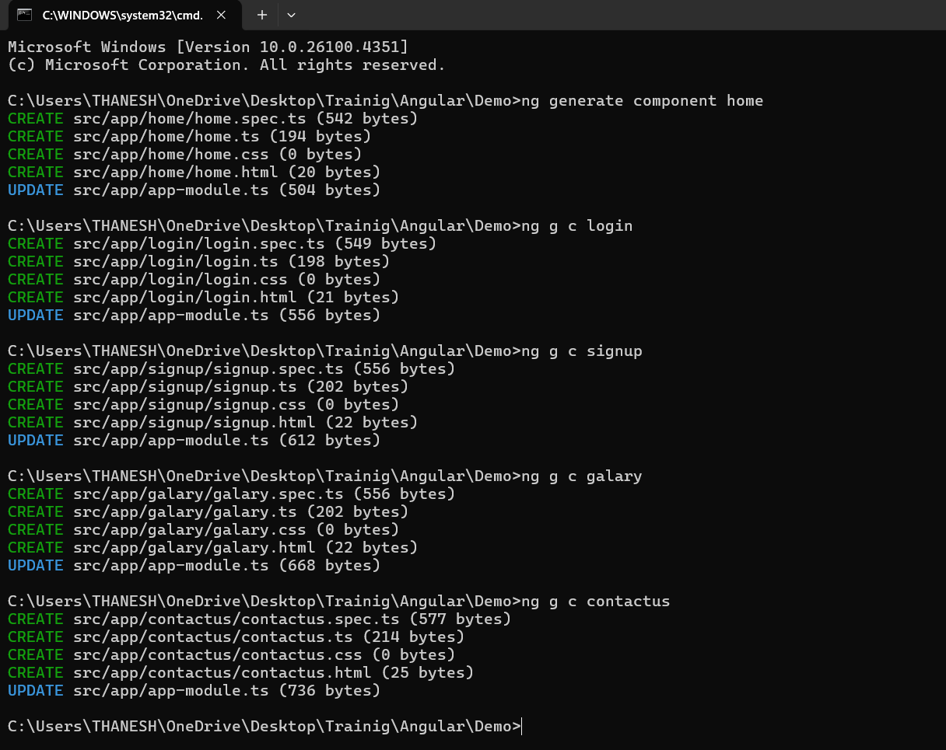

<div class="xyz">

    <h1> Hi Welcome to Angular </h1>

    <!-- <app-home></app-home>

    <app-login></app-login>

    <app-contactus></app-contactus>

    <app-galary></app-galary>

    <app-signup></app-signup> -->

    <!-- <h1>

        <a routerLink="home" > Home </a> ||

        <a routerLink="galary"> Galary  </a> ||

        <a routerLink="contactus"> Contcat US  </a> ||

        <a routerLink="login"> Login  </a> ||

        <a routerLink="signup"> Signup  </a> ||

    </h1> -->

</div>

<router-outlet></router-outlet>

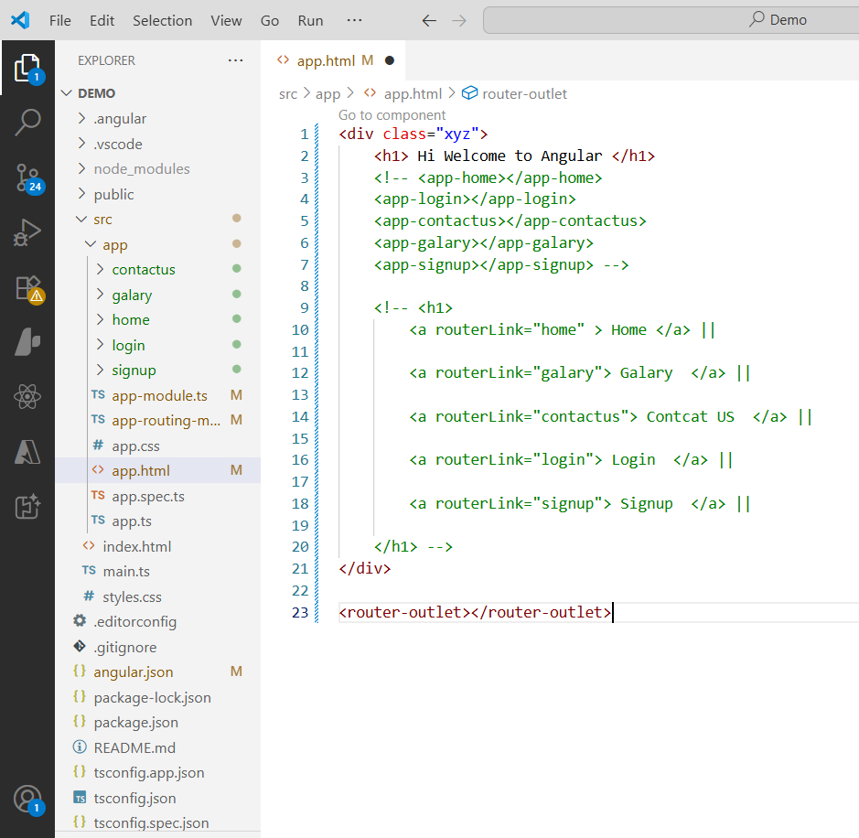

Next we need a Nav bar

So let add from bootstracp

<https://paste.ubuntu.com/p/Zmff5h5ZJS/>

API INTEGRATION …………………..!

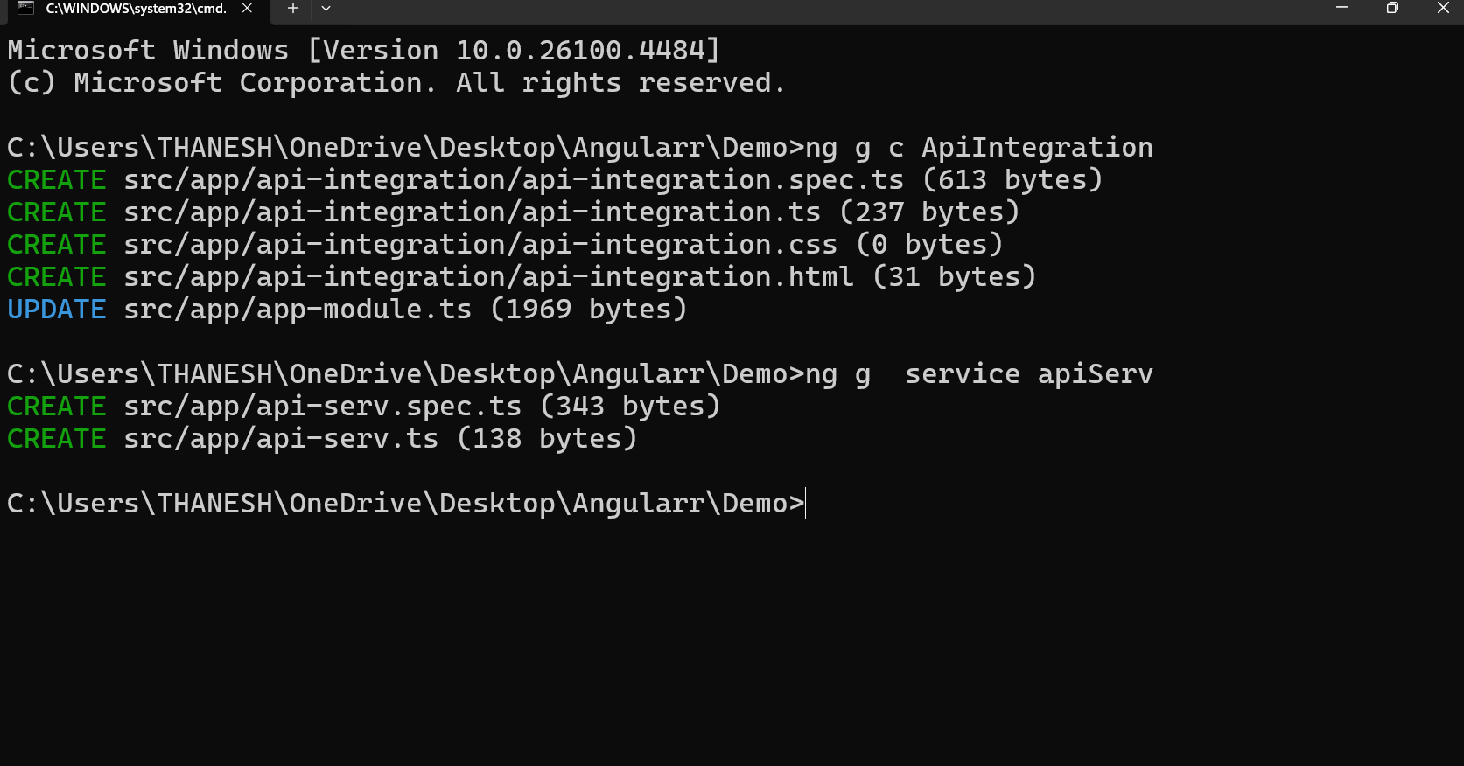

Step 2 :

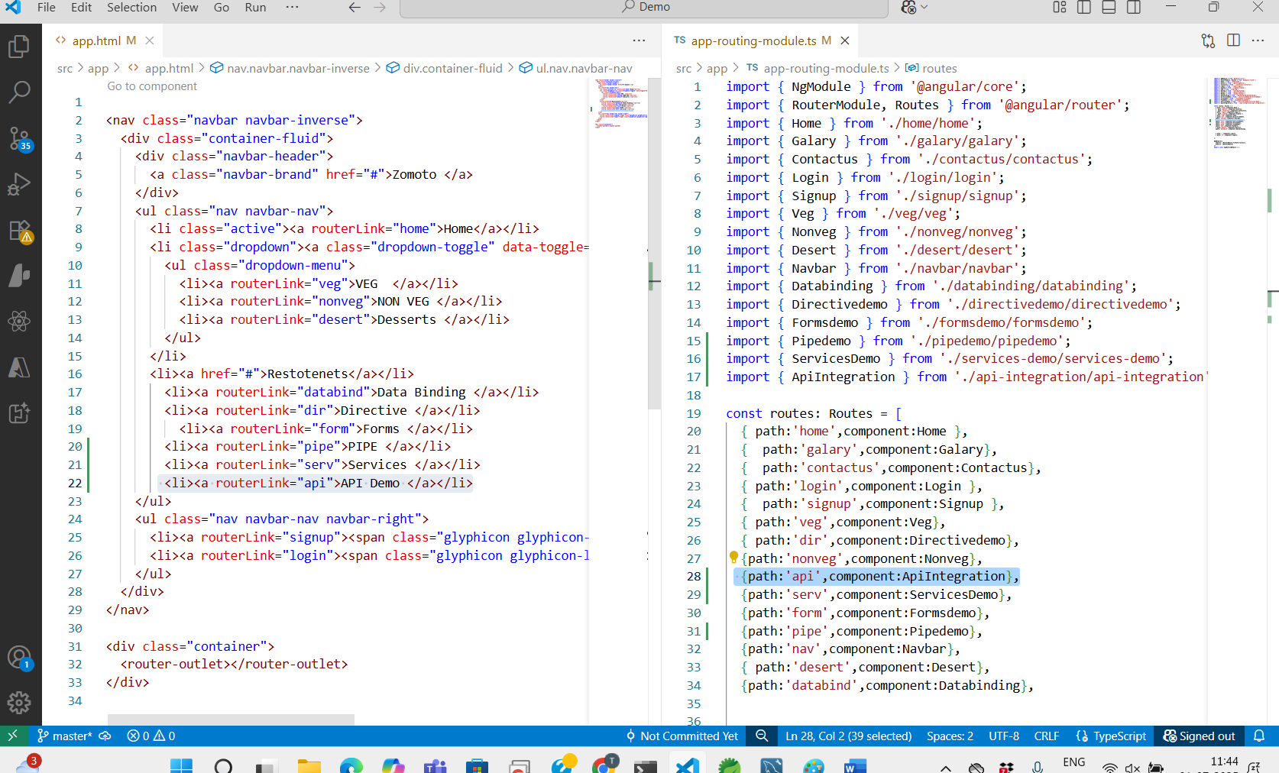

Step 3:

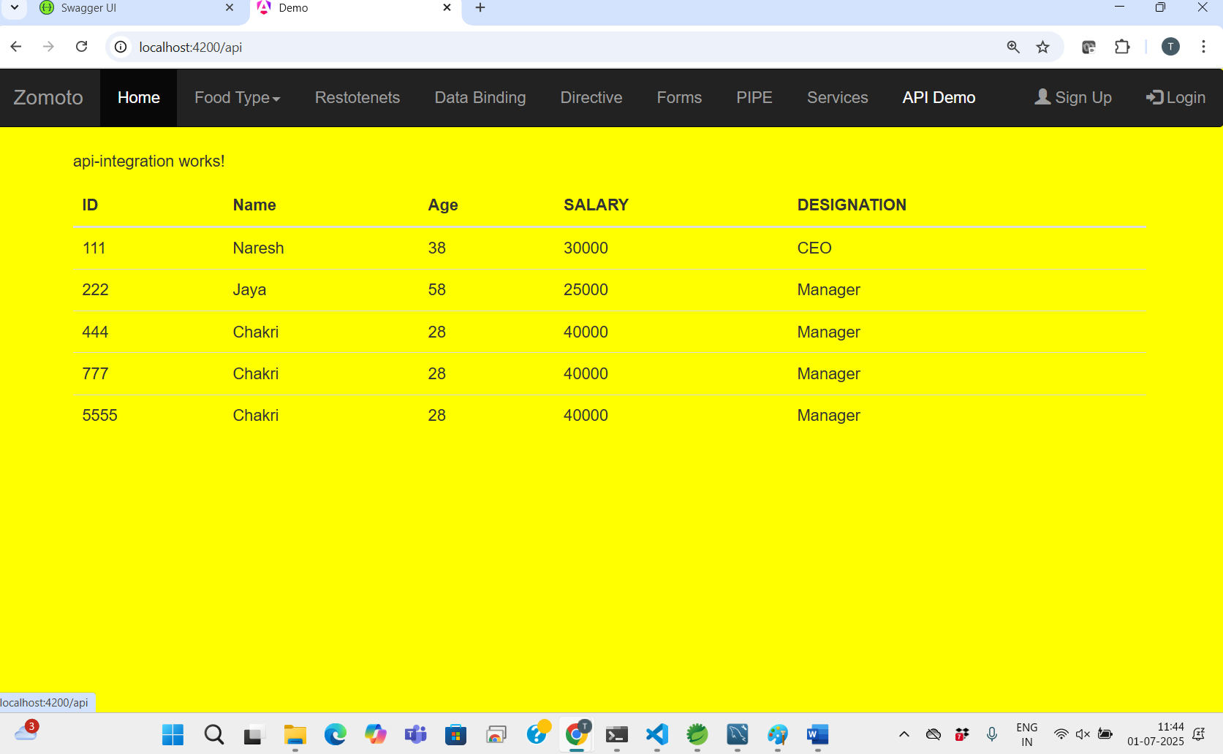

Step 4:

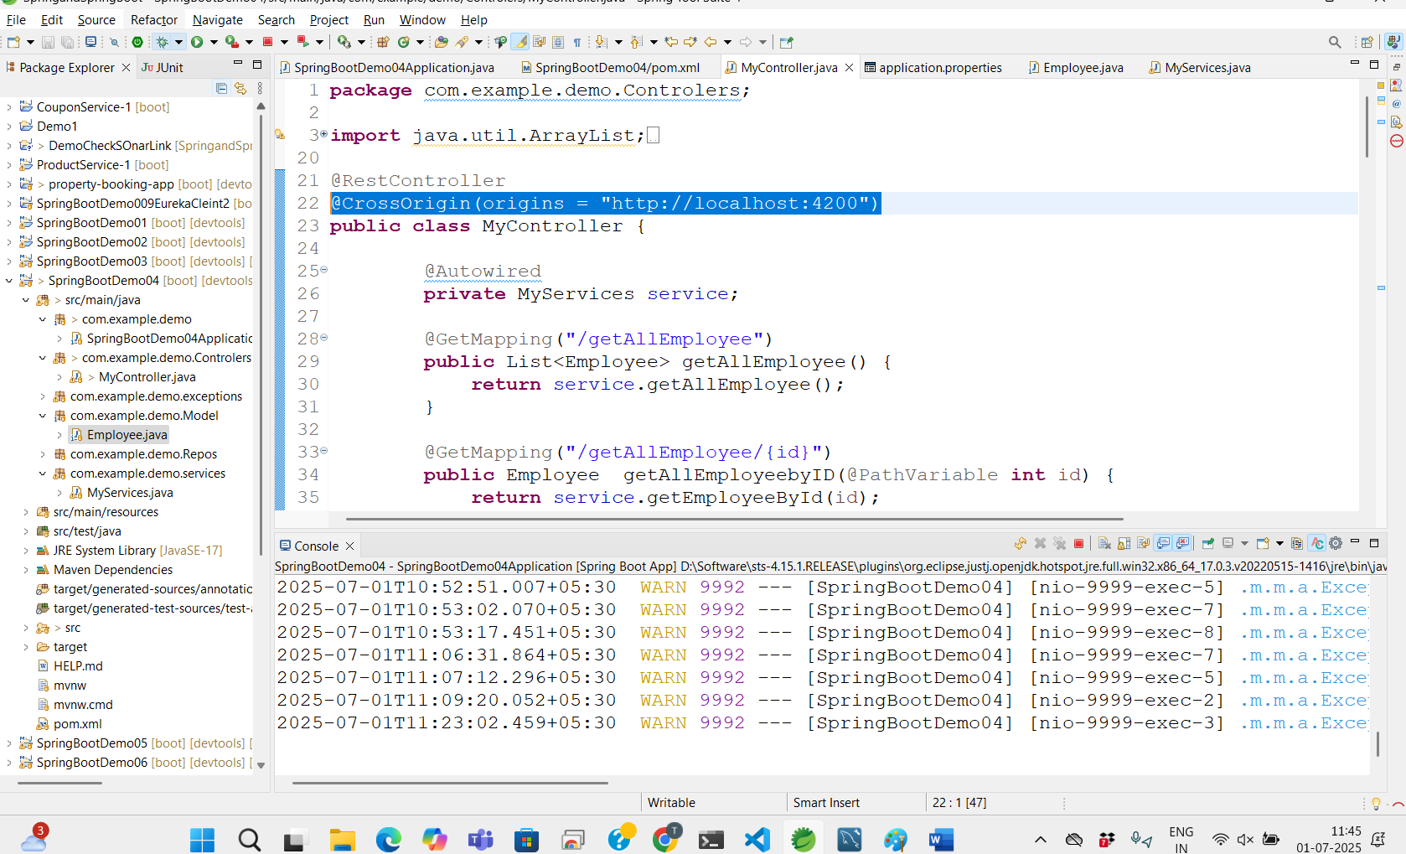

Step 5:

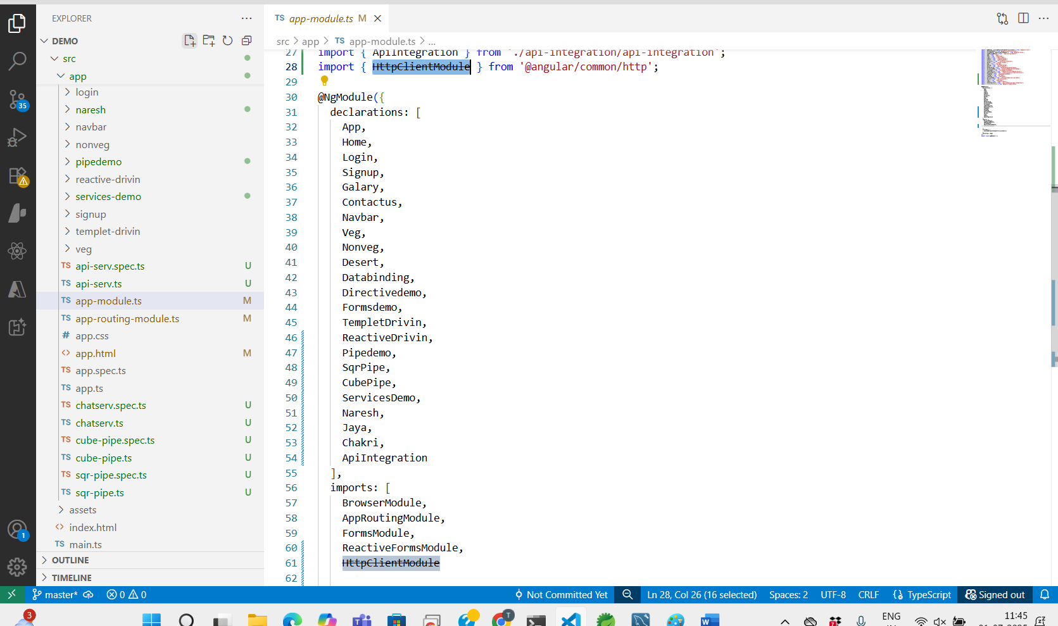

Step 6:

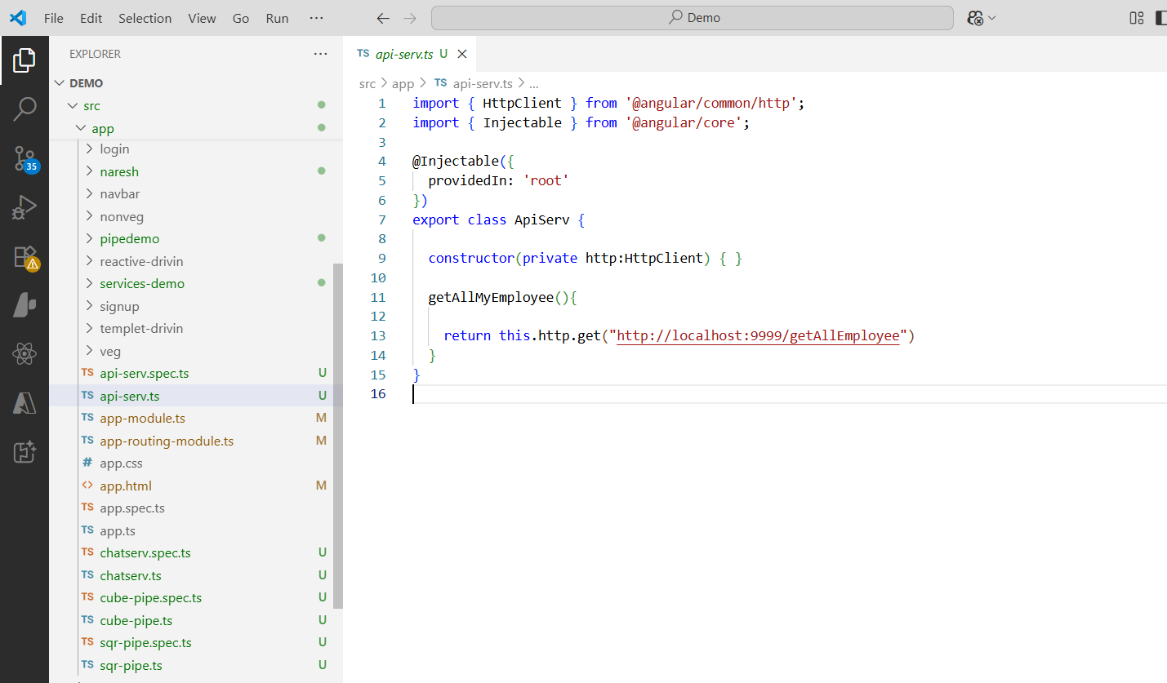Step 7 :

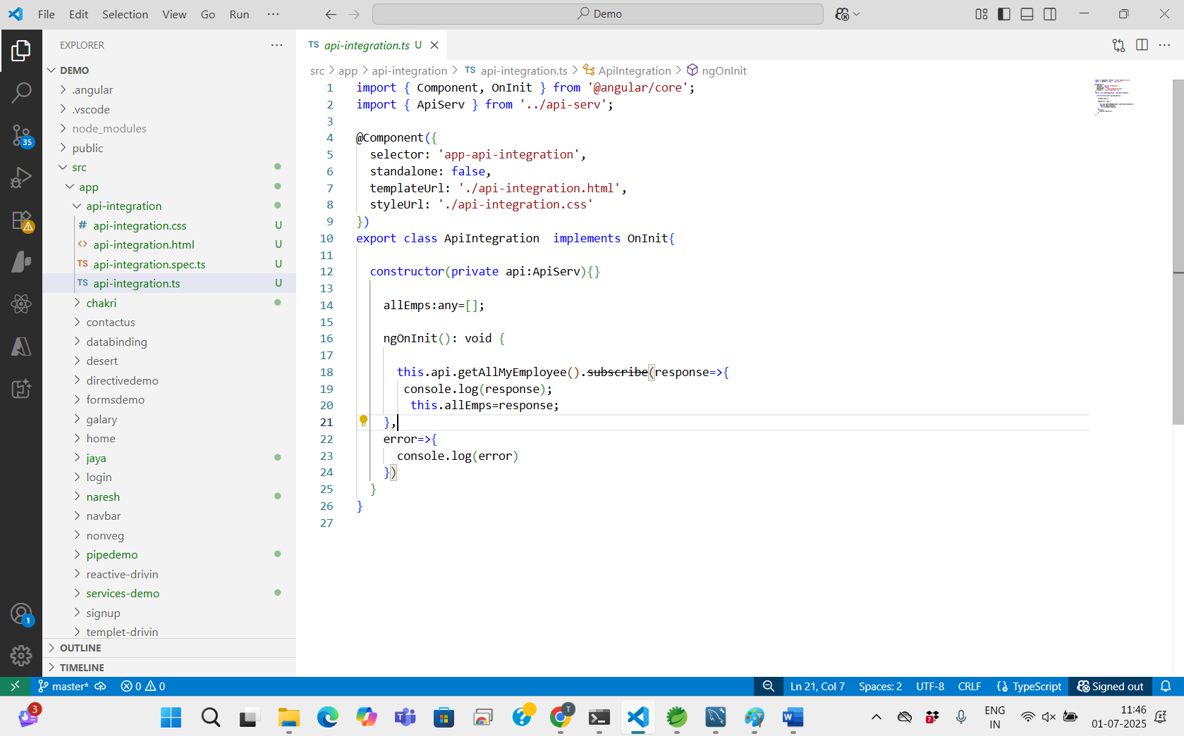

export class ApiIntegration  implements OnInit{

  constructor(private api:ApiServ){}

    allEmps:any=[];

    ngOnInit(): void {

      this.api.getAllMyEmployee().subscribe(response=>{

       console.log(response);

        this.allEmps=response;

    },

    error=>{

      console.log(error)

    })

  }

}

Stpe 8 :

<p>api-integration works!</p>

<table class="table table-hover">

    <thead>

        <tr>

            <th>ID</th>

            <th>Name</th>

            <th>Age</th>

            <th> SALARY</th>

            <th>DESIGNATION</th>

        </tr>

    </thead>

    <tbody>

        <tr \*ngFor="let emp of allEmps">

            <td>{{emp.id}}</td>

            <td>{{emp.name}}</td>

            <td>{{emp.age}}</td>

            <td>{{emp.salary}}</td>

            <td>{{emp.desig}}</td>

        </tr>

    </tbody>

</table>

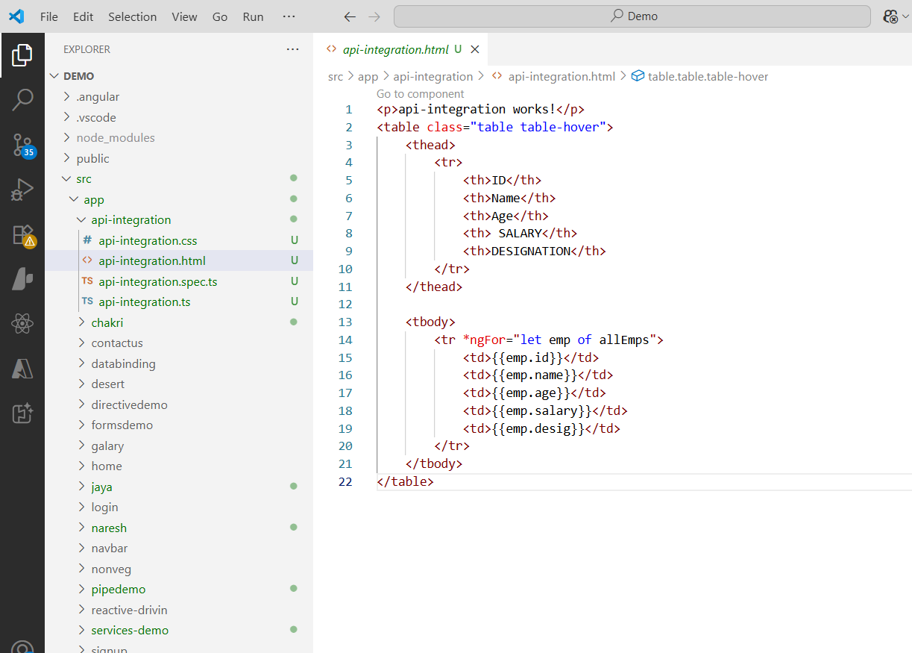

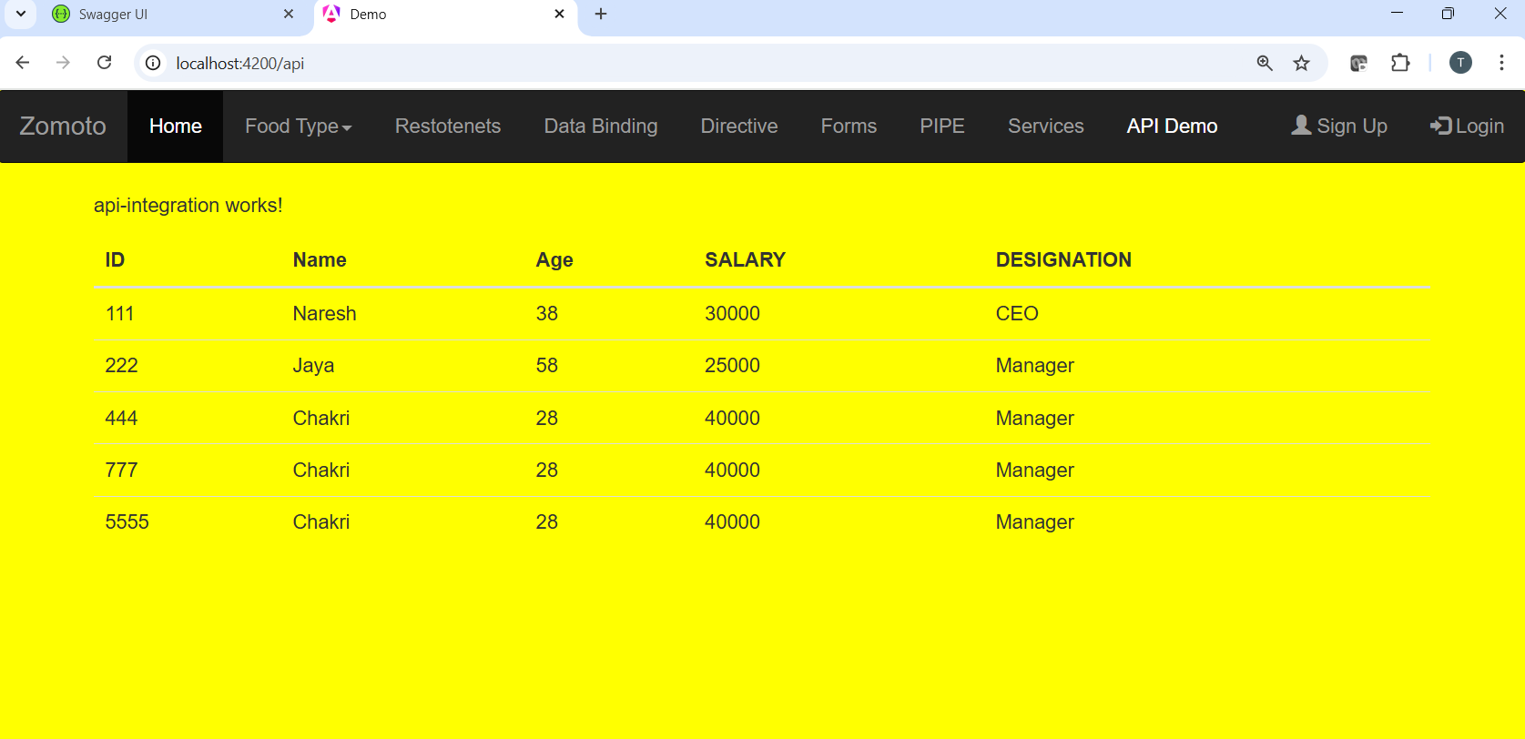

BACK END :

