**Assignment**

Frontend: HTML.CSS, Bootstrap

Backend: PHP,Mysql

Output:

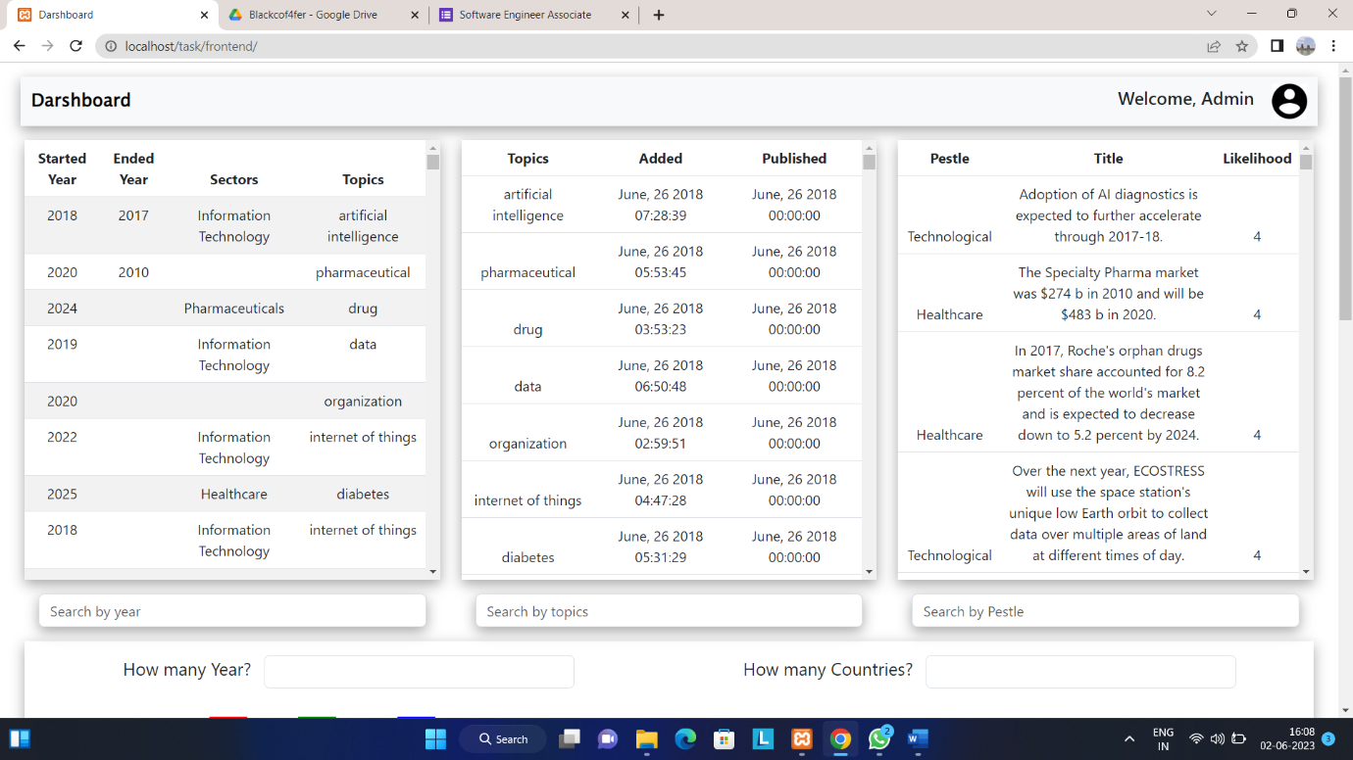

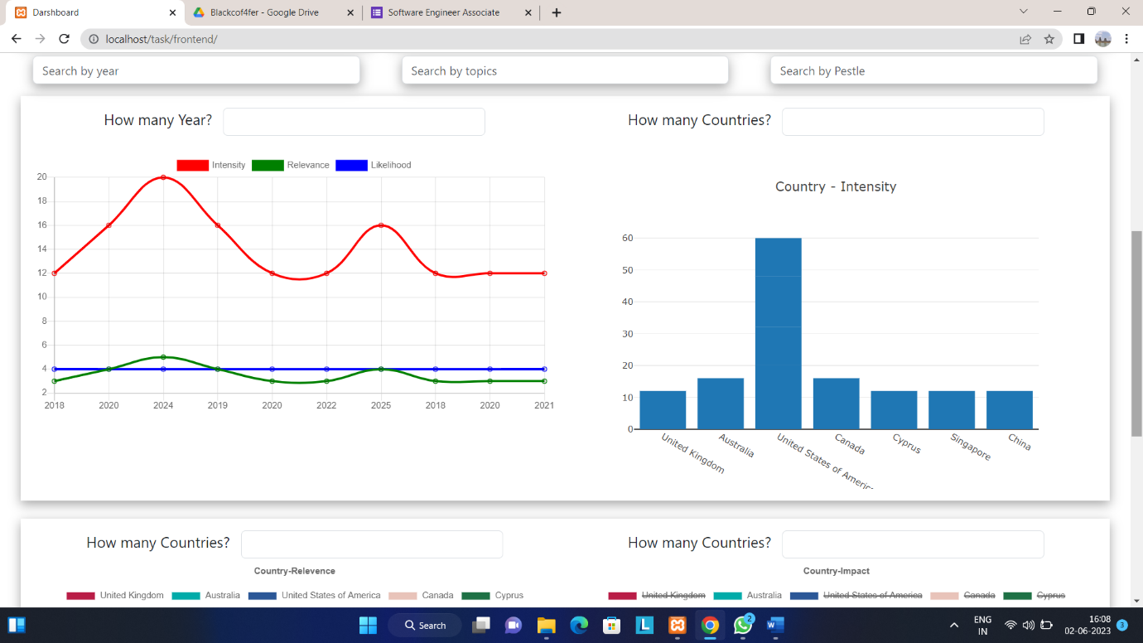

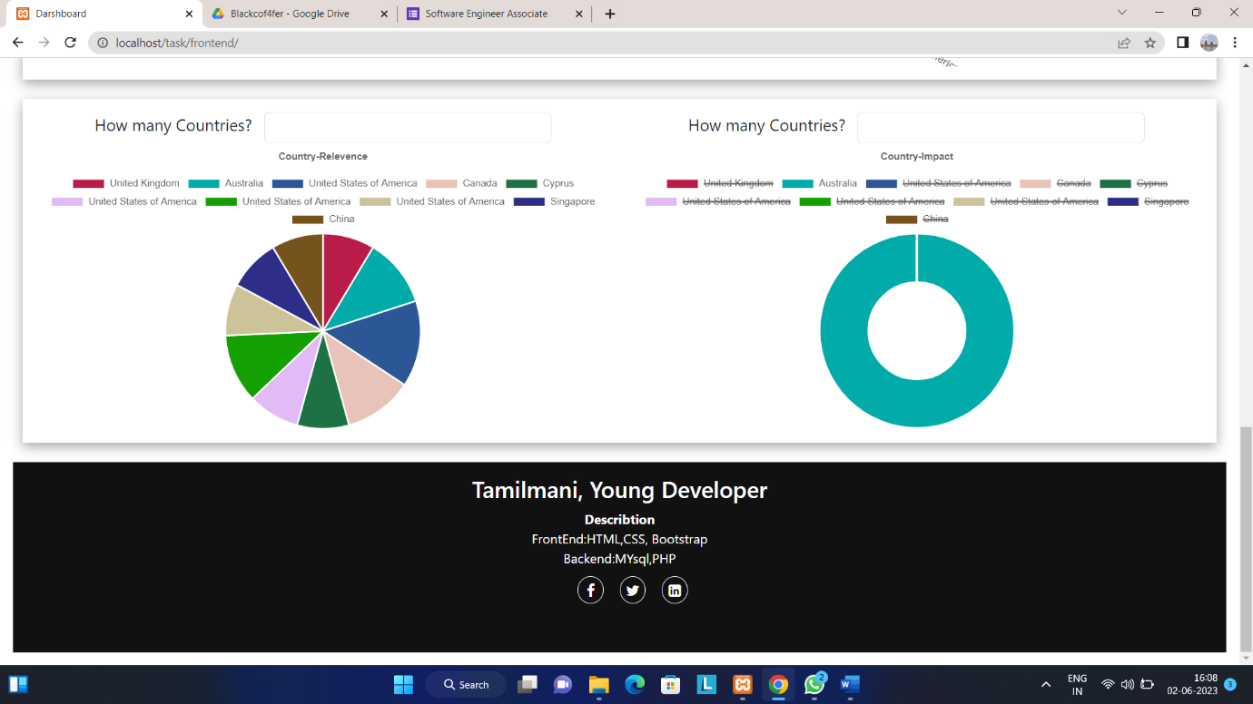

Assignment is live in : https://phpdarshboard.000webhostapp.com/”