Sponsors & Exhibitors

They have the opportunity to provide a one double sided color page to be included in the conference proceedings.
Use this template in Microsoft Mord 97-2003 to prepare your document, and send it by email to: contact@lip2014.eu (before june 1st, 2014).

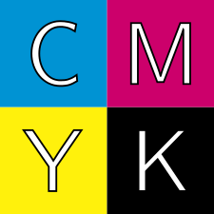

It can be a text (Palatino Linotype, 9 pts) with figures (as the present page) as well as scans of existing brochures (as shown in the second page), etc.
For optimal color reproduction use high resolution images (600 dpi) in the printing standard: cyan, magenta, yellow, and key black.

Page format: A4 portrait (WxH=210 mm x 297 mm).
Printing zone (e.g. red rectangle) : WxH=160 mm x 245 mm

