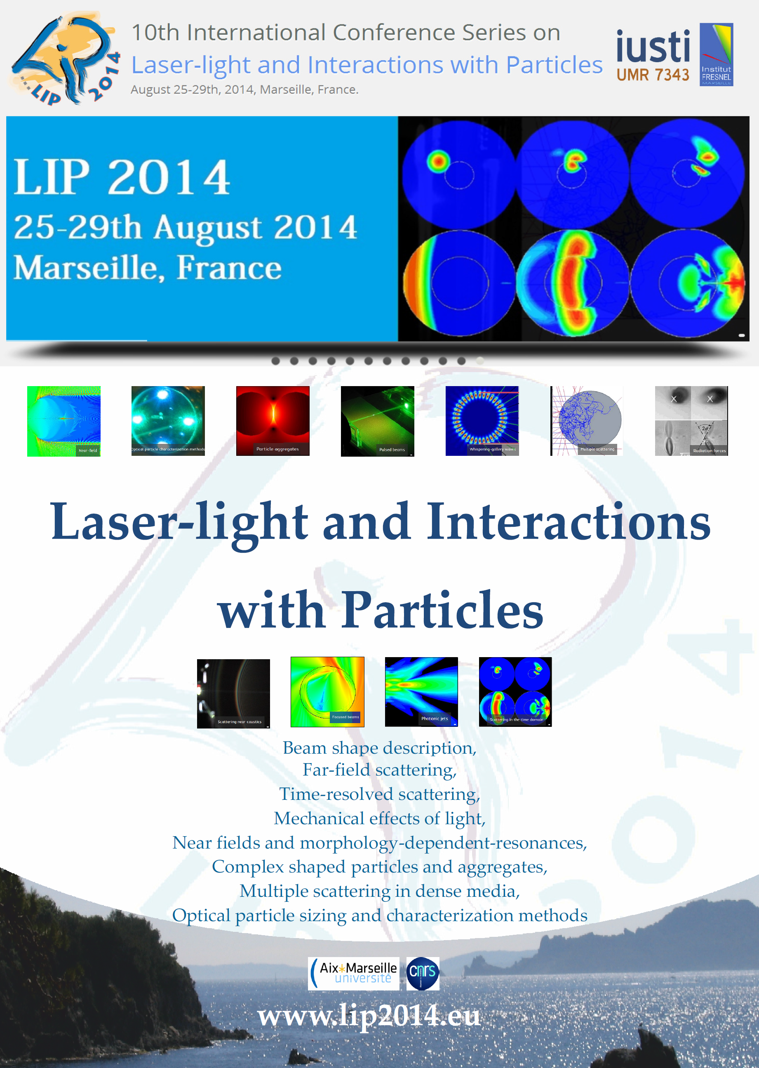

10th International Conference Series on
Laser-light and Interactions with Particles
www.lip2014.eu
August 25-29th, 2014, Marseille, France.

Co-chairs
Fabrice Onofri, IUSTI, CNRS & Aix-Marseille University, France
Brian Stout, Fresnel Institute, Aix-Marseille University, France

Conference scope and background
The 10th international conference series on “Laser-light and Interactions with Particles (LIP)” is organized by IUSTI and Fresnel institutes on August 25-29th, 2014, in Marseille, France. The conference is focused on interactions between laser beams and particles, from theory to practice, encompassing in particular the following topics : beam shape description, near fields and morphology-dependent-resonances, time-resolved scattering, multiple scattering in dense media, complex shaped particles and aggregates, optical particle sizing and characterization methods, mechanical effects of light, etc.
Applications may range from multiphase flow characterization to aerosol science and atmospheric environment, biomedical optical engineering, remote manipulation of objects, plasma and soft matter physics, quantum electrodynamics;
The present edition follows the former Optical Particle Sizing (OPS) and Optical Particle Characterization (OPC) conferences held in Rouen 1987; Tempe, AZ, 1990; Yokohama, 1993; Nürnberg, 1995; Minneapolis, MN,1998; Brighton, 2001; Kyoto, 2004; Graz, 2007 as well as the reformulated LIP conference, held in Rouen, in 2012. All these conferences have bring from 100 to 200 participants.

Booths and sponsoring
This conference series has been continually providing forums for promoting the interchange of new ideas on the development of advanced theories and models, as well as the latest experimental development.
One important objective of this conference series is the development of the relations between the academic, the industrial and business communities. Thus, three packages are offered to companies willing to sponsor this conference or, to exhibit their products and services (instrumentation, scientific publishing, etc.) during the conference.

□ Pack S (300 Euros - all taxes included): brochures & flyers are included in the conference bags plus one double sided color page advertisement in the conference proceedings. Your company logo appears on the conference proceedings and web site (up to Jul. 2015).
□ Pack B1 (900 Euros - all taxes included): Pack S + one regular participation + simple booth + 5 minutes to present your company during the dedicated plenary session.
□ Pack B2 (1100 Euros - all taxes included): Pack S + one regular participation + double booth + 10 minutes to present your company during the dedicated plenary session.

A participant registration gives access to all sessions, the conference proceedings, the list of participants, as well as coffee breaks, lunches and all social events (gala, excursion, etc.).
Simple booth (approx. 6 m²): table (WxD: 1,30x0.5m) and one poster board (grid, WxH : 1.20x1.70m)
Double booth (approx. 12 m²): two tables (WxD: 2,60x0.5m) and two poster boards.

Additional information
- Localization: Campus St Charles, Aix-Marseille University, 5 place Victor Hugo Marseille 13003 (a 2 minute walking distance from the main railway station and airport shuttles). GPS coordinates : +43° 18' 16.71"N, +5° 22' 42.59"E or 43.304642°N, 5.378498°E
- Exhibition room: booths, posters, coffee breaks and lunches are all organized in the same hall – near the main amphitheater.
- Booths will be available starting Monday 25th at 10:30am
- If necessary, the laboratory IUSTI can receive and store the equipment a few days before and after the conference (but the equipment remains under your responsibility),
- Electrical power limit on the booth is 16 A (220V/50Hz) per booth (to be discussed),
- For a second participant additional fees are based on academic ones,
- Let us know in advance if you would like to provide promotional, bags, pens, etc.

Registration
The procedure is the same as for regular participants. It is done in two steps, via the conference website: www.lip2014.eu
First step: pre-registration (after January 1st, 2014).
The conference web site of the conference will redirect you to a secured website “Azur-Colloque” managed by the French National Center for Scientific Research (CNRS). After completing the information requested and select your package, you will receive an email confirming your preregistration (this procedure may take a few days).
Second step: confirmation and payment
After the validation of your pre-registration you may complete your registration you can proceed to the payment of the registration fees by credit card (payment by bank transfer or order form will remain exceptional, contact us for more information). The organization committee will be informed by the CNRS about the status of your registration.

Contact persons :
For registration or payment issues | For scientific & technical details :
Mrs Joyce BARTOLINI (secretariat of the conference).  IUSTI - UMR n°7343 CNRS/Aix-Marseille Université  Technopôle Château Gombert - 5. r. Enrico Fermi  13453 Marseille cedex 13, France  Tel:(+33) 4 91 10 68 82 / Fax:(+33) 4 91 10 69 69  email : contact@cftl2014.fr | Dr Fabrice Onofri (Chairman)  IUSTI - UMR n°7343 CNRS/Aix-Marseille Université  Technopôle Château Gombert - 5. r. Enrico Fermi  13453 Marseille cedex 13, France  Tel:(+33) 4 91 10 68 92 / Fax:(+33) 4 91 10 69 69  email : contact@cftl2014.fr

Mise à jour du 2/10/2013

