Chicago Severe Traffic Crash Patterns 2024 to 2025
Environmental, Temporal, Road User, Demographic and Spatial Patterns
CISC7204 Data Science and Data Visualization
Assignment 02 Revised Project Proposal
(Pair01) MC631517 Tang I Choi MC637132 TAN MIN FAI MICKY

1 Project Topic Name
Visualizing Severe Traffic Crash Patterns in Chicago 2024 to 2025
Research question Where and under which temporal, environmental, road user, and demographic conditions were severe traffic crashes and injuries disproportionately represented in Chicago during 2024 and 2025?
Scope | Definition
Region | Chicago Illinois United States
Domain | Transportation road safety and public safety
Study period | 1 January 2024 to 31 December 2025
Analysis units | One record per crash vehicle unit or person as appropriate

2 Project Purpose
The project will convert a large set of police reported records into a concise visual account of when severe crashes occur, which environmental conditions coincide with higher severe crash proportions, which road users experience the highest observed rates, and where severe crashes concentrate. The work supports course learning by connecting data preparation, statistical summaries, visual selection, interactivity, and responsible interpretation in one reproducible notebook.

Learning Outcomes
- Formulate a region specific statistical question and match each part of the question to an appropriate visualization.
- Distinguish crash level, vehicle level, and person level conclusions so that denominators remain valid.
- Present findings with clear labels, counts, rates, and limitations for readers without a data science background.

Skills
The work practices Pandas selection, missing value review, datetime feature engineering, grouped aggregation, pivot tables, categorical recoding, validated many to one joins, and reproducible summary tables. It also applies Matplotlib, Seaborn, Plotly, and Folium to static, interactive, and geographic outputs.

Knowledge
The analysis will reinforce the difference between frequency and severity, the effect of observation level on a rate, the instability of small groups, and the limits of observational police data. The results will describe associations and recorded concentrations rather than causal effects or exposure adjusted risk.

Data Sources
Dataset | Unit | Rows | Planned use
Traffic Crashes Crashes | Crash | 221175 | Severity time environment and location
Traffic Crashes Vehicles | Vehicle unit | 450185 | Road user involvement
Traffic Crashes People | Person | 485110 | Age and person injury
Official links Crashes Vehicles People
Preliminary validation found 221175 unique crash identifiers and 466 records without a usable severity category. All retained vehicle and person records refer to crash identifiers in the crash table. These checks confirm that the proposed analysis is feasible with the existing public data and that no new source is required.

3 Project Tasks
The tasks follow the dependency order of the notebook. Data definitions and validation must be completed before the pair calculates rates or prepares visualizations.
- Define the measures Fix the study period, define a severe crash and a severe person injury, and state the unit used by every calculation. The output will be a short definition list used consistently in the notebook and report.
- Audit the source tables Check row counts, unique crash identifiers, date coverage, missing severity and coordinates, and the coverage of crash identifiers in the supporting tables. The notebook will display the audit counts and assertions before analysis begins.
- Prepare analysis variables Create month, weekday, hour, grouped lighting and weather variables, age groups, and binary severity indicators while keeping unknown severity as missing. Each derived field will have a visible category or range check.
- Integrate tables safely Join crash severity separately to Vehicles and People with many to one validation. Vehicles will not be joined directly to People because both contain repeated crash identifiers. The output will be two analysis tables that preserve their original record levels.
- Calculate comparable summaries Report counts and rates for time, environment, road users, age groups, and person types. Weekday hour cells below 100 crashes and lighting weather cells below 200 crashes will be suppressed, and every rate will retain its denominator.
- Create the visual evidence Produce monthly line plots, two dimensional heatmaps, numeric box plots, interactive road user bars, person level bars, and a Folium density map using the supplied CARTO Voyager tile URL. Titles, axes, units, thresholds, and hover values will match the supporting tables.
- Interpret and package the work Connect each visual to the research question and place limitations next to the relevant claim. The pair will run the notebook from top to bottom, compare the written values with the executed outputs, and prepare the notebook and report as the final submission package.

4 Project Criteria for Success
The finished work will be considered successful only when every row satisfies both the stated measure and the required evidence. The pair will apply this checklist after the complete notebook run and again before submission. A result will not pass if it lacks a denominator, uses an unstable small group, or cannot be traced to an executed cell.
Criterion | Measure | Required evidence
Authentic data | Three accessible official datasets with source URLs | City of Chicago links for Crashes, Vehicles, and People
Reproducibility | All 13 numbered code cells run from top to bottom without error | Executed notebook with saved outputs
Data integrity | 221175 unique crash identifiers and validated many to one joins | Row count, identifier, and merge assertions
Missing data | The 466 unknown severity records remain missing and are excluded only where required | Missing value audit and analysis subset counts
Temporal coverage | All 24 months and the weekday hour pattern are summarized with counts and rates | Monthly figure and weekday hour output
Environmental stability | Lighting weather cells contain at least 200 crashes | Suppressed small cells and labelled heatmap
Road user comparison | Vehicle unit categories contain at least 500 records and retain their denominators | Road user rate table and interactive bars
Demographic comparison | Age groups and person types use person level injury denominators | Person rate table and Figure 3
Spatial coverage | Severe crashes with valid nonzero coordinates appear on the Folium map | 3287 mapped severe crashes and CARTO basemap
Visual clarity | Every figure states its title, axes, units, threshold, and interpretation scope | Figures 1 to 3 and the notebook visuals
Interpretation | Claims remain descriptive and state the exposure and causality limits | Written limitations beside the relevant findings

Preliminary Evidence
The executed notebook already demonstrates feasibility. It identifies 3312 severe crashes among 220709 crashes with known severity, an overall rate of 1.50 percent, and retains 3287 severe crashes with valid coordinates. The unique identifier and join checks preserve the crash, vehicle, and person units of analysis, while the count thresholds prevent small groups from determining the main comparisons.
Figures 1 to 3 check three distinct parts of the research question. The monthly rate plot shows temporal variation across 2024 and 2025. The environmental heatmap applies the 200 crash threshold and shows a 2.94 percent rate for rain on dark lighted roads, compared with 1.30 percent for daylight in rain. The person level charts identify the 75 and older group at 1.57 percent and pedestrians at 13.61 percent. These values are descriptive comparisons, not causal estimates.

Visual Evidence
The three figures provide temporal, environmental, and demographic evidence for the success criteria. Their values are produced by the same executed notebook used for the reported counts.
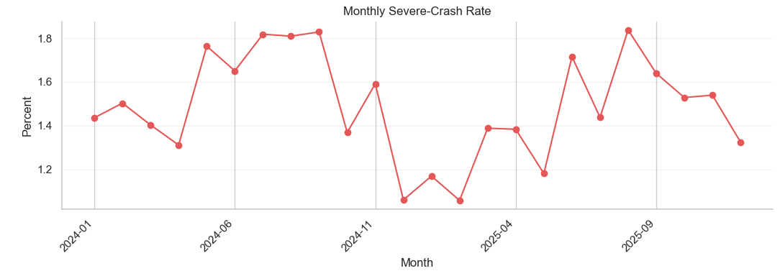
Figure 1 Monthly severe crash rate in Chicago 2024 to 2025

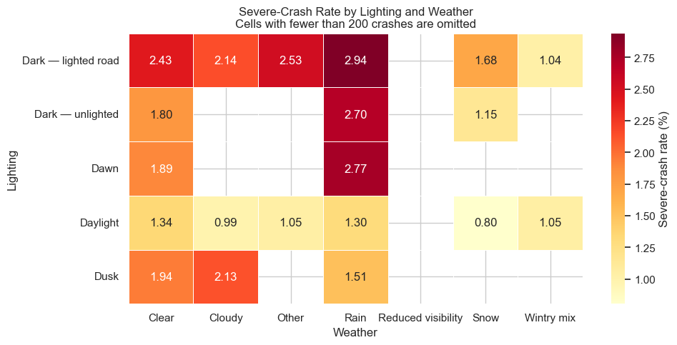
Figure 2 Severe crash rate by lighting and weather Cells below 200 crashes are omitted

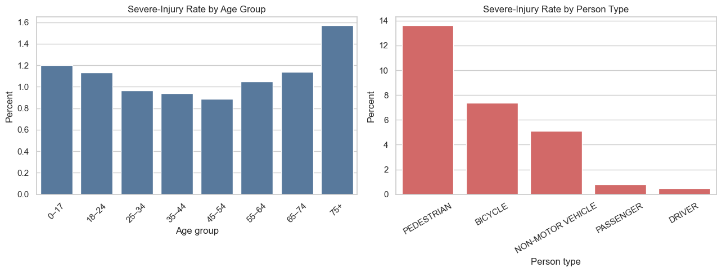
Figure 3 Person level severe injury rate by age group and person type

5 Project Collaboration
Member | Responsibilities
MC631517 Tang I Choi | Prepares the vehicle-level and person-level data; checks crash-ID coverage and the validated joins; completes the road-user and demographic summaries; reviews the Plotly and Folium outputs, labels, and units; independently checks row counts, thresholds, rates, and missing-data treatment; maintains the progress and decision record; edits the collaboration, visualization justification, and references sections; proofreads the notebook and report; and confirms the final submission package.
MC637132 TAN MIN FAI MICKY | Defines the research question and scope; coordinates the schedule and records agreed decisions; retrieves and validates the three source datasets; prepares the crash-level data and the severity, time, environmental, and coordinate variables; completes the temporal, environmental, and spatial analyses; integrates and executes the notebook; drafts the methods, tasks, success criteria, and technical findings; checks all reported values against the executed outputs; and assembles the final submission files.

Visualization Justification
The monthly plots separate crash frequency from the severe crash proportion. The weekday hour and lighting weather heatmaps compare two conditions at a time while the count thresholds prevent small cells from dominating the story. The box plots provide compact numeric comparisons without presenting them as independent effects.
The interactive road user chart keeps the rate beside the underlying record count. The person charts distinguish age and role patterns, and the Folium heat map shows the spatial concentration of recorded severe crashes. The map is a density display rather than an exposure adjusted risk map because traffic volume and pedestrian or cycling activity are not available.

6 References
City of Chicago. Traffic crashes – crashes. https://data.cityofchicago.org/Transportation/Traffic-Crashes-Crashes/85ca-t3if, a. City of Chicago Data Portal.
City of Chicago. Traffic crashes – people. https://data.cityofchicago.org/Transportation/Traffic-Crashes-People/u6pd-qa9d, b. City of Chicago Data Portal.
City of Chicago. Traffic crashes – vehicles. https://data.cityofchicago.org/Transportation/Traffic-Crashes-Vehicles/68nd-jvt3, c. City of Chicago Data Portal.

