Worksheet-7

Name: TANUJ JOSHI UID: 25MCA20081
Branch: MCA General Section/Group: 25MCA_KAR-1
Semester: II Date of Performance: 31-03-26
Subject Name: Technical Training Subject Code: 25CAP-652

Aim of the Session:

The aim of this practical session is to apply the concept of Stored Procedures in database operations to perform tasks like insertion, updating, deletion, and retrieval of data efficiently, securely, and in a reusable manner within the database system.

Objective of the Session:

The objectives of this practical session are:
- To understand the concept of stored procedures in DBMS.
- To perform CRUD (Create, Read, Update, Delete) operations using procedures.
- To improve performance using precompiled SQL statements.
- To enhance data security and controlled access.
- To promote code reusability and modular programming.

Practical / Experiment Steps:

Step 1: Creating a table for demonstration.
- Implementing a table to store employee records.

Step 2: Creating a Stored Procedure for Insertion.
- Creating a procedure to insert new employee records.

Step 3: Creating a Stored Procedure for Update.
- Creating a procedure to update employee salary.

Step 4: Creating a Stored Procedure for Deletion.
- Creating a procedure to delete employee records.

Step 5: Creating a Stored Procedure for Retrieval.
- Creating a procedure to fetch employee data.

Procedure of the Practical:
- Start the system and log in to the computer.
- Open the PostgreSQL client tool (psql / pgAdmin).
- Create Tables.

CREATE TABLE Employees (
EmpID SERIAL PRIMARY KEY,
EmpName VARCHAR(50),
Salary DECIMAL(10,2),
Dept VARCHAR(50)
);

- Insert Sample Data

INSERT INTO Employees (EmpName, Salary, Dept) VALUES
('Amit', 50000, 'IT'),
('Riya', 45000, 'HR');

- Stored Procedure for INSERT

CREATE OR REPLACE PROCEDURE AddEmployee(
p_name VARCHAR,
p_salary DECIMAL,
p_dept VARCHAR
)
LANGUAGE plpgsql
AS $$
BEGIN
INSERT INTO Employees (EmpName, Salary, Dept)
VALUES (p_name, p_salary, p_dept);
END;
$$;

CALL AddEmployee('Kunal', 60000, 'Finance');
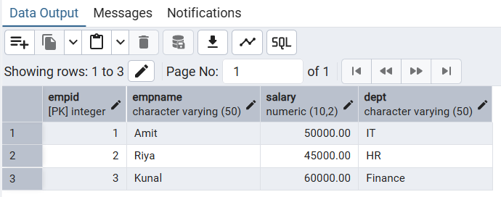

- Stored Procedure for UPDATE

CREATE OR REPLACE PROCEDURE UpdateSalary(
p_id INT,
p_salary DECIMAL
)
LANGUAGE plpgsql
AS $$
BEGIN
UPDATE Employees
SET Salary = p_salary
WHERE EmpID = p_id;
END;
$$;

CALL UpdateSalary(1, 55000);
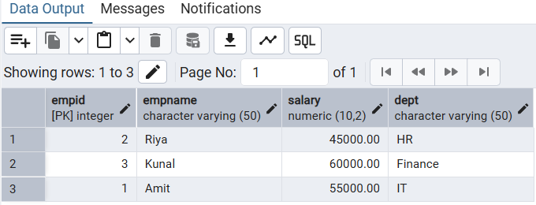

- Stored Procedure for DELETE

CREATE OR REPLACE PROCEDURE DeleteEmployee(
p_id INT
)
LANGUAGE plpgsql
AS $$
BEGIN
DELETE FROM Employees
WHERE EmpID = p_id;
END;
$$;

CALL DeleteEmployee(2);
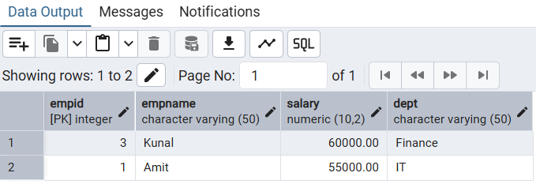
- Verify the output after execution.
- Note down the results obtained.
- Save the work and take screenshots for record.
I/O Analysis:
Input Provided:
- SQL stored procedure definitions
- Employee table data
- Procedure calls for CRUD operations
Output Generated:
- New records inserted into table
- Updated employee salary
- Deleted records from table
- Retrieved employee data
Learning Outcomes:
- Understanding the concept of stored procedures
- Ability to perform CRUD operations using procedures
- Improved database performance and security
- Code reusability and modular approach
- Practical exposure to real-world database applications.

