Worksheet-9

Name: TANUJ JOSHI UID: 25MCA20081
Branch: MCA General Section/Group: 25MCA_KAR-1
Semester: II Date of Performance: 21-04-26
Subject Name: Technical Training Subject Code: 25CAP-652

Aim of the Session:

The aim of this practical session is to implement database triggers in PostgreSQL to automatically calculate values and enforce constraints during data insertion operations.

Objective of the Session:

The objectives of this practical session are:
- To understand the concept of triggers in DBMS.
- To automate actions using triggers during INSERT operations.
- To enforce constraints and maintain data integrity.
- To perform automatic calculations using triggers.
- To reduce manual intervention in database operations.

Practical / Experiment Steps:

Step 1: Creating a table for demonstration.
- Implementing a table to store employee salary details.

Step 2: Creating a Trigger Function.
- Creating a function to calculate bonus automatically.

Step 3: Creating a Trigger.
- Creating a trigger that executes before inserting data.

Step 4: Inserting Data.
- Inserting records to check automatic trigger execution.

Step 5: Verifying Results.
- Displaying table data to confirm trigger functionality.

Procedure of the Practical:
- Start the system and log in to the computer.
- Open the PostgreSQL client tool (psql / pgAdmin).
- Create Tables.

CREATE TABLE EmployeeSalary (
EmpID SERIAL PRIMARY KEY,
EmpName VARCHAR(50),
Salary DECIMAL(10,2),
Bonus DECIMAL(10,2)
);

- Create Trigger Function

CREATE OR REPLACE FUNCTION calculate_bonus()
RETURNS TRIGGER AS $$
BEGIN
NEW.Bonus := NEW.Salary * 0.10;
RETURN NEW;
END;
$$ LANGUAGE plpgsql;

- Create Trigger

CREATE TRIGGER before_insert_bonus
BEFORE INSERT ON EmployeeSalary
FOR EACH ROW
EXECUTE FUNCTION calculate_bonus();

- Insert Data

INSERT INTO EmployeeSalary (EmpName, Salary)
VALUES ('Amit', 50000),
('Riya', 60000);

- Display Data

SELECT * FROM EmployeeSalary;
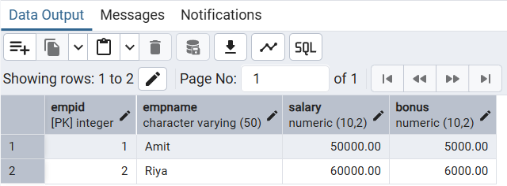
- Verify the output after execution.
- Note down the results obtained.
- Save the work and take screenshots for record.
I/O Analysis:
Input Provided:
- Table structure for employee salary
- Trigger function definition
- Trigger creation query
- Insert statements
Output Generated:
- Automatic calculation of bonus (10% of salary)
- Inserted records with computed bonus values
- Maintained data consistency
Learning Outcomes:
- Understanding the concept of database triggers
- Ability to automate database operations
- Enforcing constraints using triggers
- Reducing manual effort through automation
- Practical knowledge of PostgreSQL trigger implementation

