Table of Contents

1.0 Sketch (User Interface Design) 2
2.0 Class Diagram (OO Design) 10
3.0 Sample Output 11

1.0 Sketch (User Interface Design)
Owners Tab (will be shown when user click the “Owners” tab. It lists all the added owner’s info in TABLE):
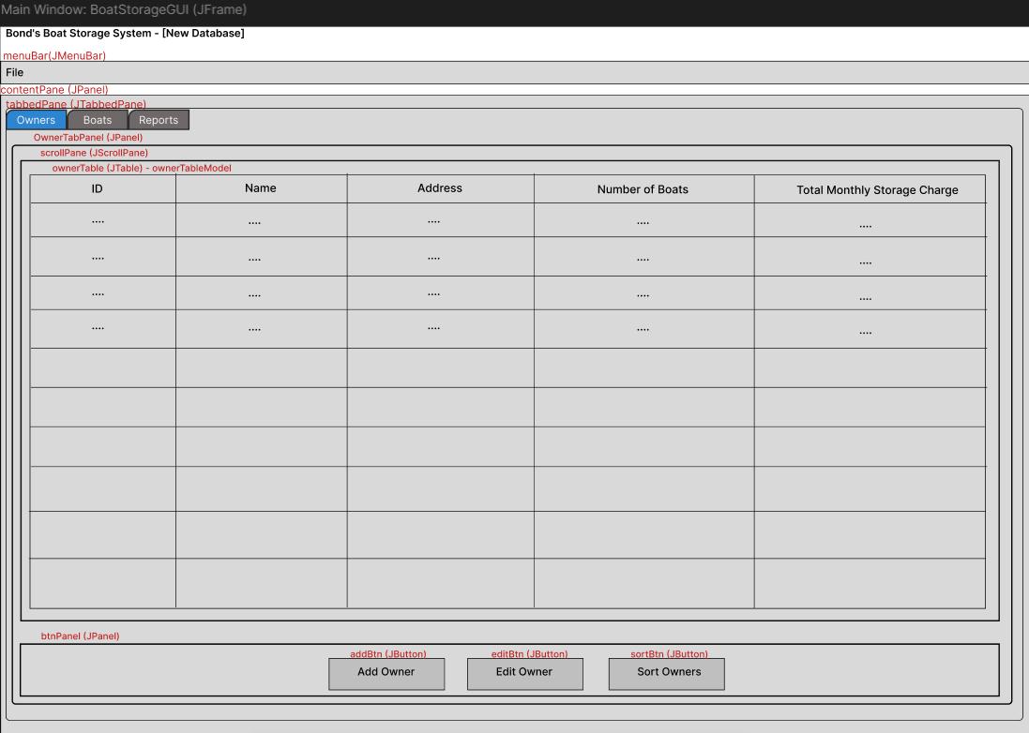
Add Owner Dialog (that will be pop-up after user click the “Add Owner” button from Owners Tab):
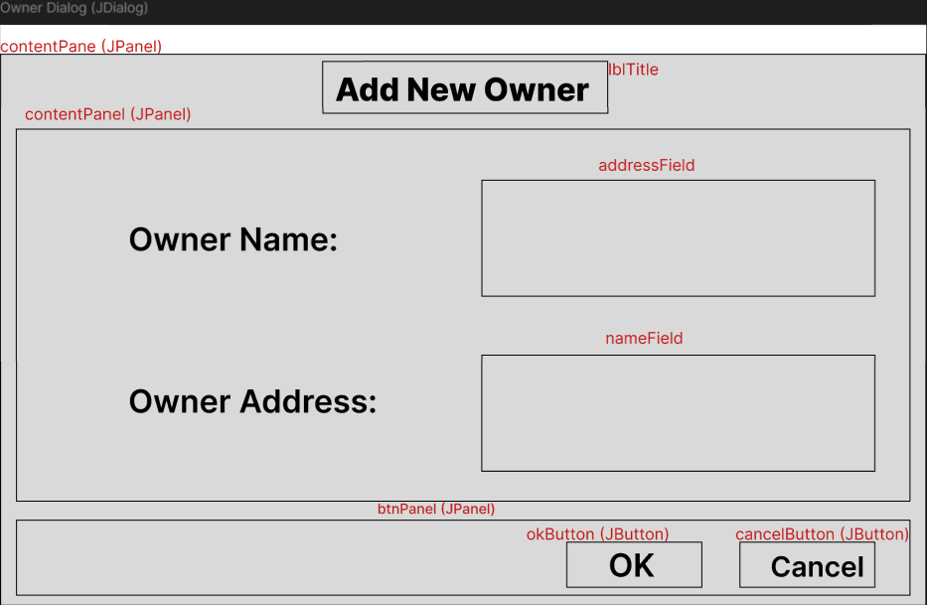

Edit Owner Dialog (that will be pop-up after user selected an owner row and click the “Edit Owner” button from Owners Tab):
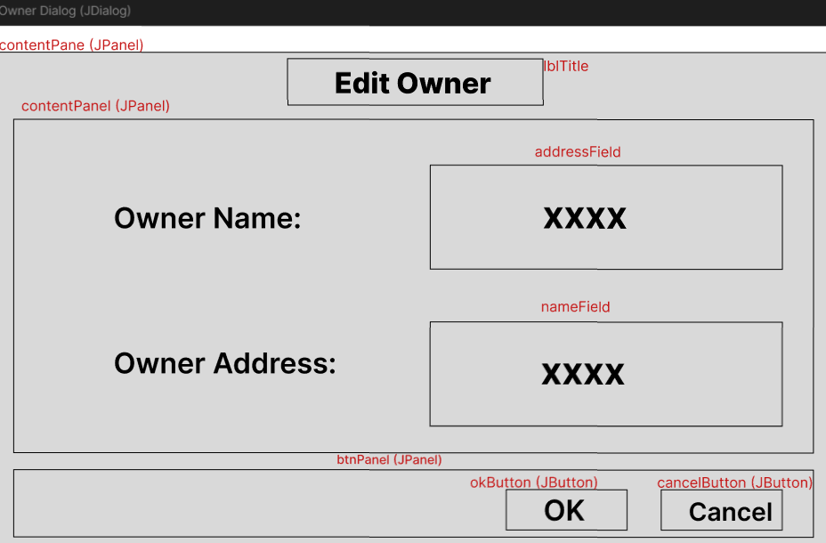
Sort Owner Dialog (that will be pop-up after user click the “Sort Owners” button from Owners Tab):
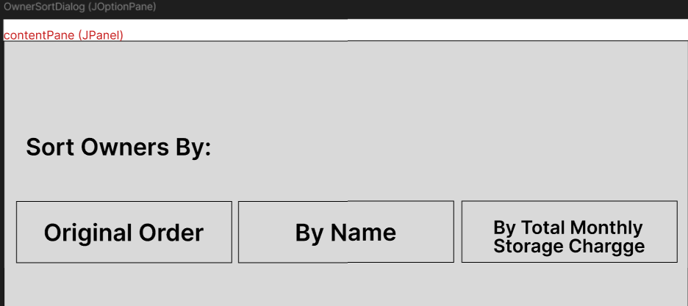

Boats Tab (will be shown when user click the “Boats” tab. It lists all the added boat’s info in TABLE):
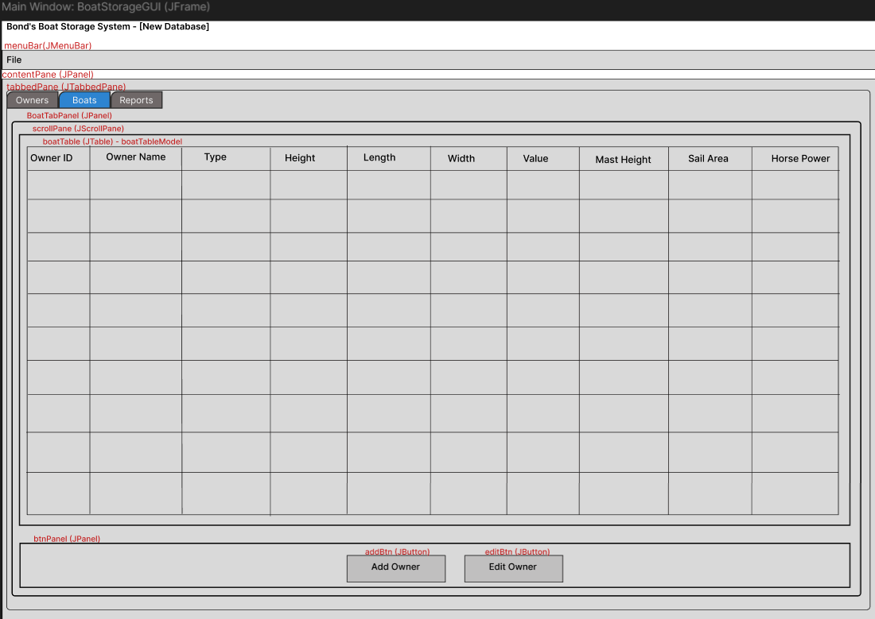

Add Boat Dialog (that will be pop-up after user click the “Add Boat” button from Boats Tab):
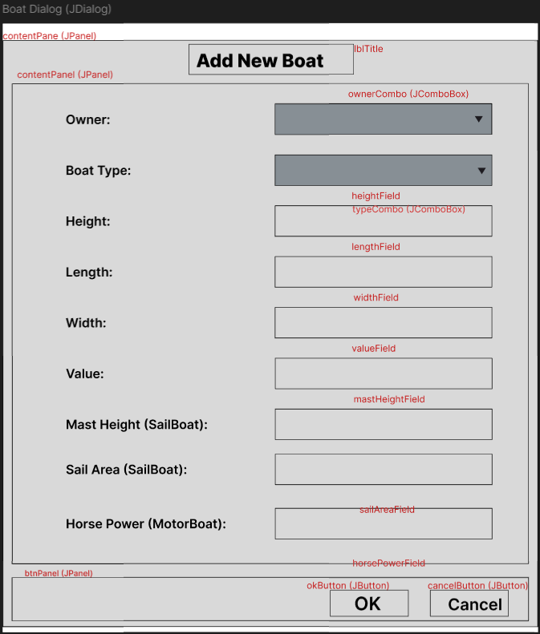

Edit Boat Dialog (that will be pop-up after user selected a boat row and click the “Edit Boat” button from Boats Tab):
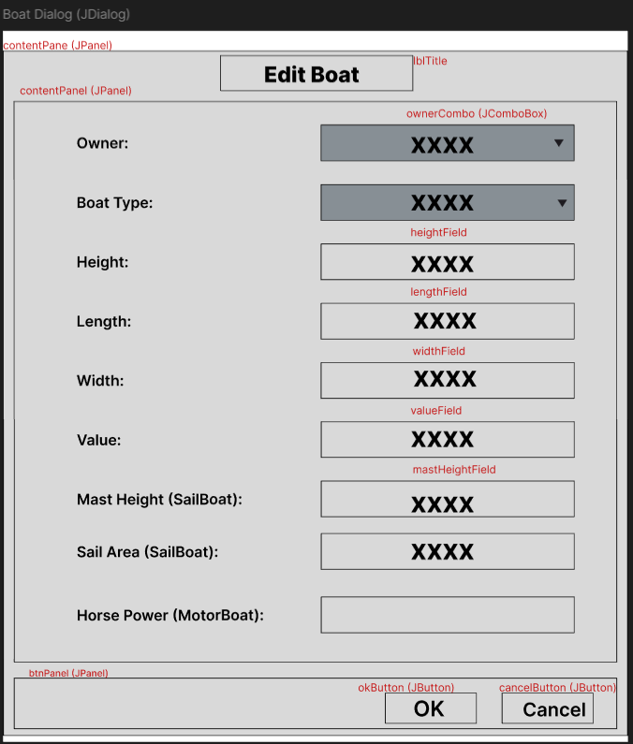

Reports Tab (will be shown when user click the “Reports” tab. By default, it will show the “Show Charges Summary” table. If user click “Show Boat Counts”, it changes to “Show Boat Counts” table. If user click “Show Owner Charges”, it changes to the “Show Owner Charges” table.). If user click “Show Charges Summary”, it changes to the “Show Charges Summary” table.:
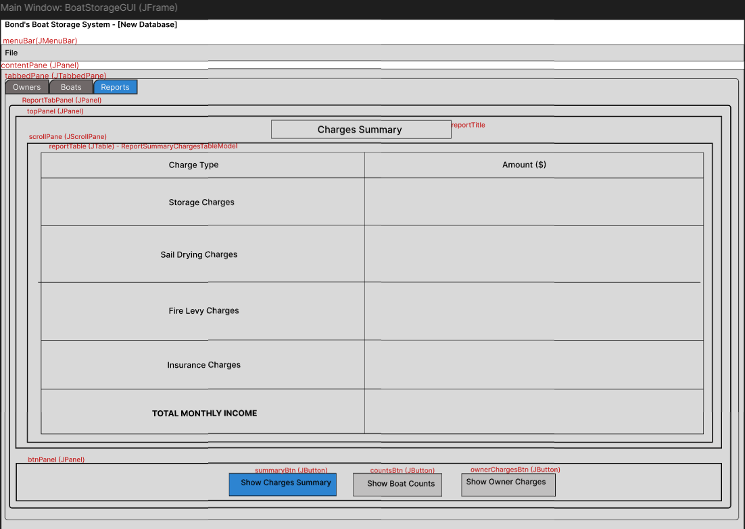

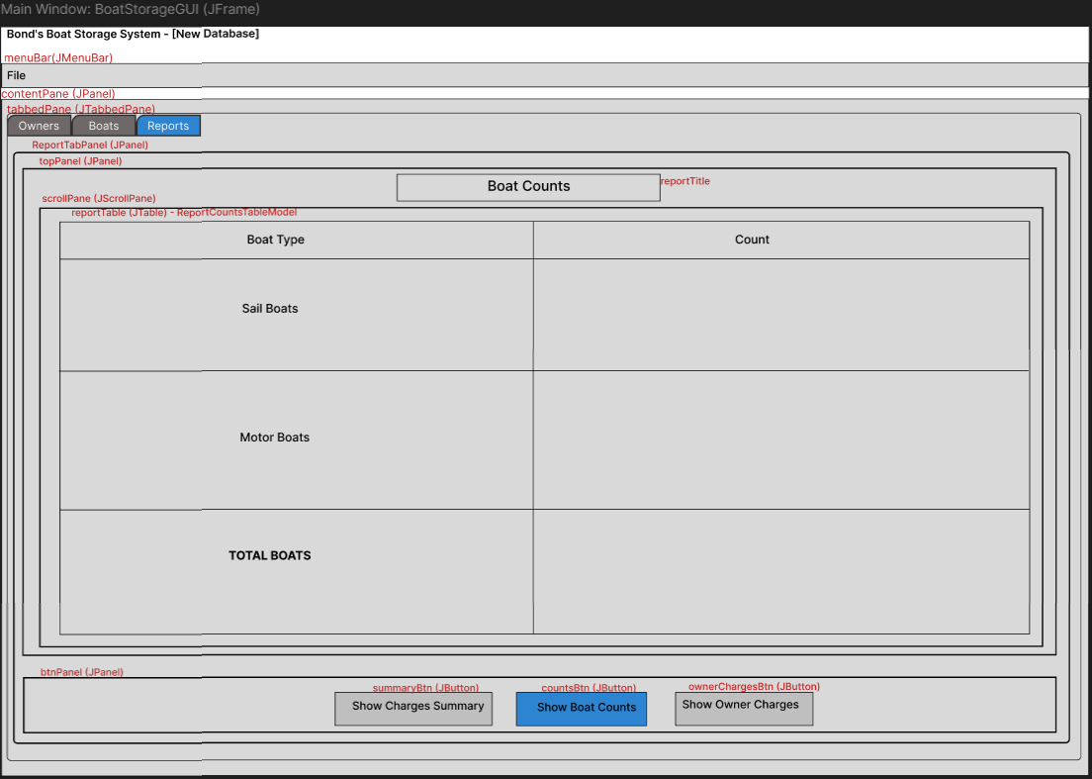

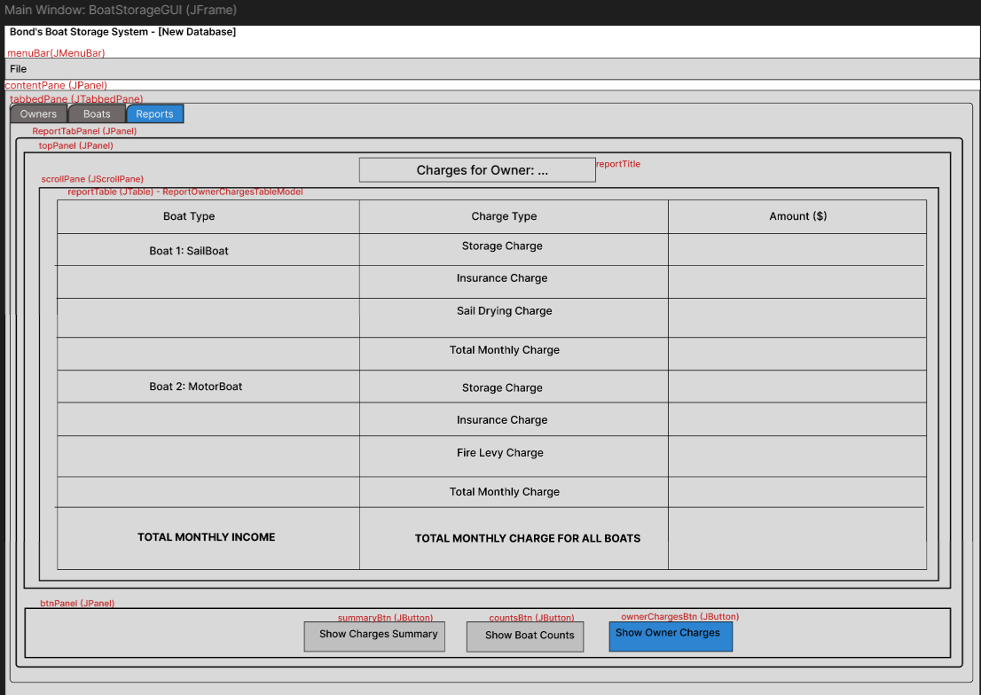

File Menu Bar (will be shown up after the user clicks "File" from the top of the JFrame.)
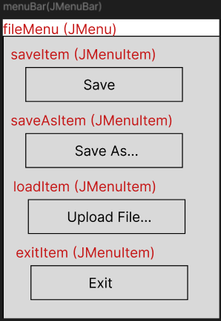

2.0 Class Diagram (OO Design)
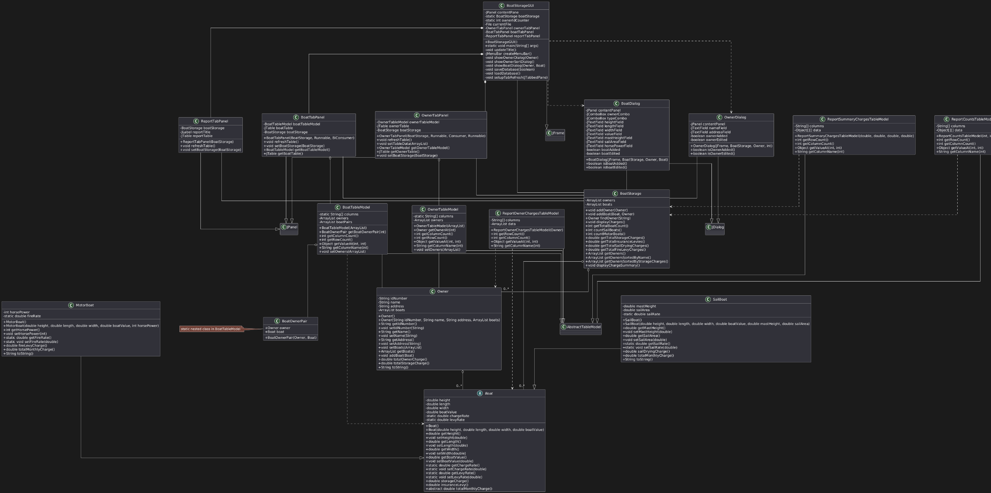

3.0 Sample Output

After starting the GUI program, a frame window titled “Bond’s Boat Storage System” will be shown. By default, the Owners tab is displayed first. Users can control the three tabs: Owners, Boats, and Reports.

Now, go through the interface at first look (without any data added yet):
- After clicking the “Owners” tab, the OwnerTabPanel will be shown, which includes a table listing all added owners’ information and a button panel with three buttons: “Add Owner”, “Edit Owner”, and “Sort Owner”.
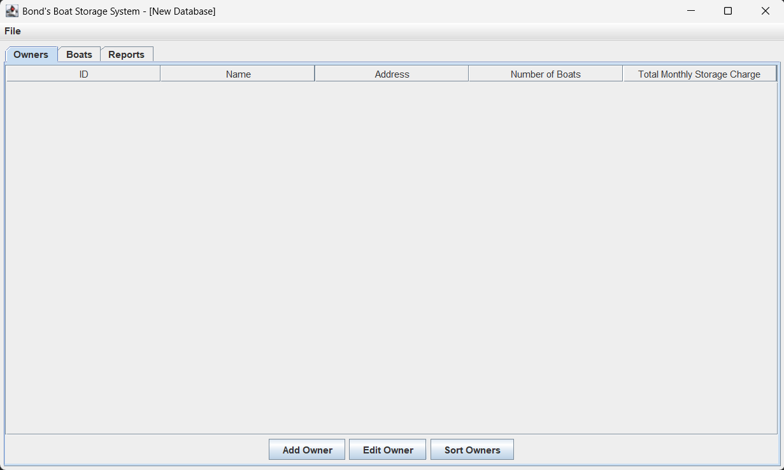

- If you click the “Add Owner” button, an “Add Owner” dialog will pop up, allowing users to add a new owner to the system.

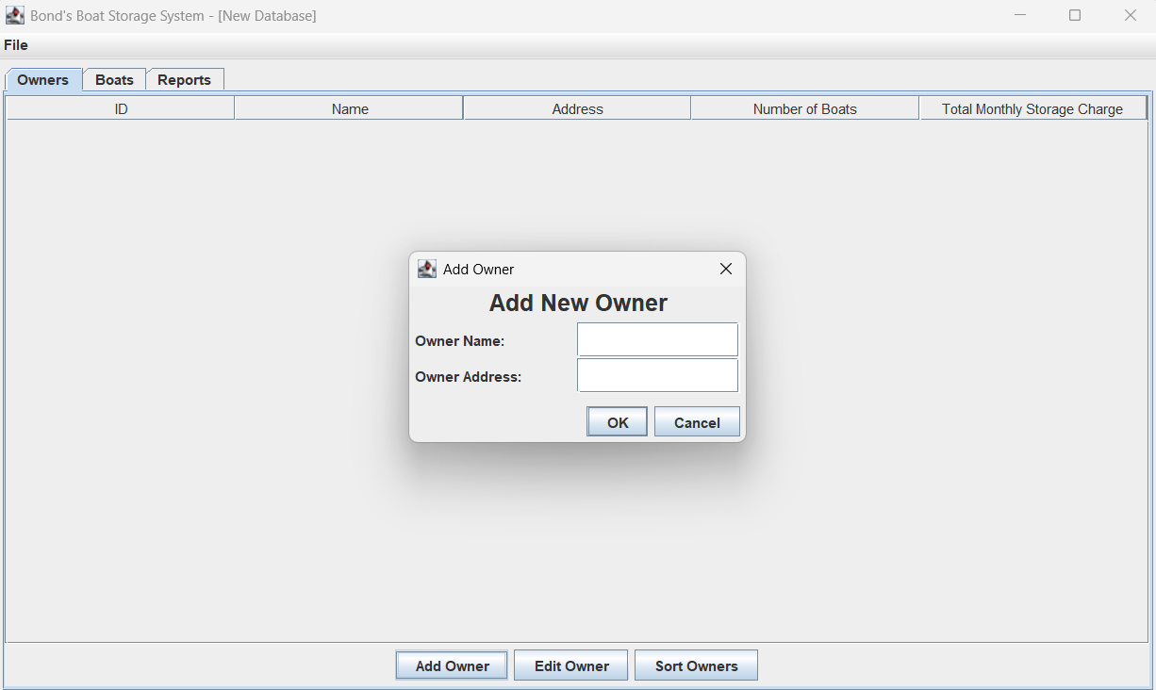

- Since the owner table has no data yet, no owner row can be selected. If the user clicks the “Edit Owner” button, the error message “Please select an owner to edit” will pop up.

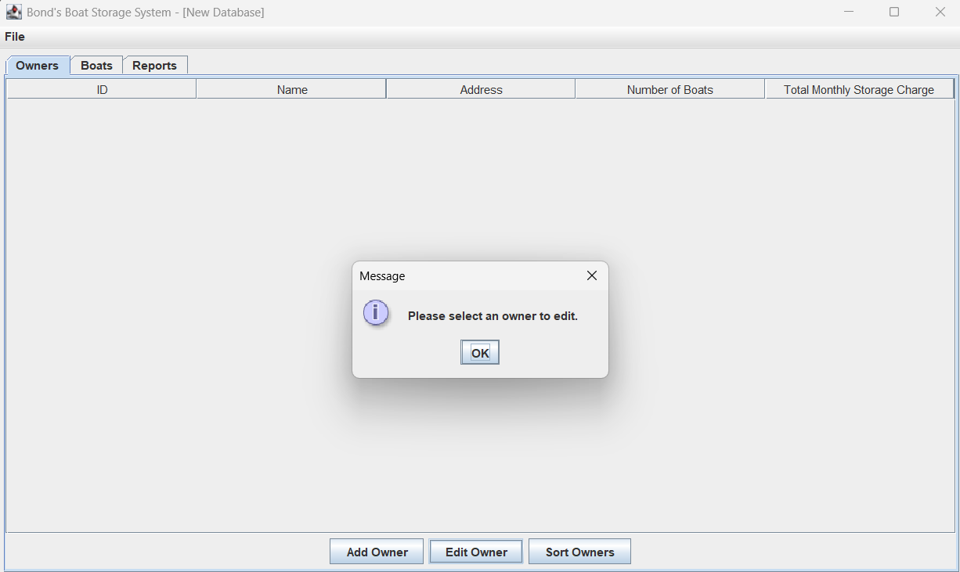

- If the user clicks the "Sort Owners" button, the SortOwner Option Pane will be shown with three option buttons (Original Order, By Name, By Total Monthly Storage Charge).

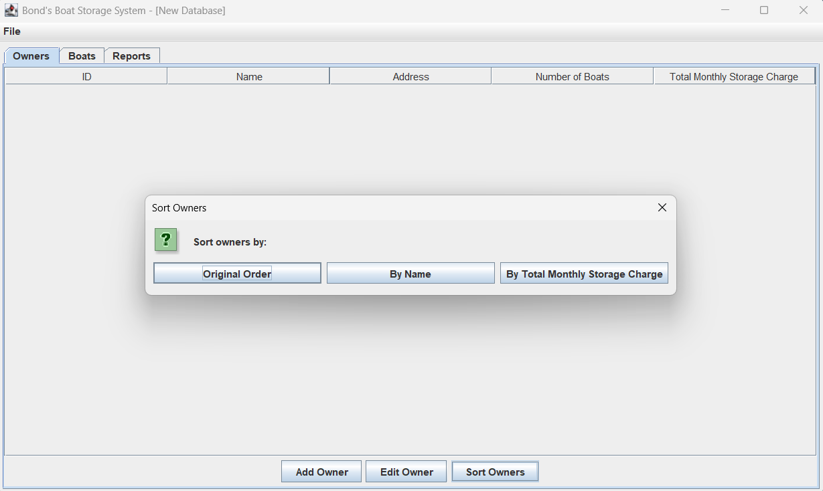
- After clicking the “Boats” tab, the BoatTabPanel will be shown, which includes a table listing all added boats’ information and a button panel with two buttons: “Add Boat” and “Edit Boat”.
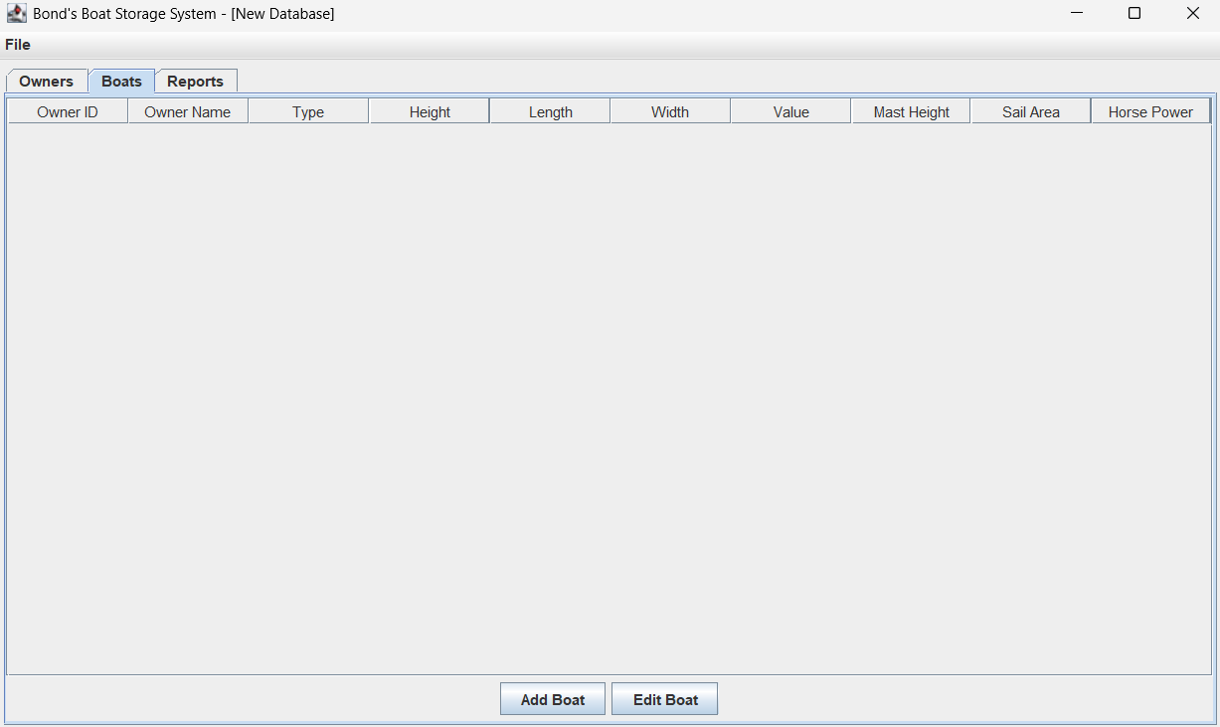
- For now, since the owner table has no data yet, if you click the “Add Boat” button, an error message will pop up: "No owners available. Please add an owner before adding a boat."
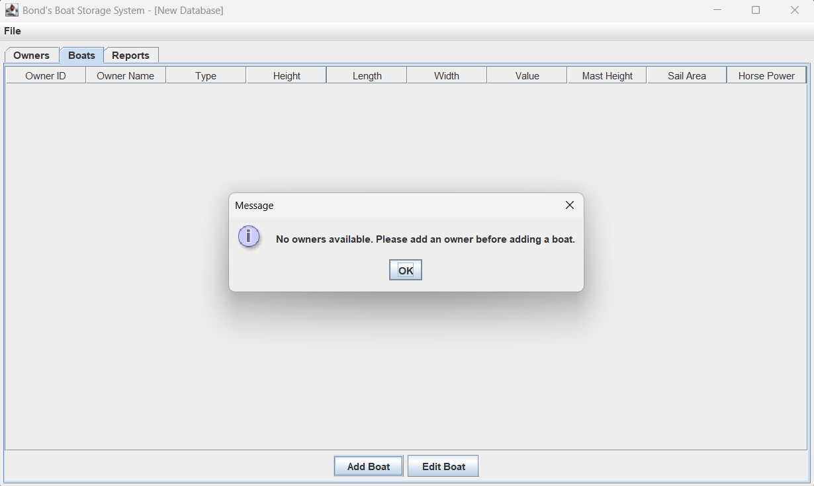

- Also, since there is no data, if the user clicks the “Edit Boat” button, the error message “Please select a boat to edit” will pop up.
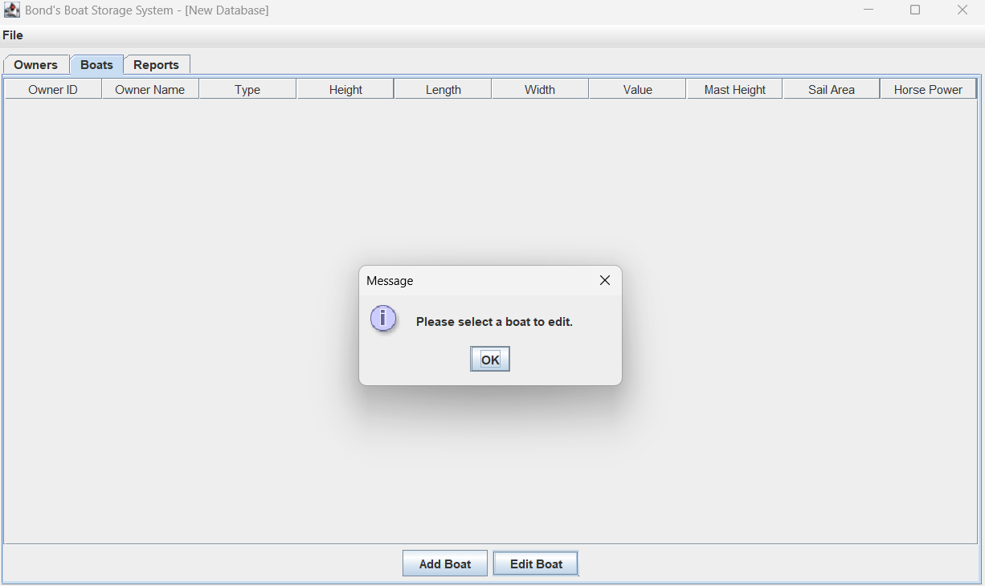

- After clicking the “Reports” tab, the ReportTabPanel will be shown, which includes:
- A button panel with three buttons: “Show Charges Summary”, “Show Boat Counts”, and “Show Owner Charges”.
- A report table that displays three different models for three different reports, depending on the user’s button selection.
If the user clicks the “Show Charges Summary” button (selected by default), the report table will use the "ReportSummaryChargesTableModel" to display the summary of the TOTAL storage charges, sail drying charges, fire levy charges, and insurance levies applicable to ALL boat owners for Bond’s business.
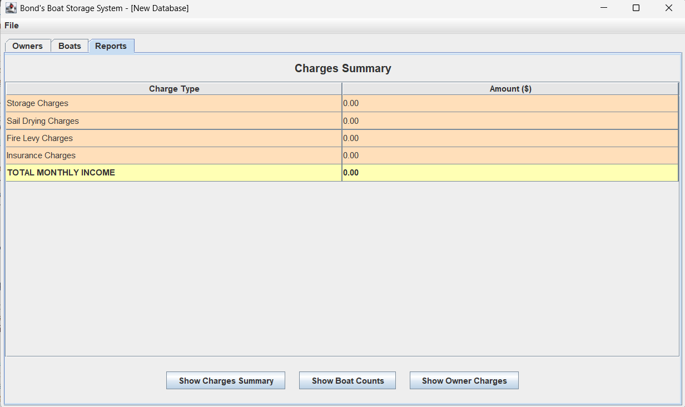

- If the user clicks the “Show Boat Counts” button, the report table will use the "ReportCountsTableModel" to display the count of sail boats, motor boats, and the total boat count currently at Bond’s Boats Storage.
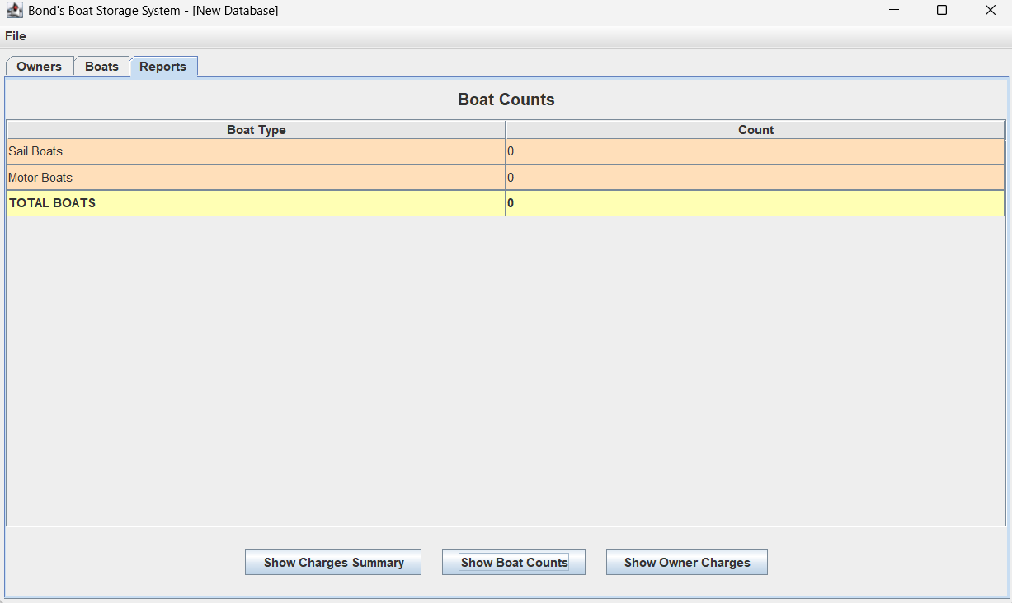

- If the user clicks the “Show Owner Charges” button, a popup window will ask the user to enter an owner ID. If the entered owner ID is not found in the system, a pop-up error message “OWNER NOT FOUND” will be shown. If the owner ID is found, the report table will use the "ReportOwnerChargesTableModel" to display the storage charges, sail drying charges, fire levy charges, and insurance levies for ALL boats belonging to the entered owner.
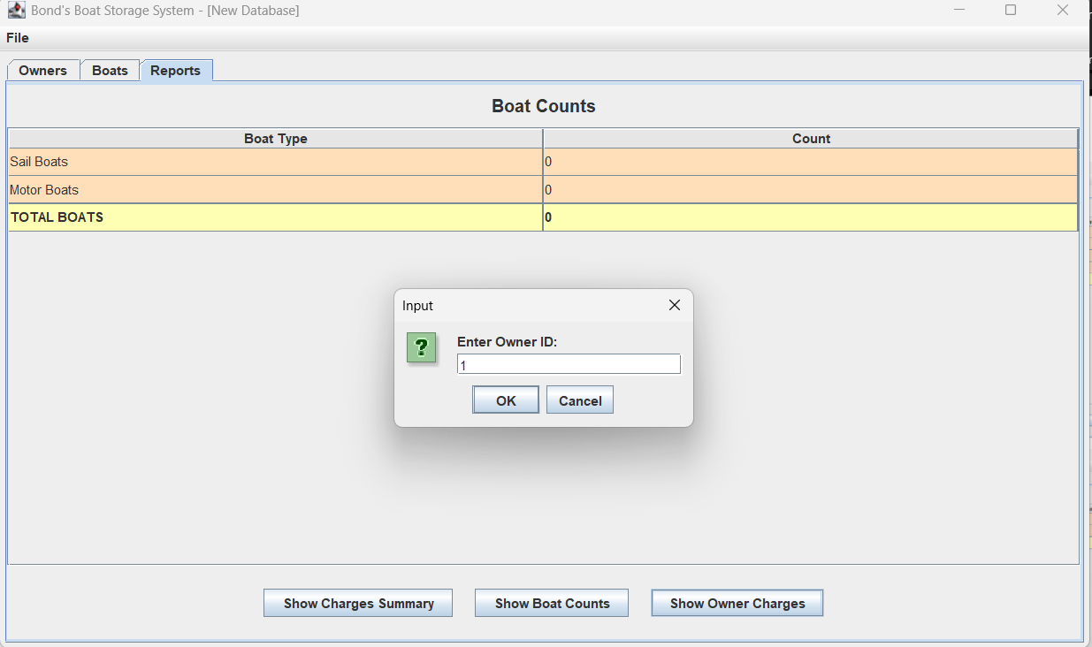
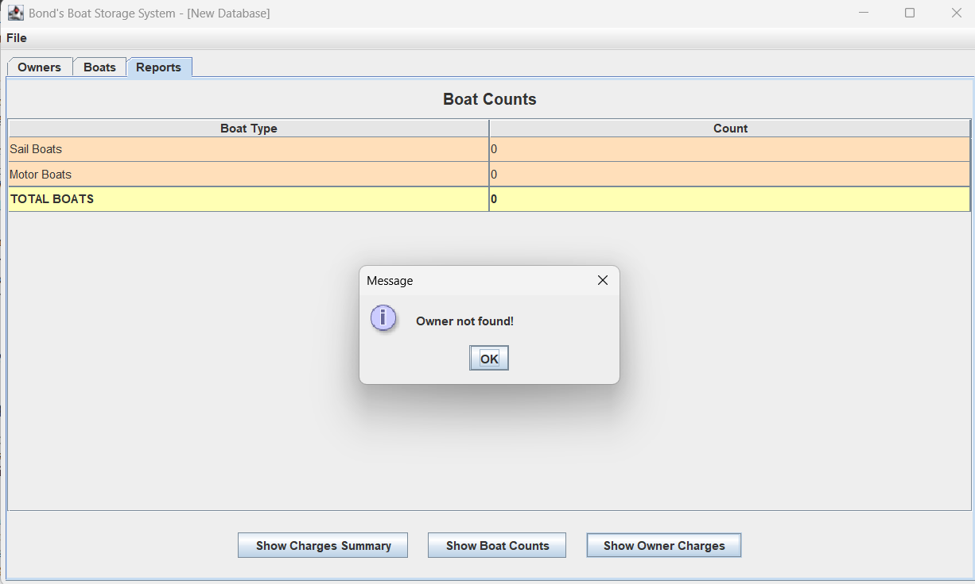

Now, user goes back to the Owners tab and tries to add a new owner to the system:
- Click the Owners tab.
- Click the Add Owner button.
- An "Add Owner" dialog will appear, which consists of two required fields (owner name, owner address).
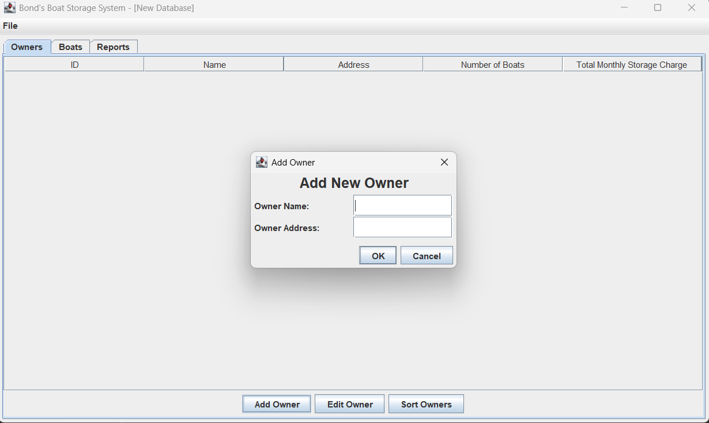
- If one of these fields is empty, the system will pop up an error message: "Name and address cannot be empty."
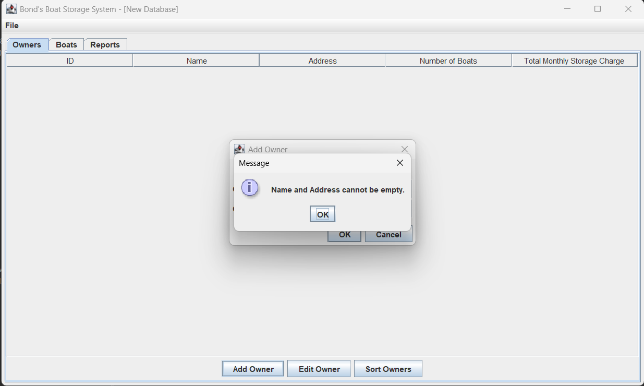
- If the user provides both fields, the system will show a success message: "Owner added successfully with ID 'XX'!"
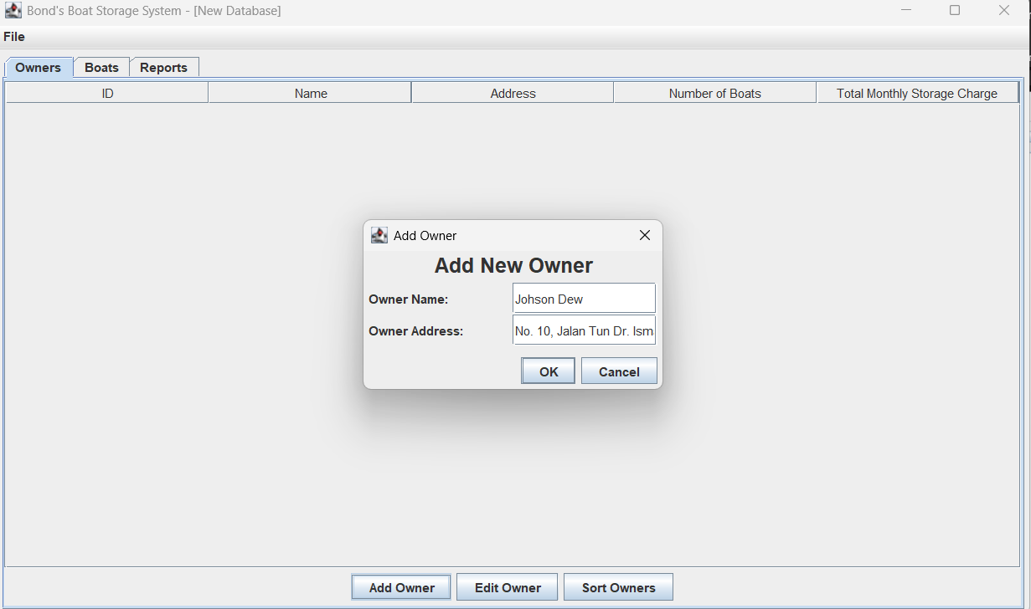
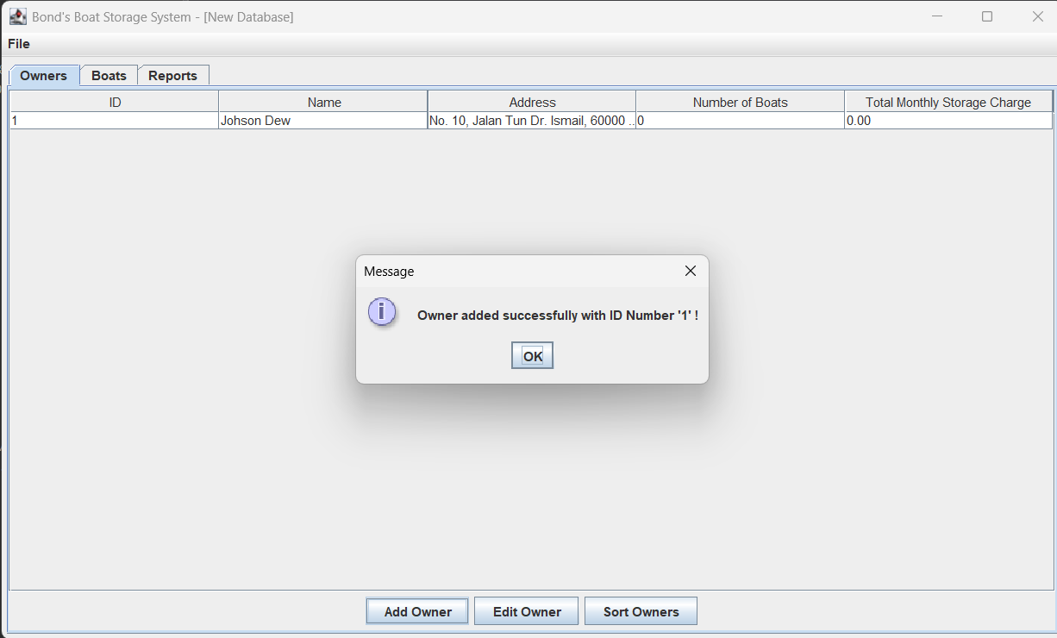

- Now, if the user selects one of the owner rows (with data) and clicks the "Edit Owner" button, the system will show the "Edit Owner" dialog, which consists of two required fields (owner name, owner address). The selected owner’s data will be shown in the two input fields. User can choose to save their edited data by clicking “OK button. If the user does not want to edit, they may choose the close icon or "Cancel" button from the edit dialog to close it.
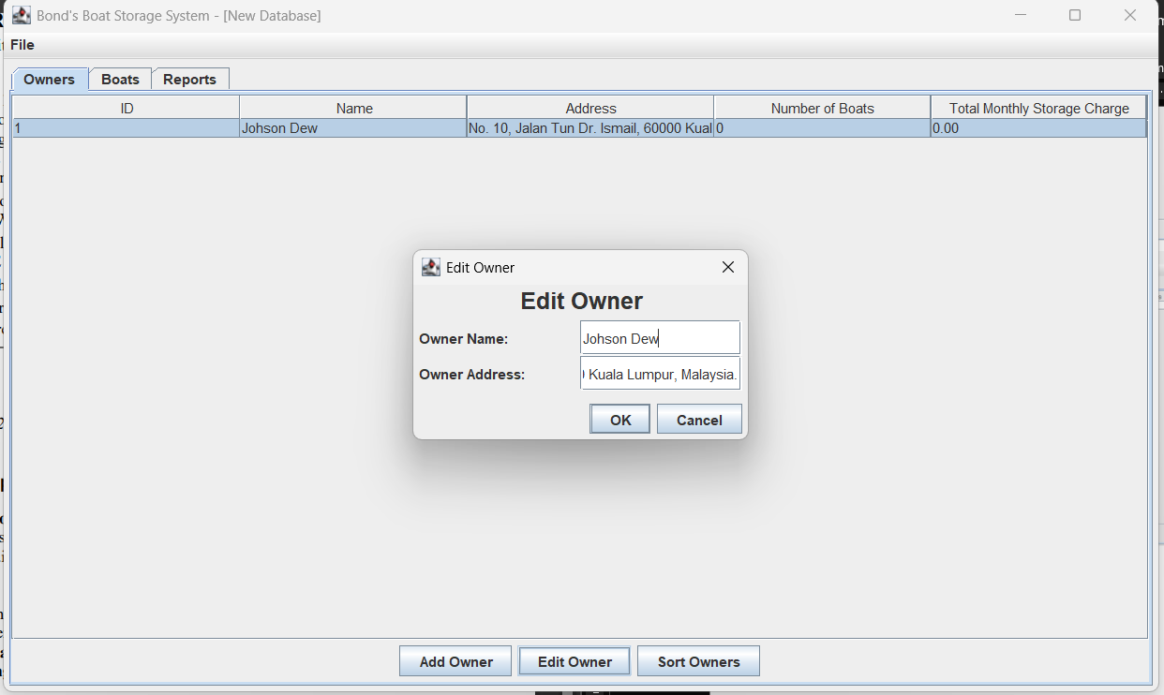
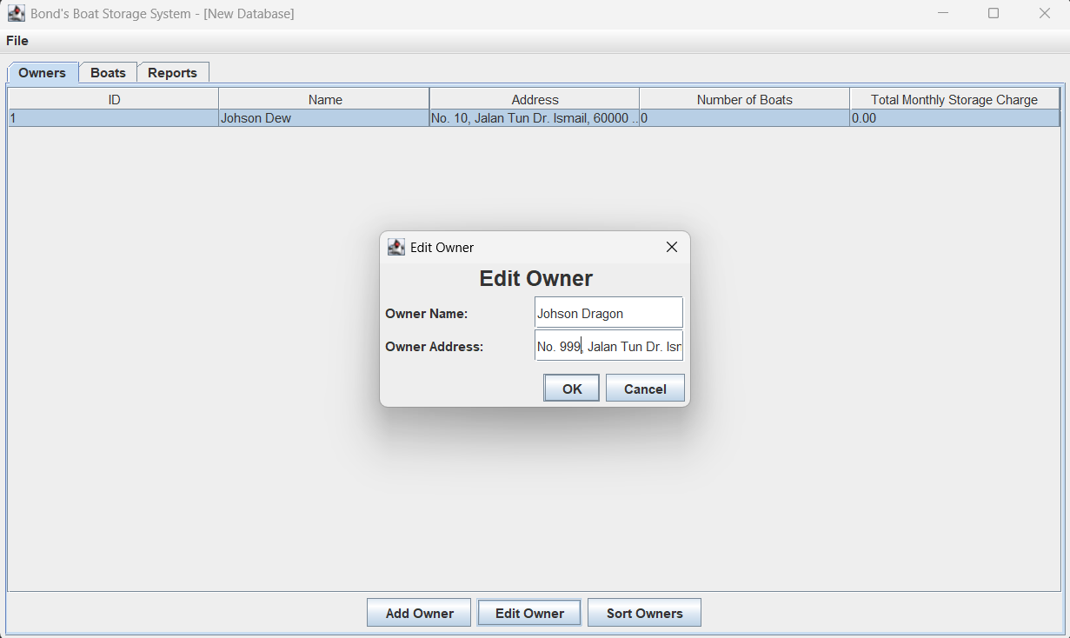

- After the user edited value and clicked "OK", a success message will pop up: "Owner edited successfully."
- The owners table will update with the new owner data.
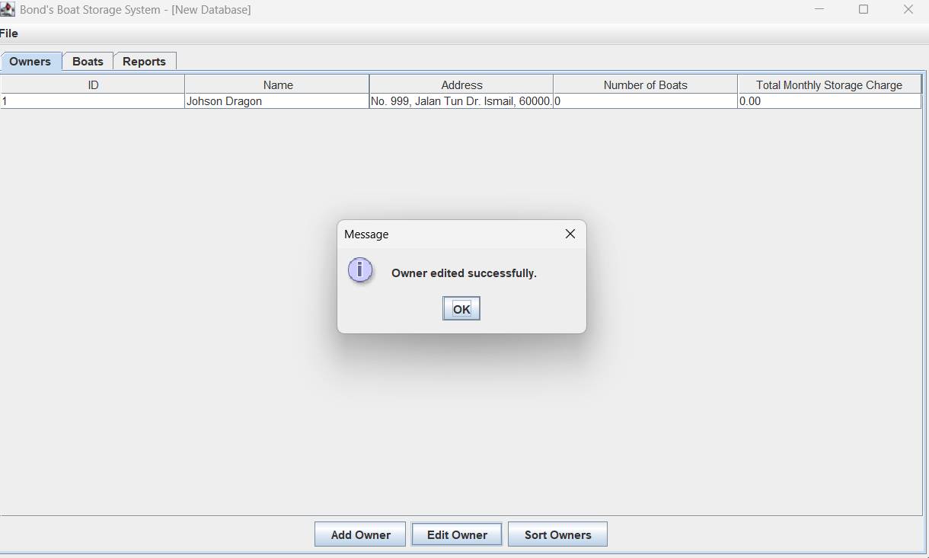

Now, user goes back to the Boats tab and tries to add a new boat to the system:
- Click the Boats tab.
- Click the Add Boat button.
- An "Add Boat" dialog will appear, which consists of nine fields (owner, boat type, height, length, width, value, mast height, sail area, horse power). The user can select the owner to add the boat for by clicking the arrow and selecting from all currently added owners. The user can select the boat type by clicking the arrow and choosing either SailBoat or MotorBoat.
- If the user selects "Sail Boat" as the boat type, there are eight required fields to fill in (owner, boat type, height, length, width, value, mast height, sail area).
- If the user selects "Motor Boat" as the boat type, there are seven required fields to fill in (owner, boat type, height, length, width, value, horse power).
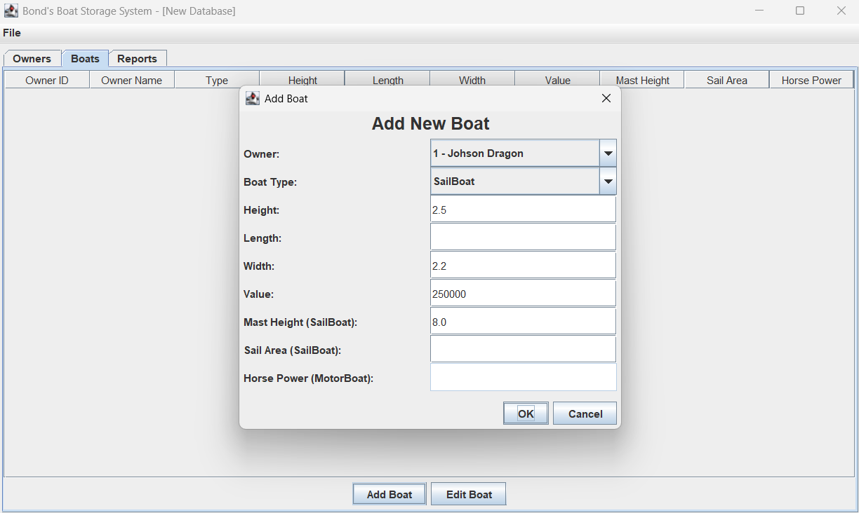

- If any required field is empty and the user clicks "OK", the system will pop up an error message: "<XXX> fields cannot be empty."
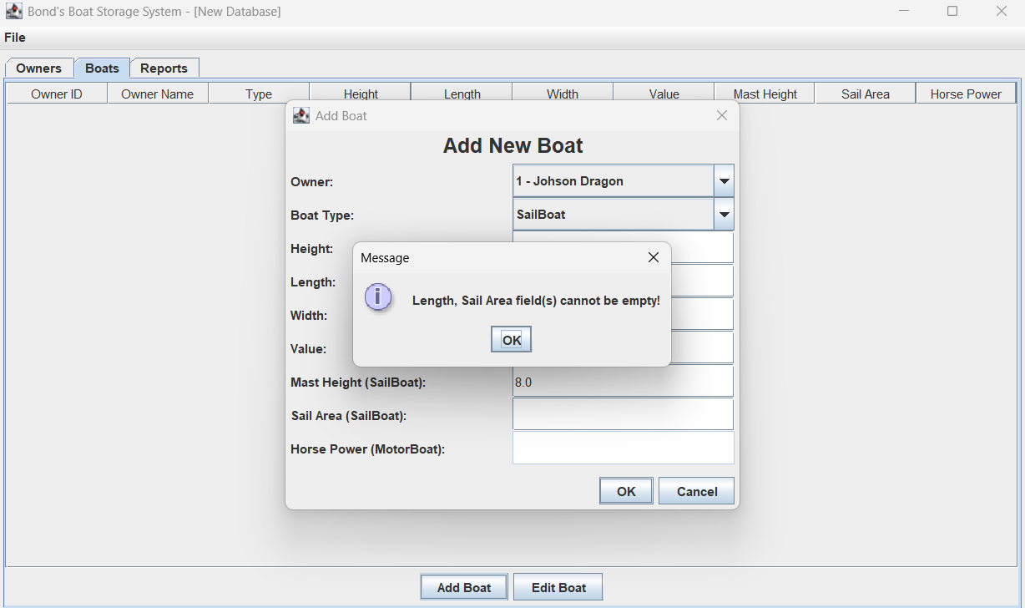

- If any required field is a negative number and the user clicks "OK", the system will pop up an error message: "<XXX> must all be positive numbers."
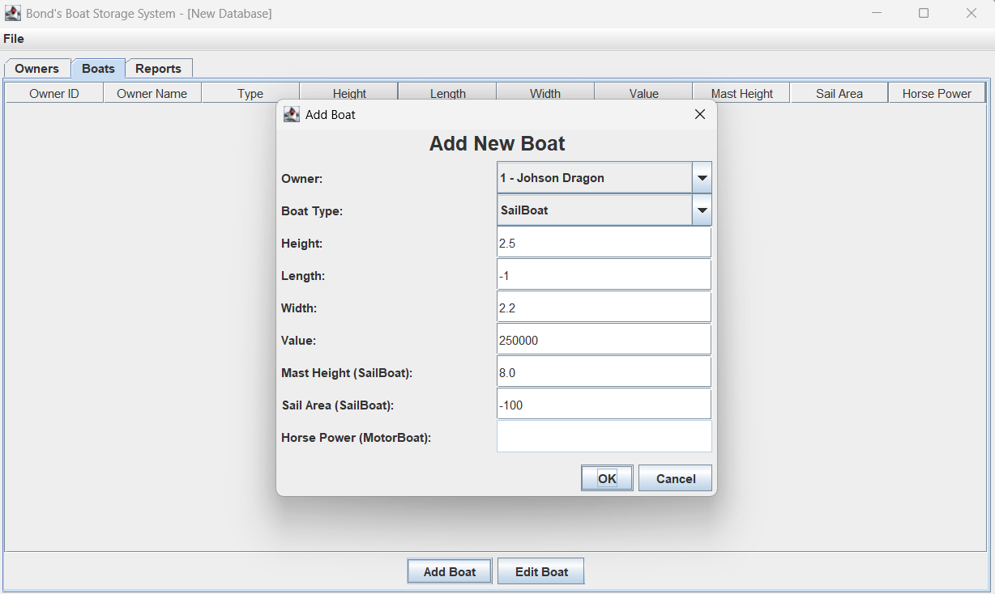

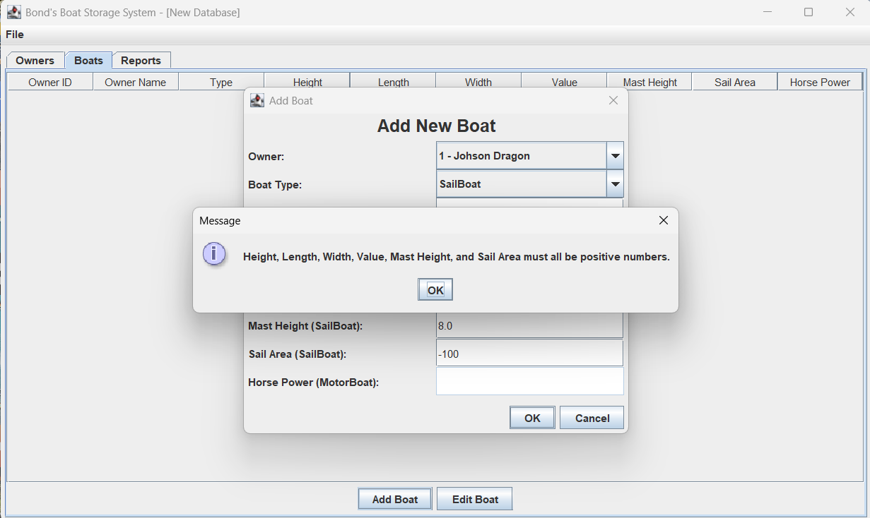

- If any required field (except owner and boat type) is not a number, the system will pop up an error message: "Invalid input. Please enter valid numbers."
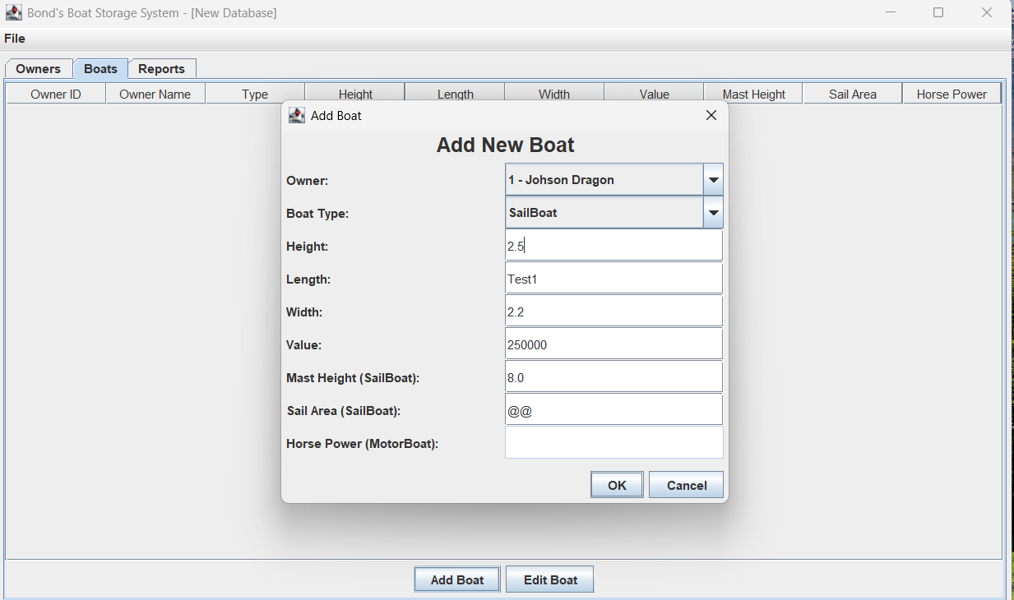
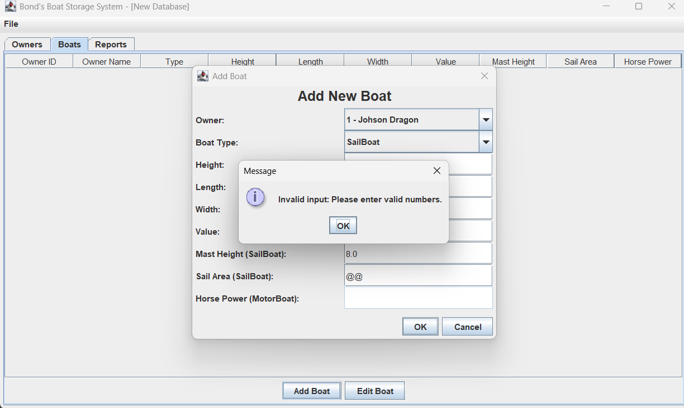

- If the user provides all fields with valid values and clicks "OK", the system will show a success message: "Boat added successfully!"
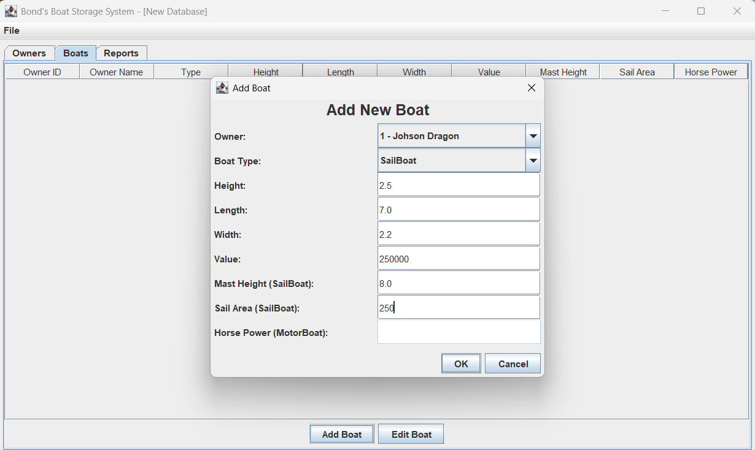
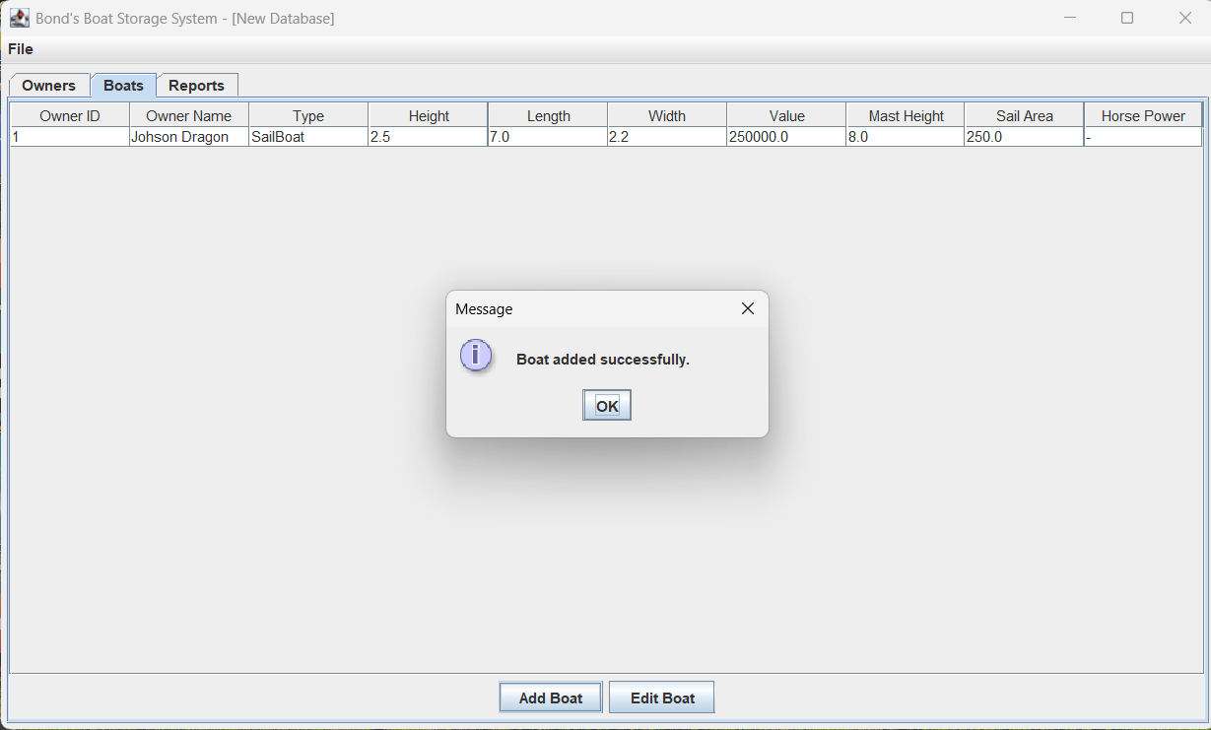

- Add new boat (Motor boat type):
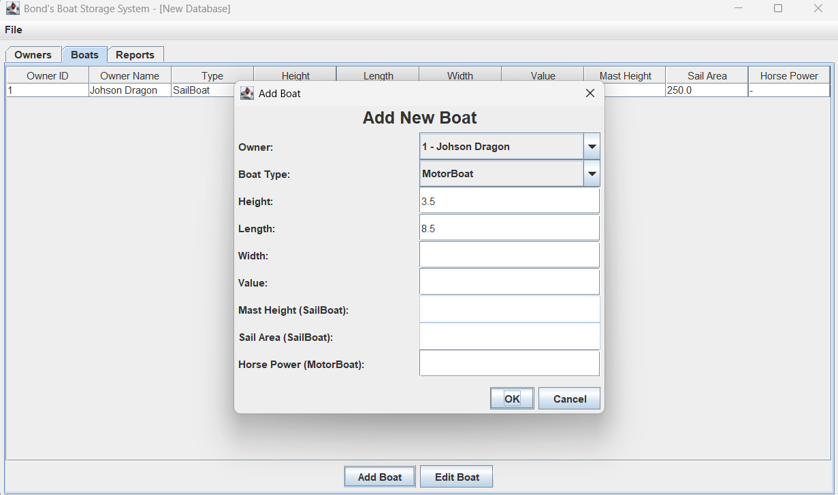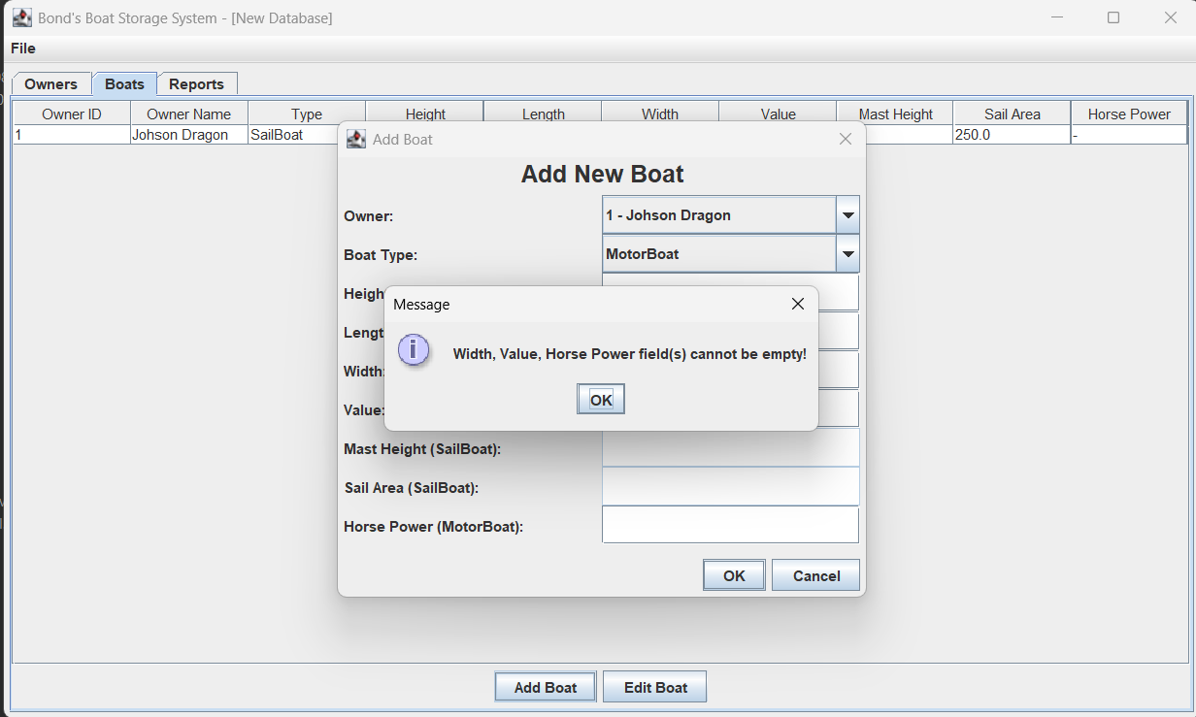
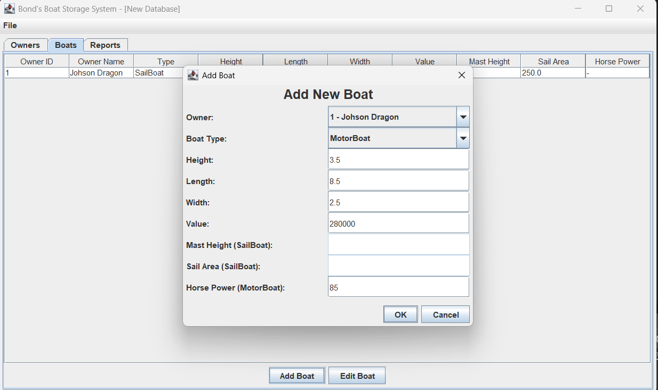
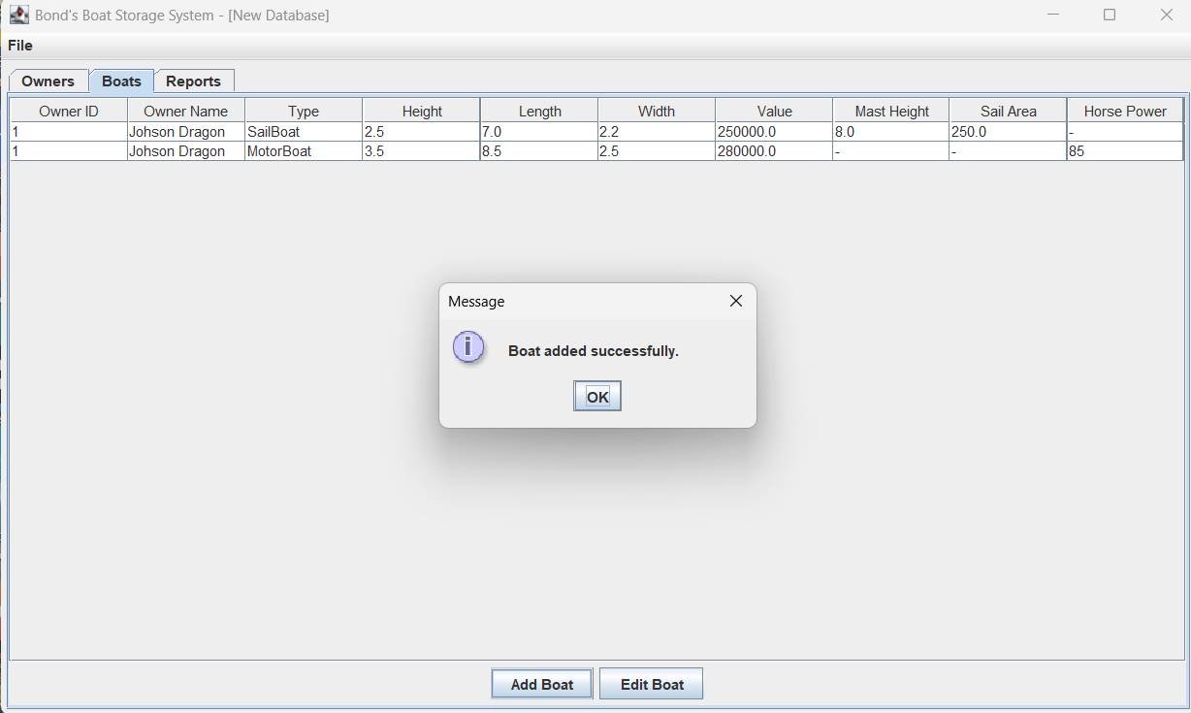

- Now, if the user selects one of the boat rows (with data) and clicks the "Edit Boat" button, the system will show the "Edit Boat" dialog, which will display all nine fields details (owner, boat type, height, length, width, value, mast height, sail area, horse power) for the selected boat. Here, the user cannot reselect the owner or boat type, as these fields are disabled.
- If the selected boat is a "Sail Boat", there are six required fields (height, length, width, value, mast height, sail area).
- If the selected boat is a "Motor Boat", there are five required fields (height, length, width, value, horse power).
- If any required field is edited to be empty, the system will pop up an error message: "<XXX> fields cannot be empty."
- If the user does not want to edit, they may choose the close icon or "Cancel" button from the edit dialog to close it.
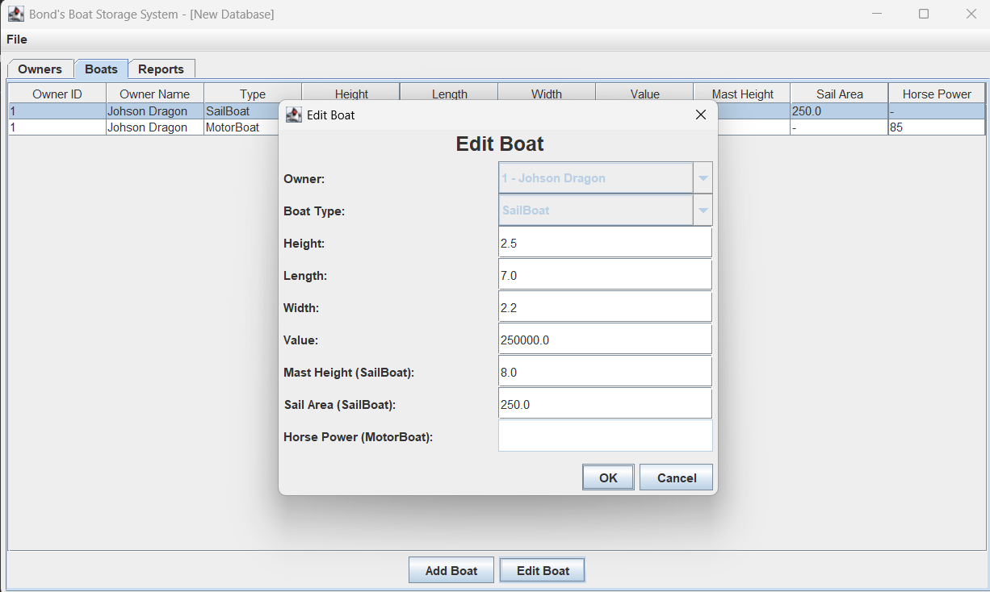

- If the user edited fields with valid values and clicks "OK", a success message will pop up: "Boat edited successfully."
- After the user edits successfully, the boats table will update with the new boat data.
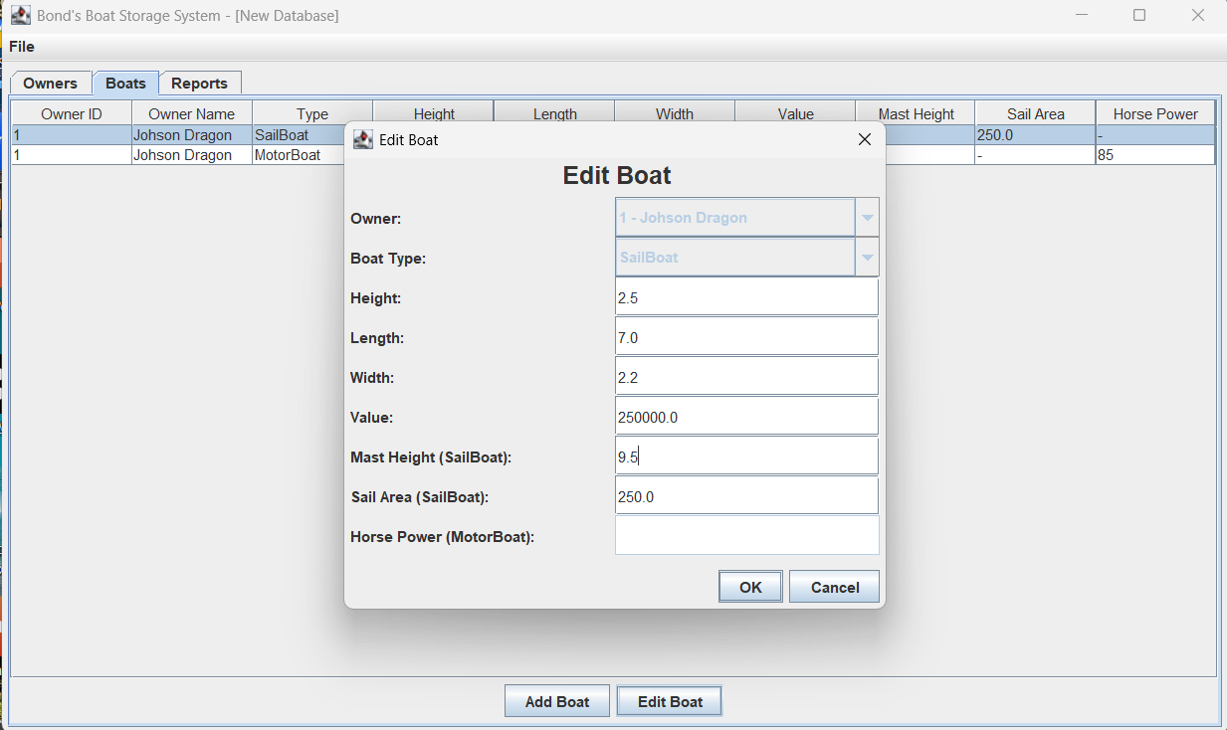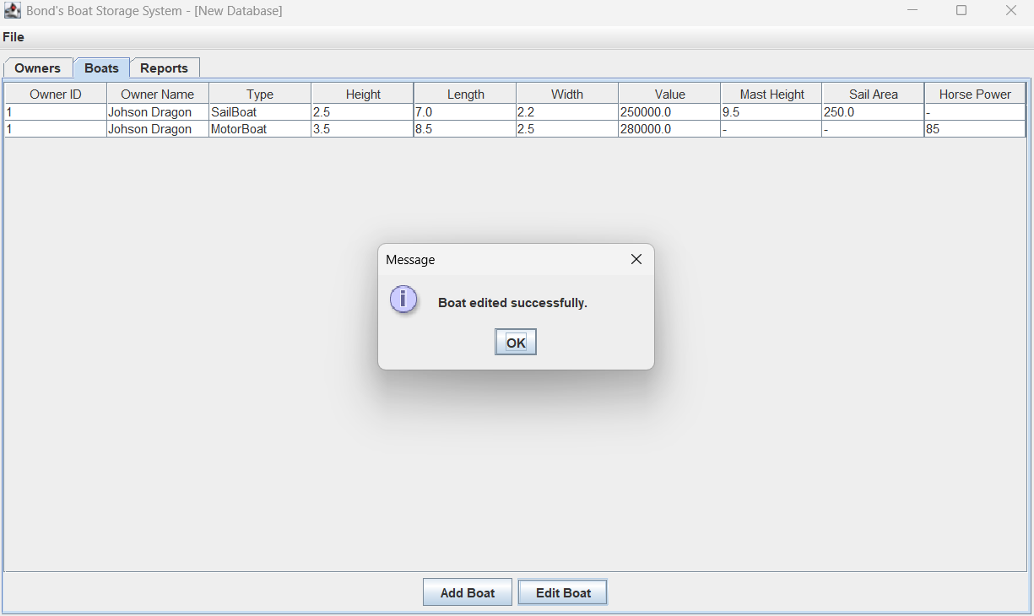

Now, user goes back to the Owners tab and tries to add more new owners to the system:
- Click the Owners tab.
- Click the Add Owner button.
- Add two more new owners: Jason Wong & Emma Watson in the "Add Owner" dialog.
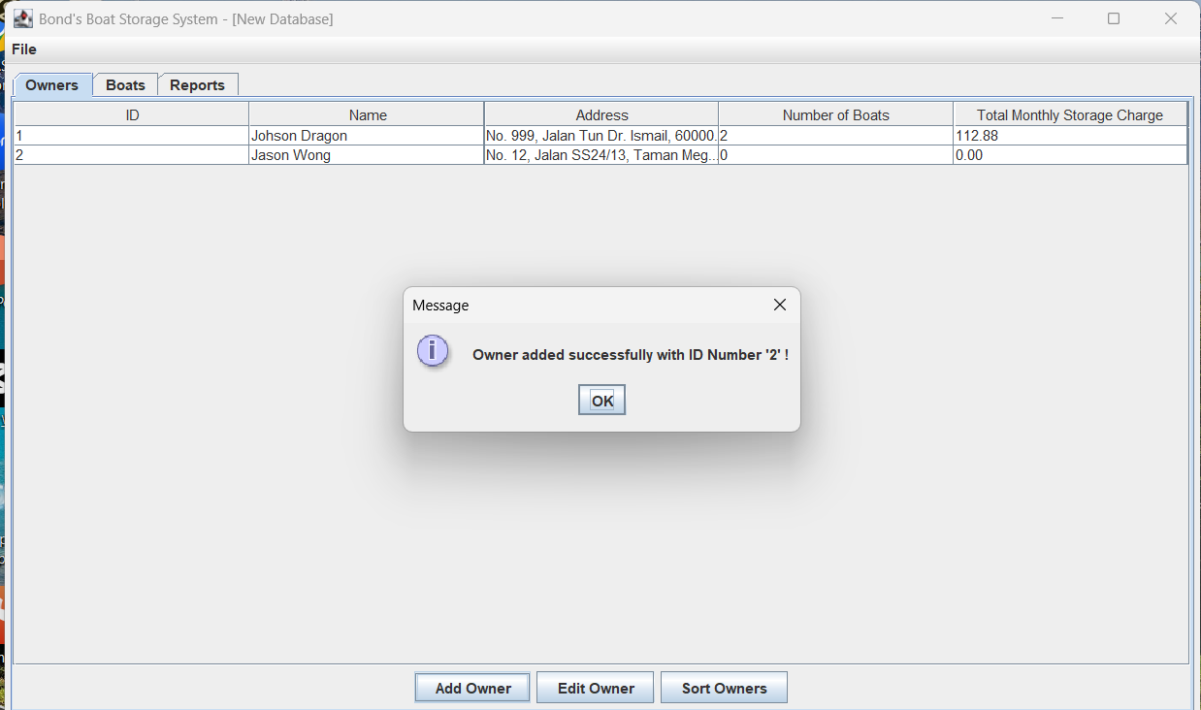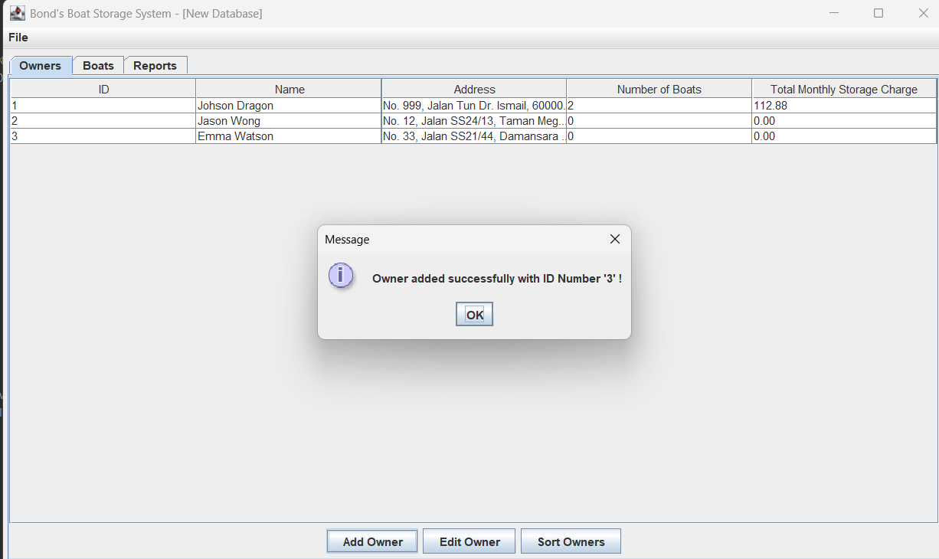

Now, user goes back to the Boats tab and tries to add more new boats to the system:
- Click the Boats tab.
- Click the Add Boat button.
- Add new boats for Jason Wong & Emma Watson in the "Add Boat" dialog.
- In the "Add Boat" dialog, they can choose between all owners that have been added previously from the owner field. Also, they can choose between SailBoat or MotorBoat for the boat type.
- Provide all valid values
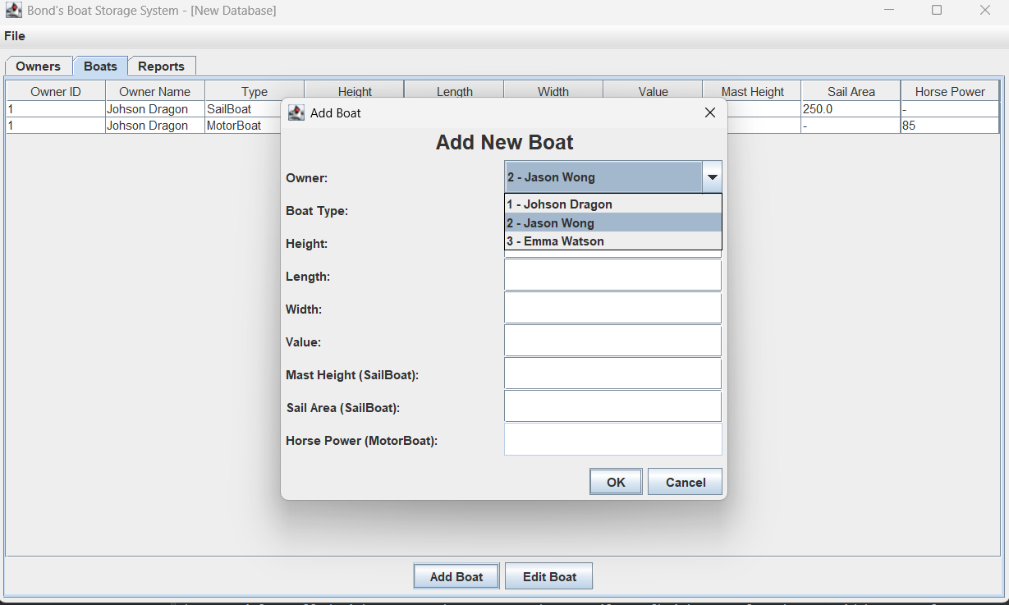
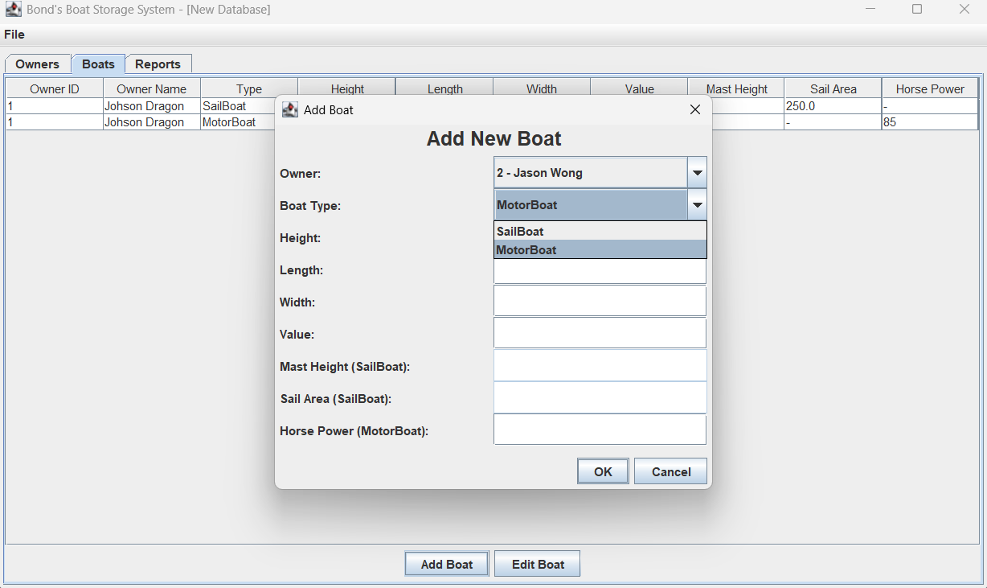

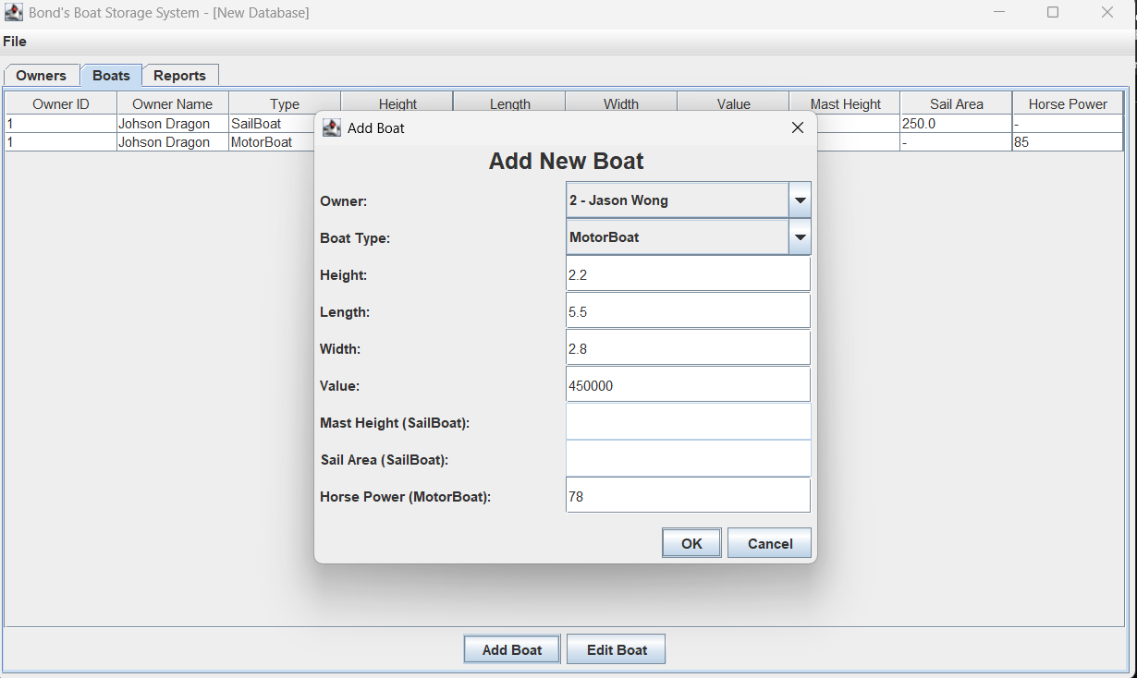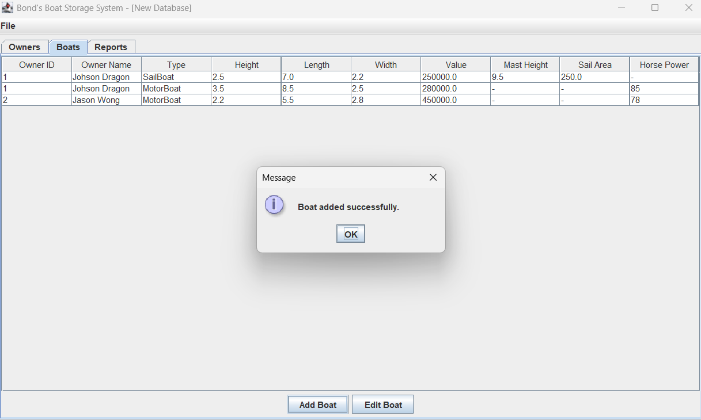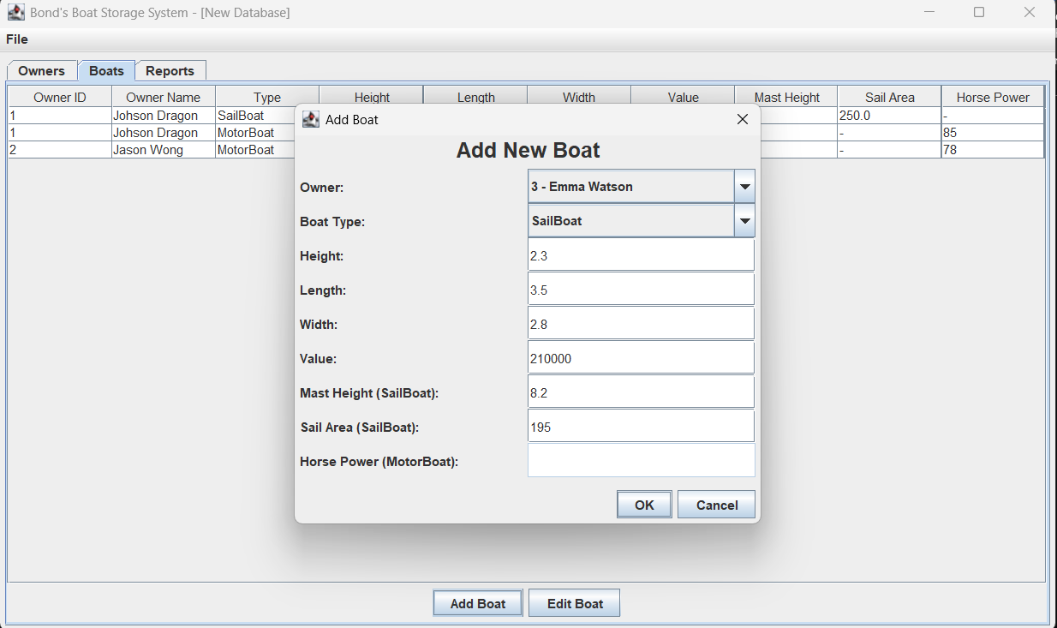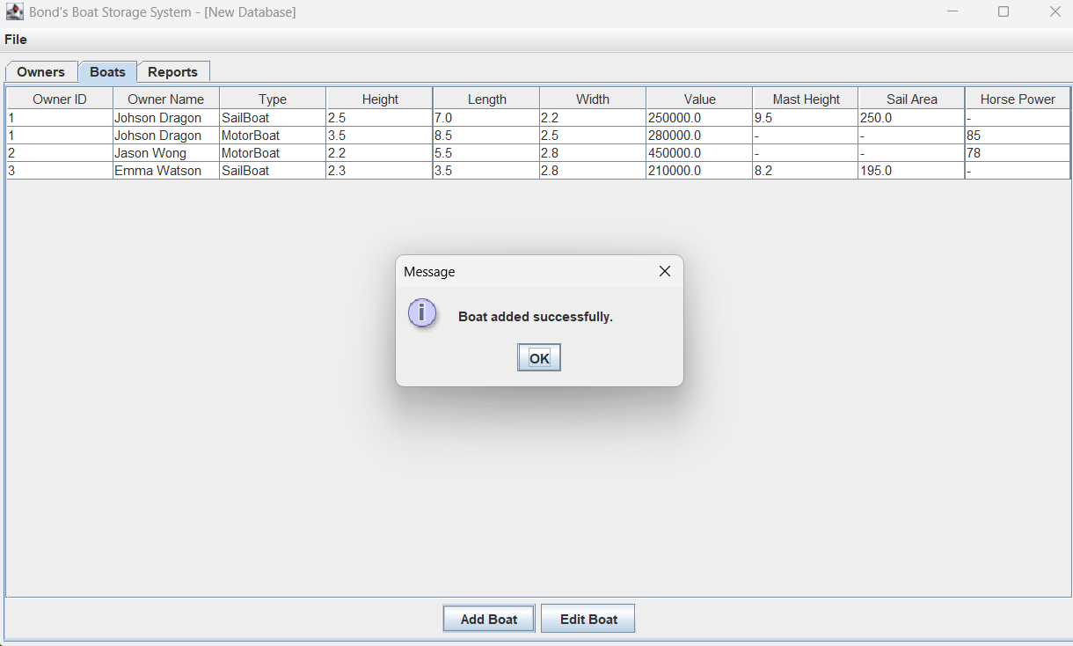

Now, user goes back to the Owners tab and clicks the "Sort Owners" button.
- If the user selects “Original Order”, the system will remain as it is (showing the original order by default).
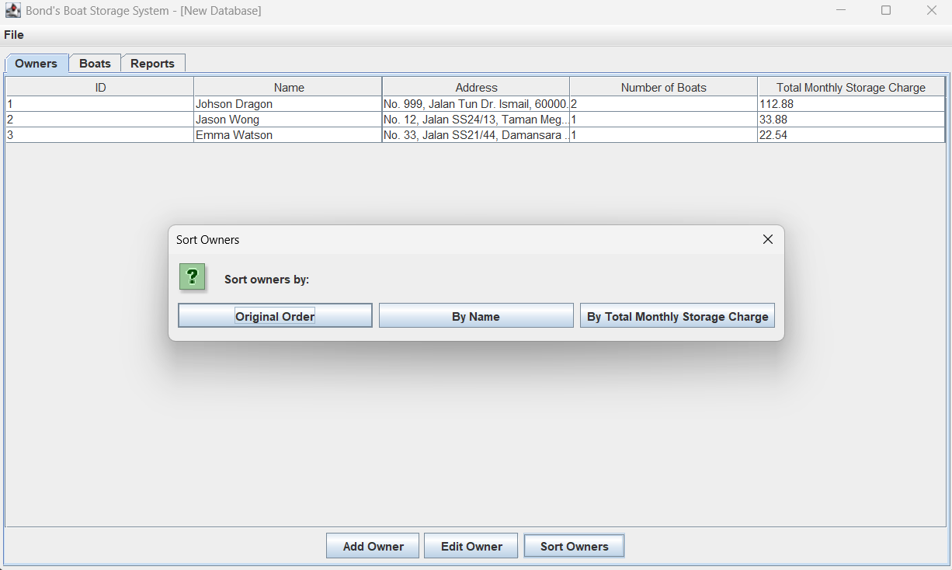
- If the user selects “By Name”, the owner table will be shown in alphabetical order (ascending). 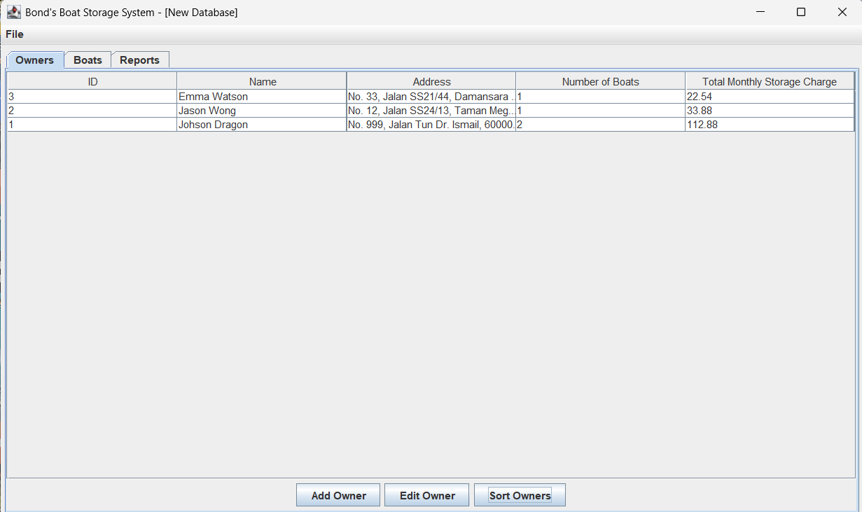

3. If the user selects “Total Monthly Storage Charge”, the owner table will be sorted in descending order (from largest to smallest) by total monthly storage charge.
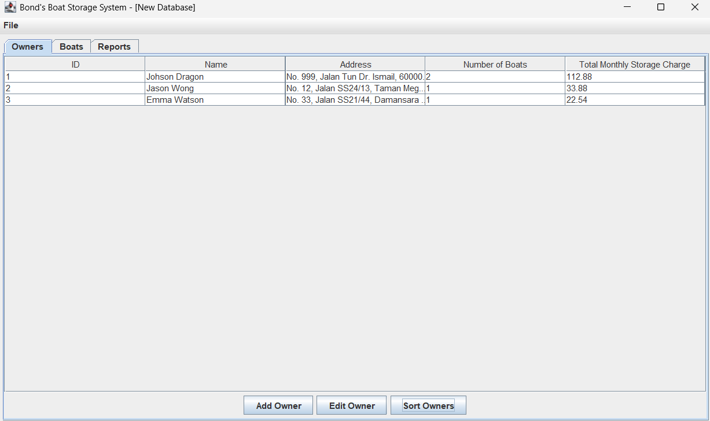

Now, switch to the “Reports” tab and click “Show Charges Summary”:
- It will show a summary display of the TOTAL storage charges, sail drying charges, fire levy charges, and insurance levies that are applicable in total to ALL boat owners for Bond’s business, based on all the data added previously.
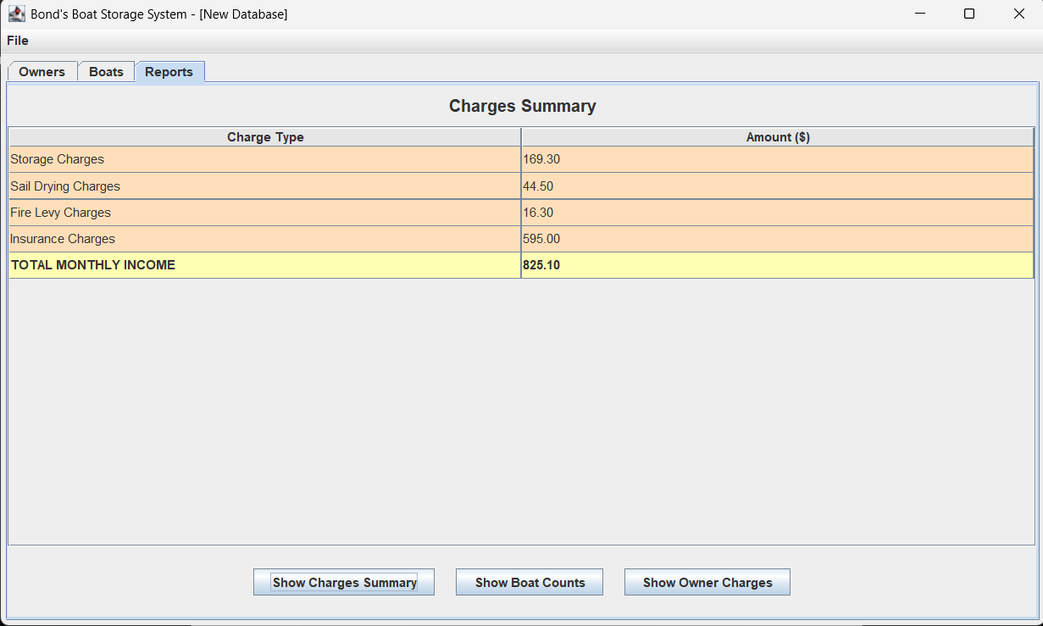
Now, switch to the “Reports” tab and click “Show Boat Counts”:
- It will show a count of the number of sail boats, a count of the number of motor boats, and the total boat count currently at Bond’s Boats Storage, based on all the data added previously.
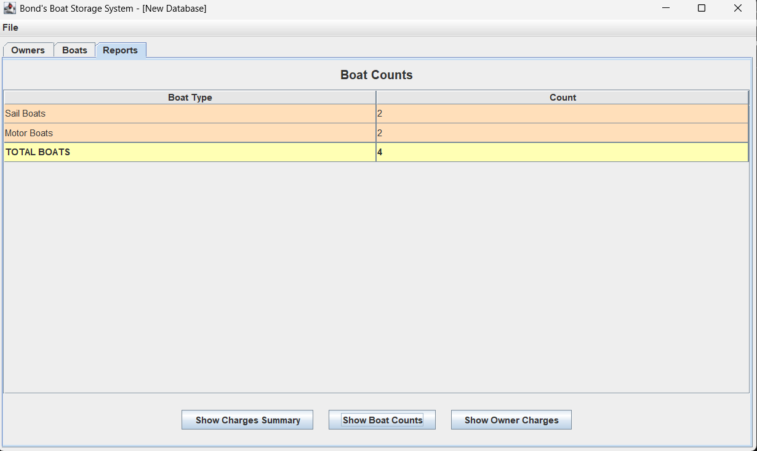

Now, switch to the “Reports” tab and click “Show Owner Charges”:
- A popup window will ask the user to enter an owner ID.
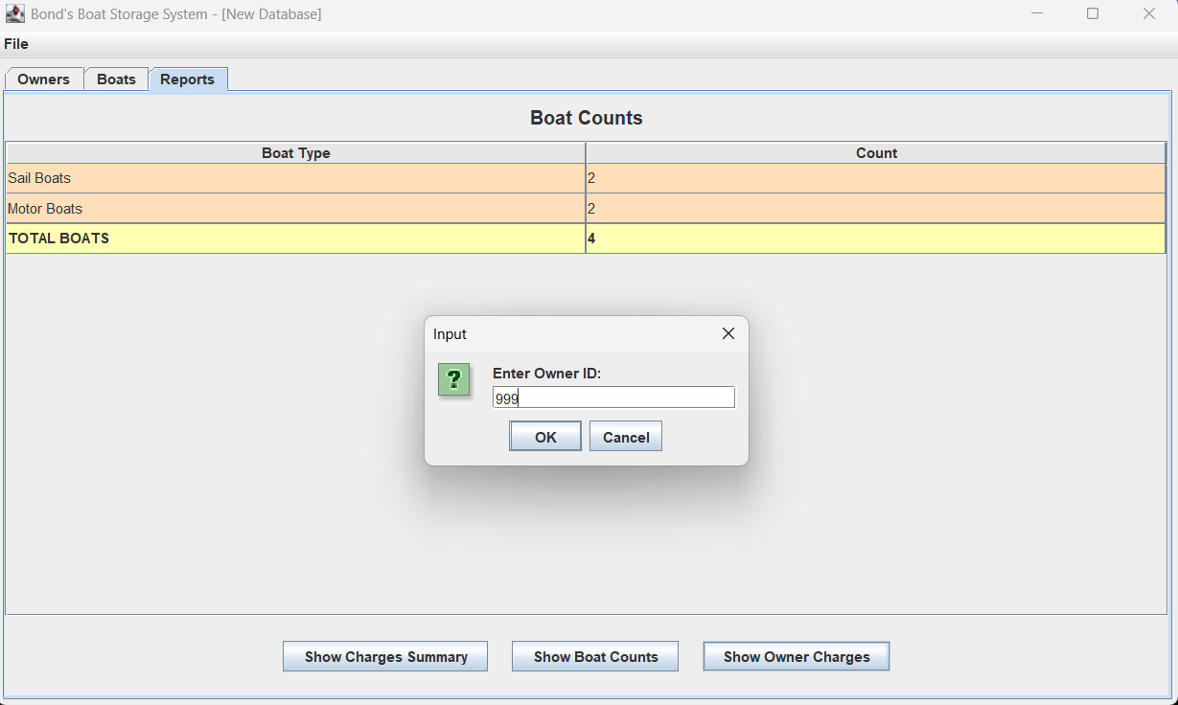
- If the given owner ID is not found, the system will prompt “Owner not found”.
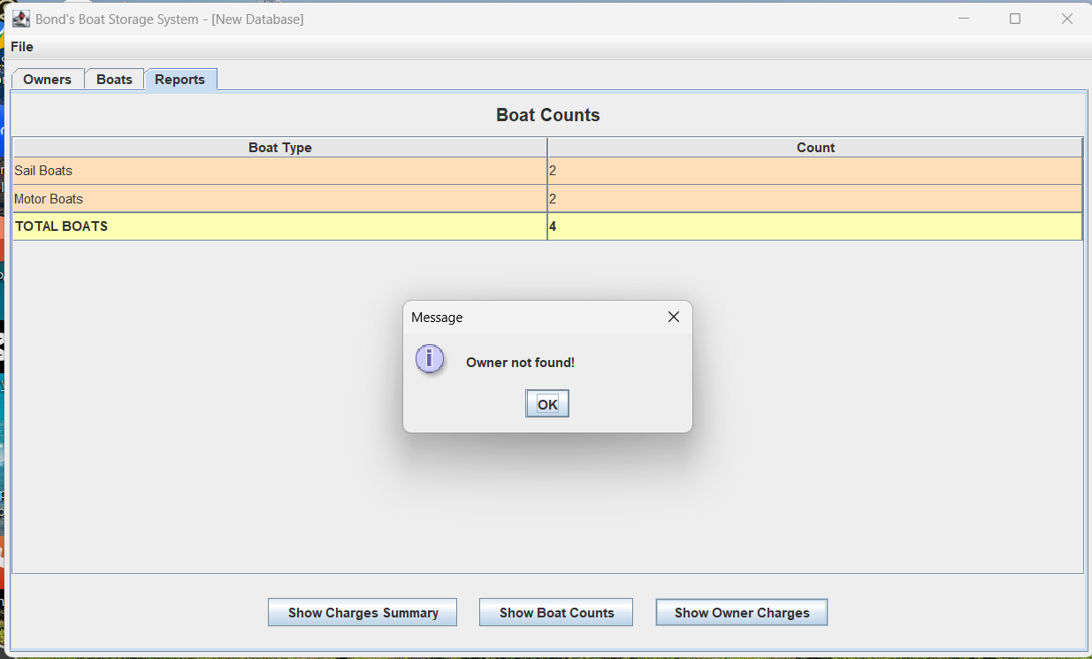

- If the owner ID is found, it will show a table displaying all types of charges for all boats belonging to the entered owner, based on all the data added previously.
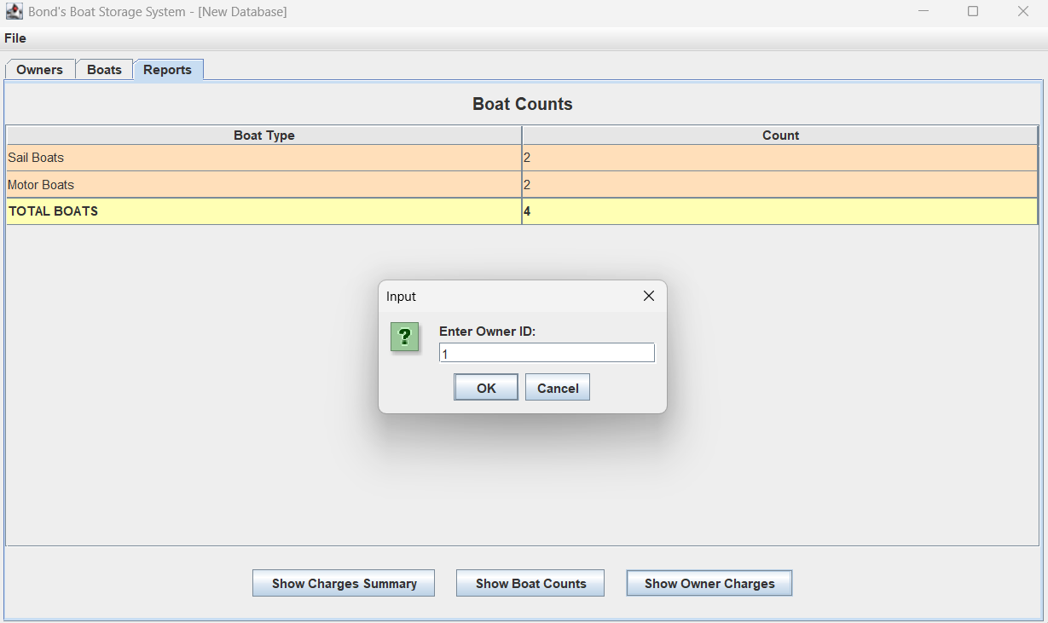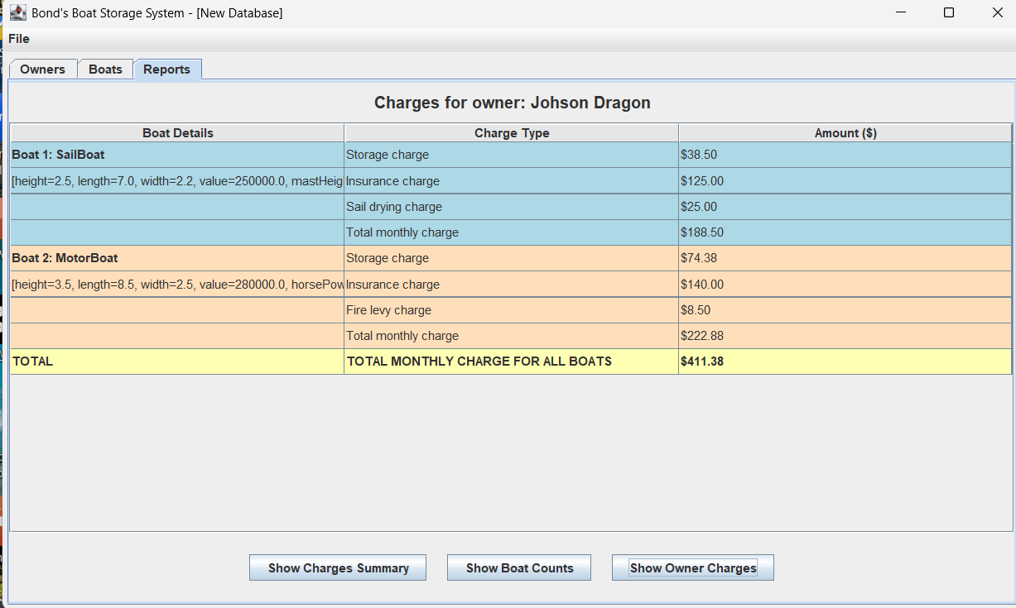

Now, the user can choose “Save As” from the File Menu to save the new database to a new file location:
- Choose the file location and enter file name for saving this database to the file.
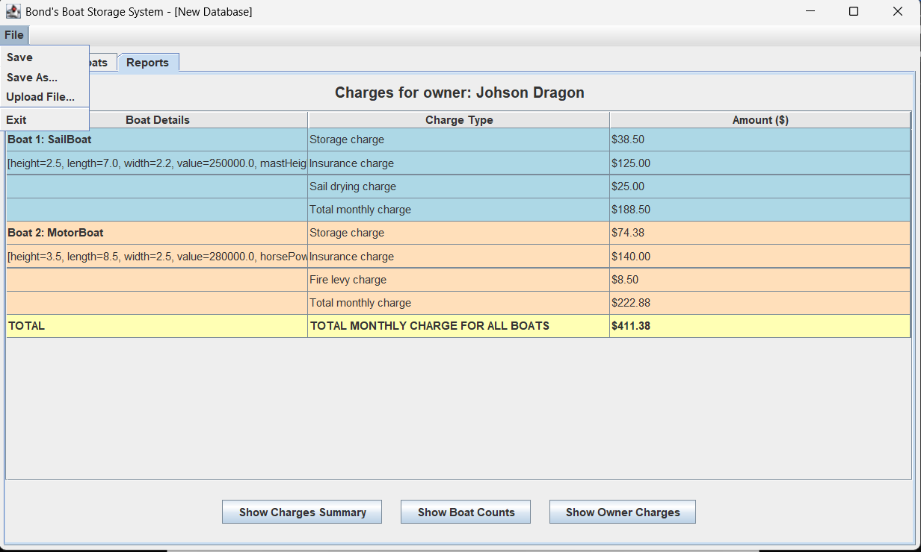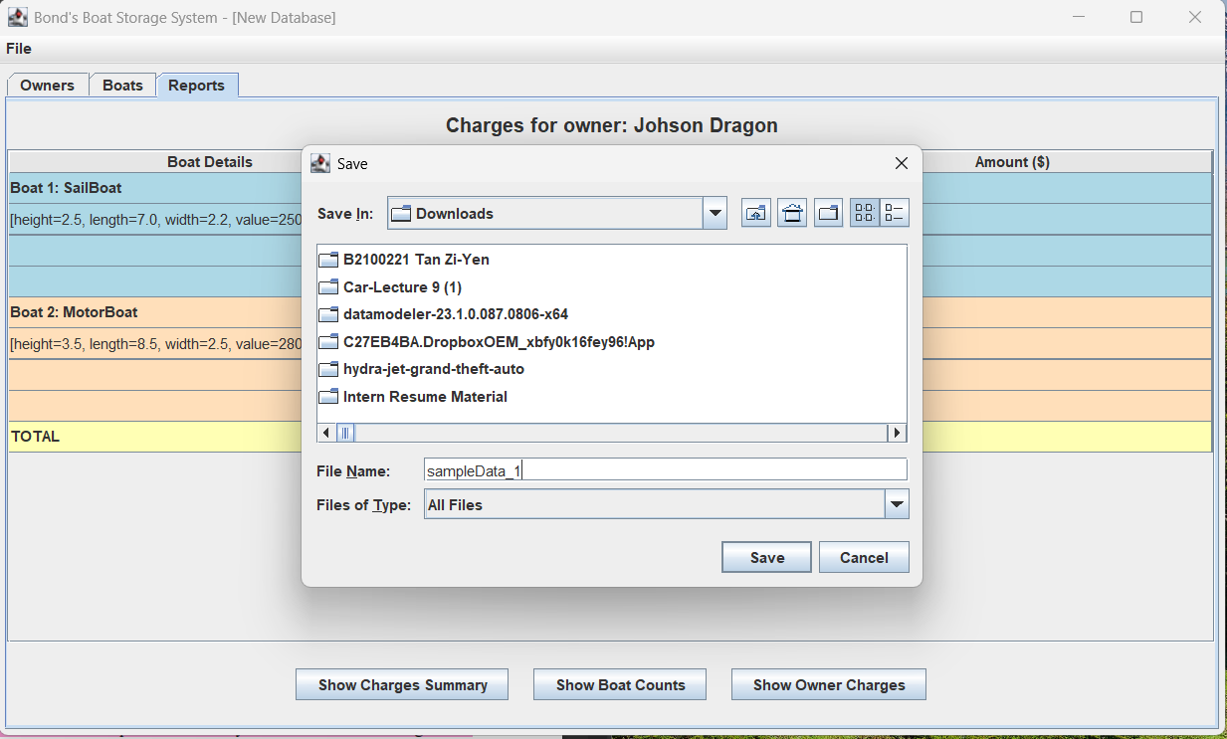
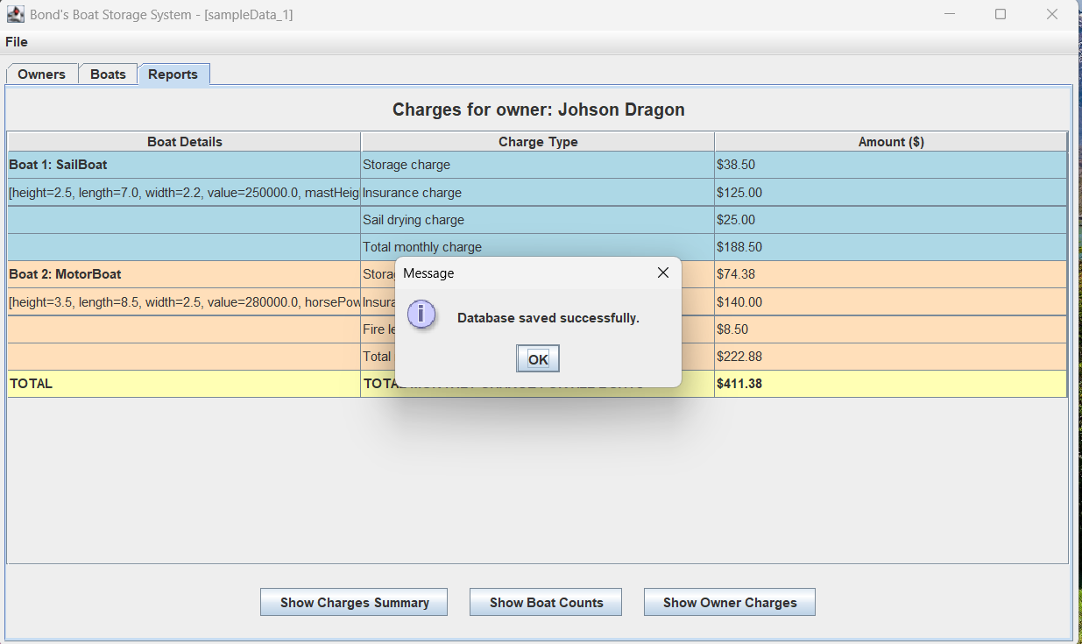

Now, load the data that just been saved into the file “sampleData_1” to system:
- Close the Java GUI program and rerun it. No data is shown currently since it is a new database.
- Choose “Upload File”, and the file chooser will appear. Find and select the file named “sampleData_1” to load all data from the previously saved file.
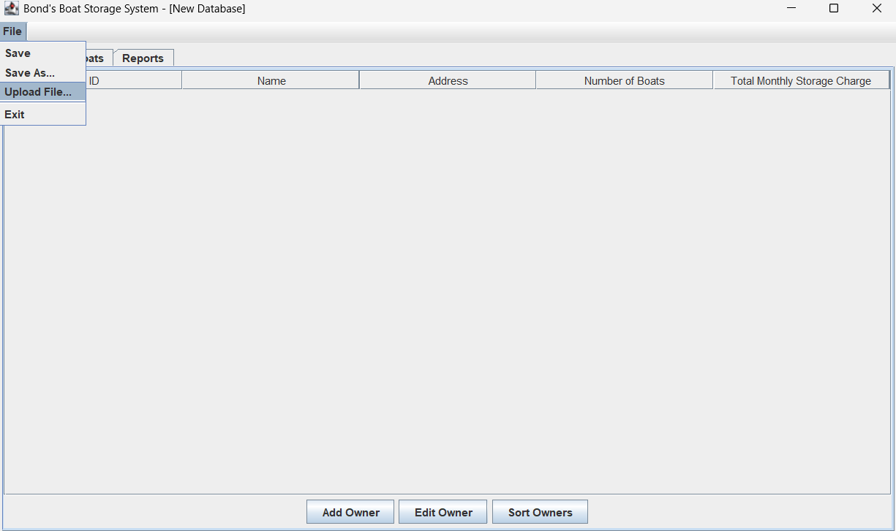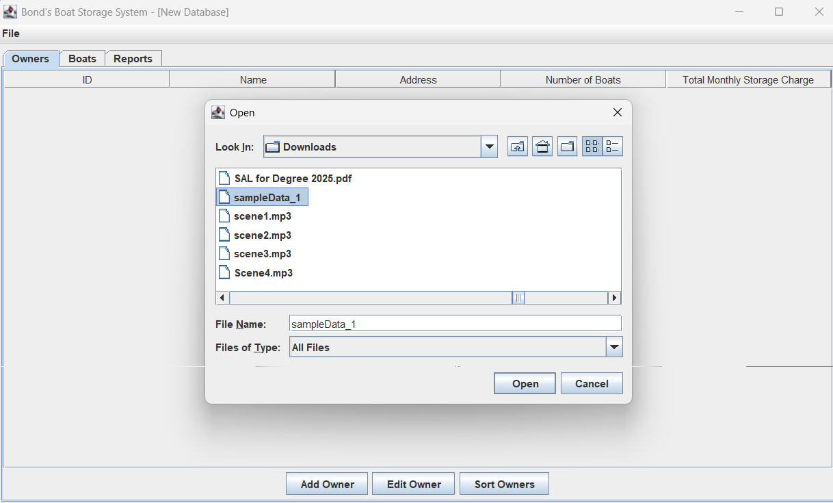

- After that, a “Database loaded successfully” message is shown, and all the data stored in the “sampleData_1” file is loaded back.
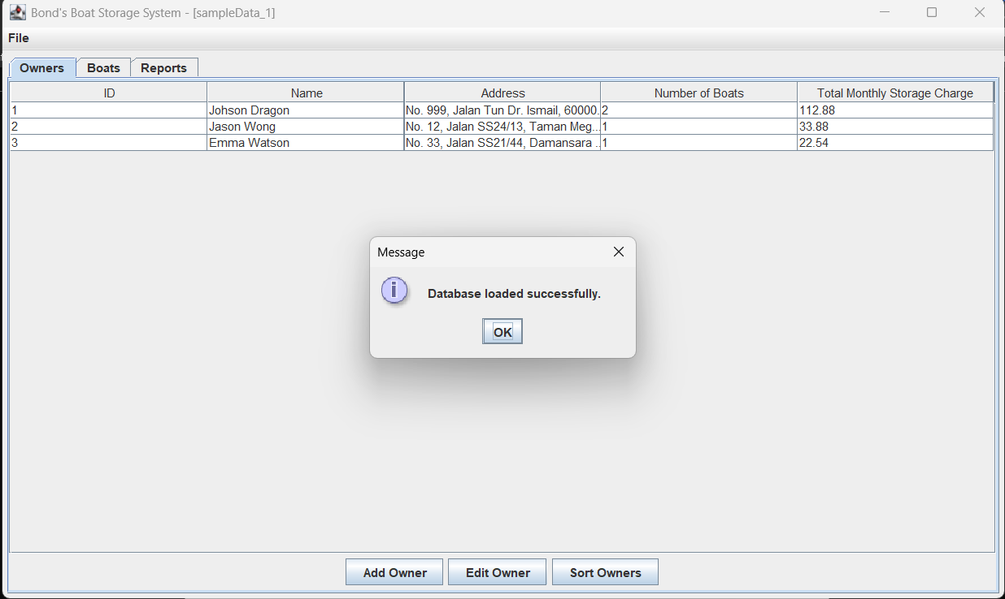

Now, try to add a new owner and add a boat for the owner.
- Add new owner 4 “Harry Potter” information.
- Then, choose File → “Save” to save all the updated data to the existing file "sampleData_1".
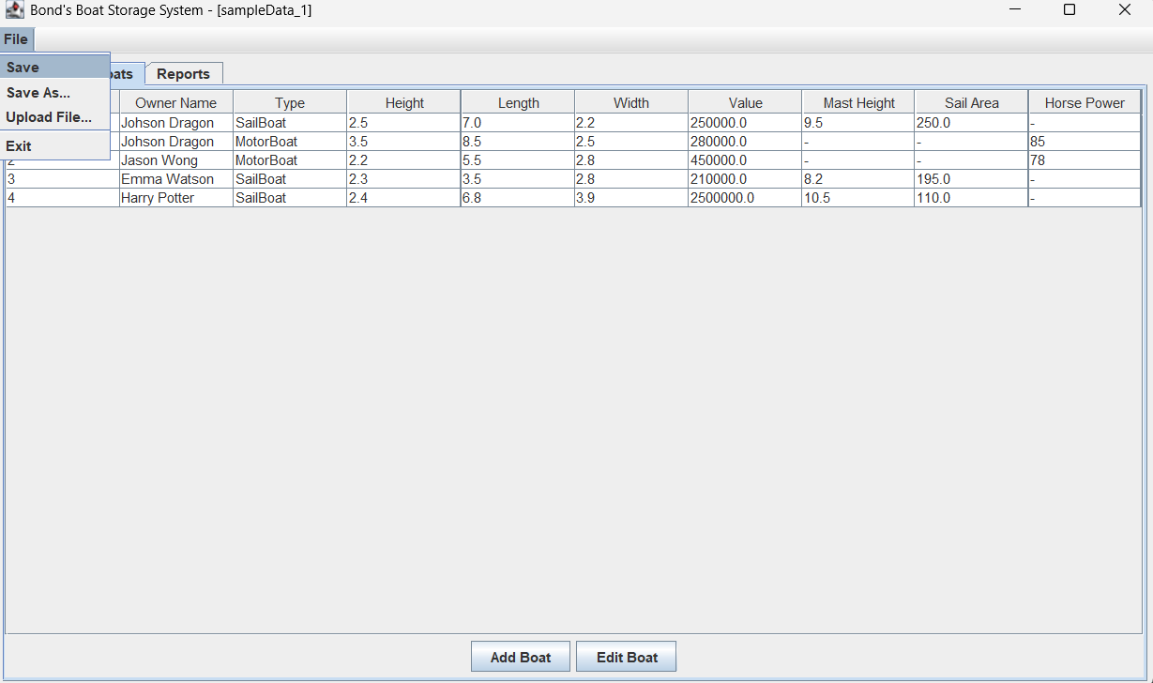
- After clicking “Save”, the system will prompt “Database saved successfully” to the existing file.
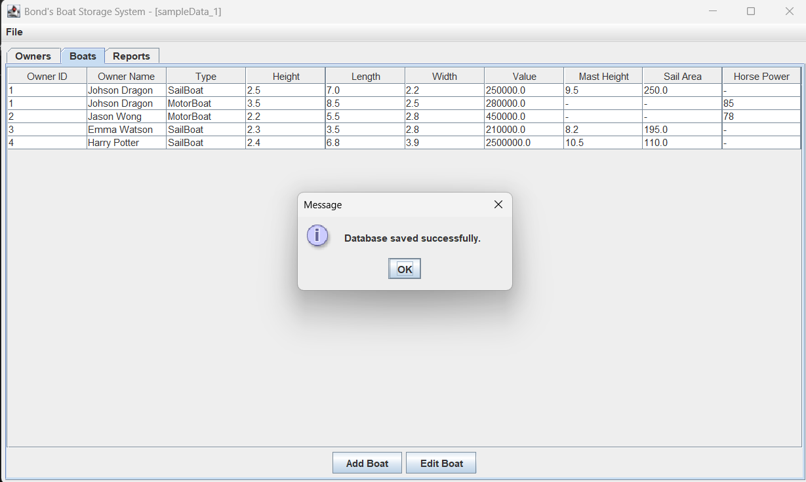

Now, close the Java GUI program again, and choose “Upload File”:
- The file chooser will appear. Find and select the file named “sampleData_1” to load all data from the previously saved file.
- Now, you can see that all newly added owners and boats are loaded back as well, meaning the data was successfully saved to the “sampleData_1” file previously. 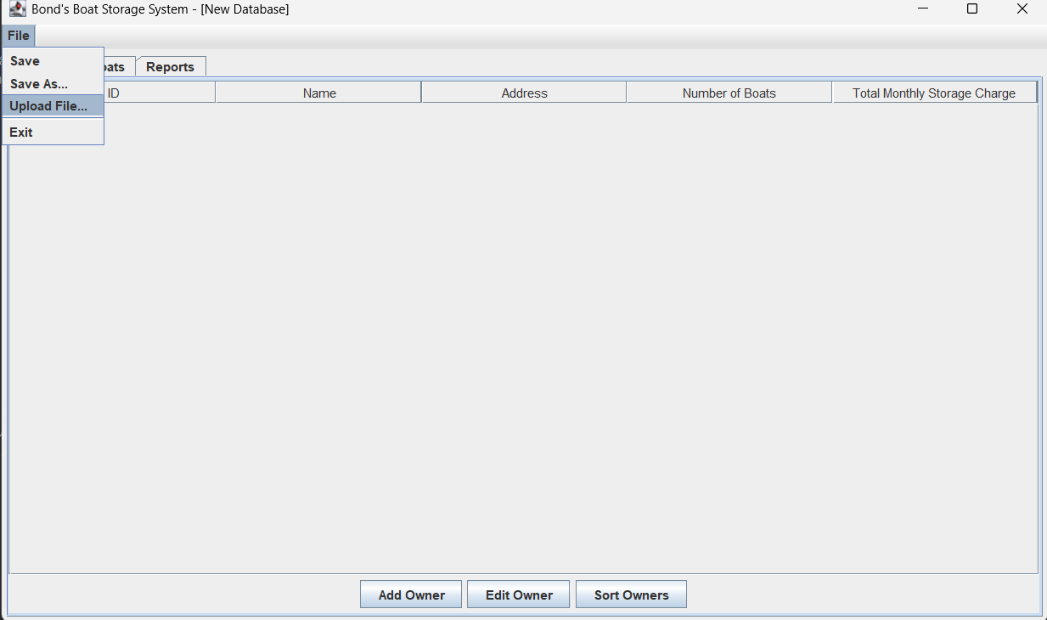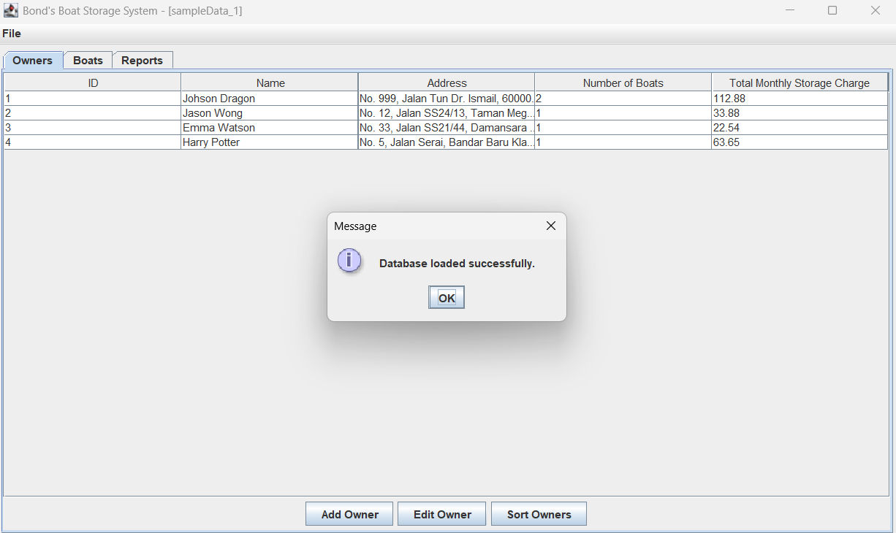

User can close the GUI program by choosing “Exit” from File menu: 