test file for paste with picture, formula and table

Table – test table

|  |  |  |  |
| --- | --- | --- | --- |
| 1 |  |  |  |

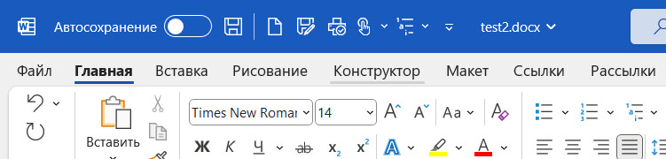

Figure 1 – test figure

<pasted_file_insert_test>

One more text