Game Design Document

Fill up the Following document

1. Write the title of your project

Army Agent Game

1. What is the goal of the game?

To find the place in which terrorist are planning bomb blast and catch terrorist and stop bomb blast.

1. Write a brief story of your game?

When he is small he watches army movies and inspired from that how army is sacrifices their life for country and I promise to myself that I will also become army agent and sacrifice my life for my country

1. Which are the playing characters of this game?

* Playing characters are the ones which respond to the user based on the input from the user
* Cars, monkeys, dinos, wizards etc, are the playing characters in the game.

|  |  |  |
| --- | --- | --- |
| Number | Character Name | What can this character do? |
| 1 | Undercover agent | He will solve the unscramble words to scramble wrds |
|  |  |  |
|  |  |  |
|  |  |  |
|  |  |  |
|  |  |  |
|  |  |  |
|  |  |  |

1. Which are the Non Playing Characters of this game?

* Non Playing characters are the ones which don't have an action or a behaviour when the user interacts with the game.
* Hurdles, stones, bananas, coins, etc are non playing characters in the game.

|  |  |  |
| --- | --- | --- |
| Number | Character Name | What can this character do? |
| 1 | terrorist | He will plant the bomb |
| 2 | Army chief | He will give us the task |
|  |  |  |
|  |  |  |
|  |  |  |
|  |  |  |
|  |  |  |
|  |  |  |

Draw your imagination of this game. What does this game look like?

* Draw the game either on your computer or on paper,
* Add images of scenes of the game to show each of the playing and non-playing characters at least once.

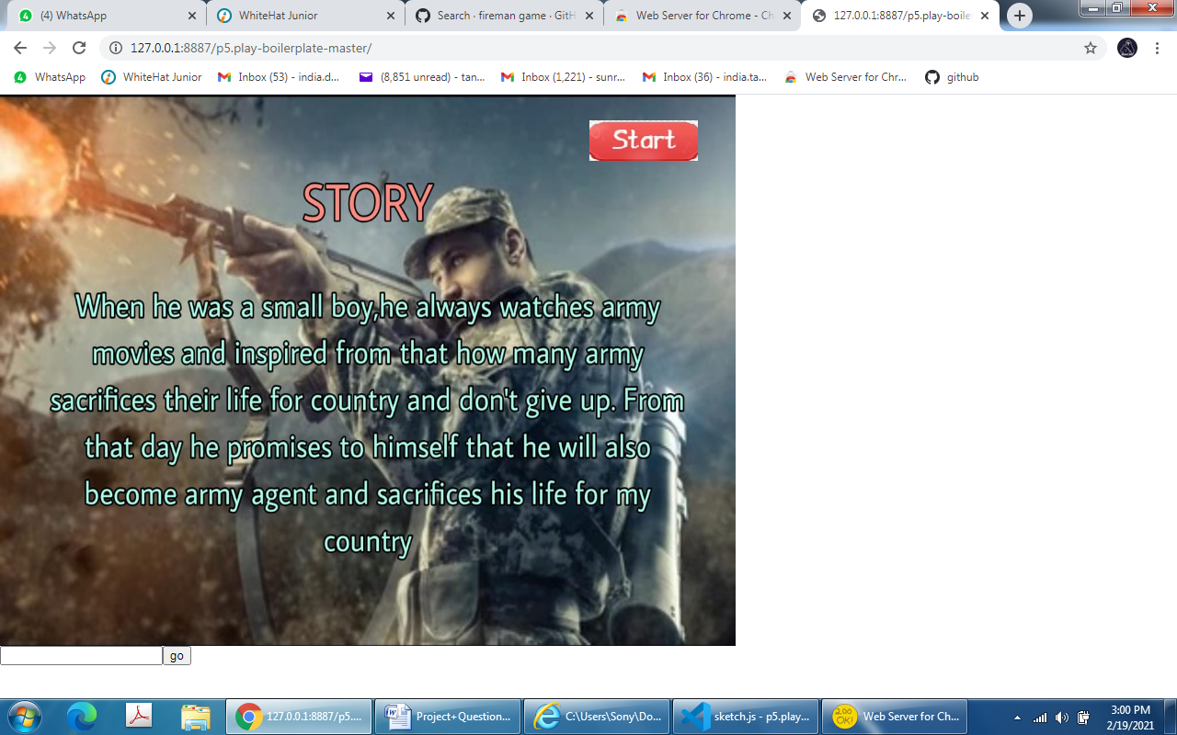

How do you plan to make your game engaging?

Answer After every mission the place of bomb blast will increase to solve, By every missions your post will also increase, you have also time to solve the mission and if you can’t do it in time the post will decrease