Assignment 1: Dimensionality Reduction and Visualization

Due: September 23 2015 11:59PM

Three datasets (Iris, Cho, Iyer) can be found on Piazza.

In this project, you will use existing Principle Components Analysis (PCA) software to project high-dimensional data to 2 dimensions, and plot the 2-dimensional data points.

Please take the following steps:

1. Choose your preferred programming language(s), and search for the software that conducts PCA and draws scatter plots.

2. Apply PCA on the Iris dataset and get the two-dimensional data points. Draw them in a scatter plot. Compare the scatter plot with the given plot below and see if you get the plot correctly.

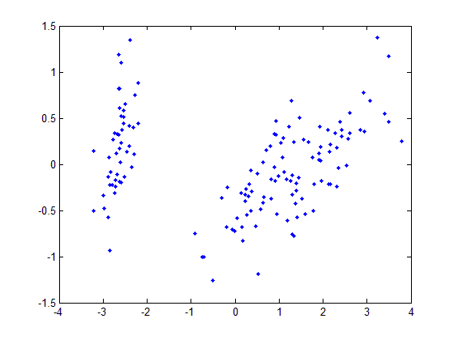
Iris Data
3. If Step 2 works fine, then apply PCA on the Cho and Iyer datasets and draw a scatter plot for each dataset using the same procedure discussed in Step 2.

4. Prepare your submission. Your final submission should be a zip file named as First Name_Last Name.zip (e.g., Jing_Gao.zip). In the zip file, you should include:
- A folder “Code”, which contains all the codes used in this project. Inside the folder, please have a file “README” which describes how to run your code.
- Report: A doc or pdf file named as First Name_Last Name.doc or First Name_Last Name.pdf The report should consist of the following parts: 1) The two scatter plots. Please label them properly by the dataset names and have tick marks along both axes in each plot. 2) The core codes of applying PCA and drawing the plots.

5. Log in any CSE department server and submit your zip file as follows:
submit_cse469 Jing_Gao.zip
(replace “Jing_Gao” by your name)

Please refer to Course Syllabus for late submission policy. We will take the submission time recorded by the server as the time of your submission.

This assignment must be done independently. Running your submitted code should be able to reproduce the plots in the report. Note that copying code/report from another group or source is not allowed and may result in an F in the grades of all the team members. Academic integrity policy can be found at http://www.cse.buffalo.edu/shared/policies/academic.php

