

American International University-Bangladesh (AIUB)  
**Department of Computer Science  
Faculty of Science &Technology (FST)  
Fall 19_2020**

**Tuition Management System**

Sec: **C**

A software Engineering project submitted

By

ABRAR, M. AUMLANUL (17-34206-1)

SAIMON, MD. ZILLUR RAHMAN (17-34006-1)

POLLOB, MAHBUBUR RAHMAN (17-33983-1)

TANIA RAHMAN (17-33841-1)

The project will be evaluated for the following Course Outcomes

|  |  |
| --- | --- |
| CO3: Choose appropriate software engineering model in a software development environment | Total Marks |
|  |
| Content Knowledge [5Marks] |  |
| Argumentation [5Marks] |  |
| Evidence of Argumentation [5Marks] |  |
| Completeness, Spelling, grammar and Organization of the Answer [5Marks] |  |
|  | |
| CO4: Explain the roles and their responsibilities in the software project management activities | Total Marks |
|  |
| Project Background Analysis [5Marks] |  |
| Project Role identification [5Marks] |  |
| Responsibility Description [5Marks] |  |
| Completeness, Spelling, grammar and Organization of the Answer [5Marks] |  |

Table of Contents

**Serial Table of Content Page Number**

1. Problem Domain

Background to the Problem …………………………………………………………………………………………………….4

Proposed Solution …………………………………………………………………………………………………….……………4

1. Solution Description

System Feature …………………………………………………………………………………….…………………………………5

1. UML Diagram

Scenario ………………………………………………………………………………………………………………….………………5

Activity Diagram ……………………………………………………………………………………..………………………………6

Use Case Diagram ……………………………………………………………………………..……………………………………7

ER Diagram …………………………………………………………………………………………………..…………………………7

Class Diagram …………………………………………………………………………………..………….…………………………8

1. Process Model ……………………………………………………………………………….……………….………………………9
2. Project Role and Responsibilities …………………………………………………….………………………………………9
3. Estimation …………………………………………………………………………………………………………….………………10
4. Scheduling ………………………………………………………………………………………………………….…………………11
5. Conclusion ……………………………………………………………………………………………………………….……………12

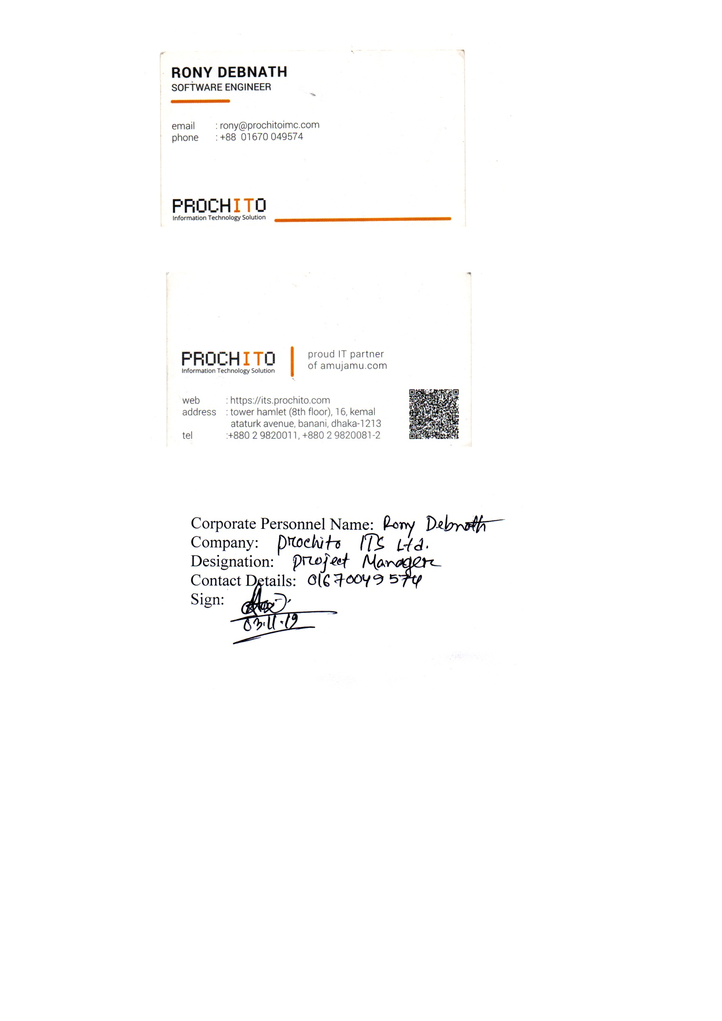

1. **PROBLEM DOMAIN**

**1.1 Background to the Problem**

One-to-one tuition is proven to be one of the best ways to improve grades. And grades are directly linked to life chances and career progression. But until now, tuition has been out of reach for most families – it was too expensive, availability was low, or it relied on living near a good tutor.

1. Hard to find a Tuition.

2. Hard to find a quality tutor.

3. Tutors get problem with the payment.

Root cause: There is no Way /method to verify a quality tutor and Guardian.

Parents don’t find a quality /experienced tutor for their children’s.

Tutor don’t get paid in time or being sacked without any reason.

That is why it is so important to consider

**1.2 Proposed Solution**

We have a idea to solve this entire Tuition System. We will create a software Main objective of our software is make a healthy relationship between parents and tutor .Our software ensure the payment verification so the tutor won’t get any problems with the payment.

Our software will verify the tutors Education Background and tuition Experience .That’s how parents can find the perfect tutor for their children.

1. **SOLUTION DESCRIPTION**

**2.1 System Features**

The project provides the following feature for the users:

There will be three users one is admin another is Tutor rest one is Guardian

All the users must have to register.

· All the data entry will be made by form.

· System will provide to change or edit entered values.

· Maintain record in short time of period.

· System will allocate the Search Result.

1. **UML Diagrams**

**Scenario:** In the Tuition Management System a Parent can find Tutor for their children and a tutor can find his/her desired tuition. At first, Guardian have to sign up with their Children’s educational details. Then they can search tutor based on their area, salary, and subject and tutor experience. System will show the tutor list based on the search. Guardian give request to the tutor and if tutor accepts then the tuition will begin. Tutor have to sign up with their real information. Tutor can also search tuition based on their experience, salary, and subject and tuition area. At the end of the month, Guardian will pay the tuition fee through Digital Payment. Guardian and Tutor both have to have Digital Payment System.

**Activity Diagram:**

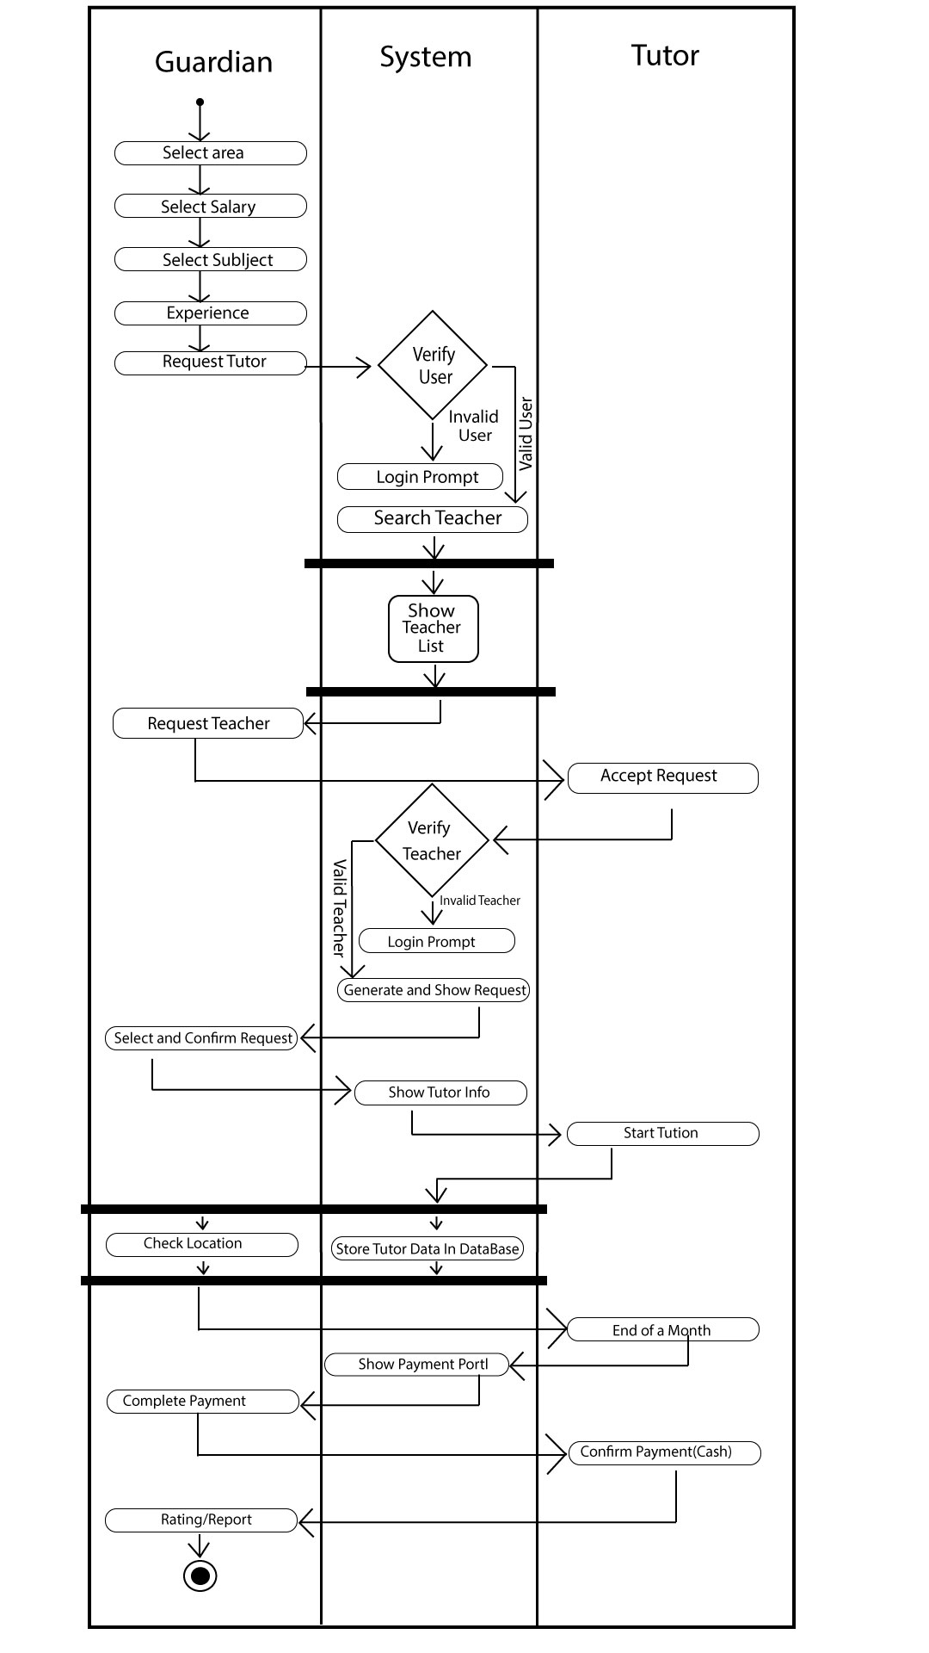

**Use Case Diagram:**

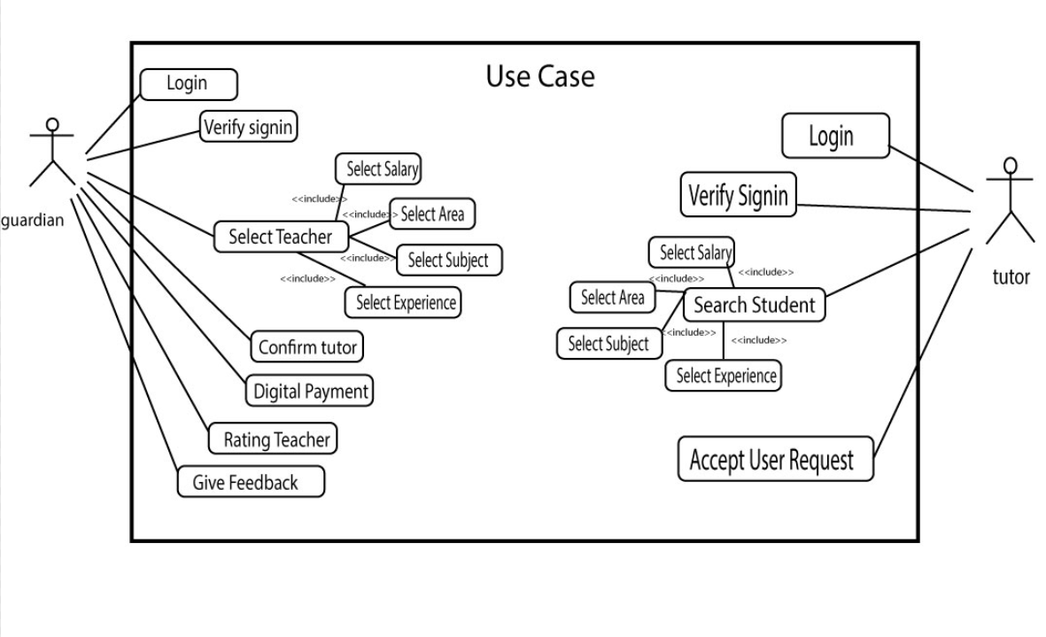

**ER Diagram:**

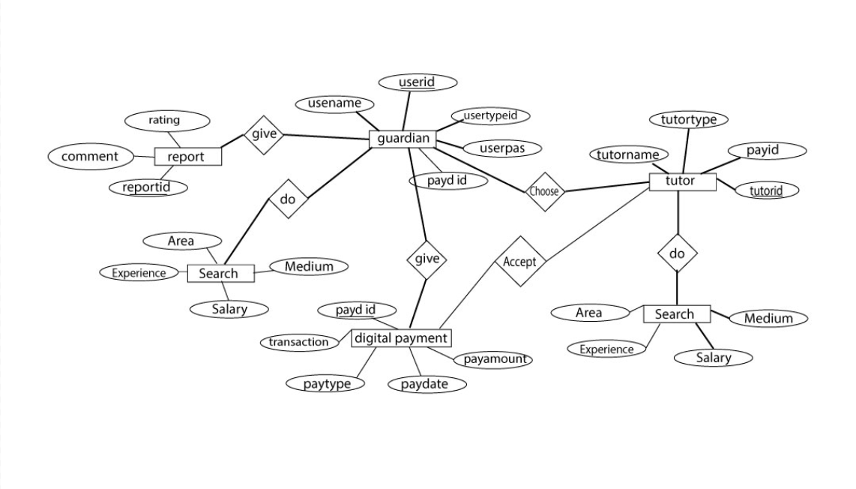

**Class Diagram:**

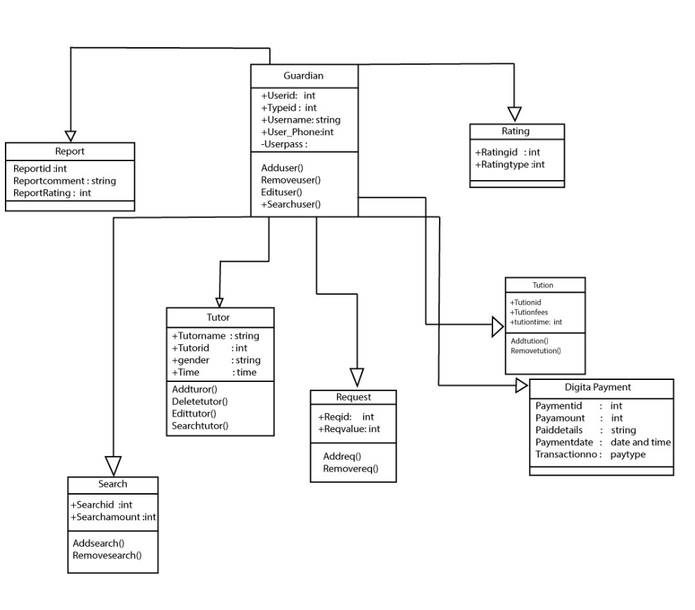

1. **SOFTWARE DEVELOPMENTLIFE CYCLE**

**3.1 Process Model:**

Waterfall Model

1. This model is used only when the requirements are very well known, clear and fixed.

2. Product definition is stable.

3. Technology is understood.

4. There are no ambiguous requirements

5. Ample resources with required expertise are available freely

6. The project is short.

In Our Project, very less customer interaction is involved during the development of the product. Once the product is ready then only it can be demonstrated to the end users.

Once the product is developed and if any failure occurs then the cost of fixing such issues are very high, because we need to update everything from document till the logic.

That’s Why we choose Waterfall Software Development Model.

**5. Project Role Identification and Responsibilities**

1. **Requirement analysis**

The first phase is about collecting information that pertains to the project’s requirements. The purpose of the product and its function is defined. Conducting [brainstorming sessions](https://zenkit.com/en/blog/how-to-find-the-right-brainstorm-methods-for-your-team/) are a common way to ensure the scope and requirements are understood by everyone on the team.

**2. System Design**

This next phase involves creating the design according to the requirements of the first phase. The purpose of this phase is to select hardware and system requirements, and to also make clear of the overall system architecture.

**3. Implementation**

This phase is where the programs, which are known as units, are first developed. They are individually developed and tested for their functionality, a process that is known as Unit Testing. They are then integrated into the following phase.

1. **System testing**

By this phase, the software has been designed and needs to go through testing to determine any errors or issues. The testing phase of Waterfall project management is imperative as it can ensure the customer is not confronted by any difficulties

1. **System Deployment**

Once the product has been tested, it is then distributed into the customer environment.

1. **Maintenance:**

The final phase happens after installation. The maintenance phase involves making adjustments to the system to improve performance. The modifications are per the requests from the customer or any faults detected during the live use of the product.

**6. Effort Estimation:**

User Interface = 2000 LOC

Database Connection = 500 LOC

Logic Expression = 2500 LOC

Build Function = 3000 LOC

Total =8 000 LOC

Our project is a Semi-detached type of project. So the values will be follows

Project complexity, p = 1.12

SLOC depend connection, T =0.35

Coefficient<Effort Factor>=3.0

SLOC = 9000

**Effort** = PM = Coefficient *(SLOC/1000) ^P

=2.5*(8000/1000) ^1.12

=25.66

**Development Time**

= DM = 2.5*(PM) ^T

=2.50*(35.15) ^0.35

=7.78

**Required number of people**

= ST = PM/DM = 25.66/7.78

= 3.298

=4 person

1. **Scheduling**

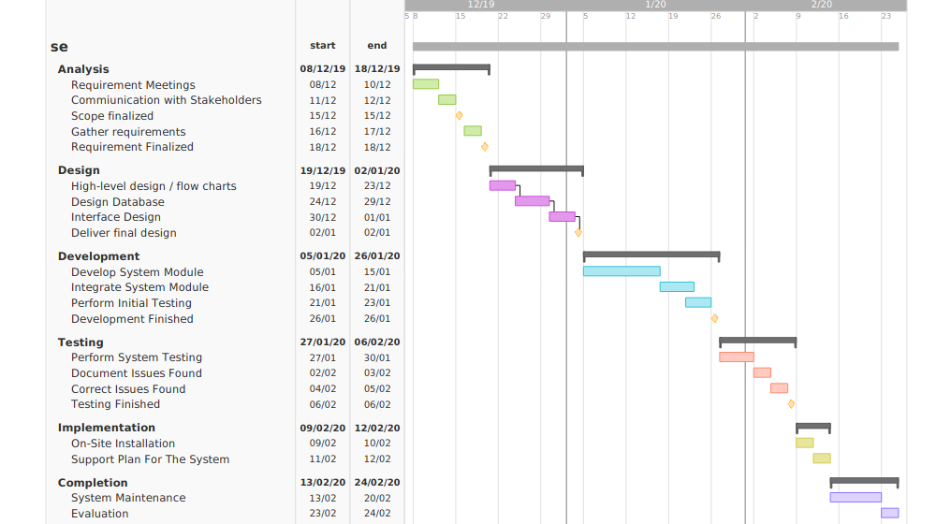

1. **Conclusion:**

We have discussed about all the possible ways to implement the software. We estimated a time for the software build. We have also discussed about the model by which we can make the software and all the risk management.