Azure_databricks:
Creating compute:
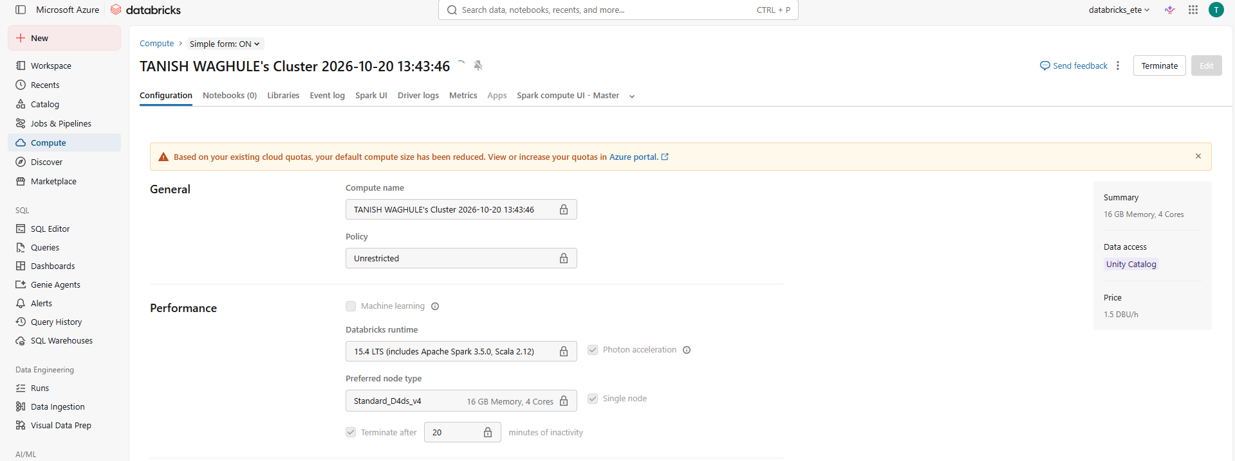
Data autoload:
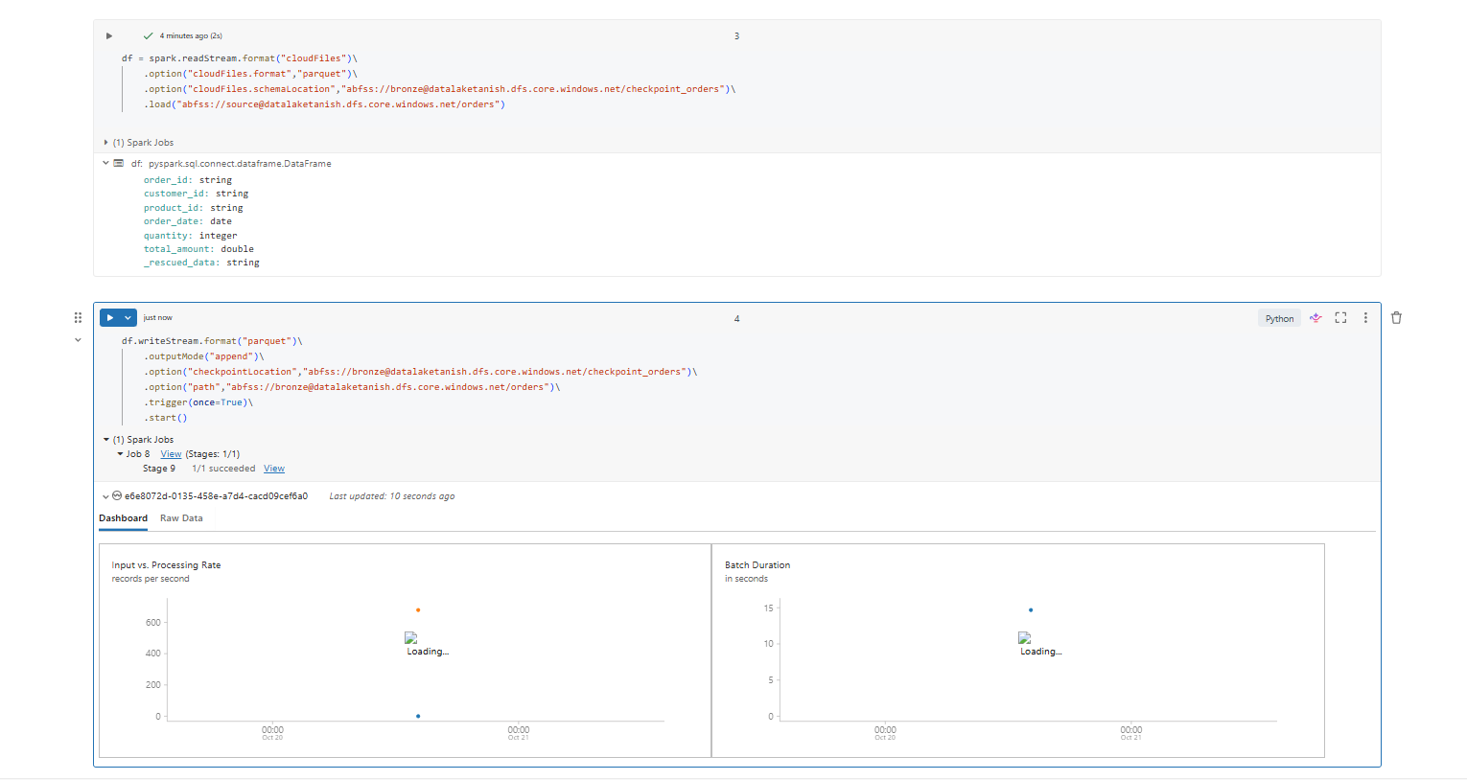
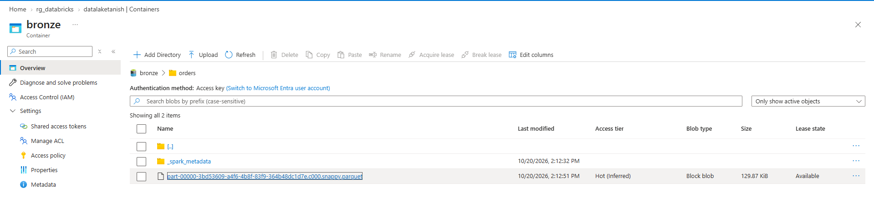
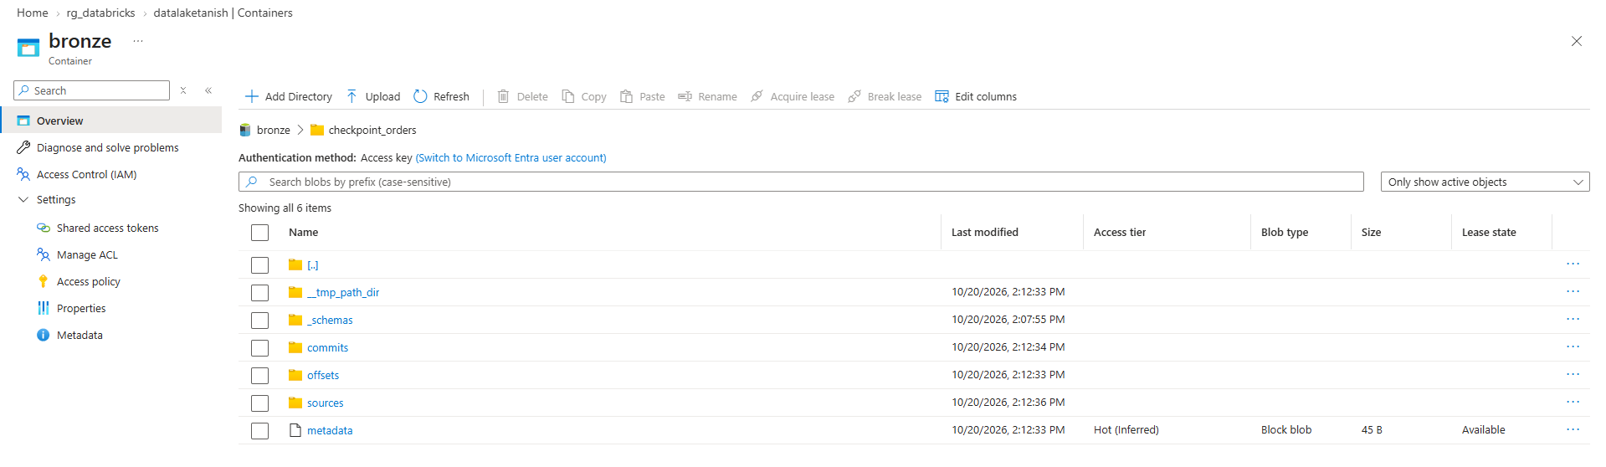

Next day new data cam upload it to source :
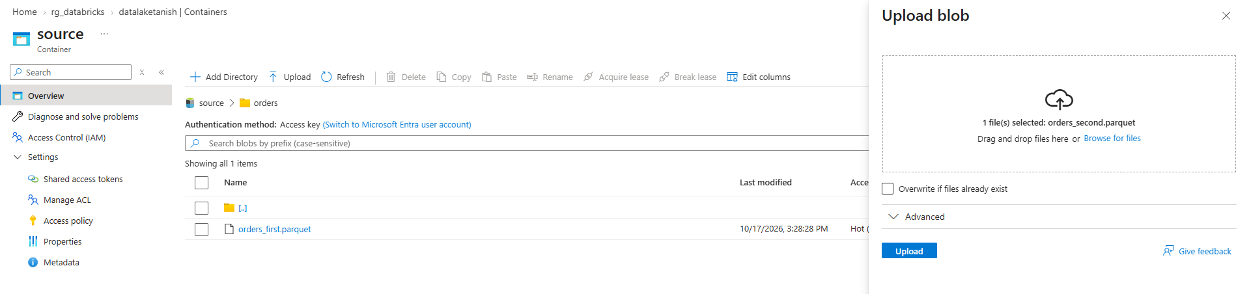

Again run the read/write stream cells and we can see more 10 records it were 9990 now it became 10000:
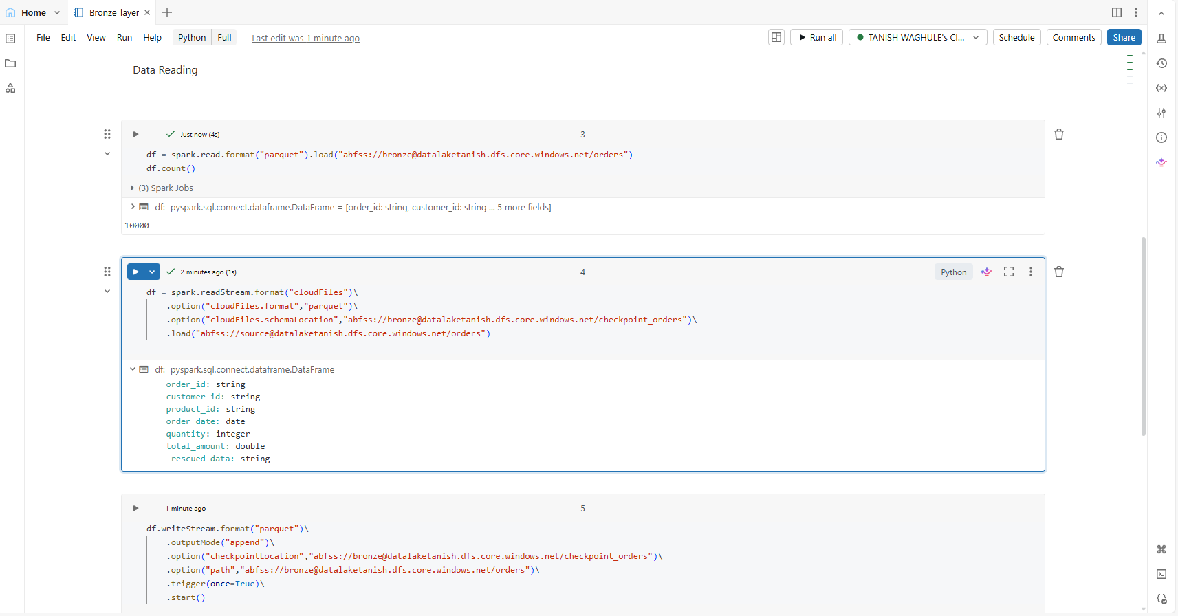
Only new data is processed bcoz of roxdb
We did it for orders now we will make it dynamic as we also have customers , products … in irl we will be having many such so we have to make it dynamic ..
So we will create parameters .. at start of note book :
Databricks widgets are interactive UI controls that allow you to pass dynamic parameters into your notebooks, queries, and dashboards
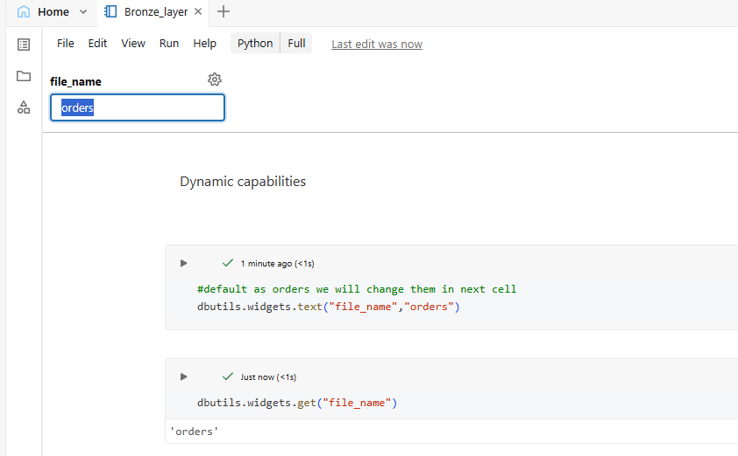
We can change the values here in box other than orders ..
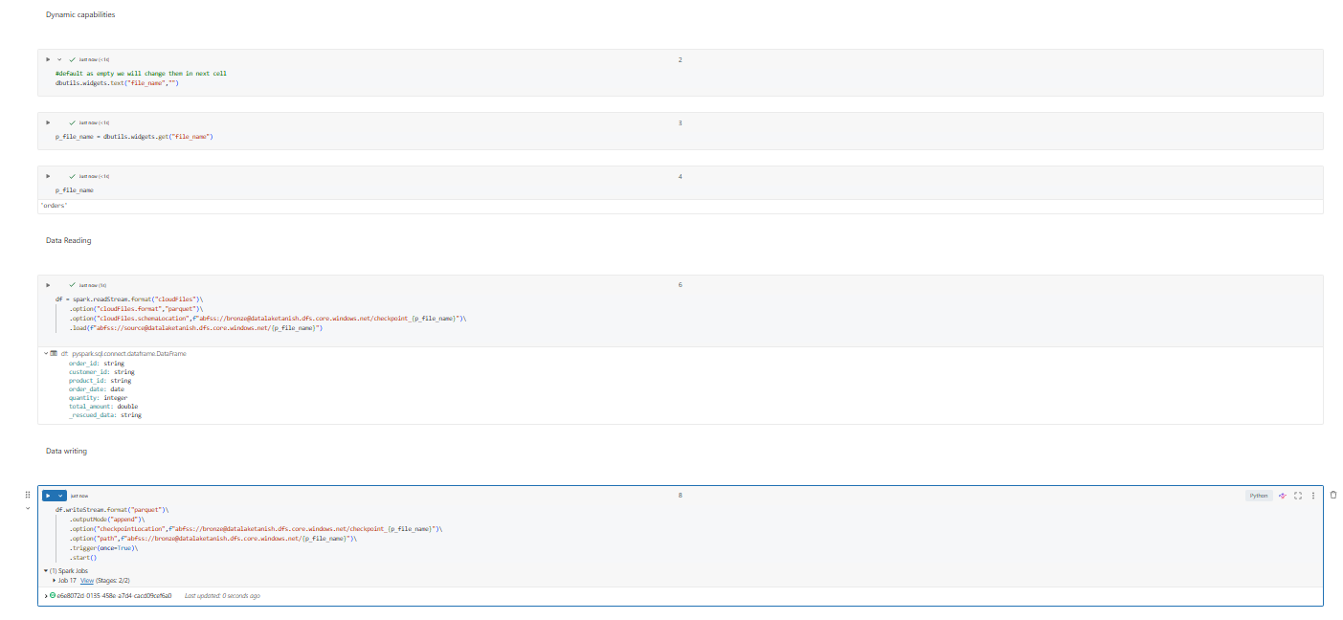
Pass other parameters now and run all :
with the help of job:
