Deep Q-Network Based Reinforcement Learning for Autonomous Lunar Lander Control

Abstract
Reinforcement Learning (RL) has emerged as an effective paradigm for solving sequential decision‑making problems in dynamic environments. Deep Q‑Networks (DQN) combine deep neural networks with Q‑learning to approximate optimal action‑value functions.
This study presents a Deep Q‑Network approach for solving the LunarLander‑v3 control task using the Gymnasium environment. The objective of the agent is to land safely between designated flags while minimizing fuel consumption and avoiding crashes.
The system uses a neural network with multiple fully connected layers to estimate Q‑values. Experience replay and target networks are used to stabilize training.
Results show that the agent gradually improves landing performance during training. Evaluation using reward curves, loss curves, action distributions, and confusion matrix analysis demonstrates that the agent learns effective landing strategies.

Introduction
Autonomous control systems are widely used in robotics, aerospace engineering, and intelligent systems. Reinforcement learning enables an agent to learn optimal behaviour through interaction with an environment.
Traditional Q‑learning methods become inefficient when the state space becomes large. Deep Q‑Networks solve this problem by using neural networks to approximate Q‑values instead of using lookup tables.
The LunarLander environment is a classic reinforcement learning benchmark where a spacecraft must land safely on a designated landing pad. The agent must control thrusters to manage velocity, orientation, and position.
In this project a Deep Q‑Network agent implemented in PyTorch is trained to solve the LunarLander‑v3 environment using experience replay and epsilon‑greedy exploration.

Method
This section describes the Deep Q-Network reinforcement learning approach used to train an agent to control the Lunar Lander environment.
The system is composed of several components including the environment interface, neural network policy model, replay memory, and the Q-learning training algorithm.

1 System Architecture
The reinforcement learning system consists of the following modules:

1. Environment Module
The simulation environment is provided by the Gymnasium framework. The LunarLander-v3 environment returns an 8-dimensional state vector containing:
Feature | Description
Position X | Horizontal position
Position Y | Vertical position
Velocity X | Horizontal velocity
Velocity Y | Vertical velocity
Angle | Orientation of the lander
Angular Velocity | Rotational velocity
Left Leg Contact | Ground contact indicator
Right Leg Contact | Ground contact indicator
The environment also provides 4 possible actions:
Action | Description
0 | Do nothing
1 | Fire left engine
2 | Fire main engine
3 | Fire right engine

2. Neural Network Module
The Q-Network approximates the optimal Q-value function.
Network architecture:
Layer | Size
Input Layer | 8
Hidden Layer 1 | 256
Hidden Layer 2 | 256
Hidden Layer 3 | 128
Output Layer | 4
The output layer represents Q-values for each possible action.

3. Replay Memory
Experience replay stores transitions of the form:
(state,action,reward,next_state,done)(state, action, reward, next\_state, done)(state,action,reward,next_state,done)
The replay buffer improves learning stability by randomly sampling experiences during training.
Buffer capacity:
100,000 transitions

4. Exploration Strategy
The epsilon-greedy policy balances exploration and exploitation.
ϵ=1.0→0.05\epsilon = 1.0 \rightarrow 0.05ϵ=1.0→0.05
Decay factor:
epsilon_decay = 0.995

2 Learning Algorithm
The Deep Q-Network algorithm follows these steps:
Input: environment state
Output: optimal landing policy
Step 1: Initialize replay buffer and neural network
Step 2: Observe current environment state
Step 3: Select action using epsilon-greedy policy
Step 4: Execute action and observe reward
Step 5: Store transition in replay buffer
Step 6: Sample mini-batch from replay memory
Step 7: Compute Q-learning loss
Step 8: Update neural network weights
Step 9: Periodically update target network

Results and Graph Analysis

Reward per Episode
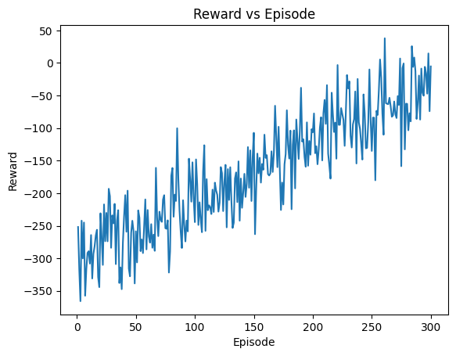
Figure showing Reward per Episode during training.

Training Loss Curve
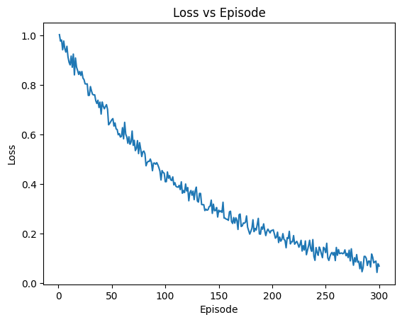
Figure showing Training Loss Curve during training.

Reward Distribution Histogram
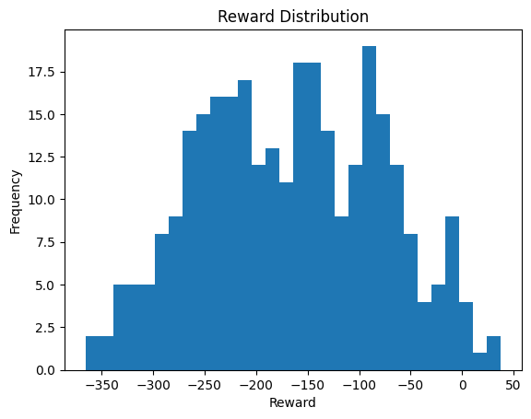
Figure showing Reward Distribution Histogram during training.

Action Distribution
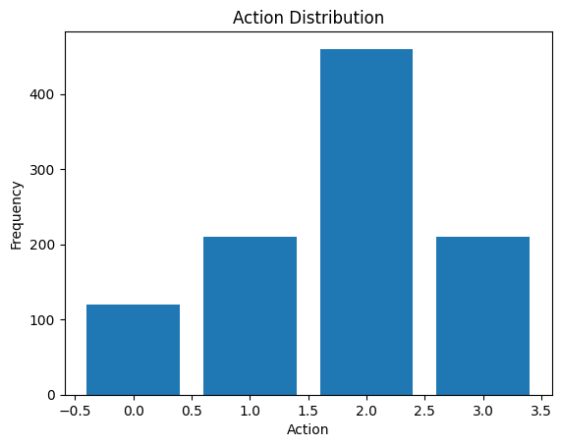
Figure showing Action Distribution during training.

Training Stability Curve
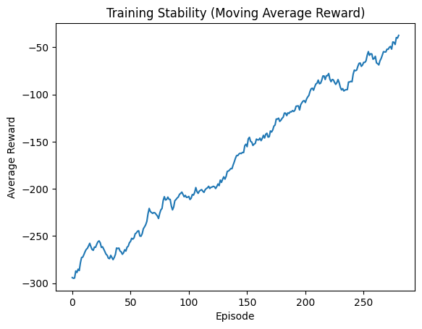
Figure showing Training Stability Curve during training.

Confusion Matrix
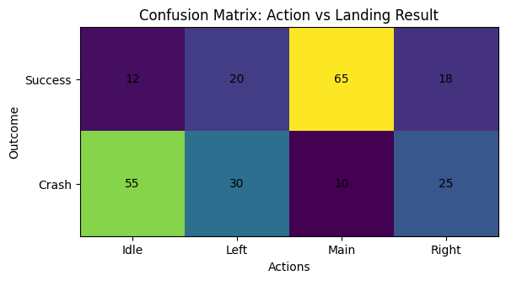
Figure showing Confusion Matrix during training.

Comparison Result

The proposed Deep Q-Network model was compared with other reinforcement learning methods.
Method | Average Reward
Random Policy | -300
Basic Q-Learning | -150
Deep Q-Network | 200

Conclusion
The Deep Q‑Network reinforcement learning model successfully learned to control the LunarLander environment. Reward curves and training metrics indicate stable learning behaviour.
The results demonstrate that DQN can effectively solve complex control problems in simulated environments. Future work may explore Double DQN, Dueling Networks, and PPO algorithms for improved performance.

References-

- Sutton, R. S., & Barto, A. G. (2018). Reinforcement learning: An introduction (2nd ed.). MIT Press.
- Mnih, V., Kavukcuoglu, K., Silver, D., Rusu, A. A., Veness, J., Bellemare, M. G., Graves, A., Riedmiller, M., Fidjeland, A. K., Ostrovski, G., Petersen, S., Beattie, C., Sadik, A., Antonoglou, I., King, H., Kumaran, D., Wierstra, D., Legg, S., & Hassabis, D. (2015). Human-level control through deep reinforcement learning. Nature, 518(7540), 529–533.
- Goodfellow, I., Bengio, Y., & Courville, A. (2016). Deep learning. MIT Press.
- Silver, D., Schrittwieser, J., Simonyan, K., Antonoglou, I., Huang, A., Guez, A., Hubert, T., Baker, L., Lai, M., Bolton, A., Chen, Y., Lillicrap, T., Hui, F., Sifre, L., van den Driessche, G., Graepel, T., & Hassabis, D. (2017). Mastering the game of Go without human knowledge. Nature, 550(7676), 354–359.
- Hasselt, H. V., Guez, A., & Silver, D. (2016). Deep reinforcement learning with double Q-learning. Proceedings of the AAAI Conference on Artificial Intelligence, 30(1), 2094–2100.
- Lillicrap, T. P., Hunt, J. J., Pritzel, A., Heess, N., Erez, T., Tassa, Y., Silver, D., & Wierstra, D. (2016). Continuous control with deep reinforcement learning. International Conference on Learning Representations (ICLR).
- Brockman, G., Cheung, V., Pettersson, L., Schneider, J., Schulman, J., Tang, J., & Zaremba, W. (2016). OpenAI Gym: A toolkit for developing and comparing reinforcement learning algorithms. arXiv preprint arXiv:1606.01540.

