Name : Tanishq J Ghodadra

Sem : 7

Div : B

Roll No : 100

Subject : Full stack

Q:1) Create 2 components using CDN approach.

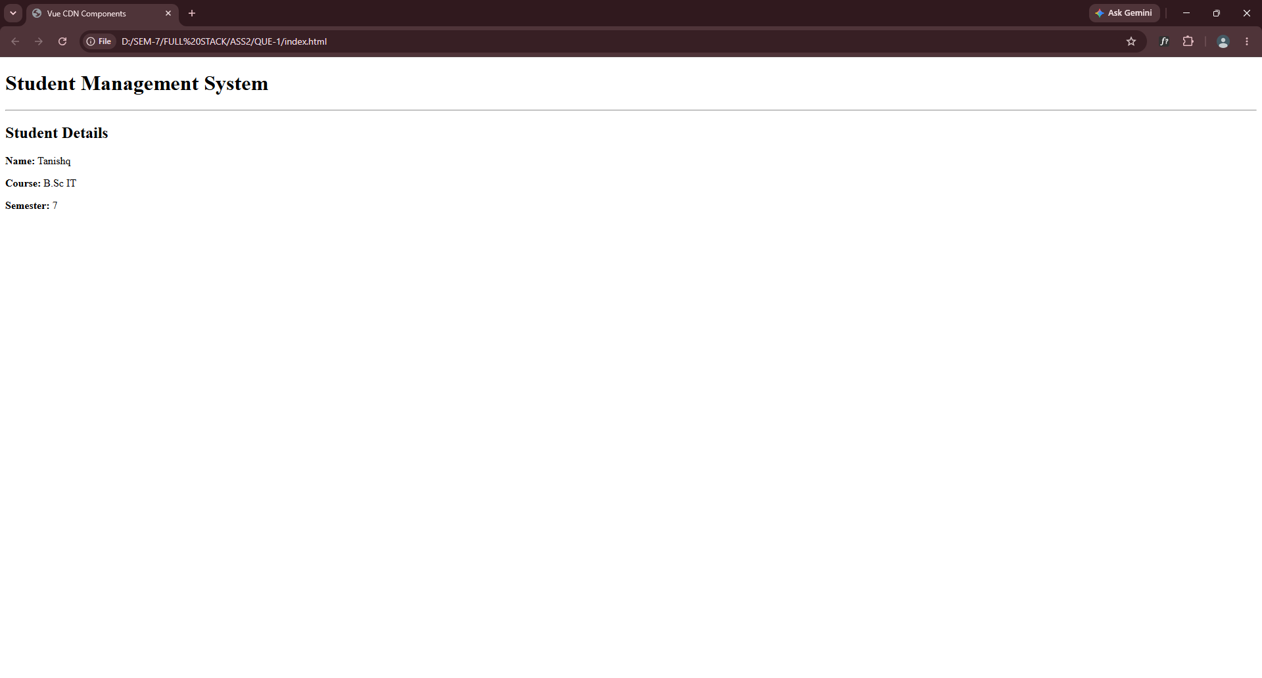

Q:2) Create Vite/CRA based react app, add bootstrap to it, add router to it and give links for components with following requirements:
1) Create and display component using function component.
2) Take a suitable case and develop

components for
conditional rendering, list, nested components, children (containment)
3) Develop counter component with increment, decrement, reset.
4) Develop

components using useState and useRef using function components.
5) Develop components for digital clock using useState and useEffect.
6) Develop

component for live form validation with manual validation.
7)

Develop component for live form validation with any third party validation library.
8)

Develop component that fetches data from a

employees .json JSON file and display in a table.
9)

Develop component to fetch data from students.json and display. Add search and filtering. Search should be based on student firstname and filtering is based on semester, div, gender etc.

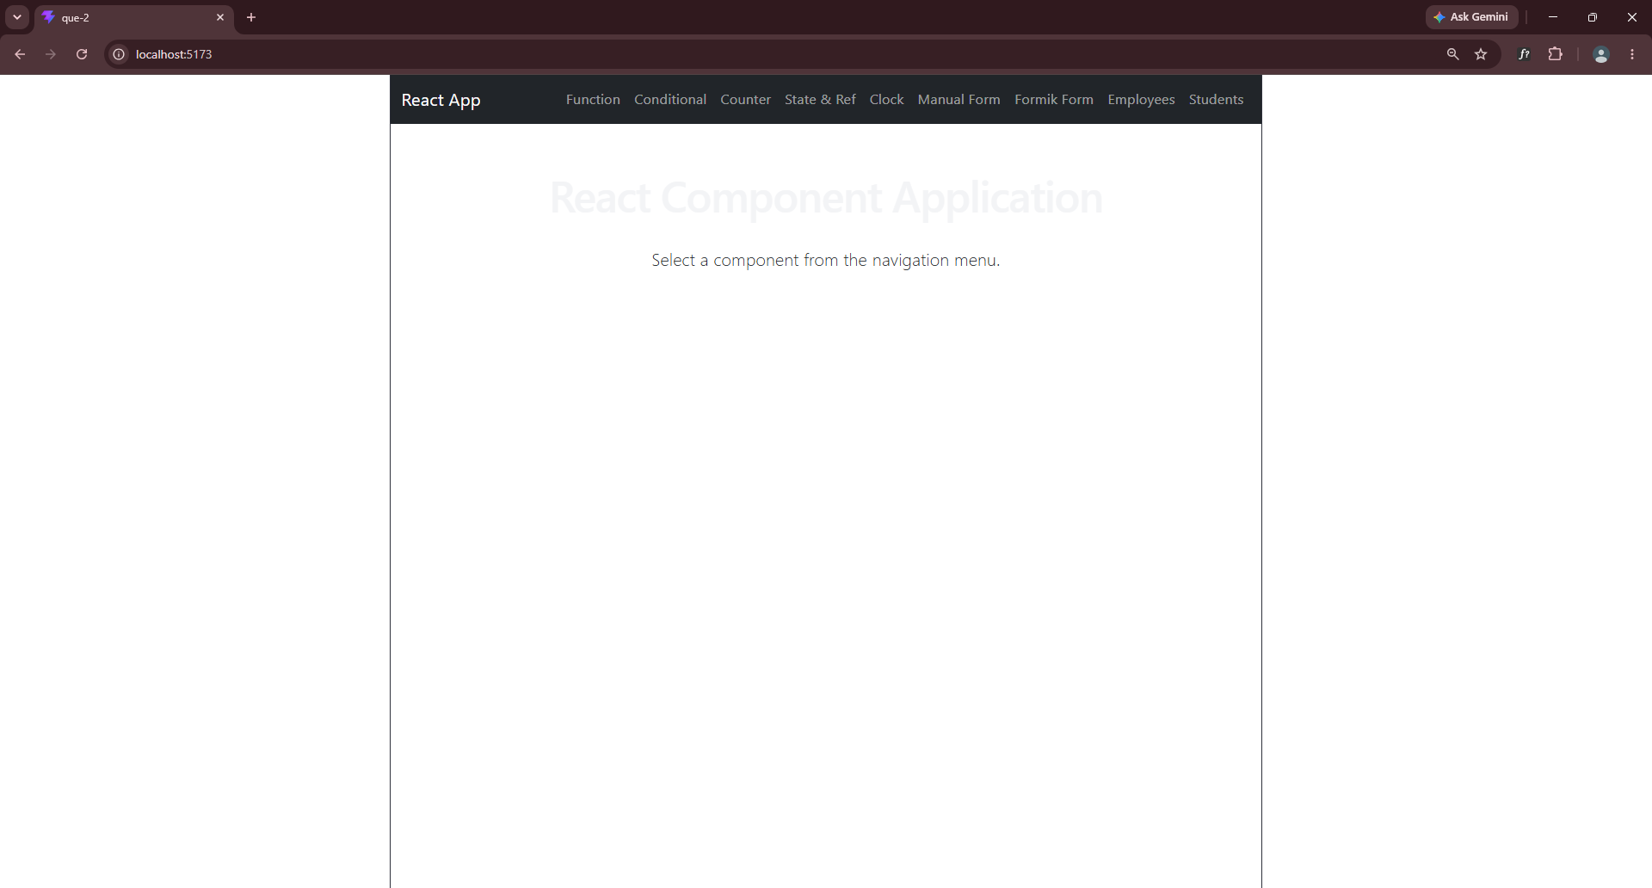

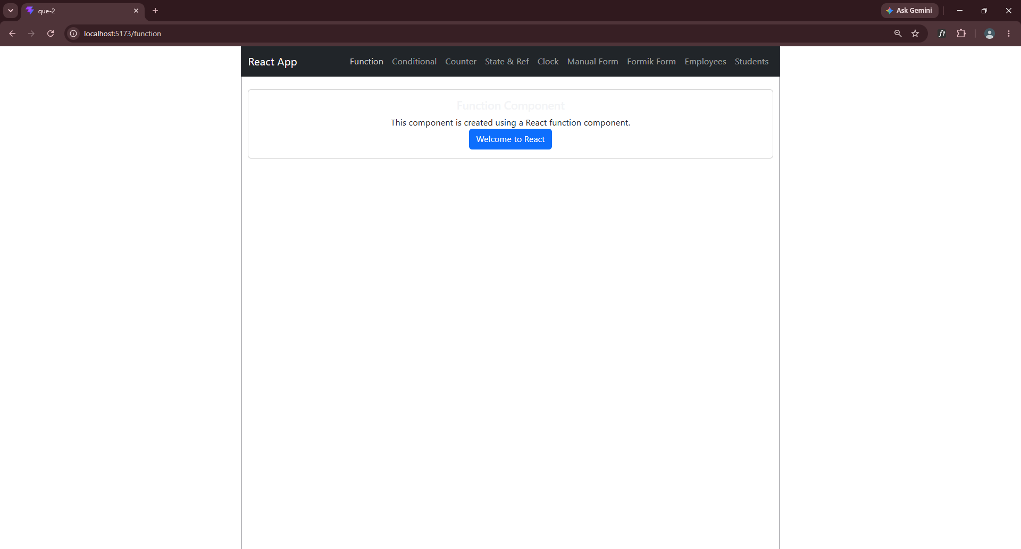

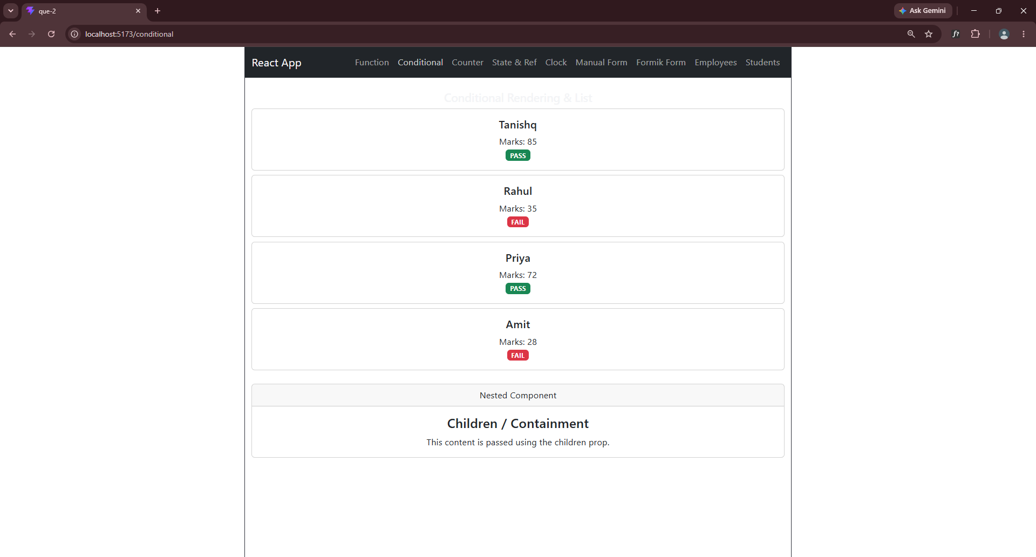
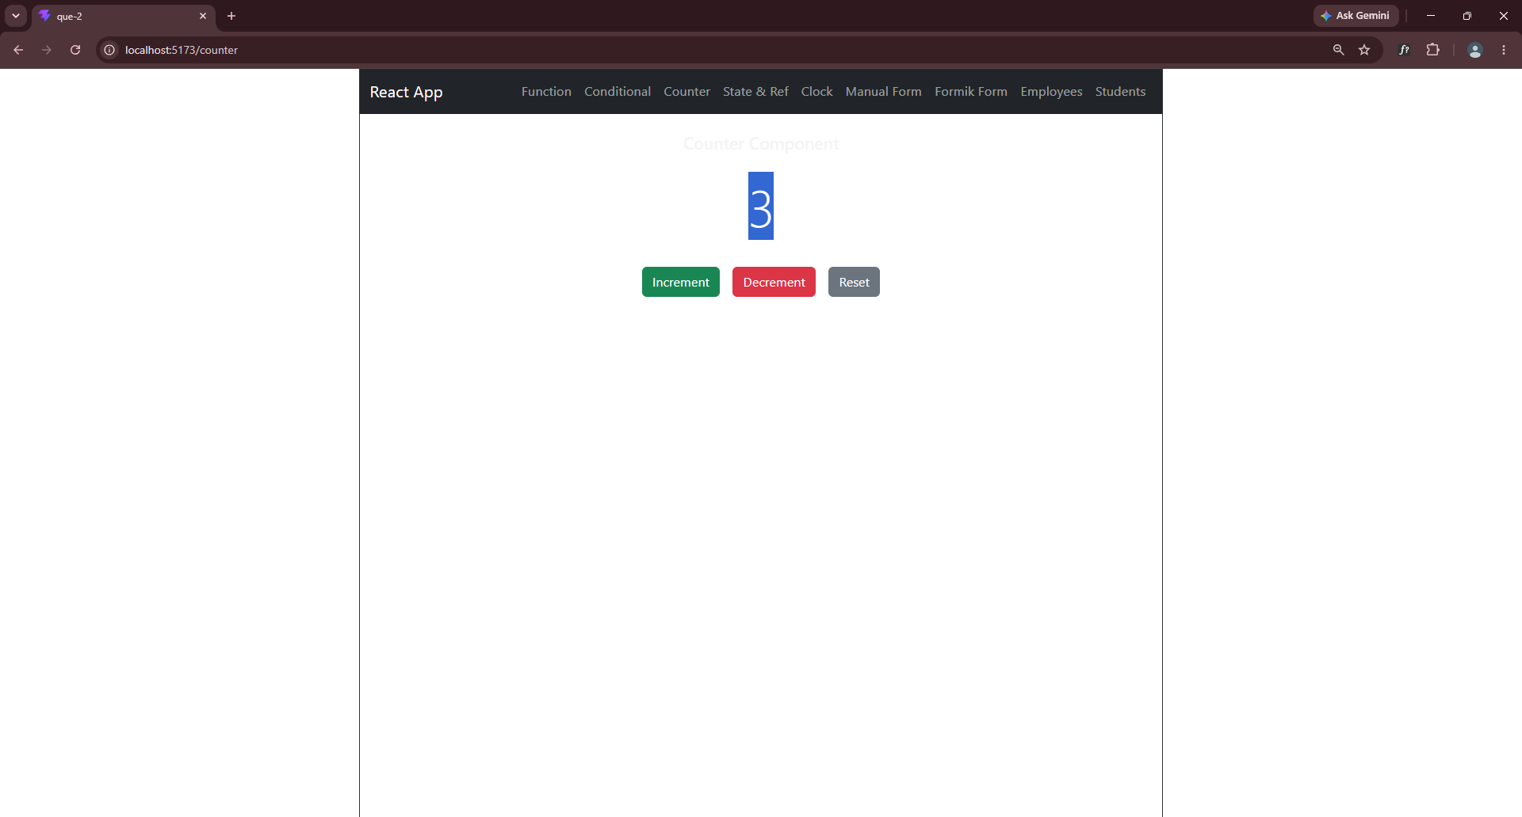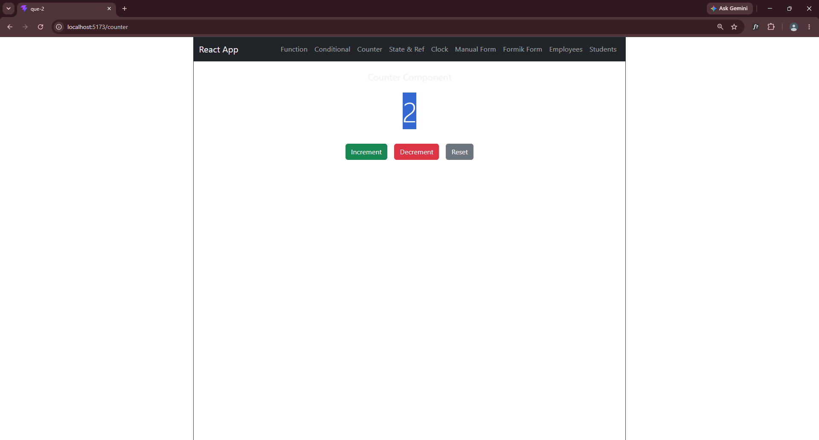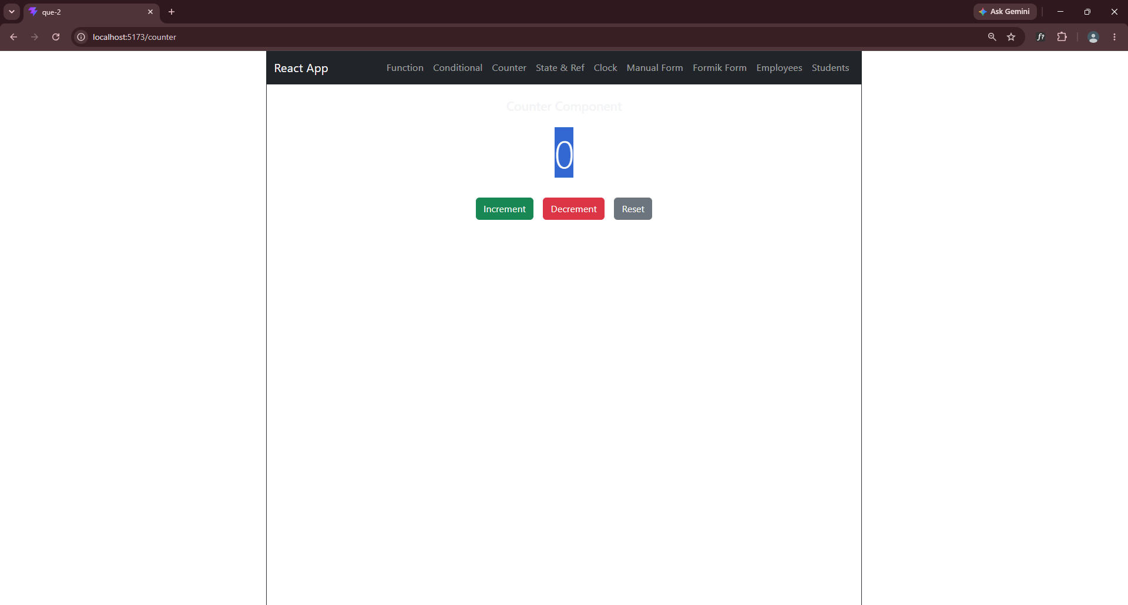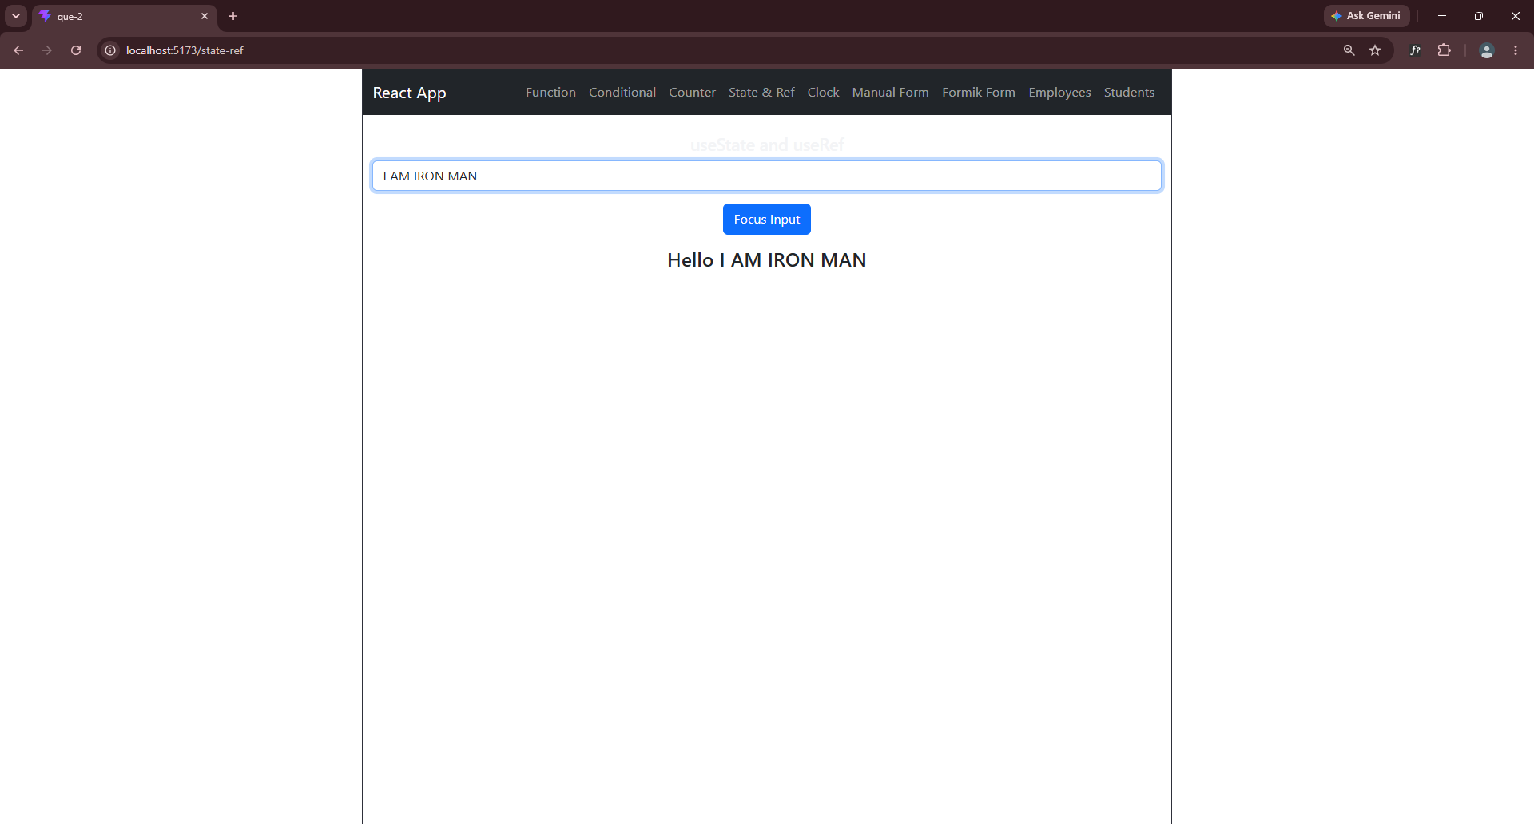

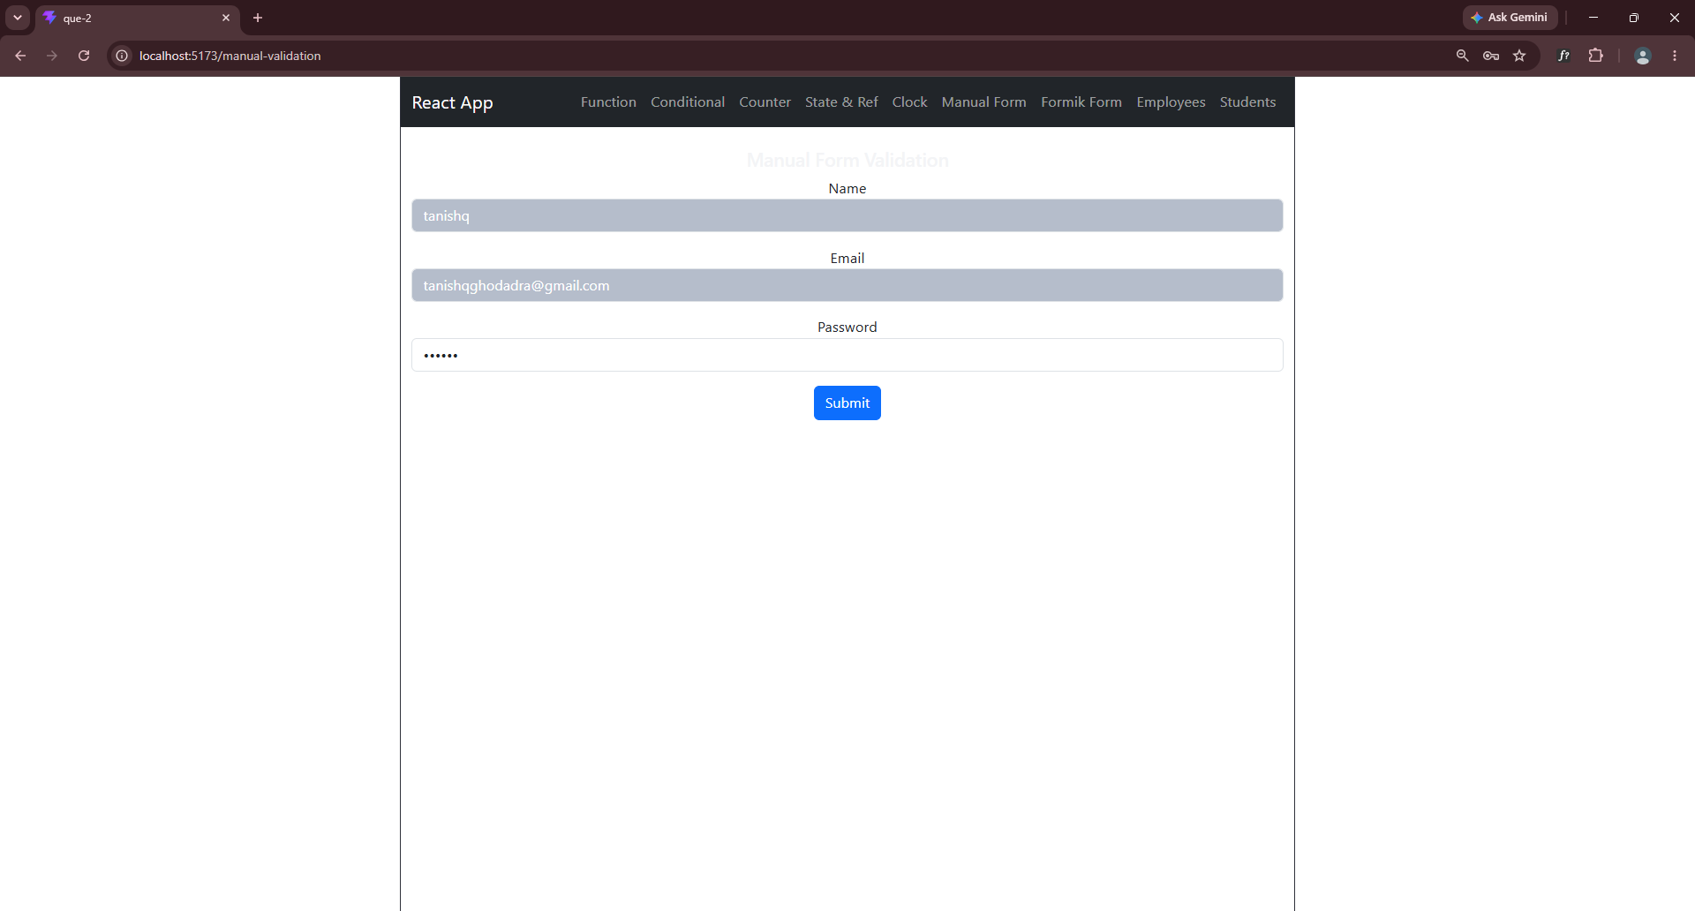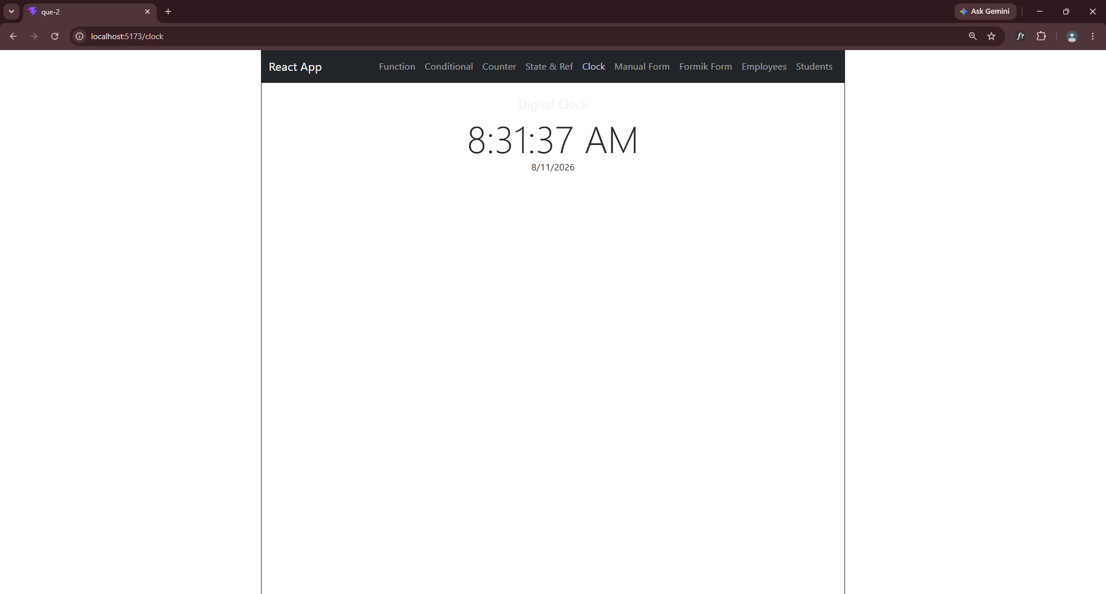
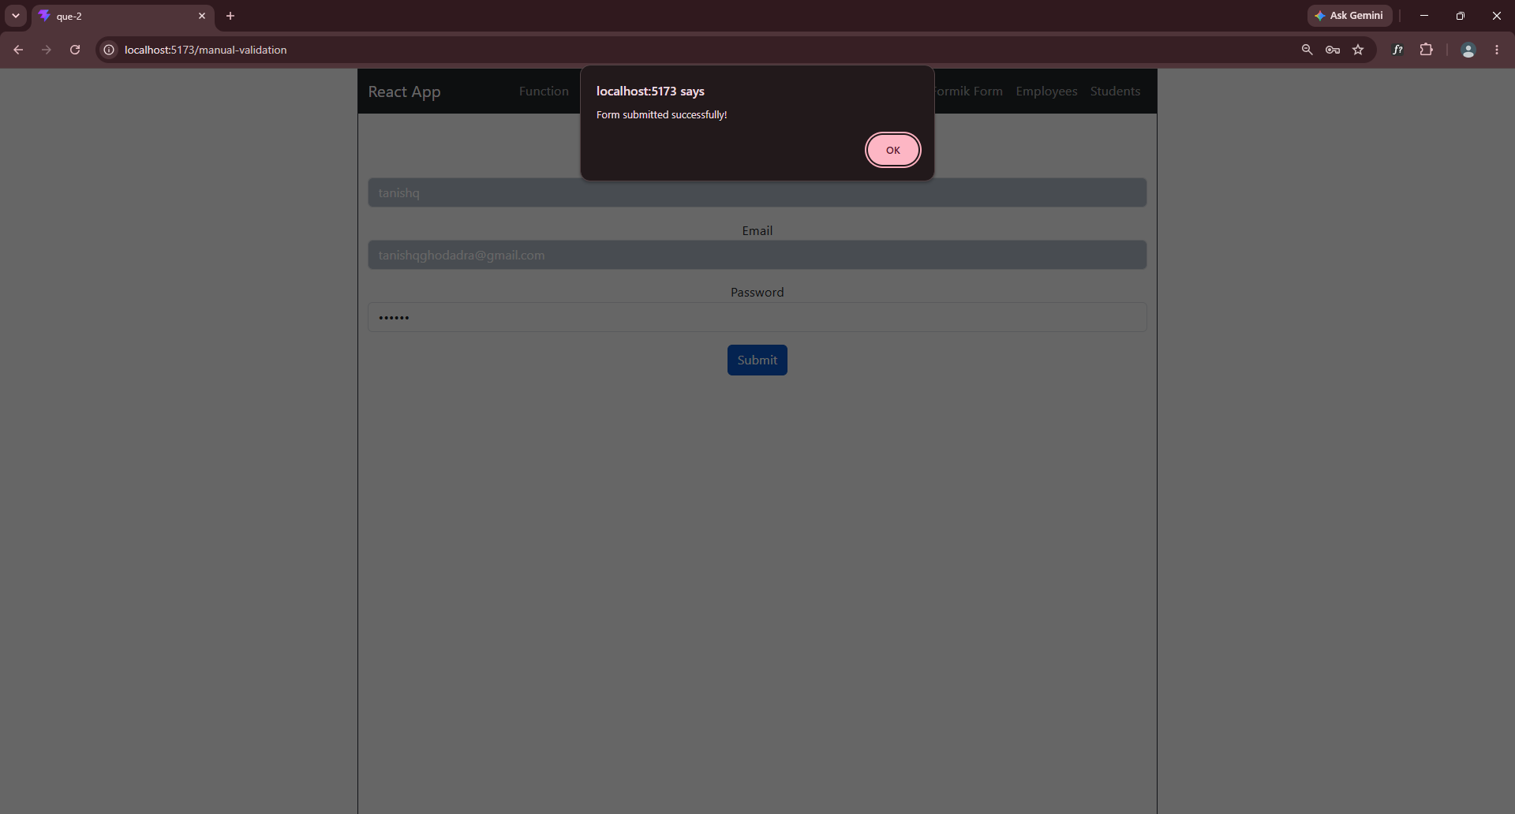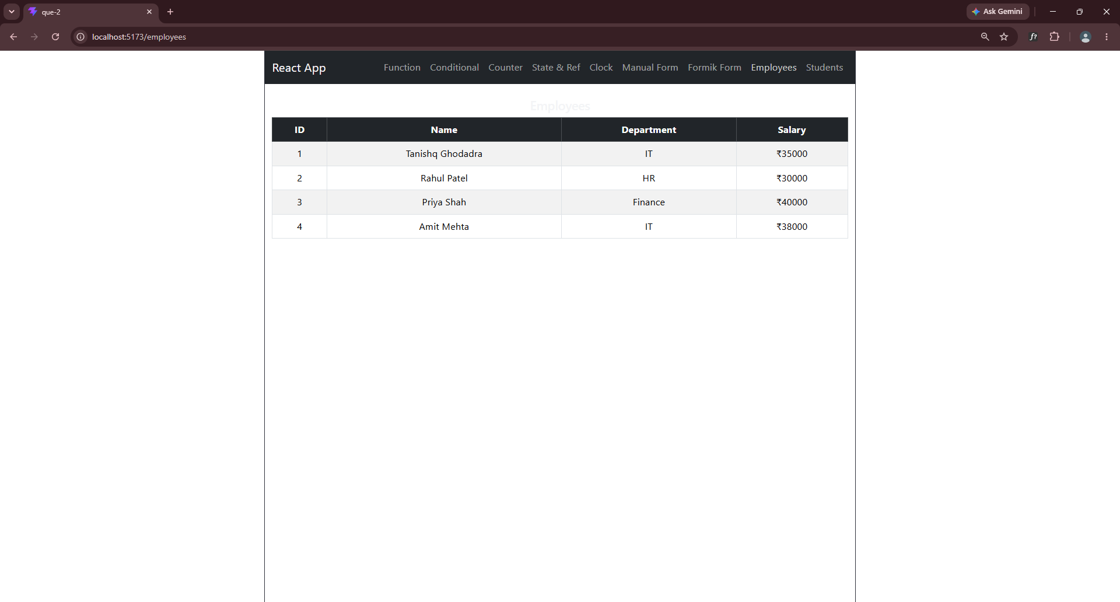

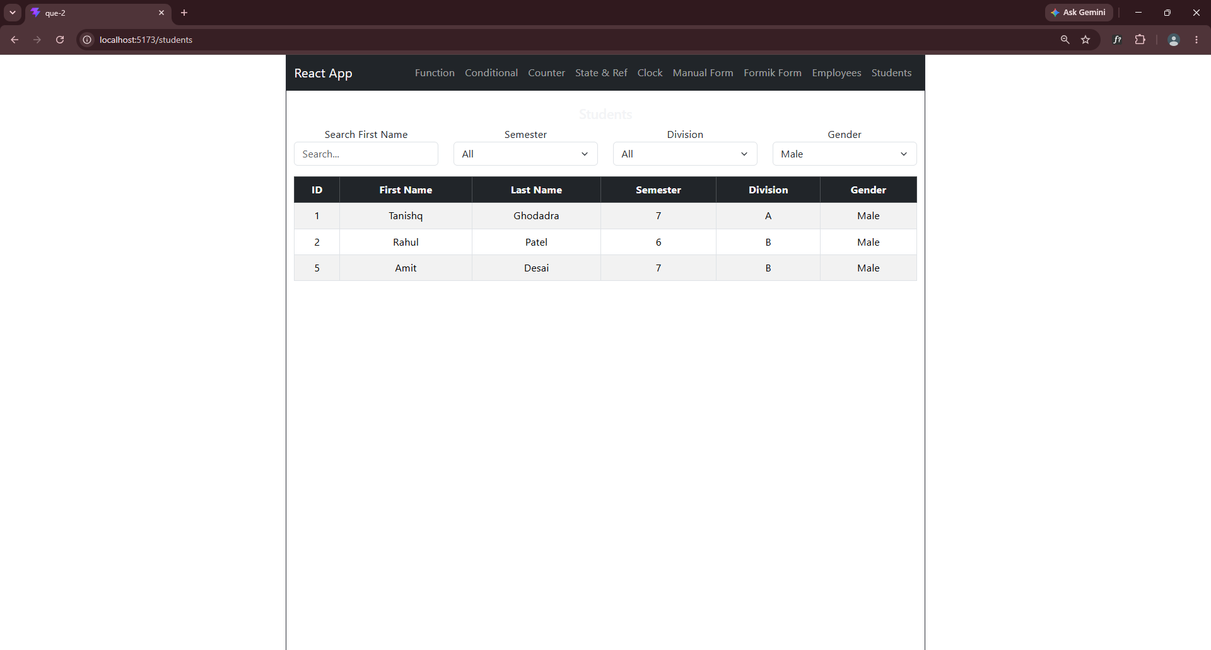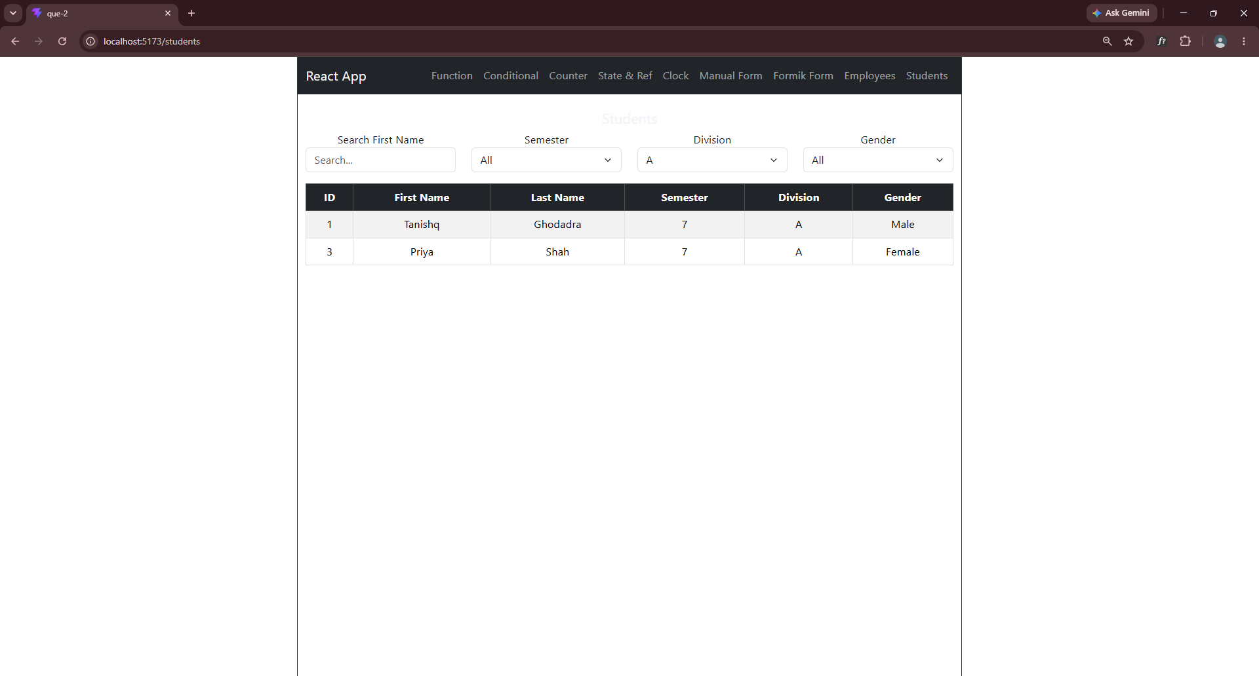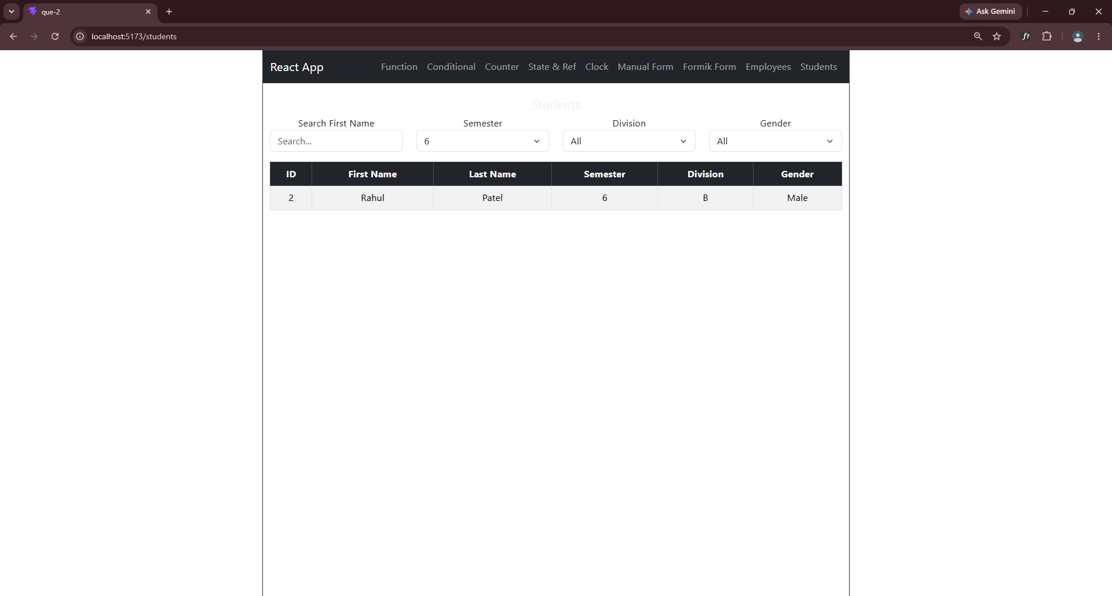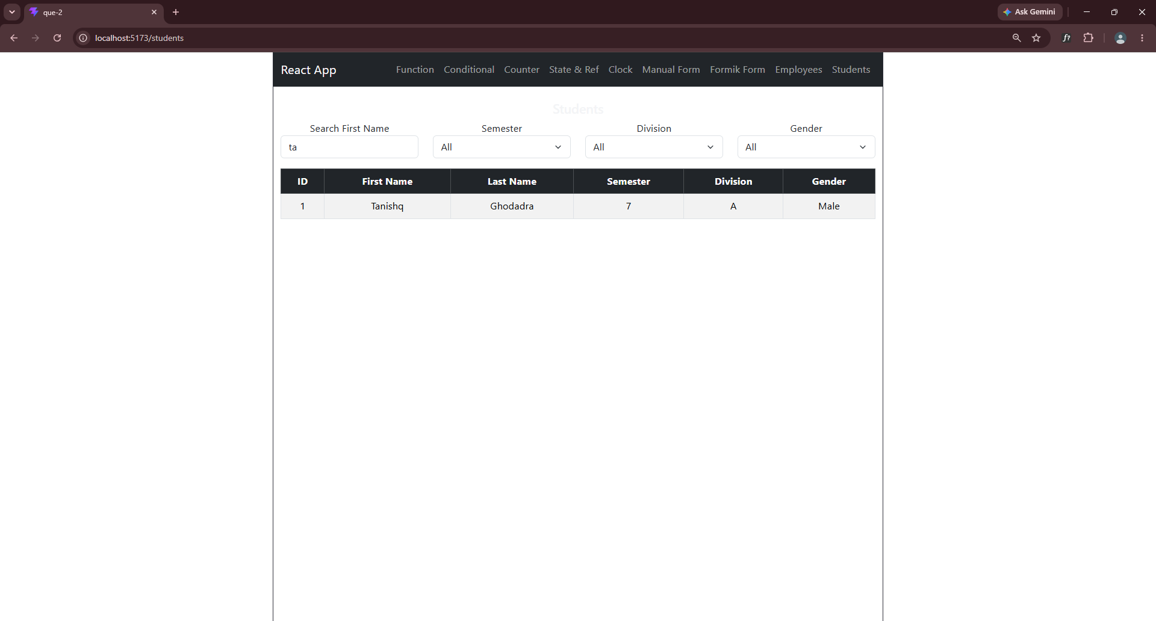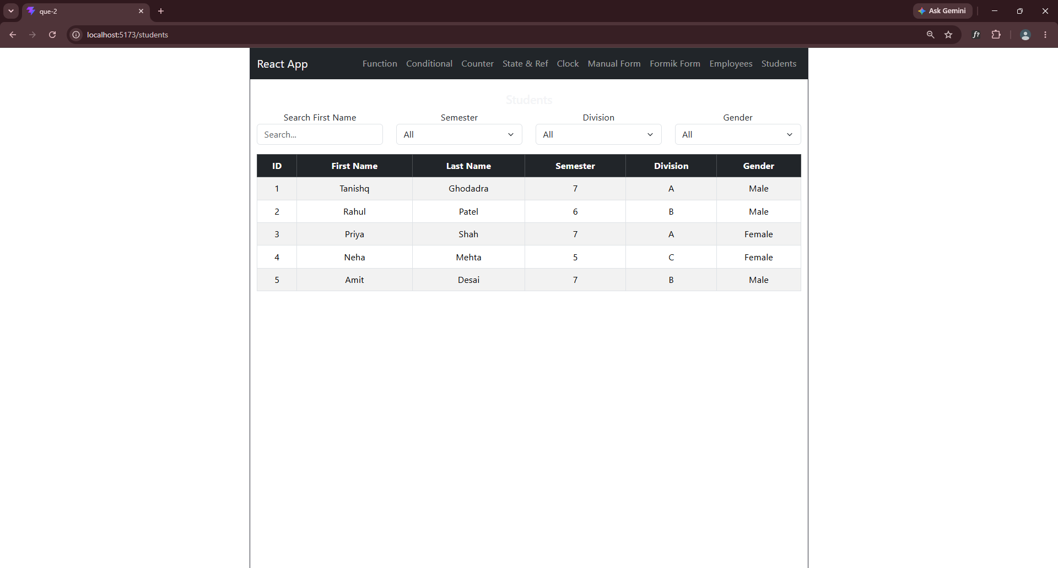

- Q:3 Develop "To Do" app.

