Ideation Phase

Define the Problem Statements

|  |  |
| --- | --- |
| Date | 28 June 2025 |
| Team ID | LTVIP2025TMID59298 |
| Project Name | Book Nest |
| Maximum Marks | 2 Marks |

**Customer Problem Statement Template:**

**Book Ordering Application – Problem Understanding**

To better understand the frustrations and motivations of a Book Nest user, we developed a **user empathy framework** focused on their **thoughts, actions, and feelings**.

This empathy-based layout provides insights into the **typical user journey and challenges** when using a book-ordering platform:

**🔍 SAYS**

* “What book should I order?”
* “It’s annoying to navigate this interface.”
* “The designs are too cluttered.”

**💭 THINK & FEEL**

* Has noticed books on sale but is skeptical.
* Thinks the platform may not reflect their preferences or reading habits.
* Feels unsure due to outdated interface or complex design.

**👁️ SEES**

* Limited payment options (e.g., only cash or single digital method).
* Repetitive or unclear product displays.

**😞 PAIN POINTS**

* Lack of free shipping.
* Unattractive or unclear pricing.
* Difficulty finding niche books (e.g., university material).

**💡 GAINS**

* Convenience of online ordering.
* Fast delivery for available stock.
* Simpler comparison of options (once understood)

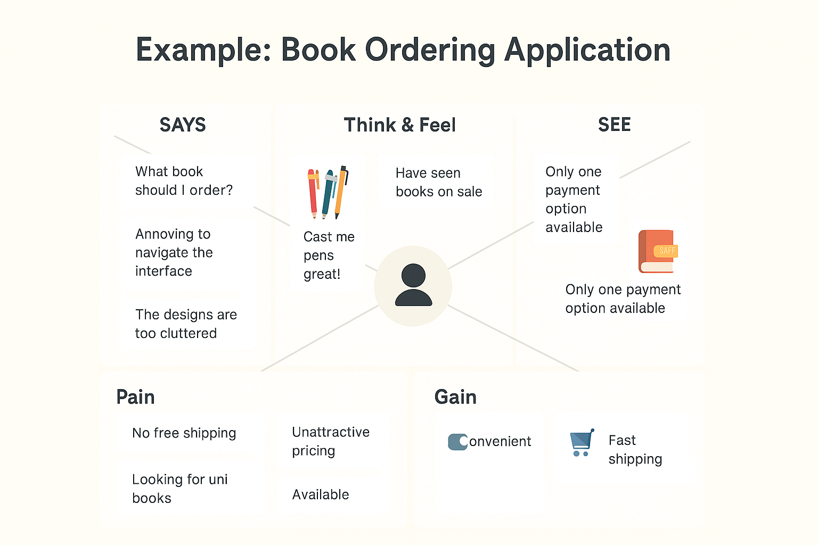

Bottom of Form