**Data Flow Diagram For Library management System**

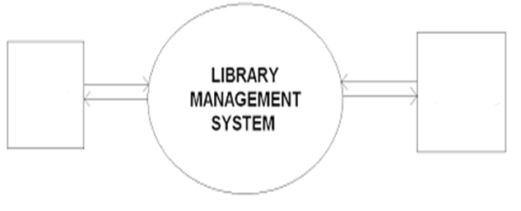

**BOOKS**

**STUDENTS**

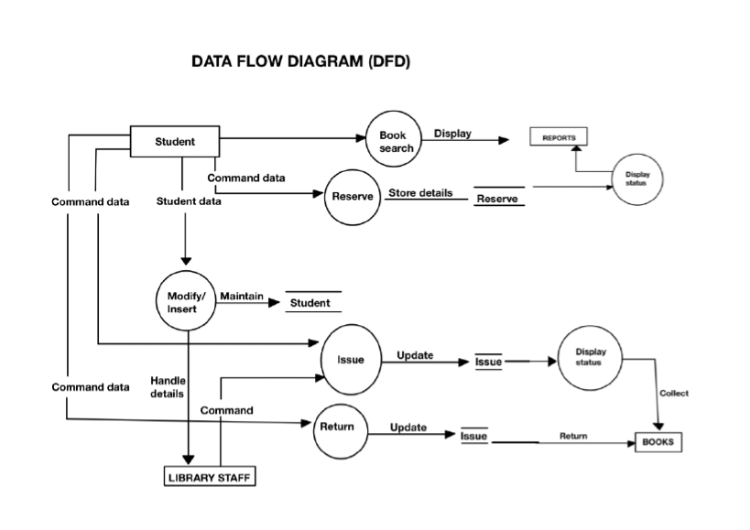

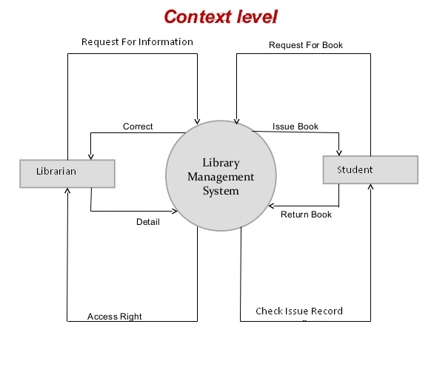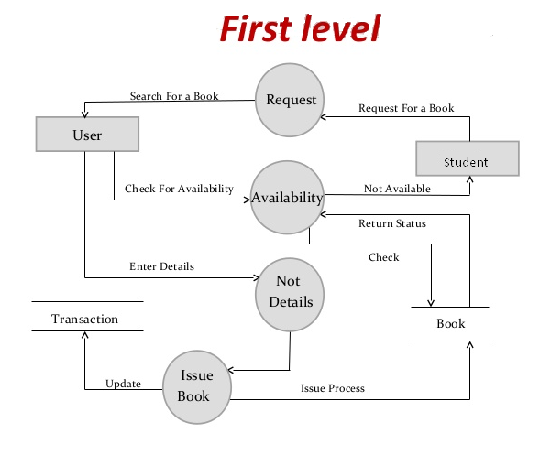

**E-R Diagram of Library Management System**

**Borrow by**

**Student**

**Books**